

**THE CATHOLIC UNIVERSITY OF EASTERN AFRICA**

**UNIT CODE: CMT 302**

**UNIT TITLE: ADVANCED DATABASE SYSTEMS**

**PROJECT NAME: ONLINE BUS TICKET BOOKING SYSTEM**

**SUBMISSION DATE: 22TH NOV 2024**

**GROUP NO:31 STREAM B**

**MEMBERS:**

**1062811- JULIUS MAINGI NJUGUNA**

**1062793- NJENGA KENDI**

**1046045- SHARON CHEPKORIR**

**1045121- LUCY MWONGELI**

**1049060- PETER KILUNDA**

**OVERVIEW**

Badariah, (2007) emphasised that the online bus ticket booking System which

was developed at Politeknik Kota Kuala Terengganu (PKKT) was to make sure

that users could make their online booking or reservations to their desired transport

companies with facilities provided by the new system. He pointed out that the

methodology and technology being used in this new transport system could be

applied to other areas of activities. The user who wants to use the transport must

make an application to book the transport before boarding.

Similarly, after considering the type of system which Badariah adopted, this

project will be designed with the same aim of presenting the customers of Wema

Transport Company with the opportunity of making reservations at the comfort of

their homes or offices without being faced with the challenges of queuing at

counters before embarking on any journey. This project will also enlighten

prospective customers and users of the system on the need to patronise the system

as it displays more advantages over the old system by providing an easy to use

Graphic User interface (GUI) interaction, checking availability of routes before

boarding etc.

**RATIONALE:**

Online bus ticket booking systems can be justified for a variety of reasons, including:

Convenience for customers: Customers can book tickets at any time, from any device, and from anywhere with an internet connection. This eliminates the need for phone calls or physical visits.

Streamlined operations: Online booking systems can automate reservation processes, simplify calendar management, and improve communication with clients.

Reduced risk of human error: Online booking systems can help reduce the risk of human error.

Increased revenue: Online booking systems can help increase revenue to its servicing company.

Superior customer experience: Online booking systems can help deliver a superior customer experience and leave reviews and ratings by customers.

Avoid disappointment of queues: Online ticketing allows visitors to purchase tickets in advance, avoiding the need to wait in long queues.

**OBJECTIVES:**

The main purpose of this project is to automate the manual procedures of reserving a

bus ticket for a road journey facilitated through a transport company.

The specific objectives of this project consists of:

i) To provide a web-based bus booking system where a customer can

buy a bus ticket without the need to queue up at the counter.

ii) To enable customers to check the availability of buses online.

iii) To enable customers to choose their seats online.

iii) To enable customers to check the time of departure for a bus.

iv) To enable customers to pay for their bus ticket online.

iv) To provide the ability of customers to cancel their reservation online incase of change of plans.

**SYSTEM DESIGN:**

**(i) ER- DIAGRAMS-**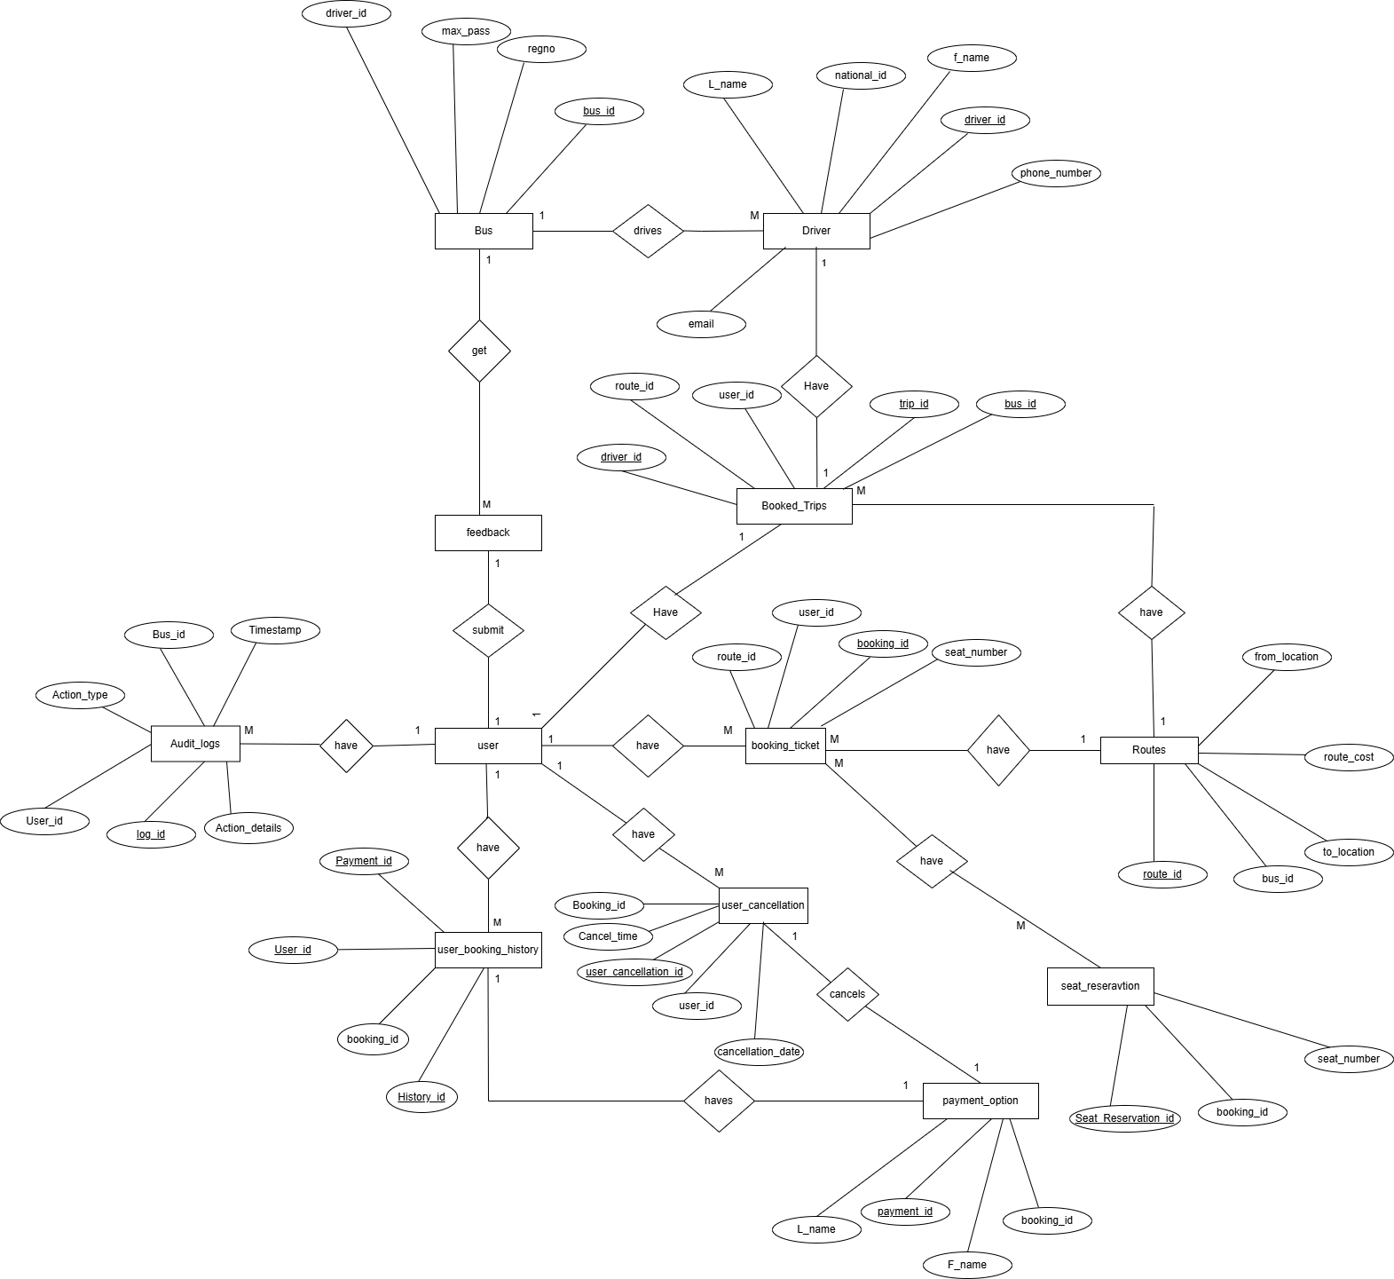

**(ii)TABLE STRUCTURES**

**1.Users table**

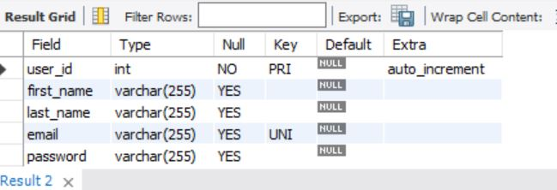

**2.Routes table**

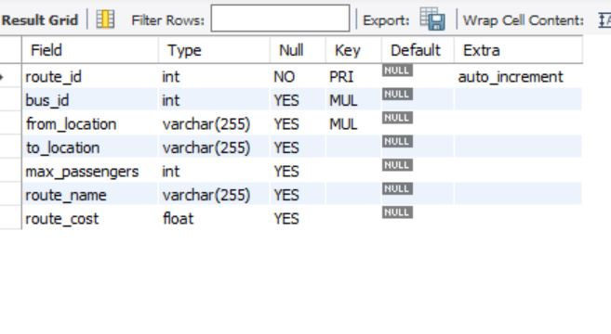

**3.Buses table**

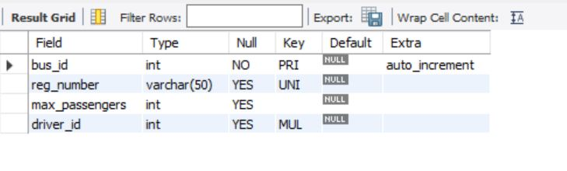

**4.Drivers table**

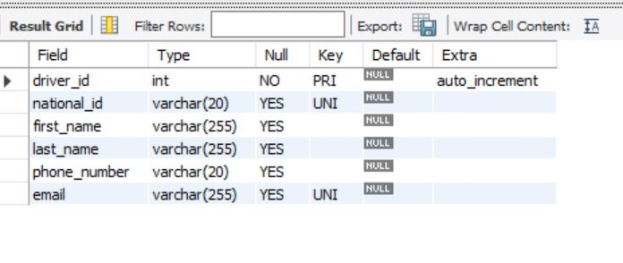

**5 Admin table**

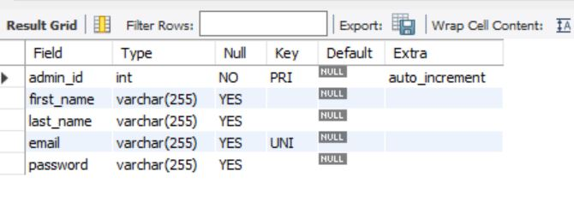

**6 Booking Ticket**

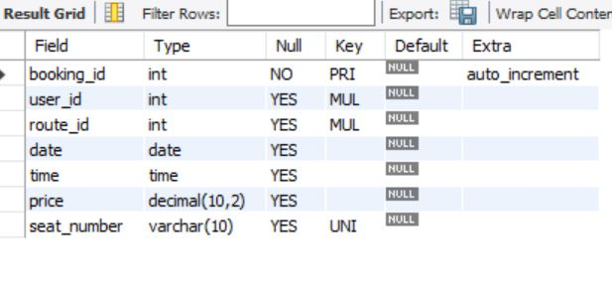

**7.Payment_option**

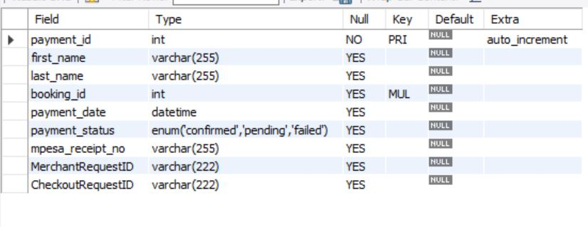

**8.Seat_Reservation**

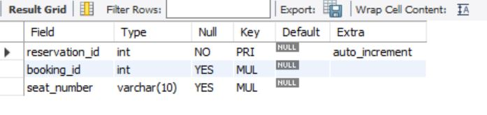

**9.User_booking_history**

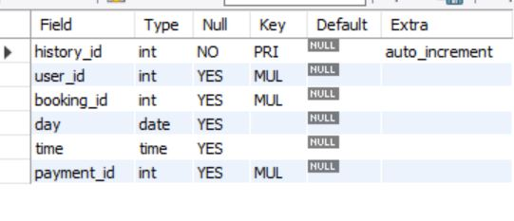

**10.Booked_trips**

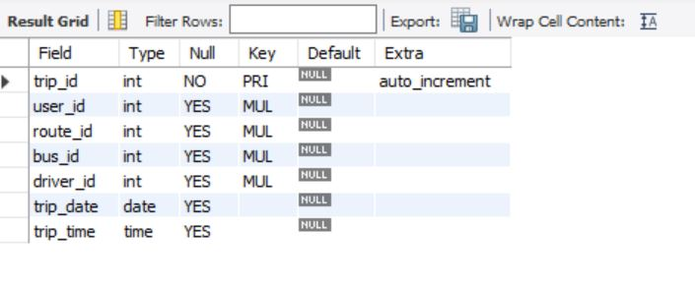

**11.Feedback table**

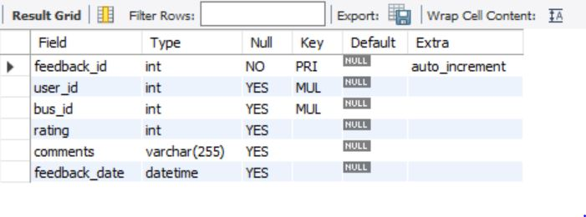

**12.Audit_Logs**

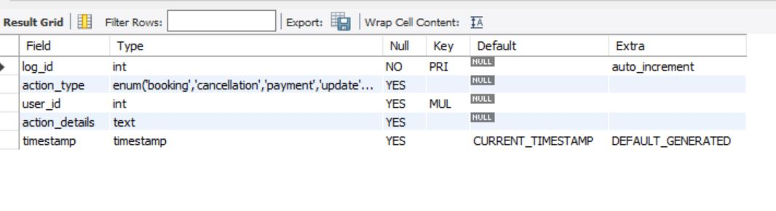

**13.User_cancellation_table**

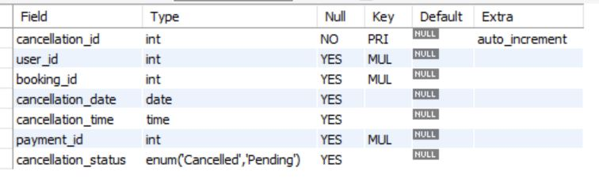

**(iii) SQL SCHEMA**

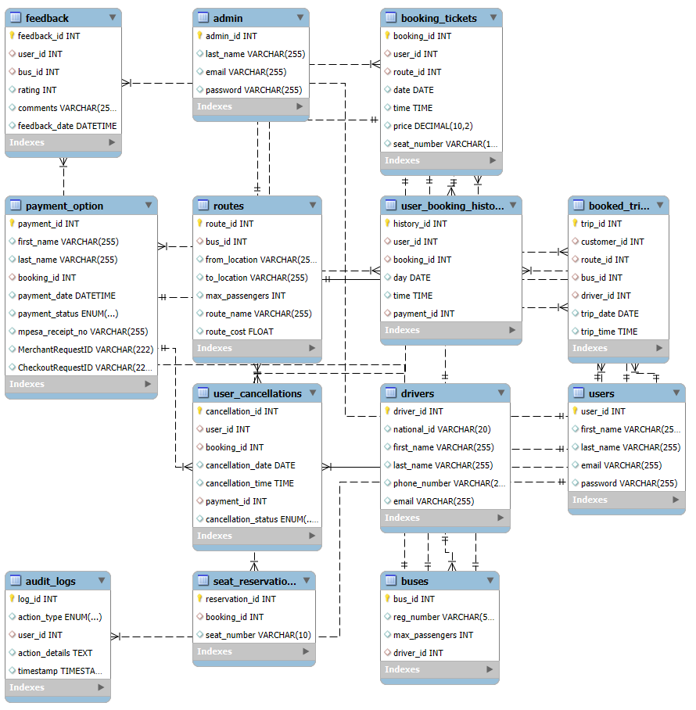

**TABLE CREATION SCRIPTS**

**Tables**

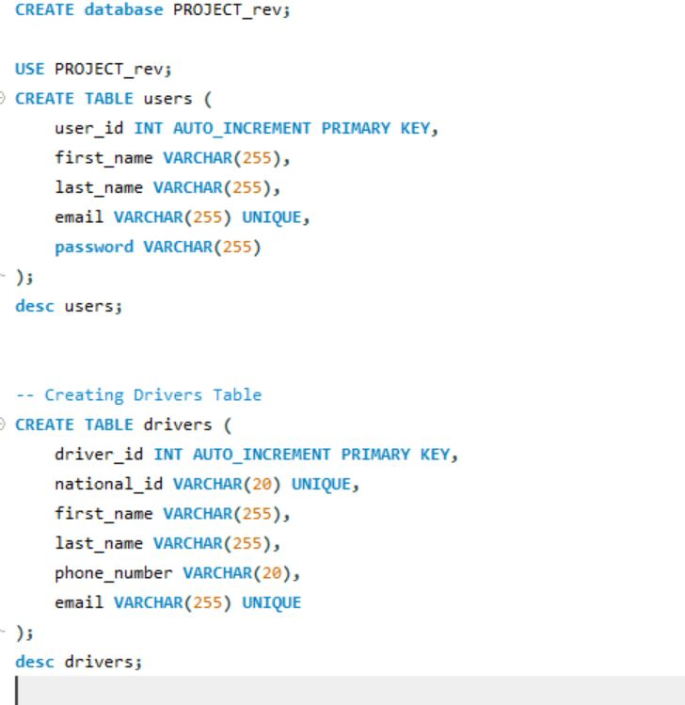

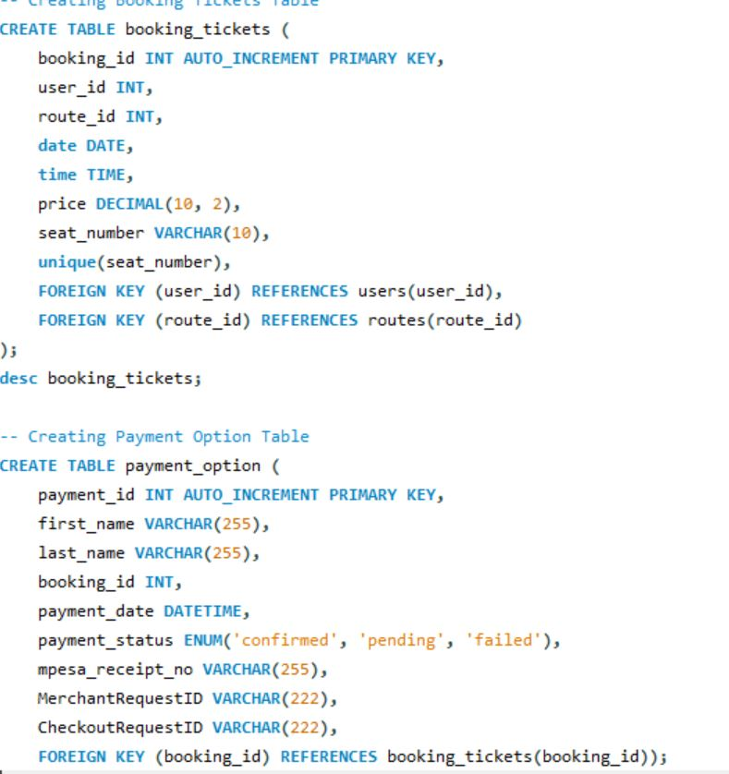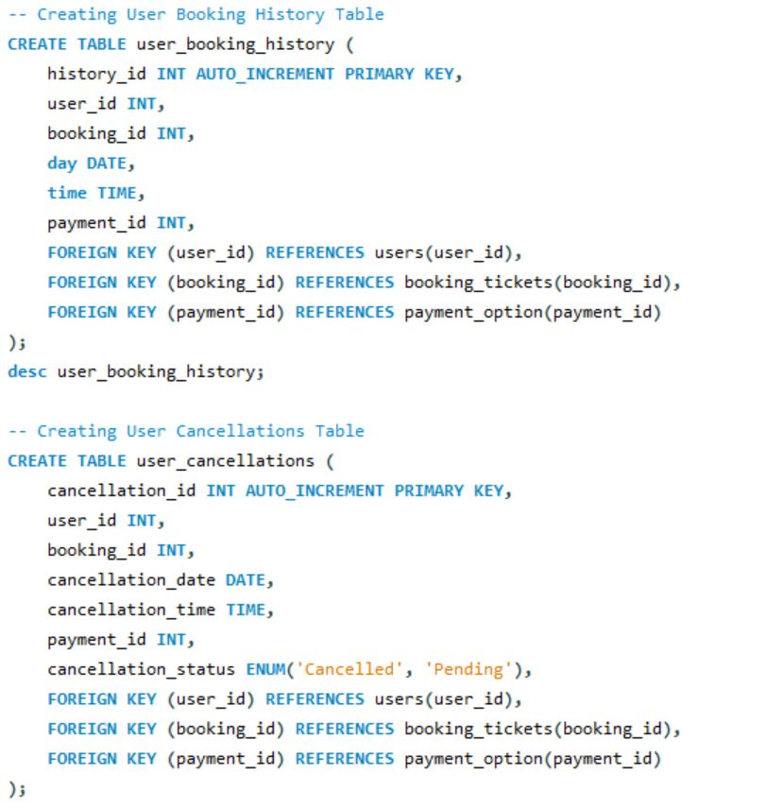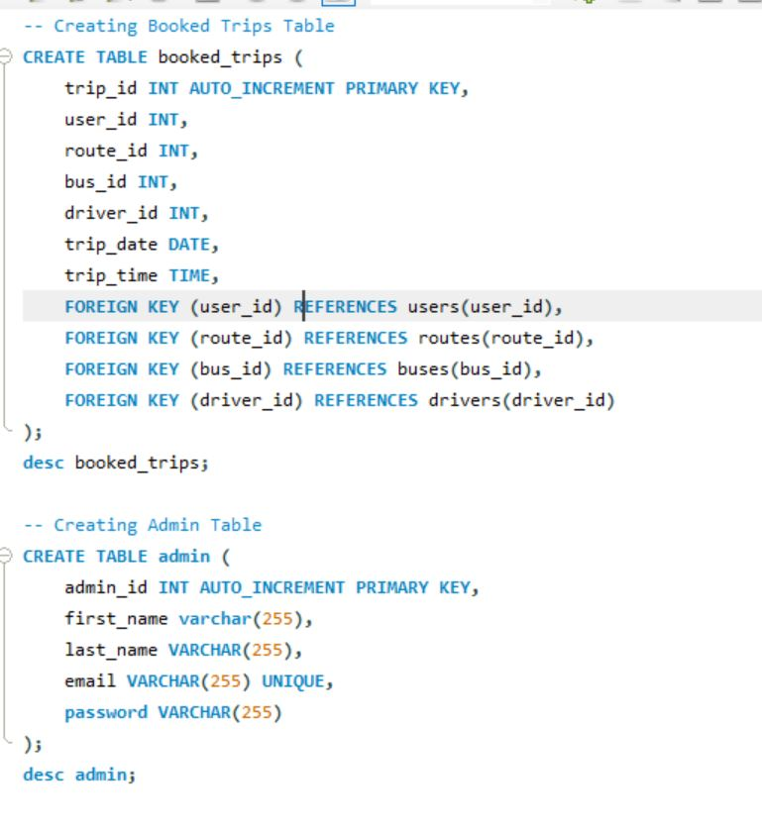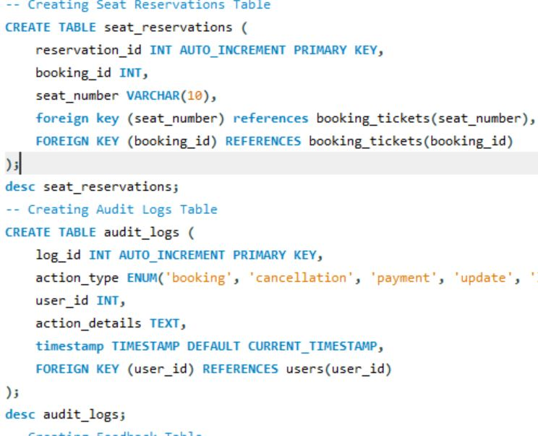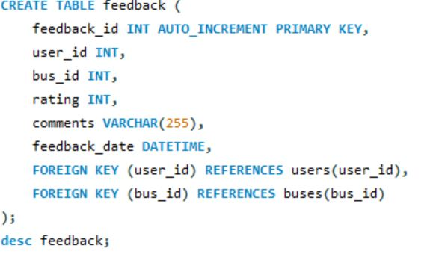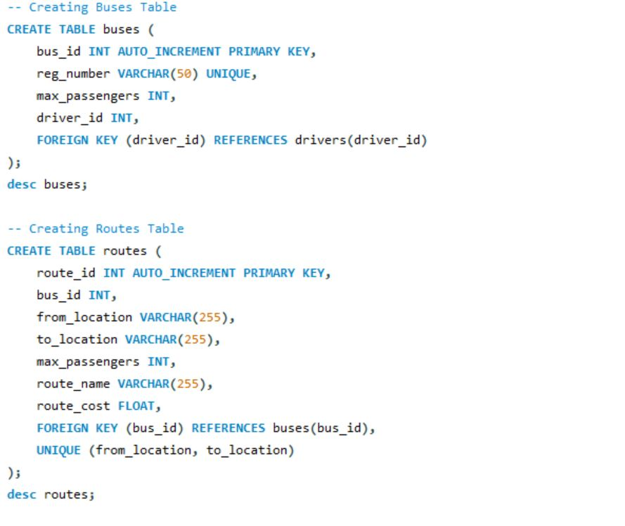

**INSERTION**

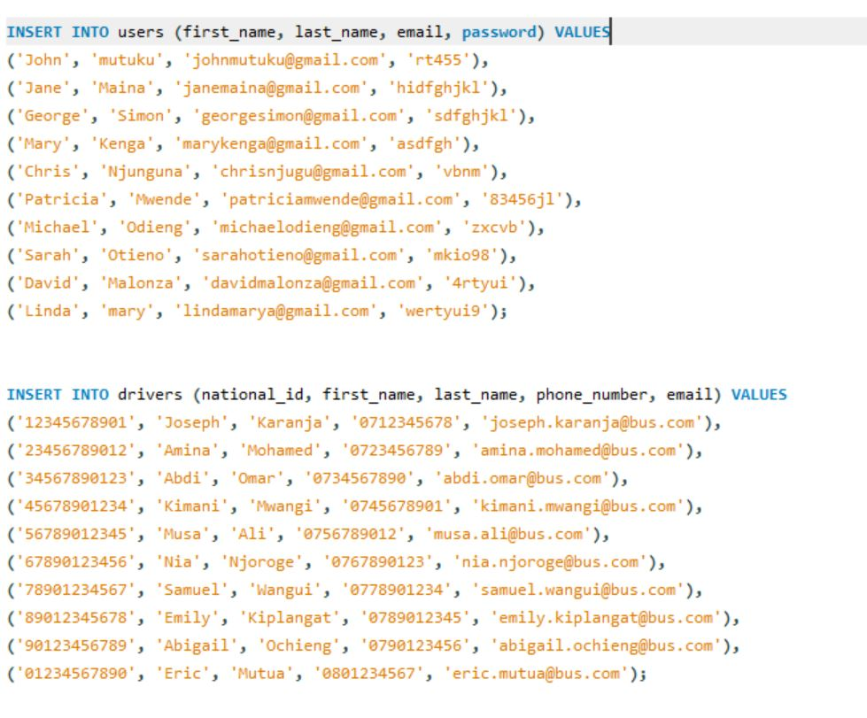

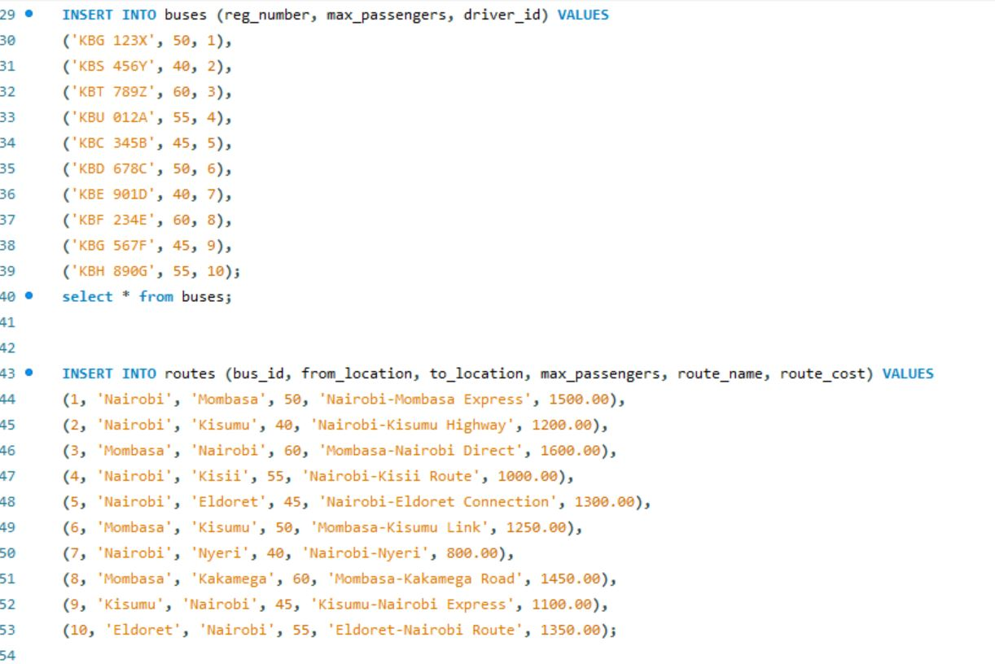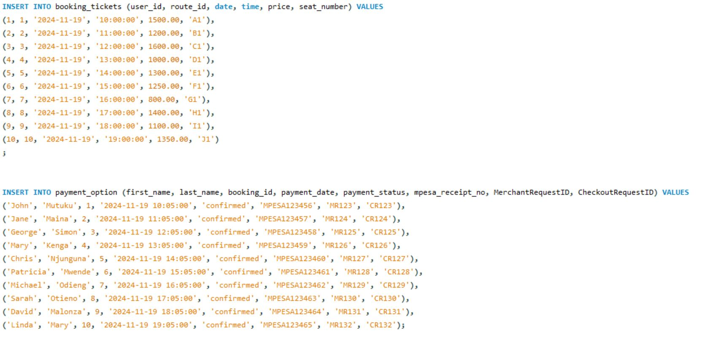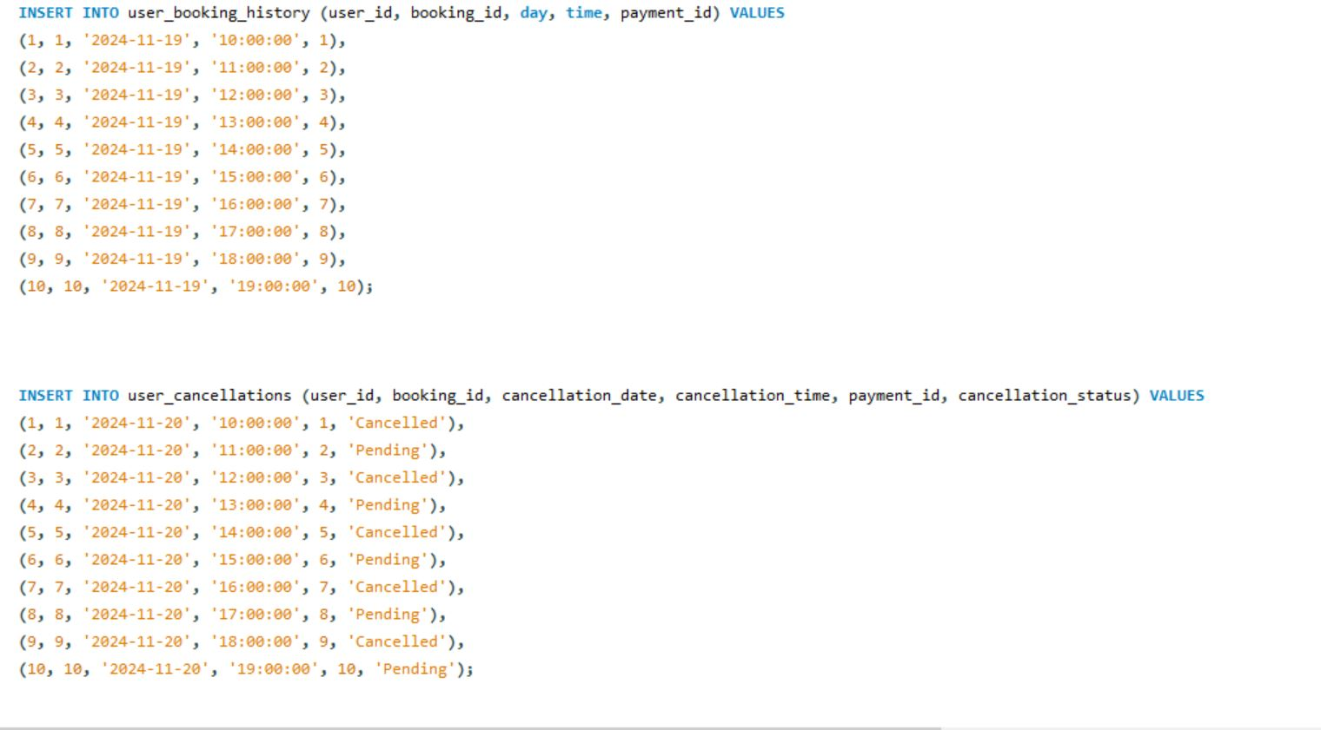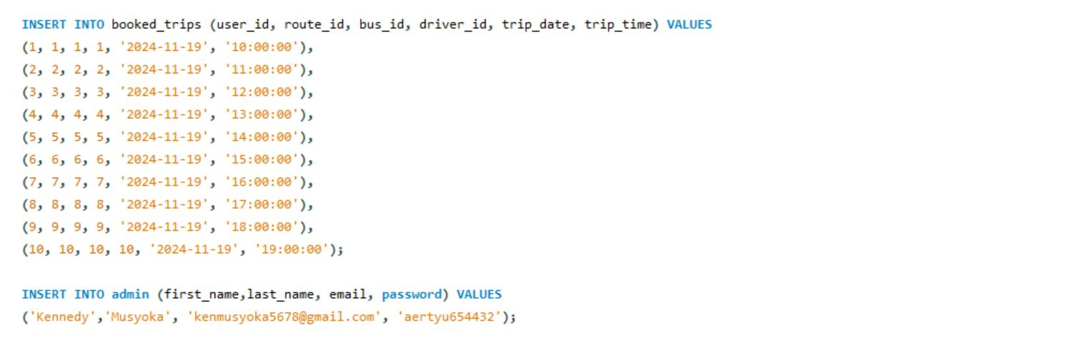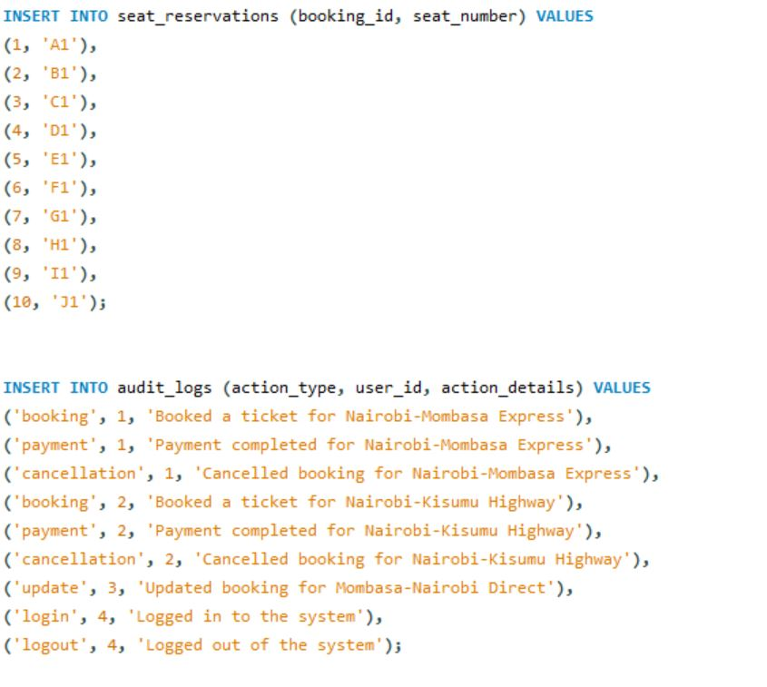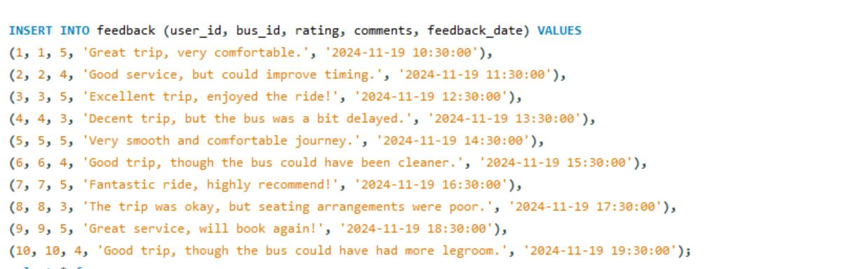

**IMPLEMENTATION:**

**(i)CRUD OPERATIONS**

1. users_side_operations

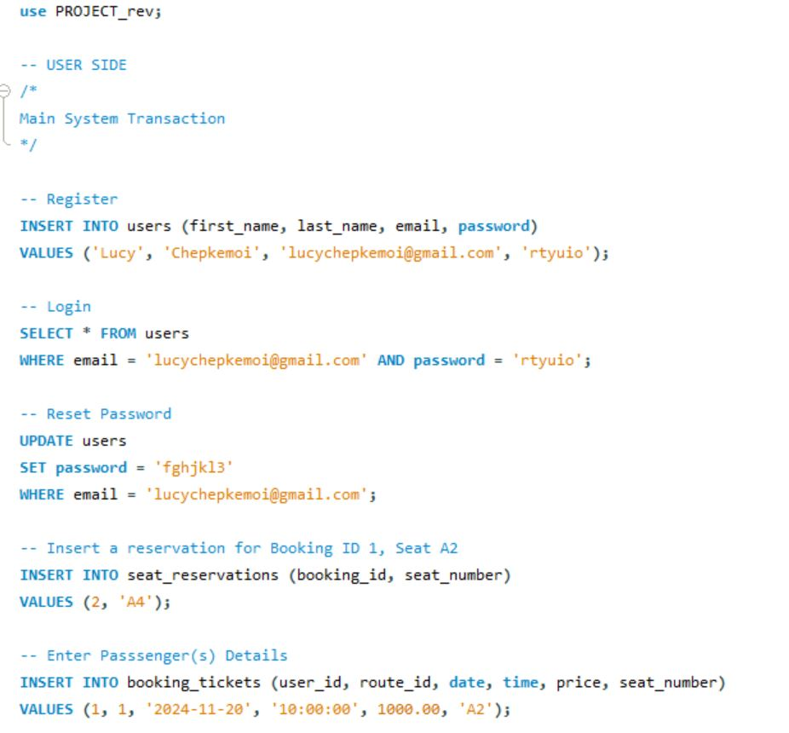

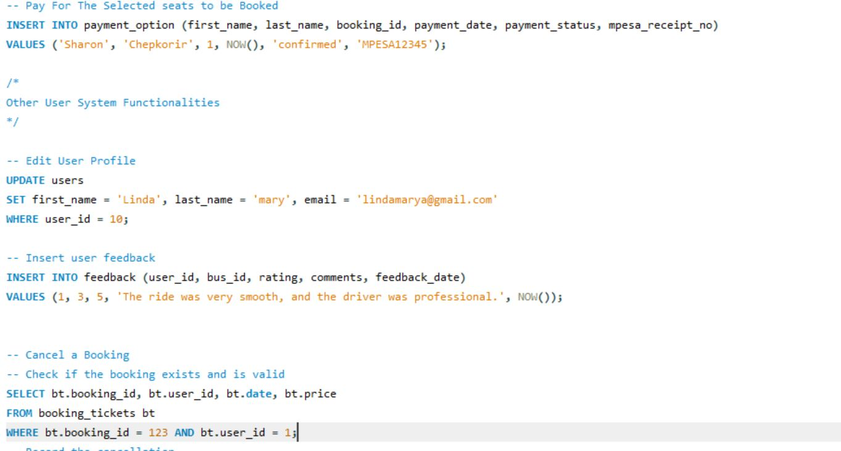

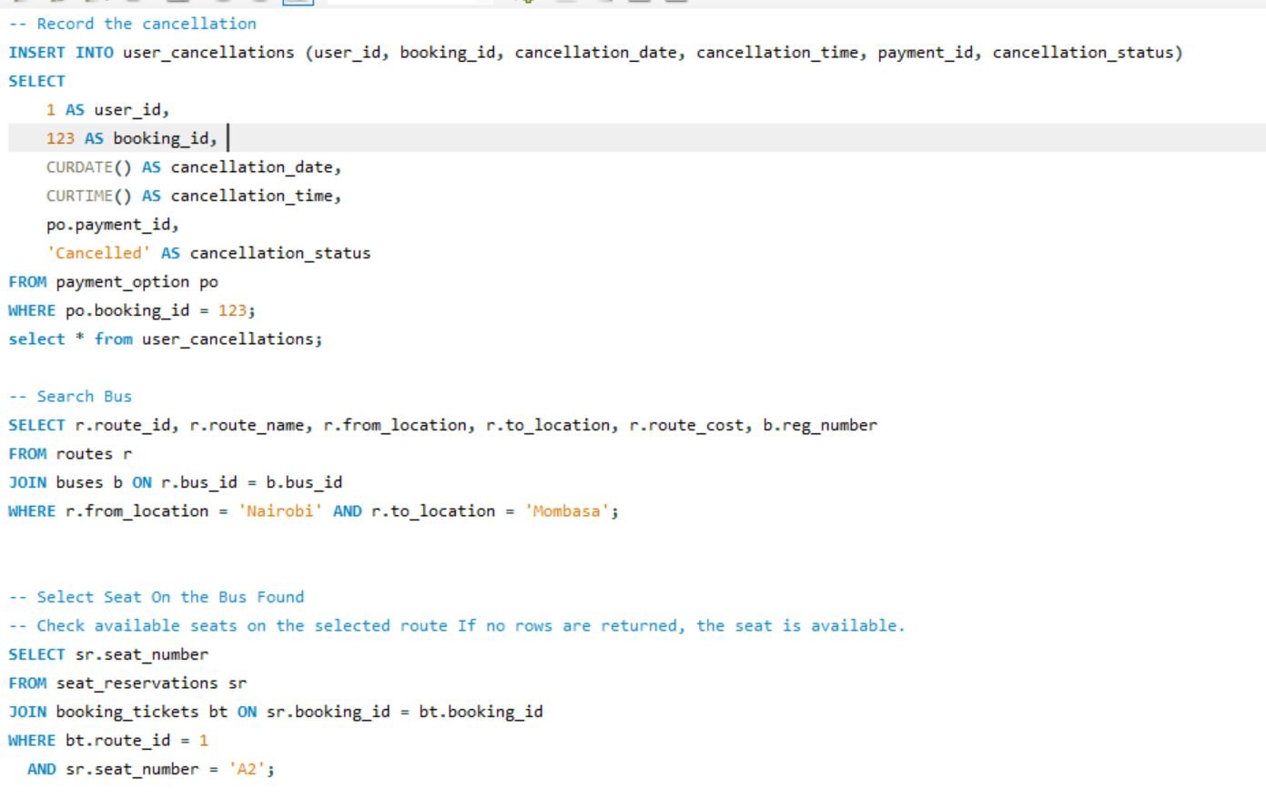

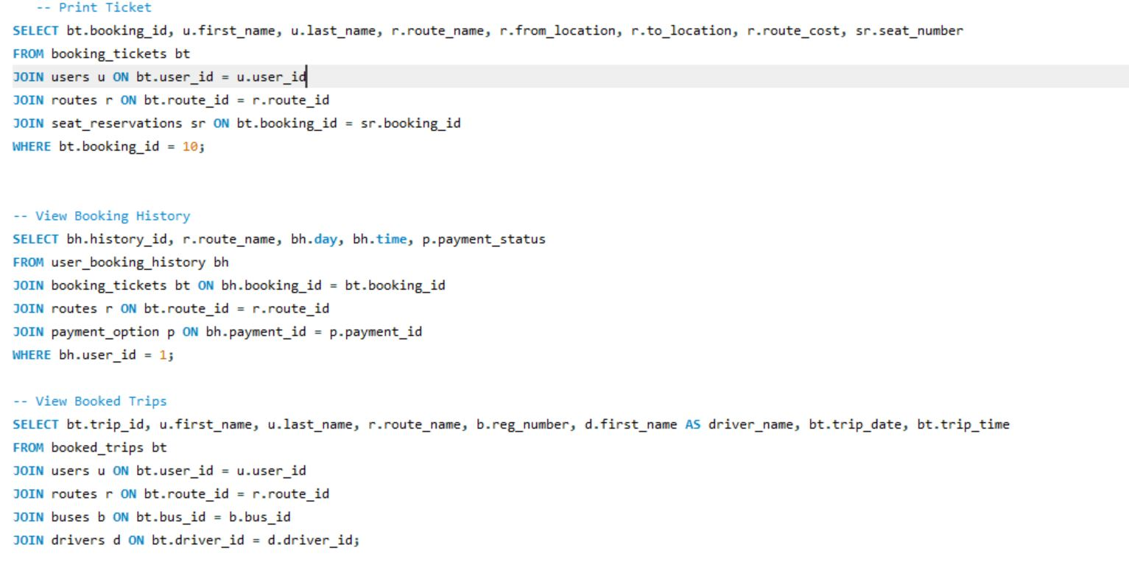

**(b)admin_side_operations**

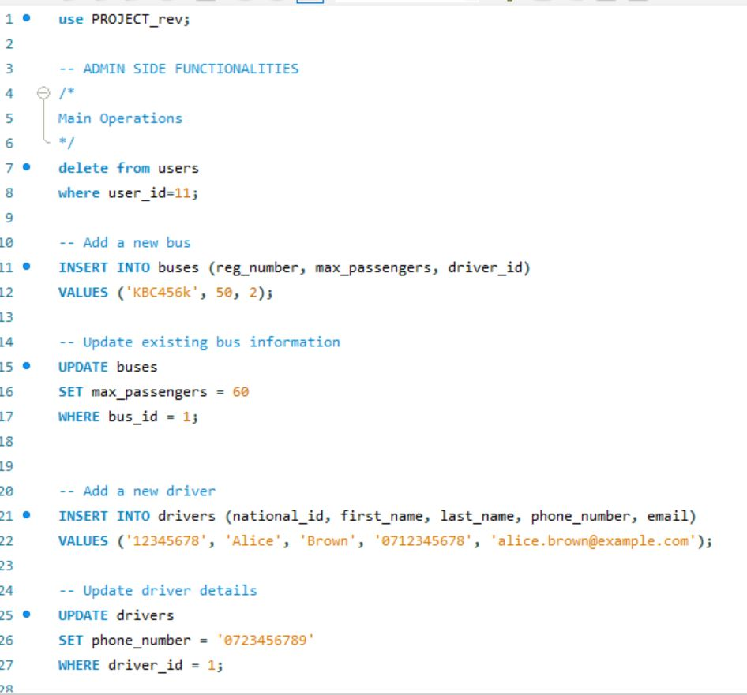

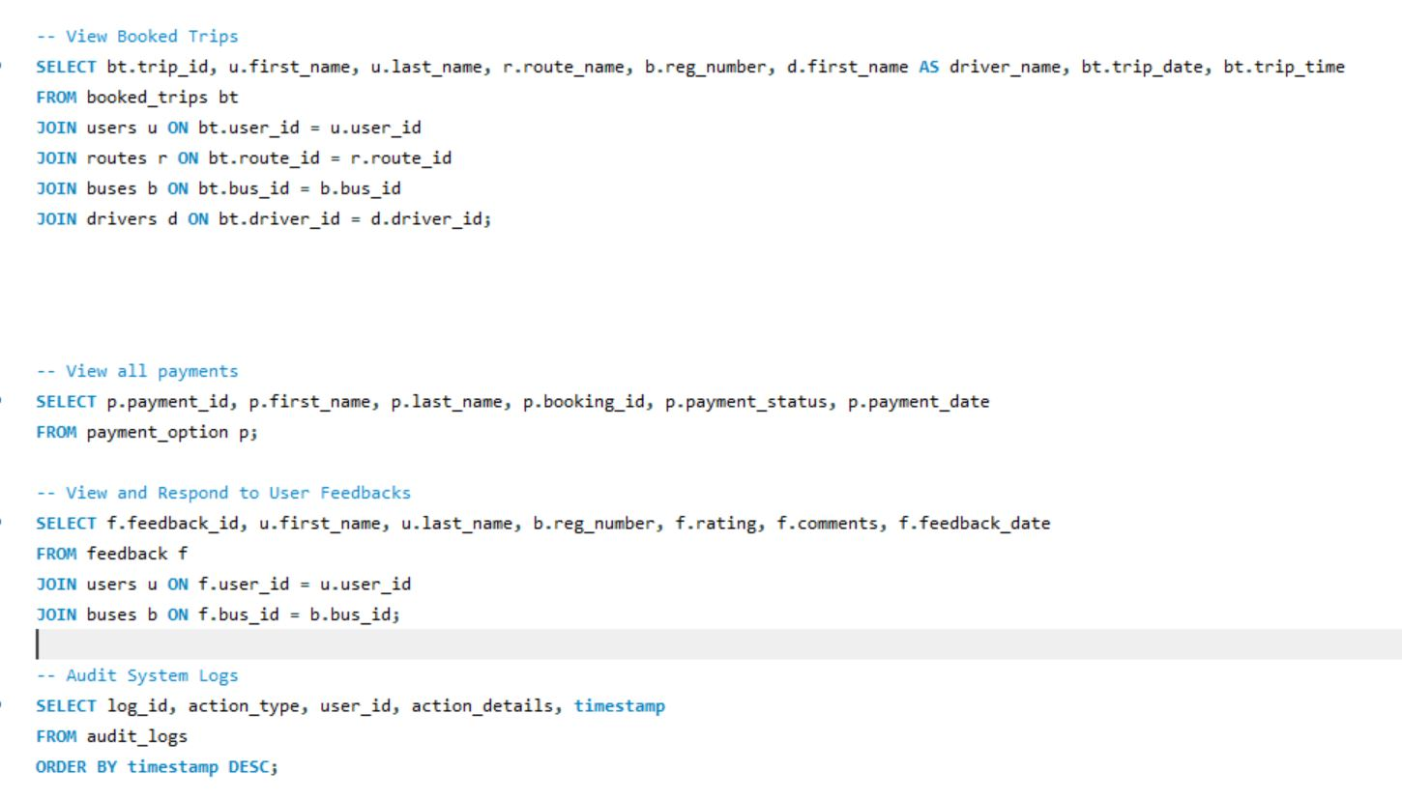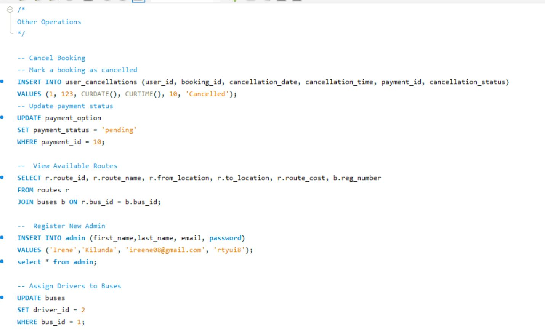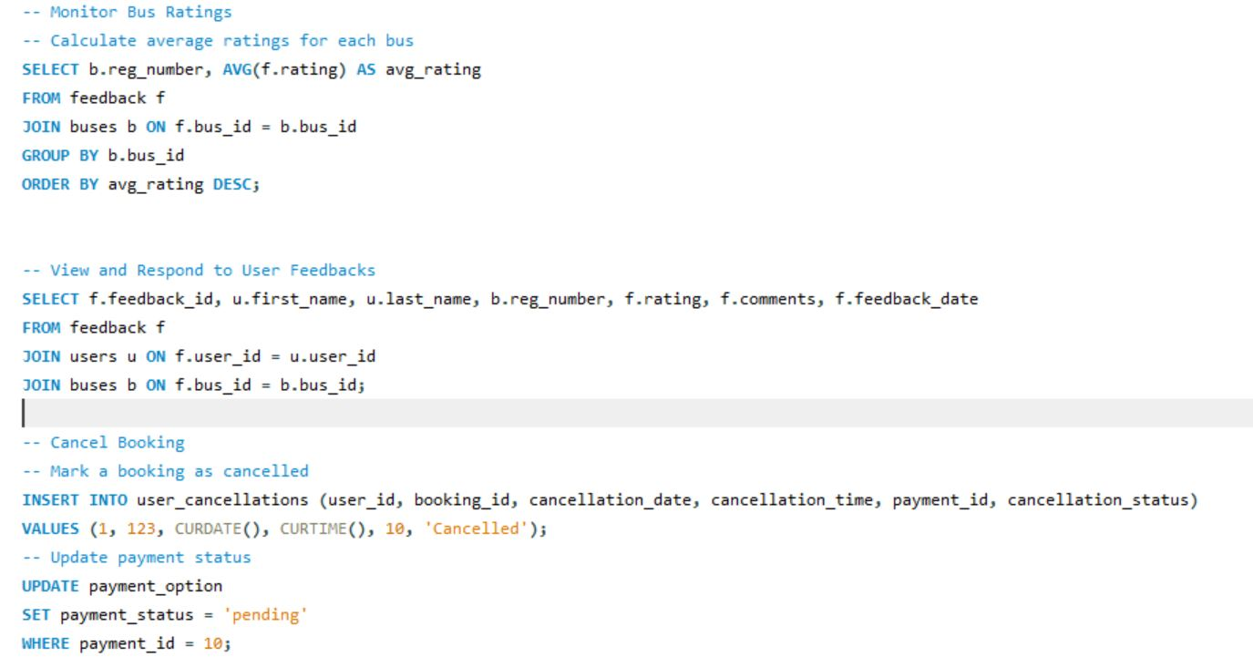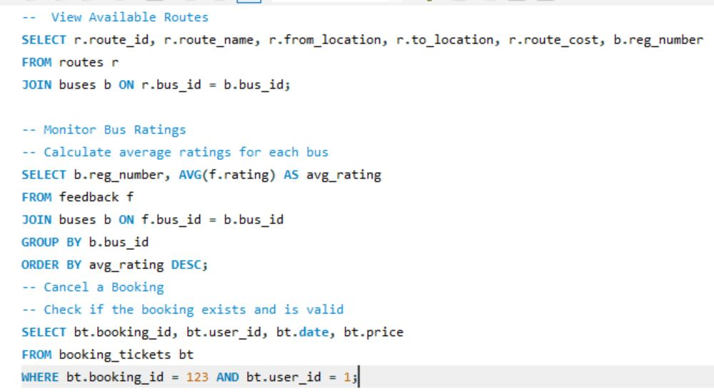

**ADVANCED QUERIES**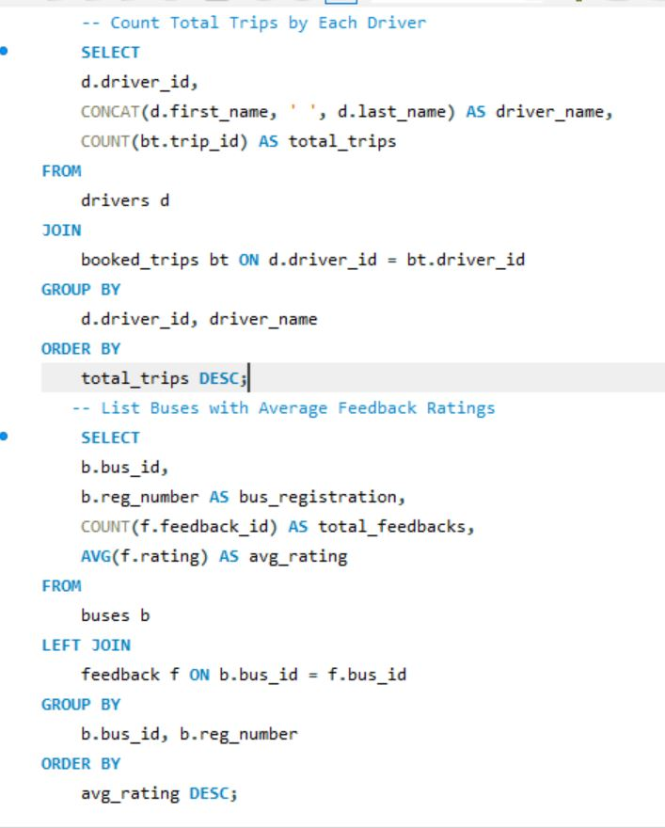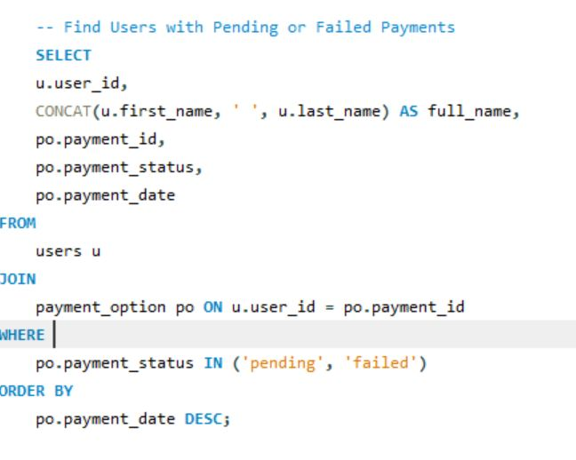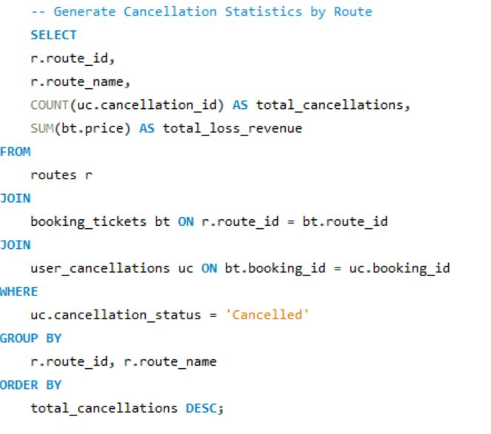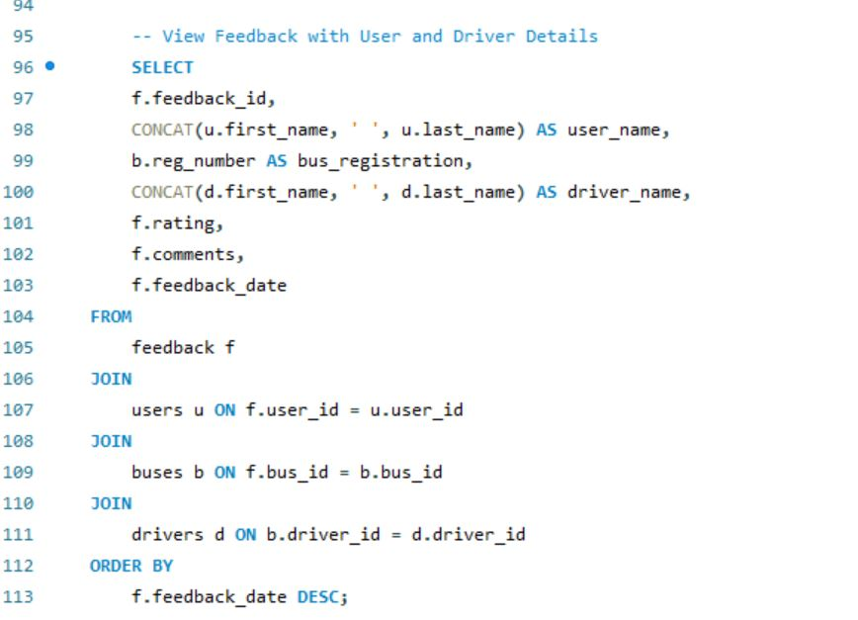

**TESTING AND VALIDATION:**

This system has been tested by use of input scenarios, hence ensuring that the constraints, foreign keys and Enums behave as expected.

**CONCLUSIONS AND RECOMMENDATIONS:**

**Conclusions:**

This online bus ticket booking system will provide numerous advantages such as enhancing customer satisfaction, smooth operations and increased revenue. This is because it allows customers to book tickets, select seats, and make payments online, at the comfort of their homes or offices. The system will also reduce the dependency of customers going to physical booking counters in order to buy a ticket hence making the process more convenient and reliable. Additionally, viewing of seat availability and booking data enables better resource management by reducing operational errors like overbooking.

Overall, the system meets modern customer expectations and will also strengthen the W Transport competitive position in the market.

**Future recommendations:**

***Offer more Integrated Payment Options***: such as credit cards, mobile wallets, and bank transfers, to cater to varied customer preferences.

***Real-Time Notifications:*** Implement notification systems that update customers on booking confirmations, trip reminders, and any changes or delays in schedules.

***Offer Promotions***: Offer promotional discounts on different seasons to encourage more bookings in the future.

***Incorporate Data Analytics:*** This will enable admins to track and understand the booking trends, popular routes.

**REFERENCES:**

Cosmas, N. I., Etus, C., Ajere, I. U., & Godswill, A. U. (2015). Online bus ticket reservation system. Int J Comput Sci Stat, 1(2).

Oloyede, M. O., Alaya, S. M., & Adewole, K. S. (2014). Development of an online bus ticket reservation system for a transportation service in Nigeria. Development, 5(12), 40-2.

Adam, T. (2019). Automated bus ticket reservation system for ethiopian bus transport system. IOSR Journal of Computer Engineering (IOSR-JCE), 21(3), 22-27.