International Bus Booking System (IBBS)

Project Gantt Chart
This document contains the project time schedule for the IBBS project (October 2025 - May 2026).
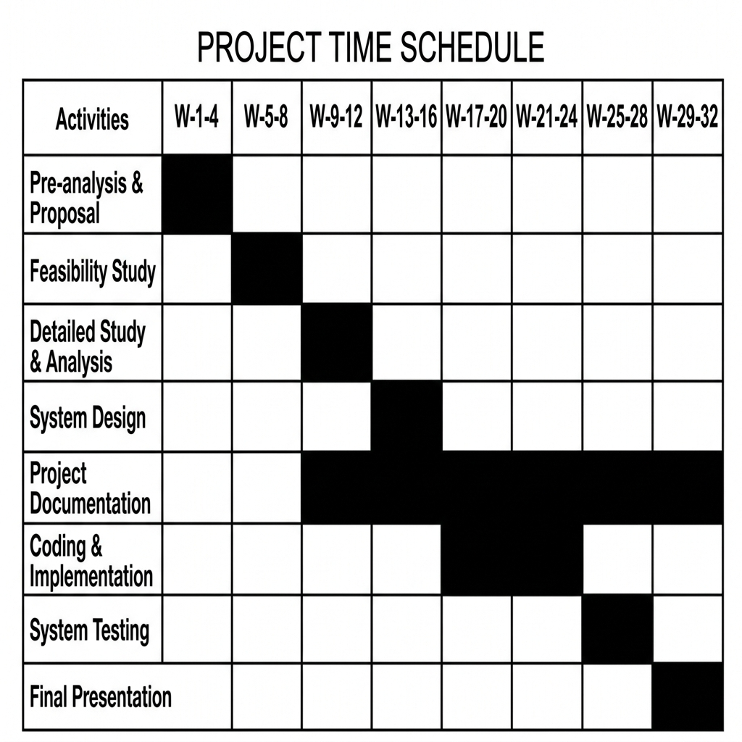
Figure: IBBS Project Gantt Chart (Oct 2025 - May 2026)

