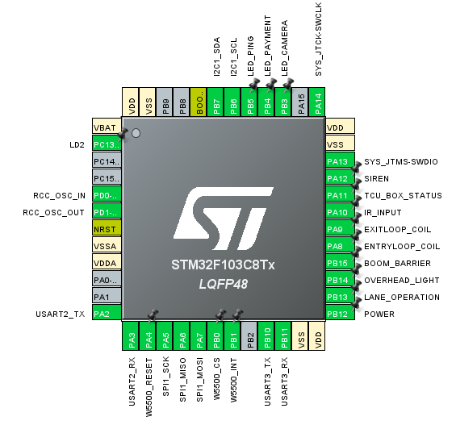

TYPE | GPIO NAME | GPIO PIN | MODE | Use Case
INPUT | ENTRYLOOP_COIL | PA8 | INTERRUPT | ENTRY LOOP COIL DETECTION
INPUT | EXITLOOP_COIL | PA9 | INTERRUPT | EXIT LOOP COIL DETECTION
INPUT | IR_INPUT | PA10 | INTERRUPT | IR SENSOR CAR DETECTION
INPUT | TCU_BOX_STATUS | PA11 | INTERRUPT | TCU BOX OPEN/CLOSE DETECTION
UART2 | UART2_TX | PA3 | INTERRUPT,DMA | UART RESPONSE SEND
UART2 | UART2_RX | PA2 | INTERRUPT,DMA | UART COMMAND RECEIVE
UART3 | UART3_TX | PB10 | POLLING | UART PRINT DEBUG
UART3 | UART3_RX | PB11 | POLLING | -
OUTPUT | W5500_CS | PB0 | POLLING | SELECT W5500 DURING INITIALIZATION
OUTPUT | W5500_INT | PB1 | INTERRUPT | INTERRUPT GENERATION FOR W5500
OUTPUT | W5500_RESET | PA4 | POLLING | TO RESET W5500 DURING INITIALIZATION
SPI1 | SPI1_SCK | PA5 | SPI | SPI CLOCK CONNECTION WITH W5500
SPI1 | SPI1_MISO | PA6 | SPI | MASTER IN/SLAVE OUT CONN. WITH W5500
SPI1 | SPI1_MOSI | PA7 | SPI | MASTER OUT/SLAVE IN CONN. WITH W5500
I2C1 | I2C1_SDA | PB7 | - | DATA CONN WITH RTC MODULE
I2C1 | I2C_SCL | PB6 | - | CLOCK CONN SETUP WITH RTC MODULE
OUTPUT | LED_CAMERA | PB3 | POLLING | LIGHT UP UPON CAMERA TRIGGER
OUTPUT | LED_PAYMENT | PB4 | POLLING | LIGHT UP UPON PAYMENT DONE
OUTPUT | LED_PING | PB5 | POLLING | LIGHT TOGGLE WHEN CONNECTED WITH PC
OUTPUT | BOOM_BARRIER | PB15 | POLLING | CONTROLS BOOM BARRIER POSITION
OUTPUT | SIREN | PA12 | POLLING | CONTROLS SIREN ON/OFF
OUTPUT | LANE_OPERATION | PB13 | POLLING | CONTROLS LANE_OPERATION LIGHT
OUTPUT | OVERHEAD_LIGHT | PB14 | POLLING | CONTROLS OVERHEAD_LIGHT ON/OFF
OUTPUT | POWER | PB12 | POLLING | POWERS ON/OFF PC, RFID, CAMERA, BOOM ETC

