PROJECT REPORT
AI Track — Console
A 3-feature AI web application: voice-enabled translation, a retrieval-based FAQ chatbot, and a rule-based AI music generator.

Project name AI Track — Console
Delivered as | PHP-only build (no Python runtime required)
Core stack | PHP 7.4+, HTML5, CSS3, Vanilla JavaScript
Optional stack | Python 3.8+ / Flask edition also provided as an alternative backend
Deployment target | XAMPP / Apache, or PHP's built-in server
Report date | July 2026

Contents
- 1 . Executive Summary
- 2 . Feature Breakdown
- 3 . Architecture
- 4 . Technology Stack
- 5 . File Structure
- 6 . Setup & Installation
- 7 . How Each AI Feature Works
- 8 . Known Limitations
- 9 . Possible Extensions

Executive Summary
This project packages three independent AI-style features behind a single, unified web dashboard ( “console”). It was originally built as a two-tier system (PHP frontend + Python/Flask AI backend), then re-implemented as a single-tier, pure-PHP build to remove the Python installation dependency and simplify deployment on a typical XAMPP setup.
Both versions expose the same three capabilities and the same UI. The PHP-only build is the recommended default because it needs nothing beyond PHP itself, which XAMPP already includes.

Feature Breakdown

Task 1 — Voice-Enabled Translation
- Translates free text between 12 languages (English, Spanish, French, German, Italian, Portuguese, Russian, Chinese, Japanese, Arabic, Hindi, Urdu).
- Optional voice input via the browser's Web Speech API (Chrome-based browsers).
- Calls Google's public translation endpoint directly — no API key or billing account needed.

Task 2 — Context-Aware FAQ Chatbot
- Answers questions about orders, shipping, returns, payments, warranty, and account help.
- Uses a genuine retrieval pipeline: TF-IDF vectorization plus cosine similarity, not a hardcoded keyword match.
- Returns a live confidence score (0–100%) alongside the matched FAQ, shown as a meter in the UI.
- Falls back to a support-contact message when confidence is below threshold (25%).

Task 3 — AI Music Pattern Generator
- Takes a genre (classical, jazz, electronic, rock, ambient), a tempo (BPM), and a mood.
- Returns a suggested compositional style, a chord progression appropriate to the genre, an 8-note melody sample, and a base64-encoded placeholder MIDI token.
- Fully rule-based and deterministic in structure, randomized in note/progression choice for variety on repeated runs.

Architecture
Two architectures were built for this project; both ship the identical front-end UI.

Option A — Pure PHP (recommended, current default)
A single Apache/PHP process serves everything. The browser posts form-encoded requests to index.php, which routes to functions in ai_functions.php and returns JSON. No second server, no cross-process networking, no separate runtime.
Browser (JS fetch) → index.php (router) → ai_functions.php (translate / chatbot / music) → JSON response → UI update

Option B — PHP frontend + Python/Flask backend
The original design split responsibilities: PHP served the UI and proxied requests over HTTP (via cURL) to a Flask REST API on port 5000, which used scikit-learn (TfidfVectorizer, cosine_similarity) for the chatbot. This is heavier to deploy (two runtimes, two processes) but keeps AI logic in Python if the project later needs genuine ML models.
Browser → index.php → cURL → Flask API (ai_backend.py, port 5000) → JSON response → PHP → UI update

Technology Stack
Server language PHP 7.4+ (tested on PHP 8.3)
Frontend | HTML5, CSS3 (custom — no framework), vanilla JavaScript (fetch  API)
Fonts | Sora (headings), Inter (body), IBM Plex Mono (data/readouts)
Translation source | translate.googleapis.com (free public endpoint, no key)
Retrieval method | TF-IDF term weighting + cosine similarity, implemented from scratch in PHP
Voice input | Web Speech API (browser-native, no server component)
Alternative backend | Python 3.8+, Flask, flask-cors, scikit-learn, numpy, requests
Recommended server | XAMPP (Apache + PHP) or PHP's built-in server (php -S)

File Structure
Pure-PHP build:
AI_Track_Project_PHP/
index.php # UI + request router (single entry point)
ai_functions.php # All AI logic: translate(), RAGChatbotPHP, ai_generate_music() README.md # Setup guide
Python/Flask build (alternative):
AI_Track_Project/
ai_backend.py # Flask API: /api/translate, /api/chat, /api/generate_music requirements.txt # flask, flask-cors, requests, numpy, scikit-learn index.php # UI, proxies requests to the Flask API via cURL run_all.bat / run_all.sh # Starts both servers together
README.md

Setup & Installation (Pure PHP build )
Step 1 — Install XAMPP (skip if already installed)
Download from apachefriends.org. This installs Apache and PHP together; no separate PHP install is needed.
Step 2 — Place the project
Copy the project folder into: C:\xampp\htdocs\AI_Track_Project_PHP\
Step 3 — Start Apache
Open the XAMPP Control Panel and click Start next to Apache.
Step 4 — Open in browser
http://localhost/AI_Track_Project_PHP/index.php
No terminal needs to stay open, no pip/Python install, and no second server process.

How Each AI Feature Works

Translation pipeline
- User submits source text, source language, target language.
- PHP builds a GET request to translate.googleapis.com with client=gtx and dt=t.
- Response is a nested JSON array; PHP concatenates the translated text segments.
- Requires an active internet connection on the server machine.

Chatbot retrieval pipeline (TF-IDF + cosine similarity)
- 10 FAQ question/answer pairs form a small corpus, tokenized and lowercased.
- Document frequency is computed per term, then a smoothed IDF weight: log((1+N)/(1+df)) + 1.
- Each FAQ question and the incoming user question are converted to TF×IDF vectors over the shared vocabulary.
- Cosine similarity is computed between the query vector and every FAQ vector; the highest-scoring FAQ is returned if its score exceeds 0.25 (25%), otherwise a fallback message is shown.
- This was verified with test queries during development — e.g. “How can I track my package?” correctly matched “How do I track my order?” at 73% confidence, and an unrelated query returned 0 % with the fallback response.

Music generator logic
- Genre and mood are mapped through lookup tables to a suggested style (e.g. jazz → “Modal Jazz”) and a description of musical elements (e.g. calm → “slow tempo, soft dynamics”).
- A chord progression is randomly chosen from a small set appropriate to the genre (e.g. jazz → ii-V-I or I-vi-ii-V).
- An 8-note melody is sampled from one octave (C4–C5) and shuffled for variety.
- No external API calls; runs fully offline.

Known Limitations
- Translation requires outbound internet access from the server; if curl cannot resolve translate.googleapis.com (DNS/firewall/proxy issues), only that feature is affected.
- The chatbot's knowledge is limited to the 10 FAQs defined in ai_functions.php — it does not learn or search external sources.
- The music generator produces a compositional sketch (style, chords, melody notes), not an audio file or a playable MIDI file — the 'midi_data' field is a placeholder token.
- Voice input depends on browser support for the Web Speech API (best supported in Chrome/Edge; not available in all browsers).

Possible Extensions
- Expand the FAQ corpus and/or persist it in a database instead of a PHP array.
- Swap the placeholder MIDI token for a real generated .mid file using a PHP MIDI library.
- Add response caching for translation requests to reduce repeated external calls.
- Add authentication and per-user chat history if deployed beyond a local demo.
- If heavier ML is needed later, the Python/Flask backend (Option B) can be reattached without changing the front-end UI, since both expose the same JSON contract.
GITHUB LINK:
https://github.com/Maira-svg/INTERNGROW-AI-TRACK-PROJECT/blob/main/AI_Track_Project_PHP/README.md
Project screenshorts:
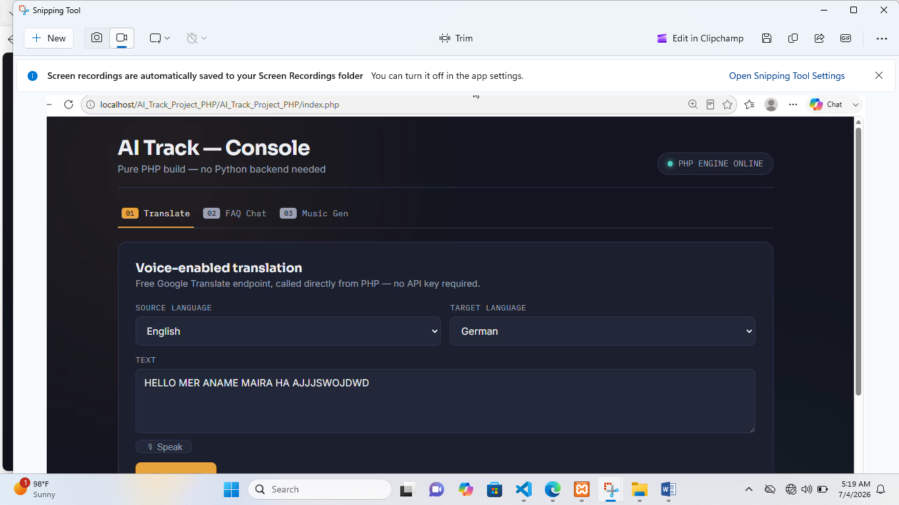
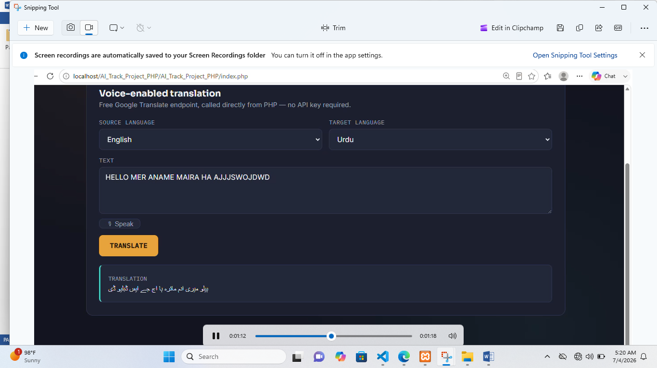
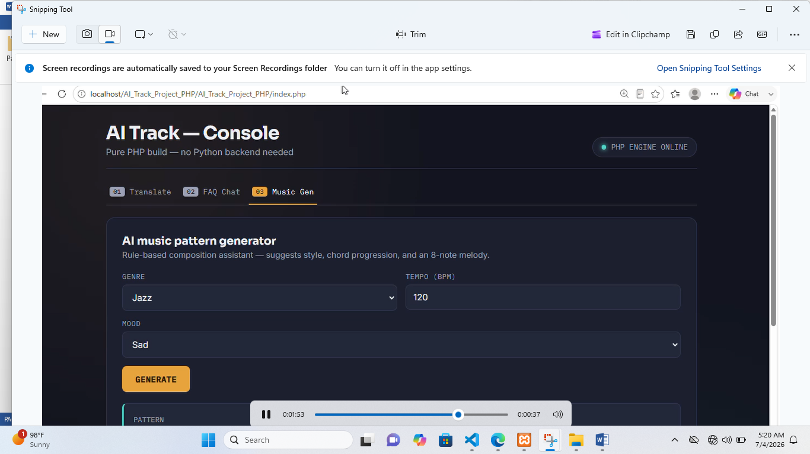
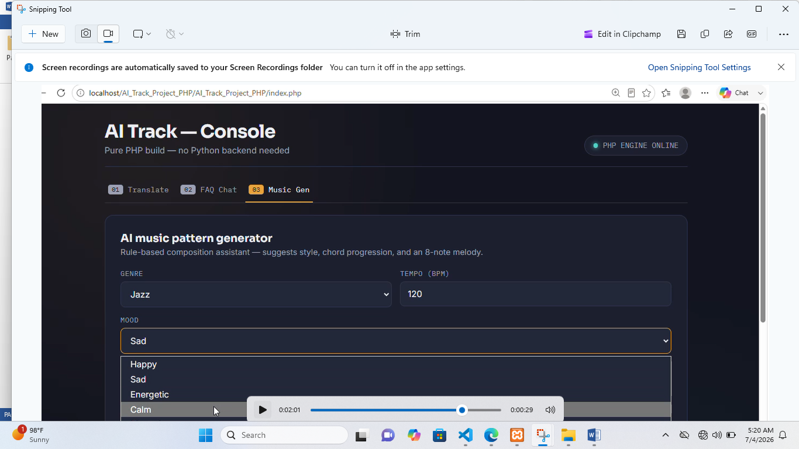
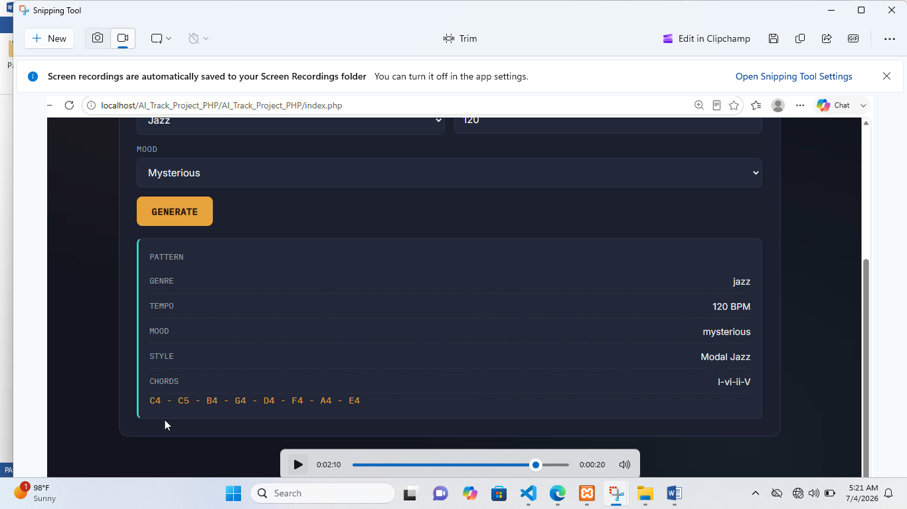
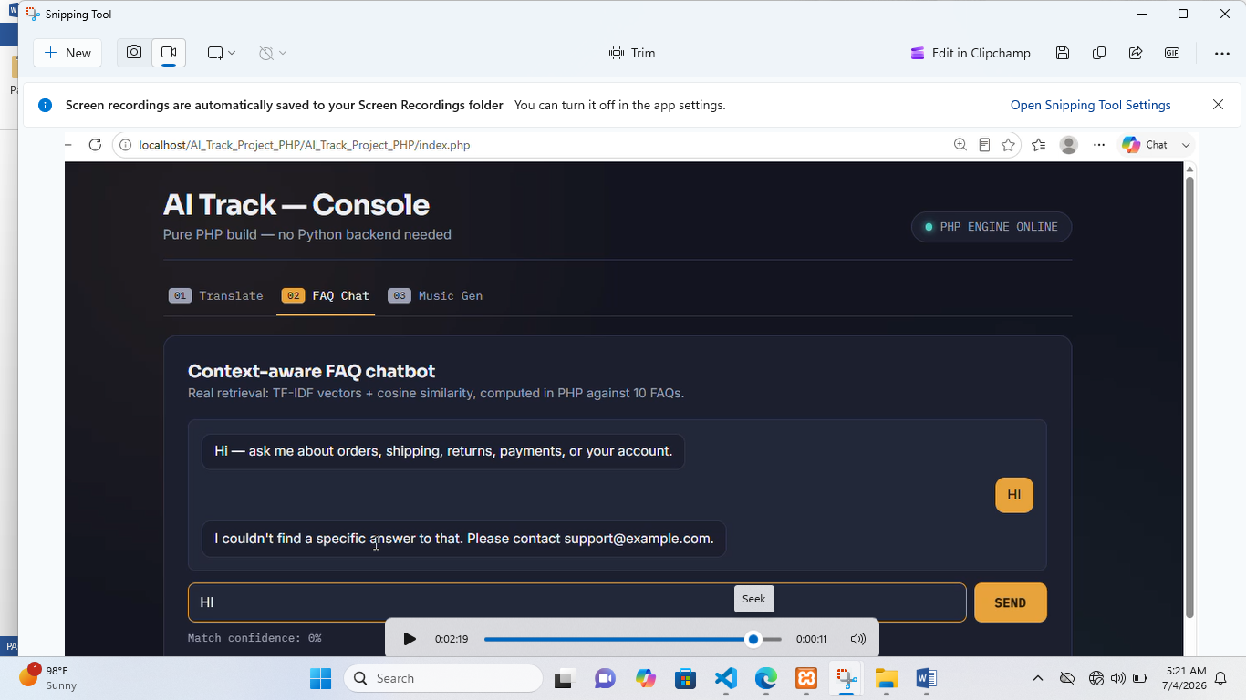

End of report.

