Analysis of staffing levels for nursing and adult inpatient care

Mairead Bermingham

2023-08-10

# Scenario

Job applicants have been asked as part of the interview process for the ‘Data and Measurement Advisory’ role with Healthcare Improvement Scotland (HIS) have been asked to analyse staffing levels data across three Clinical areas collected daily by the Senior Charge Nurse, and to present and discuss finding at hospital management meeting to discuss safe staffing levels within Hospital X. Clinical area A and B are 25 and 30 bedded adult inpatient wards respectively. Bed capacity can be over 100% due to admissions/discharges and the opening of surge beds where available. All data, charts, images, documents and code associated with this exercise can be accessed from [gitHub](https://github.com/MaireadLBermingham/Staffing_levels_for_Nursing_and_Adult_Inpatient_Care_Quality_and_Safety.git)

# Aim

## Health and Care (Staffing) (Scotland) Act 2019

The Act was passed by the Scottish Parliament in 2019. Its implementation was paused due to the COVID-19 pandemic. All the provisions within the Act will come into force in April 2024. The Act was passed by Parliament in 2019, but implementation was paused due to the pandemic. All the provisions within the Act will come into force in April 2024. The aim of the Act is to be an enabler of high-quality care and improved outcomes for service users of health service and care services by ensuring appropriate staffing.

### General duty

The Act places duties on health boards, care service providers, Healthcare Improvement Scotland (HIS), the Care Inspectorate and Scottish Ministers. to ensure appropriate staffing. As health professionals, it is our duty to ensuring both appropriate numbers and types of staff as necessary are working as appropriate for  
* health, welling and safety of patients  
* and provision of safe and high-quality care * staff well-being in so far as it impacts the aforementioned conditions.  
We are also required to submit quarterly Board reports, and to publish and submit an annual report to the Scottish Ministers detailing how it has carried out its duties under the following sections

Our **aim** is to ensure safe and high-quality care through consistent data collection to scaffold improvement initiatives, and facilitate mandatory reporting, maintain the proportion of registered nurses as a percentage of total nursing staff above 65%, and the whole time equivalent (WTE) used meets or exceeds the WTE required to staff the ward.

## Adult inpatient care journey

The patient will be referred by a GP or Accident and emergency service, and will be admitted from outpatients or theater to the inpatient ward, where a nurse will look after them and manage their pain. The patient will be cared for by the healthcare team, which includes doctors, nurses, healthcare assistants and others. Staff on the wards will be working to a planned date for their discharge home or into community care (Figure 1).

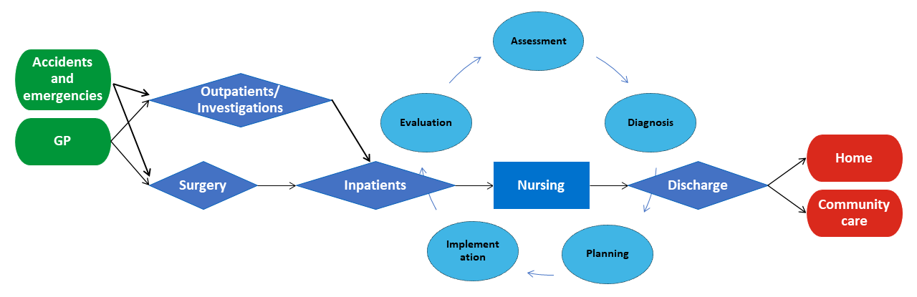

Figure 1. The adult inpatient care journey. This figure shows is the steps in reviewing and developing a nursing care plan for adult inpatients addmitted onto an inpatient ward.

## The nursing process

The nursing process is a methodical problem-solving approach used to identify, prevent and treat actual or potential health issues and promote well-being. It has five steps: assessment, diagnosis, planning, implementation and evaluation (Figure 2) (Semachew, 2018).

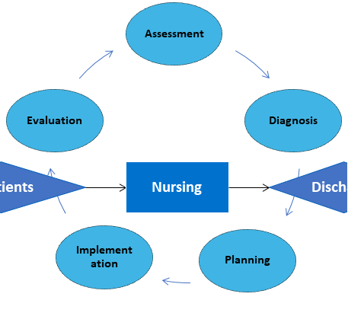

Figure 2. The nursing process. This figure focuses on the five steps in nursing of adult inpatients addmitted onto an inpatient ward process.

### DMA data

The data provided as part of the Data and Measurement Advisory job interview process will collected by a Senior staff nurse and her line manager and team from Clinical areas, using the Professional Judgement and Adult In-Patient tools. The tools are applied concurrently for at least 2 weeks (14 consecutive days, with no intervening days) (Scotland, 2022).

#### The Professional Judgement tool

The Professional Judgement tool facilitates compliance with national recommendations that Senior staff nurses and their line managers should use this tool to determine staffing requirements, supporting an evidence-based workforce planning.

#### Adult In-Patient

The Adult In-Patient tool supports Senior staff nurses and their line managers in making evidence‐based staffing levels decisions by assessing patient dependency and/or acuity and nursing activity.

#### Process measures

#### Measures that indicate that steps we have put in place to achive our stated aim are being reliably implemented.

The data provided by the recruitment panel consists of a serious of process measures of available staff, and patient care complexity data (Table 1).

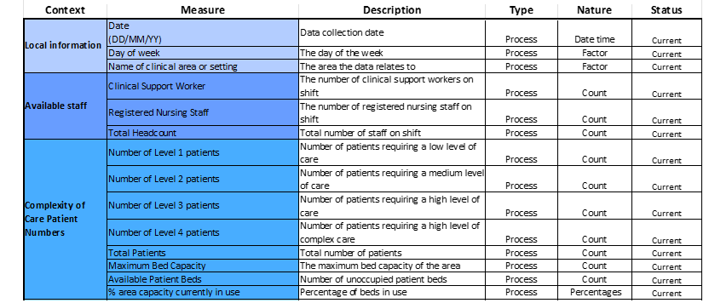 #### Measures of nursing care quality and performance However measures of nursing care quality and performance across the Nursing process are not included in the DMA data (Figure 2). I would like to propose to the Senior staff nurse during the management meeting that we should be making use of routinely collected nursing sensitive indicators to determine whether nursing care quality and performance has an impact patients (Table 2) (Oner et al., 2021).

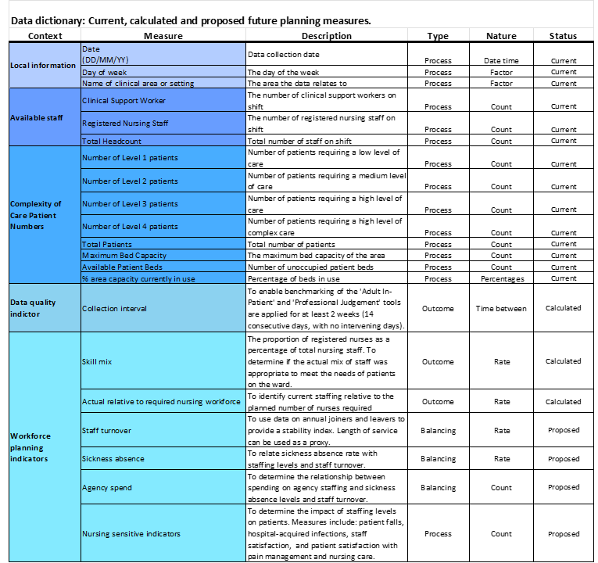

Table 2. Updated DMA data dictionary. This table provides descripts of the context, descrition, type and nature of the DMA data pata provied by the recruitment panel, calculated and posposed measures.

#### Outcome measures

##### Measures that demonstrate or not that we are working toward achiveng our stated aim.

There are no outcome measures included in the DMA data that directly more improved performance or that we are working towards or stated aim of ensuring safe and high quality care through **consistent data collection** to scaffold improvement initiatives, and facile an mandatory reporting, maintain the **proportion of registered nurses as percentage of total nursing staff above 65%**, and the **whole time equivalent (WTE) used meets or exceeds the WTE required** to staff the ward. I have there for used the process measures provided to calculate three outcomes measures: * **Collection interval.** To enable benchmarking, the Adult In-Patient and Professional Judgement tools are applied for at least 2 weeks (14 consecutive days, with no intervening days). * **Proportion of registered nurses (RN) as percentage of total nursing staff.** To determine if the actual mix of staff was appropriate to meet the needs of patients on the ward. The benchmark average on general hospital wards is 65% registered nurses (Table 2) (Nursing, 2006).

#### Balancing measures

##### Measures that track if improvements in one part of the system to ensure they are causing unintended consequences elsewhere in the system.

We need to look at the systems as a whole from different directions and ensure that staffing improvements not causing problems in other parts of the system. I would like to propose to the Senior staff nurse during the management meeting that we should be making use of the routinely collected staff turnover, sickness absence and agency spend balancing measures to reflect what may be happening elsewhere in the system as a result of the staffing improvements in the adult inpatient ward (Table 2) (Ball, 2010).

# Updating the DMA Exercise data

I develop accessible, transparent, time saving, data and measurement handing pipelines, exploratory and downstream analyses and reports in RMarkdown, and use GitHub version control to make it possible for others, including my future self, to collaborate on projects and reproduce results. Many stakeholder are not familiar with R nor accessing project folder and documents via GitHub. I there for produce less technical, code free reports, MS Excel Workbooks and PowerPoint presentations as part of my workflow to facilitate collaboration with less technical stakeholders.

Table 1. DMA Exercise data structure.

## tibble [54 × 14] (S3: tbl_df/tbl/data.frame)  
## $ Date : POSIXct[1:54], format: "2023-01-01" "2023-01-01" ...  
## $ Day : chr [1:54] "Sunday" "Sunday" "Monday" "Monday" ...  
## $ ClinicalArea : chr [1:54] "B" "A" "B" "A" ...  
## $ Clinical Support Worker : num [1:54] 4 3 3 2 4 3 4 2 4 4 ...  
## $ Registered Nursing Staff : num [1:54] 5 3 3 3 6 4 3 3 3 4 ...  
## $ Total Headcount : logi [1:54] NA NA NA NA NA NA ...  
## $ Number of Level 1 patients: num [1:54] 10 12 8 9 14 14 10 11 10 11 ...  
## $ Number of Level 2 patients: num [1:54] 7 7 6 5 9 7 8 6 8 9 ...  
## $ Number of Level 3 patients: num [1:54] 4 3 2 5 6 5 4 3 4 4 ...  
## $ Number of Level 4 patients: num [1:54] 3 2 1 3 4 2 1 2 1 3 ...  
## $ Total Patients : logi [1:54] NA NA NA NA NA NA ...  
## $ Maximum Bed Capacity : logi [1:54] NA NA NA NA NA NA ...  
## $ Available Patient Beds : logi [1:54] NA NA NA NA NA NA ...  
## $ Activity : logi [1:54] NA NA NA NA NA NA ...

The data fame included 14 variables and 54 rows. The ‘Day of week’,‘Total Headcount’, ‘Total Patients’, ‘Maximum Bed Capacity’,‘Available Patient Beds’, and ‘% area capacity currently in use (Total Patients/Maximum Bed Capacity)’ variables are empty and need to be populated.

## Populating the ‘Total Headcount’ , ‘Total Patients’, ‘Maximum Bed Capacity’, ‘Available Patient Beds’ and ‘% area capacity currently in use’ process measures.

In the ‘Scenario tab in the DMA Exercise data MS Excel file we were informed that Clinical area A is a 25 bedded ward, and Clinical area B is a 30 bedded ward. Furthermore we were told that bed capacity can be over 100% due to admissions/discharges and opening of surge beds where available. This information was used information to populated the ’Maximum Bed Capacity’ variable.

## # A tibble: 6 × 14  
## Date Day ClinicalArea `Clinical Support Worker`  
## <dttm> <chr> <chr> <dbl>  
## 1 2023-01-01 00:00:00 Sunday B 4  
## 2 2023-01-01 00:00:00 Sunday A 3  
## 3 2023-01-02 00:00:00 Monday B 3  
## 4 2023-01-02 00:00:00 Monday A 2  
## 5 2023-01-03 00:00:00 Tuesday B 4  
## 6 2023-01-03 00:00:00 Tuesday A 3  
## # ℹ 10 more variables: `Registered Nursing Staff` <dbl>,  
## # `Total Headcount` <dbl>, `Number of Level 1 patients` <dbl>,  
## # `Number of Level 2 patients` <dbl>, `Number of Level 3 patients` <dbl>,  
## # `Number of Level 4 patients` <dbl>, `Total Patients` <dbl>,  
## # `Maximum Bed Capacity` <dbl>, `Available Patient Beds` <dbl>,  
## # `% area capacity currently in use` <dbl>

## Populating the day of the week variable

I use the ‘lubricate’ package to extract the day of the week from the Date variable. ‘Lubridate’ is an R package that makes it easier to work with dates and times.

### Looking at the consistentancy of collection across week days.

Table 1. Frequency distribution of day of the week by Clinical area.

## # A tibble: 3 × 8  
## ClinicalArea Mon Tue Wed Thu Fri Sat Sun  
## <chr> <int> <int> <int> <int> <int> <int> <int>  
## 1 A 4 3 4 1 3 4 4  
## 2 B 5 5 1 4 4 4 5  
## 3 C 0 0 1 0 1 0 1

Consistency of collection appears greater in Clinical area B based on the frequency distribution of day of the week. There appears at first glance to be a relationship between low week day counts in Clinical area A and data collected in Clinical area A. Could it be that the team misassigned the name of the clinical area.

# Examining the relationship between the dates data was collected in Clinical area C and the other two areas.

There is only one of the three dates, the 11/1/2023 that you could infer the the team may have misassigned the name of Clinical area B with C. Before making this change, I would have to confirm this with the Senior Charge Nurse. For the purpose, of the analyses for the upcoming meeting, I will assume the data has been correctly assassinated to Clinical area C. Data was collected at all three Clinical areas for the other two dates.

#### Clinical area C

Ward capacity details were not provided for Clinical area C. As such the ‘% area capacity currently in use’ measure can not be calculated. Only Clinical area A and B will be included in down stream analysis, and the last three records in the data set from Clinical area C removed.

## Calculating the the ‘Collection interval’, ‘Skill mix’ and ‘Nurse staffing relative to patient requirments’ outcome measures

#### Exmaming the consistance of data collection in Cinical areas A and B.

To determine the consistency of data collection I calculated the data collection interval.

Table 1. The frequency distribution of Collection interval by Clinical Area.

| Clinical area | Collection interval | Frequency | Percent |
| --- | --- | --- | --- |
| A | 1 | 15 | 68.18% |
| A | 2 | 6 | 27.27% |
| A | 3 | 1 | 4.55% |
| B | 1 | 24 | 88.89% |
| B | 2 | 3 | 11.11% |

The consistency of data collection was much higher in Clinical area B, compared to A. In total, 89% of records were collected within one data, as opposed to 68% in clinical area C.

### Calculating the ‘Skill mix’ and Nurse staffing relative to patient requirements outcome varaiables

Skill mix was simply calculated as the rate of Registered nursing staff to total nursing staff. !

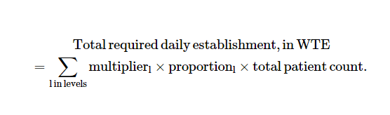

The total daily required establishment, WTE was calculated as.

Using general ward multipliers for level 1-4 patients (Griffiths et al., 2020).

## < table of extent 0 >

# Checking for missing records and removing redundant variables

| lag1_Date | lag1_ClinicalArea | CollectionInterval |
| --- | --- | --- |
| 2 | 2 | 2 |

The data is complete, the only missing records are those associated with the ‘Collection interval’ measure. I have set those missing records to zero, and removed redundant variables.

# Adding the updated data to the DMA Exercise data Excel file

The original DMA Exercise data Excel file was read in again, and a working DMA Exercise working data Excel file set up in the project output data folder to collect, data updates, summary tables, charts, results and comments for stakeholder to review prior to the Hospital X management meeting.

# Visual representation of the three calculated outcome variables

## [1] "We have 23 and 28 data points in Clinical areas A and B respectively. This means the lower limit for the number of runs are seven and ten and the upper limit is 17 and 20 runs to demonstrate non-random variable attributable to changes in staffing levels."

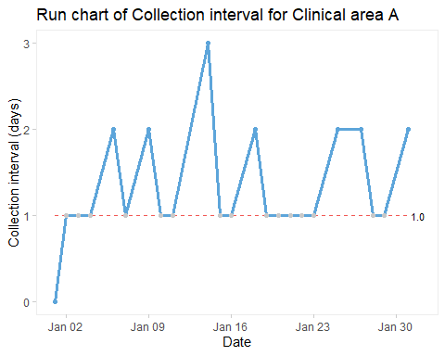

## [1] "The collection interval for Clinical area A was inconsistent. No shifts or trends were seen on the run chart. The median was one, it was therefore not possible to assess the number of runs. However, an astronomical point of three days was measured on Saturday the 14th of January 2023."

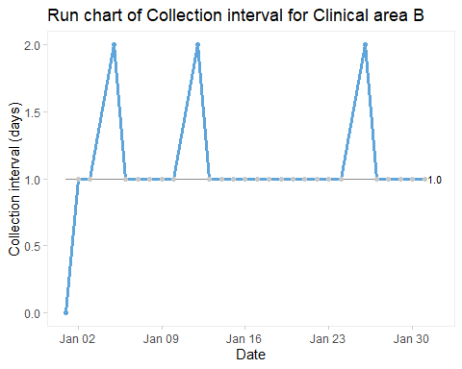

## [1] "The collection interval for Clinical area B was more consistent, only missing three sample dates. No shifts or trends were seen on the run chart. Six runs can be seen on the run chant, which is below the lower limit of 10, suggesting statistically significant change."

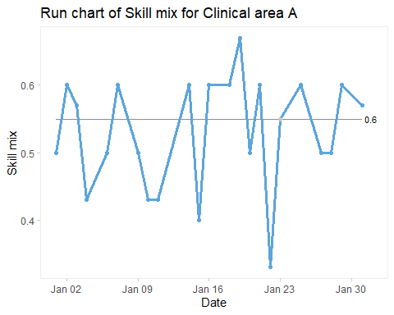

## [1] "The Skill mix for Clinical area A was low and variable and only exceeded the benchmark of .65 on Thursday, the 19th of January 2023. No shifts or trends were seen on the run chart. Thirteen runs can be seen on the run chant, which is below the upper limit of 17, suggesting no statistically significant change. However, an astronomical point of .33 was measured on Sunday the 22nd of January 2023."

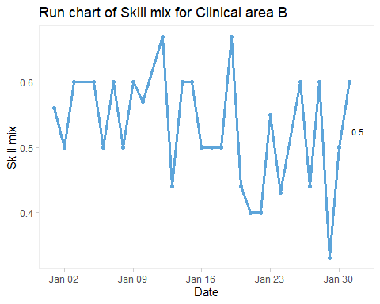

## [1] "The Skill mix for Clinical area B was also low and variable and only exceeded the benchmark of .65 on Thursday, the 12th and 19th of January 2023. Clinical area A also exceeded the benchmark on the 19th of January, 2023. It was interesting to hear what insights Senior Charge Nurse has as to why performance improved dramatically at the two Clinical areas on that date. No shifts or trends were seen on the run chart. Eighteen runs can be seen on the run chant, which is below the upper limit of 20, suggesting no statistically significant change. However, an astronomical point of .33 was measured on Sunday the 29th of January 2023."

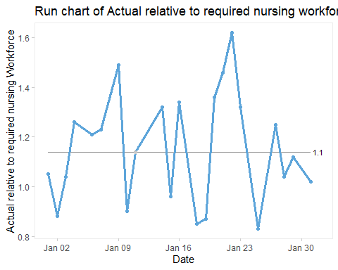

## [1] "The Actual relative to required nursing workforce for Clinical area A fell below our set benchmark of one on six occasions. No shifts or trends were seen on the run chart. Eleven runs can be seen on the run chant, which is below the upper limit of 20, suggesting no statistically significant change. However, an astronomical point of 1.62 was measured on Sunday the 22nd of January 2023."

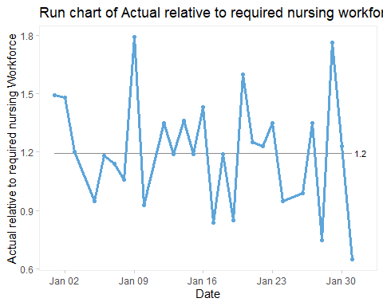

## [1] "The Actual relative to required nursing workforce for Clinical area B fell below our set benchmark of one on nine occasions. No shifts or trends were seen on the run chart. Eleven runs can be seen on the run chant, which is above the lower limit of 10, suggesting no statistically significant change. However, astronomical points of 1.79 and 1.76 were measured on Monday the 9th and Sunday the 29th of January 2023. Another astronomical point of 0.65 was measured on the 31st of January, 2023."

# References

Ball, J., 2010. [Guidance on safe nurse staffing levels in the UK](https://www.rcn.org.uk/-/media/Royal-College-Of-Nursing/Documents/Publications/Obselete/PUB-003860.pdf).

Griffiths, P., Saville, C., Ball, J.E., Chable, R., Dimech, A., Jones, J., Jeffrey, Y., Pattison, N., Saucedo, A.R., Sinden, N., 2020. The Safer Nursing Care Tool as a guide to nurse staffing requirements on hospital wards: Observational and modelling study.

Nursing, R.C. of, 2006. [RCN policy unit policy guidance 15/2006: Setting appropriate ward nurse staffing levels in NHS acute trusts](https://www.rcn.org.uk/-/media/Royal-College-Of-Nursing/Documents/Policies-and-briefings/UK-Wide/Policies/2006/1506.pdf).

Oner, B., Zengul, F.D., Oner, N., Ivankova, N.V., Karadag, A., Patrician, P.A., 2021. Nursing‐sensitive indicators for nursing care: A systematic review (1997–2017). Nursing open 8, 1005–1022.

Scotland, H.I., 2022. [Adult inpatient workload tool: User guide](https://www.healthcareimprovementscotland.org/idoc.ashx?docid=d6d8c442-ccc1-4eac-a3b3-98efe55df4e5&version=-1).

Semachew, A., 2018. Implementation of nursing process in clinical settings: The case of three governmental hospitals in Ethiopia, 2017. BMC research notes 11, 1–5.