Analysis of staffing levels for nursing and adult inpatient care

Mairead Bermingham

2023-08-10

# Scenario

Job applicants have been asked as part of the interview process for the ‘Data and Measurement Advisory’ role with Healthcare Improvement Scotland (HIS) have been asked to analyse staffing levels data across three Clinical areas collected daily by the Senior Charge Nurse, and to present and discuss finding at hospital management meeting to discuss safe staffing levels within Hospital X. Clinical area A and B are 25 and 30 bedded adult inpatient wards respectively. Bed capacity can be over 100% due to admissions/discharges and the opening of surge beds where available. All data, charts, images, documents and code associated with this exercise can be accessed from [gitHub](https://github.com/MaireadLBermingham/Staffing_levels_for_Nursing_and_Adult_Inpatient_Care_Quality_and_Safety.git).

# Aim

## Health and Care (Staffing) (Scotland) Act 2019

The Act was passed by the Scottish Parliament in 2019. Its implementation was paused due to the COVID-19 pandemic. All the provisions within the Act will come into force in April 2024. The Act was passed by Parliament in 2019, but implementation was paused due to the pandemic. All the provisions within the Act will come into force in April 2024. The aim of the Act is to be an enabler of high-quality care and improved outcomes for service users of health service and care services by ensuring appropriate staffing.

### General duty

The Act places duties on health boards, care service providers, Healthcare Improvement Scotland (HIS), the Care Inspectorate and Scottish Ministers. to ensure appropriate staffing. As health professionals, it is our duty to ensuring both appropriate numbers and types of staff as necessary are working as appropriate for  
* health, welling and safety of patients  
* and provision of safe and high-quality care * staff well-being in so far as it impacts the aforementioned conditions.  
We are also required to submit quarterly Board reports, and to publish and submit an annual report to the Scottish Ministers detailing how it has carried out its duties under the following sections

Our **aim** is to ensure safe and high-quality care through consistent data collection to scaffold improvement initiatives, and facilitate mandatory reporting, maintain the proportion of registered nurses as a percentage of total nursing staff above 65%, and the whole time equivalent (WTE) used meets or exceeds the WTE required to staff the ward.

### DMA data

The data provided as part of the Data and Measurement Advisory job interview process will collected by a Senior staff nurse and her line manager and team from Clinical areas, using the Professional Judgement and Adult In-Patient tools. The tools are applied concurrently for at least 2 weeks (14 consecutive days, with no intervening days) (Scotland, 2022).

#### The Professional Judgement tool

The Professional Judgement tool facilitates compliance with national recommendations that Senior staff nurses and their line managers should use this tool to determine staffing requirements, supporting an evidence-based workforce planning.

#### Adult In-Patient

The Adult In-Patient tool supports Senior staff nurses and their line managers in making evidence‐based staffing levels decisions by assessing patient dependency and/or acuity and nursing activity.

#### Process measures

#### Measures that indicate that steps we have put in place to achive our stated aim are being reliably implemented.

The data provided by the recruitment panel consists of a serious of process measures of available staff, and patient care complexity data (Table 1).

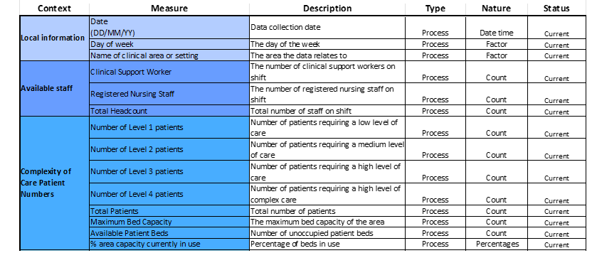

Table 1. DMA data dictionary. This table provides a description of the context, descrition, type and nature of the DMA data pata provied by the recruitment panel.

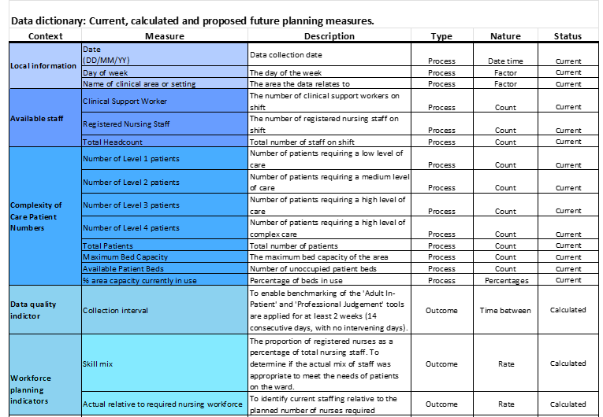

Table 2. Updated DMA data dictionary. This table provides descripts of the context, descrition, type and nature of the DMA data pata provied by the recruitment panel and calculated.

#### Outcome measures

##### Measures that demonstrate or not that we are working toward achiveng our stated aim.

There are no outcome measures included in the DMA data that directly more improved performance or that we are working towards or stated aim of ensuring safe and high quality care through **consistent data collection** to scaffold improvement initiatives, and facile an mandatory reporting, maintain the **proportion of registered nurses as percentage of total nursing staff above 65%**, and the **whole time equivalent (WTE) used meets or exceeds the WTE required** to staff the ward. I have there for used the process measures provided to calculate three outcomes measures: * **Collection interval.** To enable benchmarking, the Adult In-Patient and Professional Judgement tools are applied for at least 2 weeks (14 consecutive days, with no intervening days). * **Proportion of registered nurses (RN) as percentage of total nursing staff.** To determine if the actual mix of staff was appropriate to meet the needs of patients on the ward. The benchmark average on general hospital wards is 65% registered nurses (Table 2) (Nursing, 2006).

# Updating the DMA Exercise data

I develop accessible, transparent, time saving, data and measurement handing pipelines, exploratory and downstream analyses and reports in RMarkdown, and use GitHub version control to make it possible for others, including my future self, to collaborate on projects and reproduce results. Many stakeholder are not familiar with R nor accessing project folder and documents via GitHub. I there for produce less technical, code free reports, MS Excel Workbooks and PowerPoint presentations as part of my workflow to facilitate collaboration with less technical stakeholders.

Table 1. DMA Exercise data structure.

## tibble [54 × 14] (S3: tbl_df/tbl/data.frame)  
## $ Date : POSIXct[1:54], format: "2023-01-01" "2023-01-01" ...  
## $ Day : chr [1:54] "Sunday" "Sunday" "Monday" "Monday" ...  
## $ ClinicalArea : chr [1:54] "B" "A" "B" "A" ...  
## $ Clinical Support Worker : num [1:54] 4 3 3 2 4 3 4 2 4 4 ...  
## $ Registered Nursing Staff : num [1:54] 5 3 3 3 6 4 3 3 3 4 ...  
## $ Total Headcount : logi [1:54] NA NA NA NA NA NA ...  
## $ Number of Level 1 patients: num [1:54] 10 12 8 9 14 14 10 11 10 11 ...  
## $ Number of Level 2 patients: num [1:54] 7 7 6 5 9 7 8 6 8 9 ...  
## $ Number of Level 3 patients: num [1:54] 4 3 2 5 6 5 4 3 4 4 ...  
## $ Number of Level 4 patients: num [1:54] 3 2 1 3 4 2 1 2 1 3 ...  
## $ Total Patients : logi [1:54] NA NA NA NA NA NA ...  
## $ Maximum Bed Capacity : logi [1:54] NA NA NA NA NA NA ...  
## $ Available Patient Beds : logi [1:54] NA NA NA NA NA NA ...  
## $ Activity : logi [1:54] NA NA NA NA NA NA ...

The data fame included 14 variables and 54 rows. The ‘Day of week’,‘Total Headcount’, ‘Total Patients’, ‘Maximum Bed Capacity’,‘Available Patient Beds’, and ‘% area capacity currently in use (Total Patients/Maximum Bed Capacity)’ variables are empty and need to be populated.

## Populating the ‘Total Headcount’ , ‘Total Patients’, ‘Maximum Bed Capacity’, ‘Available Patient Beds’ and ‘% area capacity currently in use’ process measures.

In the ‘Scenario tab in the DMA Exercise data MS Excel file we were informed that Clinical area A is a 25 bedded ward, and Clinical area B is a 30 bedded ward. Furthermore we were told that bed capacity can be over 100% due to admissions/discharges and opening of surge beds where available. This information was used information to populated the ’Maximum Bed Capacity’ variable.

## # A tibble: 6 × 14  
## Date Day ClinicalArea `Clinical Support Worker`  
## <dttm> <chr> <chr> <dbl>  
## 1 2023-01-01 00:00:00 Sunday B 4  
## 2 2023-01-01 00:00:00 Sunday A 3  
## 3 2023-01-02 00:00:00 Monday B 3  
## 4 2023-01-02 00:00:00 Monday A 2  
## 5 2023-01-03 00:00:00 Tuesday B 4  
## 6 2023-01-03 00:00:00 Tuesday A 3  
## # ℹ 10 more variables: `Registered Nursing Staff` <dbl>,  
## # `Total Headcount` <dbl>, `Number of Level 1 patients` <dbl>,  
## # `Number of Level 2 patients` <dbl>, `Number of Level 3 patients` <dbl>,  
## # `Number of Level 4 patients` <dbl>, `Total Patients` <dbl>,  
## # `Maximum Bed Capacity` <dbl>, `Available Patient Beds` <dbl>,  
## # `% area capacity currently in use` <dbl>

## Populating the day of the week variable

I use the ‘lubricate’ package to extract the day of the week from the Date variable. ‘Lubridate’ is an R package that makes it easier to work with dates and times.

### Looking at the consistentancy of collection across week days.

Table 1. Frequency distribution of day of the week by Clinical area.

## # A tibble: 3 × 8  
## ClinicalArea Mon Tue Wed Thu Fri Sat Sun  
## <chr> <int> <int> <int> <int> <int> <int> <int>  
## 1 A 4 3 4 1 3 4 4  
## 2 B 5 5 1 4 4 4 5  
## 3 C 0 0 1 0 1 0 1

Consistency of collection appears greater in Clinical area B based on the frequency distribution of day of the week. There appears at first glance to be a relationship between low week day counts in Clinical area A and data collected in Clinical area A. Could it be that the team misassigned the name of the clinical area.

# Examining the relationship between the dates data was collected in Clinical area C and the other two areas.

There is only one of the three dates, the 11/1/2023 that you could infer the the team may have misassigned the name of Clinical area B with C. Before making this change, I would have to confirm this with the Senior Charge Nurse. For the purpose, of the analyses for the upcoming meeting, I will assume the data has been correctly assassinated to Clinical area C. Data was collected at all three Clinical areas for the other two dates.

#### Clinical area C

Ward capacity details were not provided for Clinical area C. As such the ‘% area capacity currently in use’ measure can not be calculated. Only Clinical area A and B will be included in down stream analysis, and the last three records in the data set from Clinical area C removed.

## Calculating the the ‘Collection interval’, ‘Skill mix’ and ‘Nurse staffing relative to patient requirments’ outcome measures

#### Exmaming the consistance of data collection in Cinical areas A and B.

To determine the consistency of data collection I calculated the data collection interval.

Table 1. The frequency distribution of Collection interval by Clinical Area.

| Clinical area | Collection interval | Frequency | Percent |
| --- | --- | --- | --- |
| A | 1 | 15 | 68.18% |
| A | 2 | 6 | 27.27% |
| A | 3 | 1 | 4.55% |
| B | 1 | 24 | 88.89% |
| B | 2 | 3 | 11.11% |

The consistency of data collection was much higher in Clinical area B, compared to A. In total, 89% of records were collected within one data, as opposed to 68% in clinical area C.

### Calculating the ‘Skill mix’ and Nurse staffing relative to patient requirements outcome varaiables

Skill mix was simply calculated as the rate of Registered nursing staff to total nursing staff. !

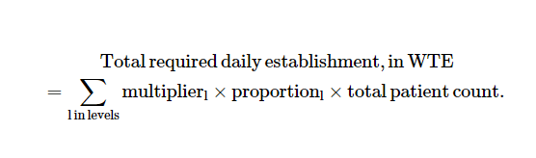

The total daily required establishment, WTE was calculated as.

Using general ward multipliers for level 1-4 patients (Griffiths et al., 2020).

## < table of extent 0 >

# Checking for missing records and removing redundant variables

| lag1_Date | lag1_ClinicalArea | CollectionInterval |
| --- | --- | --- |
| 2 | 2 | 2 |

The data is complete, the only missing records are those associated with the ‘Collection interval’ measure. I have set those missing records to zero, and removed redundant variables.

# Adding the updated data to the DMA Exercise data Excel file

The original DMA Exercise data Excel file was read in again, and a working DMA Exercise working data Excel file set up in the project output data folder to collect, data updates, summary tables, charts, results and comments for stakeholder to review prior to the Hospital X management meeting.

## Warning in file.create(to[okay]): cannot create file  
## './Output/Data/DMAExercise_workings.xlsx', reason 'Permission denied'

# Visual representation of the three calculated outcome variables

## Run charts

Run charts were used to plot the DMA exercise data over time to observe trends, patterns, and variation in three outcome measures over time and to study the effect of your improvement efforts. The primary purpose of run charts is to identify non-random variation resulting from real change (**anhoj2014RunChartsRevisited?**).

We have 23 and 28 data points in Clinical areas A and B, respectively. This means the lower limit for the number of runs are seven and ten, and the upper limit is 17 and 20 runs to demonstrate non-random variance attributable to changes in staffing levels.

# Run chart of Collection interval for Clinical area A

Figure 1a. Run chart of Collection interval for Clinical area A. The run chart is a plot of Collection interval for Clinical area A over time. The horizontal line is the median, which divides the data points in two halves. The green line represents the established benchmark for the measurement.

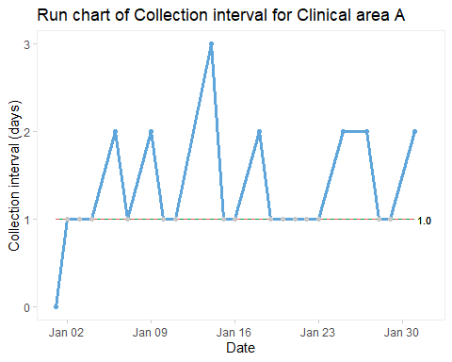

The collection interval for Clinical area A was inconsistent. No shifts or trends were seen on the run chart. The median was one, it was therefore not possible to assess the number of runs. However, an astronomical point of three days was measured on Saturday, the 14th of January 2023 (Figure 1a).

# Run chart of Collection interval for Clinical area B

Figure 1b. Run chart of Collection interval for Clinical area B. The run chart is a plot of Collection interval for Clinical area B over time. The horizontal line is the median, which divides the data points in two halves. The green line represents the established benchmark for the measurement.

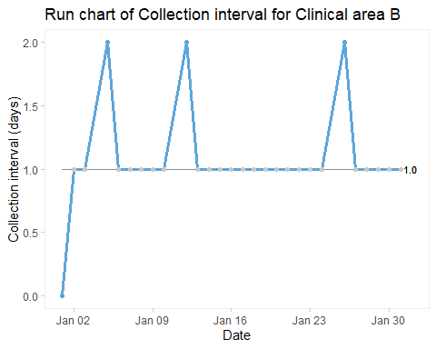

The collection interval for Clinical area B was more consistent, only missing three sample dates. No shifts or trends were seen on the run chart. Six runs can be seen on the run chant, which is below the lower limit of 10, suggesting statistically significant change.

# Run chart of Skill mix for Clinical area A

Figure 1c. Run chart of Skill mix for Clinical area A. The run chart is a plot of Skill mix for Clinical area A over time. The horizontal line is the median, which divides the data points in two halves. The green line represents the established benchmark for the measurement.

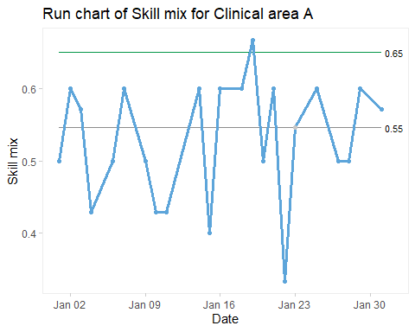

The Skill mix for Clinical area A was low and variable and only exceeded the benchmark of .65 on Thursday, the 19th of January 2023. No shifts or trends were seen on the run chart. Thirteen runs can be seen on the run chant, which is below the upper limit of 17, suggesting no statistically significant change. However, an astronomical point of .33 was measured on Sunday, the 22nd of January, 2023.

# Run chart of Skill mix for Clinical area B

Figure 1d. Run chart of Skill mix for Clinical area B. The run chart is a plot of Skill mix for Clinical area B over time. The horizontal line is the median, which divides the data points in two halves. The green line represents the established benchmark for the measurement.

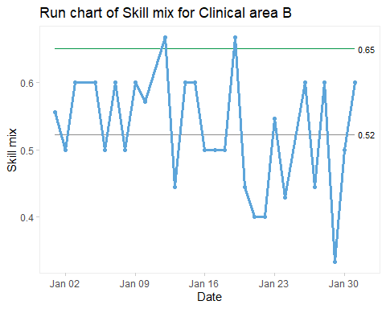

The Skill mix for Clinical area B was also low and variable and exceeded the benchmark of .65 with two astronomical points on Thursday, the 12th and 19th of January 2023. Clinical area A also exceeded the benchmark on the 19th of January, 2023. It was interesting to hear what insights Senior Charge Nurse has as to why performance improved dramatically at the two Clinical areas on that date. No shifts or trends were seen on the run chart. Eighteen runs can be seen on the run chant, which is below the upper limit of 20, suggesting no statistically significant change. However, an astronomical point of .33 was measured on Sunday, the 29th of January, 2023.

# Run chart of Actual relative to required nursing workforce for Clinical area A

Figure 1e. Run chart of Actual relative to required nursing workforce for Clinical area A. The run chart is a plot of Actual relative to required nursing workforce for Clinical area A over time. The horizontal line is the median, which divides the data points in two halves. The green line represents the established benchmark for the measurement.

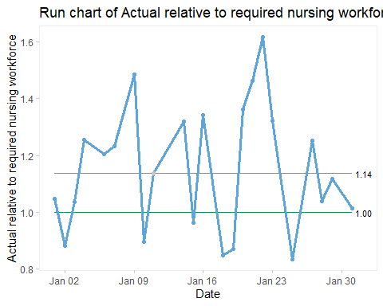

The Actual relative to required nursing workforce for Clinical area A fell below our set benchmark of one on six occasions. No shifts or trends were seen on the run chart. Eleven runs can be seen on the run chant, which is below the upper limit of 20, suggesting no statistically significant change. However, an astronomical point of 1.62 was measured on Sunday, the 22nd of January, 2023.

# Run chart of Actual relative to required nursing workforce for Clinical area B

Figure 1f. Run chart of Actual relative to required nursing workforce for Clinical area B. The run chart is a plot of Actual relative to required nursing workforce for Clinical area B over time. The horizontal line is the median, which divides the data points in two halves. The green line represents the established benchmark for the measurement.

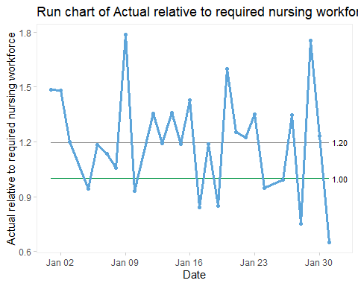

The Actual relative to required nursing workforce for Clinical area B fell below our set benchmark of one on nine occasions. No shifts or trends were seen on the run chart. Eleven runs can be seen on the run chant, which is above the lower limit of 10, suggesting no statistically significant change. However, astronomical points of 1.79 and 1.76 were measured on Monday the 9th and Sunday the 29th of January 2023. Another astronomical point of 0.65 was measured on Tuesday, the 31st of January, 2023.

# Bean plots

Although for the most part, the three outcome measures have exhibited random variation, i.e. variation not related due to any staffing improvements you have introduced. Nonetheless, random variation is driven by chance events that affect operational processes, people and patient outcomes equally and may potentially provide insights into performance gaps and areas that need improvement.

As such, bean plots were used to compare variation in the outcome variables between Clinical areas A and B and the day of the week. The primary purpose of run charts is to visually represent and compare variation across categorical groups (**kampstra2022PackageBeanplot?**).

# Bean plot of the variation in Skill mix across Clinical areas A and B

I could not compare the variation in Skill mix by Clinical areas A and B across the day of the week. The measurement within the two Clinical areas was too sparse to compare across the day of the week. I, therefore, compared the variation in Skill mix across Clinical areas A and B, then combined the data for the two Clinical areas and compared the variation in Skill mix across the day of the week.

Figure 2a. Bean plot of the variation in Skill mix across Clinical areas A and B. The Bean plot is a plot comparing Skill mix variation across Clinical areas A and B. Black horizontal thick lines of each bean plot indicate the category median of the measurement. The broken black horizontal line is the across-category median of the measurement. The short and thin black horizontal lines within each bean plot represent each measure value. Most of the measure values lie in the area where the bean plot is widest. The green line represents the established benchmark for the measurement.

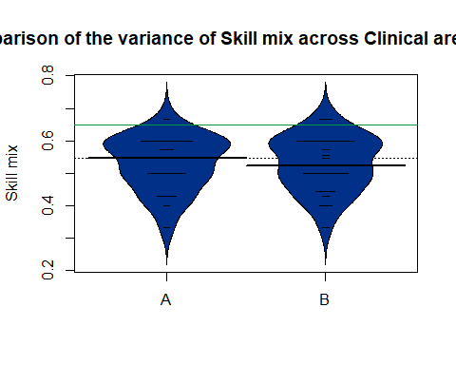 The weight of the variance in skill mix is below the recommended threshold of 0.65 in both Clinical areas. Clinical area A slightly outperforms Clinical area B, having a greater portion of measurement values above the combined median of the two Clinical areas.

# Bean plot of the variation in Skill mix from Clinical areas A and B across the day of the week.

Figure 2b. Bean plot of the variation in Skill mix from Clinical areas A and B across the day of the week. The Bean plot is a plot comparing Skill mix variation from Clinical areas A and B across the day of the week. Black horizontal thick lines of each bean plot indicate the category median of the measurement. The broken black horizontal line is the across-category median of the measurement. The short and thin black horizontal lines within each bean plot represent each measure value. Most of the measure values lie in the area where the bean plot is widest. The green line represents the established benchmark for the measurement. 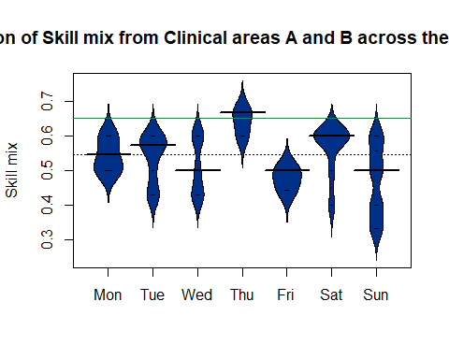

The weight of the variance in skill mix from Clinical areas A and B across the day of the week was below the established threshold of 0.65. Only on Thursdays was the weight of the variance in skill mix from Clinical areas A and B above the threshold. Maintaining the recommended skill mix appears to be particularly problematic on Wednesdays, Fridays and Sundays.

# Bean plot of the variation in Actual relative to required nursing workforce by Clinical areas A and B across the day of the week.

Figure 2c. Bean plot of the variation in Actual relative to required nursing workforce by Clinical areas A and B across the day of the week. The Bean plot is a plot comparing variation in Actual relative to required nursing workforce by Clinical areas A and B across the day of the week. Black horizontal thick lines of each bean plot indicate the category median of the measurement. The broken black horizontal line is the across-category median of the measurement. The short and thin, black and white horizontal lines within each bean plot represent each measure value. Most of the measure values lie in the area where the bean plot is widest. The green line represents the established benchmark for the measurement.

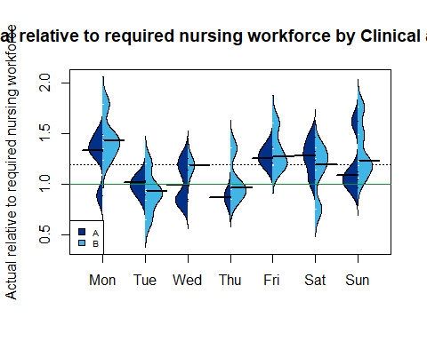

The weight of the variance in Actual relative to required nursing workforce in both Clinical areas was above our established benchmark of 1. However, there is room for improvement, as the weight of the variance in Actual relative to required nursing workforce was below the threshold on Tuesdays in Clinical area B and in both Clinical area A and B on Thursdays. ######################################################################################### ##############################################

# Pareto chart

The day of the week appears to have an impact all three outcome measures. In order to concentrate improvement efforts we need to determine the days of the week that have the greatest impact.

Using a Pareto Chart helps to concentrate improvement efforts on the factors that have the greatest impact. It helps to effectively communicate the rationale for focusing on certain areas.

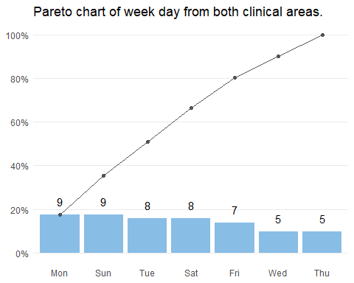

East London NHS Foundation Trust

Records collected on Mondays, sundays, Tuesdays, Saturdays and fidays account for 80% of records collected. The Fewest record are collected on Wednesdays and Thursdays. It will be instersting to discuss the resons for this with the Senior charge nurse at the managemnt meeting.

Improvment Plant. Questions to inform the improvment plan?  
* Have the three records in Cinical area C been missassigned? * What contingances can we put in place to ensure data is collecected data, particulary on wednesdays and thursdays? * What factors do we need to consider to improve the Skill mix toward the recomended bench mark of 0.65?  
* What contingances can we put in place to ensure whole time equivalent (WTE) used meets or exceeds the WTE required to staff the ward, particulary on Thuesdays and thursdays?

Find the root causes of the issues

Ishikawa diagram

library(qcc)

cause.and.effect(cause=list(Measurements=c(“Micrometers”, “Microscopes”, “Inspectors”), Materials=c(“Alloys”, “Lubricants”, “Suppliers”), Personnel=c(“Shifts”, “Supervisors”, “Training”, “Operators”), Environment=c(“Condensation”, “Moisture”), Methods=c(“Brake”, “Engager”, “Angle”), Machines=c(“Speed”, “Lathes”, “Bits”, “Sockets”)), effect=“Surface Flaws”)

```

# Findings

Other than eight astronomical points across the three outcome measures across Clinical area A and B, which warrant further scrutiny. No other evidence of non-random variance was attributable to changes in staffing levels observed in the data. Skill mix appears to be independent of Actual relative to the required nursing workforce (Table 3). Poor skill mix appears most problematic on Sundays. As expected, there appears to be a relationship between Actual relative to the required nursing workforce and consistency of data collection, both appeared to be most problematic on Sundays.

Previous research has shown that, on average, acute patients admitted to hospital emergency departments on a weekend experience worse outcomes than those admitted on a weekday(**honeyford2018WeekendEffectDoes?**). Why the day of the week affects the outcome measures remains unclear. Factors contributing to the day of the week effects as such warrant consideration.

|  |
| --- |
| Table 3. A synthesis table of the impact of the day of the week effects on the staffing level outcome variables in Clinical area A and B. |

Table 3. A synthesis table of the impact of the day of the week effects on the staffing level outcome variables in Clinical area A and B.

|  |
| --- |
| Table 3. A synthesis table of the impact of week day effects on the staffing level outcome variables in Clinical area A and B. |

Table 3. A synthesis table of the impact of week day effects on the staffing level outcome variables in Clinical area A and B.

# Considerstions

Now that we have studied the data, we need to work together to consider redesigning your improvement plan based on the evidence presented in this report.

## Questions to inform your improvement plan.

I would be very grateful if could consider these four questions before joining the Hospital X management meeting this week: 1. Have the three records in Clinical area C been misassigned? + If so, will it be possible to reassign them to the correct Clinical area? 2. What contingencies can we put in place to ensure data is collected daily, particularly on Wednesdays and Thursdays? 3. What factors do we need to consider to move the Skill mix toward the recommended benchmark of 0.65? 4. What contingencies can we put in place to ensure the whole time equivalent (WTE) used meets or exceeds the WTE required to staff the ward, particularly on Tuesdays and Thursdays?

## Adult inpatient care journey

Let us consider the Adult inpatient care journey. First, the patient will be referred by a GP or Accident and emergency service and will be admitted from outpatients or theatre to the inpatient ward. A nurse will then look after them and manage their pain. During their stay, a patient will be cared for by a multidisciplinary healthcare team, which includes doctors, nurses, healthcare assistants and others. Nursing staff on the ward will be working to a planned date for their discharge home or into community care (Figure 1).

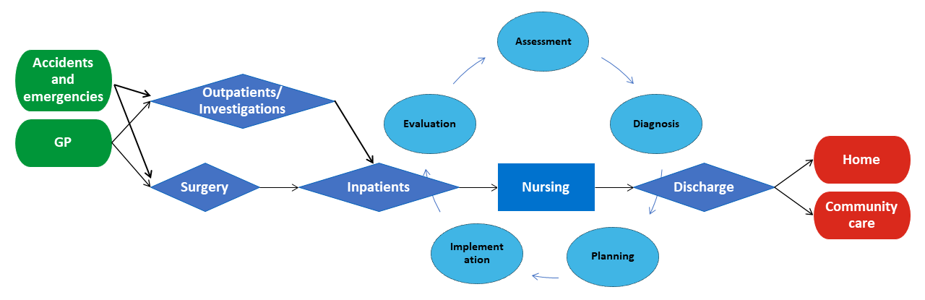

Figure 1. The adult inpatient care journey. This figure shows the steps in reviewing and developing a nursing care plan for adult inpatients admitted onto an inpatient ward.

## The nursing process

The nursing process is a methodical problem-solving approach used to identify, prevent and treat actual or potential health issues and promote well-being. It has five steps: assessment, diagnosis, planning, implementation and evaluation (Figure 2) (Semachew, 2018).

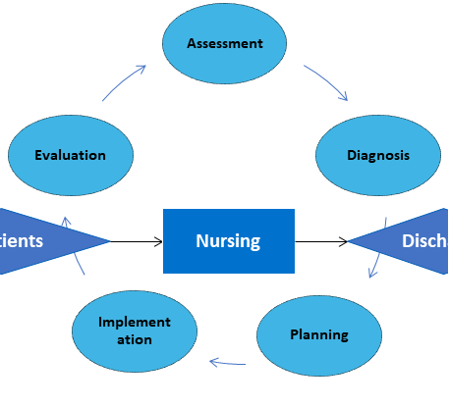

Figure 2. The nursing process. This figure focuses on the five steps in nursing of adult inpatients admitted onto an inpatient ward process.

### DMA data

After considering the Adult inpatient care journey, What measures do we need to start collecting in the future that can reliably demonstrate that we are making strides towards achieving our stated aim of ensuring safe and high-quality care through consistent data collection to scaffold improvement initiatives, and facilitating mandatory reporting, maintain the proportion of registered nurses as a percentage of total nursing staff above 65%, and the whole time equivalent (WTE) used meets or exceeds the WTE required to staff the ward?

#### Process measures

#### Measures that indicate that steps we have put in place to achieve our stated aim are being reliably implemented.

The data provided by the recruitment panel consists of a series of process measures of available staff, and patient care complexity data (Table 1).

#### Measures of nursing care quality and performance

However, nursing care quality and performance measures across the Nursing process are not included in the DMA data (Figure 2). I would like to propose that we should consider making use of routinely collected nursing-sensitive indicators to determine whether nursing care quality and performance have an impact on patient outcomes (Table 2) (Oner et al., 2021).

#### Balancing measures

##### Measures that track improvements in one part of the system to ensure they are causing unintended consequences elsewhere in the system.

We now need to consider the system from different directions and ensure that any implemented staffing improvements do not cause problems in other parts of the system. I would like to propose that we should consider making use of routinely collected staff turnover, sickness absence and agency spending balancing measures to reflect what may be happening elsewhere in the system because of the staffing improvements in the adult inpatient ward (Table 2) (Ball, 2010).

## Casue and effect analysis

Working through cause and effect analysis enables those involved to create a snapshot of the team’s collective knowledge of the issue, gain a shared insight into the problem, and start to consider the design of possible staffing improvements based on the finding from the DMA exercise data presented in this report. I che create a seleton of fkid goon chare for you to consider prier toe the I would very muc aprescie what factors mey imacat…

# References

Ball, J., 2010. [Guidance on safe nurse staffing levels in the UK](https://www.rcn.org.uk/-/media/Royal-College-Of-Nursing/Documents/Publications/Obselete/PUB-003860.pdf).

Griffiths, P., Saville, C., Ball, J.E., Chable, R., Dimech, A., Jones, J., Jeffrey, Y., Pattison, N., Saucedo, A.R., Sinden, N., 2020. The Safer Nursing Care Tool as a guide to nurse staffing requirements on hospital wards: Observational and modelling study.

Nursing, R.C. of, 2006. [RCN policy unit policy guidance 15/2006: Setting appropriate ward nurse staffing levels in NHS acute trusts](https://www.rcn.org.uk/-/media/Royal-College-Of-Nursing/Documents/Policies-and-briefings/UK-Wide/Policies/2006/1506.pdf).

Oner, B., Zengul, F.D., Oner, N., Ivankova, N.V., Karadag, A., Patrician, P.A., 2021. Nursing‐sensitive indicators for nursing care: A systematic review (1997–2017). Nursing open 8, 1005–1022.

Scotland, H.I., 2022. [Adult inpatient workload tool: User guide](https://www.healthcareimprovementscotland.org/idoc.ashx?docid=d6d8c442-ccc1-4eac-a3b3-98efe55df4e5&version=-1).

Semachew, A., 2018. Implementation of nursing process in clinical settings: The case of three governmental hospitals in Ethiopia, 2017. BMC research notes 11, 1–5.