CT414: Assignment 1
By Ultan Griffin 12450558 and Brendan Connolly 12370346

This document contains a general description of the code as well as screenshots of the working code.

On the server side, the main objectives were to store the assessments, as well as confirm correct login by the students. The first step in this is to have server be available for connection by printing “ExamEngine bound”.
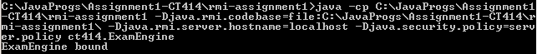
Then they will then enter their student i.d and password
As shown in the last two lines in the command line above.
Once that is accepted, a brief synopsis of what assessments are available to them, they will also be asked to pick which one they would like to do.
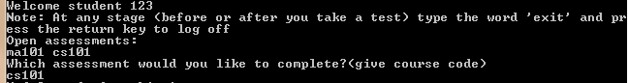
Once they have chosen which one to work on, all of the questions will be present and the user will be prompted to choose which question they would like to do (no particular order required) by typing the number of the question.
There will also be the Answers to each question directly underneath them. To answer them, you have to enter the number of the answer (not the answer itself) for it to be accepted. If they would like, the availability to check which answer they choose is possible by typing “-1” *this is shown in the second screen shot following.
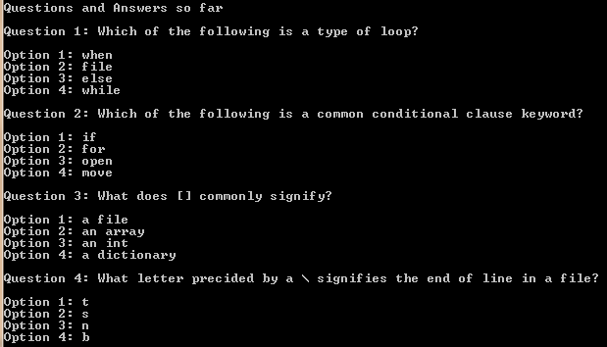
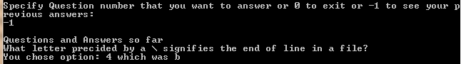
Once the user is happy with their work, they have the availability to enter “0” to submit their work, and simultaneously exit the assignment.
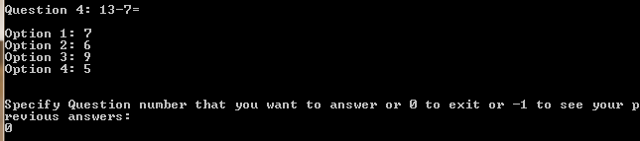
They then have the option to attempt the other assignment by typing in the course code, or “exit” to exit the server.
