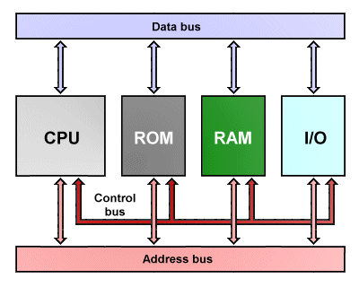
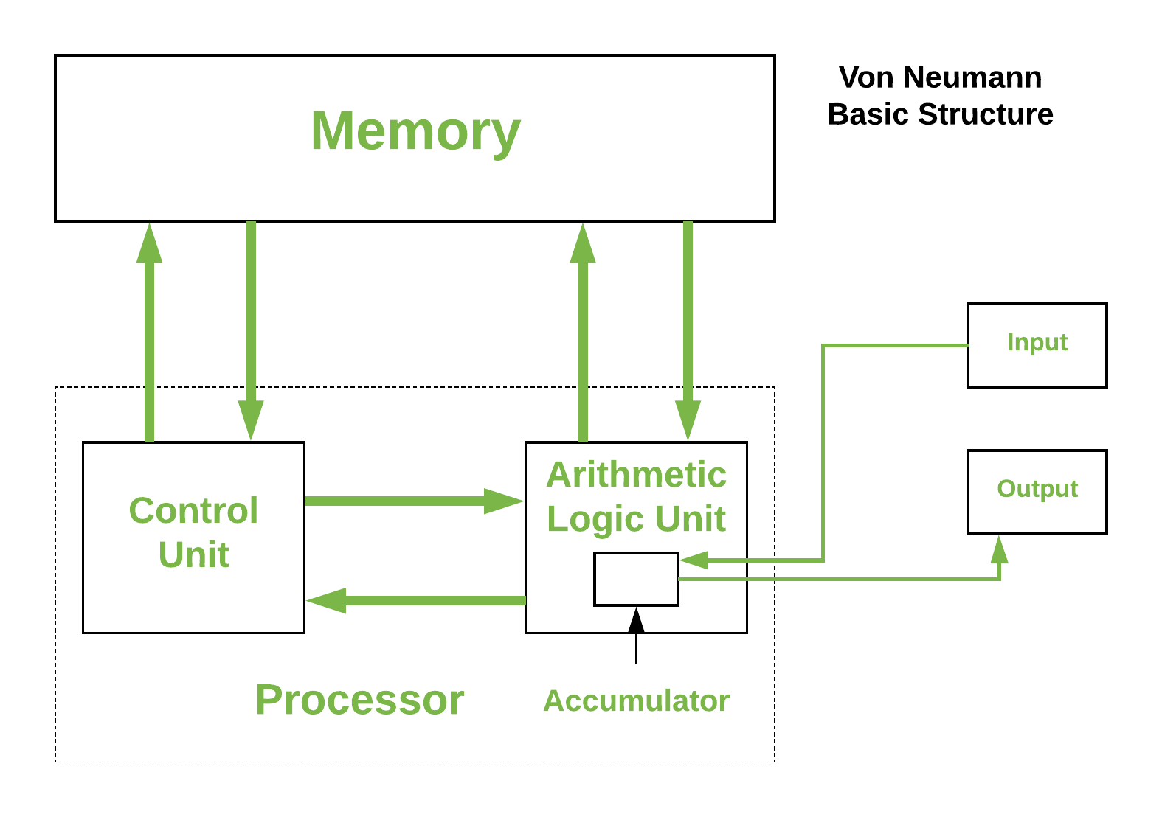

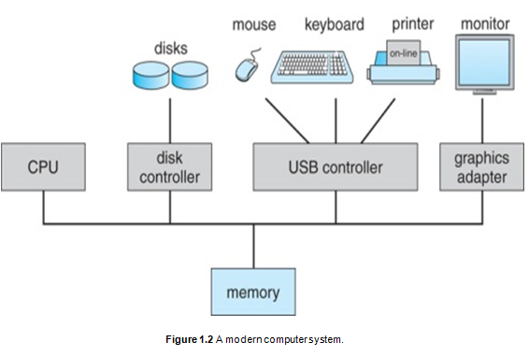

https://youtu.be/h-NM1xSSzHQ?si=B6fgeA7t6xVZw05A

Slide 1: Title Slide
Title: The Keyboard: An In-Depth Look Subtitle: How Keyboards Work, Types, and Their Role in Computer Systems

Slide 2: Introduction to Keyboards
- Title: What is a Keyboard?
- Content:
  - "A keyboard is an input device that allows users to interact with a computer by typing commands, text, and numbers."
  - Briefly explain the keyboard as a primary interface for computer interaction, and mention its origins from typewriters.

Slide 3: Types of Keyboards
- Title: Types of Keyboards
- Content:
  - "There are various keyboard layouts and types designed for different needs."
  - Common Types:
    - Standard QWERTY Keyboard: The most widely used layout for English speakers.
    - AZERTY Keyboard: Common in France and some other French-speaking countries.
    - DVORAK Keyboard: Known for being ergonomic, reducing finger movement for faster typing.
    - Mechanical vs. Membrane Keyboards: Explain the difference in technology and typing feel.

Slide 4: Keyboard Anatomy
- Title: Inside a Keyboard
- Content:
  - Break down components of a keyboard:
    - Key Switches: Mechanism beneath each key.
    - Controller: The small processor that interprets key presses.
    - PCB (Printed Circuit Board): Where electronic connections are made.
  - Mechanical vs. Membrane Switches: Explain how each type functions, mentioning that mechanical keyboards have individual switches for each key, while membrane keyboards use a single sheet that registers keypresses.

Slide 5: Key Layouts and Functions
- Title: Key Layouts and Functions
- Content:
  - Alphabet Keys: Standard typing keys.
  - Function Keys (F1-F12): Used for specific system commands, such as F5 for refresh.
  - Modifier Keys: Shift, Ctrl, Alt, used for shortcuts and special commands.
  - Numeric Keypad: Often separate, useful for number entry.
  - Navigation Keys: Arrow keys, Home, End, Page Up, and Page Down.

Slide 6: How Keyboards Connect with Computers
- Title: Keyboard Connections
- Content:
  - Wired Keyboards: USB and PS/2 connections.
  - Wireless Keyboards: Bluetooth and RF technology for wireless communication.
  - Mention how keystrokes are sent as binary signals to the computer for interpretation.

Slide 7: Keyboard Shortcuts
- Title: Useful Keyboard Shortcuts
- Content:
  - Highlight some of the most common and useful shortcuts:
    - Copy (Ctrl + C) and Paste (Ctrl + V)
    - Undo (Ctrl + Z)
    - Save (Ctrl + S)
    - Cut (Ctrl + X)
    - Find (Ctrl + F)
  - Alt + Tab: Switch between open applications.

Slide 8: Evolution of Keyboards
- Title: History and Evolution
- Content:
  - Discuss the evolution from typewriters to mechanical keyboards, then to modern membrane and chiclet-style keyboards.
  - Mention advancements like backlit keyboards, programmable keys, and RGB lighting in gaming keyboards.

Slide 9: Advantages and Disadvantages
- Title: Keyboard Advantages and Disadvantages
- Content:
  - Advantages:
    - Precision and speed for data entry.
    - Shortcut functionality enhances productivity.
  - Disadvantages:
    - Physical strain (RSI) from prolonged use.
    - Requires more space compared to touch interfaces.

Slide 10: Future of Keyboards
- Title: The Future of Keyboards
- Content:
  - Emerging technologies: Virtual Keyboards projected onto surfaces, AI-powered predictive typing, and touchscreen keyboards.
  - Discuss how these may impact the traditional keyboard’s role.

Slide 11: Summary
- Title: Summary
- Content:
  - Recap on what was covered:
    - The role and types of keyboards.
    - How keyboards work internally.
    - Key layouts and their functions.
    - The evolution and future possibilities of keyboards.

This outline provides a foundation to create a well-rounded presentation on keyboards, covering their history, structure, technology, and future. Let me know if you’d like assistance in generating specific content or images for each slide.
4o
When you press a key on your keyboard and the corresponding character or command appears on your screen, several intricate steps take place almost instantaneously. Here’s a simplified breakdown of the process, from key press to screen display:

Step 1: Key Press and Signal Creation
Key Pressed: When you press a key, it triggers a mechanism within the keyboard. In a mechanical keyboard, each key has its own switch that closes an electrical circuit. In a membrane keyboard, pressing a key pushes a layer down to complete a circuit.
Electrical Signal Sent: Closing the circuit sends an electrical signal to the keyboard's microcontroller (the small computer within the keyboard).
Step 2: Keyboard Microcontroller Processing
Key Code Generation: The microcontroller interprets the signal and converts it into a specific scancode (a unique binary code that represents the pressed key).
Sending Scancode to Computer: The scancode is sent from the keyboard to the computer through either a wired (USB) or wireless connection.
Step 3: Operating System Interpretation
Receiving Scancode: The computer's Operating System (OS), like Windows or macOS, receives the scancode from the keyboard.
Translation to ASCII/Unicode: The OS interprets the scancode and translates it into a recognizable character code, such as ASCII or Unicode (e.g., the letter "A" or the number "1").
Step 4: Instruction Execution
Application Layer: The OS determines which application or text field is currently active (in focus) and sends the character or command to that application.
Rendering on Screen: If the key is for typing (e.g., pressing "A"), the OS instructs the active application (like a word processor) to display the letter on the screen.
Step 5: Graphics Rendering
Graphics Processing: The character is processed by the graphics card and the display driver, which translates it into pixels or a graphical form for display.
Showing on Screen: Finally, the display (monitor or screen) lights up specific pixels to render the character, so you see the letter "A" or the desired command result appear on the screen.
Summary of Process:
Key Press → Electrical Signal → Microcontroller (scancode)
Scancode to OS → Translated into character code
OS sends to Application → Rendered by Graphics Processor → Displayed on Screen
The entire process happens in milliseconds, allowing you to see the result almost instantly!

In computer architecture, a keyboard is an essential input device that allows users to interact with the computer by entering data and commands. The keyboard is structured in layers of hardware, firmware, and software, connecting with the CPU and other components to process keystrokes efficiently. Here’s an overview of how the keyboard fits into computer architecture and interacts with components like the CPU, RAM, and system bus:

1. Keyboard as an Input Device
The keyboard is part of the peripheral devices in a computer system architecture, designed to send data to the computer in the form of ASCII or Unicode characters, control codes, and command inputs.
It operates on a matrix circuit layout, with rows and columns connecting each key. Pressing a key completes a circuit, enabling the keyboard’s microcontroller to detect which key was pressed.
2. Keyboard Controller
Inside the keyboard, there is a small microcontroller that monitors key presses, generates scancodes, and manages the communication with the computer’s central processing unit (CPU).
The controller also performs debouncing, a process to ensure that the signal is steady and doesn’t register multiple key presses from a single physical press.
3. Data Transmission to the Computer
When a key is pressed, the microcontroller in the keyboard sends a scancode through a USB or PS/2 connection to the keyboard controller in the computer (typically part of the motherboard).
The computer’s keyboard controller then sends the data over the system bus, allowing the CPU to receive and process the input.
4. CPU Processing of Keyboard Input
The CPU receives the scancode and interprets it according to the active operating system. The CPU determines which program or process needs to handle the input, typically the program currently in focus.
Using interrupt requests (IRQs), the CPU prioritizes keyboard inputs to ensure fast response times, as each key press generates an interrupt that the CPU quickly responds to.
5. Interaction with Memory (RAM)
The interpreted character or command is then stored in RAM temporarily, allowing applications to access it as needed for text input, command execution, or control operations.
For example, if you’re typing in a text editor, each character you type is stored in memory until saved, modified, or deleted.
6. Operating System Role
The operating system (OS) provides software-level drivers and handlers that facilitate communication between the keyboard hardware and the application layer.
The OS translates the scancode received from the keyboard into a readable format (ASCII or Unicode) and then forwards it to the application currently in use.
7. Display and Output
Once the OS and CPU process the input, the command or character is sent to the graphics processing unit (GPU), if applicable, and then displayed on the monitor.
For example, pressing the "A" key in a word processor results in the letter "A" appearing on the screen, as the keyboard input has been converted to visible output.
Summary of the Keyboard’s Role in Computer Architecture
Hardware Layer: Keyboard sends input through the microcontroller, which converts it to scancodes.
Data Transmission: Scancodes are sent via the system bus to the CPU.s
CPU & OS Processing: CPU interprets and forwards the input to applications via the OS.
Memory Interaction: Input data is stored in RAM for temporary use.
Output Display: Characters are displayed via GPU on the monitor.
Architecture Diagram
In a basic architecture diagram, the keyboard would connect through:

Peripheral Device Interface (e.g., USB/PS/2)
Keyboard Controller (on motherboard)
System Bus to the CPU
RAM for temporary storage
OS and Application Layer for further processing
Output Devices (like the display)
This layered communication makes the keyboard a critical component for user interaction, bridging hardware and software functionality in computer architecture.
