| Lab Report | | | |
| --- | --- | --- | --- |
| Course Title: Computer Networks Lab | | | |
| Autumn 2024  Section:7BF | | | |
| Lab No: 1 | | | |
| **Name of Labwork:** Create a network of 4 hosts. One of the hosts will create a message and send it to its neighbor. Other hosts will just keep on sending the message to one of their neighbors. Run and record the event log. | | | |
|  | Student’s ID  Date of Performance  Date of Submission  Team Name | : C213232  : 11.09.2024  : 16.09.2024  : Phoenix | |
|  | Marks | | : |

**Name of Labwork:** Create a network of 4 hosts. One of the hosts will create a message and send it to its neighbor. Other hosts will just keep on sending the message to one of their neighbors. Run and record the event log.

**1. Introduction:**

In this lab experiment, I have simulated a simple network consist of four interconnected hosts. The goal of the experiment is to understand and observe the fundamental principles of message passing and routing within a network. One host in the network initiates the communication by creating and sending a message to its neighboring host. The other hosts in the network continue to propagate the message by forwarding it to one of their neighboring nodes, simulating a basic peer-to-peer communication model.

**2. Constructing Network(NED):**

First of all, we have to create a NED file and write the given code.

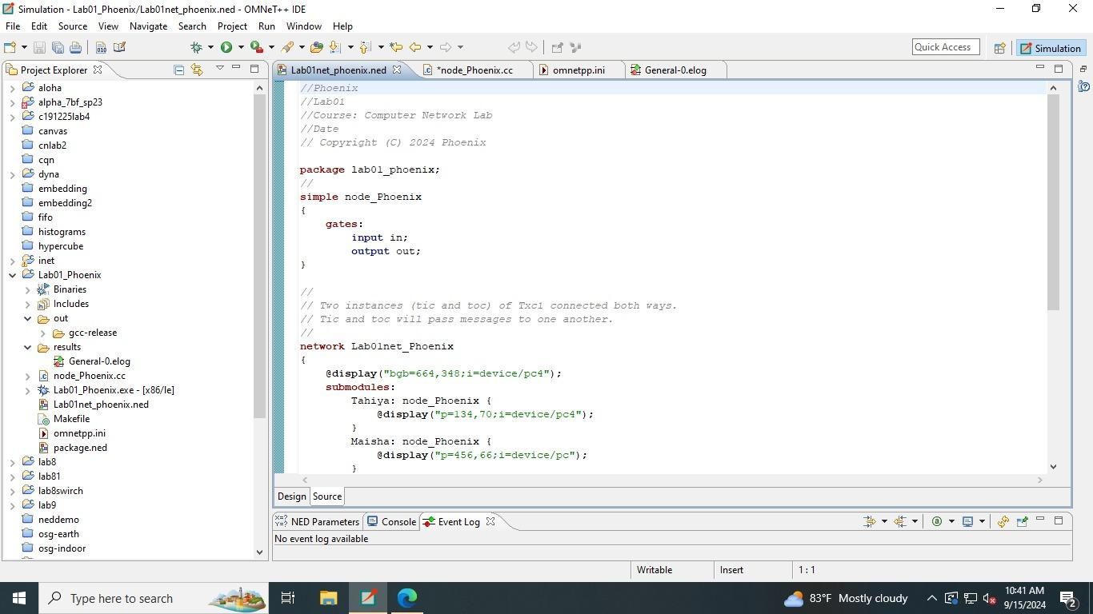

**Figure 1.1: Desktop SS of NED file**

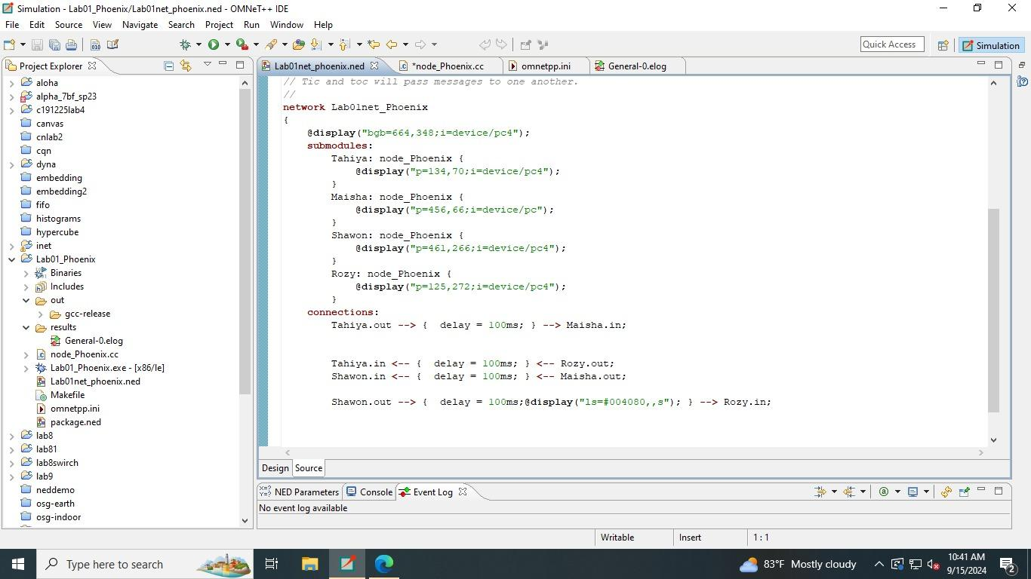

**Figure 1.2: Desktop SS of NED file**

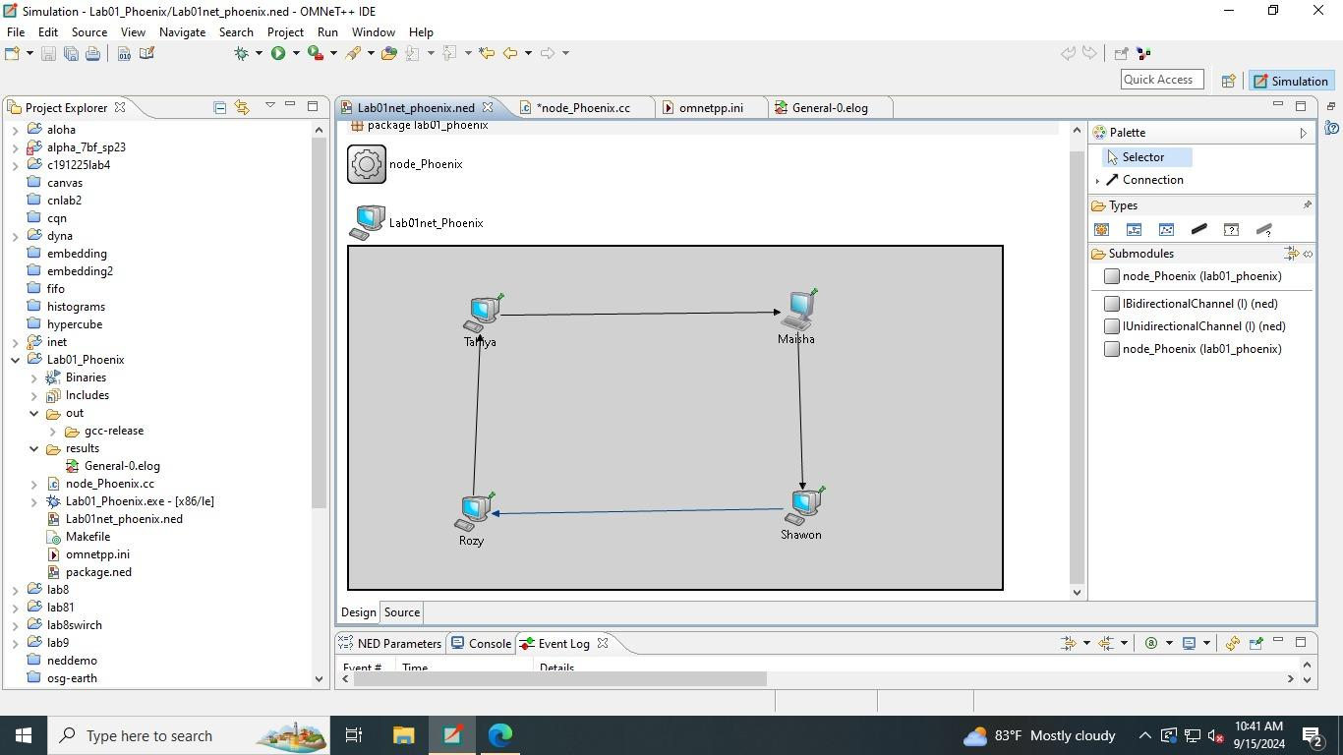

**Figure 2: Desktop SS of NED file**

**3. Building Module(C++ file):**

We have to write the source file to build the logic.

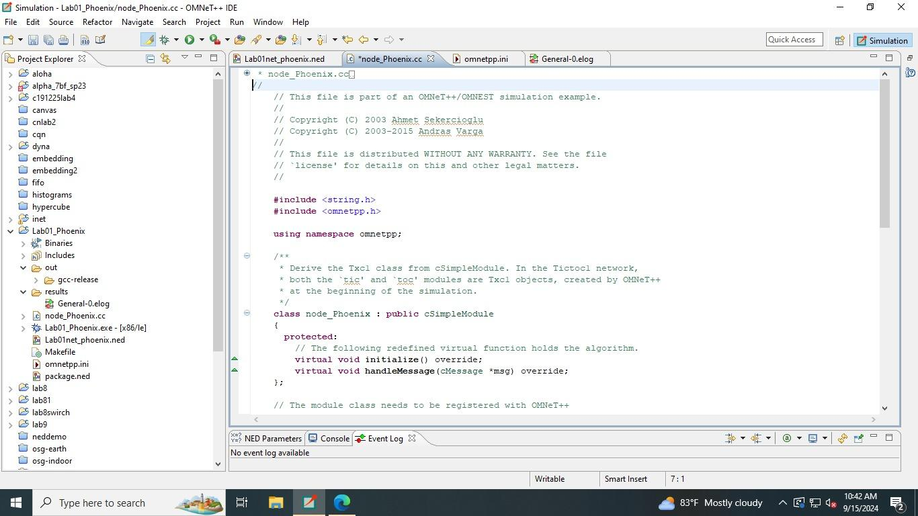

**Figure 1.2: Desktop SS of NED file**

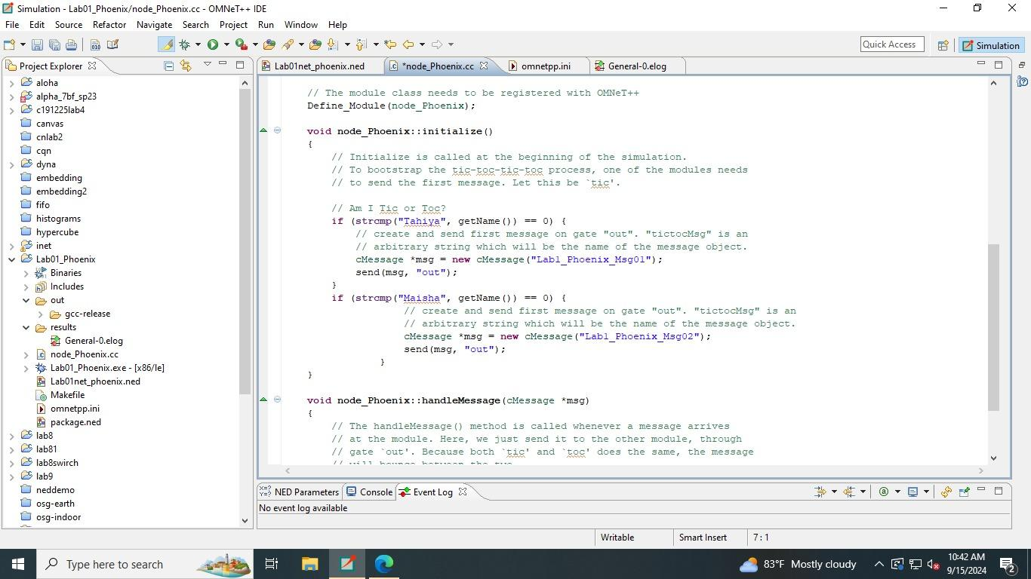

**Figure 2.1: Desktop SS of CC file**

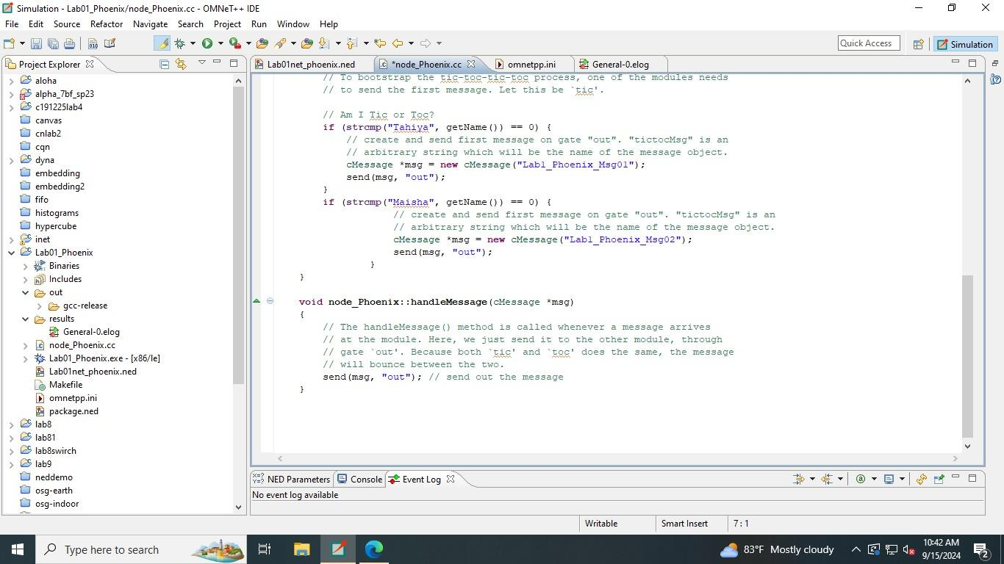

**Figure 2.2: Desktop SS of CC file**

**4. Initializing simulation(ini file):**

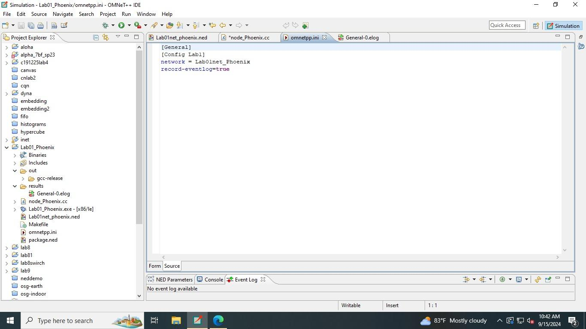

**Figure 3: Desktop SS of ini file**

**5. Experiment:**

In this labwork, the goal is to create a simple network of four hosts, where one host generates a message and sends it to its neighboring host. The other hosts in the network will receive the message and forward it to one of their neighbors in a round-robin fashion or based on predefined routing rules.

##### Network Topology:

* The network will consist of 4 hosts: Host Tahiya, Host Maisha, Host Shawon, and Host Rozy.
* These hosts will be connected in a circular or linear topology, where each host is aware of its neighboring hosts.

**6. Result and Analysis:**

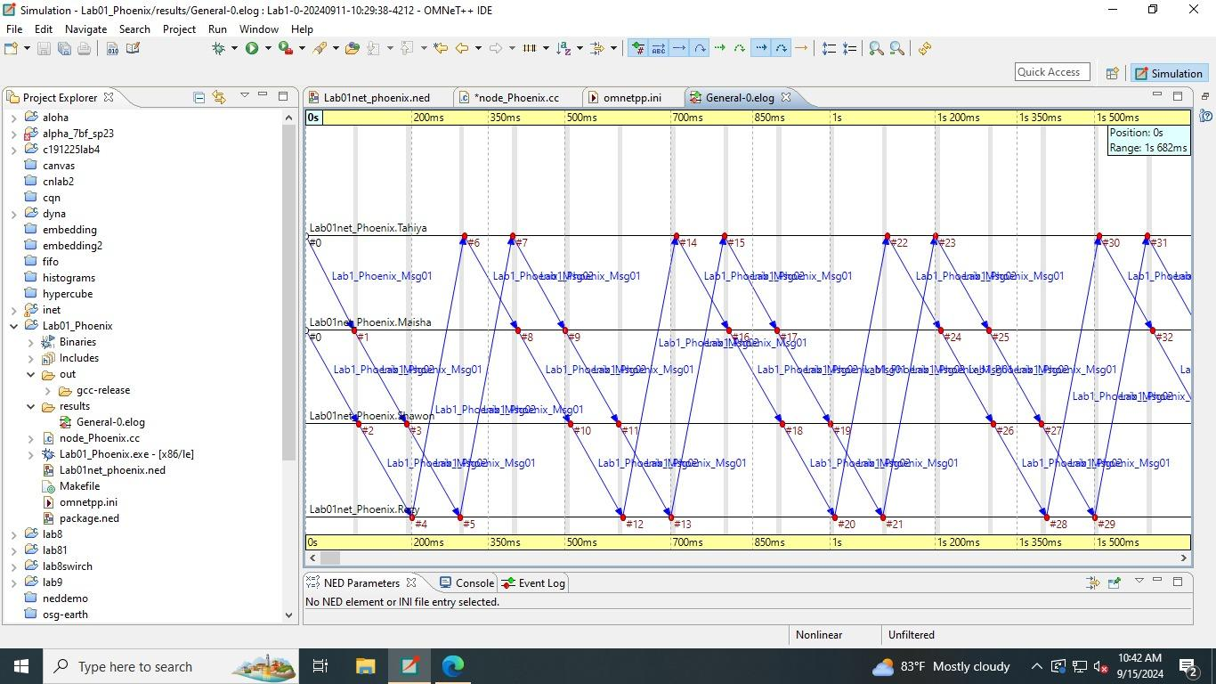

**Result:**

The simulation involves multiple hosts (e.g., Lab01net_Phoenix.Tahiya, Lab01net_Phoenix.Maisha, Lab01net_Phoenix.Shawon, Lab01net_Phoenix.Rozy, etc.) that pass a message between each other. The message is denoted as Lab1.Phoenix_Msg01.

The event log tracks the time (in milliseconds) when the message is passed between different hosts.

The message is passed in a sequential manner, alternating between hosts as depicted by the crisscrossing pattern of blue lines between hosts.

The X-axis represents the time of the simulation (starting from 0s and extending to 1.5s), while the Y-axis lists the participating hosts in the network.

**Analysis:**

**Message Propagation:** The message is being propagated between neighboring hosts in a consistent manner. It starts from one host, such as Tahiya, and moves to the next host (Maisha), and so on. The zigzag pattern confirms the consistent forwarding of the message.

**Timing of Message Passing:** The message transmission takes place at regular intervals, approximately every 150ms to 200ms. This indicates that the network operates in a time-scheduled manner or at fixed intervals to pass messages to neighbors.

**Synchronous Communication:** Based on the diagram, the network communication appears to be synchronized, meaning that every host sends and receives messages at similar intervals without significant delays or losses. The constant pattern of message exchanges supports this.

**No Message Loss:** No indication of message loss or failures can be inferred from the event log, as the messages are consistently passed between hosts without any missing events. Each message exchange between hosts has been recorded, reflecting a reliable message-passing protocol in this simulation.

**Network Load:** The simulation shows that all the hosts are actively involved in the communication process. Each host plays the role of both sender and receiver during the simulation window. This confirms an even distribution of network load, where no single node is overloaded with a disproportionate amount of messages.

**Latency Observation:** From the recorded event log, the message transmission latency between hosts seems minimal, as each message is passed quickly from one host to another in a predictable, sequential pattern.

**7. Conclusion:**

The simulation successfully demonstrates a message-passing network where hosts communicate by forwarding messages to one another. The message travels smoothly without interruption, and the timing between message exchanges indicates consistent latency. This experiment highlights how messages can be reliably passed between nodes in a simple, small-scale network, providing valuable insights into the efficiency of peer-to-peer communication protocols in a controlled environment.