**User Manual for the**

**Music XML Converter**

LE/EECS 2311 - Software Development Project



**Prepared for:** Vassilios Tzerpos

**Prepared by: Group 16**

Maisha Rahman 215083876

Nabaa Gaziy 215820095

Wenxuan Li 216374324

Ali Sheikhi 216777120

Lars Jaylen Palalon 217280041

February 28, 2021

## LIST OF CONTENTS

**LIST OF CONTENTS** **1**

**1.0 Introduction** **2**

1.1 Product Name 2

1.2 Intended Use 2

1.3 Features and Capabilities of the Product 2

1.3.1 Required Format for Text Tablatures 3

**2.0 Installation Instructions** **3**

2.1 How to Get Started 4

**3.0 Safety Warnings** **8**

**4.0 Troubleshooting** **8**

4.1 How to Deal with Occuring Problems 8

**6.0 Maintenance information** **9**

**7.0 Repair information** **9**

**8.0 Technical specifications** **9**

**9.0 Glossary** **10**

**10.0 Contact Details** **10**

**11.0 References** **10**

# **1.0 Introduction**

As a musician, having MusicXML files of your favourite songs is beneficial, since it is supported by many music apps, such as MuseScore, to precisely denote the music. For instance, you will be able to display the song in an easy-to-read fashion, you can transpose to another key, and you can play the song.

That is why we have created an easy-to-use application for quick tablature-to-MusicXML conversion. The Music XML Converter application allows the user to quickly and easily have access to MusicXML files, which are compatible with many popular music apps, right on your computer. Use this manual to delve deeper into the many unique features the Music XML Converter offers you as a musician.

## **1.1 Product Name**

The name of this product is Music XML Converter.

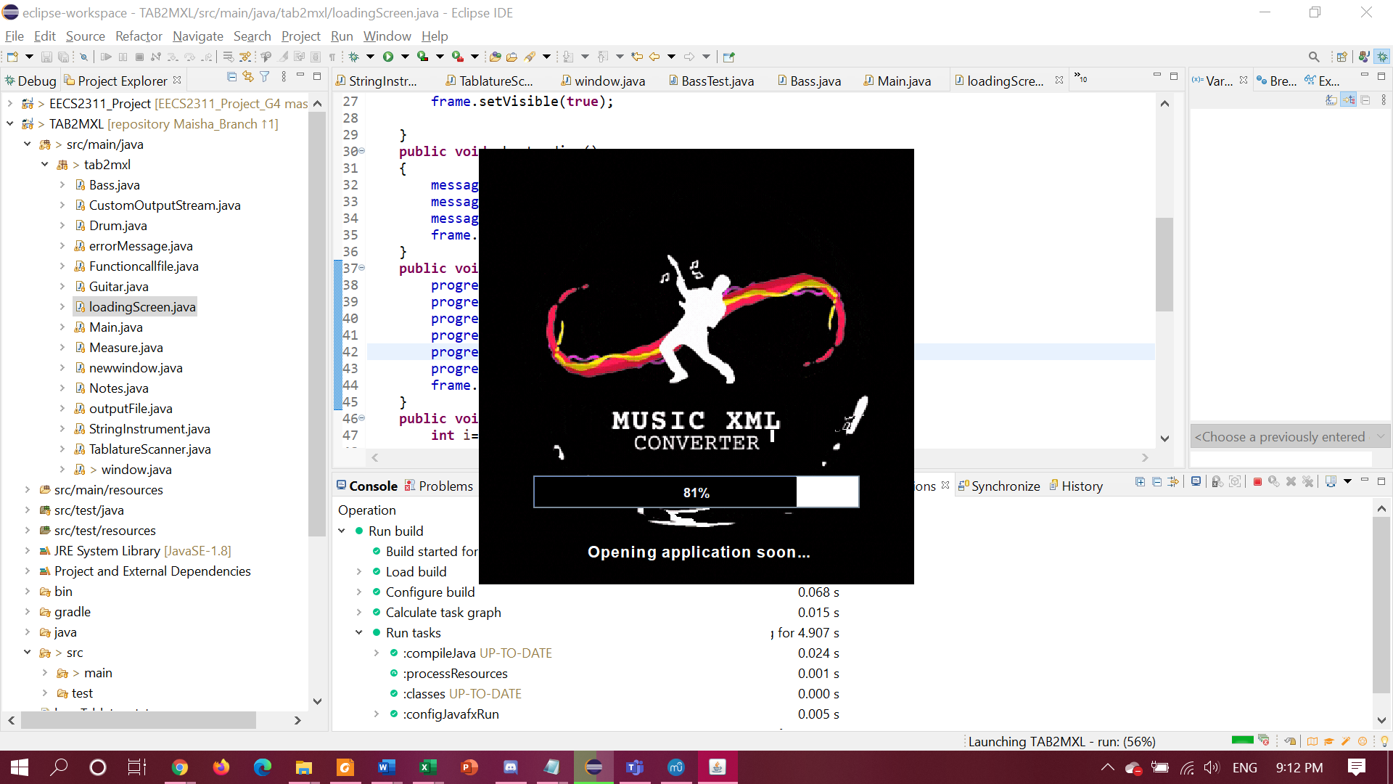

**Figure 1.**  The loading screen for the Music XML Converter.

## **1.2 Intended Use**

The Music XML Converter program is intended for musicians and music enthusiasts to convert music tablature files into MusicXML files that can be read by many different software.

## **1.3 Features and Capabilities of the Product**

* The software is able to accept and identify three types of tablature: Guitar, Bass, and Drums.
* Translates these tablature text files into .xml files.
  + **Note:** As of now, the program can only translate bass and guitar tablatures. Future updates will enhance the application to successfully translate drum tablatures as well.
  + **Note:** Also, the ability for the program to read chords has not been implemented yet

### **1.3.1 Required Format for Text Tablatures**

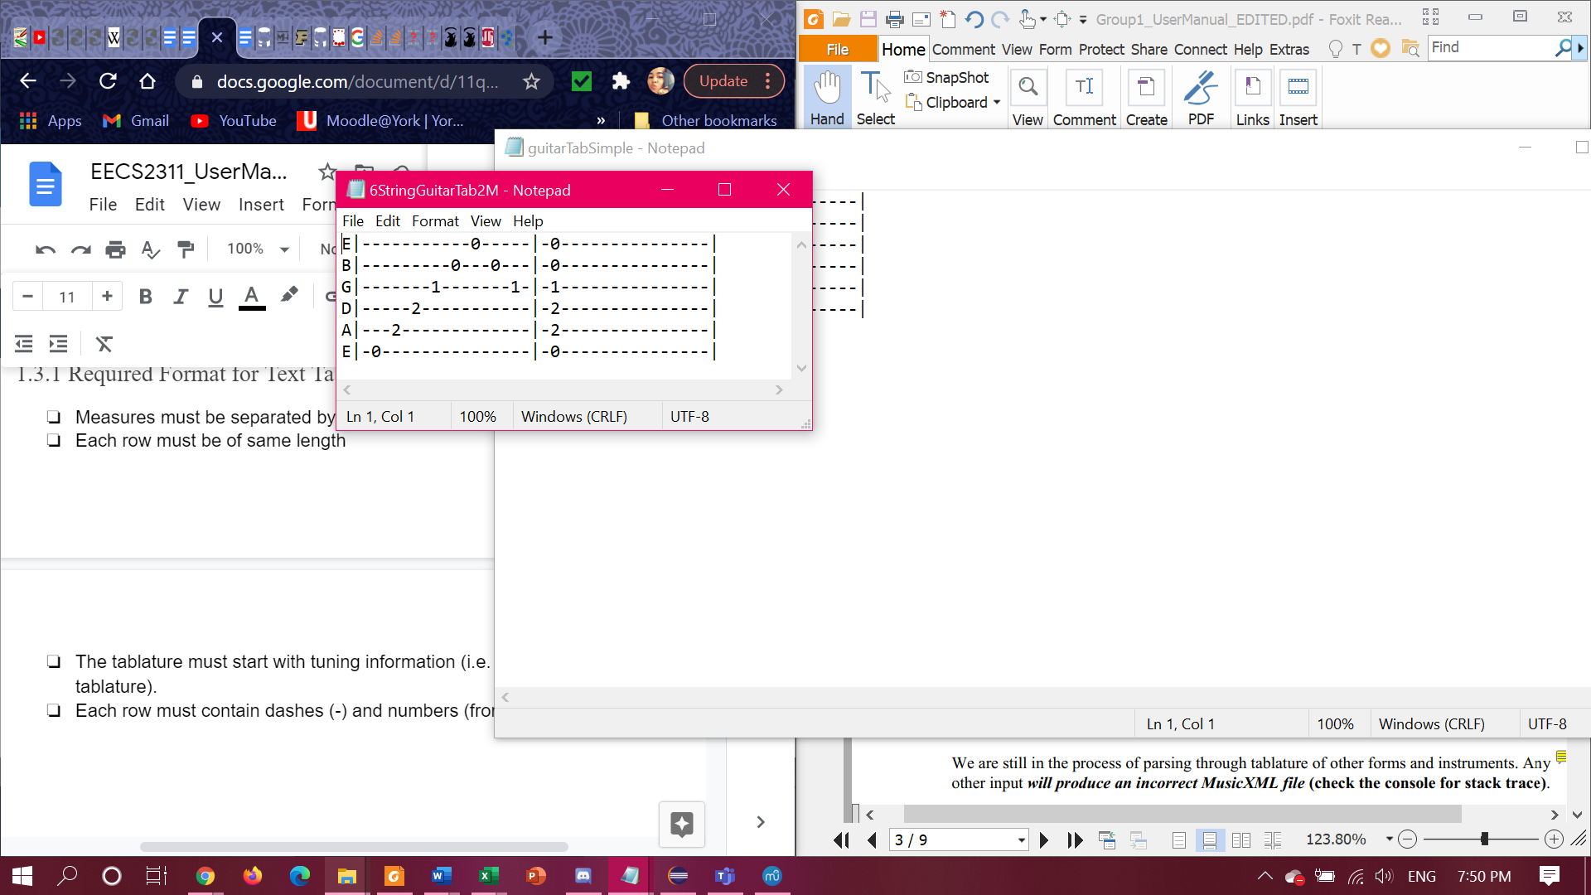

**Figure 2.** Here is a basic guitar tablature.

Please make sure the text tablatures are properly formatted:

* Measures must be separated by |
* Each row must be of same length
* The tablature must start with tuning information (i.e. the letters at the left side of the tablature).
* Each row must contain dashes (-) and numbers (from 0 to 9)

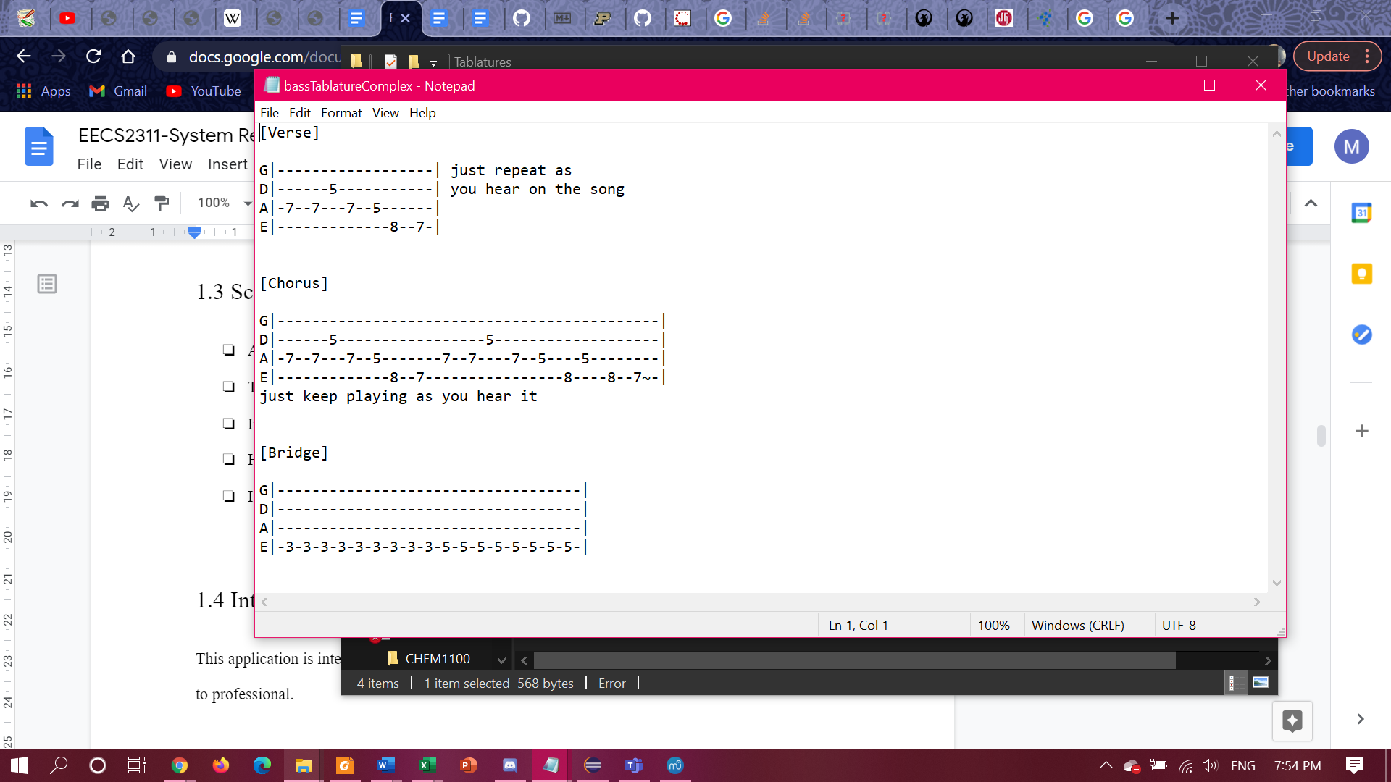

**Figure 2.**  Here is an example of a bass tablature that is acceptable for the Music XML Converter.

# **2.0 Installation Instructions**

Watch the installation instruction video or follow the instructions below:

**Video:** <https://drive.google.com/file/d/1od-uFQz56az2wgBGw4dp7sMfGSxWE1tr/view?usp=sharing>

**How to Run MusicXML Converter Program on Eclipse:**

\*\***Note:** The name of the java file for the Music XML Converter is called TAB2MXL.

1. Import the TAB2MXL program into Eclipse:
   1. If Eclipse is not installed on the system, please install the latest version found in the link below.

<https://www.eclipse.org/downloads/packages/installer>

* 1. If Eclipse is installed already, check for any new updates before starting.
  2. Import as a project from Git:
     1. In the Eclipse *File* menu, choose *Import*, then under *Git* folder, choose *Projects from Git* and click *Next*.
     2. Click on *Clone URI.*
     3. Copy and paste the URL of the repository from github.com into the URI field and click *Next*.
     4. Only select the *master* branch.
     5. Keep clicking *Next* and finally *Finish*.
     6. You now have a copy of the program.

1. In Eclipse, open *Gradle Tasks* window
   1. Go to *Window*→ *Show View* → *Other...*. Then Select *Gradle Tasks*.
2. In *Gradle Tasks*, under *application* folder, double click on *run*.
3. A window will pop-up. This is the user interface for the Music XML Converter application.
4. Music XML Converter application is now running.
5. Open your tablature using the app then click on *Translate* to see it in MusicXML format, you can also save the file.

**How to Run the Music XML Converter Executable:**

1. If you do not have Java Runtime Environment installed, please install the latest version.

https://www.java.com/en/download/

1. Make sure you have to have the latest version of Java.
2. Download the Music XML Converter executable.
3. Run the executable.

## **2.1 How to Get Started**

This is a guideline for every function supported by the Music Xml Convertor in a step-by-step manner:

**Getting Started with the User Interface:**

1. Once you run the Music XML Converter program, a window will pop up on the screen (refer to **Figure 3**). This is the user interface for the Music XML Converter program.

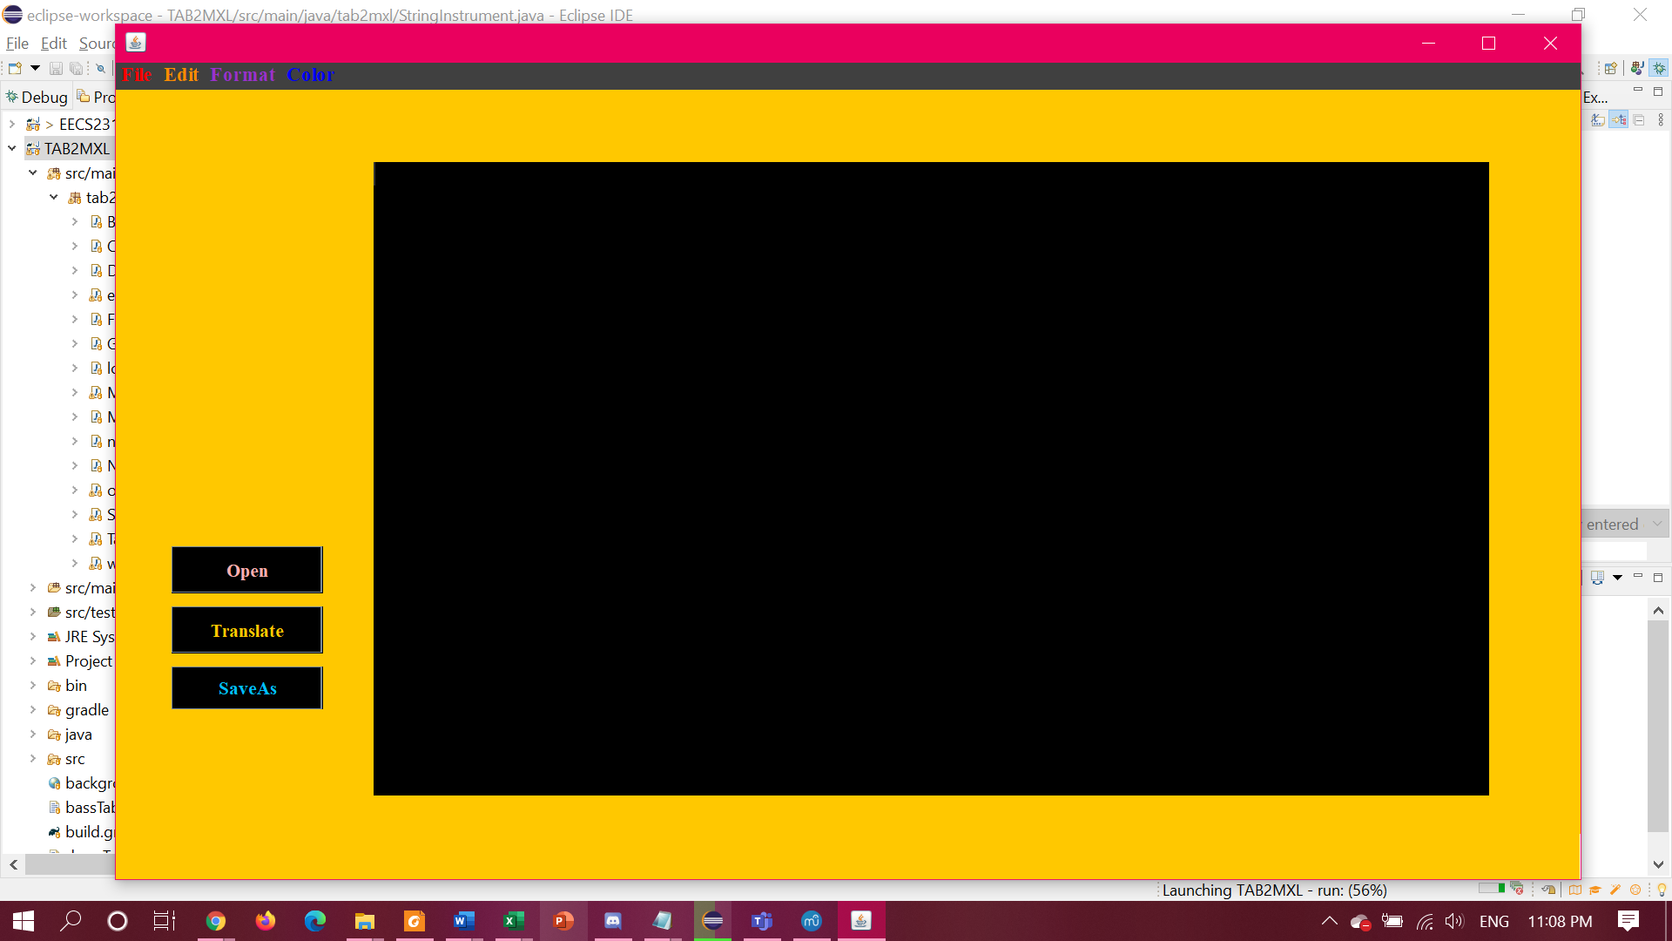

**Figure 3.** The pop-up window after running the Music XML Converter program.

1. The window has a bar at the top of the window containing *File*, *Edit*, *Format* and *Color* drop down menus.
   1. If you click on *File*, you are presented with these options:
      1. *New*, *Open*, *Save*, *Save As*, and *Exit*
      2. Clicking on *New* provides a new blank page.
      3. Clicking on *Open* will open up a File Explorer window. You can search for and select the text file that you want to convert to MusicXML format.
         1. Once the file is selected, the Music XML Converter program will open that file, and you will be able to see the contents of the text file in the white box area in the window (refer to **Figure 5**).
         2. You can also copy and paste the tablature in the blank window
      4. Clicking on *Save/Save As* will save the converted file.
      5. *Exit* would quit the application.
   2. *Format*, offers the following:
      1. *Word Wrap*, *Font*, and *Font Size*
         1. *Font* list provides options to change the font of the text in the white text box.
         2. *Font Size* list to choose the size of the text size.
2. On the left side of the window, there are three buttons.
   1. The first one is *Open*. Clicking on it will open up a File Explorer window, to choose a file to be translated (refer to **Figure 4**).
      1. Make sure that the text file is a bass or guitar tablature.

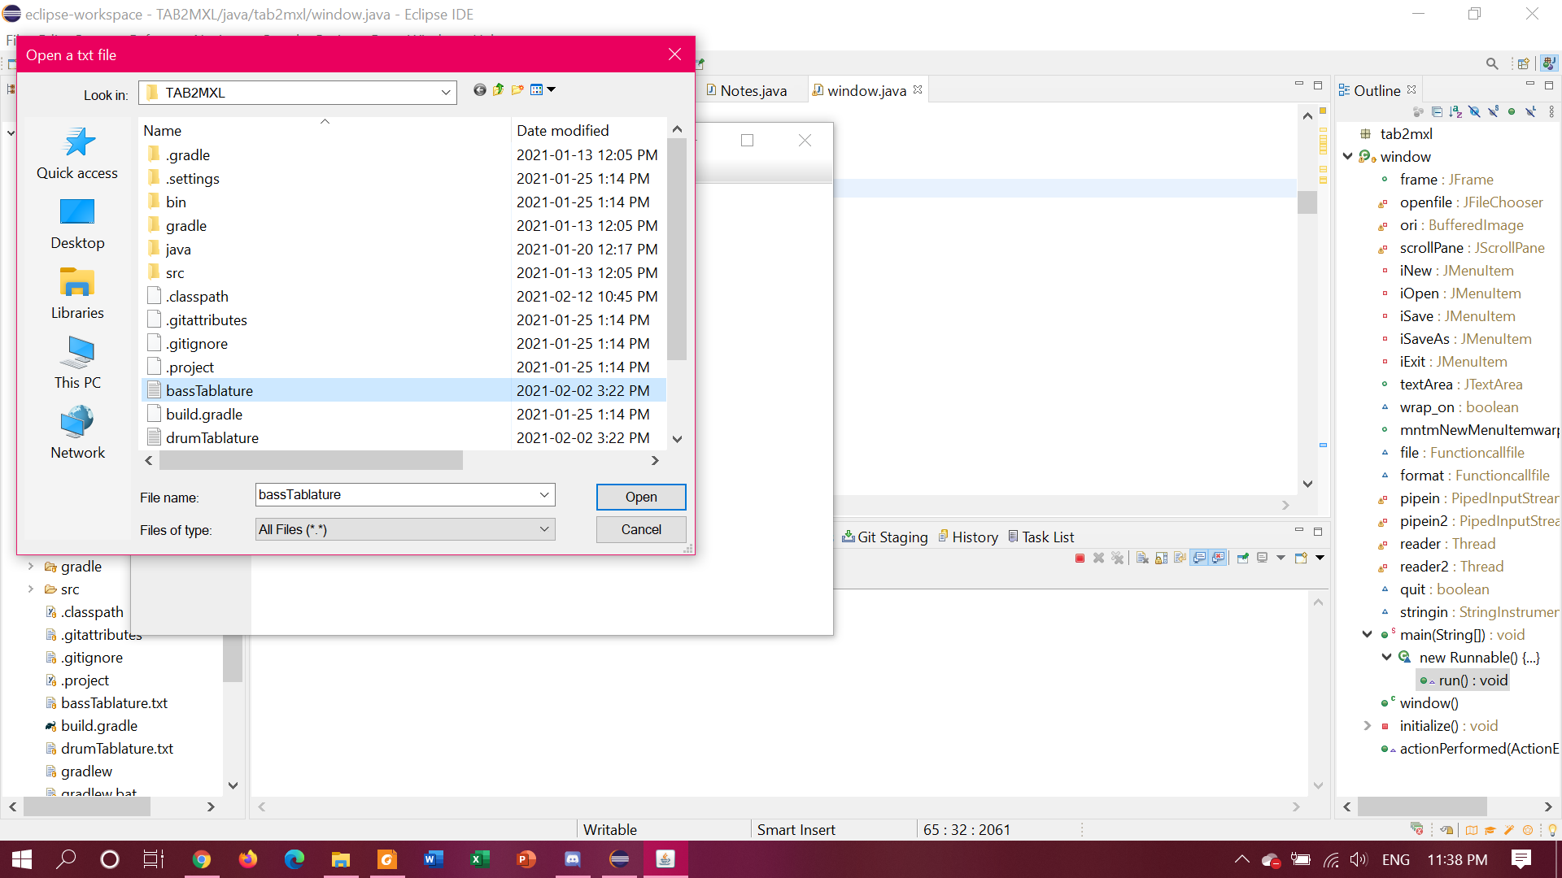

**Figure 4**. The File Explorer window.

* 1. Once the file is selected, the program will display the contents of the text file in the white box area in the window
  2. A bass tablature is selected for this example, the result should be similar to the content shown in **Figure 5**.
     1. **Note:** As of now, the program can translate bass and guitar tablatures. Future updates will enhance the Music XML Converter to translate drum tablature as well.

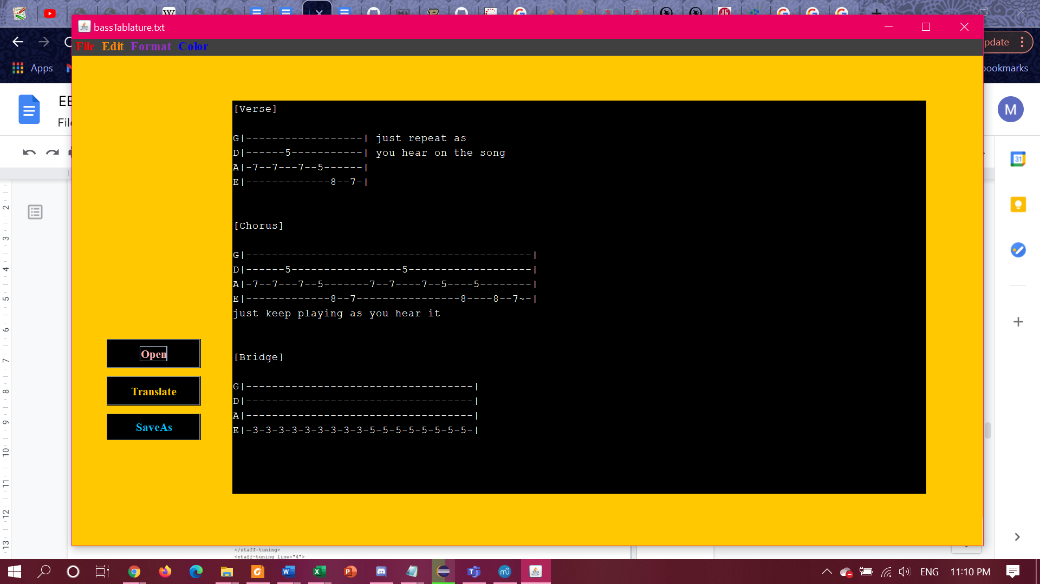

**Figure 5.** The contents of the bass tablature text file selected to be converted to .xml file.

1. To convert the selected file to .xml file, click on *Translate*. Then the translation is displayed in the white space.

(Refer to **Figure 6**).

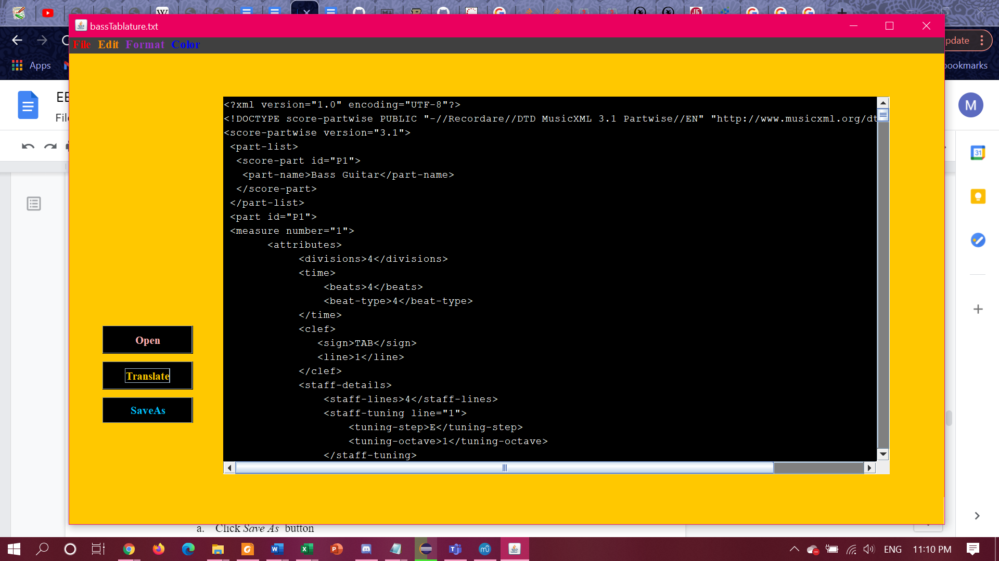

**Figure 6.**  The result after clicking *translate* in the Music XML Converter program.

1. Now, to save your translation:
   1. Click *Save As*  button
   2. Name your file and click *Save*

Now that you are familiar with these steps, you are now ready to use the Music XML Converter!

Once you have your xml file, you can upload it into a music software application like MuseScore.

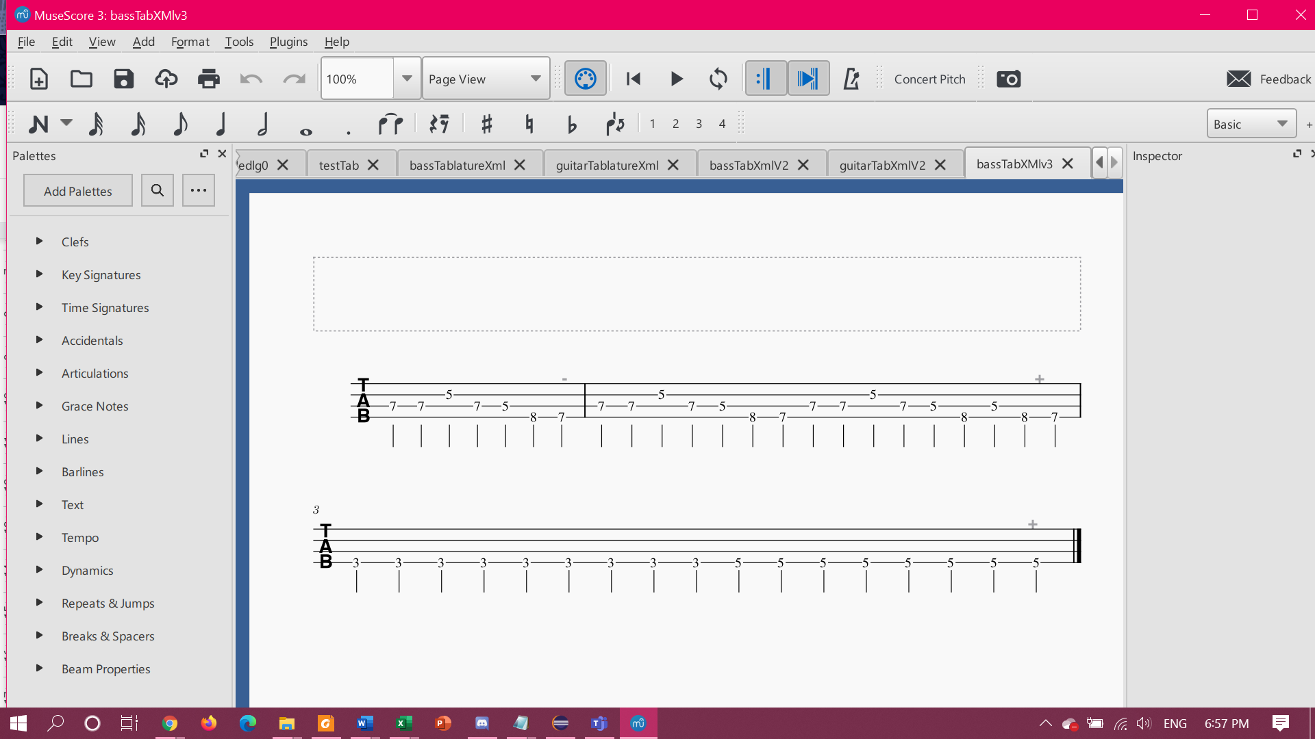

**Figure 7.** This is the music notation in MuseScore from BassTablature.txt.

# **3.0 Safety Warnings**

The following safety statements provide the caution information you need to know, before installing and/or using the product:

* Download the Music XML Converter from the official github repository, and verify the checksum.
* Ensure to have the correct URL from github.
* Security warning on opening/loading files using the Music XML Converter:
  + Do not use files obtained from websites that you do not trust as it may contain viruses.

# **4.0 Troubleshooting**

* In the case of any occurring problem with the system, please refer to this section
* The program will display an error message, if the input is not compatible with the program features.

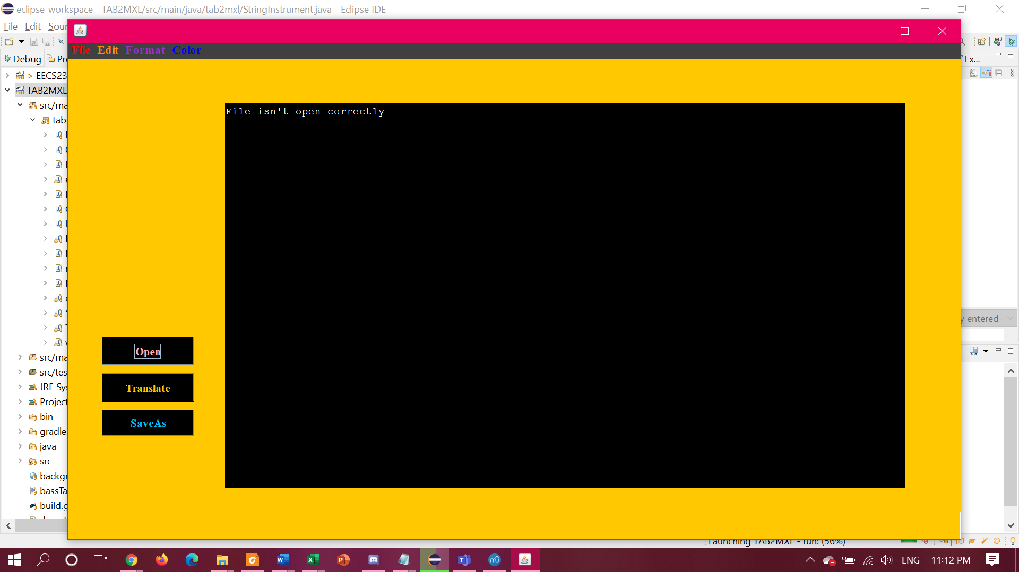

**Figure 8.** This is the error message appears if no text file is selected after clicking *Open*.

## **4.1 How to Deal with Occuring Problems**

* An “Empty text area” error message appears when the *Translate* button is selected, without selecting a text file for translation.
  + To fix this problem, click on *Open* to choose a .txt file and then click *Translate*.
* You receive an exception message after choosing a drum tablature, as shown in **Figure 9**.
  + To avoid this problem, ensure the tablature selected is either bass or guitar.

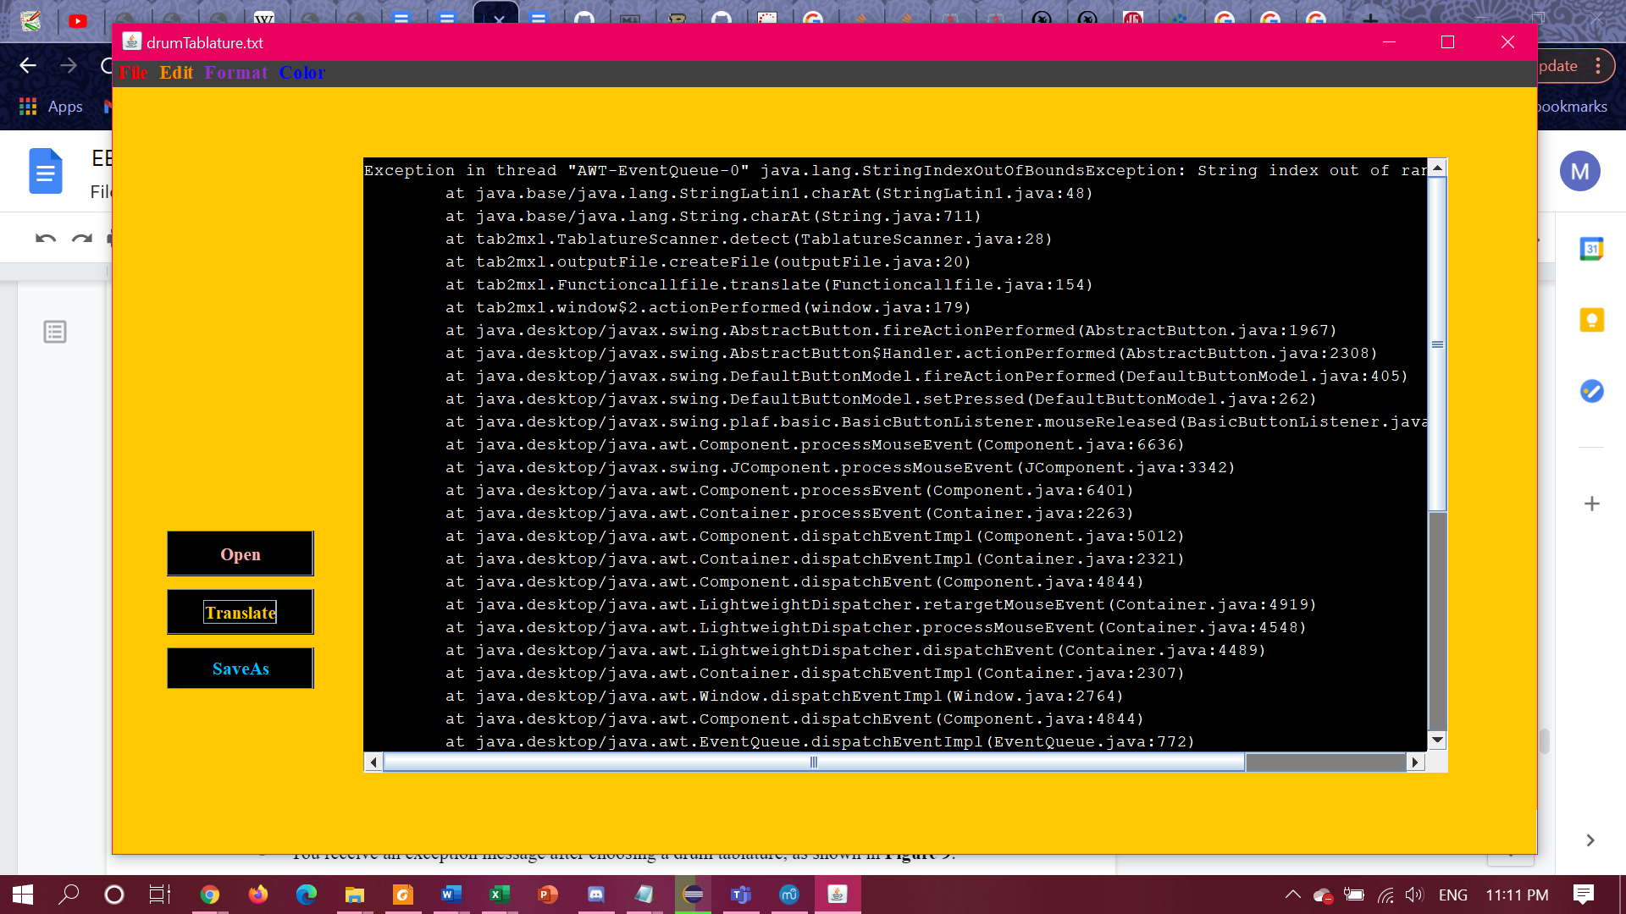

**Figure 9.** An exception message after translating a drum tab.

# **6.0 Maintenance information**

For software maintenance purposes, the user will be prompted to download software updates for the Music XML Converter program. This is solely to correct faults, fix defects, and to improve performance or other attributes.

* The product is currently in its prototype stage. Expect future updates that will enhance the Music XML Converter so that it can successfully translate drum tablatures.
* Also, expect future updates that will improve the MusicXML output.

# **7.0 Repair information**

If the Music XML Converter program is not working properly, even after troubleshooting, please delete it, redownload it, verify md5 checksum, and run it again.

# **8.0 Technical specifications**

* Currently, the Music XML Converter only accepts .txt files containing tablature for guitar and bass.
  + Note: Future updates will enhance the Music XML converter so that it can successfully translate drum tablatures.
  + Do not select/load other types of text files.
  + Do not select/load files that are not text files.

# **9.0 Glossary**

**Eclipse** - is an integrated development environment (IDE) used in computer programming.

**MuseScore** - a free music composition and notation software.

**MusicXML** - a free file format developed by the music research community that can be used to precisely denote a piece of music.

**TAB2MXL** - is the Java filename for the Music XML Converter program. It is designed to convert musical text tablatures to MusicXML files.

# **10.0 Contact Details**

Feel free to reach us on [xmlconvertor@gmail.com](mailto:xmlconvertor@gmail.com) if you have any further questions. We hope that you enjoy our product!

# **11.0 References**

[1] Kichline, “User Manual” <http://onsongapp.com/docs/interface/menubar/utilities-menu/getting-started/manual/> (accessed February 13, 2021)