PROJECT PROPOSAL
HallMenu RU

A Real-Time Hall Dining & Canteen Information System
University of Rajshahi, Bangladesh
Platform | React Native (Expo) — Android & iOS
Backend / Database | Google Firebase + Cloud Firestore
Authentication | Firebase Authentication (Email/Password)
Version | 1.0 (Initial Release)
App Category | Mobile Application — Hall Management
Total Halls | 17 Halls (11 Boys + 6 Girls)
Moderator Accounts | 34 (2 per hall: Dining + Canteen)
Target Institution | University of Rajshahi, Bangladesh

1. Title
App Name: HallMenu RU
HallMenu RU is a cross-platform mobile application built to provide real-time dining and canteen information for residential hall students of Rajshahi University (RU). Through this app, students can instantly check daily meal menus, food availability status, special feast schedules, and important notices — all from their smartphones, without needing to physically visit the dining hall.

2. Introduction / Background
Rajshahi University is one of the largest public universities in Bangladesh, with thousands of residential students across 17 halls — 11 boys' halls and 6 girls' halls. Each hall operates its own dining facility and canteen, collectively serving hundreds of students every single day.

Despite the scale and daily importance of this system, all communication regarding meal availability and menu information remains entirely manual and informal. Notices are physically pinned on boards, announcements are made verbally, and information spreads through personal messaging channels. This creates a fragmented, unreliable system where students frequently walk to the dining hall only to discover that a meal is unavailable, delayed, or already finished.

There exists no digital platform that unifies hall dining information across all RU halls. HallMenu RU addresses this critical gap by providing a centralized, real-time information system for both students and authorized hall moderators.

3. Problem Statement
Students of Rajshahi University face the following critical challenges in their daily dining experience:

- No centralized digital platform exists to view daily dining or canteen menus across RU halls.
- Students waste time walking to the dining hall without knowing whether food is available, finished, or delayed.
- Moderators have no efficient digital tool to update or broadcast menu changes in real time.
- Special feast schedules, prices, and menus are shared manually, leading to poor student awareness.
- Important notices (food shortages, delays, closures) reach students too late, if at all.
- No accountability mechanism exists to confirm that daily menu updates have actually been made.
- Student food feedback has no formal digital channel, leaving quality issues unaddressed.

In summary: "Students face significant difficulty in accessing real-time hall dining and canteen information, resulting in unnecessary inconvenience, wasted time, and poor daily meal planning."

4. Objectives
The primary objectives of HallMenu RU are:

- Provide a real-time digital platform for students to check dining and canteen menus across all 17 RU halls.
- Enable authorized moderators to update meal status, item availability, and food counts instantly from their smartphones.
- Automate the daily menu management process using Duplicate Yesterday and quick status reset features.
- Reduce student inconvenience by allowing informed decisions before visiting the dining hall.
- Digitize the feast scheduling and notice posting system to maximize student awareness.
- Introduce an update verification and history tracking system to ensure moderator accountability.
- Provide a student food review channel for meal quality feedback.
- Deliver a scalable, maintainable solution using modern cloud-based infrastructure.

5. Features

5.1 Student Features
- Hall List with search and Boys/Girls filter — view all 17 halls with live update status badge.
- Daily Menu Viewer — see today's breakfast, lunch, and dinner with item names, prices, remaining count, and status (Available / Low / Finished).
- Canteen Menu Viewer — view all-day canteen items with real-time stock status.
- Feast Updates — view upcoming and past feast events with full details and countdown.
- Notice Board — view hall notices posted by moderators (delay, shortage, closure, etc.).
- Food Reviews — submit meal ratings and comments (future release).
- Onboarding Screen — guided first-time introduction to the app.
- Splash Screen — branded entry with automatic routing based on first-visit status.

5.2 Moderator Features
- Role-based Login — secure Firebase Authentication for Dining and Canteen Moderators separately.
- Moderator Dashboard — centralized control panel with all management tools for the assigned hall.
- Dining Menu Editor — add/edit full menu with items, price, count, status, time, and notes per meal session.
- Canteen Menu Editor — manage canteen items with price, stock count, and availability status.
- Quick Status Update — rapidly update food availability and stock count item-by-item without re-entering full menu.
- Bulk Action — apply Available/Low/Finished status to all items with a single tap.
- Notice Editor — post hall-specific notices with type, title, message, and expiry duration.
- Feast Editor — schedule special feast events with date, title, time range, menu items, and price.
- Daily Reset — duplicate yesterday's menu as today's starting template, or clear all items for a fresh start.
- Preview Mode — preview how the menu will appear to students before saving.
- Verification Screen — view update status, moderator name, last updated time, and full update history log.

6. Target Users

User Type | Description | Primary Actions
Students | Residential students of all 17 RU halls | View menus, check availability, read notices & feasts
Dining Moderators | Authorized dining hall staff (1 per hall) | Update meal menu, quick status, notices, feast events
Canteen Moderators | Authorized canteen operators (1 per hall) | Manage canteen items, update stock & status, notices
University Admin | Hall administration and management oversight | Monitor via Verification screen and update history logs

7. System Design / Technical Architecture

7.1 System Architecture
HallMenu RU uses a three-layer serverless architecture. The Client Layer contains the React Native app running on students' and moderators' smartphones. The Application Layer is a repository module (repository.js) that centralizes all data access logic. The Backend Layer is Google Firebase, providing authentication and cloud database services with no custom server required.

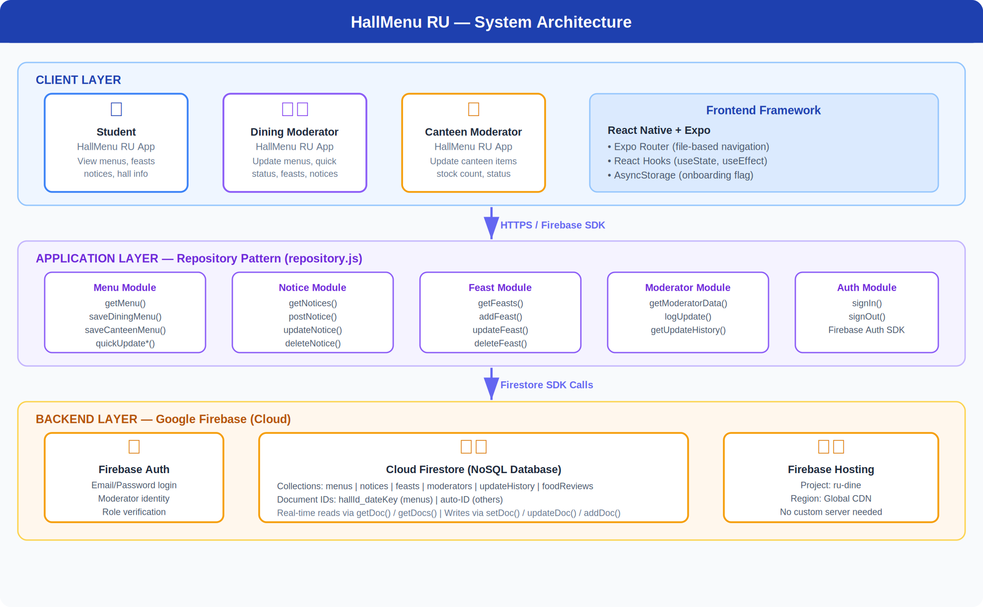
Figure: System Architecture — Three-Layer Design (Client · Repository · Firebase)

7.2 Frontend Stack

Framework | React Native (Expo) — cross-platform for Android and iOS
Navigation | Expo Router — file-based routing with Stack navigation
UI Components | Custom React Native StyleSheet — no external UI library
State Management | React Hooks (useState, useEffect) — local component state
Local Storage | AsyncStorage — onboarding completion flag
Language | JavaScript ES6+

7.3 Backend Stack

Backend Service | Google Firebase — fully managed, serverless cloud platform
Authentication | Firebase Authentication — email/password login for moderators
Database | Cloud Firestore — NoSQL real-time document database
Data Access | Repository pattern (repository.js) — all DB calls centralized
DB Operations | getDoc, setDoc, updateDoc, addDoc, deleteDoc, getDocs, query
Custom Server | None — all logic runs client-side via the Firebase JS SDK

7.4 Database Schema — Entity Relationship Diagram
The following ER diagram shows all 9 Firestore collections used in HallMenu RU and their relationships. Relational links are maintained via hallId, menuId, and mealId foreign key fields within each document.

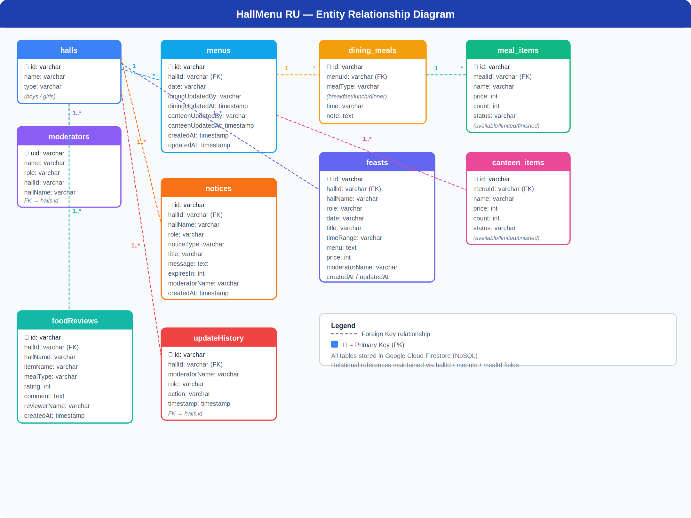
Figure: Entity Relationship Diagram — HallMenu RU Firestore Collections

7.5 Firestore Collections Summary

Collection | Document ID | Key Fields | Purpose
menus | hallId_dateKey | hallId, date, dining, canteen, updatedBy/At | Daily dining meals & canteen items per hall
dining_meals | auto-ID | menuId, mealType, time, note | Breakfast / lunch / dinner session metadata
meal_items | auto-ID | mealId, name, price, count, status | Individual food items within a dining meal
canteen_items | auto-ID | menuId, name, price, count, status | Canteen food items for a given menu day
moderators | Firebase UID | uid, hallId, hallName, name, role | Moderator identity and hall assignment
notices | auto-ID | hallId, role, noticeType, message, expiresIn | Hall notices (dining/canteen moderators)
feasts | auto-ID | hallId, date, title, menu, price, timeRange | Special feast events with full details
foodReviews | auto-ID | hallId, itemName, rating, comment, mealType | Student food reviews (future feature)
updateHistory | auto-ID | hallId, moderatorName, role, action, timestamp | Audit log of all moderator update actions

7.6 User Flow Diagram
The following diagram illustrates how different users navigate through HallMenu RU from app launch to their primary actions. The student flow (green) and moderator flow (purple) diverge at the Home Screen based on role selection.

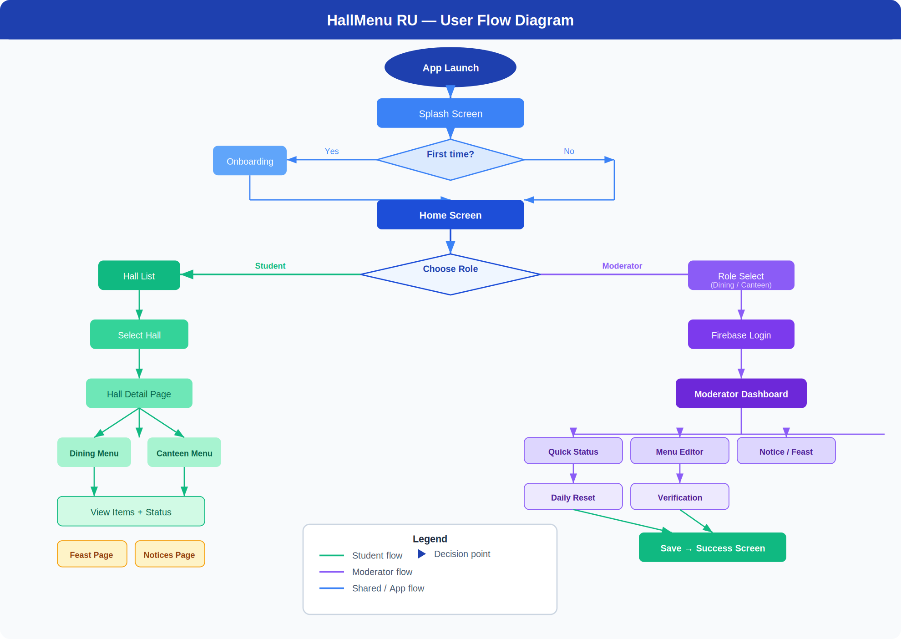
Figure: User Flow Diagram — Student & Moderator Navigation Paths

7.7 Screen Navigation Map
The following diagram maps every screen in the app and shows the navigation connections between them. It distinguishes student-facing screens (green), moderator-facing screens (purple), and shared screens (blue/orange).

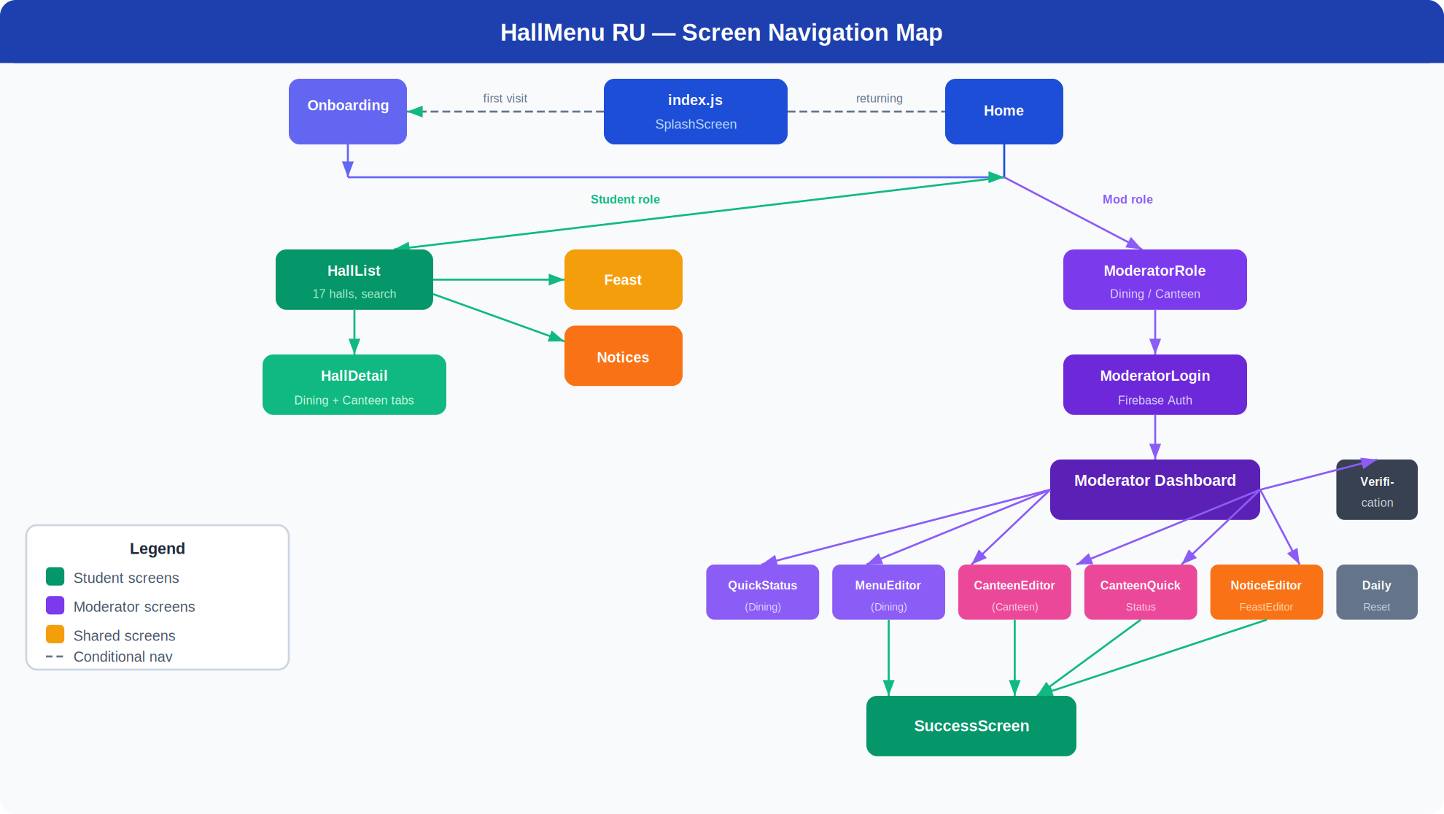
Figure: Screen Navigation Map — Full App Route Structure

7.8 Student Flow Summary

- App launch → Splash Screen checks AsyncStorage for onboarding flag.
- First visit → Onboarding (3-slide intro) → Home Screen.
- Returning visit → Home Screen directly.
- Home → Student role → Hall List (17 halls, search, Boys/Girls filter).
- Hall List also links to Feast Page and Notice Page via quick-links.
- Select hall → Hall Detail → choose Dining or Canteen tab → view items with live status badges.

7.9 Moderator Flow Summary

- Home → Moderator role → Role Select (Dining / Canteen).
- ModeratorLogin → Firebase email/password authentication → getModeratorData() validates UID.
- On success → Moderator Dashboard for the assigned hall.
- From Dashboard: Quick Status, Menu Editor, Canteen Editor, Notice Editor, Feast Editor, Daily Reset, Verification.
- All save actions → SuccessScreen → Back to Dashboard option.

8. Methodology
The project follows an Agile-inspired iterative development methodology with clearly defined phases:

- Phase 1 — Requirement Analysis — Identify problems faced by RU students, gather hall structure data (17 halls, roles), define functional and non-functional requirements.
- Phase 2 — System Design — Design Firestore data models, define screen flows for student and moderator roles, plan the repository layer for all data access operations.
- Phase 3 — UI/UX Design — Design mobile-first screens with React Native StyleSheet; establish consistent design language (color palette, typography, component patterns).
- Phase 4 — Frontend Development — Build all screens using React Native + Expo Router; implement state management with React Hooks; integrate AsyncStorage.
- Phase 5 — Backend Integration — Connect Firebase Authentication for moderator login; implement Firestore CRUD via the repository module; configure Firebase project.
- Phase 6 — Testing — Unit test repository functions; manually test all user flows; test edge cases (empty menus, network errors, invalid logins); security rule validation.
- Phase 7 — Deployment — Build production APK via Expo EAS Build; configure for Play Store; seed 34 moderator accounts using the admin seeding script.

9. Tools & Technologies

Category | Tool / Technology | Purpose
Mobile Framework | React Native (Expo) | Cross-platform app development for Android & iOS
Navigation | Expo Router | File-based screen routing and stack navigation
Language | JavaScript ES6+ | Primary development language
Authentication | Firebase Authentication | Secure email/password login for moderators
Database | Cloud Firestore (Firebase) | Real-time NoSQL cloud database
Local Storage | AsyncStorage | Onboarding state persistence on device
Code Editor | Visual Studio Code | Primary development environment
Version Control | GitHub | Source code management and collaboration
API Testing | Postman | Firebase rule and endpoint validation
Build Service | Expo EAS Build | Cloud-based APK/IPA generation
Admin Scripting | Node.js + Firebase Admin SDK | Bulk moderator account seeding script
Design Reference | Figma | UI wireframe and screen layout planning

10. Timeline / Work Plan

Phase | Duration | Key Tasks & Deliverables
Phase 1 — Planning | Week 1 | Requirement gathering, hall data collection, Firestore schema planning, architecture design
Phase 2 — Setup | Week 2 | UI wireframing, React Native project init, Expo Router config, Firebase project setup
Phase 3 — Student UI | Week 3–4 | Splash, Onboarding, Home, Hall List, Hall Detail, Feast, Notices screens
Phase 4 — Moderator UI | Week 5–6 | Login, Dashboard, Menu Editor, Canteen Editor, Quick Status, Notice/Feast, Daily Reset
Phase 5 — Integration | Week 7 | Firebase Auth, Firestore CRUD, repository module, Verification screen, reset logic
Phase 6 — Testing | Week 8 | User flow testing, edge cases, Firebase security rules, bug fixes, performance review
Phase 7 — Deployment | Week 9 | Moderator seeding script, Expo EAS APK build, Play Store submission, documentation

11. Expected Outcome
Upon successful completion and deployment of HallMenu RU, the following outcomes are expected:

- Students across all 17 RU halls will have instant access to today's dining and canteen menus from their smartphones.
- Moderators will be able to update meal information in under 60 seconds using the Quick Status feature, replacing the manual notice-board system.
- Special feast events will be visible to all students with full details: date, menu, price, and countdown timer.
- Hall notices will reach students immediately upon posting, eliminating information delays.
- The Verification screen will provide administrators with a transparent audit trail of all moderator updates.
- 34 moderator accounts (2 per hall) will be active across all 17 halls, seeded via the automated admin script.
- The app will be available on Android via the Google Play Store, built through Expo EAS Build.

12. Future Scope
The following enhancements are planned for future versions of HallMenu RU:

- Push Notifications — real-time alerts when menu status changes or new notices are posted, using Firebase Cloud Messaging (FCM).
- Food Review System — students rate and comment on individual meal items (foodReviews collection already defined in the schema).
- AI-Powered Menu Suggestions — use historical dining data to suggest meal planning patterns for moderators.
- Nutritional Information — display calorie counts and nutritional details for each dining item.
- Multi-University Expansion — extend the platform to other public universities in Bangladesh (BUET, DU, CUET, etc.).
- Admin Web Dashboard — a web-based management console for university administration to oversee all halls.
- Student Accounts — personal accounts with bookmarked halls and personalized notifications.
- Offline Mode — cache the last-known menu locally for access without internet connectivity.
- Analytics Dashboard — usage statistics, popular meals, and moderator update frequency reports.
- iOS Release — expand from Android to iOS via Expo EAS Build for the Apple App Store.

13. Conclusion
HallMenu RU addresses a real and pressing daily problem faced by thousands of students at Rajshahi University. By replacing the outdated, manual dining information system with a modern, real-time mobile application, the project delivers immediate and measurable improvements to student life on campus.

The app is built on industry-standard technologies — React Native, Expo, and Google Firebase — ensuring reliability, scalability, and ease of future maintenance. Its dual-role architecture (student viewer + moderator editor) with Firebase Authentication ensures that only authorized personnel can modify information, while all students benefit from transparent, real-time data access.

With support for all 17 RU halls, 34 moderator accounts, a comprehensive feature set covering menus, canteen management, feasts, notices, daily reset, and verification — and a clear roadmap for push notifications, food reviews, and AI features — HallMenu RU is positioned to become the definitive digital dining companion for the Rajshahi University community.

— End of Proposal — HallMenu RU | University of Rajshahi | 2025

