

Lab Assignment 3

Course: Higher Level Programming Language Lab
Course Code: CSEL-3204

Submitted To
Dr. MD. Manowarul Islam
Professor
Department of CSE
Jagannath University

Submitted By
Maisha Binte Monir
ID: B210305016
Session: 2021-22 (CSE-13)

Task 1: Line Plot
Create a line chart showing monthly sales. Add title, labels, grid, markers, and explain the sales trend. Sample example
months = ["Jan", "Feb", "Mar", "Apr", "May", "Jun"]
sales = [120, 150, 170, 160, 200, 220]
import matplotlib.pyplot as plt

months = ["Jan", "Feb", "Mar", "Apr", "May", "Jun", "Jul", "Aug"]
sales = [120, 135, 150, 145, 170, 190, 200, 180]

plt.plot(months, sales, marker='o')
plt.title("Monthly Sales Analysis")
plt.xlabel("Months")
plt.ylabel("Sales")
plt.grid(True)
plt.show()
Output: 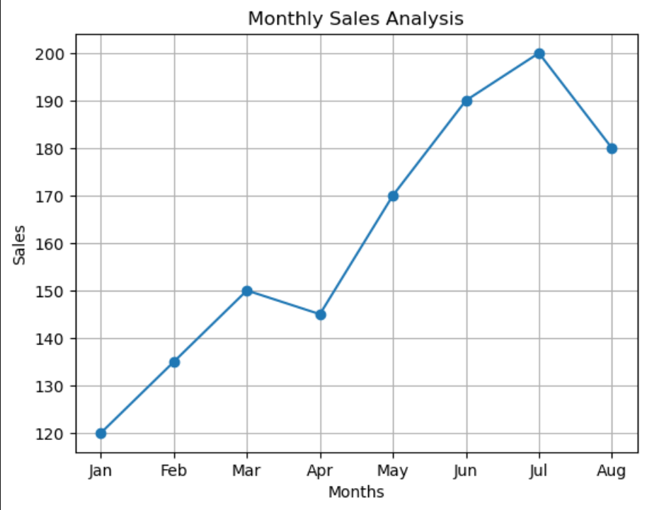
From the dataset: Jan -> Mar: steady increase (120 -> 150)
Apr: slight dip (150 -> 145), possible seasonal fluctuation or demand slowdown
May -> Jul: strong growth (145 -> 190), indicating recovery and expansion
Jul -> Aug: Sharp decline (200 -> 180), indicating dramatic sales decrease
Overall: General upward growth trend Minor temporary decline in April Strong positive momentum in later months Sharp decline in August

Task 2: Multiple Line Plot
Compare two students' performances across subjects using different line styles and a legend. Interpret the results.
subjects = ["Math", "Physics", "Chemistry", "Biology", "English", "ICT"]
student_A = [85, 78, 90, 88, 76, 92]
student_B = [80, 82, 87, 85, 79, 89]
Requirements:
• Use different line styles and markers.
• Add a legend.
• Add a suitable title.
import numpy as np
subjects = ["Math", "Physics", "CSE", "English", "History"]

student1 = [78, 85, 90, 87, 78]
student2 = [65, 70, 72, 77, 78]
x = np.arange(len(subjects))
width = 0.35

plt.plot(x - width/2, student1, linestyle='-', marker='o', label="Student 1")
plt.plot(x - width/2, student2, linestyle='--', marker='s', label="Student 2")

plt.title("Performance Comparison of Two Students")
plt.xlabel("Subjects")
plt.ylabel("Marks")
plt.xticks(x,subjects)
plt.legend()
plt.show()

Output: 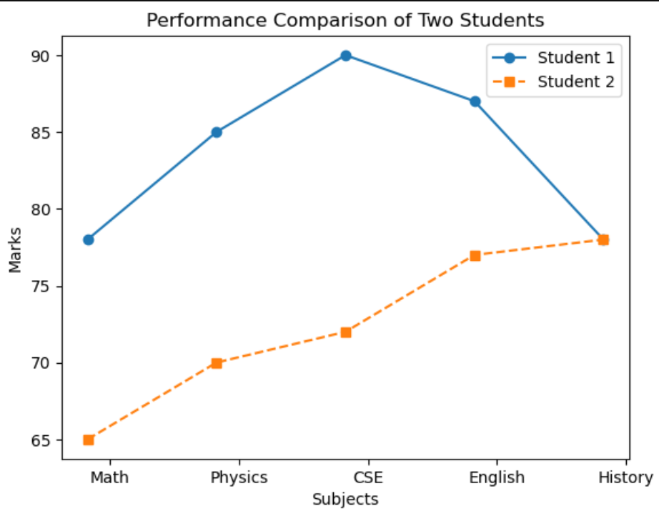
Student 1 consistently outperforms Student 2 in all subjects. The largest gap appears in CSE (90 vs 72), indicating stronger computing skills. Student 2 shows moderate but consistent performance. Overall, student 1 performs better than student 2.

Task 3: Bar Chart
Visualize student enrollment in departments. Display values above bars and discuss which department has the highest enrollment.
departments = ["CSE", "EEE", "BBA", "Civil", "English"]
students = [250, 180, 300, 120, 150]
Requirements:
• Add different colors.
• Display values on top of each bar.
departments = ["CSE", "EEE", "ME", "Civil", "IPE"]
students = [200, 180, 300, 160, 150]

colors = ["blue", "green", "orange", "red", "purple"]
bars = plt.bar(departments, students, color=colors)

for bar in bars:
height = bar.get_height()
plt.text(bar.get_x() + bar.get_width()/2, height, str(height), ha='center', va='bottom')

plt.title("Student Enrollment by Department")
plt.xlabel("Departments")
plt.ylabel("Number of Students")
plt.show()
Output: 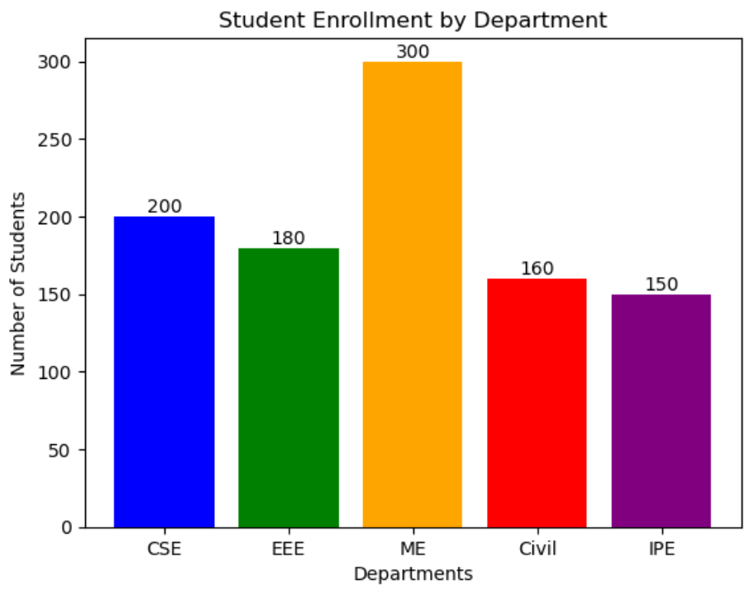
As we can see, ME has the highest enrolment.

Task 4: Histogram
Plot marks distribution. Choose appropriate bins and explain whether the data is symmetric, skewed, or clustered.
marks = [65, 70, 75, 80, 85, 90, 72, 68, 95, 88,
77, 83, 91, 73, 69, 81, 86, 92, 78, 74]
Requirements:
• Use appropriate bins.
• Add title and axis labels.
• Explain the distribution of marks.

marks = [42, 55, 60, 67, 71, 73, 75, 78, 80, 82,
84, 85, 87, 89, 90, 92, 94, 96, 98, 100]

plt.hist(marks, bins=7, color= "green", edgecolor="red")
plt.title("Distribution of Student Marks")
plt.xlabel("Marks")
plt.ylabel("Number of Students")
plt.show()
Output: 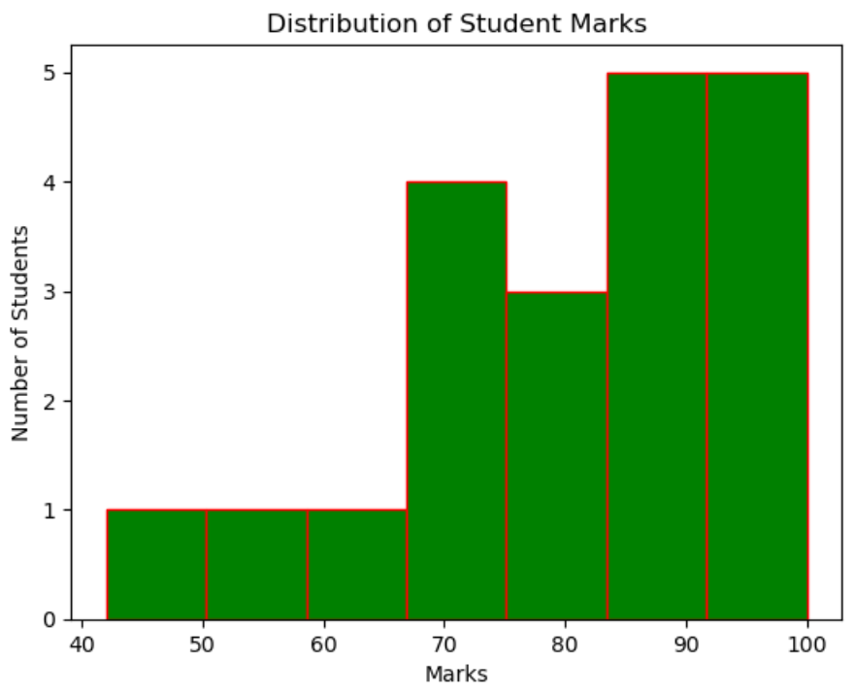
The distribution is slightly left-skewed (negatively skewed) because most students scored high marks while a few students scored much lower. The data is clustered in the higher mark ranges, indicating generally good academic performance.

Task 5: Pie Chart
Show daily activity distribution. Display percentages and highlight the largest segment.
activities = ["Study", "Sleep", "Exercise", "Entertainment", "Others"]
hours = [6, 8, 1, 4, 5]
Requirements:
• Display percentages.
• Highlight the largest segment.
• Add a title.
activities = ["Study", "Sleep", "Exercise", "Entertainment", "Others"]
hours = [6, 8, 1, 4, 5]
explode = [0, 0.1, 0, 0, 0]

plt.pie(hours, labels=activities, autopct='%1.1f%%', explode=explode)
plt.title("Daily Activity Distribution")
plt.show()
Output: 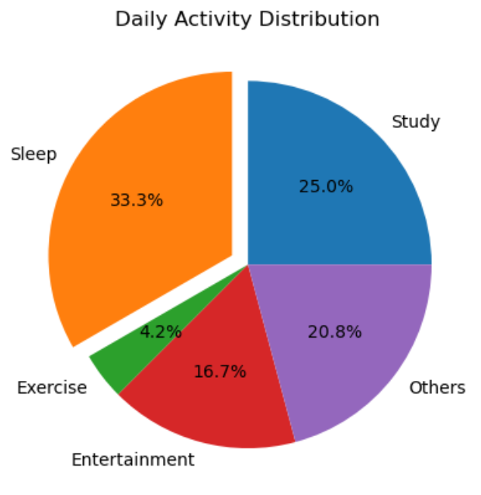

Task 6: Student Performance Dashboard
Task: Create a figure containing four subplots using Matplotlib to visualize different aspects of student performance.
Requirements
Create a dashboard with the following plots:
1. Line Plot: Monthly Attendance
- Display attendance percentage for six months.
- Include title, axis labels, markers, and grid.
2. Bar Chart: Subject-wise Marks
- Display marks obtained in different subjects.
- Include title and axis labels.
- Show marks on top of each bar.
3. Pie Chart: Daily Time Allocation
- Show how a student spends time in different activities.
- Display percentage values.
- Highlight the largest section.
4. Histogram: Exam Score Distribution
- Show the frequency distribution of exam scores.
- Include appropriate bins, title, and axis labels.
Additional Requirements
• Use plt.subplots(2, 2) to create the dashboard.
• Set a suitable figure size.
• Add titles to all subplots.
• Use plt.tight_layout() to avoid overlapping elements.
• Save the dashboard as student_dashboard.png.
• Include comments in your code.
# Monthly Attendance
months = ["Jul", "Aug", "Sep", "Oct", "Nov", "Dec"]
attendance = [78, 82, 85, 88, 91, 93]

# Subject-wise Marks
subjects = ["CSE", "Math", "Statistics", "DBMS", "English"]
marks = [92, 85, 78, 88, 81]

# Daily Activities (Hours)
activities = ["Classes", "Sleep", "Coding", "Social Media", "Others"]
hours = [5, 7, 4, 2, 6]

# Exam Scores
scores = [52, 58, 61, 65, 67, 69, 72, 74, 76, 78,
81, 83, 85, 87, 89, 91, 93, 95, 97, 99]
fig, ax = plt.subplots(2, 2, figsize=(12, 8))
# Line Plot: Monthly Attendance
ax[0, 0].plot(months, attendance, marker='o')
ax[0, 0].set_title("Monthly Attendance")
ax[0, 0].set_xlabel("Month")
ax[0, 0].set_ylabel("Attendance (%)")
ax[0, 0].grid(True)

# Bar Chart: Subject-wise Marks
bars = ax[0, 1].bar(subjects, marks, color='orange')
ax[0, 1].set_title("Subject-wise Marks")
ax[0, 1].set_xlabel("Subjects")
ax[0, 1].set_ylabel("Marks")

for bar in bars:
ax[0, 1].text(bar.get_x() + bar.get_width()/2, bar.get_height(), str(bar.get_height()), ha='center')

# Pie Chart: Daily Time Allocation
explode = [0, 0.1, 0, 0, 0]
ax[1, 0].pie(hours, labels=activities, autopct='%1.1f%%', explode=explode)
ax[1, 0].set_title("Daily Time Allocation")

# Histogram: Exam Score Distribution
ax[1, 1].hist(scores, bins=7, color="violet", edgecolor="blue")
ax[1, 1].set_title("Exam Score Distribution")
ax[1, 1].set_xlabel("Score")
ax[1, 1].set_ylabel("Frequency")

plt.tight_layout()
plt.savefig("student_dashboard.png")
plt.show()
Output: 