PENETRATION TESTING REPORT

FOOTPRINTING & NETWORK SCANNING PHASES

W2-PM-FINAL | CYBERSECURITY | NETWORKWALKS
Report date: 20 September 2026

Prepared from the supplied practical evidence and aligned to the W2-PM-FINAL sample report arrangement.

Pentester Name (Cybersecurity Professional) | Abdullahi Salisu lawan
Program/Batch | B083-Networkwalks
Date | 20 September 2026
Modules completed | W2-PM1 (Multiple Kali Tools)  W2-PM4 (theHarvester based Footprinting attacks ) W2-PM5 (Zenmap Scanning)
Client/Target | - Networkwalks (secured written permission already)  - My own local LAN Network
Permission secured from client? | Yes
Phases covered | Phase 1: Reconnaissance & Footprinting  Phase 2: Footprinting & OSINT(theHarvester)  Phase 3: Scanning & Network Discovery

Liability, Scope & Authorization Note
This report documents educational reconnaissance, OSINT and network-discovery activities. No exploitation, brute-force authentication, privilege escalation, denial-of-service, or modification/deletion of data was performed in the supplied evidence.
Security testing must only be conducted against systems that are owned/controlled by the tester or covered by current written authorization. The sample authorization letter supplied with the course materials is dated 17–24 August 2026 and names another tester; it is therefore not treated as current authorization for this report. Authorization status for the external target activities was not independently verified here.
The report deliberately treats the captured outputs as observations rather than confirmed vulnerabilities. A discovered version, IP address, DNS record, WAF or live host does not by itself prove a security weakness.

Introduction
Week 2 focused on the information-gathering and network-discovery stages of a penetration-testing workflow. The practical work covered six Kali reconnaissance tools, theHarvester for OSINT collection, and Zenmap/Nmap for discovering live hosts on a local subnet.
The objective was to understand what information can be collected from public domain infrastructure and what can be observed inside a controlled local network. The work also emphasized recording commands, outputs and screenshots so that findings can be reproduced and professionally reported.

Objectives
- Collect publicly available domain-registration and DNS information.
- Fingerprint web technologies and HTTP response characteristics.
- Identify whether a Web Application Firewall is visible from reconnaissance.
- Use theHarvester to collect OSINT relating to a domain from available public sources.
- Discover live hosts on the tester's local subnet using a non-port-scanning ping scan.
- Record evidence and translate technical observations into risk-aware recommendations.

Tools Used
Tool | Purpose
Kali Linux | Reconnaissance and OSINT environment
WHOIS | Domain registration, registrar and name-server information
WhatWeb | Web-server, CMS, framework and plugin fingerprinting
Nslookup | DNS resolution of domain names to IP addresses
curl -I | HTTP response-header inspection
WAFW00F | Web Application Firewall fingerprinting
DNSRecon | DNS record and service enumeration
theHarvester | Public-source OSINT collection
Zenmap / Nmap | Local subnet host discovery and topology visualization

Activities Performed

Footprinting & Reconnaissance — W2-PM1
I performed the six reconnaissance exercises documented in the supplied evidence against networkwalks.com: WHOIS, WhatWeb, Nslookup, curl, WAFW00F and DNSRecon.

Task | Command | Observed Result | Interpretation
1. WHOIS | whois networkwalks.com | GoDaddy registrar; 2019  creation; 2027 expiry; HostGator name servers; DNSSEC unsigned; privacy-protected registrant. | Provides public registration and DNS-infrastructure context.
2. WhatWeb | whatweb networkwalks.com | Apache; WordPress 7.1.1; WP Download Manager 3.3.58;  jQuery 3.7.1; Bootstrap 7.1.1;  IP 192.232.216.135. | Exposes technology fingerprints useful for defensive patch and configuration review.

3. Nslookup | nslookup networkwalks.com | networkwalks.com → 192.232.216.135. | Confirms the publicly resolvable address for the web service.
4. curl | curl -I https://networkwalks.com | HTTP/2 200; Apache; WordPress-related headers;  /wp-json/ link; cache and cookie headers. | Shows information disclosed in HTTP responses.
5. WAFW00F | wafw00f networkwalks.com | ModSecurity (SpiderLabs) WAF detected; 2 requests reported. | Identifies a visible defensive control; not a vulnerability.
6. DNSRecon | dnsrecon -d networkwalks.com | SOA, NS, MX, A, TXT/SPF  and SRV records; BIND 9.16.23-RH reported; 8 SRV records. | Maps publicly observable DNS and service infrastructure.

Key W2-PM1 observations:
    - The domain is registered through GoDaddy and uses HostGator-related name servers in the captured WHOIS data.
    - The web stack exposes Apache and WordPress-related technology fingerprints.
    - The web service resolves to 192.232.216.135 in the captured run.
    - HTTP headers expose a WordPress REST API link and other implementation details.
    - WAFW00F identified ModSecurity (SpiderLabs).
    - DNSRecon returned multiple infrastructure records, including mail and service-discovery records.

Footprinting & OSINT — W2-PM4
TheHarvester 4.11.1 was used to collect open-source intelligence for microsoft.com. Two searches were captured: a Baidu search with a limit of 1000 and an all-source search with a limit of 50.
theHarvester -d microsoft.com -l 1000 -b baidu
The Baidu run returned 3 email strings, 7 hosts, no IPs and no people in the captured output.
    - Emails found: 3
    - Hosts found: 7
    - IPs found: 0
    - People found: 0
theHarvester -d microsoft.com -l 50 -b all
The all-source run returned 50 IPs, 3 email strings, 9,965 hosts, 6 ASNs and 3 interesting URLs. The output also contained numerous missing-API-key and source-specific errors. This is a limitation of the collection run and means the result should not be interpreted as an exhaustive inventory.
    - 50 IPs were reported, matching the requested result limit.
    - 3 email strings were reported.
    - 9,965 hosts were reported by the tool; many entries are wildcard-style or machine-generated names and require validation.
    - 6 ASNs were reported.
    - 3 interesting URLs were returned; full query-string URLs are not reproduced in this report because they are not required to explain the finding.
    - No LinkedIn users were found in the captured run.
The evidence also shows that many providers required API keys. Examples included Censys, BuiltWith, Hunter, Shodan, VirusTotal and others. Therefore, the observed all-source result represents only the data available to the configured tool at the time of execution.

Network Scanning — W2-PM5
Zenmap was used to perform a ping scan of the local subnet shown in the evidence. The scan was configured as:
nmap -sn 192.168.215.0/24
The scan covered 256 IP addresses and reported two hosts as up.

Host | Status | MAC / Vendor Evidence | Report Treatment
192.168.215.1 | Host is up | EC:5C:68::A6:AC:FD — PC. | Counted as one live host
192.168.215.247 | Host is up | D8:93:D4:51:D3:1E —  Xiaomi Communications | Counted as one live host
The Zenmap topology screen also displayed 192.168.56.1. Because this address is outside the scanned 192.168.215.0/24 subnet, it is treated as a separate local/virtual interface in the topology view and not as one of the two hosts discovered by the stated scan.

Risk Analysis / Impact
The following table describes security-relevant observations from the exercises. Risk levels are used as documentation priorities, not as claims of confirmed vulnerabilities.

# | Risk / Finding | Evidence / Observation | Potential Impact | Level
1 | Web technology information exposed | WhatWeb identified Apache, WordPress  7.1.1 and WP Download Manager 3.3.58. | Technology/version data can support targeted defensive review and vulnerability research. | Medium
2 | Public DNS infrastructure information | DNSRecon exposed NS, MX, A, TXT/SPF  and SRV records. | Helps build an external infrastructure profile. | Medium
3 | HTTP implementation information exposed | curl returned Apache and WordPress-related headers including /wp-json/. | May assist fingerprinting and further enumeration. | Low
4 | WAF technology identifiable | WAFW00F detected ModSecurity (SpiderLabs). | Reveals a defensive component and its fingerprint; presence is not a weakness. | Low
5 | OSINT information exposure | theHarvester returned emails, hosts, IPs and ASNs from public sources. | Public intelligence can contribute to social-engineering and attack-surface mapping risk. | Medium
6 | Multiple live local hosts | Nmap ping scan found two live hosts in 192.168.215.0/24. | Unexpected devices could indicate inventory or access-control issues; the scan itself does not prove a weakness. | Low
Important interpretation: no exploitation or vulnerability validation was performed. Consequently, the observations above should not be presented as confirmed vulnerabilities.

Recommendations
- Review publicly exposed web technology and version information and maintain timely patching.
- Review HTTP response headers and remove unnecessary implementation details where practical.
- Periodically audit DNS, MX, TXT/SPF and SRV records and remove obsolete or unintended entries.
- Maintain and monitor the Web Application Firewall configuration and logging.
- Perform periodic OSINT self-assessments to understand what infrastructure information is publicly discoverable.
- Validate harvested hosts and IP addresses before treating them as confirmed organizational assets.
- Maintain an accurate inventory of devices on the local network and investigate unknown hosts.
- Configure API credentials only for legitimate, authorized OSINT sources when a broader theHarvester assessment is required.
- Preserve raw output and screenshots so that findings can be independently reviewed.
- Keep reconnaissance and scanning within a documented authorization scope.

Limitations
- TheHarvester all-source collection produced numerous missing-API-key warnings, limiting source coverage.
- OSINT results can change over time because search engines, indexes and public data sources change.
- Tool output can include duplicate, wildcard or stale entries; validation is required before treating an item as an asset.
- The Zenmap evidence did not include a separate Windows ipconfig screenshot, so the report records the scanned subnet rather than asserting a specific host IP as the tester's local IP.
- The supplied evidence did not contain execution results for W2-PM2 (GHDB) or W2-PM3 (Maltego); those modules are therefore not represented as completed findings.

Conclusion
The Week 2 practicals demonstrated how reconnaissance, OSINT and network discovery can reveal substantial information without exploitation. WHOIS and DNSRecon exposed registration and DNS context; WhatWeb and curl revealed web-stack and HTTP characteristics; WAFW00F identified a visible defensive layer; theHarvester demonstrated the breadth of public OSINT; and Zenmap/Nmap identified live hosts within the local subnet.
The exercises also reinforced an important professional principle: information exposure is not automatically a vulnerability. Findings must be validated, documented and interpreted in context. All future testing should remain within an explicit and current authorization scope.

Evidence Collected
The following screenshots were extracted from the supplied Word document and inserted as evidence. They reflect the actual captured practical output rather than the example values in the course template.

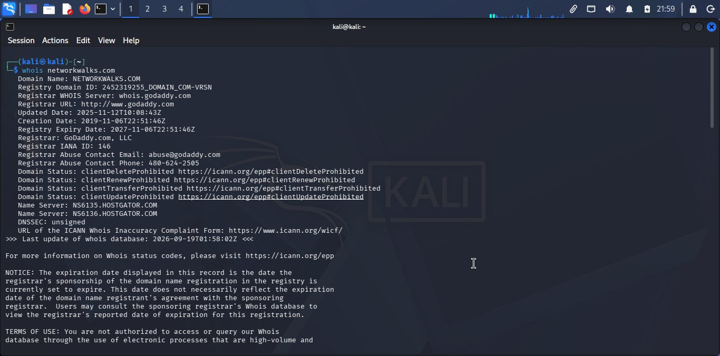
Evidence 1 — WHOIS output for networkwalks.com

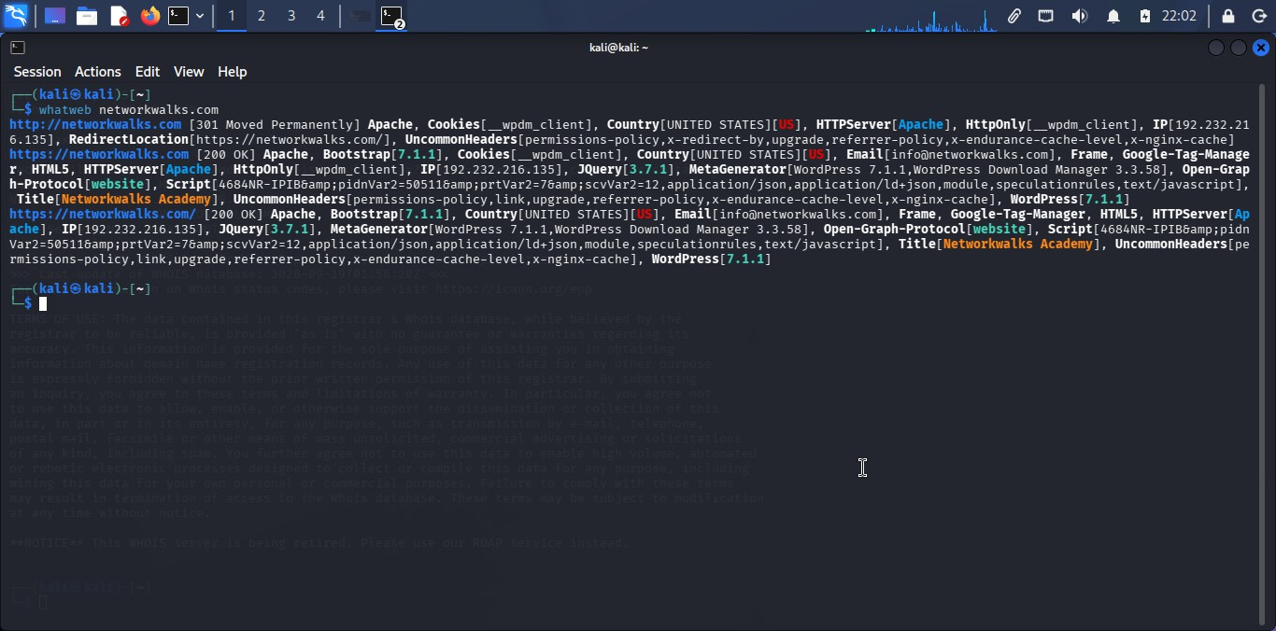
Evidence 2 — WhatWeb web-technology fingerprinting

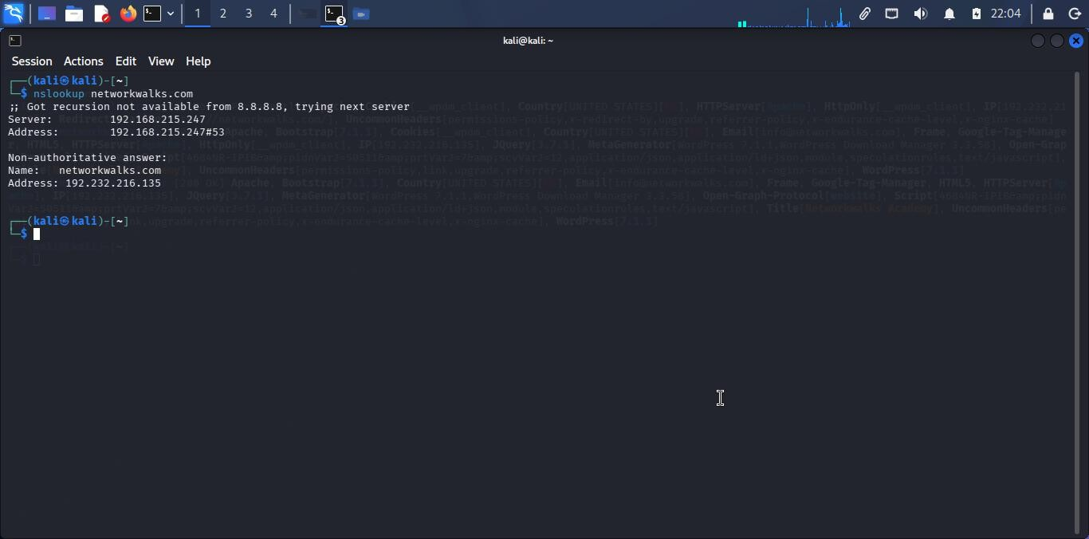
Evidence 3 — Nslookup DNS resolution

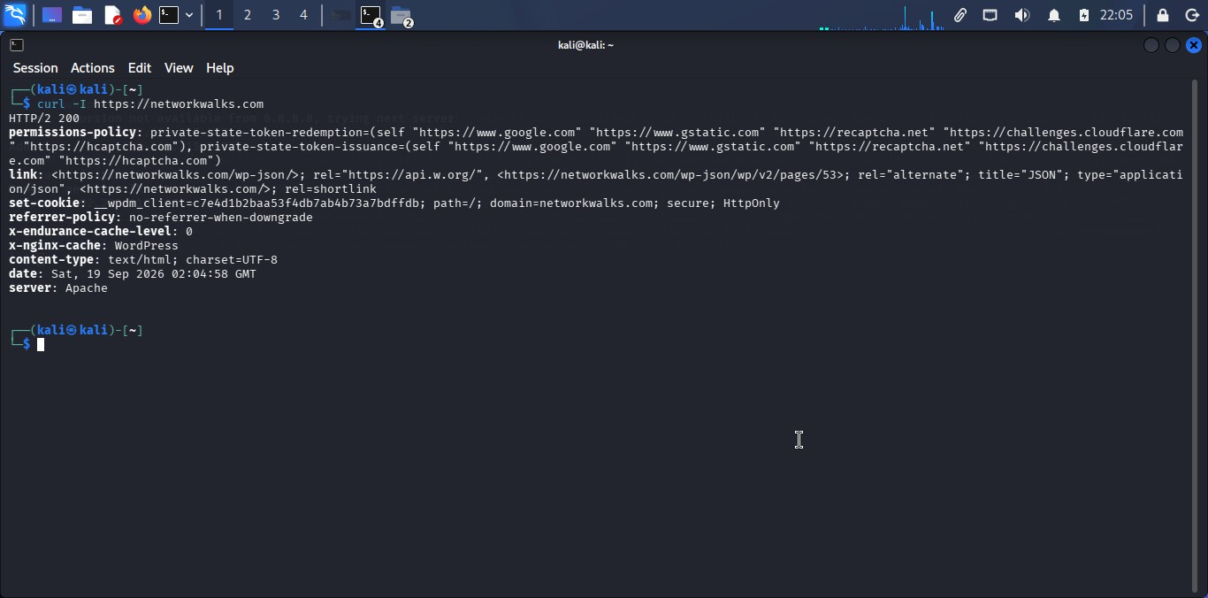
Evidence 4 — curl HTTP response headers

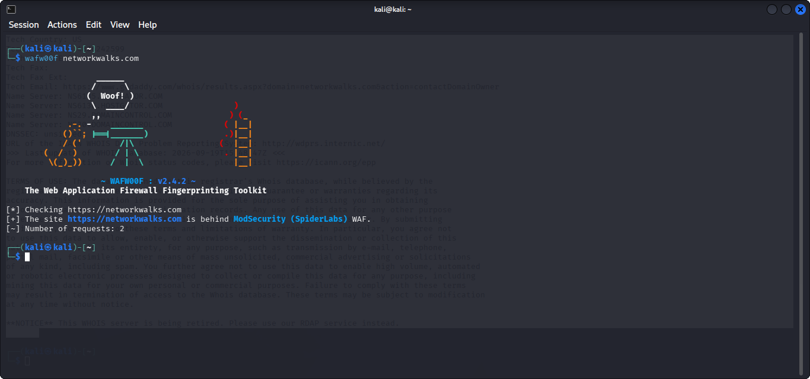
Evidence 5 — WAFW00F ModSecurity detection

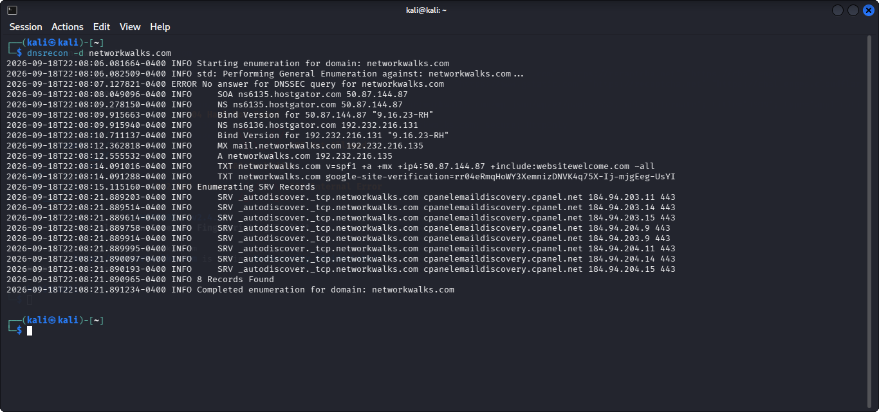
Evidence 6 — DNSRecon DNS enumeration

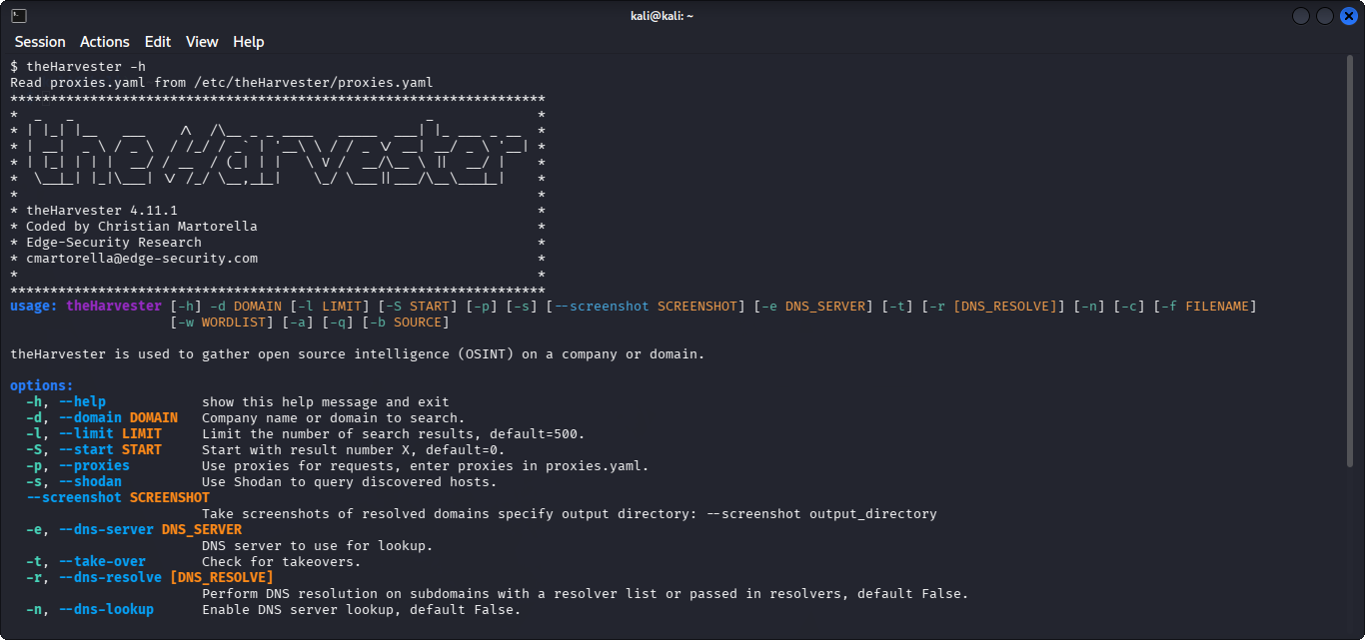
Evidence 7 — theHarvester help/version output

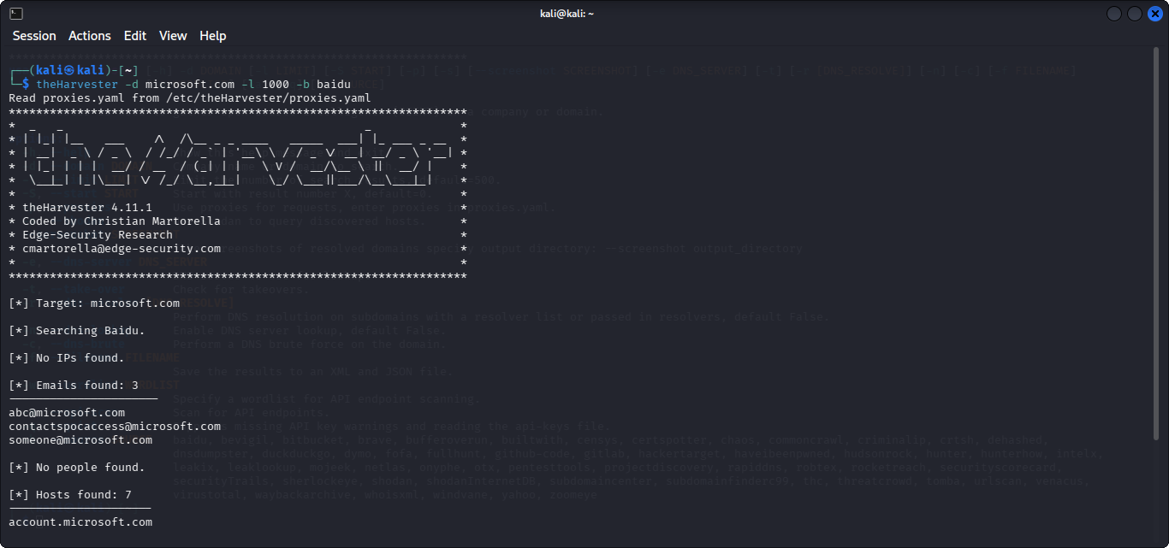
Evidence 8 — theHarvester Baidu collection

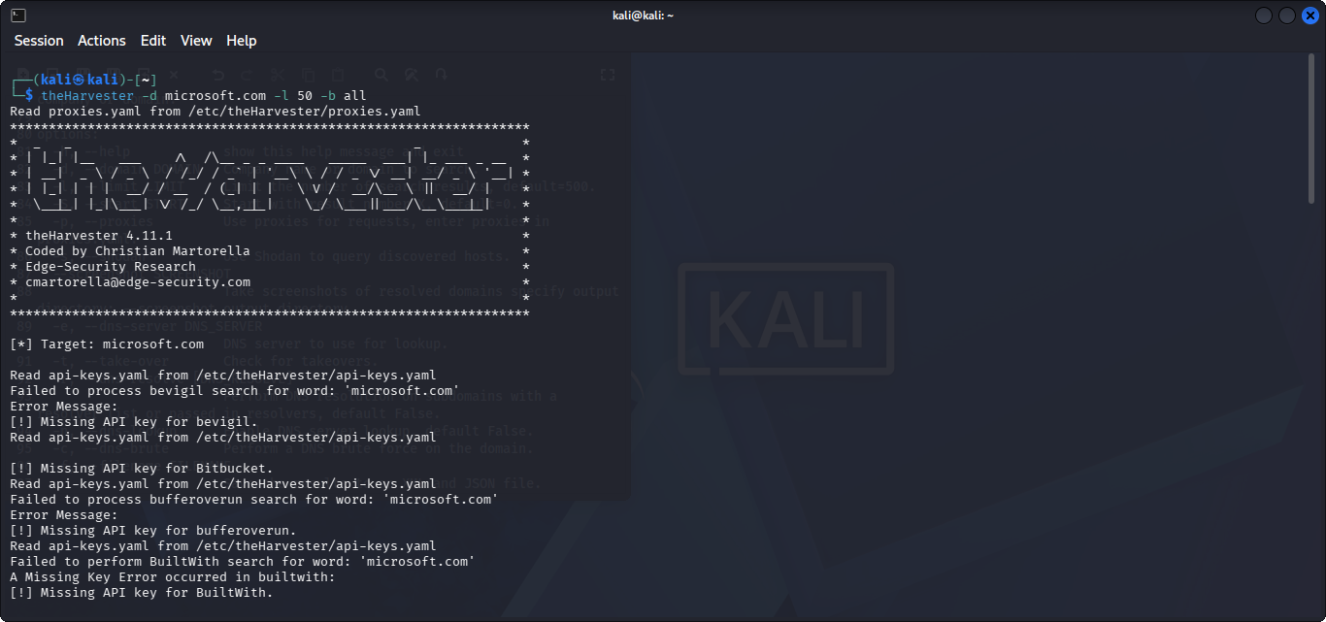
Evidence 9 — theHarvester all-source collection (initial output)

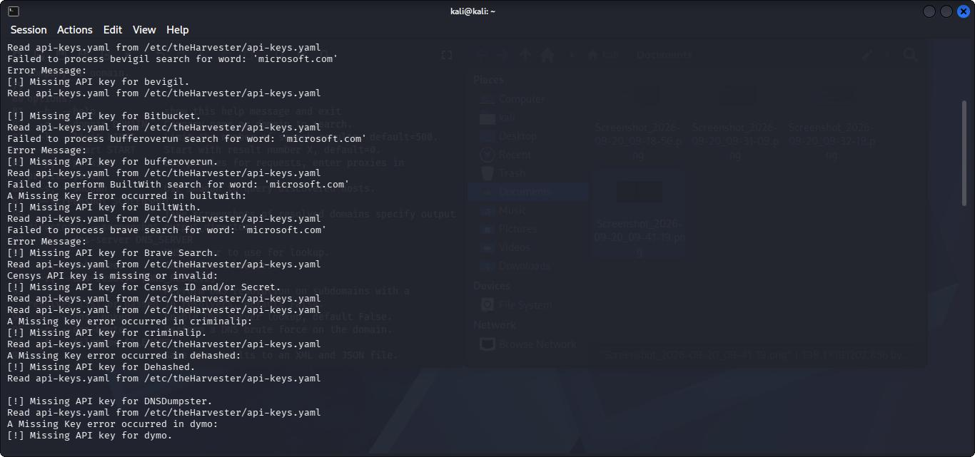
Evidence 10 — theHarvester all-source API/source warnings

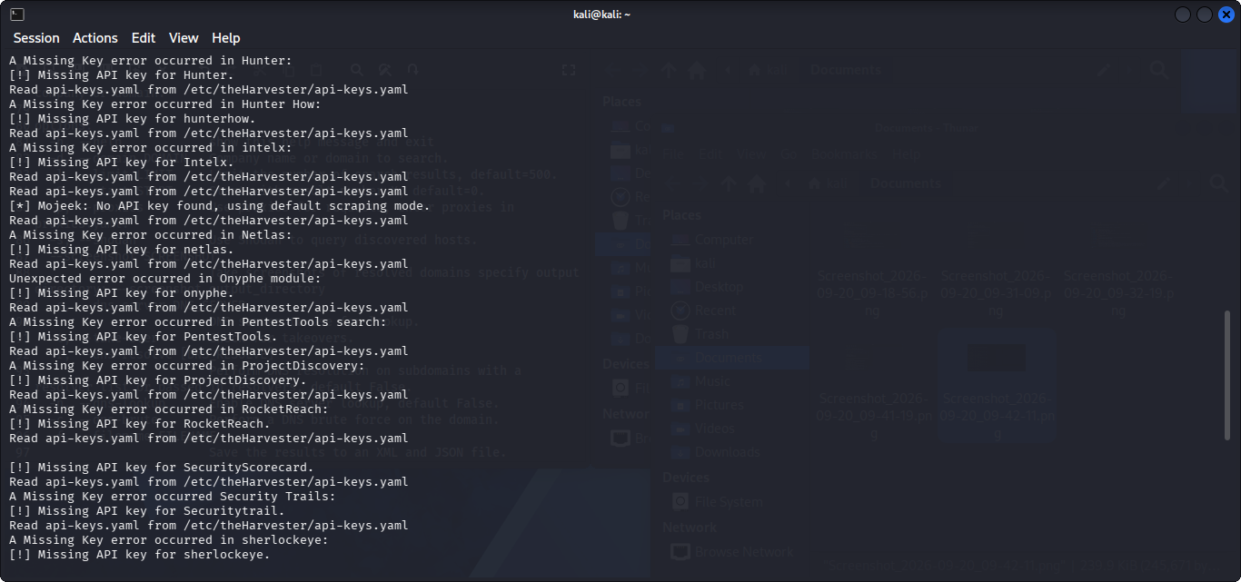
Evidence 11 — theHarvester additional source processing

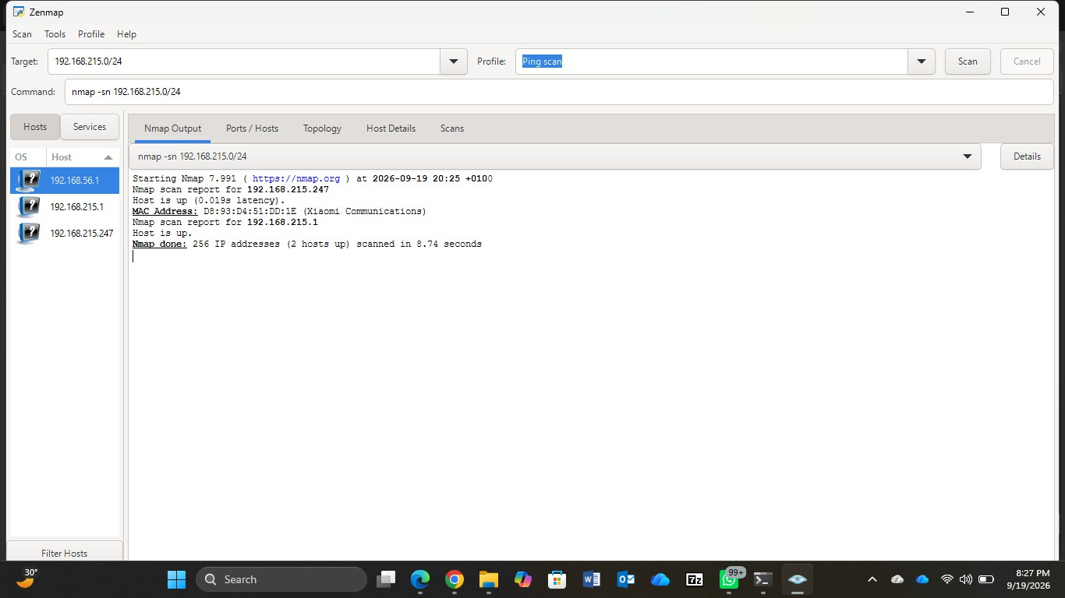
Evidence 12 — Zenmap/Nmap ping scan

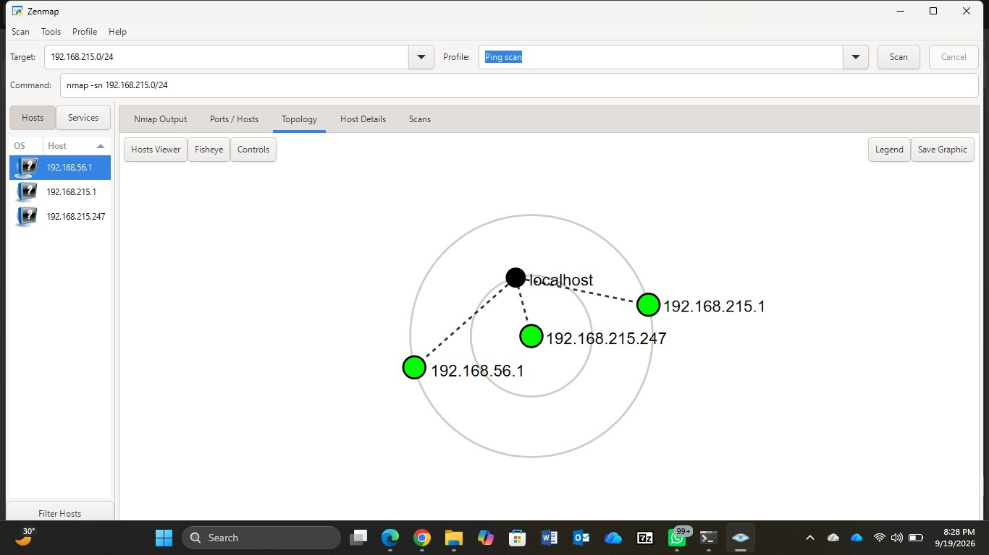
Evidence 13 — Zenmap topology view

Submission Notes
For GitHub publication, keep the README concise and avoid publishing unnecessary sensitive data from raw OSINT output. The detailed report retains the practical evidence while deliberately avoiding reproduction of long harvested host lists and full third-party authentication/authorization URLs.
End of Report.

