WEEK 3 PROJECT REPORT
Password Cracking with JTR & Networkwalks Tools
Student: Abdullahi Salisu Lawan
Week 3 | Networkwalks Cybersecurity & Ethical Hacking

Module | Task | Status
W3-PM1 | Password Cracking with JTR | Completed
W3-PM2 | Password Cracking with Networkwalks Tools | Completed

1. Introduction
Week 3 focused on password-cracking concepts and practical exercises using a protected PDF in an authorized cybersecurity training environment. The project brief lists two essential modules: W3-PM1, Password Cracking with JTR, and W3-PM2, Password Cracking with Networkwalks Tools. Both essential modules were completed.

2. Objectives
The objectives of the practical work were to understand the basic password-cracking workflow, extract a password hash from a protected PDF, use John the Ripper to attempt password recovery, use the Networkwalks browser-based tools, and verify successful recovery by opening the protected PDF.

3. W3-PM1 – Password Cracking with JTR
The JTR module introduced John the Ripper as a password-cracking tool used by security professionals to test password strength. The lab workflow involved obtaining the protected PDF, extracting its hash, saving the hash in a text file, loading the hash into JTR/Johnny, starting an attack, and then using the recovered password to open the PDF.

4. W3-PM2 – Password Cracking with Networkwalks Tools
The second essential module used the Networkwalks Hash Calculator and Password Cracker through a web browser. The documented workflow was to upload the protected PDF to the Hash Calculator, copy the complete hash beginning with $pdf$, paste it into the Password Cracker, start the attack, wait for the recovered password, and use that password to open the PDF.

5. Results
The practical work was successfully completed. The submitted evidence shows successful completion pages and captured flags. The two captured flags are recorded below as completion evidence.

6. Completion Flags
Flag 1: nw{networkwalks_flag1_jtr_270521_1}\n\nFlag 2: nw{networkwalks_persistence_jtr_270521}

7. Evidence
The screenshots below show the successful completion evidence captured during the practical work.

8. Key Learning Points
The exercise reinforced the relationship between protected files, extracted password hashes, and password-cracking tools. It also demonstrated that password recovery time can depend on password complexity and computing resources. The work provided practical experience with both a local JTR workflow and a browser-based workflow.

9. Ethical and Security Considerations
Password-cracking techniques should only be used in an authorized environment, such as a training lab or on files and systems for which explicit permission has been provided. The purpose of this exercise was security education and password-strength testing.

10. Conclusion
Week 3 was completed successfully. The two essential project modules were completed, the password-cracking workflows were practiced, and successful completion evidence was captured. The exercise improved practical understanding of password hashes, password recovery workflows, and the importance of strong password protection.

Evidence Screenshot 1 – JTR Flag


Evidence Screenshot 2 – Completion Flag
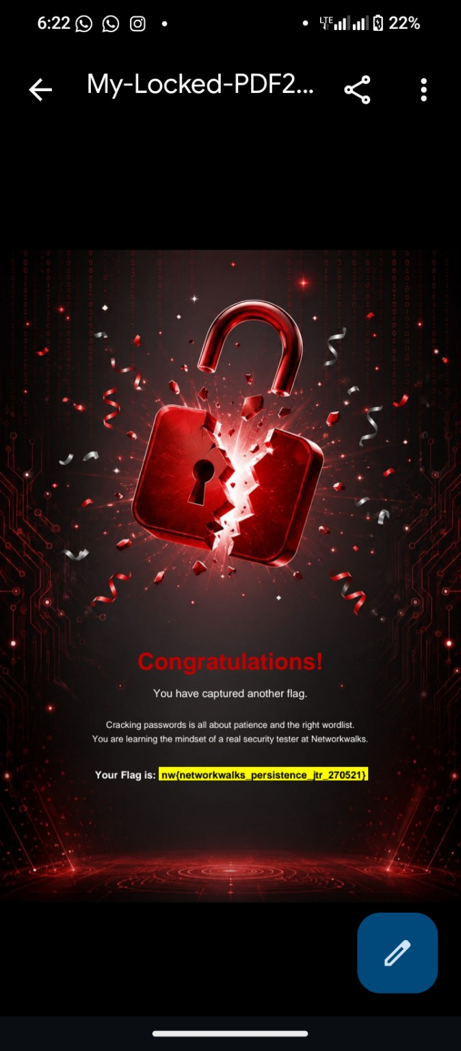

End of Week 3 Report

