CODEALPHA
CYBERSECURITY INTERNSHIP
TASK 2
PHISHING AWARENESS TRAINING
PROJECT REPORT

Prepared by
Abdullahi Salisu Lawan
Cybersecurity Internship • 2026

Table of Contents
- 1. Introduction
- 2. Project Objective
- 3. Tools and Technologies
- 4. Lab / Training Environment
- 5. Installation and Preparation
- 6. Network / Communication Context
- 7. Awareness Training Implementation
- 8. Content Explanation
- 9. Phishing Identification
- 10. Phishing Analysis
- 11. Practical Scenario
- 12. Testing
- 13. Results
- 14. Screenshots / Evidence
- 15. Challenges Encountered
- 16. Troubleshooting
- 17. Security Lessons Learned
- 18. Conclusion

1. Introduction
Phishing is a common cybersecurity threat that uses deception and social engineering to influence users into clicking malicious links, disclosing sensitive information, downloading harmful content, or taking other unsafe actions. This project, completed as CodeAlpha Cybersecurity Internship Task 2, developed a phishing awareness training presentation intended to help users recognize suspicious communications and respond safely.

2. Project Objective
The objective was to create a clear, practical, and visually consistent awareness presentation covering phishing concepts, common attack types, social-engineering techniques, warning signs, prevention methods, incident response, a practical scenario, and a short awareness quiz.

3. Tools and Technologies
Microsoft PowerPoint was used to design and organize the 17-slide training presentation. The project combines cybersecurity awareness concepts, fictional phishing examples, structured presentation layouts, and a consistent dark cybersecurity visual theme.

4. Lab / Training Environment
The work is an awareness and education exercise. It does not require a live phishing campaign or interaction with real victims. The examples are fictional and intended to demonstrate warning signs in a controlled training context.

5. Installation and Preparation
The presentation was prepared as a standalone PowerPoint training resource. Preparation involved organizing the learning sequence, creating the slide layouts, adding fictional scenarios, applying the visual theme, and reviewing the finished deck for readability and consistency.

6. Network / Communication Context
Phishing can arrive through multiple communication channels, including email, SMS or messaging applications, and voice calls. The training therefore treats phishing as a human-centered security problem that can occur across different communication paths rather than as an email-only threat.

7. Awareness Training Implementation
The training is structured from basic definition through identification, prevention, response, practical assessment, and conclusion. It introduces phishing, common attack types, social engineering, email and website indicators, smishing and vishing, protection practices, incident response, a practical scenario, a checklist, and a quiz.

8. Content Explanation
The presentation explains concepts in accessible language and uses short examples, warning indicators, checklists, and scenario-based learning. The dark cybersecurity design uses cyan, blue, amber, and red accents to distinguish normal guidance from warnings and high-risk behaviors.

9. Phishing Identification
Users are taught to examine sender addresses, domains, URLs, unexpected requests, urgent language, attachments, login pages, and requests for passwords or one-time authentication codes. The key behavior is to stop and verify rather than respond immediately.

10. Phishing Analysis
The red-flag analysis section demonstrates how a fictional phishing email can combine urgency, generic context, threats of account suspension, and a suspicious verification link. The recommended response is to avoid the link, verify the request through a trusted route, and report it when appropriate.

11. Practical Scenario
A fictional account-support message is used to test judgment. Learners compare possible actions and identify that independent verification is safer than clicking a suspicious link or replying to an unknown sender.

12. Testing
The completed presentation was reviewed for topic coverage, slide order, readability, formatting consistency, safe use of fictional examples, and logical progression. The final training deck contains 17 slides.

13. Results
The project produced a complete phishing awareness training resource covering recognition, prevention, response, and knowledge checking. The material gives users practical warning signs and actions they can apply when encountering suspicious communications.

14. Screenshots / Evidence
Seven selected figures from the completed training presentation are included in this report to provide visual evidence of the title, phishing concepts, red-flag analysis, fake-website guidance, protection guidance, practical scenario, and awareness quiz.

15. Challenges Encountered
Key development considerations included maintaining a consistent visual design, presenting cybersecurity concepts in accessible language, creating realistic but non-operational examples, and organizing the material into a logical learning sequence.

16. Troubleshooting
The presentation was reviewed for slide formatting, text readability, spacing, font sizing, consistency, and the clarity of the fictional examples. Any presentation issues were addressed through layout and content refinement before finalization.

17. Security Lessons Learned
The project reinforces that cybersecurity depends not only on technical controls but also on informed user behavior. Important lessons include verifying unexpected requests, checking URLs, recognizing social engineering, avoiding impulsive responses to urgent messages, protecting credentials, using multi-factor authentication, and reporting suspicious activity.

18. Conclusion
CodeAlpha Task 2 successfully produced a phishing awareness training resource focused on practical user education. The project provided experience in cybersecurity communication, threat awareness, presentation design, and explaining safe responses to social-engineering threats.

14. Screenshots / Evidence
The following seven figures are selected from the completed phishing-awareness presentation and are included as evidence of the final project output.

Figure 1
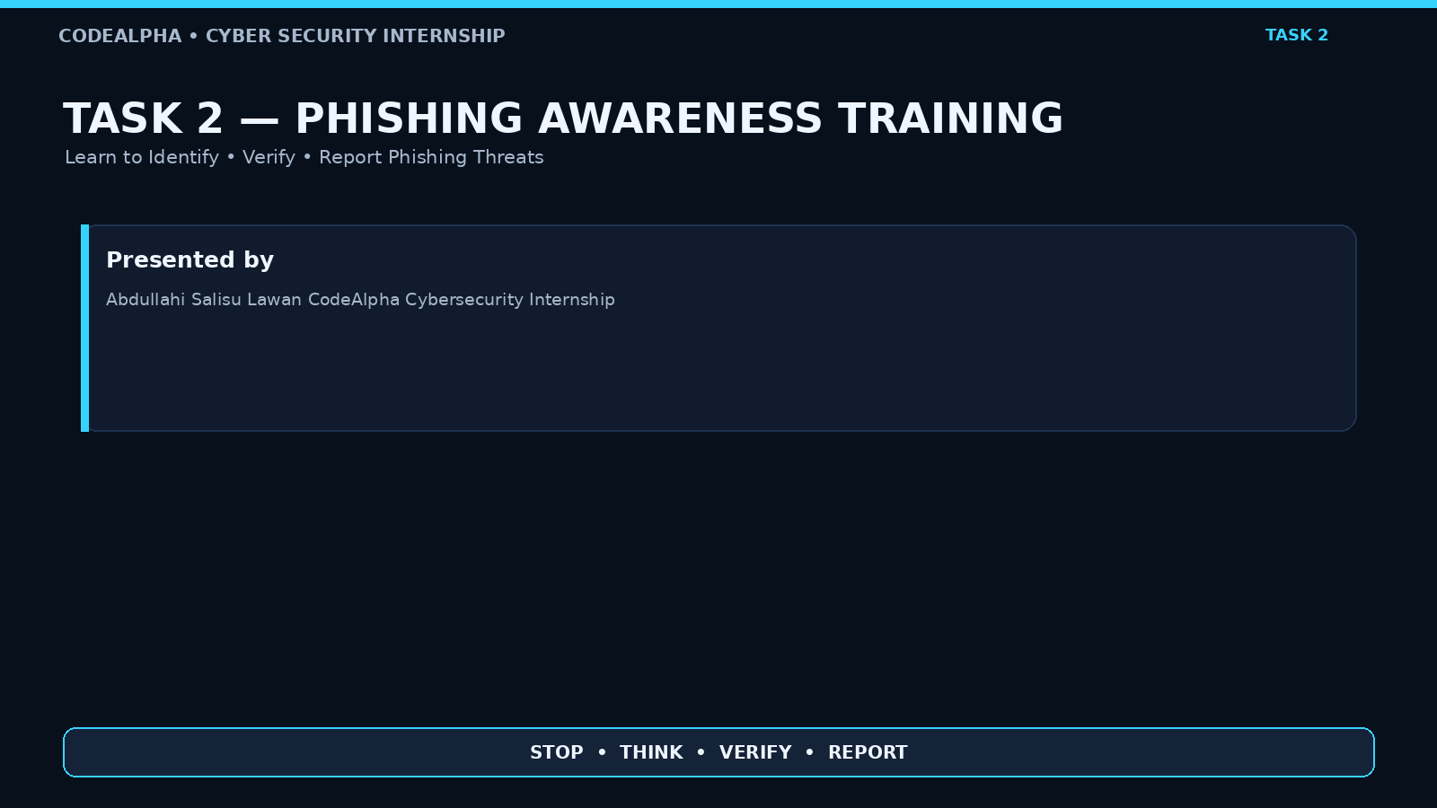
Figure 1: CodeAlpha Task 2 title slide and project identification.

Figure 2
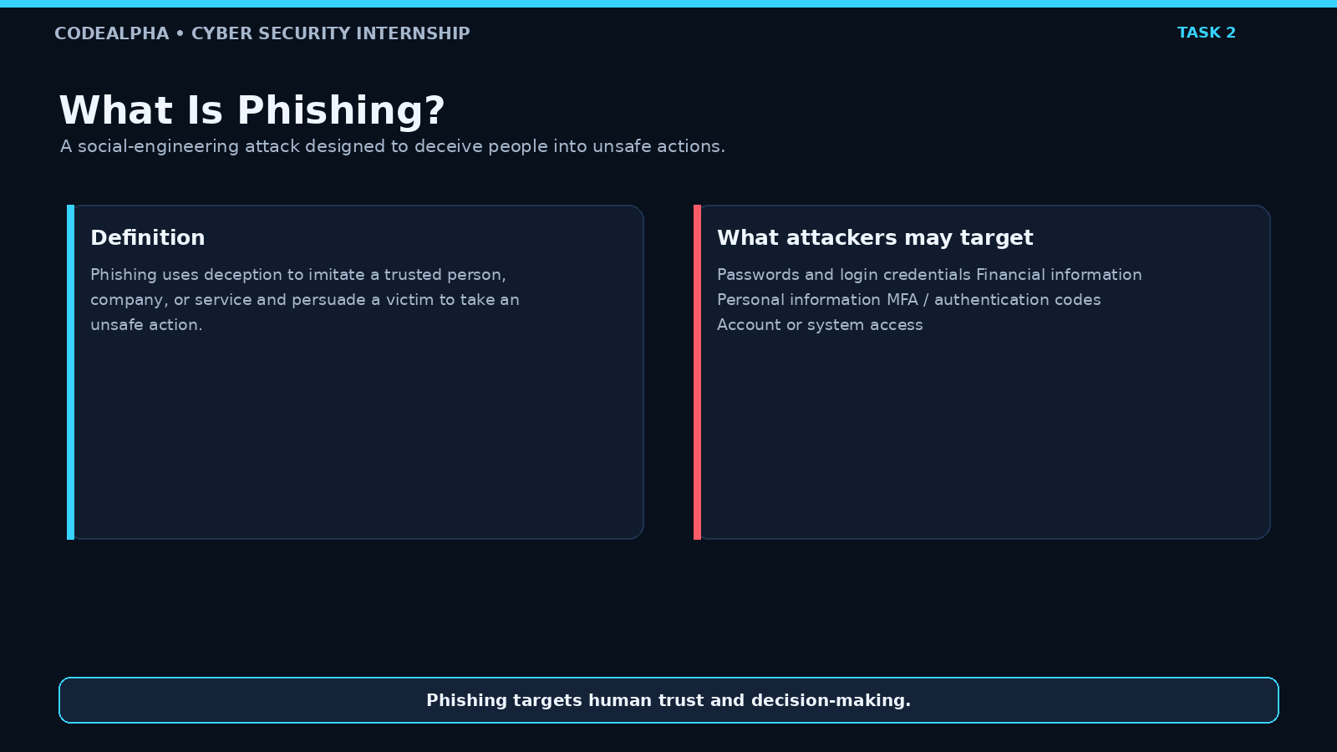
Figure 2: Introduction to phishing and the types of information attackers may target.

Figure 6
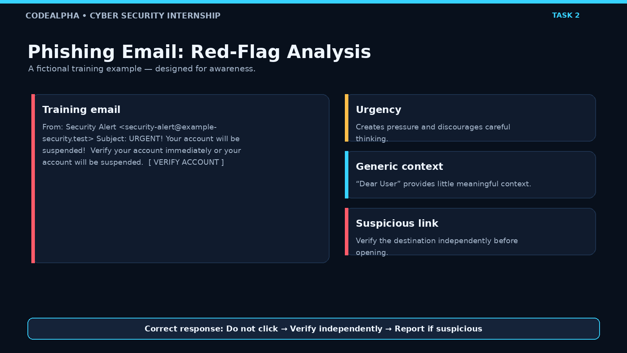
Figure 3: Fictional phishing email red-flag analysis.

Figure 7
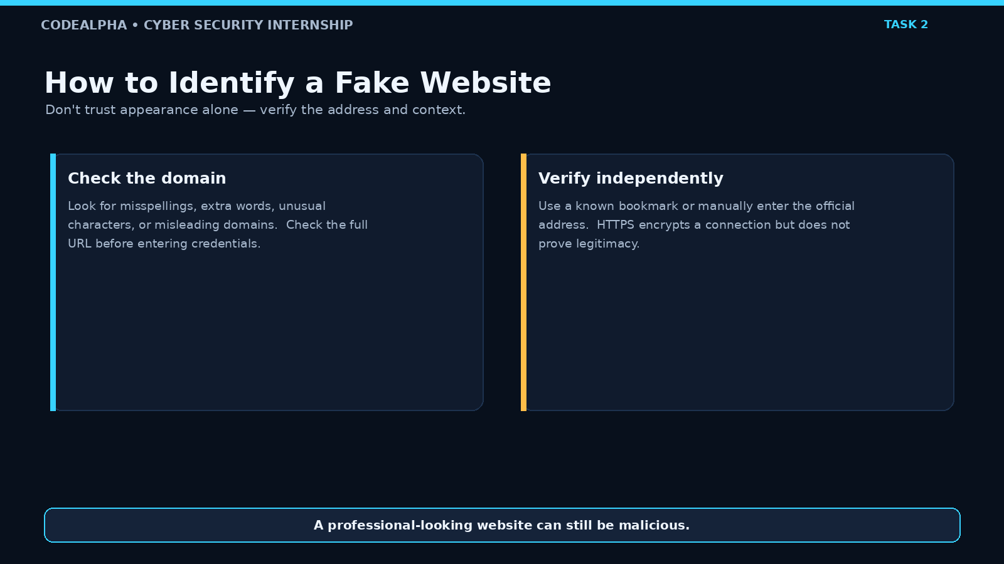
Figure 4: Guidance for identifying suspicious or fake websites.

Figure 9
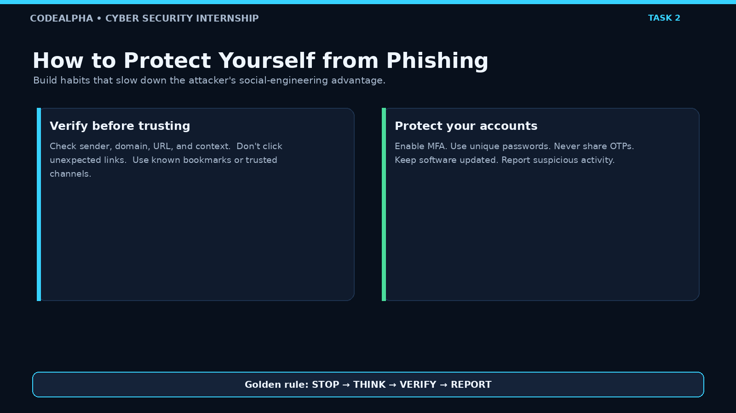
Figure 5: Recommended practices for protecting against phishing.

Figure 11
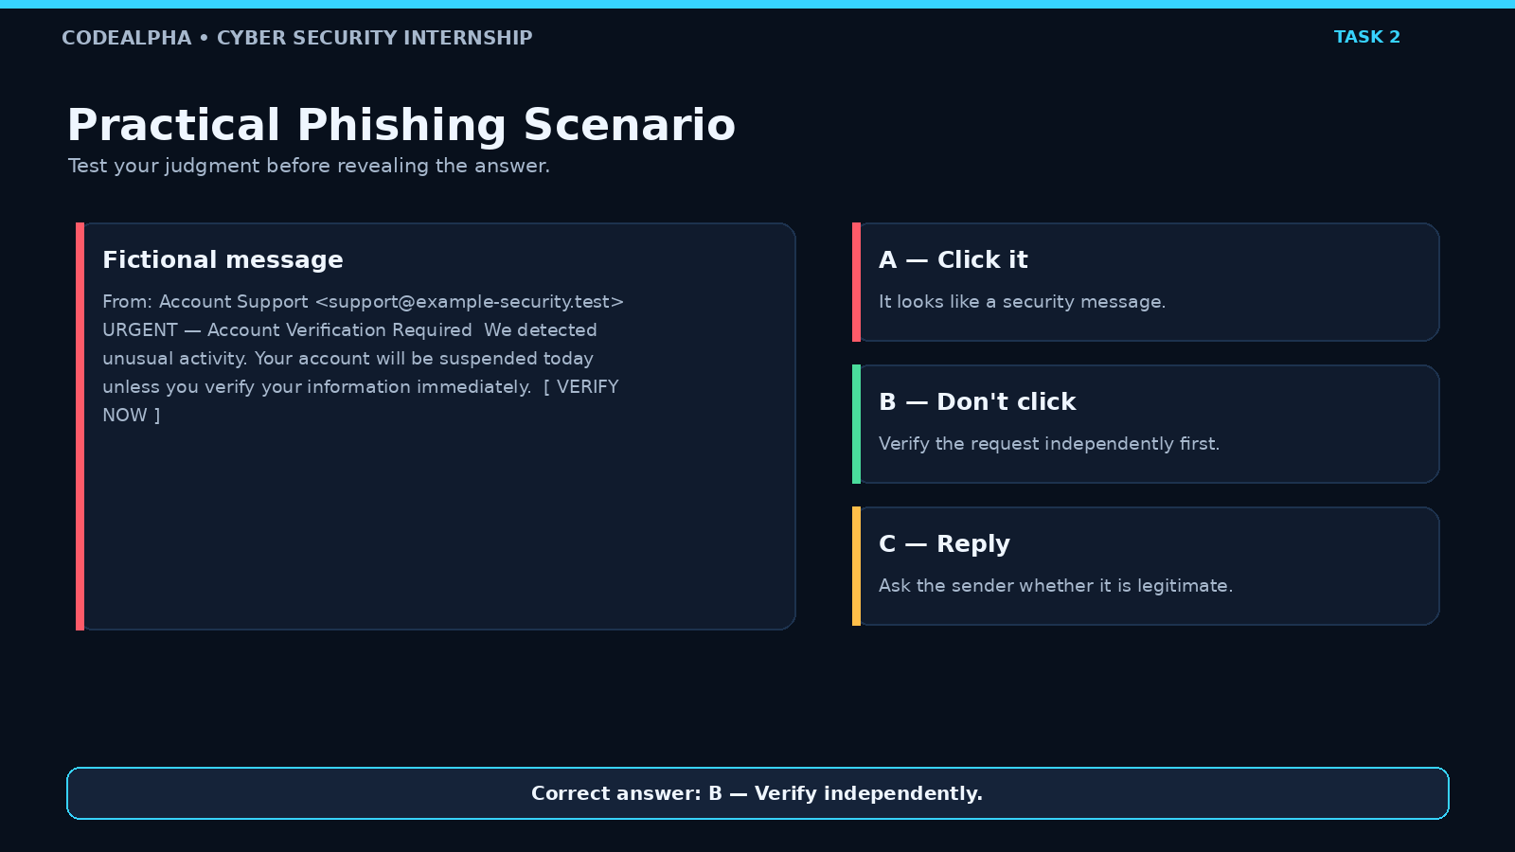
Figure 6: Practical phishing scenario used to test user judgment.

Figure 14
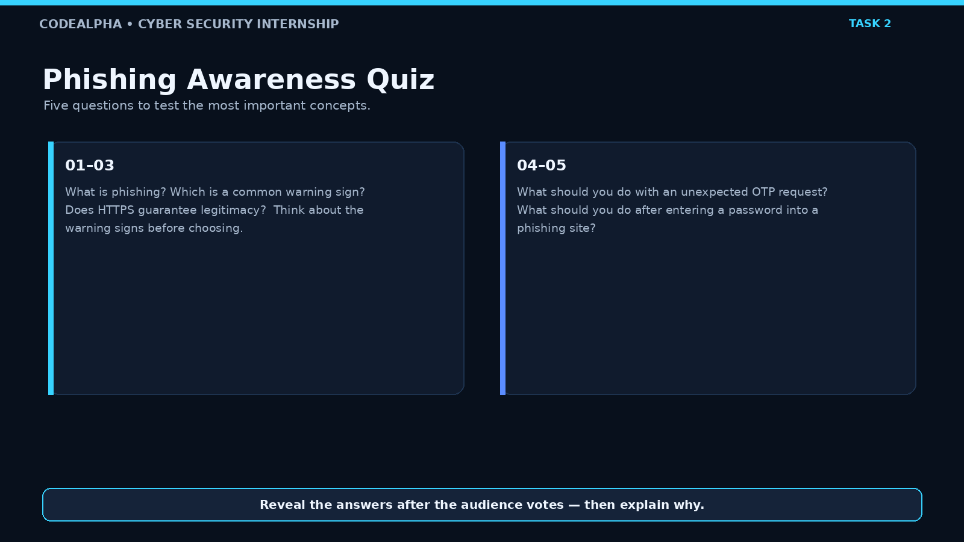
Figure 7: Phishing awareness quiz used to reinforce learning.

Appendix A — Full 17-Slide Sequence
- 1. Task 2 Title / Phishing Awareness Training
- 2. What Is Phishing?
- 3. Common Types of Phishing Attacks
- 4. Social Engineering Techniques
- 5. How to Identify a Phishing Email
- 6. Phishing Email: Red-Flag Analysis
- 7. How to Identify a Fake Website
- 8. Smishing & Vishing
- 9. How to Protect Yourself from Phishing
- 10. What If You Clicked a Phishing Link?
- 11. Practical Phishing Scenario
- 12. Phishing Red Flags Checklist
- 13. Real-World Impact of Phishing
- 14. Phishing Awareness Quiz
- 15. Key Takeaways
- 16. Conclusion
- 17. Thank You

