NETWORKWALKS CYBERSECURITY INTERNSHIP
Week 2 — Project Module 1
Footprinting & Reconnaissance with Multiple Kali Tools

Target: networkwalks.com Evidence date: 19 September 2026 Platform: Kali Linux

Executive Summary
This report documents the six reconnaissance tasks completed for W2-PM1 in the same order specified by the assignment: WHOIS, WhatWeb, nslookup, curl -I, WAFW00F, and DNSRecon. The screenshots show the actual terminal outputs produced during the exercise. The purpose of the work was information gathering and fingerprinting; no exploitation or unauthorized access was performed.

Tool sequence

# | Tool | Command | Purpose
1 | WHOIS | whois networkwalks.com | Domain registration information
2 | WhatWeb | whatweb networkwalks.com | Web technology fingerprinting
3 | nslookup | nslookup networkwalks.com | DNS resolution
4 | curl | curl -I https://networkwalks.com | HTTP response headers
5 | WAFW00F | wafw00f networkwalks.com | WAF detection
6 | DNSRecon | dnsrecon -d networkwalks.com | DNS enumeration

WHOIS
Command: whois networkwalks.com
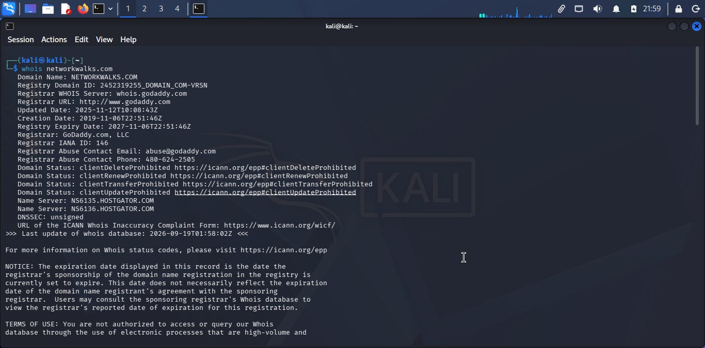

This is my WHOIS command screenshot findings!
The screenshot identifies NETWORKWALKS.COM and shows GoDaddy.com, LLC as the registrar. It shows a
2019-11-06 creation date, a registry expiry date of 2027-11-06, and the name servers NS6135.HOSTGATOR.COM and NS6136.HOSTGATOR.COM. It also shows several client protection status values and DNSSEC as unsigned.

Concept learned
WHOIS provides registration-related information about a domain. In reconnaissance, this can help establish the registrar, registration timeline, and name-server infrastructure.

WhatWeb
Command: whatweb networkwalks.com
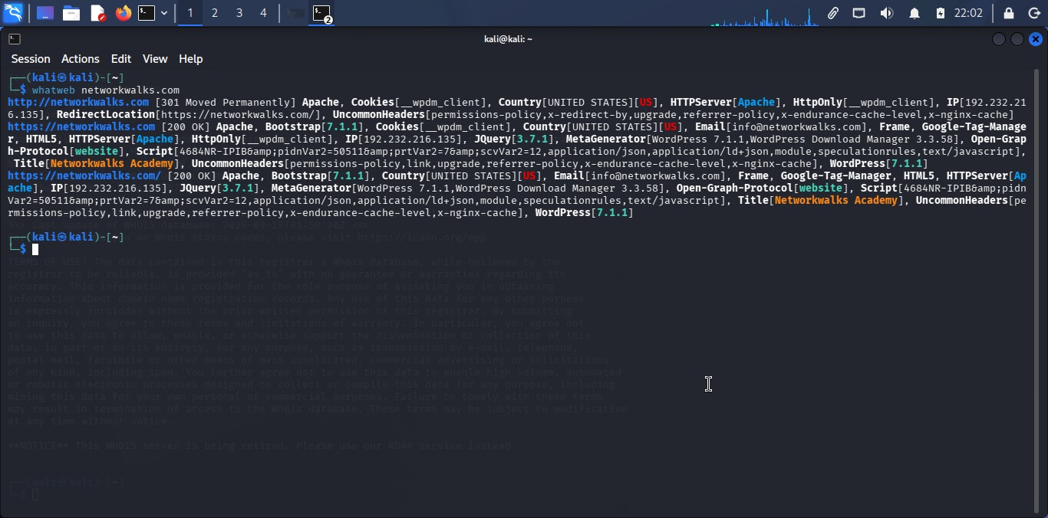

This is Whatweb command screenshot findings!
The screenshot shows an initial HTTP 301 redirect followed by HTTPS 200 responses. WhatWeb identifies Apache and WordPress-related technologies, including WordPress Download Manager and jQuery 3.7.1. It also reports an IP address of 192.232.216.135 and the public email info@networkwalks.com.

Concept learned
WhatWeb performs web technology fingerprinting. It looks for observable indicators of server software, application frameworks, plugins, libraries, and other technologies.

nslookup
Command: nslookup networkwalks.com
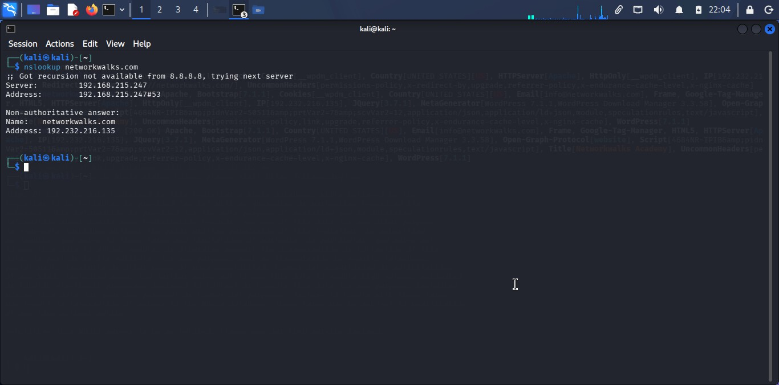

This is nslookup command screenshot findings!
The screenshot shows the DNS server used by the Kali VM as 192.168.215.247 and returns a non-authoritative answer mapping networkwalks.com to 192.232.216.135.

Concept learned
nslookup is used to query DNS. It demonstrates how a domain name resolves to an IP address and can help verify DNS configuration.

curl -I
Command: curl -I https://networkwalks.com
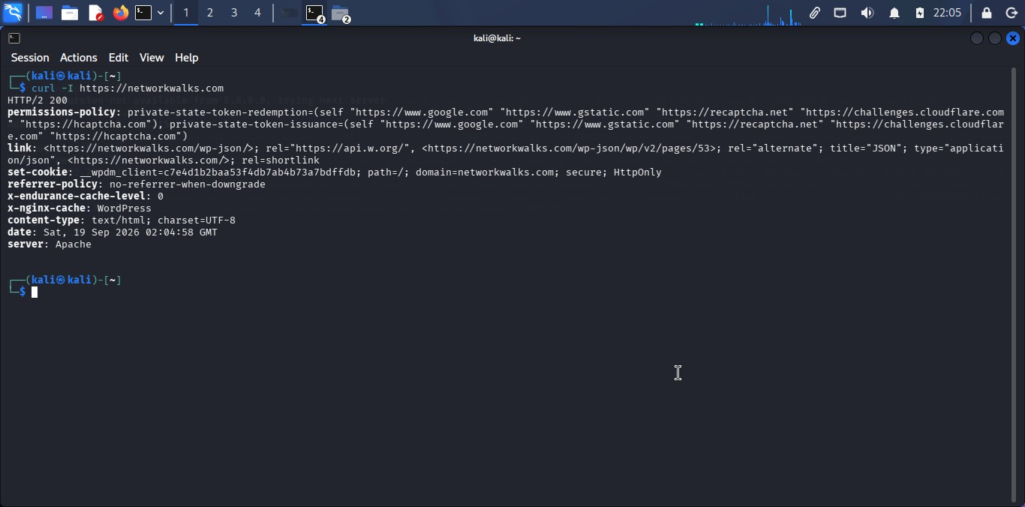

This is Curl -I command screenshot findings!
The screenshot shows HTTP/2 200 and headers including server: Apache and content-type: text/html; charset=UTF-8. It also shows WordPress-related indicators, including a /wp-json/ link and a _wpdm_client cookie, plus additional policy/cache headers.

Concept learned
curl -I requests HTTP response headers without retrieving the full page body. Headers can reveal server and application information and other details about HTTP behavior.

WAFW00F
Command: wafw00f networkwalks.com
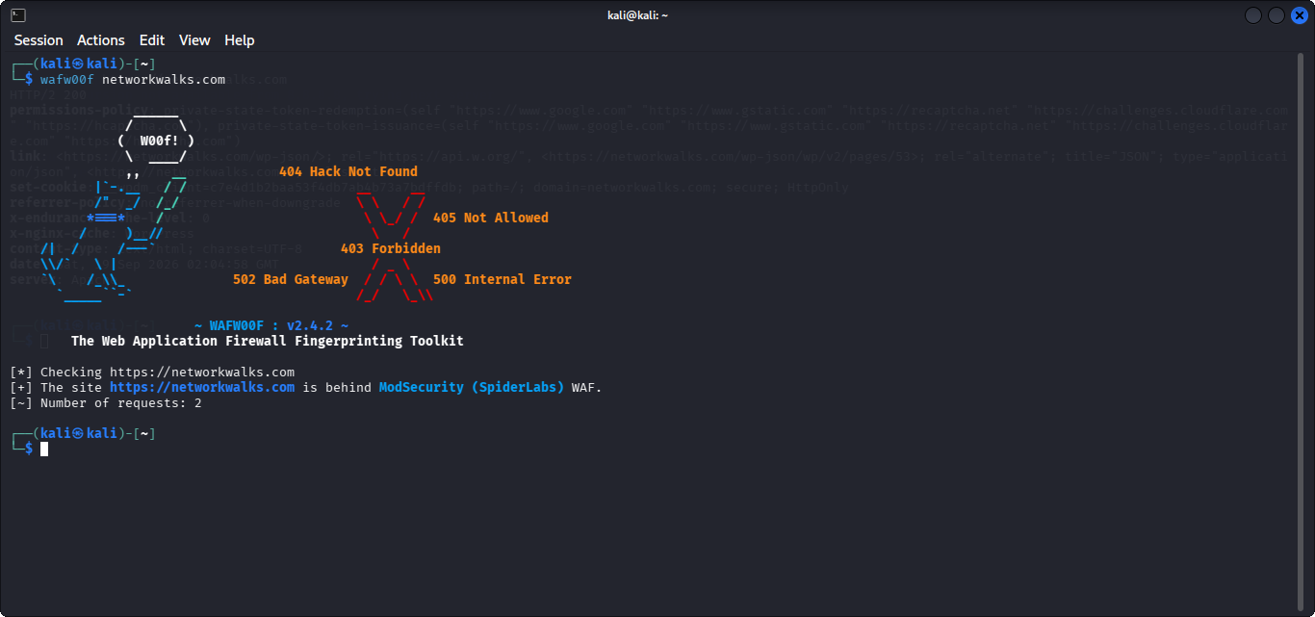

This is my WAFW00F command screenshot findings!
WAFW00F reports that the site is behind ModSecurity (SpiderLabs) WAF and shows that two requests were used for the check.

Concept learned
WAFW00F is a Web Application Firewall fingerprinting tool. A WAF is a security layer that can inspect and filter web application traffic.

DNSRecon
Command: dnsrecon -d networkwalks.com
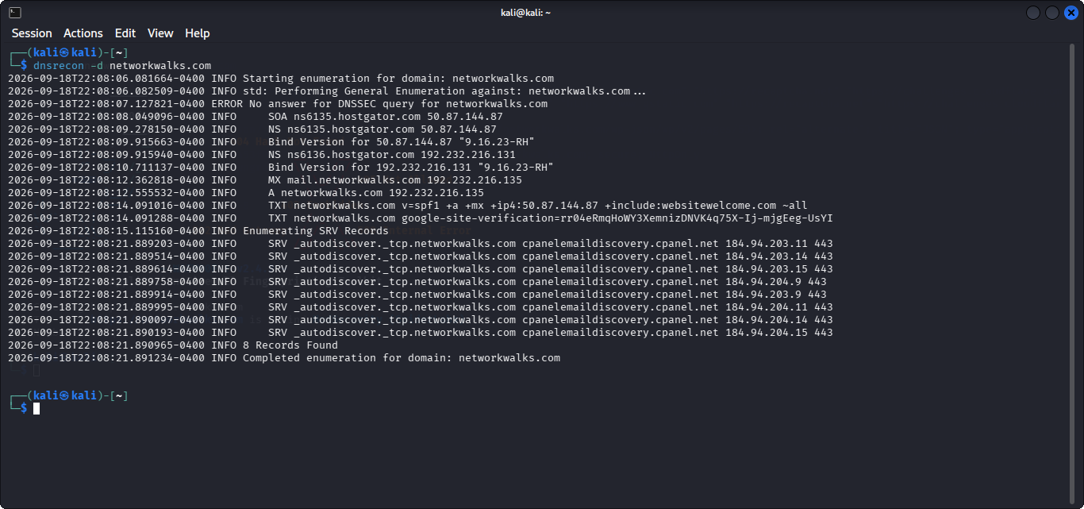

This is DNSRecon command screenshot findings!
DNSRecon reports 8 records found. The screenshot includes SOA and NS records for HostGator name servers, an MX record for mail.networkwalks.com, an A record resolving networkwalks.com to 192.232.216.135, TXT records including SPF and Google site verification, and several SRV/autodiscover records. It also reports no answer for the DNSSEC query.

Concept learned
DNSRecon automates DNS enumeration and helps identify different record types such as SOA, NS, MX, A, TXT, and SRV.

Combined Findings
The six tools reveal different layers of the same target. WHOIS supplies registration information; nslookup and DNSRecon expose DNS structure; WhatWeb fingerprints web technologies; curl reveals HTTP headers; and WAFW00F identifies an apparent WAF. The combined output forms a basic technical profile without attempting exploitation.

Area | Observed result
Domain | networkwalks.com
Registrar | GoDaddy.com, LLC
Name servers | ns6135.hostgator.com; ns6136.hostgator.com
Resolved IP | 192.232.216.135
Web server | Apache
Application indicators | WordPress / WordPress Download Manager
Library indicator | jQuery 3.7.1
WAF | ModSecurity (SpiderLabs)
DNS record types observed | SOA, NS, MX, A, TXT, SRV
DNSRecon count | 8 records found
curl status | HTTP/2 200

Learning Outcomes
WHOIS: learned domain registration reconnaissance. WhatWeb: learned web technology fingerprinting. nslookup: learned basic DNS resolution.
curl: learned how HTTP headers expose technical information.
WAFW00F: learned WAF detection/fingerprinting.
DNSRecon: learned DNS record enumeration.

Conclusion
The practical demonstrates that reconnaissance is cumulative: each tool reveals a different part of the target's externally observable footprint. A reconnaissance finding is not automatically a vulnerability; further authorized analysis would be required to establish whether any security weakness exists.
Evidence files are included in the accompanying GitHub-ready folder and numbered in the same order as the assignment.

