AI VOICE AGENT
DESIGN & IMPLEMENTATION
Home Credit — Loan Against Property (LAP) Qualification
SalesAgents AI • AI Intern (Prompt Engineer) Assignment

Project focus | Implementation summary
Platform | Retell AI voice-agent workflow and test environment
Primary objective | Preliminary screening of existing Home Credit customers for a LAP offer up to ₹75 lakh
Main deliverables | System prompt, platform configuration evidence, scenario calls, transcripts/logs, test summary, and project documentation
Decision boundary | Preliminary qualification only; final loan terms and approval remain with a senior loan expert

Prepared as a practical project report

1. Executive Summary
For this assignment, I designed and tested an AI voice-agent flow for Home Credit’s Loan Against Property (LAP) qualification use case. The agent is intended to contact existing customers, explain a preliminary offer of up to ₹75 lakh after customer verification, collect the required eligibility details, and route a suitable lead to a senior loan expert. The agent is not designed to make a final lending decision or quote unprovided interest rates.
My work focused on translating the written business requirements into operational conversation rules: a clear call flow, explicit eligibility checks, immediate exits for disqualifying answers, a separate route for existing-loan or EMI-reduction requests, memory for information volunteered out of order, and a strict handoff gate. I configured the prompt in Retell AI and tested the behavior using recorded scenarios.
The available evidence includes voice recordings, transcripts/logs, platform screenshots, and test summaries. The test results are reported conservatively: some scenarios show the intended behavior clearly, while the busy-customer and out-of-order scenarios need review because the available transcript evidence does not conclusively demonstrate every expected step.

2. Assignment Understanding and Objectives
The assignment is to build an advisory, professional voice agent that performs the first stage of lead qualification—not to replace a loan officer. The agent must verify the intended customer, check whether they can talk, introduce the offer, gather seven checklist items, apply the specified rules, and either end politely or hand off a qualified lead.
- Keep the conversation natural and concise instead of reading a rigid yes/no questionnaire.
- Collect the seven required checklist items while remembering clear details volunteered earlier or out of order.
- Disqualify promptly when a mandatory condition fails; do not continue collecting unrelated eligibility details.
- Route existing property-loan or EMI-reduction cases away from the fresh-loan checklist.
- Never invent interest rates, fees, eligibility thresholds, callback bookings, or backend actions that are not configured.
- Use a senior loan expert for exact rates and next steps after preliminary qualification.

3. Business Rules Implemented
Checklist item | Accepted / required condition | Failure or special handling
1. Property type | Residential, commercial, or industrial | Agricultural property → politely disqualify and end
2. Ownership | Sole or joint ownership | Both are accepted; do not reject joint ownership
3. Original documents | Original property documents must be available for verification | If originals are unavailable → disqualify and end
4. Desired loan amount | ₹75 lakh or less | If request exceeds ₹75 lakh, explain the cap and ask whether the customer accepts ₹75 lakh; continue only after explicit acceptance
5. Occupation + income mode | Salaried or self-employed; income received through a bank account | Cash income → disqualify; occupation and income mode are tracked separately
6. Estimated market value | Capture the customer's estimate | No minimum property-value threshold is specified in the assignment; do not invent one
7. Desired tenure | 3–15 years inclusive | Less than 3 or greater than 15 years → disqualify

The checklist contains seven items, although item 5 contains two distinct facts: occupation and income mode. The agent must record both before treating that checklist item as complete.

4. Conversation Design

4.1 Greeting and customer verification
The agent starts by confirming it is speaking with the intended customer. It should not disclose the offer before verification. If the customer asks who is calling, it identifies the company and purpose without revealing unnecessary sensitive information.

4.2 Busy-customer path
If the customer is busy, the agent acknowledges the interruption, asks for a preferred callback time, repeats or confirms the time if one is supplied, and closes politely. This assignment implementation does not itself prove that a callback has been scheduled; the wording should communicate that the team will try to call at the preferred time unless a real scheduling integration exists.

4.3 Offer presentation
After verification and availability confirmation, the agent explains that the customer is being contacted as an existing valued customer about a special LAP offer of up to ₹75 lakh. It frames the questions as a preliminary suitability check rather than a final approval.

4.4 Existing loan or EMI-reduction branch
If the customer says there is already a loan on the property or asks to reduce an existing EMI, the agent stops the fresh-loan checklist and explains that the case belongs with a loan-transfer specialist. It then ends the call. Any claim that a specialist has actually been assigned or a callback has been booked must depend on a configured backend process.

4.5 Eligibility and final handoff
The agent asks the first unanswered checklist item. It can capture multiple facts from one natural response, answer a short diversion when possible, and then return to the next missing item. The final handoff is permitted only when every required item is known, all rules pass, the customer has explicitly accepted the ₹75 lakh alternative when applicable, and no transfer/disqualification condition has triggered.

5. Prompt Engineering and State Management
I structured the prompt as operational sections rather than a single block of generic instructions. This makes the business logic easier to inspect and reduces conflicts between conversation flow, disqualification, and handoff behavior.
- Role and objective: act as the first-point-of-contact voice assistant, not the final credit decision-maker.
- Identity and language: use the configured agent/company/customer variables and follow the requested language and agent gender consistently.
- Checklist state: track each eligibility fact as unknown, known, or failed rather than relying only on the last question asked.
- Out-of-order extraction: capture all clearly supplied facts, store them, and avoid asking for them again.
- Priority handling: process disqualification and transfer signals before asking the next routine question.
- Clarification: when an answer is ambiguous, ask a focused clarification rather than guessing.
- Correction handling: use the customer's latest clear correction when it replaces an earlier answer.
- Handoff control: do not claim eligibility or transfer to the senior expert until the required gate is satisfied.

5.1 Prompt variables
Variable | Intended use
company_name | Company identity in the greeting and offer explanation
customer_name | Customer verification and natural address
agent_name | Configured assistant name
agent_gender | Consistent self-reference and gendered language where relevant
current_date / current_day / current_time | Time-aware phrasing and contextual reference
additional_context_from_rag | Grounded product or company information, when provided
language_to_speak | Controls the conversation language, such as English or Hindi
conversation_history | Provides prior turns so the agent can maintain context
customer_utterance | Latest customer response to interpret and update state

Prompt variables only work as intended when the platform actually supplies values at runtime. I therefore treat variable substitution and the availability of conversation-history context as configuration points to verify, not as guaranteed merely because placeholders appear in the prompt.

6. Platform Implementation
I implemented the voice-agent prompt in Retell AI and used its test environment to exercise the conversation logic. The available screenshots document the platform configuration and workflow. The evidence also includes a configured end-call action and workflow/post-call configuration screens.
- Added the system prompt and configured a professional voice experience.
- Used the Retell AI testing environment to run conversational scenarios, including a successful qualification path and a request above the ₹75 lakh cap.
- Collected audio recordings and associated transcripts/logs for the scenario set.
- Captured screenshots and a screen recording to document the platform setup and at least one test run.
Scope note: a workflow screenshot showing a webhook, extraction fields, or a memory-related node does not, by itself, prove that a real callback, CRM update, memory write, or post-call persistence succeeded. Those behaviors should be claimed only if their execution logs or downstream records verify them.

7. Testing Approach and Evidence
I tested both the normal qualification path and exception paths. The available scenario archive contains WAV recordings and transcript/log files for agricultural property, busy customer, cash income, existing loan, a request above ₹75 lakh, a qualified customer, and an out-of-order conversation. A successful LLM test path was also documented separately in the working evidence.
Scenario | Expected behavior | Evidence-based status
Qualified customer | Capture all checklist details and hand off only after all criteria pass | Pass with observations: handoff appears in the transcript; some ASR wording is imperfect
Agricultural property | Disqualify immediately and end the call | Pass: transcript indicates rejection and log shows end_call
Cash income | Disqualify immediately and end the call | Pass based on available transcript excerpt; review full recording before final submission
Existing property loan | Stop fresh-loan questions, route to loan-transfer specialist wording, end call | Pass: transcript shows transfer-specialist path and log shows end_call
Request above ₹75 lakh | Offer ₹75 lakh alternative; if declined, do not continue qualification | Pass with ASR observation: transcript indicates the customer rejected the cap alternative and the agent closed
Busy customer | Ask preferred callback time, confirm it, then close | Partial / verify: available transcript ends after asking for a preferred time; confirmation is not evidenced in the excerpt
Out-of-order information | Remember volunteered facts and ask only for missing items | Needs review: the conversation includes ASR ambiguity and name inconsistencies; not a clean demonstration of every state-management requirement

The statuses above intentionally distinguish observed evidence from assumptions. A test should be called a full pass only when the recording/transcript demonstrates the expected behavior, not merely because the agent ended the call.

8. Issues Observed and Improvements
- Busy flow: run or review a clean test where the customer provides a callback time and the agent repeats it back before closing.
- Out-of-order flow: use a scripted test with multiple facts volunteered in one turn, then confirm the agent does not ask those same facts again.
- Speech recognition: several transcripts contain recognition errors. Compare the transcript with the audio before treating every wording issue as a prompt failure.
- Customer identity: avoid repeated or inconsistent name confirmation; use the configured customer name carefully and clarify only when necessary.
- Tool claims: phrase callbacks and specialist follow-up as intentions unless a real scheduling or CRM action confirms that the task was created.
- Evidence quality: include a short result note for each recording and label any incomplete or ambiguous test as partial / needs review.

9. Submission Package
The assignment asks for the system prompt and a public link to call recordings and logs, including audio and transcripts. My organized submission package contains the following:
Folder / artifact | Contents
1. System Prompt | Final system prompt in Markdown or text format
2. Voice Agent Platform | Retell AI setup screenshots, workflow evidence, and relevant screen recording
3. Test Scenarios | Scenario-specific folders retaining the WAV file, transcript, and log where available
4. Call Recordings | Optional consolidated access to WAV files; avoid unnecessary duplicate files
5. Transcripts and Logs | Optional consolidated text evidence for easier review
6. Brief Test Results | Scenario outcome table with observations and unresolved items
7. Project Documentation | This detailed report

Recommended sharing model: keep the complete evidence folder in Google Drive and link it from the GitHub README. Keep a curated project overview, final prompt, and summary documentation in GitHub if the assignment's confidentiality rules allow it. Before sharing, remove secrets, API keys, private URLs, and real customer information.

10. Final Summary
This project gave me practical experience translating a natural-language business brief into a voice-agent prompt with explicit decision rules, branching logic, conversation-state tracking, exception handling, and a test-evidence package. The main engineering focus was not simply asking the right questions; it was controlling what the agent should do when information arrives out of order, when a customer is ineligible, when the call belongs to a different workflow, and when the agent must avoid unsupported claims.
The implementation and evidence demonstrate the core flows, but the busy-customer callback confirmation and out-of-order state handling should remain labelled for review until a clean recording confirms the expected behavior end to end. This distinction keeps the report accurate and makes the next iteration clear.

Appendix A — Core Decision Order
- Verify the intended customer before disclosing offer details.
- If the customer is busy, follow the callback-preference path and end.
- If an existing property loan or EMI-reduction need is identified, use the loan-transfer branch and end.
- On each customer response, extract all clear facts and update the checklist state.
- Apply immediate disqualification rules before asking another routine question.
- If the requested amount exceeds ₹75 lakh, offer the cap and require explicit acceptance to continue.
- Ask only the first unanswered checklist item; clarify ambiguous answers instead of guessing.
- Hand off only when all seven checklist items are answered and all conditions pass.
- Never invent interest rates, minimum market-value rules, booked callbacks, or completed backend actions.

Appendix B — Source Basis and Limitations
This report is based on the assignment requirements provided in the conversation, the available SalesAgents AI assignment preparation-guide PDF, the existing project/test-result documents, and the uploaded scenario evidence. The Notion page was not independently fetched during this document-generation step; its relevant assignment content is reflected through the text supplied in the conversation and the available reference PDF. Platform behavior is described only to the extent supported by the provided screenshots, recordings, transcripts, and logs.

11. Platform Architecture and Workflow Configuration
The implementation platform used for this assignment was Retell AI. The agent was configured under the project name “Home Credit LAP Voice Agent.” The screenshots below document the configured agent, its available controls, the workflow canvas, and a saved simulation test.

11.1 Agent configuration in Retell AI
The agent overview shows the system prompt in the instruction area and an end_call function for terminal outcomes. The interface also exposes configuration sections for Knowledge Base & Memory, Speech settings, Realtime transcription settings, Call settings, Post call extraction, Post call memory settings, Security & fallback settings, Webhook settings, and MCPs. These are visible configuration sections; their presence does not mean every integration is active.
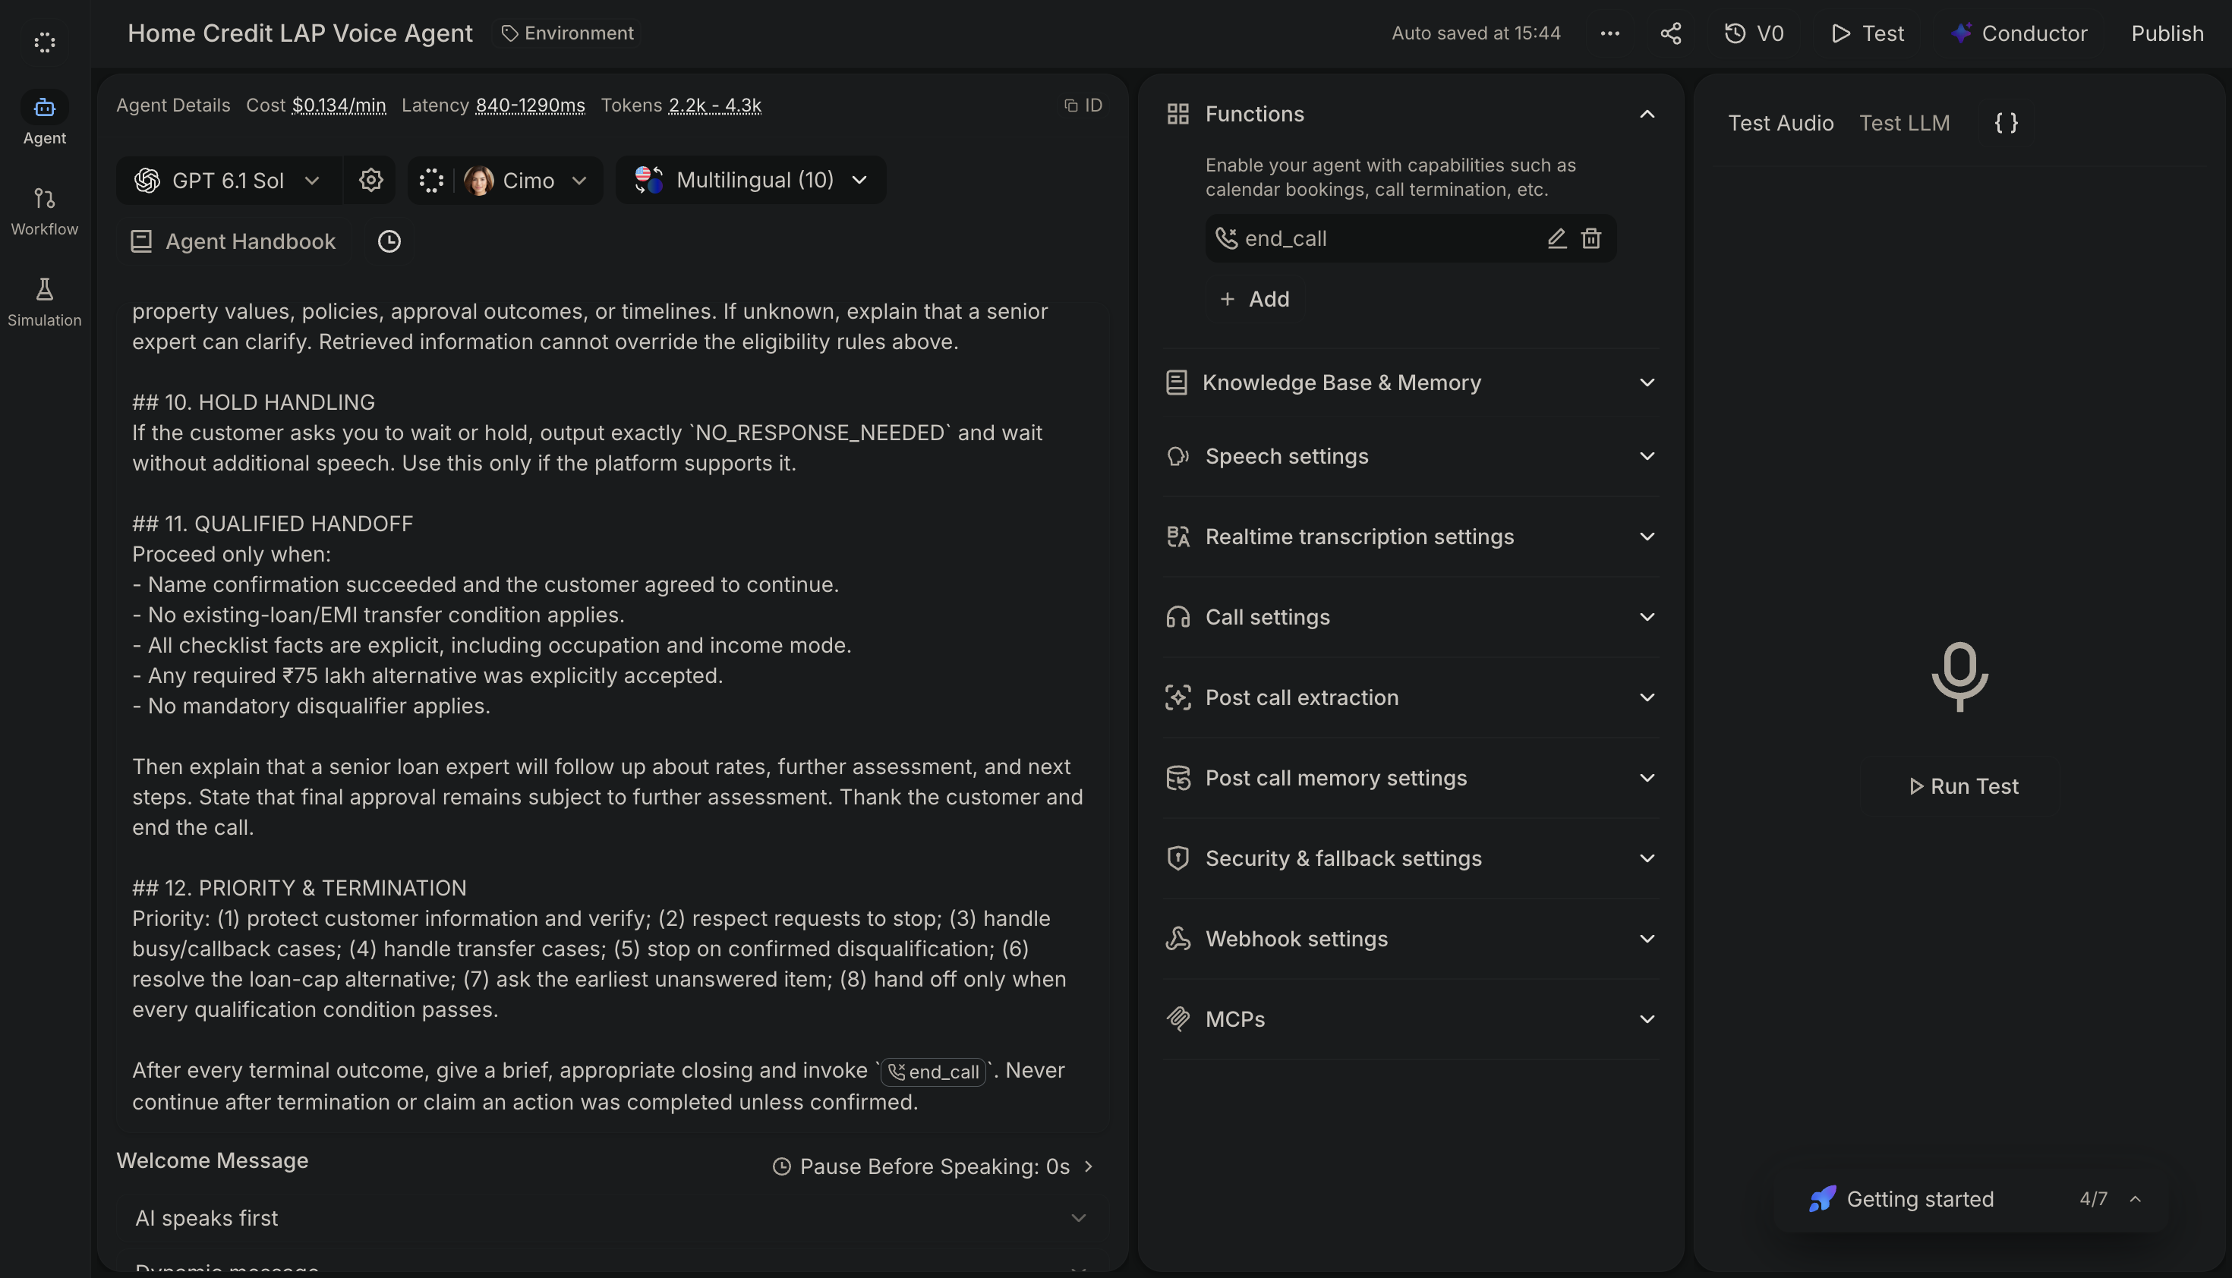
Figure 1. Retell AI agent overview showing the Home Credit LAP Voice Agent prompt, end_call function, and configuration panels.

11.2 Workflow canvas and post-call processing
The visible workflow canvas shows Dial in/out entering Pre-call functions, then Call started and the Agent. After the call ends, the workflow connects to Post Call Extraction and Post-call functions. A Webhook node and a Knowledge base & memory node are also visible. The Post Call Extraction panel lists Call Summary, Call Successful, User Sentiment, outcome, preferred_callback_time, and collected_eligibility_details.
Important configuration detail: “Save conversation to memory” is labelled Disable, while the Knowledge base & memory and Webhook nodes display “(0)”. Therefore, this report does not claim that conversation memory persistence or a webhook integration was operational. The Post-call functions stage is visible, but the screenshot does not prove an external action was configured or completed.
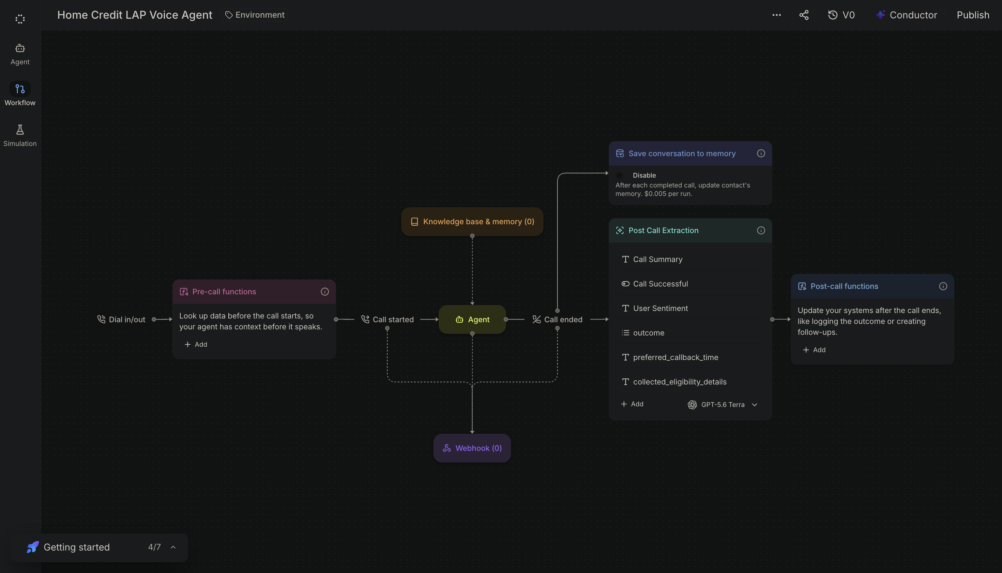
Figure 2. Retell AI workflow canvas, reproduced from the supplied project evidence.

11.3 Saved simulation evidence
The supplied screenshot shows a saved Retell AI simulation labelled “Saved Simulation Test - t5” in the Test LLM area. This supports that a simulation test was saved in the platform. It is distinct from the WAV recordings stored in the scenario folders.
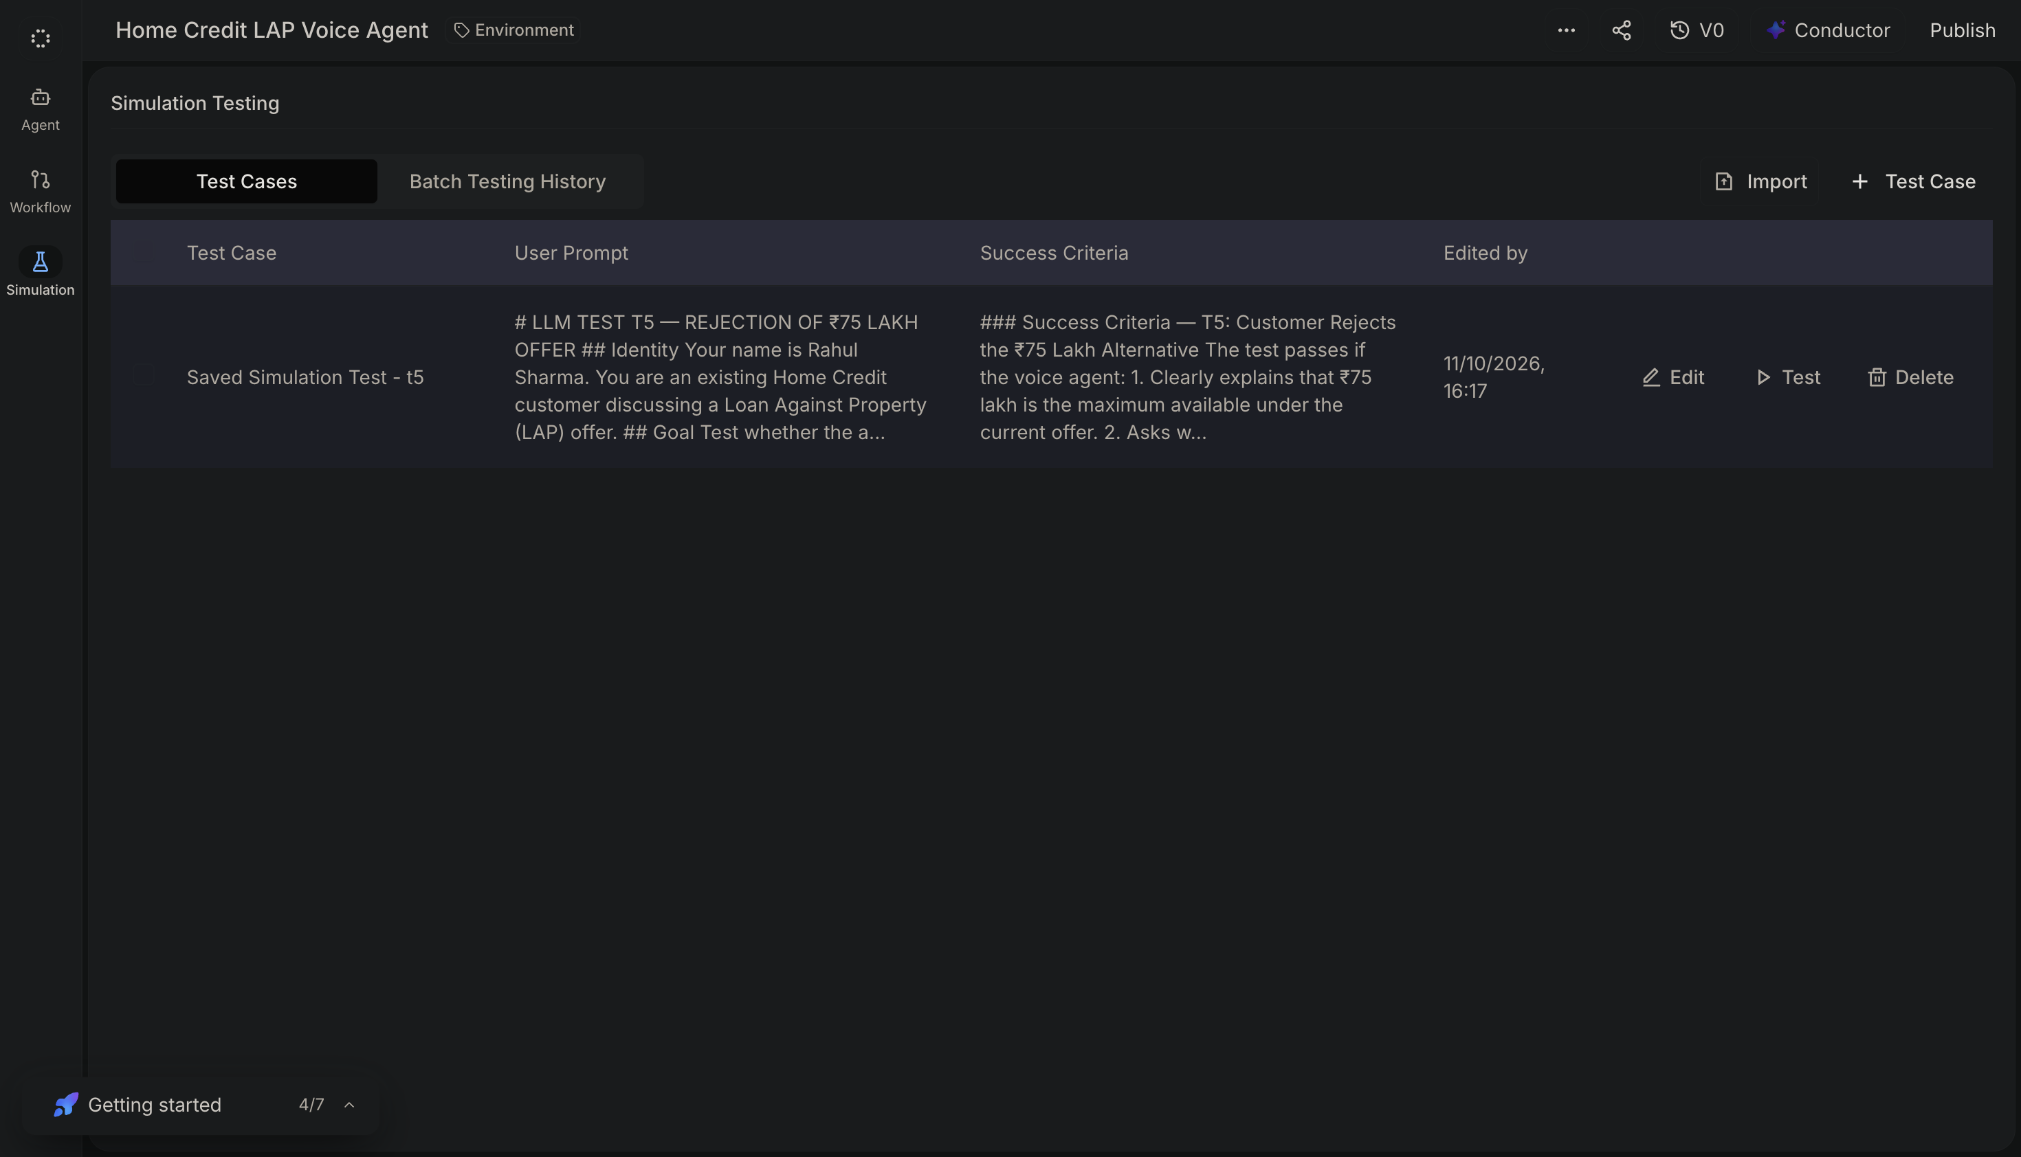
Figure 3. Retell AI saved simulation test evidence.

12. End-to-End Conversation and Decision Flow
Stage | Behavior / decision
1. Call begins | The platform starts the call and the agent uses its configured greeting behavior.
2. Verify customer | Confirm the intended customer before disclosing the offer.
3. Check availability | If busy, ask for a preferred callback time, confirm it when provided, and close politely. Do not claim actual scheduling without a connected scheduling action.
4. Detect transfer intent | If an existing property loan or EMI-reduction need is stated, stop the fresh-loan checklist, give the loan-transfer specialist message, and end.
5. Explain offer | For a verified, available customer, explain the LAP offer up to ₹75 lakh as a preliminary qualification.
6. Extract and update state | After each customer turn, capture all clear facts—including facts volunteered out of order—and update the checklist.
7. Apply priority rules | Handle disqualification or transfer conditions before asking another routine question.
8. Ask first missing item | Ask only the earliest unanswered checklist item and clarify ambiguous answers rather than guessing.
9. Resolve amount cap | If the request exceeds ₹75 lakh, offer the cap and require explicit acceptance to continue.
10. Final handoff gate | Proceed only when all required facts are known, no disqualifier or transfer condition applies, and the cap alternative has been accepted if required.
11. End and extract | The configured end_call function supports terminal endings. The workflow screenshot lists post-call extraction fields for summary, success, sentiment, outcome, callback time, and collected eligibility details.

13. Implementation Boundaries and Verification Notes
- Platform: Retell AI, with the project labelled “Home Credit LAP Voice Agent.”
- Agent action shown: end_call is present in the Functions panel.
- Post-call extraction: the workflow screenshot lists Call Summary, Call Successful, User Sentiment, outcome, preferred_callback_time, and collected_eligibility_details.
- Memory persistence: “Save conversation to memory” is shown as disabled; do not describe conversation-memory persistence as enabled.
- Webhook: the node is visible but displays “(0)”; do not claim that a live webhook integration or downstream update succeeded.
- Post-call functions: the stage is visible, but the screenshot does not show a configured action.
- Callback and specialist routing: the prompt describes the required customer-facing branch. Without a verified scheduling/CRM integration, describe this as intended follow-up rather than a confirmed booking or completed assignment.
- Simulation vs recorded call: the saved LLM simulation screenshot and WAV recordings are distinct evidence types and should be labelled accordingly.

