Phil Watz

Maithreya Chakravarthula

University of Texas at Dallas

AT&T - Big Data Regional Fall Case Competition

* Create a plan on how to collect social media data concerning customer experiences (AT&T will not provide any data for this competition)
* Identify key factors that go into positive or negative customer experiences from the data you collected- list the different social media platforms involved in analysis
* Present the procedure you would take to drill down to specific retail store customer sentiment and how you would rank the locations based on your findings
* Extra Deliverable: Dive deeper into the data and utilize data analytic techniques to go along with your procedure. This is not required but welcomed if you have time

Data Collection: Data used for this project will come from a variety of sources, such as: [ATT.com](https://www.att.com/), actual store data, Yelp, Google Reviews, Foursquare, Twitter and Facebook pages, and academic papers pertaining to how social media correlates to retail sales performance (data collected will be stored in Excel/Google Sheets).

Key Factors Pertaining to Positive and Negative Customer Experiences:

* Customers are looking for ways to feel valued and make their lives easier
* Discover which experiences do not matter to customers, in order to focus on areas they value
* Factors determining a positive customer experience vary by retail category
* Finding and implementing the top experiences your customers value do have an impact on their behavior

Customers are looking for ways to feel valued and make their lives easier: It’s no surprise that the biggest factor in fostering a positive retail customer experience is making your customers feel like they matter, rather than just another statistic. Customers would like the freedom of picking their own sale items, which is different from offering items at the lowest price. It’s about allowing the customer to control their interaction based on their unique needs and wants. Secondly, you can add value to customers by offering a hassle-free return policy - retail brands with generous return policies are often highly-regarded. Shoppers also want to receive the lowest price without needed to work for it, without needing additional coupons or offers such as store-branded credit cards to give them the “best price.” Lastly, customers who redeem loyalty points for additional savings feel more valued than those without loyalty programs. Studies have shown that over one-third of customers feel that point programs for extra savings were important because not only does it save them money, it encourages them to spend more money.

Discover which experiences do not matter to customers, in order to focus on areas they value: In a study where 27 unique elements that pertain to a positive customer experience were polled, the five that mattered the least to consumers were:

* Access to the cardholder’s club - enjoy coffee of a glass of wine or just relax in a space reserved for cardholders (8%)
* Associates available to carry your purchases to your car (8%)
* Complimentary bottled water and coffee (7%)
* Access to complimentary laptops and tablets when in the store (6%)
* Valet parking means you don’t have to worry about finding parking spaces (6%)

Knowing which of these matter least to customers is important because it allows retailers to focus their resources and efforts on what elements matter most to their customers. However, shopper expectations are different, what may matter to some may not matter the general population or certain retail segments.

Factors determining a positive customer experience vary by retail category: Retailers often survey customers to think back on some of their most positive retail experiences, to which different retail categories/segments have been established, to which retailers can narrow down specific categories to focus on and improve in order to meet metrics and profits. The following is a customer experience drive chart by retail category:

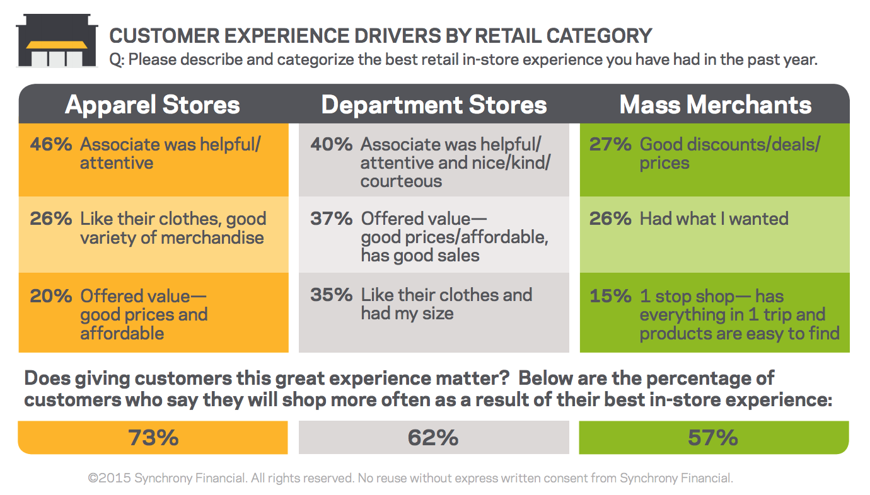

Finding and implementing the top experiences your customers value do have an impact on their behavior: The value of an excellent customer experience cannot be overstated, and customers are more willing to to pay more for a product or service in exchange for great customer service.

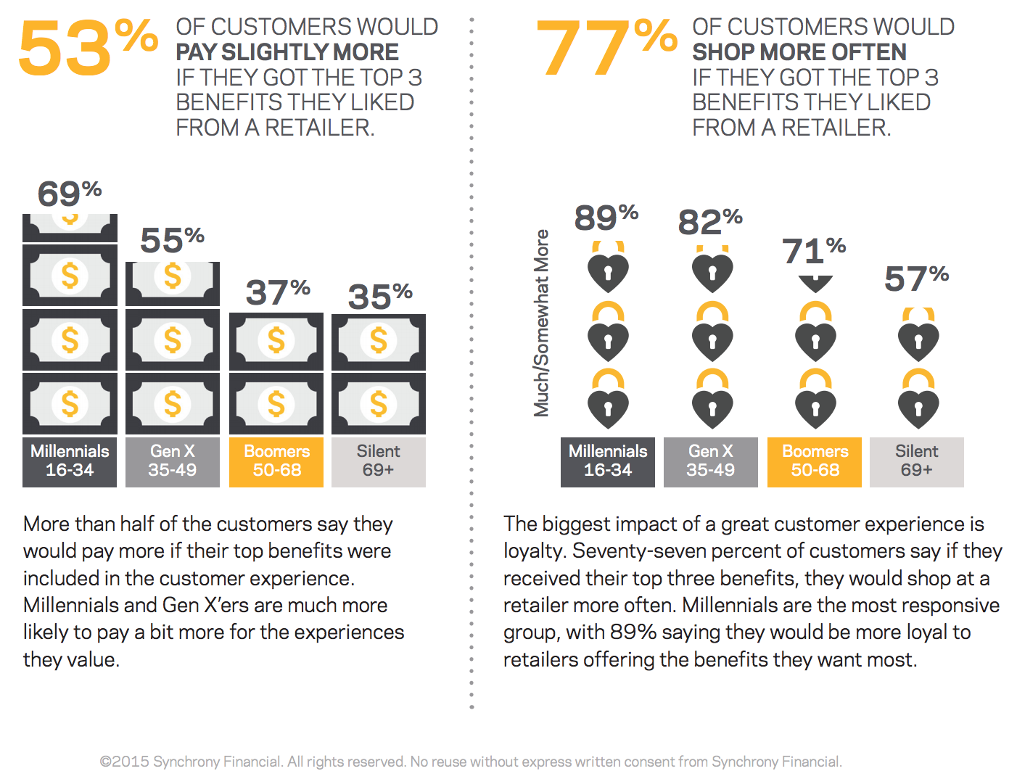

The Retail Customer Experience (2015, September 30). Retrieved October 20, 2016, from https://www.synchronyfinancial.com/SynchronyFinancialCustomerExperienceWhitePaperSept2015.pdf

Calvin College openURL resolver

The process we plan on using to find the correlation between the social media comments and the retail store performance is as follows.

1. We plan on first gathering data of demographics and break them up by zip code. This could be gathered from the US census bureau’s website.
2. Using Hofstede's cultural dimensions theory, we plan to apply the dimension ratings by culture within the zip code to get the basic understanding of the area's overall consumer behavior.
3. Once we have classified our information, we plan on building an analytics engine on R for clustering, and regression analysis. We plan on topping this with a User Interface to allow users some flexibility to pick and choose from various different options.
4. We have found a couple of applications that gathers tweets (using a particular #). This application would help us filter through various tweets directed towards AT&T’s customer service (@ATTCares).
5. We have already gathered data of social media comments from Google Reviews and Yelp. Once we have all the data we need, we plan on creating a database and export into our analytics engine to run through analysis.
6. In addition to this, we plan on cross referencing our findings with the retail stores sales figures. This way we understand the true result, and the real correlation between comments to sales.
7. Finally, to cap it off, we have acquired the performance figures of the top 10 retail stores. We plan on adding up the sales and comparing that to the total retail sales to see if there is anything that is missing in our analysis.

In order to drill down to specific retail store customer sentiment, we have gone through various academic papers that help us reach to a certain conclusion. We plan on implementing a “Perceptual Filter” to the customers within the specified region. This means studying the effects of:

* Exposure – knowing and reacting to an existing stimuli (seeing a poster, flyer, a TV ad etc.)
* Attitude – What a customer feels, thinks and believes something.
* Lifestyle – What a customer values? How the person wants to spend his money and time, and live his life.
* Roles – The position the individual (customer) takes up when he is with a group.
* Motivation – A desire to achieve. Could be anything from wanting a product ‘X’ to needing the same product. How much he wants it.
* Situation – One of the most influential factors that affect buying decisions. Situation can dictate why, how, where, when and what customers have to purchase. More often than not, situation tends to divert the regular decision making process of the customer (Kotler, 2007).
* Culture – The way an individual lives. This is gained through observation, experience and interaction with the other members of the society. Culture is generally the make or break of the decision. It is the behavior, belief and actions taken by customers (Kotler, 2007).

These factors and its effects could be studied using the Hofstede's cultural dimensions. Hoftede’s Theory of Cultural Dimension is a theory that looks at unique aspects of cultures and rates them on a scale for comparison.

Hofstede’s Theory of Cultural Dimensions deals with six dimensions:

Power Distance: the extent to which society accepts the fact that power in institution and organizations is distributed unequally (Petzall and Kim Teo).

Uncertainty Avoidance: the extent to which society feels threatened by uncertain and ambiguous situations (Petzall and Kim Teo).

Individualism: the degree to which people live in a loosely knit social structure and are motivated by self-interests and the interests of their immediate family members, versus a tight social structure in which people distinguish between in-groups and out-groups.

Masculinity: the extent to which the dominant values in society are masculine (assertiveness, material acquisition) rather than feminine (caring for others, quality of life, a people orientation) (Petzall and Kim Teo).

Long Term Orientation: how every society has to maintain some links with its own past while dealing with the challenges of the present and future (Hofstede, 2010).

Indulgence: the extent to which people try to control their desires and impulses (Geert Hofstede, 2013).

Once we have segregated the data into the categories we have discussed above, we plan on scaling the data to make sure there is no one factor that dominates or skews the findings and then weight them based on the impact they have on the buyer’s satisfaction. After this, the initial rankings of the locations would be based on a weighted average rating method.

Through our initial research, we have been able to find that the social media platforms that customers use tend to change based on what they want to express. Through this we were able to pin down that the following social media platforms would be the most suitable for our primary analysis:

Pinterest is a platform that customers tend to visit to look at the stores product range. It is interesting to note that retailers/ businesses often engage viewers through high quality images and give them free reign to browse and examine potential purchases. As one of the largest social media networks in the world it is also a great source of referral traffic which we plan on taking into consideration in our analysis.

Facebook is a great place to engage existing customers and offer sales and promotions. This is where social media is a sales tool. Facebook advertising is a major benefit of the network as it allows you to direct traffic to either the brand’s Facebook page or to its actual website. We have noticed that independent retailers have their own FB page and followers or users posting comments on it.

Twitter is used for customer service and to gain customer insights about the brand, certain products and their sentiment about products they have already purchased. Twitter Advanced Search is a useful function retailers use to see what people are saying about their brand. As mentioned to gain insights into customers sentiments, we plan on using the shiny app we mentioned above.

Reference Used:

<http://www.census.gov/quickfacts/table/RHI305210/48113>

<https://geert-hofstede.com/united-states.html>

<https://socialmediasydney.net.au/how-retailers-can-use-social-media-to-their-advantage/>

<http://smallbusiness.chron.com/social-media-affect-retail-businesses-39275.html>

<https://socialmediaweek.org/blog/2015/03/how-social-media-impacts-retail-brands/>

social media reviews and retail performance

https://www.internetretailer.com/2011/04/13/most-consumers-seek-out-online-reviews-not-social-media