Ex No: 1  Date: 19-06-26 | Building and Training a Basic Neural Network for Binary Classification

Objective:

To build a logistic regression classifier to recognize cat’s vs non cat using Gradient descent implementation.

Descriptions:

Binary classification is the task of classifying elements of a given set into two groups. Logistic regression is an algorithm for binary classification. We have an input image x and the output y is a label to recognize the image. 1 means cat is on an image, 0 means that a non-cat object is in an image.
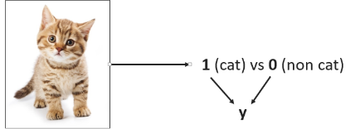

Logistic regression is a supervised learning algorithm that we can use when labels are either 0 or 1 and this is the so-called Binary Classification Problem. An input feature vector X may correspond to an image that we want to recognize as either a cat picture (1) or a non-cat picture (0). That is, we want an algorithm to output the prediction which is an estimate of y: Logistic Regression doesn't have a hidden layer. If you initialize the weights to zeros, the first example x fed in the logistic regression will output zero but the derivatives of the Logistic Regression depend on the input x (because there's no hidden layer) which is not zero. So at the second iteration, the weights values follow x's distribution and are different from each other if x is not a constant vector.

Model:

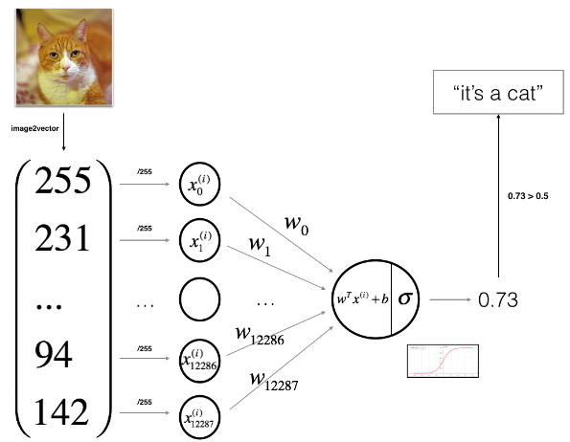

Building the parts of algorithm

The main steps for building a Neural Network are:
- Define the model structure (such as number of input features)
- Initialize the model's parameters
- Loop:
  - Calculate current loss (forward propagation)
  - Calculate current gradient (backward propagation)
  - Update parameters (gradient descent)

GitHub Link:

Maithri606/ML_LAB

