**CSE3002 Internet and Web Programming (Lab Component)**

Assessment-2 (HTML and CSS) Date: 09/08/2022

Slot: L41+42 (ELA)

Name: Maitrey Bhute Reg. No: 20BCE0771

**Question**

1) Demonstrate the concept of HTML and CSS for any application of your choice. Create a homepage (add details about the application/your personal details) containing the tabs to toggle between the other pages (registration, login pages). Apply CSS styles including selectors, box models, customized background - borders- text effects, multiple columns layout, animations, etc.,

**Code:**

<!DOCTYPE html>

<html lang="en">

  <head>

    <title>Lab-1 Assignment</title>

  </head>

  <body>

    <form method="get" style="font-size: 18px;">

      <fieldset>

        <table style="margin-left: 25vw;">

          <legend id="title" style="margin-left: 40vw;">

            <h2>Student Registration</h2>

          </legend>

          <tr style="vertical-align: baseline">

            <td width="400px">

              <h3>Personal Data</h3>

              <label autofocus for="name">Name:</label>

              <input

                placeholder="eg. John Smith"

                id="name"

                type="text"

                name="name"

                autofocus              />

              <br /><br />

              <label for="email">Email:</label>

              <input

                placeholder="eg. domain@gmail.com"

                id="email"

                type="email"

                name="email"

              />

              <br /><br />

              <label for="bdate">Birthdate:</label>

              <input  id="bdate" type="date" name="bdate" />

              <br /><br />

              <label for="age">Age: </label>

              <input  id="age" type="number" name="age" min="18" />

              <output name="x" for="a"></output>

              <br /><br />

              <label>Gender: </label>

              <input  type="radio" name="gender" value="male" />

              <label for="male">Male</label>

              <input type="radio" name="gender" value="female" />

              <label for="female">Female</label>

              <input type="radio" name="gender" value="female" />

              <label for="female">Other</label>

              <br /><br />

              <label>Nationality:</label>

              <input  name="nationality" list="editors" />

              <datalist id="editors">

                <option selected value="Indian"></option>

                <option value="NRI"></option>

                <option value="Foreigner"></option>

              </datalist>

              <br /><br />

              <label>Address:</label>

              <br />

              <textarea  name="address" width="100px"></textarea>

              <br /><br />

              <input id="reset" type="reset" style="font-size: 15px;"/>

              <input id="reset" type="submit" style="font-size: 15px;"/>

            </td>

            <td>

              <legend><h3>Academic Data</h3></legend>

              <label for="regno">Reg. No:</label>

              <input

                id="regno"

                name="regno"

                type="text"

                pattern="^[1-9]{1}[0-9]{1}[A-Za-z]{3}([0-9999]{4})$"

              />

              <br /><br />

              <label>Skills:</label>

              <input type="checkbox" id="html" name="lang1" value="html" />

              <label for="html">HTML</label>

              <input type="checkbox" id="css" name="lang2" value="css" />

              <label for="css">CSS</label>

              <input type="checkbox" id="js" name="lang3" value="js" />

              <label for="js">JavaScript</label>

              <input type="checkbox" id="js" name="lang4" value="js" />

              <label for="js">PHP</label>

              <br /><br />

              <label>Upload Your Image:</label>

              <input type="file" accept="image/*" name="image" />

              <br />

              <br /><br />

            </td>

          </tr>

          <tr></tr>

        </table>

        <br />

      </fieldset>

    </form>

  </body>

</html>

**Output:**

* Used theme of a hackathon portal
* Used forms in previous DA as a registration form of hackathon portal sign up / sign in.
* Used box model, animations, different fonts
* Created more than one web-pages to connect website features

**Screenshots:**



**Main Page**

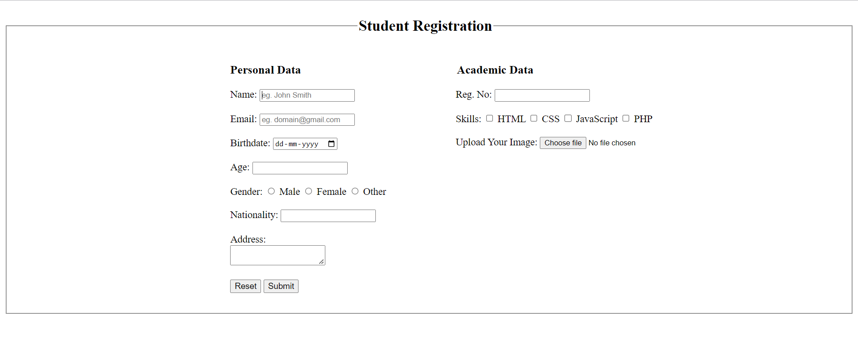

**Required fields: (**Name, Email, Birthdate, Age, Gender, Nationality, Address, Reg. No.**)**

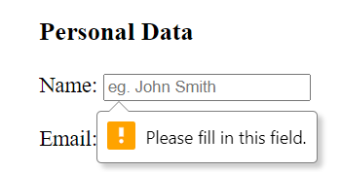

**Used Regex (**Reg. No**.):**

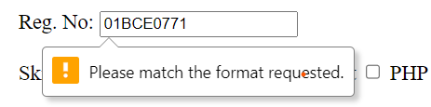

**After putting Inputs:**

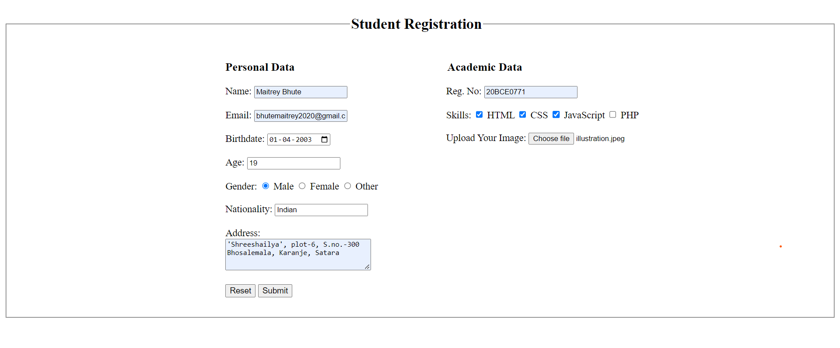

**URL change due to GET method:**

http://127.0.0.1:5501/lab1.html?name=Maitrey+Bhute&email=bhutemaitrey2020%40gmail.com&bdate=2003-04-01&age=19&gender=male&nationality=Indian&address=%27Shreeshailya%27%2C+plot-6%2C+S.no.-300%0D%0ABhosalemala%2C+Karanje%2C+Satara&regno=20BCE0771&lang1=html&lang2=css&lang3=js&image=illustration.jpeg