B.Tech Project CP-303
Virtual Instrumentation of Arc Welding

Updated Project Report
Department of Mechanical Engineering, IIT Ropar



Supervised by:
Dr. Chandrakant K. Nirala

Submitted by:
Chahat - 2022MEB1046
Arnav Maitreya - 2022MEB1299

Submitted on: 18th April, 2026

Content 2
Chapter 1: Introduction 4
1.1 Background and Motivation 4
1.2 Problem Description 4
1.3 Objectives 5
Chapter 2 : Methodology 1 – Evaluation Techniques 6
2.1 Overview 6
2.2 Pearson Correlation Coefficient 6
3.3 Mean Squared Error (MSE) 6
3.4 Dynamic Time Warping (DTW) 7
3.5 Statistical Feature Comparison 7
Chapter 4 : Methodology 2 – Synthetic Signal Generator 8
4.1 Signal Segmentation 8
The first step in synthetic signal generation was segmenting the welding signal into individual peaks 8
Since welding signals are continuous time-series signals, segmentation was required to isolate individual welding events 8
The segmentation process involved: 8
● Detecting peaks in current or power signals 8
● Identifying the start and end points of each peak 8
● Extracting a time window around each peak 8
signal generation 8
4.2 Generative Adversarial Networks (GAN) 8
4.3 Spring-Mass Displacement Calculation 9
4.4 Markov Model 9
4.5 Semi-Markov Model 9
Chapter 5 : Work Progress 10
5.1 Data Collection 10
5.2 Signal Preprocessing 10
5.3 Feature Extraction 11
5.4 Synthetic Signal Generation Experiments 11
5.5 Development of Semi‑Markov Model 11
Chapter 6: Challenges Faced 12
6.1 Limited Dataset Availability 12
This limitation significantly affected the performance of generative models 12
6.2 Peak Alignment Issues 12
6.3 Autocorrelation Function (ACF) Mismatch 13
6.4 Incorrect Signal Distribution 13
6.5 Sensitivity to Input Data 13
6.7 Instability in GAN Training 14
Chapter 7: Results - Development of Dashboard for Result Visualization 15
7.1 Visualization of Welding Signals 16
7.2 Peak Analysis 16
7.3 Correlation and Evaluation Metrics 16
7.4 Interactive Analysis 16
7.5 Purpose of the Dashboard 16

Each segmented peak represents a single welding arc event, which forms the basis for synthetic
Chapter 9: Conclusion 17
Chapter 10: References 1

1: Introduction

1.1 Background and Motivation
Welding is one of the most widely used manufacturing processes in industries such as automotive, aerospace, construction, and heavy engineering. The quality and strength of welded joints depend heavily on electrical parameters like Voltage (V) and Current (I) during the welding process. These parameters vary continuously with time and reflect the behavior of the welding arc.

Modern welding systems allow monitoring of electrical signals through Virtual Instrumentation, which records time‑series data of voltage and current using computer-based measurement systems. By analyzing these signals, it is possible to understand welding behavior, detect abnormalities, and monitor weld quality.

However, raw welding signals are continuous and complex, making it difficult to directly interpret welding conditions. Therefore, signal processing and data analytics techniques are required to extract useful information from these signals.

This project focuses on analyzing welding electrical signals, identifying individual welding events (peaks), and categorizing them into meaningful classes such as normal arcing, effective welding, and short circuits.

1.2 Problem Description
Modern welding machines generate large amounts of electrical signal data such as Voltage (V), Current (I), and Power (P) with respect to time. These signals contain valuable information about welding arc behavior and weld quality.
Traditionally, to obtain sufficient datasets for analysis, welding machines must be operated repeatedly under different parameter settings. This requires the machine to run continuously for long durations, which leads to:
- High electrical energy consumption
- Increased equipment wear
- Higher operational cost
- Time-consuming experimentation
Additionally, the signals generated during welding are continuous and complex, making it difficult to identify individual welding events and categorize them into different welding conditions. Therefore, there is a need to develop a system that can:

- Analyze welding voltage and current signals
- Detect and segment welding peaks
- Categorize welding events into meaningful classes
- Generate additional realistic datasets without repeatedly running the welding machine
By generating synthetic or augmented datasets from existing welding signal data, the proposed system can reduce the need to operate welding machines solely for data collection, thereby saving a large amount of electrical energy and reducing experimental costs.

1.3 Objectives

The main objectives of the project are:
- To collect welding electrical signal data using Virtual Instrumentation.
- To analyze voltage and current signals obtained from the welding process.
- To preprocess and clean the signal data for accurate analysis.
- To detect peaks in the welding signal representing individual welding events.
- To extract meaningful features from each welding peak.
- To generate additional realistic datasets from existing signals.
- To classify each welding peak into categories such as:
○ Normal arcing
○ Effective welding
○ Short circuit
- To develop a structured dataset that can be used for intelligent welding analysis.

2 : Methodology 1 – Evaluation Techniques

2.1 Overview
Evaluation techniques were used to assess the similarity between the original welding signals and the generated synthetic signals. These techniques help determine whether the synthetic data preserves the statistical and temporal characteristics of the real welding signals.
The evaluation focused on measuring correlation, error, and similarity between the real and generated signals.

2.2 Pearson Correlation Coefficient
The Pearson correlation coefficient was used to measure the linear relationship between real and synthetic signals.
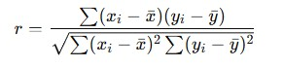
Where:
- xixi = real signal values
- yiyi = synthetic signal values
- xˉxˉ, yˉyˉ = mean values
A correlation value close to 1 indicates strong similarity between signals.

3.3 Mean Squared Error (MSE)
Mean Squared Error measures the average squared difference between real and synthetic signals.
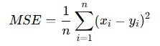
Where:
- xixi = real signal value
- yiyi = synthetic signal value
- n = number of samples
Lower MSE values indicate that the generated signals are closer to the real signals.

3.4 Dynamic Time Warping (DTW)
Dynamic Time Warping (DTW) measures similarity between two time‑series signals that may vary in speed or duration.
This metric is useful because welding signals may have peaks that occur at slightly different time intervals while still representing the same welding behavior.

3.5 Statistical Feature Comparison
Statistical properties of real and synthetic signals were also compared.
The following features were analyzed:
- Mean value
- Variance
- Standard deviation
- Peak amplitude
- Signal duration
This comparison ensured that the generated signals maintained the statistical characteristics of the original dataset.

4 : Methodology 2 – Synthetic Signal Generator

4.1 Signal Segmentation

The first step in synthetic signal generation was segmenting the welding signal into individual peaks.

Since welding signals are continuous time-series signals, segmentation was required to isolate individual welding events.

The segmentation process involved:

● Detecting peaks in current or power signals

● Identifying the start and end points of each peak

● Extracting a time window around each peak
Each segmented peak represents a single welding arc event, which forms the basis for synthetic signal

generation.

4.2 Generative Adversarial Networks (GAN)
The initial approach used for generating synthetic welding signals was Generative Adversarial Networks (GANs).
A GAN consists of two neural networks:
Generator
The generator produces synthetic welding signals that resemble the real signals.
Discriminator
The discriminator evaluates whether the generated signal is real or synthetic.
The GAN objective function is:
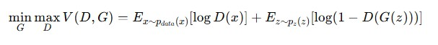
However, GAN models did not perform well due to:
- Limited dataset size
- Training instability
- Difficulty capturing complex welding signal patterns

4.3 Spring-Mass Displacement Calculation
To better handle time‑series data, TimeGAN was explored.
TimeGAN integrates:
- Generative Adversarial Networks
- Recurrent neural networks
- Temporal embedding
It aims to preserve both:
- Feature distribution
- Temporal dynamics
Despite these advantages, the generated signals did not closely match the real welding signals.

4.4 Markov Model
A Markov model was then explored to represent welding signal transitions.
The Markov assumption states:

P(Xn+1 =j∣Xn =i)
Meaning that the next state depends only on the current state.
However, Markov models assume constant time duration in each state, which does not accurately represent welding signals where state durations vary.

4.5 Semi-Markov Model
To overcome the limitations of Markov models, a Semi‑Markov model was implemented.
A Semi‑Markov process allows transitions between states with variable time durations.
The transition probability is defined as:
Pij (t)=P(Xn+1 =j,Tn+1 −Tn ≤t∣Xn =i)
Where:
- XnXn = current state
- Xn+1Xn+1 = next state
- TnTn = time of transition

The model includes:
- State transition matrix
- Sojourn time distribution
This approach provided a better representation of the temporal behavior of welding signals and produced more realistic synthetic data.

Chapter 5 : Work Progress
The project progressed through multiple stages, starting from data acquisition and signal analysis to synthetic signal generation and evaluation.

5.1 Data Collection
The first stage involved collecting welding electrical signals using a virtual instrumentation system. Voltage and current signals generated during the welding process were recorded as time‑series data. These signals represent the behavior of the welding arc under different welding conditions.
The collected data was stored in tabular format and visualized as voltage‑time and current‑time graphs.

5.2 Signal Preprocessing
The raw welding signals contained noise and fluctuations due to electrical disturbances and sensor measurements. Therefore, preprocessing techniques were applied to improve signal quality.
This stage involved:
- Noise filtering
- Signal smoothing
- Normalization of voltage and current values
These steps helped obtain clean signals suitable for further analysis.

5.3 Feature Extraction
After segmentation, different features were extracted from each welding peak to describe the signal behavior numerically.
The extracted features included:
- Maximum current
- Minimum voltage
- Peak power
- Peak duration
- Rise time and fall time
- Statistical measures such as mean and variance
These features helped represent the welding signals in a structured format for further modeling.

5.4 Synthetic Signal Generation Experiments
To expand the dataset, several synthetic signal generation techniques were explored.
Initially, Generative Adversarial Networks (GAN) were implemented to generate artificial welding signals. However, the generated signals did not accurately represent the real welding patterns.
Next, TimeGAN, a model designed specifically for time‑series data, was implemented. Although it improved temporal modeling, the generated signals still showed mismatches with the original welding data.

5.5 Development of Semi‑Markov Model
A Markov model was first tested to represent transitions between welding states. However, the Markov model assumed fixed state durations, which did not reflect the variability present in welding signals.
To overcome this limitation, a Semi‑Markov model was implemented. This model allows variable durations in each state and better captures the temporal characteristics of welding signals.
The Semi‑Markov model was used to generate synthetic signal sequences that closely resemble the behavior of real welding signals.

Chapter 6: Challenges Faced
During the development of the project, several technical challenges were encountered while analyzing welding signals and generating synthetic data. These challenges were mainly related to signal characteristics, modeling limitations, and evaluation of the generated signals.

6.1 Limited Dataset Availability
One of the major challenges faced during the project was the limited availability of welding signal data. Deep learning models such as GAN and TimeGAN typically require large datasets to learn complex signal patterns effectively.

However, the available dataset contained a limited number of welding signal samples. As a result:

- The models could not capture the full variability of welding signals.
- Training instability occurred in deep learning models. ● Generated synthetic signals lacked diversity.

This limitation significantly affected the performance of generative models.

6.2 Peak Alignment Issues
Another important challenge was related to peak alignment in synthetic signals.

In the original welding signals, peaks correspond to welding arc events and occur at specific intervals. However, when synthetic signals were generated:

- The peaks did not occur at the correct time locations.
- The number of peaks per unit time differed from the real signals.
- Some generated signals contained extra peaks, while others had missing peaks.
This mismatch made it difficult to accurately reproduce the temporal characteristics of the original welding signals.

6.3 Autocorrelation Function (ACF) Mismatch
The Autocorrelation Function (ACF) was used to analyze the temporal dependency within the welding signals.
When comparing the ACF of the real signals and synthetic signals, it was observed that:
- The autocorrelation patterns did not match closely.
- The generated signals failed to preserve the temporal relationships present in the original dataset. ● Periodic characteristics of the welding signal were not accurately captured.
This indicated that the synthetic models were not fully learning the underlying temporal structure of the welding process.

6.4 Incorrect Signal Distribution
Another issue encountered was that the statistical distribution of the generated signals differed from the original signals.

For example:
- Mean values of voltage or current sometimes deviated significantly.
- Variance of generated signals was either too high or too low.
- Peak amplitudes were not consistent with real welding signals.

These discrepancies indicated that the models were not properly capturing the statistical characteristics of the data.

6.5 Sensitivity to Input Data
The models used for synthetic signal generation were highly sensitive to the quality and structure of the input data.
Challenges related to input data included:
- Missing or inconsistent data points
- Noise in the raw signals
- Improper segmentation of peaks
If the input signals were not properly preprocessed or segmented, the generated synthetic signals became inaccurate.

6.6 Difficulty in Modeling Temporal Variability
Welding signals exhibit significant temporal variability, meaning that:
- The duration of welding peaks varies.
- The time between peaks is not constant.
- Signal amplitudes change depending on welding parameters.
Traditional models such as Markov chains assume fixed transition timing, which made it difficult to represent the real welding signal behavior accurately.
This limitation motivated the use of Semi-Markov models, which allow variable state durations.

6.7 Instability in GAN Training
During the implementation of GAN-based models, several training issues were observed:
- Mode collapse, where the generator produces similar signals repeatedly.
- Difficulty in balancing the generator and discriminator networks. ● Slow convergence during training.
These issues resulted in synthetic signals that did not accurately represent the real welding signal patterns.

6.8 Model Selection Challenges
Selecting an appropriate model for synthetic signal generation required experimentation with multiple approaches.
Several models were explored:
- GAN
- TimeGAN
- Markov Model
- Semi-Markov Model
Each model had advantages and limitations. Identifying the most suitable model required extensive testing and evaluation.
Eventually, the Semi-Markov model was selected because it could better capture the temporal behavior and state duration variability present in welding signals.

6.9 Evaluation Difficulties
Evaluating the quality of synthetic signals was also challenging. Multiple metrics had to be used to determine how closely the generated signals matched the real signals.
These included:
- Pearson correlation
- Mean Squared Error (MSE)
- Dynamic Time Warping (DTW)
- Autocorrelation comparison
Interpreting these metrics together to determine the effectiveness of the models required careful analysis.

Chapter 7: Results - Development of Dashboard for Result Visualization
After implementing the Semi‑Markov model and generating synthetic welding signals, a dashboard was developed to visualize and analyze the results in an interactive manner. The purpose of the dashboard was to provide a clear and organized way to compare the real welding signals and the generated synthetic signals.
The dashboard integrates different visualization components to display important aspects of the analysis, including signal behavior, peak distribution, and statistical comparison.
The dashboard includes the following features:
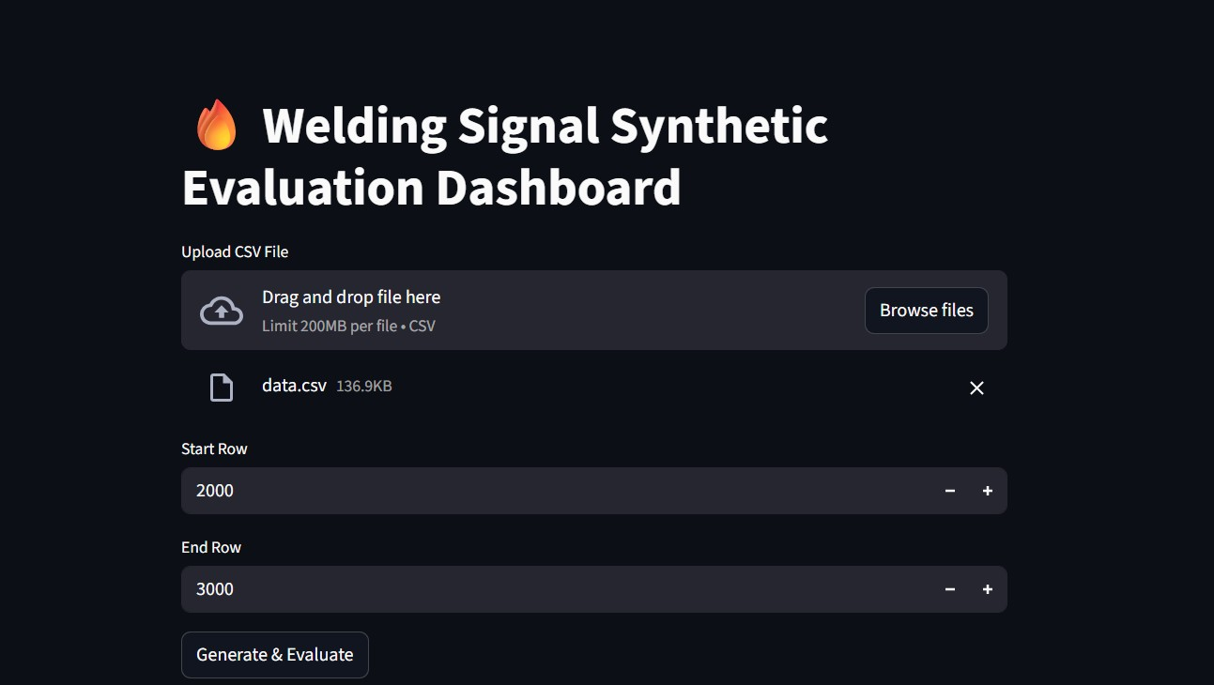

7.1 Visualization of Welding Signals
Graphs were created to display voltage vs time and current vs time signals for both real and synthetic datasets. This helped in visually verifying whether the generated signals follow similar patterns as the original welding signals.
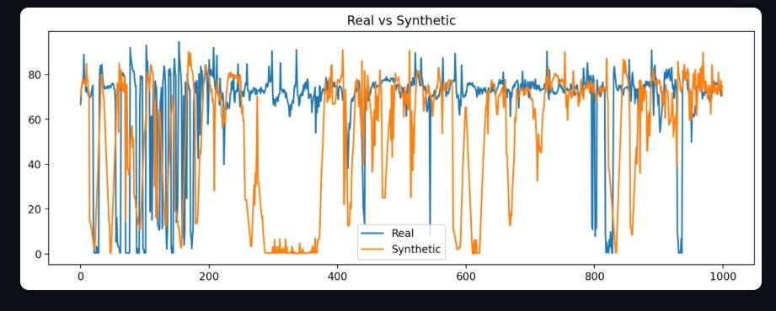

7.2 Peak Analysis
The dashboard displays detected peaks for each signal segment. This allows comparison of the number of peaks per unit time, peak amplitudes, and peak intervals between real and synthetic signals.
Statistical Comparison
Key statistical properties of the signals such as:
- Mean
- Variance
- Standard deviation
- Peak amplitude were displayed in the dashboard to compare the similarity between real and generated signals.

7.3 Correlation and Evaluation Metrics
The dashboard also presents the calculated evaluation metrics used in the project, including:
- Pearson correlation coefficient
- Mean Squared Error (MSE)
- Dynamic Time Warping (DTW)
- Autocorrelation analysis
These metrics help quantify the similarity between the real and synthetic datasets.
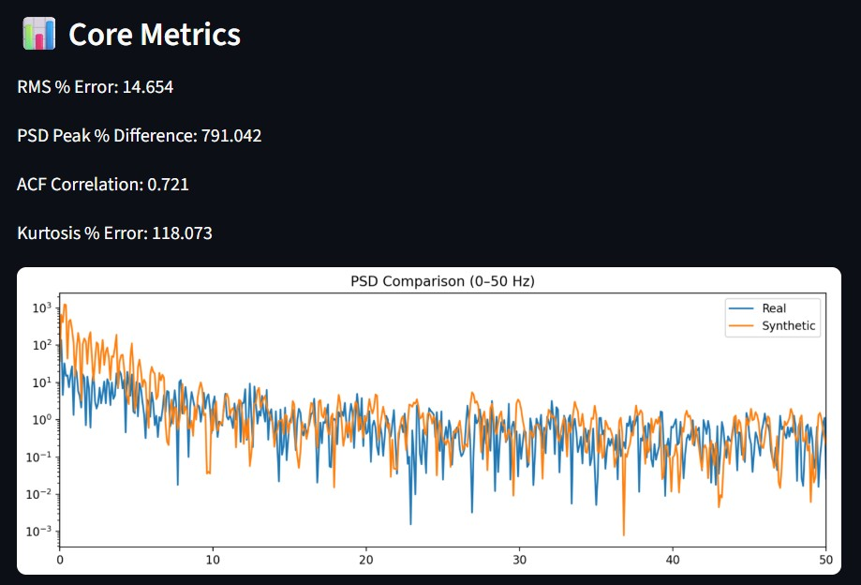

7.4 Interactive Analysis
The dashboard allows easier interpretation of results by presenting multiple visualizations and metrics in a single interface. This helps quickly evaluate the effectiveness of the Semi‑Markov synthetic signal generator.
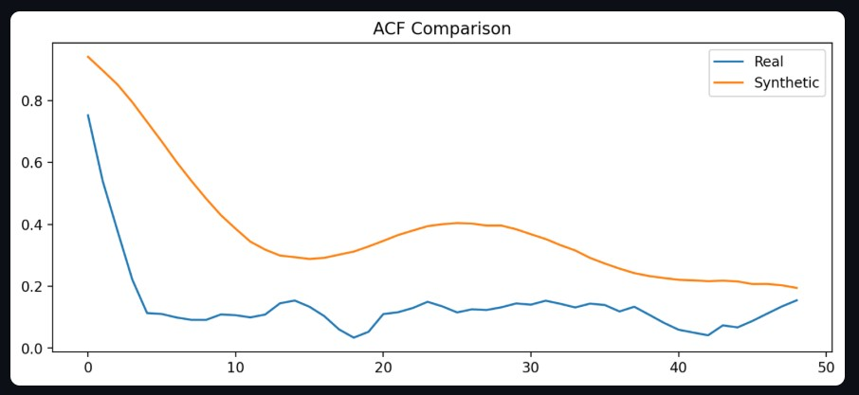

7.5 Purpose of the Dashboard
The dashboard serves as a tool for:
- Visual validation of synthetic signals
- Comparison between real and generated data
- Monitoring evaluation metrics
- Presenting results in an intuitive and organized manner
This visualization platform makes it easier to interpret the performance of the developed synthetic signal generation model.

- Chapter 8: Future Scope

8.1 Integration of Audio Signals with Welding Signals
In future work, the audio signals generated during the welding process can be recorded and synchronized with the corresponding voltage and current signals obtained from the welding machine. Welding arcs produce characteristic sound patterns that reflect the behavior of the welding process. By collecting both electrical and audio signals simultaneously, it will be possible to analyze how the sound produced during welding relates to the variations in welding current and arc stability.

Chapter 9: Conclusion
This project focused on the analysis of welding arc signals using virtual instrumentation and data analytics techniques. The objective of the work was to analyze voltage and current signals generated during the welding process, segment the signals into individual welding events, and generate synthetic signals to expand the available dataset without repeatedly operating the welding machine.
Initially, welding signal data was collected and processed to remove noise and irregularities. The signals were then segmented into individual peaks corresponding to welding arc events. From these segmented peaks, several electrical, temporal, and statistical features were extracted to better understand the behavior of the welding process.
To address the challenge of limited datasets, multiple synthetic signal generation approaches were explored. Generative models such as GAN and TimeGAN were initially implemented to generate time‑series signals. However, due to limited data availability and the complex temporal nature of welding signals, these models did not produce satisfactory results.
Subsequently, probabilistic approaches were explored. A Markov model was tested but was found to be limited because it assumes constant state durations. To overcome this limitation, a Semi‑Markov model was implemented, which allows variable state durations and better represents the temporal characteristics of welding signals.
The synthetic signals generated using the Semi‑Markov model were evaluated using several statistical and correlation metrics, including Pearson correlation, Mean Squared Error (MSE), Dynamic Time Warping (DTW), and autocorrelation analysis. The results showed that the semi‑Markov approach produced synthetic signals that preserved the statistical and temporal characteristics of the original welding signals more effectively than the previously tested models.
One of the key contributions of this work is the ability to generate realistic welding signal data without repeatedly running the welding machine. This approach helps reduce energy consumption, experimental cost, and machine usage, making the process more efficient and sustainable.
Overall, the project demonstrates that probabilistic temporal models such as Semi‑Markov models can effectively generate synthetic welding signals and support further analysis of welding processes. The developed methodology can be used as a foundation for future work in welding process monitoring, intelligent welding systems, and machine learning‑based quality prediction.

Chapter 10: Post-Mid-Semester Progress and Updated Dashboard Development
10.1 Overview of Additional Work
After the mid-semester report, the project moved from a mainly signal-processing study into a complete interactive welding-signal evaluation framework. The current code base now contains a Streamlit dashboard that not only generates and compares synthetic welding current signals, but also interprets them in terms of power delivery, cumulative energy, heat transfer, material response, and peak-type behavior. In other words, the project has progressed from synthetic signal generation alone to a full engineering analysis environment.
The main additions completed after mid-semester are listed below:
- An upgraded Streamlit dashboard in appli.py for report-style interactive analysis.
- A side-by-side real-versus-synthetic comparison workflow across current, power, energy, PSD, ACF, heat, material, and peak behavior.
- A voltage-aware heat calculation module that uses the detected voltage trace when available and a user-defined reference voltage otherwise.
- A mild-steel thermodynamic sufficiency module that estimates mass, required heat, final temperature, and melting status.
- A peak detection and classification framework with user control over resistance, minimum height, minimum distance, prominence, smoothing window, and analysis time interval.
- A themed and numbered dashboard structure so the analysis reads like a technical report.
10.2 Updated Problem Formulation
At the current stage, the problem is no longer only to produce a synthetic welding current signal. The broader problem addressed by the project is to determine whether the synthetic signal can reproduce the real welding process closely enough to be useful for engineering analysis and interpretation. The updated dashboard therefore compares the real and synthetic signals from multiple viewpoints: waveform similarity, electrical power behavior, cumulative energy, spectral structure, temporal memory, welding heat delivery, mild-steel response, and local peak classification.
This updated problem formulation is important because a synthetic signal may appear visually similar to the real signal while still differing in heat input, energy deposition, dominant switching frequencies, or peak categories. The present version of the project explicitly measures those differences instead of relying only on visual similarity.
10.3 Current Synthetic Generator Used in the Code
The active synthetic generator is implemented in generator.py through the function generate_synthetic_and_metrics(df, start_row, end_row). In the current post-mid-semester code version, the generator is data-driven and block-based. It does not create a waveform from pure random noise. Instead, it learns the ON and OFF current structure from the real welding signal and recombines those blocks to form a synthetic signal of the same length as the selected analysis window.
The generator first reads the real signal columns Relative_ms and Current_A. A current threshold is then estimated using the histogram of current amplitudes. When at least two peaks are detected in the histogram, the threshold is taken as the mean of the two lowest histogram peak values. If that is not possible, the code falls back to the 45th percentile of the current signal. This threshold separates the signal into ON-state and OFF-state regions.
After thresholding, the full current trace is segmented into contiguous ON blocks and OFF blocks. Only blocks longer than a few samples are retained. During synthetic generation, one ON block and one OFF block are alternately sampled from those libraries. Each selected block is perturbed with temporally correlated autoregressive noise. The lag-1 autocorrelation of the real current is first estimated, then clipped into a stable range, and finally used in the recurrence noise[i] = phi * noise[i-1] + random_term. This preserves smoothness and local temporal continuity.
The generator also applies a short fade transition between the end of the already generated synthetic signal and the beginning of the new sampled block. This reduces unrealistic discontinuities. The resulting synthetic current therefore preserves the real signal's ON/OFF structure, amplitude ranges, local variability, and switching rhythm more faithfully than a simple random generator.
10.4 Mathematical Basis of the Updated Comparison Framework
Several mathematical expressions are now used in the updated dashboard. The first group is the basic similarity and electrical comparison logic. For the waveform metrics, the code computes RMS current for the real and synthetic signals and reports RMS percentage error. It also computes Pearson correlation between the real and synthetic current traces, and a Pearson correlation between their autocorrelation sequences.
The power spectral density is computed using Welch's method. The sampling frequency is obtained from the median spacing of the time axis in milliseconds. The dominant PSD magnitude of the real and synthetic signals is compared to evaluate whether the main oscillation energy is preserved. Kurtosis is also compared to measure whether the synthetic distribution preserves the sharpness and tail behavior of the real signal.
For electrical and thermal analysis, the updated dashboard uses the core relation P(t) = V(t) x I(t). Total electrical energy is obtained by discrete integration: E_total = sum(P_i x Delta t). The useful heat entering the weld is modeled by Q_net = eta x E_total, where eta is the user-defined efficiency. Heat input per unit length is computed from the useful heat and travel length, and the instantaneous heat-input trace is computed sample by sample from useful electrical power divided by travel speed.
The dashboard further computes cumulative energy, cumulative useful heat, average power, peak power, heat density, and percentage gaps between the real and synthetic results. These mathematical quantities make the comparison much stronger than a simple signal plot because they connect the waveform directly to engineering interpretation.
10.5 Heat Transfer and Welding Interpretation Module
A major post-mid-semester addition is the heat transfer module in heat_utils.py. This module first determines the instantaneous power either from a supplied voltage trace or from the user-entered default voltage. The energy is then integrated over time. The useful portion of that energy is estimated through the efficiency factor eta, and the losses are distributed into physically interpretable categories such as conduction to the surrounding plate, convection to the surroundings, radiation loss, spatter and fume loss, and torch/electrode/fixture loss.
The dashboard presents these quantities not only numerically but also visually. It contains side-by-side energy-distribution plots for real and synthetic signals, cumulative heat plots, instantaneous heat-input-per-unit-length plots, and explanatory notes for each loss mechanism. This is one of the most important project expansions after mid-semester, because the current work now explains what the signal differences mean physically for welding rather than only statistically.
10.6 Mild-Steel Material Analysis
Another major addition after mid-semester is the material response analysis for mild steel. This analysis uses standard material constants for density, specific heat, melting temperature, initial temperature, and latent heat of fusion. From the user-defined weld area and weld length, the code estimates the weld volume and mass. It then computes the sensible heat needed to raise the material from the initial temperature to the melting temperature and adds the latent heat required for phase change.
The total heat required for melting is therefore Q_required = m x c x (T_m - T_0) + m x L_f. The supplied useful heat is compared against that requirement. The module also estimates temperature rise through Delta T = Q_net / (m x c), final temperature through T_final = T_0 + Delta T, and heat sufficiency percentage through Q_net / Q_required x 100. Based on these values, the dashboard reports whether melting is achieved in the real case and in the synthetic case.
This addition is especially important because it converts the comparison from pure signal analytics into a physically meaningful welding result. It allows the report to explain whether differences in synthetic current would matter in terms of actual heating and melting of the workpiece.
10.7 Peak Detection, Peak Power, and Peak-Type Classification
The latest stage of work after mid-semester is the explicit peak-analysis module added to the end of the dashboard. This module works on a user-selected peak-analysis time interval within the broader selected row window. The current traces used for the peak analysis are the same real and synthetic current traces already shown in the dashboard, but the analysis can be restricted to a specific time frame chosen by the user.
The peak module first smooths the current using a user-controlled moving-average window. It then detects local maxima, including flat plateau peaks. Candidate peaks are filtered using three controls: minimum peak height, minimum prominence, and minimum distance between peaks. If the distance is not explicitly given, the code derives an automatic distance from the sample spacing and the total duration of the chosen peak-analysis interval.
For every accepted peak, the dashboard computes a reference current I0 from the largest accepted peak. Then the peak-current ratio I_peak / I0 is used for classification. The peak power is computed from the user-defined resistance using P_peak = I_peak^2 x R. The current code uses four classes: Normal, Effective, Arcing, and Short. Their present thresholds are Normal for 0.90 <= I_peak/I0 <= 1.00, Effective for 0.65 <= I_peak/I0 < 0.90, Arcing for 0.55 <= I_peak/I0 < 0.65, and Short for I_peak/I0 < 0.55.
The peak-analysis section now reports total peak count, average peak power, dominant peak type, side-by-side peak tables, category-wise percentage distribution, and category-wise average peak power for the real and synthetic signals. This makes the updated dashboard much more useful for pulse-wise interpretation of welding behavior.
10.8 User Interface and Reporting Improvements
The post-mid-semester work also includes substantial presentation and usability improvements. The dashboard now uses a report-style layout with numbered themed section headers so that each analysis type is visually separated. The major blocks are Current Waveform Analysis, Power and Energy Delivery Analysis, Quantitative Match Metrics, Frequency and Temporal Pattern Analysis, Heat Transfer and Welding Heat Analysis, Material Response Analysis for Mild Steel, and Peak Detection and Peak-Type Classification.
The interface also provides live user controls for the row window, heat parameters, peak-detection parameters, and the peak-analysis time interval. Side-by-side charts are used wherever possible so that the real and synthetic results can be compared directly. Short explanatory interpretation cards are included beneath or beside the plots so that the dashboard can also be used as a presentation and viva tool, not just as a technical coding interface.
10.9 Present Project Status and Summary
At the present stage, the project has matured into a complete synthetic welding-signal evaluation platform. The earlier mid-semester work established the core problem, segmentation ideas, and synthetic-signal-generation direction. The post-mid-semester work has added a robust interactive dashboard, a currently active block-based synthetic generator in generator.py, a multi-metric comparison workflow, voltage-aware power and heat calculations, mild-steel thermal sufficiency analysis, user-controlled peak detection and classification, and a structured visual report format.
In summary, the new contributions completed after mid-semester have significantly expanded the project from a modeling exercise into a physically interpretable engineering analysis system. The current version can now answer not only whether the synthetic signal looks similar to the real one, but also whether it behaves similarly in terms of energy delivery, heat transfer, material heating, and peak-type distribution. This represents the main progress achieved after the mid-semester report.

