Pokémon Tournament Assessment

Tech Stack: ASP.NET Core 8, Angular 18, TypeScript, Bootstrap 5

Backend Architecture

Layered Architecture
I built the backend by adopting a layered architecture because it provides:
- Clean separation of concerns
- High maintainability
- Easy unit testing
- Scalability for future features
- A structure aligned with enterprise systems
This ensures the backend remains organized and adaptable.

Architecture Layers
Domain Layer
I defined core business entities such as Pokémon, battle results, and statistics. This layer contains pure logic and stays independent from external dependencies.
Application Layer
I implemented tournament logic here: sorting, battle rules, win/loss/tie calculations. This layer defines domain models and applies business rules.
Infrastructure Layer
I built the PokeAPI client here. It handles HTTP calls and maps external JSON into domain models. Since external calls stays under Infrastructure layer.
API Layer (WebAPI)
I exposed endpoints to the frontend. Controllers receive requests, call services, and return DTOs.

Backend Models

Models
Pokemon: Represents a Pokémon with ID, name, type, wins, losses, ties, and base experience.
PokemonDTO: A DTO sent to the frontend for display and sorting.
PokemonAPIResponse: Model to map json fields from external API
Enums
BattleResults: Represents the outcome of a battle between two Pokémon.
SortOptions: SortOptions & SortDirection Enums used to keep sorting predictable and type-safe.

Concepts Applied
- DTOs: I used DTOs to send only the necessary data to the frontend, keeping my internal models protected and the API responses clean.
- Enums: I used enums to avoid hardcoded strings and make sorting options predictable and easy to maintain.
- Mapping: I mapped the external API response into my own Pokémon model, and later mapped that model into a DTO. This kept each layer working with the right shape of data.
- Encapsulation: I kept logic inside the right services, battle rules in BattleService, tournament flow in TournamentService. This made the backend easier to understand and change
- Async/await: I used async/await to call the external API efficiently without blocking the system.
- Dependency Injection: I relied on DI so my services stayed loosely coupled and easy to test or replace.
- Interfaces: I defined interfaces like IPokeClient to separate “what the service does” from “how it does it,” making the architecture flexible and testable.
These concepts help maintain a clean and testable backend.

Infrastructure Layer

PokeAPI Client
I created a dedicated client to communicate with PokeAPI.
- IPokeClient: Defines how the application fetches Pokémon.
- PokeClient: Implements the interface using HttpClient.
This keeps controllers clean, makes API calls testable, follows dependency inversion, allows mocking during tests
Store external API base URL in appsettings.json instead of hardcoding it. This keeps external dependencies flexible and environment-specific.

Application Layer

TournamentService
This service:
- Fetches Pokémon
- Runs battles
- Calculates wins/losses/ties
- Sorts results
- Returns final statistics

Steps:
- Generate random Pokémon IDs: I first generated a list of random Pokémon IDs to decide which Pokémon participate in the tournament.
- Call external APIs (PokeAPI): I used these IDs to fetch Pokémon details from PokeAPI and map the responses into clean domain models.
- Run round‑robin battles: I ran a round‑robin tournament where every Pokémon battles every other Pokémon once, updating wins/losses/ties.
- Sorted final results

BattleService
This service:
- Applies battle rules
- Determines winners
- Updates statistics

Concepts Used
- Business rule encapsulation
- Sorting algorithms
- LINQ
- Single Responsibility Principle

API Layer

Pokémon Controller
I exposed endpoints that accept sorting parameters.
The controller:
- Validates input
- Calls TournamentService
- Returns DTOs
Concepts Applied
- Model binding
- Query parameters
- Validation
- IActionResult
- Mapping domain → DTO

Frontend (Angular)

UI Features
The frontend displays:
- Sorting dropdown
- Direction dropdown
- Items per page
- Pokémon cards with stats

Configured the backend API URL inside environment.ts. This avoids hardcoding URLs inside services.

Angular Concepts Used
- Components
- Services
- HttpClient
- Helper class
- Two-way binding (ngModel)
- ngFor loops
- Bootstrap layout
- Custom mapping for enum labels
- UI alignment fixes

Test Cases:

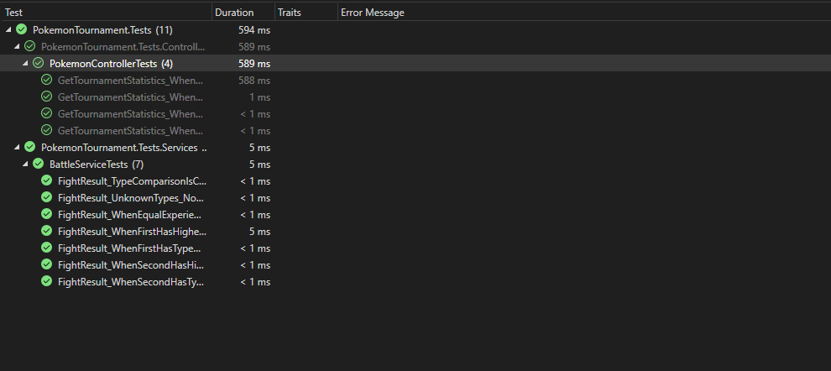

Output

Swagger Endpoint:
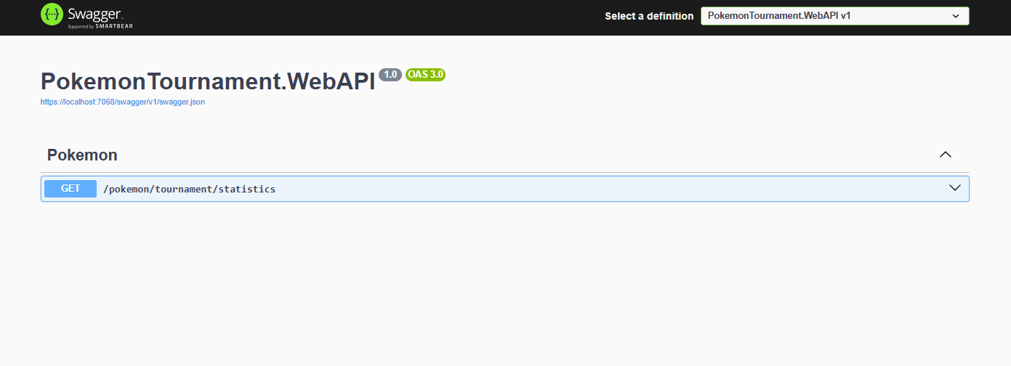
UI:
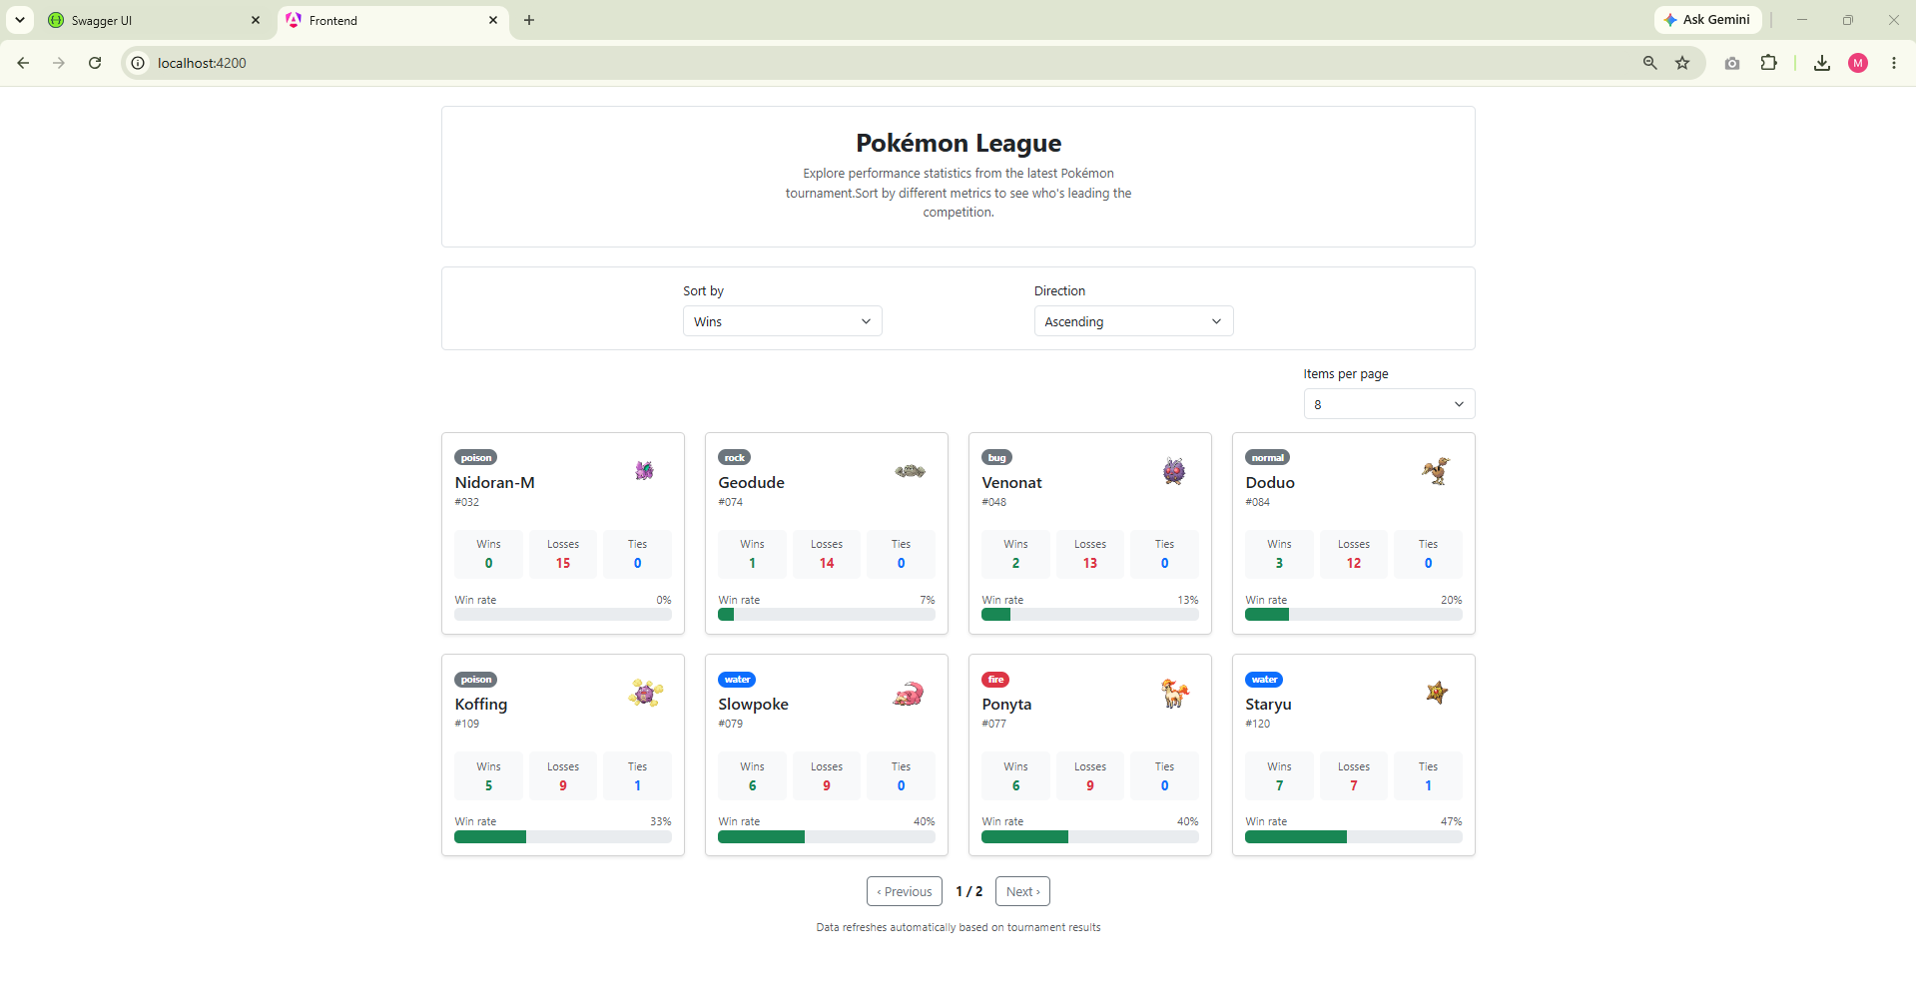

Items per page: 4
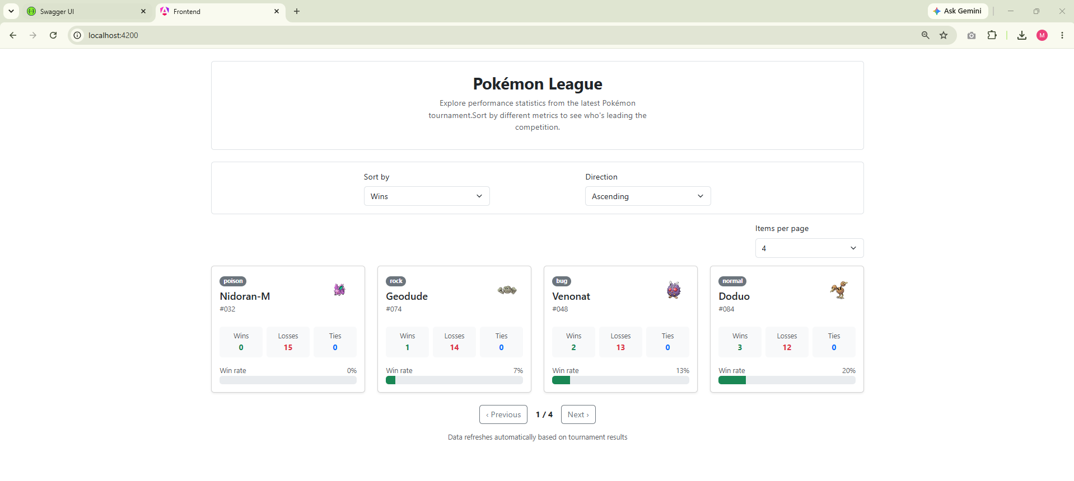
Responsive:
