**User defined door lock**

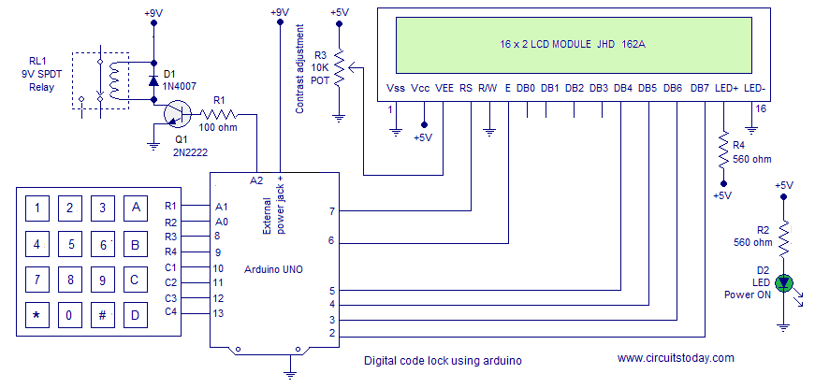

Usage of Device Installation – You will be asked to input 5 digits as password at the initial boot/reset of the device. The ꆈ first 5 digits you input at installation will be saved as your SET PASSWORD. The device will go LOCKED after setting PASSWORD.

Key A – for unlocking the device. Input correct password and press A for Unlocking.

Key B – for locking any time. Just press B and you will see the LOCKED message.

Key C – for changing the password. Input the correct password and Press C. You will see message asking to ENTER NEW PASSWORD.

Enter 5 digits as password. The ꆈrst 5 digits you enter will be SAVED as NEW PASSWORD. Exceptions – You can not use keys ‘A’, ‘B’ and ‘C’ inside the password combination. These 3 keys are control keys of the device with speciꆈc functions. The program checks for these key presses (at the password setting time – you may see the SetPassword() function and look the condition to check for invalid key press) and identies them as Invalid Keys. You will have to input 5 new digits as password after an Invalid Key press. Important Variables and Arrays pass[6] – is the array used to save and hold the user defined password. check[6] – is the array used to collect & hold user input. This user input data (in check[] array) is compared with pass[] array to authenticate.