AI in cyber security
Introduction To AI
Prepared by: Maitri Vatsal Jani

Student ID: AIDS20262004

Course: PGDM (AI & DS) 2026-28

College: Adani Institute of Digital Technology Management

Group No.: 9

1. Introduction
The financial sector is increasingly dependent on digital technologies for banking, payments, online transactions, and customer data management. While digitalization has improved convenience and efficiency, it has also increased the risk of cyber threats such as phishing, identity theft, financial fraud, ransomware, and unauthorized access to sensitive information. According to Forbes and Global FinTech Series, the financial sector accounts for 35% of all data breaches.
Traditional cybersecurity systems often rely on predefined rules and known threat patterns, making it difficult to identify new and sophisticated attacks in real time. In India's banking, financial services, and insurance (BFSI) sector, 43% of Chief Information Security Officers believe attackers have outpaced their defences. Mid-sized banks and NBFCs experience 1.6 times more attacks per organization than global peers due to underinvestment.
Artificial Intelligence (AI) and Machine Learning (ML) are emerging as powerful technologies for strengthening financial cybersecurity. AI enables systems to analyse information, identify potential threats, and support automated decision-making, while ML algorithms learn from historical and real-time data to recognize patterns, detect unusual activities, and predict potential risks.

2. Cybersecurity Threats Faced By Financial Services Companies
  - Malware Attacks
A malware attack occurs when cybercriminals use malicious software, such as viruses, worms, spyware, or trojan horses, to enter a system without permission. Their aim may be to steal sensitive information, disrupt services, or gain unauthorized access to accounts and funds. In the financial sector, malware can target banks, insurance companies, stockbrokers, payment gateways, ATMs, and digital banking applications. Malicious software is typically inserted through phishing emails or by compromised web applications.
  - Ransomware Attacks
Ransomware is emerging as the most dangerous threat in the cybersecurity landscape. It now accounts for 48% of all data breaches globally, the highest share on record, according to the Verizon 2026 Data Breach Investigations Report.
At first, attackers encrypt the data on a system and then demand a ransom for the decryption key. Ransomware gangs have changed their tactics after 2019. Now, they typically steal the data before encryption which is known as exfiltration. By threatening to sell and publish the data if the ransom is unpaid, the criminals double their leverage on the victim.
Financial institutions are particularly vulnerable to this double threat, since they can’t afford downtime and the attackers hold vast amounts of their clients’ sensitive financial information.
  - DoS (Denial of Service) and DDoS (Distributed Denial of Service) Attacks
A DoS (Denial of Service) attack occurs when a single device floods a target server or network with excessive traffic making it slow or unavailable to legitimate users.
A DDoS (Distributed Denial of Service) attack is a larger-scale version that uses multiple distributed, compromised devices—often organized into a network called a botnet—to overwhelm the target. Sometimes DDoS attacks are carried out to divert the attention of company officials from a large scale cyber attack happening in the background.
  - Social Engineering Attacks
Social engineering is the psychological manipulation of people into breaking security rules, revealing sensitive data, or granting unauthorized access to systems.
In the financial services sector, people are tricked by fraudsters into revealing internet banking passwords, OTPs and ATM PINs. This can result in unauthorized transactions and financial losses. Phishing is a type of social engineering technique in which fraudulent emails and text messages (smishing) are sent which appear genuine but contain malicious links and infected files which when opened install malware on their system.
Image 1 (Appendix) depicts the Social Engineering Attack Lifecycle.
  - AI Enabled Cyber Attacks
Cybercriminals are using AI to make their attacks faster and more convincing. Rather than relying on static scripts, modern threat actors weaponize advanced frontier AI models and autonomous agentic systems to scale operations, continuously probe infrastructure, and hide within legitimate traffic.
Deepfake technology presents another serious challenge for financial institutions. Cyber criminals now leverage advanced Generative AI architectures, such as Generative Adversarial Networks (GANs) and neural voice cloning, to orchestrate sophisticated impersonation campaigns.

3. Impact Of Cyber Threats On The Financial Services Sector
Cyberattacks can affect financial institutions in several ways:
Direct financial losses: Fraudulent transactions and data breaches lead to monetary losses and recovery costs.
Operational disruption: Cyberattacks can interrupt banking and payment services.
Regulatory and legal costs: Security failures may result in penalties, investigations, and legal expenses.
Loss of customer trust: Poor data protection can damage reputation and drive customers to competitors.

4. How AI & ML Can Be Used To Prevent, Detect and Respond To Cybersecurity Threats
  - User & Entity Behaviour Analytics (UEBA)
UEBA tracks the daily activities of human users (employees, contractors) and non-human entities (servers, routers, service accounts) inside a corporate network. ML models build a baseline of normal activity for employees, customers, and devices. They flag sudden changes, such as weird login hours, unusual data downloads, or unauthorized account access. Instead of looking for known virus files, UEBA focuses on insider threats, compromised credentials, and data exfiltration by identifying when a user deviates from their personal normal baseline.
The 3 core machine learning pillars of UEBA:

(i) Profiling & Baseline Creation
Algorithms used: Unsupervised Learning: K-Means Clustering
Before a system can identify unusual behaviour, it needs to understand what normal activity looks like. The system automatically groups users into groups based on their job roles and activities. (e.g. Finance Team vs. DevOps). If a database administrator starts accessing HR salary spreadsheets, the algorithm notices this unusual behaviour and immediately flags it.
(ii) Chronological Sequence Analysis
Algorithms used: Deep learning: Recurrent Neural Networks (RNNs), Long Short-Term Memory (LSTM) Networks
LSTM is a specialized type of RNN designed to process time-series and sequential data. For example, if an employee's normal sequence is Login Check Email Open Sales Dashboard. But, the sequence suddenly changes to Login Disable Local Security Logs Download 50 GB encrypted archive. An LSTM can catch this anomalous pattern, even if downloading data or checking settings are individually allowed actions.
(iii) Dimensionality Reduction & Deviation Scoring (Anomaly Detection)
Corporate logs contain hundreds of variables per user action (IP address, time, device type, packet size, port number). Algorithms must collapse this complex data to find the hidden patterns.
Algorithms used: Anomaly Detection: Principal Component Analysis (PCA), Isolation Forests
PCA shrinks hundreds of data variables down to the core features that represent a user's normal behavioural footprint. If a new action moves away from that compressed footprint, an Isolation Forest mathematically isolates that event as a high-risk outlier and calculates a risk score.
  - Real-Time Fraud Detection
Real-time fraud detection systems analyse financial transactions as they occur to identify suspicious spending, stolen credentials, and potentially fraudulent transfers. Their purpose is to stop fraud before money leaves the institution while allowing genuine transactions to proceed without unnecessary delays.
Core machine learning algorithms:
(i) Supervised Learning (Known Threat Detection):
Random Forests & Gradient Boosting (XGBoost): These are the workhorses for transaction fraud detection due to their speed and ability to handle tabular data. They analyse thousands of data points (e.g. transaction size, location history, merchant type) to output a fraud probability score in milliseconds.
(ii) Unsupervised Learning (Anomaly Detection):
Isolation Forests: Excellent at spotting outliers. Instead of learning what fraud looks like, they isolate anomalies. For e.g. A sudden multi-million dollar wire transfer from an account that usually moves small amounts.
(iii) Graph Neural Networks (GNNs):
Map out relationships between accounts, IP addresses, and devices. They are highly effective at uncovering money laundering networks and coordinated botnet attacks that look independent on the surface.
  - Phishing and Social Engineering Defence
Natural Language Processing (NLP) and classification algorithms scan incoming emails, links, and message content to identify malicious content, spoofed senders, and AI-generated spear-phishing attempts.
Core machine learning techniques:
(i) Classification Algorithms: Classification algorithms like Decision Tree, Random Forest, and SVM learn from examples of legitimate and malicious messages and classify new messages into categories such as safe, suspicious, or fraud.
(ii) Natural Language Processing (NLP) & Transformational LLMs: NLP helps systems understand the meaning and context of written messages. Transformer models, such as fine-tuned BERT models or smaller language models, can identify signs of urgency, coercion, unusual financial requests, and attempts to obtain credentials.
(iii) Audio Biometrics & Artifact Analysis: AI-based audio analysis can help detect deepfake audio and video messages. It can examine unusual pauses, frequency patterns, or other audio characteristics that suggest that a voice has been artificially generated.
4.4 Malware Identification & Combating Zero-Day Attacks
Unlike old rule-based antivirus tools that look for known code signatures, ML uses behavioural analysis to spot brand-new (zero-day) malware or ransomware on the basis of how it tries to interact with the system.
Core machine learning techniques:
(i) Support Vector Machines (SVM): Frequently used for network intrusion detection to accurately classify incoming data packets as malicious or benign.
(ii) Autoencoders (Deep Learning): Neural networks trained exclusively on normal network traffic and user logins. When a brand-new, zero-day malware strain acts up, the autoencoder fails to accurately reconstruct the data pattern, immediately triggering a high-priority alert.
  - Automated Incident Response
When a threat is verified, ML models can isolate infected endpoints, lock compromised user accounts, or restrict network traffic instantly to stop a breach from spreading.
Key machine learning algorithms:
(i) Classification: Classifies security events as severe or minor and identifies threat types such as malware, phishing, or ransomware.
(ii) Predictive Analytics: Estimates risk and helps prioritise incidents based on the likelihood and potential impact of an attack.
(iii) Reinforcement Learning: Can learn response strategies by evaluating actions and their outcomes in controlled environments.

SOAR (Security Orchestration, Automation & Response)
SOAR is a cybersecurity technology that connects different security tools and automates actions to detect, investigate, and respond to cyber threats. It helps a financial institution move from manually handling every security alert to coordinating fast, consistent, and partially or fully automated responses. When integrated with AI and ML, it can use threat detection alerts to trigger faster and more informed responses.
When an ML model triggers a critical security event, the automated response infrastructure follows a structured workflow:
High-Risk ML Alert SOAR Ingestion Context Enrichment Automated Playbook Execution Human Verification Loop

From Traditional SOAR to Agentic SOAR
While traditional SOAR relies on deterministic execution (rigid, rule-based playbooks that follow predefined branch logic), agentic SOAR introduces contextual reasoning. Instead of executing an explicit series of hardcoded steps, an autonomous AI agent is given a goal, equipped with tools (via APIs), and decides its own investigative path based on real-time findings.
Image 2 (Appendix) depicts the AI-powered cybersecurity workflow.

5. AI-Driven Cybersecurity Solutions: Industry Applications
5.1 Palo Alto Networks
Palo Alto’s Precision AI technology combines machine learning (ML), deep learning, and generative AI (GenAI) to prevent and detect sophisticated cyberattacks. AI-driven solutions analyse large volumes of security data to identify suspicious patterns and emerging threats, even when traditional signature-based methods may fail.
Palo Alto Networks is using AI for real-time zero-day threat prevention, where AI analyses file behaviour to detect unknown malware. Security operations are automated through Cortex XSIAM, which correlates security alerts, prioritizes incidents, and supports rapid threat containment. Additionally, it also protects organizations against AI-related risks, such as sensitive data leaks and attacks targeting AI applications. Its AI copilots help security analysts investigate threats, summarize incidents, and develop security policies more efficiently.

5.2 Microsoft
Microsoft uses AI across its cybersecurity ecosystem to monitor threats, analyse suspicious activities, and automate incident response. Solutions such as Microsoft Defender and Microsoft Sentinel combine security data from multiple devices, applications, networks, and cloud environments to identify potential attacks, including phishing, malware, and ransomware.
Microsoft Security Copilot assists analysts by explaining security alerts, supporting malware investigations, generating threat-hunting queries, and preparing incident reports through natural-language instructions. Microsoft Purview also helps organizations monitor sensitive data usage and reduce the risk of confidential information being exposed through generative AI tools.

5.3 Quick Heal (Seqrite)
Quick Heal and its enterprise cybersecurity brand, Seqrite, use AI and machine learning to identify malicious activities and protect digital devices against evolving cyber threats. Its GoDeep.AI technology analyses file and system behaviour to detect suspicious patterns, helping prevent both known malware and emerging threats that may bypass traditional security methods.
AntiFraud.AI helps identify potentially fraudulent messages, malicious links, and phone-based scams, reducing the risk of users falling victim to digital financial fraud. Additionally, its Security Intelligent Assistant (SIA) provides conversational assistance, helping users understand security alerts and manage device protection more easily.

6. Key Risks and Challenges In AI Integration
6.1 Adversarial AI
It refers to techniques that manipulate machine learning models by exploiting their mathematical decision boundaries to produce wrong outputs or leak data.
Attack types:
Evasion Attacks: Modifying inputs post-deployment so a trained model misclassifies them while looking normal to humans.

Data Poisoning: Corrupting the training dataset at the foundational model training stage by injecting malicious data so that the model learns the wrong patterns.

Prompt Injection: Hiding unauthorized instructions inside text or data read by Large Language Models (LLMs) to bypass guardrails.

Model Extraction & Stealing: Querying an AI model repeatedly to clone its functionality.

How does adversarial AI work?
Step 1: Identify AI weaknesses - Attackers study how an AI-based security system detects threats, fraud, or suspicious activities.
Step 2: Manipulate the input - They modify data, messages, transactions, or other inputs so the AI model misclassifies a malicious activity as legitimate.
Step 3: Evade detection - If the manipulation succeeds, the attack may bypass security controls and reach the target.

  - Ethical challenges
Accountability: It is difficult to assign blame when an AI system suffers a false negative (misses a real attack), resulting in a major data breach.

Data Privacy: Training security AI requires massive amounts of data, often leading to invasive user monitoring and data over-collection.

Algorithmic Bias & Data Accuracy: Skewed training data can cause AI to unfairly flag specific users or regions as threats. If the AI suffers from high false positives (wrongly flagging safe activity as a threat), it often impacts specific groups unfairly.

Transparency & Explainability: Many advanced models operate as “black boxes”, making it hard for humans to audit or understand their decisions.

Dual-Use: The exact same AI tools used to defend networks can be weaponized by hackers to automate cyberattacks.

Over-Reliance: Teams can become complacent, blindly trusting automated outputs and losing the critical thinking skills needed to catch subtle or novel threats.

  - RoI Challenge

Introducing AI into cybersecurity can be expensive. Financial institutions may need to invest in software licences, cloud infrastructure, data integration, skilled professionals, employee training, and ongoing maintenance. At the same time, it can be difficult to measure the exact financial value of an attack that was prevented. This creates a challenge when evaluating the return on investment.

7. Overcoming AI Implementation Challenges - Responsible AI Integration
Implementing AI responsibly requires fixing key bottlenecks across technology, data, culture, and ethics.
To achieve responsible AI integration within the Indian Financial Services Sector, financial institutions (Banks, NBFCs, and FinTechs) must actively counter adversarial threats and ethical pitfalls.

Phase 1: Defending Against Adversarial AI
Adversarial Training: Feeding known adversarial examples into the model during training stage so that it learns to recognize and resist them.
Data Validation & Sanitization: Inspecting and cleaning training data to block poisoned inputs before they corrupt the system.
Continuous Monitoring & Rate Limiting: Tracking unusual query patterns and setting limits to stop automated model-stealing or probing.
Frameworks like MITRE ATLAS: ATLAS is a globally accessible, living knowledge base documenting the tactics, techniques, and procedures used by adversaries to target and manipulate AI & ML systems.

Phase 2: Resolving Ethical & Governance Challenges
Accountability & Governance: Establish AI risk committees, maintain audit trails, and ensure human oversight of critical AI decisions.
Privacy Protection: Follow applicable DPDP Act requirements and use data minimisation, encryption, and privacy-enhancing technologies.
Algorithmic Fairness & Bias Mitigation: Regularly audit AI models to prevent unfair credit decisions and discrimination against certain groups.
Explainable AI (XAI) for Transparency: Use framework-native tools like SHAP (SHapley Additive exPlanations) or LIME to unpack and translate complex automated decisions into clear, auditable parameters.
Guarding Against Over-Reliance: Ensure that cybersecurity experts and financial professionals review high-risk alerts and suspicious transactions. Train employees regularly and use AI as a decision-support tool rather than a complete replacement for human judgement.

The NIST AI Risk Management Framework (AI RMF 1.0) provides guidance for identifying and managing AI-related risks throughout a system's lifecycle. Image 3 (Appendix) depicts AI Risk Management Framework by NIST.
For Indian financial institutions deploying AI, responsible integration is anchored by two critical frameworks: the RBI’s FREE-AI Framework (strategic and ethical governance) and CERT-In’s AI Cybersecurity Guidelines (technical and threat-defence controls).

Phase 3: Cost Benefit Analysis in AI Integration
Measure Efficiency Metrics: Track the reduction in Mean Time to Detect (MTTD) and Mean Time to Respond (MTTR), then convert those saved analyst hours into direct monetary values.
Cost Comparison: Compare the overall cost of AI integration against the massive cost of a data breach.
Account for Hidden Lifecycle Costs: Do not just look at the software license. Also account for the costs of data pipeline cleaning, continuous model retraining/tuning, and the human analyst time required to manage false positives.

8. Conclusion
AI and machine learning are transforming financial cybersecurity by enabling faster threat detection, better fraud prevention, and quicker responses to cyberattacks. However, their success depends on responsible implementation, continuous monitoring, and human supervision.
The goal is to build a proactive, intelligent, and resilient financial cybersecurity system where AI-driven speed works alongside human expertise and accountability.

References
https://www.resecurity.com/blog/article/digital-threats-targeting-india-banking-financial-services-and-insurance-insurance-bfsi-sector
https://www.cristie.com/news/the-role-of-artificial-intelligence-ai-and-machine-learning-ml-in-financial-sector-cybersecurity
https://swimlane.com/blog/the-role-of-machine-learning-in-cybersecurity/
https://www.paloaltonetworks.com/cyberpedia/what-are-adversarial-attacks-on-AI-Machine-Learning
https://www.microsoft.com/en-us/security/business/solutions/generative-ai-cybersecurity
https://www.quickheal.co.in/knowledge-centre/ai-security-quick-heals-predictive-threat-protection/
https://swimlane.com/blog/automated-incident-response/#h-automated-incident-response-how-it-works-amp-expert-tips
https://nvlpubs.nist.gov/nistpubs/ai/NIST.AI.100-1.pdf

Appendix
Image 1: Social Engineering Attack Lifecycle Source: https://www.imperva.com/learn/application-security/social-engineering-attack/
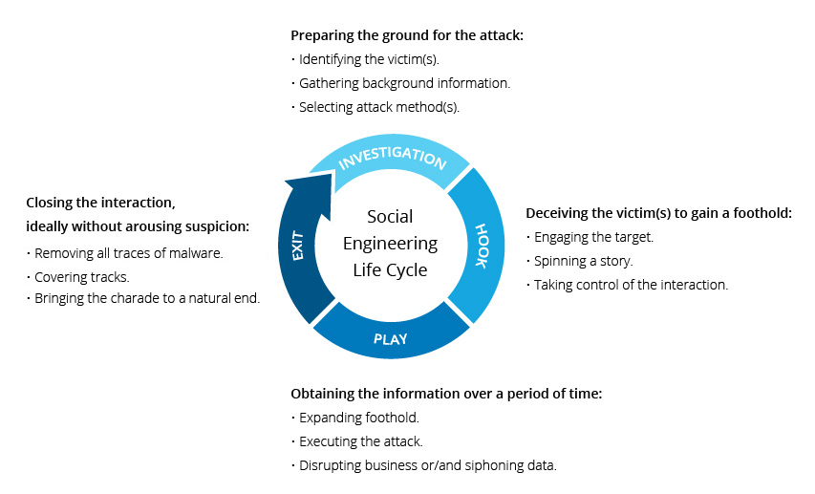

Image 2 : AI powered cybersecurity workflow Source: Chat GPT
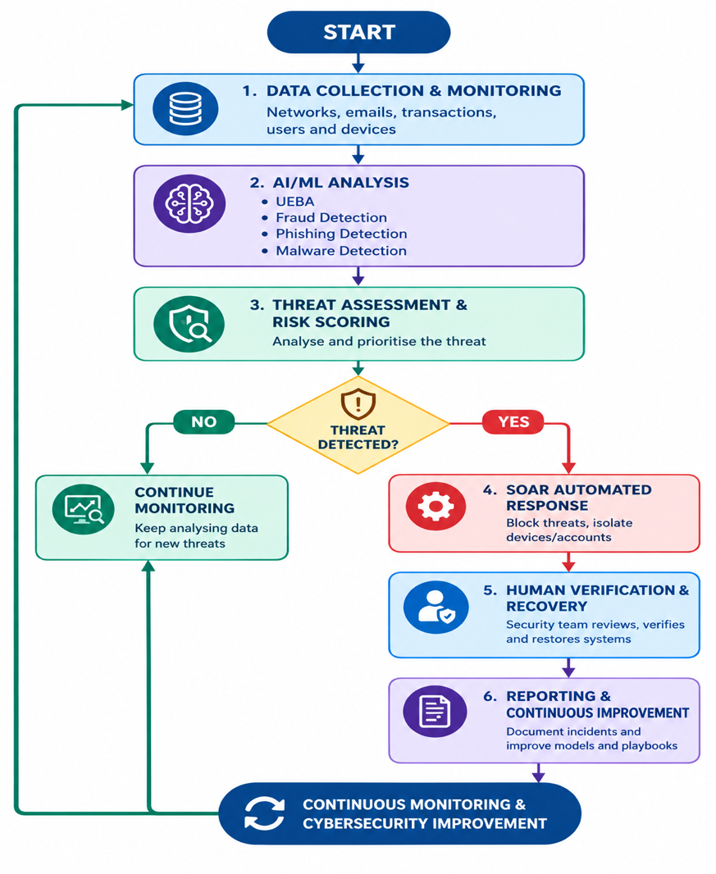
Image 3 : AI Risk Management Framework By NIST Source: https://nvlpubs.nist.gov/nistpubs/ai/NIST.AI.100-1.pdf
