**Set OI cutoff = 100 with no limit(total patient of 615)**

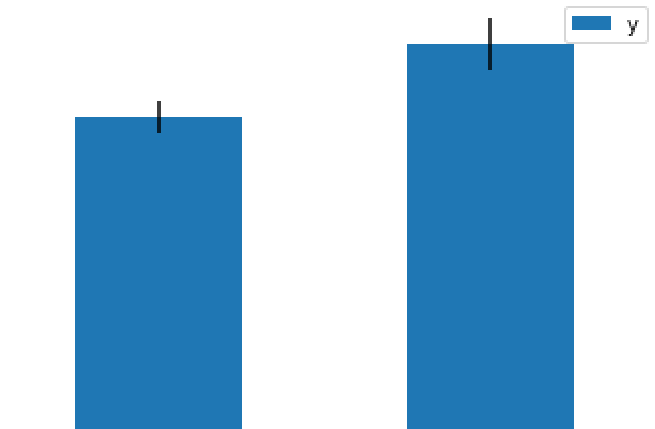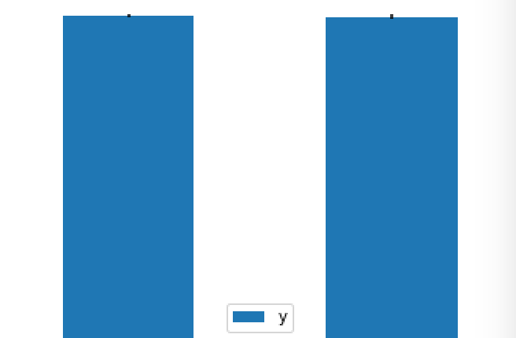

CVP pre CVP post DBP pre DBP post

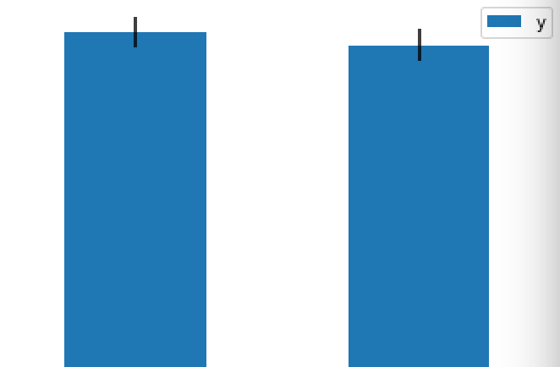

CVP/DBP pre CVP/DBP post

**Set OI cutoff = 100, limit OI pre ranged 100~200, OI post ranged 0~100**

**(total patient of 68)**

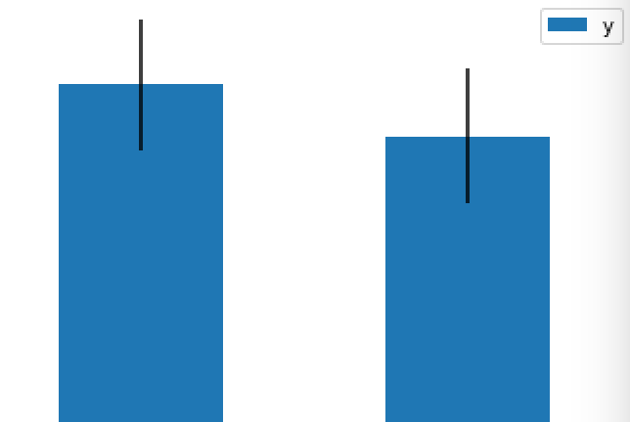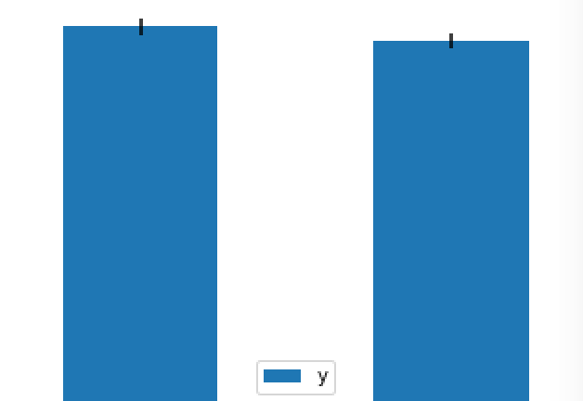

CVP pre CVP post DBP pre DBP post

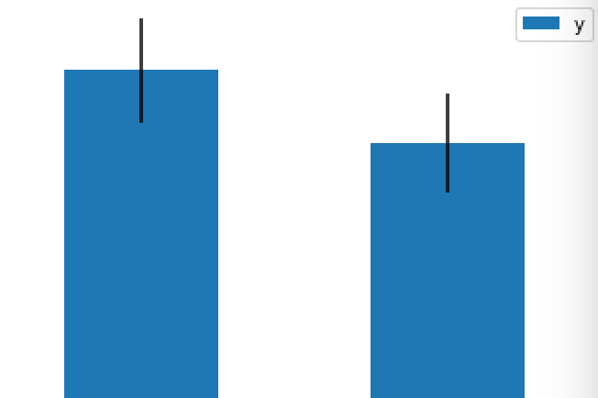

CVP/DBP pre CVP/DBP post

**Set OI cutoff = 200 with no limit(total patient of 1301)**

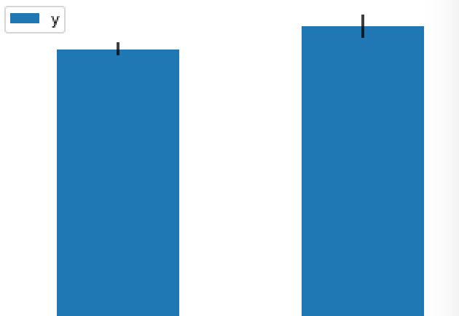

CVP pre CVP post DBP pre DBP post

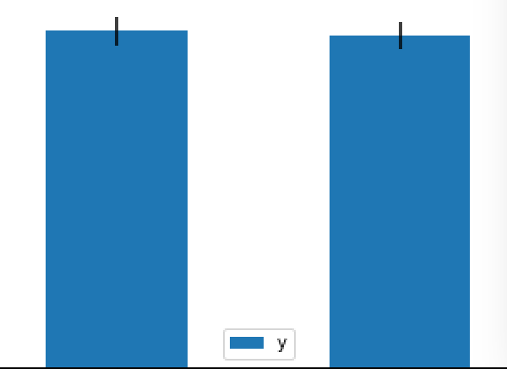

CVP/DBP pre CVP/DBP post

**Set OI cutoff = 100, limit OI pre ranged 100~200, OI post ranged 0~100**

**(total patient of 143)**

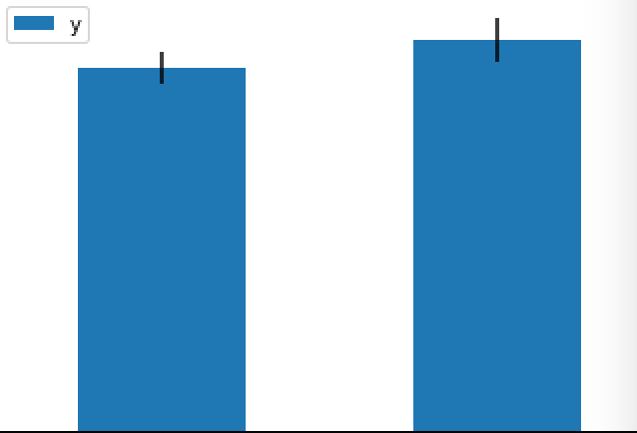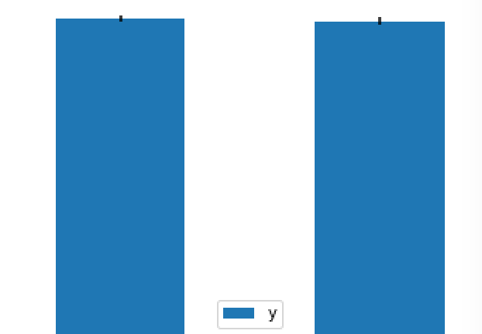

CVP pre CVP post DBP pre DBP post



CVP/DBP pre CVP/DBP post