**Impact of Fluid Balance on Mortality in Sepsis - Analysis of a Large Critical Care Database**

Feb 14, 2018

### Study cohort: all sepsis patients in MIMIC



#### *Figure 1.1: Data inclusion flow*

#### *Table 1.2 Baseline characteristics, stratified by quartile of 24hr-Fluid balance*

|  |  |  |  |  |  |
| --- | --- | --- | --- | --- | --- |
|  | **Group1**  **(n=2571)** | **Group2**  **(n= 2570)** | **Group3**  **(n=2571)** | **Group4**  **(n=2571)** | **p-value** |
| age (mean (sd)), years | 67.53 (16.28) | 68.03 (16.49) | 66.55 (16.99) | 64.75 (16.81) | <0.001 |
| Gender=Male, (%) | 1259 (49.0) | 1250 (48.6) | 1176 (45.7) | 1191 (46.3) | 0.043 |
| weight (mean (sd)), KG | 81.74 (24.99) | 79.29 (24.88) | 79.98 (24.02) | 82.63 (25.66) | <0.001 |
| LOS hospital (mean (sd)), Days | 15.12 (14.17) | 15.28 (14.09) | 15.70 (15.89) | 17.71 (16.29) | <0.001 |
| LOS ICU (mean (sd)), Days | 6.72 (9.28) | 6.90 (8.40) | 7.52 (8.99) | 9.00 (10.05) | <0.001 |
| Mechanical ventilation duration (mean (sd)), hours | 13.45 (10.27) | 14.50 (9.84) | 15.16 (9.53) | 16.33 (8.65) | <0.001 |
| **PAST MEDICAL HISTORY, YES (%)** |  |  |  |  |  |
| Diabete | 788 (30.6%) | 695 (27.0%) | 656 (25.5%) | 689 (26.8%) | <0.001 |
| Hypertension | 413 (16.1%) | 370 (14.4%) | 326 (12.7%) | 263 (10.2%) | <0.001 |
| Congestive heart failure | 742 (28.9%) | 681 (26.5%) | 577 (22.4%) | 471 (18.3%) | <0.001 |
| Renal failure | 496 (19.3%) | 464 (18.1%) | 384 (14.9%) | 324 (12.6%) | <0.001 |
| Liver disease | 168 (6.5%) | 208 (8.1%) | 225 (8.8%) | 295 (11.5%) | <0.001 |
| Cancer | 156 (6.1%) | 188 (7.3%) | 211 (8.2%) | 227 (8.8%) | 0.001 |
| AIDS | 15 (0.6%) | 17 (0.7%) | 8 (0.3%) | 6 (0.2%) | 0.059 |
| Chronic pulmonary disease | 634 (24.7%) | 601 (23.4%) | 506 (19.7%) | 429 (16.7%) | <0.001 |
| Obesity | 159 (6.2%) | 122 (4.7%) | 119 (4.6%) | 194 (7.5%) | <0.001 |
| Dialysis | 162 (7.0%) | 257 (10.8%) | 223 (9.3%) | 259 (10.4%) | <0.001 |
| ESKD | 68 (2.6%) | 103 (4.0%) | 68 (2.6%) | 42 (1.6%) | <0.001 |
| Pulmonary infection | 878 (34.2%) | 775 (30.2%) | 679 (26.4%) | 517 (20.1%) | <0.001 |
| **CLINICAL SCORE, MEAN(SD)** |  |  |  |  |  |
| SOFA | 5.24 (3.03) | 6.21 (3.43) | 7.24 (3.83) | 9.58 (4.53) | <0.001 |
| GCS Score | 10.75 (4.31) | 9.94 (4.48) | 9.09 (4.61) | 7.36 (4.65) | <0.001 |
| OASIS | 34.86 (9.66) | 38.39 (10.05) | 40.17 (10.53) | 44.04 (10.72) | <0.001 |
| **LABORATORY VALUES, MEAN(SD)** |  |  |  |  |  |
| Hemoglobin | 11.56 (2.18) | 11.67 (2.23) | 11.60 (2.28) | 11.63 (2.37) | 0.389 |
| Creatinine | 1.59 (1.55) | 1.76 (1.87) | 1.70 (1.64) | 1.75 (1.53) | 0.001 |
| WBC | 12.29 (8.77) | 13.29 (11.61) | 13.75 (12.72) | 13.73 (10.80) | <0.001 |
| **VITAL SIGNS, MEAN(SD)** |  |  |  |  |  |
| Temperature | 36.77 (0.94) | 36.77 (1.02) | 36.76 (1.20) | 36.53 (1.25) | <0.001 |
| Respiratory rate | 20.60 (6.34) | 19.98 (6.05) | 20.14 (6.72) | 20.09 (7.01) | 0.004 |
| Heart rate | 89.84 (19.93) | 90.64 (20.25) | 93.92 (21.23) | 97.76 (21.41) | <0.001 |
| MBP | 84.43 (18.02) | 81.82 (19.47) | 79.76 (19.04) | 77.55 (19.06) | <0.001 |
| **24Hour FLUID BALANCE, MEDIAN[IQR], mL** | -315.75 [-1079.52, 248.87] | 1816.10 [1300.75, 2309.00] | 4299.00 [3525.10, 5221.09] | 9707.61 [7747.74, 13130.46] | <0.001 |
| **MORTALITY (%)** |  |  |  |  |  |
| Hospital expire | 422 (16.4%) | 536 (20.9%) | 557 (21.7%) | 685 (26.6%) | <0.001 |
| ICU expire | 264 (10.3%) | 336 (13.1%) | 380 (14.8%) | 522 (20.3%) | <0.001 |
| 28-day expire | 381 (14.8%) | 469 (18.2%) | 494 (19.2%) | 592 (23.0%) | <0.001 |

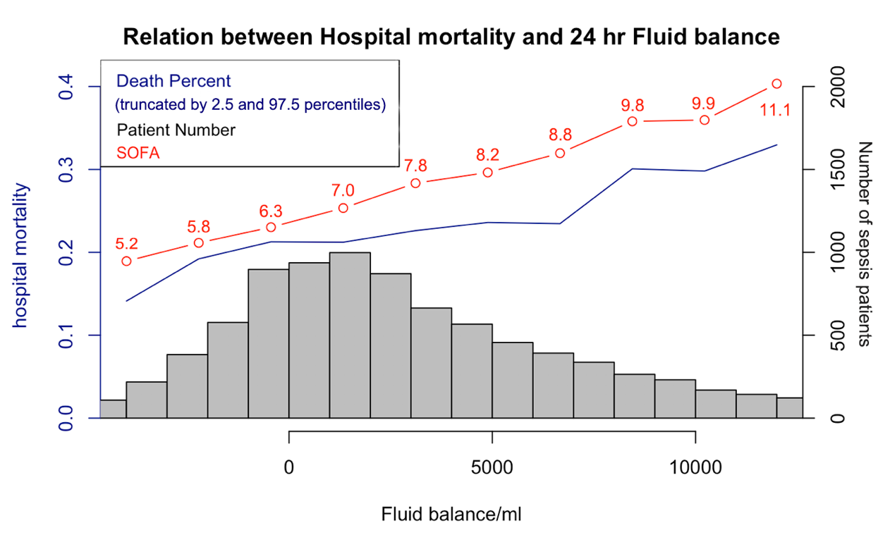

**Figure 1.2 Relation between Hospital mortality, SOFA and Fluid balance**

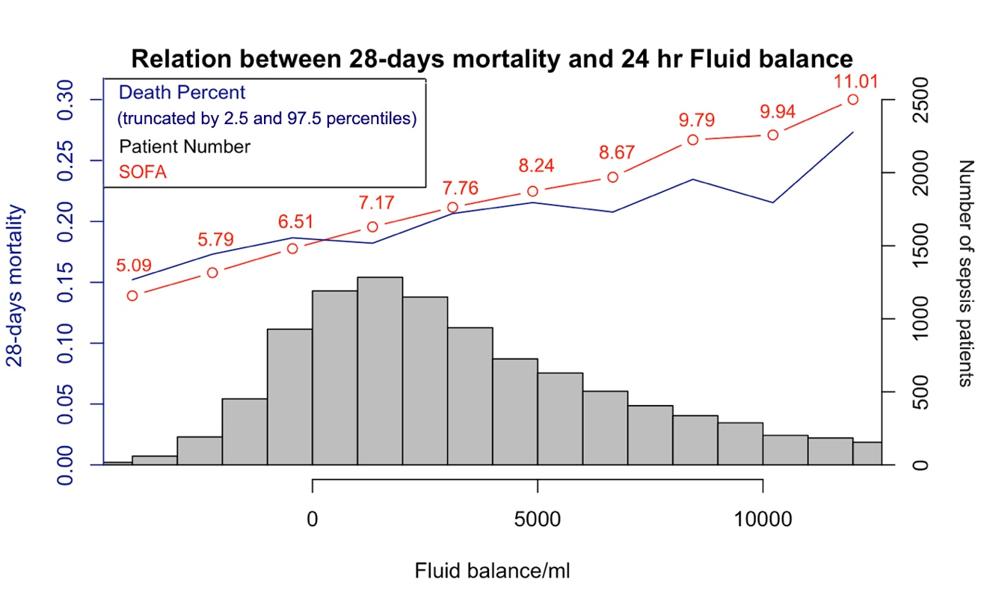

**Figure 1.3 Relation between 28-days mortality, SOFA and Fluid balance**

***Table 1.3 Use logistic regression to evaluate Relationship between FB and 28-day mortality status, stratified by quartile of fluid balance***

|  |  |  |  |  |  |
| --- | --- | --- | --- | --- | --- |
| OR(95% CI), p-value | | | | | |
|  | **group1** | **group2** | **group3** | **group4** | **per 1L increase in FB** |
| Model 1  ALL patients | 1.00 Ref. | 1.06 ( 0.9 , 1.25 )  p = 0.512 | 0.89 ( 0.76 , 1.06 )  p = 0.192 | 0.73 ( 0.61 , 0.88 )  p = 0.001 | 0.97 ( 0.96 , 0.98 )  p < 0.001 |
| Model 2  PUL | 1.00 Ref. | 1.23 ( 0.92 , 1.66 )  p = 0.165 | 1.12 ( 0.83 , 1.52 )  p = 0.451 | 0.96 ( 0.7 , 1.32 )  p = 0.821 | 0.98 ( 0.96 , 1.01 )  p = 0.126 |
| Model 3  CKD | 1.00 Ref. | 1.43 ( 0.92 , 2.24 )  p = 0.11 | 1.45 ( 0.94 , 2.27 )  p = 0.096 | 1.23 ( 0.78 , 1.97 )  p = 0.373 | 0.99 ( 0.96 , 1.02 )  p = 0.637 |
| Model 4  CHF | 1.00 Ref. | 1.21 ( 0.89 , 1.66 )  p = 0.227 | 1.17 ( 0.85 , 1.6 )  p = 0.337 | 0.93 ( 0.67 , 1.31 )  p = 0.684 | 0.97 ( 0.94 , 0.99 )  p = 0.02 |
| Model 5  Hypertension | 1.00 Ref. | 1.16 ( 0.7 , 1.94 )  p = 0.558 | 1.4 ( 0.86 , 2.3 )  p = 0.185 | * 1. ( 0.6 , 1.71 )   2. p = 0.982 | 0.99 ( 0.95 , 1.03 )  p = 0.642 |

***Model1 for all patients adjusted for*** *age, gender, weight, hemoglobin, creatinine, WBC, temperature, respiratory rate, heart rate, MBP, mechanical ventilation duration, GCS, sofa, diabetes, hypertension, congestive heart failure, renal failure, liver disease, cancer, aids , chronic pulmonary diseases, obesity , ESKD, pulmonary infection, dialysis*

***Model2 for PUL*** *respected to model 1* ***except*** *pulmonary infection*

***Model3 for CKD*** *respected to model 1* ***except*** *renal failure*

***Model4 for CHF*** *respected to model 1* ***except*** *congestive heart failure*

***Model5 for Hypertension*** *respected to model 1* ***except*** *hypertension*

***(models below would respect to the same criterial)***

***Table 1.4 Use logistic regression to evaluate Relationship between FB and ICU mortality status, stratified by quartile of fluid balance***

|  |  |  |  |  |  |
| --- | --- | --- | --- | --- | --- |
| OR(95% CI), p-value | | | | | |
|  | **group1** | **group2** | **group3** | **group4** | **per 1L increase in FB** |
| Model1  ALL patients | 1.00 Ref. | 1.01 ( 0.83 , 1.23 )  p = 0.909 | 0.86 ( 0.71 , 1.04 )  p = 0.125 | 0.75 ( 0.61 , 0.92 )  p = 0.005 | 0.98 ( 0.96 , 0.99 )  p < 0.001 |
| Model2  PUL | 1.00 Ref. | 0.97 ( 0.7 , 1.35 )  p = 0.868 | 0.83 ( 0.6 , 1.16 )  p = 0.284 | 0.74 ( 0.53 , 1.05 )  p = 0.095 | 0.96 ( 0.94 , 0.99 )  p = 0.008 |
| Model3  CKD | 1.00 Ref. | 1.56 ( 0.91 , 2.74 )  p = 0.115 | 1.41 ( 0.82 , 2.47 )  p = 0.223 | 1.2 ( 0.69 , 2.14 )  p = 0.524 | 0.99 ( 0.95 , 1.02 )  p = 0.557 |
| Model4  CHF | 1.00 Ref. | 1.13 ( 0.78 , 1.64 )  p = 0.516 | 1.2 ( 0.83 , 1.72 )  p = 0.333 | 1.02 ( 0.7 , 1.5 )  p = 0.914 | 0.98 ( 0.95 , 1 )  p = 0.103 |
| Model5  Hypertension | 1.00 Ref. | 1.06 ( 0.58 , 2 )  p = 0.843 | 1.34 ( 0.75 , 2.45 )  p = 0.33 | 0.93 ( 0.5 , 1.76 )  p = 0.831 | 0.99 ( 0.95 , 1.03 )  p = 0.577 |

#### *Table 1.5 Use logistic regression to evaluate Relationship between fluid balance and Hospital mortality status, the group was stratified by quartile of fluid balance*

|  |  |  |  |  |  |
| --- | --- | --- | --- | --- | --- |
| OR(95% CI), p-value | | | | | |
|  | **group1** | **group2** | **group3** | **group4** | **per 1L increase in FB** |
| Model1  ALL patients | 1.00 Ref. | 1.11 ( 0.95 , 1.3 )  p = 0.182 | 0.92 ( 0.79 , 1.09 )  p = 0.334 | 0.8 ( 0.67 , 0.95 )  p = 0.01 | 0.98 ( 0.97 , 0.99 )  p < 0.001 |
| Model2  PUL | 1.00 Ref. | 1.27 ( 0.95 , 1.7 )  p = 0.105 | 1.2 ( 0.9 , 1.61 )  p = 0.217 | 1.08 ( 0.8 , 1.47 )  p = 0.612 | 0.99 ( 0.96 , 1.01 )  p = 0.332 |
| Model3  CKD | 1.00 Ref. | 1.34 ( 0.89 , 2.03 )  p = 0.167 | 1.34 ( 0.89 , 2.04 )  p = 0.169 | 1.16 ( 0.75 , 1.8 )  p = 0.507 | 0.99 ( 0.96 , 1.03 )  p = 0.746 |
| Model4  CHF | 1.00 Ref. | 1.29 ( 0.95 , 1.74 )  p = 0.103 | 1.27 ( 0.94 , 1.72 )  p = 0.127 | 1.05 ( 0.76 , 1.45 )  p = 0.749 | 0.98 ( 0.96 , 1.01 )  p = 0.159 |
| Model 5  Hypertension | 1.00 Ref. | 1.23 ( 0.76 , 2 )  p = 0.408 | 1.4 ( 0.88 , 2.27 )  p = 0.163 | 1.11 ( 0.67 , 1.84 )  p = 0.686 | 0.99 ( 0.96 , 1.03 )  p = 0.765 |

***Table 1.6 Use linear regression to evaluate Relationship between 24hour-fluid balance and LOS ICU, stratified by quartile of fluid balance***

|  |  |  |  |  |  |
| --- | --- | --- | --- | --- | --- |
| OR(95% CI), p-value | | | | | |
|  | **group1** | **group2** | **group3** | **group4** | **per 1L increase in FB** |
| Model1  ALL patients | 1.00 Ref. | -0.3 ( -0.81 , 0.21 )  p = 0.255 | -0.13 ( -0.65 , 0.4 )  p = 0.638 | 0.21 ( -0.35 , 0.78 )  p = 0.457 | 0.06 ( 0.02 , 0.1 )  p = 0.004 |
| Model2  PUL | 1.00 Ref. | -0.35 ( -1.2 , 0.5 )  p = 0.422 | 0.75 ( -0.11 , 1.61 )  p = 0.089 | 1.04 ( 0.13 , 1.95 )  p = 0.025 | 0.16 ( 0.08 , 0.23 )  p < 0.001 |
| Model3  CKD | 1.00 Ref. | -0.21 ( -1.39 , 0.97)  p = 0.725 | 0.37 ( -0.83 , 1.58 )  p = 0.543 | 1.89 ( 0.61 , 3.17 )  p = 0.004 | 0.26 ( 0.16 , 0.36 )  p < 0.001 |
| Model4  CHF | 1.00 Ref. | 0.15 ( -1 , 1.29 )  p = 0.803 | 0.58 ( -0.58 , 1.74 )  p = 0.33 | 0.83 ( -0.4 , 2.07 )  p = 0.187 | 0.11 ( 0.01 , 0.21 )  p = 0.024 |
| Model5  Hypertension | 1.00 Ref. | -0.3 ( -1.64 , 1.03 )  p = 0.657 | 0.36 ( -0.99 , 1.72 )  p = 0.599 | 1.56 ( 0.12 , 3 )  p = 0.034 | 0.21 ( 0.1 , 0.33 )  p < 0.001 |

***Table1.7 Use logistic regression to evaluate 24-hour FB effect on 28-days expire status***

|  |  |  |
| --- | --- | --- |
|  | OR(95% CI) | p value |
| (Intercept) | 1.18 ( 0.17 , 8.09 ) | 0.865 |
| Age | 1.03 ( 1.03 , 1.03 ) | < 0.001 |
| Gender=Male | 0.89 ( 0.79 , 1 ) | 0.046 |
| Weight | 0.99 ( 0.99 , 1 ) | < 0.001 |
| Hemoglobin | 0.97 ( 0.95 , 1 ) | 0.049 |
| Creatinine | 0.95 ( 0.91 , 0.99 ) | 0.022 |
| WBC | 1.01 ( 1 , 1.01 ) | 0.001 |
| Temperature | 0.87 ( 0.83 , 0.91 ) | < 0.001 |
| Respiratory rate | 1.04 ( 1.03 , 1.05 ) | < 0.001 |
| Heart rate | 1 ( 1 , 1.01 ) | 0.004 |
| MBP | 1 ( 0.99 , 1 ) | 0.104 |
| Mechanical ventilation duration | 0.99 ( 0.99 , 1 ) | 0.002 |
| GCS | 1 ( 0.98 , 1.02 ) | 0.994 |
| SOFA | 1.19 ( 1.17 , 1.22 ) | < 0.001 |
| Diabetes | 0.91 ( 0.8 , 1.03 ) | 0.143 |
| Hypertension | 0.73 ( 0.55 , 0.96 ) | 0.025 |
| Congestive heart failure | 1.03 ( 0.91 , 1.17 ) | 0.63 |
| Renal failure | 1.04 ( 0.8 , 1.34 ) | 0.766 |
| Liver disease | 1.76 ( 1.46 , 2.12 ) | < 0.001 |
| cancer | 2.61 ( 2.17 , 3.13 ) | < 0.001 |
| AIDS | 0.71 ( 0.2 , 1.87 ) | 0.533 |
| Chronic pulmonary disease | 0.99 ( 0.87 , 1.14 ) | 0.93 |
| Obesity | 0.98 ( 0.73 , 1.3 ) | 0.882 |
| ESKD | 0.87 ( 0.59 , 1.27 ) | 0.479 |
| Pulmonary infection | 1.22 ( 1.08 , 1.39 ) | 0.001 |
| Dialysis | 1.15 ( 0.92 , 1.41 ) | 0.21 |
| Group2 | 1.06 ( 0.9 , 1.25 ) | 0.512 |
| Group3 | 0.89 ( 0.76 , 1.06 ) | 0.192 |
| Group4 | 0.73 ( 0.61 , 0.88 ) | 0.001 |

***Table 1.8 Use logistic regression to evaluate 24-hour FB effect(category variable, stratified by quartile of 24-hour FB ) on hospital expire status***

|  |  |  |
| --- | --- | --- |
|  | OR(95% CI) | p value |
| (Intercept) | 2.25 ( 0.35 , 14.5 ) | 0.392 |
| Age | 1.03 ( 1.02 , 1.03 ) | < 0.001 |
| Gender=Male | 0.87 ( 0.77 , 0.97 ) | 0.012 |
| Weight | 0.99 ( 0.99 , 1 ) | < 0.001 |
| Hemoglobin | 0.95 ( 0.93 , 0.97 ) | < 0.001 |
| Creatinine | 0.91 ( 0.87 , 0.94 ) | < 0.001 |
| WBC | 1.01 ( 1 , 1.01 ) | 0.007 |
| Temperature | 0.86 ( 0.82 , 0.9 ) | < 0.001 |
| Respiratory rate | 1.04 ( 1.03 , 1.05 ) | < 0.001 |
| Heart rate | 1.01 ( 1 , 1.01 ) | < 0.001 |
| MBP | 1 ( 1 , 1 ) | 0.317 |
| Mechanical ventilation duration | 0.99 ( 0.98 , 0.99 ) | < 0.001 |
| GCS | 1 ( 0.99 , 1.02 ) | 0.676 |
| SOFA | 1.2 ( 1.17 , 1.22 ) | < 0.001 |
| Diabetes | 0.86 ( 0.76 , 0.98 ) | 0.02 |
| Hypertension | 0.68 ( 0.52 , 0.88 ) | 0.004 |
| Congestive heart failure | 1.14 ( 1.01 , 1.29 ) | 0.034 |
| Renal failure | 1.08 ( 0.84 , 1.37 ) | 0.563 |
| Liver disease | 1.76 ( 1.47 , 2.11 ) | < 0.001 |
| cancer | 2.55 ( 2.13 , 3.04 ) | < 0.001 |
| AIDS | 0.91 ( 0.33 , 2.15 ) | 0.845 |
| Chronic pulmonary disease | 0.9 ( 0.79 , 1.03 ) | 0.113 |
| Obesity | 0.91 ( 0.69 , 1.2 ) | 0.509 |
| ESKD | 0.76 ( 0.53 , 1.08 ) | 0.127 |
| Pulmonary infection | 1.18 ( 1.04 , 1.33 ) | 0.008 |
| Dialysis | 1.96 ( 1.61 , 2.39 ) | < 0.001 |
| Group2 | 1.11 ( 0.95 , 1.3 ) | 0.182 |
| Group3 | 0.92 ( 0.79 , 1.09 ) | 0.334 |
| Group4 | 0.8 ( 0.67 , 0.95 ) | 0.01 |

***Table 1.9 Use logistic regression to evaluate 24-hour FB effect(category variable, stratified by quartile of 24-hour FB ) on ICU expire status***

|  |  |  |
| --- | --- | --- |
|  | OR(95% CI) | p value |
| (Intercept) | 1.24 ( 0.15 , 10.11 ) | 0.838 |
| Age | 1.02 ( 1.02 , 1.03 ) | < 0.001 |
| Gender=Male | 1.03 ( 0.9 , 1.17 ) | 0.698 |
| Weight | 1 ( 0.99 , 1 ) | 0.02 |
| Hemoglobin | 0.98 ( 0.95 , 1 ) | 0.085 |
| Creatinine | 0.93 ( 0.88 , 0.97 ) | 0.002 |
| WBC | 1 ( 1 , 1.01 ) | 0.098 |
| Temperature | 0.86 ( 0.81 , 0.91 ) | < 0.001 |
| Respiratory rate | 1.04 ( 1.03 , 1.05 ) | < 0.001 |
| Heart rate | 1.01 ( 1 , 1.01 ) | < 0.001 |
| MBP | 1 ( 0.99 , 1 ) | 0.193 |
| Mechanical ventilation duration | 0.98 ( 0.97 , 0.99 ) | < 0.001 |
| GCS | 0.97 ( 0.95 , 0.99 ) | 0.003 |
| SOFA | 1.24 ( 1.21 , 1.27 ) | < 0.001 |
| Diabetes | 0.89 ( 0.77 , 1.04 ) | 0.138 |
| Hypertension | 0.74 ( 0.54 , 1.02 ) | 0.064 |
| Congestive heart failure | 1.05 ( 0.91 , 1.21 ) | 0.506 |
| Renal failure | 0.92 ( 0.68 , 1.23 ) | 0.559 |
| Liver disease | 1.39 ( 1.12 , 1.71 ) | 0.002 |
| cancer | 2.48 ( 2.02 , 3.03 ) | < 0.001 |
| AIDS | 0.93 ( 0.26 , 2.57 ) | 0.906 |
| Chronic pulmonary disease | 1 ( 0.86 , 1.17 ) | 0.964 |
| Obesity | 0.89 ( 0.64 , 1.22 ) | 0.462 |
| ESKD | 0.84 ( 0.55 , 1.27 ) | 0.416 |
| Pulmonary infection | 1.28 ( 1.12 , 1.47 ) | < 0.001 |
| Dialysis | 1.66 ( 1.33 , 2.08 ) | < 0.001 |
| Group2 | 1.01 ( 0.83 , 1.23 ) | 0.909 |
| Group3 | 0.86 ( 0.71 , 1.04 ) | 0.125 |
| Group4 | 0.75 ( 0.61 , 0.92 ) | 0.005 |