**Impact of Fluid Balance on Mortality in Sepsis - Analysis of a Large Critical Care Database**

Jan 31, 2018

### Study cohort: all sepsis patients in MIMIC



#### *Figure 1.1: Data inclusion flow*

#### *Table 1.2 Baseline characteristics, stratified by quartile of 24hr-Fluid balance*

|  |  |  |  |  |  |
| --- | --- | --- | --- | --- | --- |
|  | **Group1**  **(n= 2597)** | **Group2**  **(n= 2596)** | **Group3**  **(n= 2597)** | **Group4**  **(n=2597)** | **p-value** |
| age (mean (sd)), years | 67.53 (16.25) | 68.04 (16.50) | 66.60 (16.98) | 64.56 (16.85) | <0.001 |
| Gender=Male, (%) | 1264 (48.7) | 1261 (48.6) | 1184 (45.6) | 1201 (46.2) | 0.049 |
| weight (mean (sd)), KG | 81.98 (25.13) | 79.29 (24.84) | 79.96 (23.99) | 82.86 (25.70) | <0.001 |
| LOS hospital (mean (sd)), Days | 15.06 (14.06) | 15.28 (14.11) | 15.68 (15.84) | 17.86 (16.46) | <0.001 |
| LOS ICU (mean (sd)), Days | 6.69 (9.24) | 6.88 (8.38) | 7.51 (8.97) | 9.12 (10.11) | <0.001 |
| Mechanical ventilation duration (mean (sd)), hours | 13.46 (10.28) | 14.51 (9.84) | 15.19 (9.52) | 16.27 (8.68) | <0.001 |
| **PAST MEDICAL HISTORY, YES (%)** |  |  |  |  |  |
| Diabetes | 799 (30.8%) | 702 (27.0%) | 664 (25.6%) | 687 (26.5%) | <0.001 |
| Hypertension | 424 (16.3%) | 372 (14.3%) | 332 (12.8%) | 257 (9.9%) | <0.001 |
| Congestive heart failure | 754 (29.0%) | 688 (26.5%) | 580 (22.3%) | 473 (18.2%) | <0.001 |
| Renal failure | 506 (19.5%) | 467 (18.0%) | 390 (15.0%) | 318 (12.2%) | <0.001 |
| Liver disease | 171 (6.6%) | 208 (8.0%) | 230 (8.9%) | 299 (11.5%) | <0.001 |
| Cancer | 160 (6.2%) | 189 (7.3%) | 213 (8.2%) | 231 (8.9%) | 0.001 |
| AIDS | 15 (0.6%) | 17 (0.7%) | 8 (0.3%) | 6 (0.2%) | 0.059 |
| Chronic pulmonary disease | 643 (24.8%) | 606 (23.3%) | 510 (19.6%) | 433 (16.7%) | <0.001 |
| Obesity | 162 (6.2%) | 123 (4.7%) | 120 (4.6%) | 199 (7.7%) | <0.001 |
| Dialysis | 160 (6.8%) | 260 (10.8%) | 223 (9.2%) | 276 (11.0%) | <0.001 |
| ESKD | 68 (2.6%) | 104 (4.0%) | 68 (2.6%) | 42 (1.6%) | <0.001 |
| Pulmonary infection | 888 (34.2%) | 782 (30.1%) | 683 (26.3%) | 522 (20.1%) | <0.001 |
| **CLINICAL SCORE, MEAN(SD)** |  |  |  |  |  |
| SOFA | 5.25 (3.03) | 6.21 (3.43) | 7.24 (3.83) | 9.70 (4.57) | <0.001 |
| GCS Score | 10.74 (4.31) | 9.96 (4.48) | 9.09 (4.62) | 7.28 (4.64) | <0.001 |
| OASIS | 34.90 (9.65) | 38.36 (10.07) | 40.16 (10.54) | 44.20 (10.68) | <0.001 |
| **LABORATORY VALUES, MEAN(SD)** |  |  |  |  |  |
| Hemoglobin | 11.56 (2.17) | 11.67 (2.24) | 11.61 (2.27) | 11.62 (2.39) | 0.306 |
| Creatinine | 1.59 (1.55) | 1.76 (1.87) | 1.70 (1.63) | 1.75 (1.53) | 0.001 |
| WBC | 12.35 (9.31) | 13.28 (11.57) | 13.75 (12.67) | 13.69 (10.82) | <0.001 |
| **VITAL SIGNS, MEAN(SD)** |  |  |  |  |  |
| Temperature | 36.78 (0.94) | 36.77 (1.02) | 36.75 (1.20) | 36.52 (1.26) | <0.001 |
| Respiratory rate | 20.60 (6.36) | 19.99 (6.04) | 20.12 (6.71) | 20.08 (7.06) | 0.003 |
| Heart rate | 89.88 (19.84) | 90.69 (20.30) | 93.88 (21.19) | 97.96 (21.50) | <0.001 |
| MBP | 84.49 (17.98) | 81.82 (19.48) | 79.72 (19.01) | 77.54 (19.10) | <0.001 |
| **24Hour FLUID BALANCE, MEDIAN[IQR], mL** | -355.00  [-1188.62, 224.58] | 1803.47  [1281.77, 2300.24] | 4329.61  [3530.61, 5240.14] | 9826.13  [7830.47, 13427.71] | <0.001 |
| **MORTALITY (%)** |  |  |  |  |  |
| Hospital expire | 421 (16.2%) | 541 (20.8%) | 563 (21.7%) | 701 (27.0%) | <0.001 |
| ICU expire | 265 (10.2%) | 338 (13.0%) | 386 (14.9%) | 534 (20.6%) | <0.001 |
| 28-day expire | 381 (14.7%) | 473 (18.2%) | 500 (19.3%) | 606 (23.2%) | <0.001 |

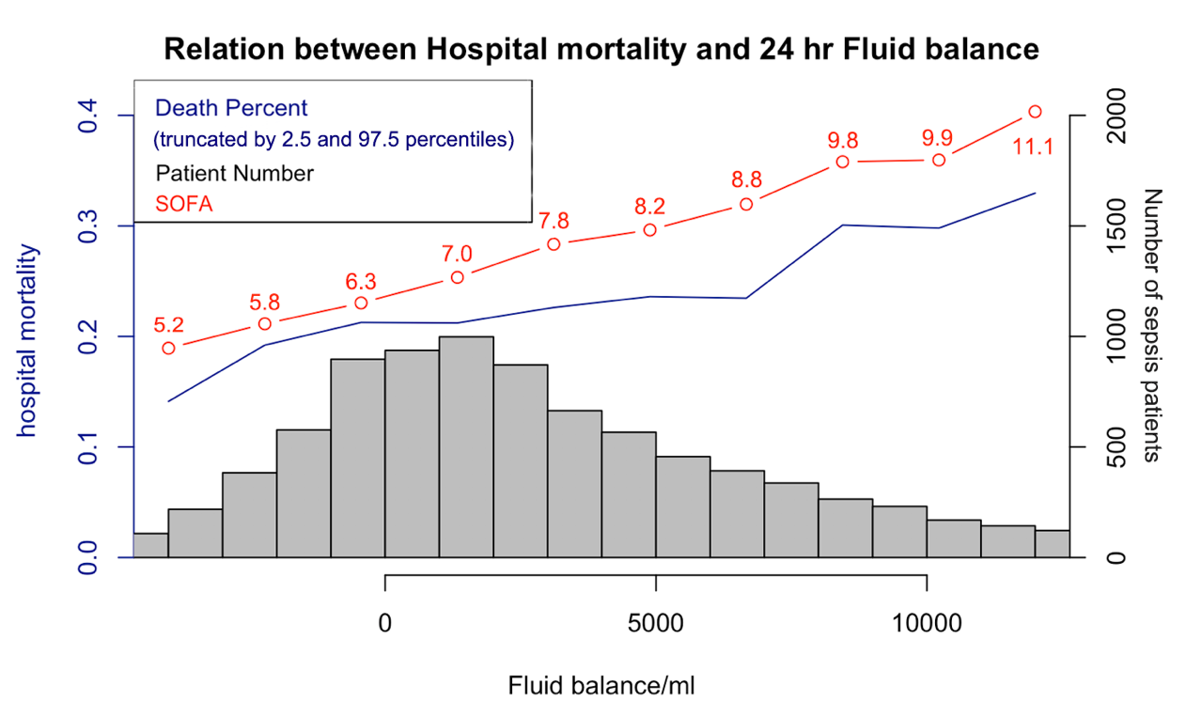

**Figure 1.2 Relation between Hospital mortality, SOFA and Fluid balance**

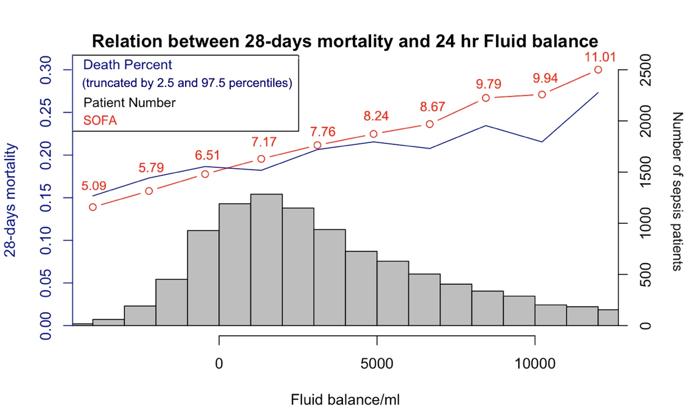

**Figure 1.3 Relation between 28-days mortality, SOFA and Fluid balance**

***Table 1.3 Use logistic regression to evaluate Relationship between FB and 28-day mortality status, stratified by quartile of fluid balance***

|  |  |  |  |  |  |
| --- | --- | --- | --- | --- | --- |
| OR(95% CI), p-value | | | | | |
|  | **group1** | **group2** | **group3** | **group4** | **Per 1L increase in FB** |
| Model1  ALL patients | 1.00 Ref. | 1.11 ( 0.94 , 1.31 )  p = 0.233 | 0.97 ( 0.81 , 1.16 )  p = 0.732 | 0.87 ( 0.68 , 1.12 )  p = 0.281 | 0.99 ( 0.97 , 1 )  p = 0.092 |
| Model2  PUL | 1.00 Ref. | 1.43 ( 1.05 , 1.95 )  p = 0.022 | 1.31 ( 0.94 , 1.84 )  p = 0.109 | 1.3 ( 0.82 , 2.08 )  p = 0.267 | 0.98 ( 0.94 , 1.01 )  p = 0.147 |
| Model3  CKD | 1.00 Ref. | 1.49 ( 0.95 , 2.36 )  p = 0.086 | 1.52 ( 0.94 , 2.5 )  p = 0.091 | 1.35 ( 0.68 , 2.7 )  p = 0.396 | 0.99 ( 0.94 , 1.04 )  p = 0.718 |
| Model4  CHF | 1.00 Ref. | 1.24 ( 0.9 , 1.72 )  p = 0.191 | 1.28 ( 0.9 , 1.81 )  p = 0.171 | 1.14 ( 0.7 , 1.84 )  p = 0.594 | 0.98 ( 0.95 , 1.02 )  p = 0.293 |
| Model5  Hypertension | 1.00 Ref. | 1.25 ( 0.75 , 2.13 )  p = 0.398 | 1.41 ( 0.82 , 2.48 )  p = 0.222 | 1.05 ( 0.47 , 2.35 )  p = 0.906 | 1 ( 0.94 , 1.06 )  p = 1 |

***Model1 for all patients adjusted for*** *age, gender, weight, hemoglobin, creatinine, WBC, temperature, respiratory rate, heart rate, MBP, mechanical ventilation duration, GCS, sofa, diabetes, hypertension, congestive heart failure, renal failure, liver disease, cancer, aids , chronic pulmonary diseases, obesity , ESKD, pulmonary disease, dialysis*

***Model2 for PUL*** *respected to model 1* ***except*** *pulmonary disease*

***Model3 for CKD*** *respected to model 1* ***except*** *renal failure*

***Model4 for CHF*** *respected to model 1* ***except*** *congestive heart failure*

***Model5 for Hypertension*** *respected to model 1* ***except*** *hypertension*

***(models below would respect to the same criterial)***

***Table 1.4 Use logistic regression to evaluate Relationship between FB and ICU mortality status, stratified by quartile of fluid balance***

|  |  |  |  |  |  |
| --- | --- | --- | --- | --- | --- |
| OR(95% CI), p-value | | | | | |
|  | **group1** | **group2** | **group3** | **group4** | **Per 1L increase in FB** |
| Model1  ALL patients | 1.00 Ref. | 1.06 ( 0.87 , 1.29 )  p = 0.575 | 0.94 ( 0.77 , 1.16 )  p = 0.558 | 0.89 ( 0.67 , 1.17 )  p = 0.401 | 0.99 ( 0.97 , 1 )  p = 0.077 |
| Model2  PUL | 1.00 Ref. | 1.16 ( 0.83 , 1.63 )  p = 0.397 | 1.02 ( 0.7 , 1.47 )  p = 0.932 | 1.14 ( 0.7 , 1.89 )  p = 0.592 | 0.96 ( 0.93 , 1 )  p = 0.037 |
| Model3  CKD | 1.00 Ref. | 1.69 ( 0.96 , 3.03 )  p = 0.072 | 1.52 ( 0.84 , 2.8 )  p = 0.173 | 1.31 ( 0.59 , 2.95 )  p = 0.504 | 1 ( 0.94 , 1.05 )  p = 0.89 |
| Model4  CHF | 1.00 Ref. | 1.2 ( 0.83 , 1.76 )  p = 0.338 | 1.29 ( 0.87 , 1.92 )  p = 0.207 | 1.26 ( 0.74 , 2.13 )  p = 0.393 | 0.98 ( 0.95 , 1.02 )  p = 0.336 |
| Model5  Hypertension | 1.00 Ref. | 1.23 ( 0.65 , 2.38 )  p = 0.526 | 1.45 ( 0.76 , 2.84 )  p = 0.272 | 1.03 ( 0.42 , 2.59 )  p = 0.943 | 1 ( 0.94 , 1.06 )  p = 0.981 |

#### *Table 1.5 Use logistic regression to evaluate Relationship between fluid balance and Hospital mortality status, the group was stratified by quartile of fluid balance*

|  |  |  |  |  |  |
| --- | --- | --- | --- | --- | --- |
| OR(95% CI), p-value | | | | | |
|  | **group1** | **group2** | **group3** | **group4** | **Per 1L increase in FB** |
| Model1  ALL patients | 1.00 Ref. | 1.16 ( 0.99 , 1.36 )  p = 0.07 | 0.98 ( 0.83 , 1.17 )  p = 0.851 | 0.9 ( 0.7 , 1.14 )  p = 0.372 | 0.99 ( 0.98 , 1.01 )  p = 0.244 |
| Model2  PUL | 1.00 Ref. | 1.48 ( 1.1 , 2 )  p = 0.01 | 1.43 ( 1.04 , 1.99 )  p = 0.029 | 1.53 ( 0.98 , 2.4 )  p = 0.061 | 0.97 ( 0.94 , 1 )  p = 0.066 |
| Model3  CKD | 1.00 Ref. | 1.35 ( 0.88 , 2.07 )  p = 0.168 | 1.33 ( 0.84 , 2.12 )  p = 0.22 | 1.13 ( 0.58 , 2.19 )  p = 0.711 | 1 ( 0.95 , 1.05 )  p = 0.96 |
| Model4  CHF | 1.00 Ref. | 1.28 ( 0.94 , 1.75 )  p = 0.121 | 1.38 ( 0.99 , 1.93 )  p = 0.058 | 1.24 ( 0.78 , 1.95 )  p = 0.365 | 0.99 ( 0.95 , 1.02 )  p = 0.373 |
| Model5  Hypertension | 1.00 Ref. | 1.32 ( 0.8 , 2.19 )  p = 0.275 | 1.44 ( 0.85 , 2.47 )  p = 0.18 | 1.2 ( 0.56 , 2.6 )  p = 0.634 | 1 ( 0.94 , 1.05 )  p = 0.875 |

**Table 1.6 Use linear regression to evaluate Relationship between 24hour-fluid balance and LOS ICU, stratified by quartile of fluid balance**

|  |  |  |  |  |  |
| --- | --- | --- | --- | --- | --- |
|  | group1 | group2 | group3 | group4 | Per 1L increase in FB |
| ALL patients | 1.00 Ref. | -0.46 ( -0.98 , 0.06 )  p = 0.082 | -0.45 ( -1.01 , 0.12 )  p = 0.119 | -0.61 ( -1.39 , 0.18 )  p = 0.13 | 0.07 ( 0.03 , 0.12 )  p = 0.002 |
| PUL | 1.00 Ref. | -0.63 ( -1.51 , 0.25 )  p = 0.159 | 0.14 ( -0.82 , 1.1 )  p = 0.78 | -0.34 ( -1.7 , 1.02 )  p = 0.624 | 0.15 ( 0.05 , 0.25 )  p = 0.004 |
| CKD | 1.00 Ref. | -0.72 ( -1.93 , 0.5 )  p = 0.248 | -0.83 ( -2.19 , 0.53 )  p = 0.23 | -0.93 ( -2.96 , 1.11 )  p = 0.372 | 0.29 ( 0.13 , 0.44 )  p < 0.001 |
| CHF | 1.00 Ref. | -0.13 ( -1.31 , 1.06 )  p = 0.835 | -0.06 ( -1.36 , 1.23 )  p = 0.924 | -0.61 ( -2.45 , 1.22 )  p = 0.513 | 0.14 ( 0.01 , 0.28 )  p = 0.036 |
| Hypertension | 1.00 Ref. | -0.68 ( -2.07 , 0.71 )  p = 0.336 | -0.71 ( -2.27 , 0.84 )  p = 0.369 | -0.81 ( -3.15 , 1.53 )  p = 0.496 | 0.25 ( 0.06 , 0.44 )  p = 0.009 |

***Table1.7 Use logistic regression to evaluate 24-hour FB effect on 28-days expire status***

|  |  |  |
| --- | --- | --- |
|  | OR(95% CI) | p value |
| (Intercept) | 1.27 ( 0.19 , 8.46 ) | 0.807 |
| Age | 1.03 ( 1.03 , 1.03 ) | < 0.001 |
| Gender=Male | 0.9 ( 0.8 , 1.01 ) | 0.066 |
| Weight | 0.99 ( 0.99 , 1 ) | < 0.001 |
| Hemoglobin | 0.97 ( 0.95 , 1 ) | 0.047 |
| Creatinine | 0.95 ( 0.91 , 0.99 ) | 0.013 |
| WBC | 1.01 ( 1 , 1.01 ) | 0.001 |
| Temperature value | 0.87 ( 0.82 , 0.91 ) | < 0.001 |
| Respiratory rate | 1.04 ( 1.03 , 1.05 ) | < 0.001 |
| Heart rate | 1 ( 1 , 1.01 ) | 0.004 |
| MBP | 1 ( 0.99 , 1 ) | 0.121 |
| Mechanical ventilation duration | 0.99 ( 0.99 , 1 ) | 0.002 |
| GCS | 1 ( 0.98 , 1.02 ) | 0.93 |
| SOFA | 1.19 ( 1.17 , 1.22 ) | < 0.001 |
| Diabetes | 0.9 ( 0.79 , 1.02 ) | 0.1 |
| Hypertension | 0.73 ( 0.55 , 0.96 ) | 0.025 |
| Congestive heart failure | 1.04 ( 0.91 , 1.18 ) | 0.565 |
| Renal failure | 1.03 ( 0.8 , 1.33 ) | 0.802 |
| Liver disease | 1.77 ( 1.46 , 2.12 ) | < 0.001 |
| Cancer | 2.6 ( 2.17 , 3.11 ) | < 0.001 |
| AIDS | 0.71 ( 0.21 , 1.89 ) | 0.543 |
| Chronic pulmonary | 1 ( 0.87 , 1.14 ) | 0.976 |
| Obesity | 0.98 ( 0.73 , 1.3 ) | 0.878 |
| ESKD | 0.9 ( 0.61 , 1.3 ) | 0.567 |
| Pulmonary infection | 1.22 ( 1.07 , 1.38 ) | 0.002 |
| Dialysis | 1.16 ( 0.94 , 1.43 ) | 0.156 |
| Group2 | 1.08 ( 0.91 , 1.27 ) | 0.385 |
| Group3 | 0.91 ( 0.77 , 1.08 ) | 0.289 |
| Group4 | 0.75 ( 0.62 , 0.89 ) | 0.002 |

***Table 1.8 Use logistic regression to evaluate 24-hour FB effect(category variable, stratified by quartile of 24-hour FB ) on hospital expire status***

|  |  |  |
| --- | --- | --- |
|  | OR(95% CI) | p value |
| (Intercept) | 2.34 ( 0.37 , 14.7 ) | 0.365 |
| Age | 1.03 ( 1.02 , 1.03 ) | < 0.001 |
| Gender=Male | 0.88 ( 0.78 , 0.98 ) | 0.021 |
| Weight | 0.99 ( 0.99 , 1 ) | < 0.001 |
| Hemoglobin | 0.95 ( 0.93 , 0.98 ) | < 0.001 |
| Creatinine | 0.9 ( 0.87 , 0.94 ) | < 0.001 |
| WBC | 1.01 ( 1 , 1.01 ) | 0.008 |
| Temperature | 0.86 ( 0.82 , 0.9 ) | < 0.001 |
| Respiratory rate | 1.04 ( 1.03 , 1.05 ) | < 0.001 |
| Heart rate | 1.01 ( 1 , 1.01 ) | < 0.001 |
| MBP | 1 ( 1 , 1 ) | 0.342 |
| Mechanical ventilation duration | 0.99 ( 0.98 , 0.99 ) | < 0.001 |
| GCS | 1 ( 0.99 , 1.02 ) | 0.612 |
| SOFA | 1.2 ( 1.17 , 1.22 ) | < 0.001 |
| Diabetes | 0.86 ( 0.75 , 0.97 ) | 0.015 |
| Hypertension | 0.68 ( 0.52 , 0.88 ) | 0.004 |
| Congestive heart failure | 1.15 ( 1.02 , 1.3 ) | 0.027 |
| Renal failure | 1.07 ( 0.84 , 1.37 ) | 0.578 |
| Liver disease | 1.76 ( 1.47 , 2.11 ) | < 0.001 |
| cancer | 2.54 ( 2.13 , 3.03 ) | < 0.001 |
| AIDS | 0.92 ( 0.33 , 2.18 ) | 0.864 |
| Chronic pulmonary disease | 0.9 ( 0.79 , 1.03 ) | 0.124 |
| Obesity | 0.9 ( 0.68 , 1.18 ) | 0.454 |
| ESKD | 0.78 ( 0.55 , 1.11 ) | 0.172 |
| Pulmonary disease | 1.17 ( 1.04 , 1.32 ) | 0.011 |
| Dialysis | 1.96 ( 1.61 , 2.39 ) | < 0.001 |
| Group2 | 1.14 ( 0.97 , 1.33 ) | 0.107 |
| Group3 | 0.95 ( 0.81 , 1.11 ) | 0.5 |
| Group4 | 0.81 ( 0.68 , 0.96 ) | 0.017 |

***Table 1.9 Use logistic regression to evaluate 24-hour FB effect on ICU expire status***

|  |  |  |
| --- | --- | --- |
|  | OR(95% CI) | p value |
| (Intercept) | 1.34 ( 0.17 , 10.52 ) | 0.783 |
| Age | 1.03 ( 1.02 , 1.03 ) | < 0.001 |
| Gender= Male | 1.03 ( 0.91 , 1.18 ) | 0.614 |
| Weight | 1 ( 0.99 , 1 ) | 0.02 |
| Hemoglobin | 0.97 ( 0.95 , 1 ) | 0.056 |
| Creatinine | 0.93 ( 0.88 , 0.97 ) | 0.002 |
| WBC | 1 ( 1 , 1.01 ) | 0.118 |
| Temperature | 0.86 ( 0.81 , 0.91 ) | < 0.001 |
| Respiratory rate | 1.04 ( 1.03 , 1.05 ) | < 0.001 |
| Heart rate | 1.01 ( 1 , 1.01 ) | < 0.001 |
| MBP | 1 ( 0.99 , 1 ) | 0.228 |
| Mechanical ventilation duration | 0.98 ( 0.97 , 0.99 ) | < 0.001 |
| GCS | 0.97 ( 0.96 , 0.99 ) | 0.004 |
| SOFA | 1.24 ( 1.21 , 1.27 ) | < 0.001 |
| Diabetes | 0.88 ( 0.76 , 1.02 ) | 0.104 |
| Hypertension | 0.74 ( 0.54 , 1.02 ) | 0.061 |
| Congestive heart failure | 1.06 ( 0.91 , 1.22 ) | 0.45 |
| Renal failure | 0.91 ( 0.68 , 1.22 ) | 0.538 |
| Liver disease | 1.39 ( 1.12 , 1.71 ) | 0.002 |
| Cancer | 2.45 ( 2 , 2.99 ) | < 0.001 |
| AIDS | 0.95 ( 0.26 , 2.6 ) | 0.924 |
| Chronic pulmonary | 1.01 ( 0.86 , 1.17 ) | 0.93 |
| Obesity | 0.88 ( 0.63 , 1.21 ) | 0.44 |
| ESKD | 0.85 ( 0.56 , 1.28 ) | 0.44 |
| Pulmonary disease | 1.27 ( 1.11 , 1.46 ) | 0.001 |
| Dialysis | 1.66 ( 1.33 , 2.06 ) | < 0.001 |
| Group2 | 1.02 ( 0.85 , 1.24 ) | 0.806 |
| Group3 | 0.88 ( 0.73 , 1.07 ) | 0.204 |
| Group4 | 0.75 ( 0.61 , 0.92 ) | 0.006 |