

Palestine Technical University - Kadoorie

Faculty of Engineering and Technology

Computer Systems Engineering Department

**GAMIFYING PROGRAMMING LEARNING AND PROBLEM SOLVING**

**Prepared by:**

Majd Kittaeh

Omar Shaikh Ibrahim

**Supervised by:**

Nael Salman, Ph.D.

**A graduation project submitted in partial fulfillment of the requirements for the bachelor's degree in computer systems engineering.**

Tulkarm, Palestine

January, 2024

ACKNOWLEDGEMENT

We begin by expressing our gratitude to Allah for His blessings and guidance throughout this journey. We would like to extend our heartfelt appreciation to our parents and families for their unwavering support and encouragement that enabled us to successfully complete this work. We are also deeply grateful to our university Palestine Technical University - Kadoori and specifically the Faculty of Engineering and Technology for providing us with the opportunity to pursue our studies and engage in this project.

Our utmost appreciation goes to our supervisor, Dr. Nael Salman, for his invaluable guidance, continuous support, and dedication. His expertise and insightful feedback have greatly contributed to the success of this project. We would also like to extend our sincere thanks to all the faculty members of the Department of Computer Systems Engineering for their valuable teachings and assistance, which have been instrumental in shaping our knowledge and skills.

Lastly, we would like to acknowledge the efforts of everyone involved in this project, whose contributions have been instrumental in its completion. We are grateful for their collaboration and support throughout this endeavor.

**ABSTRACT**

This thesis presents the concept of fusing game design with programming teaching, aiming to leverage the principles of game design to create an engaging and effective environment for individuals to learn programming concepts.

The idea revolves around using game mechanics, such as levels, exploration, puzzles and progression to change the challenging process of programming into an interactive and enjoyable journey.

This conceptual project sets the stage for further exploration and refinement. It raises questions about the good integration of game mechanics, choosing languages and the design of challenges to maintain a balanced blend of fun and education.

As a conceptual project, it will represent an innovative and forward-thinking approach to address the challenges in programming education. As the concept evolves, it holds the potential to redefine how individuals approach and engage with programming learning.

**CHAPTER 1**

INTRODUCTION

*In this chapter, we will discuss the outlines of our project.*

**1.1 Background**

With the rise of generations that mainly consume digital content especially visual, there is a shift happening in learning preferences towards interactive and dynamic approaches. The traditional lecture-based learning may not fully capture the attention and interest of those individuals.

At the same time in this digital era, the ability to code is not only valuable for dedicated software developers but is increasingly becoming important for professionals in different fields.

Video games and programming share the same core : problem solving. Recognizing this opens up opportunities to leverage the interactive nature of gaming for educational purposes.

Another thing that supports the project direction is the scene of games modding –short for modification- communities, where players who are often teenagers learn programming to modify a game and change its content, which shows that players in high numbers are motivated to learn programming because of games.

**1.2 Problem Statement**

Many programming courses focus heavily on theoretical concepts, which gives learners no opportunities to apply their knowledge to real-world problems. Creating a video game environment with its own rules and objectives simulates the situation of writing a code to solve a real problem.

Traditional education follows a one-size-fits-all approach, which makes a problem for individuals with different learning styles, this and what we mentioned in the previous section about the newer generations being digital content consumers weakens the classroom traditional setting and calls for a more interactive methods.

**1.3 Objectives**

1. To develop a conceptual project that investigates the idea of fusing game design and programming teaching, and to provide a framework for guiding the development of such platform.
2. To ensure a smooth learning curve by starting with basics and gradually advancing and giving more difficult challenges.
3. To use challenging nature of both video games and programming to create a satisfying experience that ends with a sense of accomplishment.

**1.4 Procedures**

To achieve our project goals, we focused on developing a computer game that allows users to solve puzzles and proceed in levels by writing the proper code using a custom programming language made for our project.

To be able to do this, we started learning about interpreters and how to make a programming language in addition to studying some game design basics. Thus, we gathered the information we needed to start designing.

After gathering requirements, we analyzed and organized the information using UML (Unified Modeling Language) diagrams. These diagrams represented the structure and behavior of each functionality in the system (both game and interpreter), providing a blueprint for how they would be implemented and integrated.

Once the design phase was completed, our team transitioned into the development phase. For this, we adopted the agile approach to the Software Development Life Cycle (SDLC). The agile model is widely recognized in the software development industry, as it promotes flexibility and iterative development strategies. Our workflow progressed through cycles of planning, designing, coding, and testing specific sets of features or functionality.

By adopting the agile methodology, we were able to ensure regular communication and collaboration within our development team. This facilitated efficient decision-making, effective problem-solving, and continuous feedback loops.

Throughout the development process, we prioritized regular testing to verify the functionality, performance, and usability of the system. This iterative approach allowed us to identify and resolve issues early, ensuring a smooth and reliable user experience.

**1.5 Organization of the Study**

This thesis is divided into five chapters each one describing a part of our project.

The chapters are as the following:

* Chapter 1: Introduction: This chapter outlines the idea and the main objective of the project.
* Chapter 2: Literature review: This chapter discusses similar previous projects.
* Chapter 3: System Requirements: This chapter discusses the System Requirements (functional and non-functional).
* Chapter 4: Methodology And Technologies: This chapter discusses the methodology we used during the construction of this project.
* Chapter 5: This chapter reviews the conclusion and Future Vision for this project.
* Chapter 6: References.

**CHAPTER 2**

LITERATURE REVIEW

*In this chapter, we will discuss similar previous systems*

**2.1 Similar Work and Differences**

Scratch [0.0] is a visual programming language and online community that allows users to create interactive stories, games and animations using its simple lego-style programming language. Scratch is similar to our project as it focuses on the same audience of young students and newcomers to programming. However, it does not offer the code-to-win concept or adding game elements to the teaching process.

CodinGame [0.0] is an online platform that offers coding puzzles and challenges in the form of games where users can solve programming problems using various languages and compete with other programmers. CodinGame is similar to our project as it offers the code-to-win concept and uses puzzles and levels to teach programming. However, it uses established programming languages which does not give the flexibility we want to achieve in our project. In addition to that, a big difference is that it lacks the real-time feedback and interactivity as it plays the winning scene if the code is true and the losing one if it is false, it does not provide enough game elements.

Codecademy [0.0] is an online learning platform that offers coding lessons in various programming languages where users learn by writing and running code directly in the browser. It is similar to our project with its use of level and progressive learning but it lacks the interactivity and game elements.

**CHAPTER 3**

SYSTEM REQUIREMENTS

*This chapter discusses the System Requirements (functional and non-functional).*

**3.1 Functional Requirements**

**3.1.1 Interactive Environment**

The game should provide levels and environments that interacts at real-time with the player-written code showing them right and wrong results in visual environment.

This can be done by using the custom interpreter-based programming language by pausing the execution for an amount of time at specific lines to show the effect of the code at the objects in the environment based on the values stored in the memory.

**3.1.2 Progression**

The player's progression in game level should reflect his progression in learning. This can be done by starting with basic and simple puzzles, then introducing more concepts ensuring a smooth learning and difficulty increase curves.

Each level should use concepts of the level before it and add to them new ones to be learned and used.

**3.1.3 Challenge Description**

Inputs, outputs and the code player will write must all be described both textually and visually to ensure the requirements of the challenge and the concept it introduces are well understood by the player.

**3.1.4 Providing Help**

The player should have access to all concepts he learnt in previous levels at anytime, supported with additional examples and explanation.

**3.1.5 Code Editor**

The system must include an integrated code editor for players to write code inside the game.

In addition to that, the code editor should provide syntax highlighting and code refactoring running at real-time to get the best understanding of the written code.

**3.2 Non-Functional Requirements**

**3.2.1 Usability**

* The game's user interface should be user-friendly and consistent across all levels.
* The action that will be performed upon a key press depending on the context must be clear to the player and changes in real-time.
* The user interface must have minimal learning curve, using it in the first level is enough to get used to it.
* The game should give a feedback upon player's actions that gives him clear response of his action and the result of it.
* The user interface is adaptive and responsive, works seamlessly with different screen sizes, aspect ratios and resolutions.

**3.2.2 Scalability**

The system will be designed with scalability in mind, adding new challenges, levels, additional systems or replacing any of them should be done with no difficulties.

**CHAPTER 4**

METHODOLOGY AND TECHNOLOGIES

*This chapter discusses the methodology we used during the construction of this project representing it through Software Analysis & Design.*

**4.1 Methodology**

Methodology means the method that will be used to build this system. In addition, the methodology is the most important part of the system development. In our project, we use System Development Life Cycle (SDLC). SDLC is a series of phases in the development process. It provides a model for the development and lifecycle of an application. The SDLC process will help to produce an effective, cost-efficient, and high-quality system.

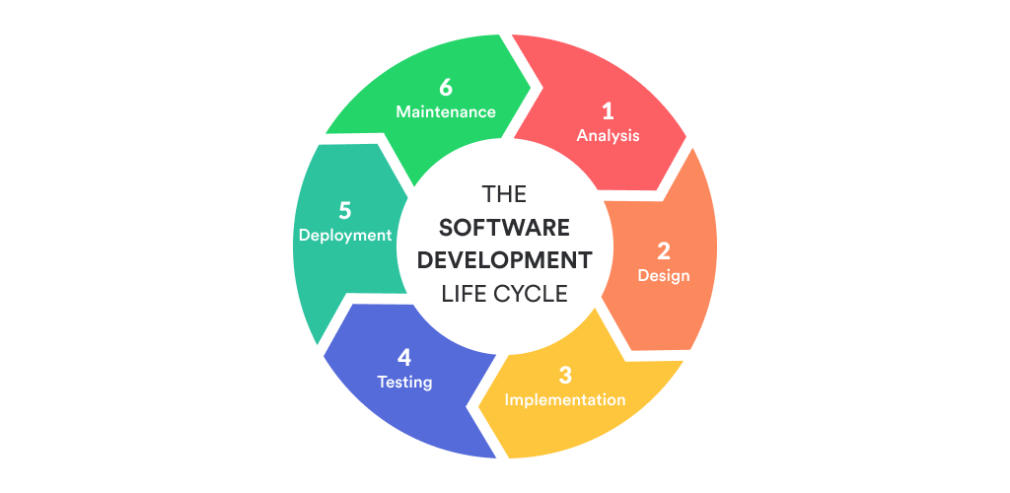

*Figure 4.1* *System Development Life Cycle*

One of several types of SDLC is the Agile model and that is what we depended on when we started work on this project because requirements may vary based on the change of our understanding of the project requirements as long as we progress, using the agile technique will be easier because it is flexible and iteratively developing. The agile method can help in plan and scheduling the system development. The development process moves from planning, development, testing then the feedback from testing is collected and fit back into the cycle.

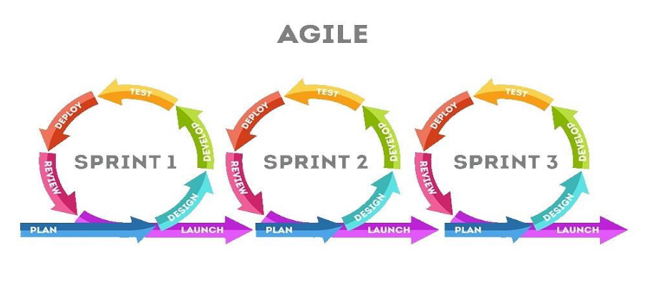

*Figure* *4.2 Agile Model*

**4.2 Technologies**

**4.2.1 Integrated Development Environment: Visual Studio**

For the implementation of the system, we used Visual Studio to write needed C# code.

Figure 4.2.1 Visual Studio Logo

Visual Studio is an integrated development environment (IDE) from Microsoft. It is used to develop computer programs including websites, web apps, web services and mobile apps.

**4.2.2 Programming Language: C#**

* C# is a simple, modern, general-purpose, object-oriented programming language.

Figure 4.2.2 C# Logo

* C# applications are intended to be economical with regard to memory and processing power requirements.
* C# is the language used to write scripts in the Unity engine.

**4.2.3 Unity 3D**

Unity 3D is a powerful and widely used game development. With Unity 3D, we can create immersive and interactive experiences by combining 3D graphics, animations, physics, and more.

Figure 4.2.3 Unity 3D Logo

Here's an overview of how Unity works:

* Scene Setup: Developers begin by setting up their Unity project and scene. They can import 3D models, textures, and other assets into the project, and arrange them within the scene to create the desired environment for the level.

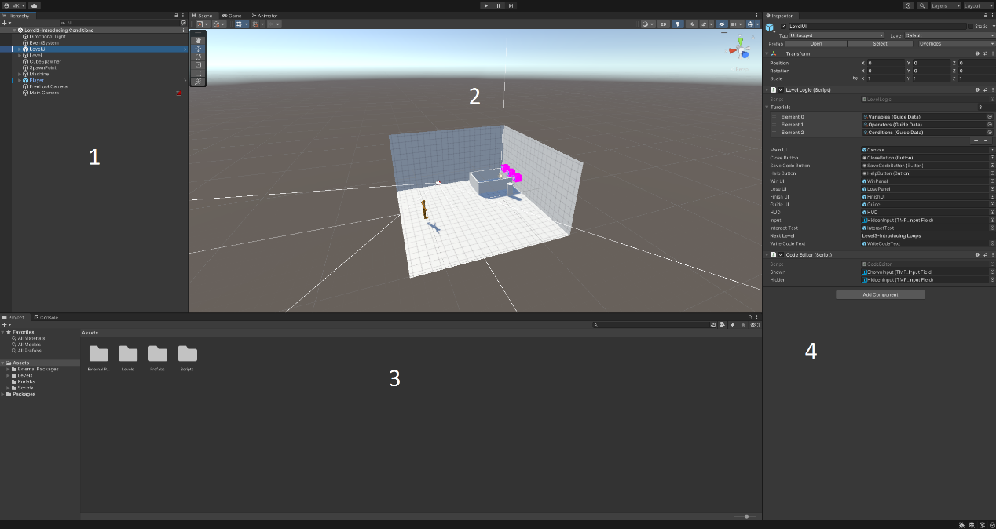

Figure 4.2.3.1 Unity Editor

1. Hierarchy: this window shows the scene name as the root and objects in the current scene as child nodes. Each one of these objects is called a GameObject and has at least the basic component Transform which describes the location, rotation and scale of the object in the scene.
2. Scene: the Scene view is where you visualize and interact with the world you create in the Editor. In the Scene view, you can select, manipulate, and modify GameObjects that act as scenery, characters, cameras, lights, and more.
3. Project Window: this is the window that shows all files in the project, with the main folder called "Assets". Project files and folders can be organized by the developer to access them easily.
4. Inspector: this window shows the components of selected object in Scene or Hierarchy. Components vary from ones included in unity by default and some written by user like C# scripts.

* Unity Components:

We will mention some Unity Components that we used in our project:

1. 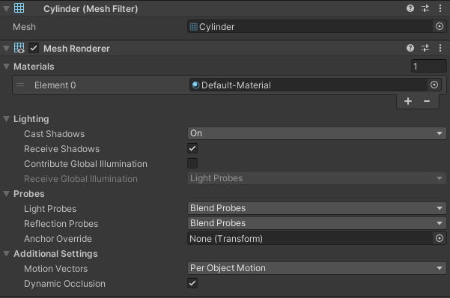Mesh Renderer and Mesh Filter: these components work together to render 3D objects.

Figure 4.2.3.2 – Mesh Renderer and Filter of a cylinder shaped object

1. 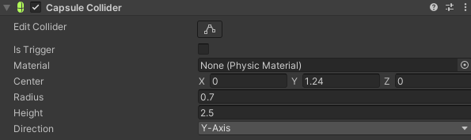Colliders: component that defines the shape of an object for the purposes of physical collisions. A collider, which is invisible, need not be the exact same shape as the object’s mesh.

Figure 4.2.3.3 – Collider Component of a capsule shaped object

1. 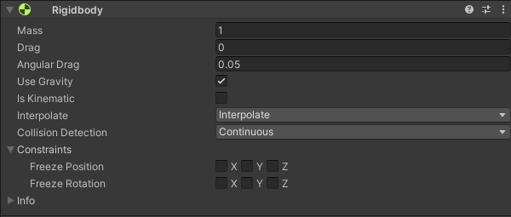Rigidbody: the main component that enables physical behavior for a GameObject. With a Rigidbody attached, the object will immediately respond to gravity.

Figure 4.2.3.4 – Rigidbody Component

1. 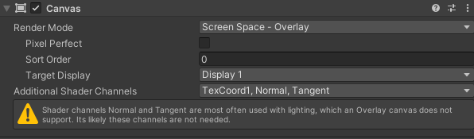UI Components: like texts, input fields and buttons. A UI Component's parent must be a Canvas which is the container of UI Objects and can be set to either show UI elements in a Screen Space or World Space.

Figure 4.2.3.5 – Canvas Component set to render in Screen Space

1. 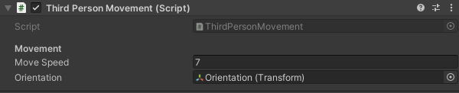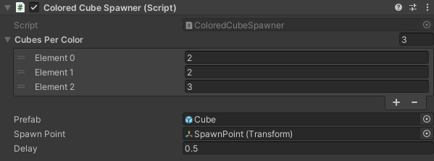C# Scripts: these are components that we implement and add to objects.

Figure 4.2.3.7 – C# Script Component – Player Movement

Figure 4.2.3.6 – C# Script Component – Colored Cube Spawner

**4.3 Software Analysis and Design**

**4.3.1 Class Diagram**

**4.3.2 Use Case Diagram**

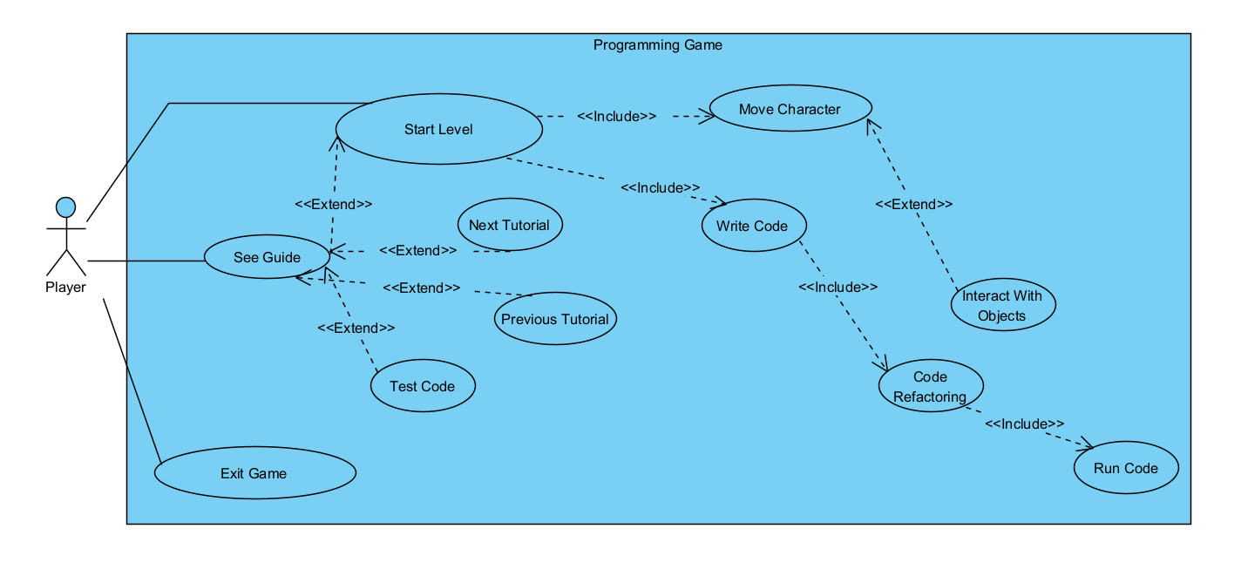

Figure 4.3.2 – Use Case Diagram

**4.3.3 Use Case Description**

Here we describe the workflow for some use cases that the users interact with.

|  |  |
| --- | --- |
| Use case name: | Start Level |
| Scenario: | Starting new level. |
| Triggering event: | Player enters new level. |
| Brief description: | Player enters level by completing the one before it.  Player should read the description of problem and explore level to write the right code. |
| Actors: | Player. |
| Related use cases: | Move Character and Write Code. |
| Preconditions: | Previous level done. |
| Postconditions: | Player must have been written the right answer or a wrong one.  If the answer is right, next level will start.  If the answer is wrong, same level will restart. |
| Flow of activities: | |  |  | | --- | --- | | **Actor** | **System** | | 1. Player starts new level 2. Player writes Code 3. Player runs the code | * 1. System sets up the scene with its objects.   2. System gives player control.   3. System starts refactoring and highlighting code.   4. System executes the code.   5. System checks for results of execution.   6. System starts level depending on the result. | |

Table 4.3.3.1 Use Case Description – Start Level

|  |  |
| --- | --- |
| Use case name: | Interacting with Objects |
| Scenario: | Player character interacts with an intractable object. |
| Triggering event: | Player character enters interact area. |
| Brief description: | Player enters interact area.  Interact trigger activates and instructions are shown on screen.  Waiting for player input to interact. |
| Actors: | Player. |
| Related use cases: | None. |
| Preconditions: | Interact trigger active |
| Postconditions: | Action will be done dependent on the intractable object. |
| Flow of activities: | |  |  | | --- | --- | | **Actor** | **System** | | 1. Player enters interact area 2. Player input | * 1. System informs player he is ready to interact.   2. System waits for player input.   3. System performs action dependent on intractable object. | |

Table 4.3.3.2 Use Case Description – Interacting with Objects

|  |  |
| --- | --- |
| Use case name: | See Guide |
| Scenario: | Player browses guide and tutorials inside game. |
| Triggering event: | Player pressing on Help/Guide button. |
| Brief description: | Player can access guide and tutorials at the main menu before playing or in the middle of a level by pausing it. |
| Actors: | Player. |
| Related use cases: | None. |
| Preconditions: | Player can access the guide before writing his code. |
| Postconditions: | Player gets access to guide and examples useful at the current level.  Player can execute these example codes and see the output.  Player can exit the guide and continue the level. |
| Flow of activities: | |  |  | | --- | --- | | **Actor** | **System** | | 1. Player presses Guide button. 2. Player presses Test Code button. 3. Player presses Back button. | * 1. System shows guide UI where player can access different examples related to the current level.   2. System executes example code and prints its output.   3. System closes guide UI.   4. System returns player to the main UI to write code. | |

Table 4.3.3.2 Use Case Description – See Guide

**4.3.4 Activity Diagrams**