Programme | Advanced Diploma in Information and Communication Technology
Module | NADV744 – Advanced Development Systems
Examiner | Melvin Kisten
Due date | 24 August 2026
GitHub repository | https://github.com/Maje107/ADVANCED-DEVELOPMENT-SOFTWARE-PROJECT
Group members
Full name | Student number
Kamogelo Bantsheng | 202311455
Gadifele Serame | 202219593
Gomolemo Precious Walaza | 202200387
Tshepang Regality Maje | 202340368
Ofentse Batlang | 202300977
Luyanda Nhlapho | 202213238

Table of Contents
1. Problem definition 3
1.1 Problem Statement 3
1.2 Why it matters in ICT 3
1.3 Plan and resources 3
2. System design 4
2.1 Architecture Overview 4
2.2 Layered Architecture 4
2.3 Data Flow 5
2.4 API endpoints 5
2.5 Tools & Technologies 6
3. Implementation 7
3.1 Project structure(simplified) 7
3.2 Sample code (Dashboard views.py) 7
3.3 GitHub 8
3.4 Error Handling Example 8
4. Testing and evaluation 9
4.1 Automated unit tests 9
4.2 Unit Testing 9
4.3 Performance and scalability notes 9
4.4 Api Testing 10
5. Report 10
5.1 Background and Context 10
5.2 Methods 10
5.3 Results and Discussion 10
5.4 Limitations 11
5.5 Future improvements 11
6. CODE & DEMO 11
6.1 How to run the System 13
7. Conclusion 14

1. Problem definition

1.1 Problem Statement
Sol Plaatje University (SPU) currently does not have a centralised digital system for booking and managing campus venues. Venue bookings are managed manually through emails, paper forms, and phone calls. Rooms, laboratories, lecture halls, tutorial rooms, and event spaces across the university are therefore allocated on an ad-hoc basis.
This manual process can lead to scheduling conflicts, double bookings, missing or unrecorded booking information, limited visibility of venue availability, and a high administrative workload. Students, lecturers, and student leaders do not have real-time access to venue availability, while administrators have limited ability to track approvals, cancellations, and booking history. A centralised campus booking system is therefore needed to improve the efficiency, accuracy, and management of venue bookings at SPU.

1.2 Why it matters in ICT
The system applies core ICT competencies, including REST API design, service-oriented architecture, role-based access control (RBAC), relational database modelling, and token-based authentication using JSON Web Tokens (JWT). It also incorporates software testing to ensure the reliability and security of the system. By automating the manual venue-booking process, the system improves efficiency, transparency, and accountability across the campus. It demonstrates how a well-engineered digital service can replace inefficient manual administrative processes with a centralized, secure, and reliable solution.

1.3 Plan and resources
Resource | Description | Purpose
Hardware | Laptop, Internet | Development and Testing
Software | Python 3,13, Django 5.x, DRF, MySQL, Postman, VS Code | Build, test, and manage the system
Methodology | Agile (Sprint-based) | Iterative development
Team Roles | Developer, Tester, UI Developer, Documenter, DevOps | Division of responsibilities
Timeline | 4 weeks | Development Cycle

2. System design

2.1 Architecture Overview
The system follows a layered, service-oriented Django architecture with three main layers: presentation, application/service, and data. The presentation layer provides a REST API and web dashboard, while the application layer handles business logic. The data layer uses a relational database to store system information. Both interfaces share the same business logic and database, avoiding duplication and maintaining consistency.
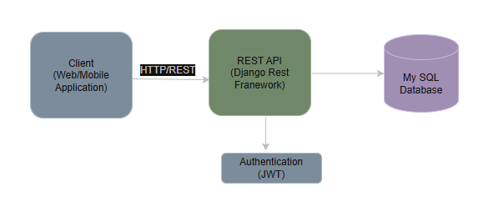

2.2 Layered Architecture
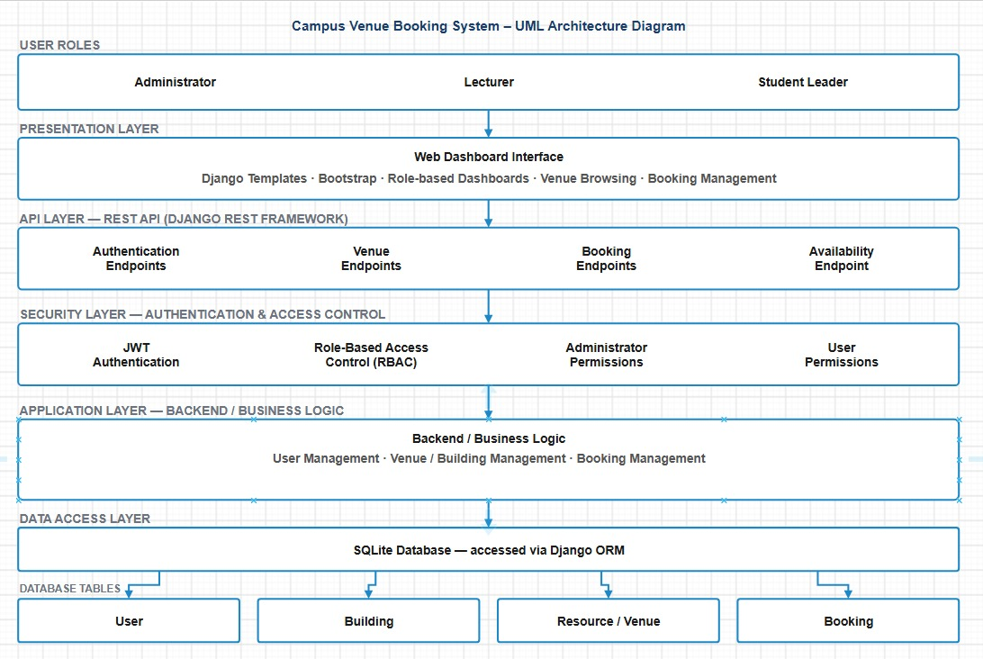
The diagram above shows the system's layered architecture, tracing a request from user to database. The three user roles — Administrator, Lecturer, and Student Leader — all interact through the Presentation Layer, a Django-templated web dashboard that handles venue browsing and booking management. Requests then pass into the API Layer, where Django REST Framework exposes dedicated endpoints for authentication, venues, bookings, and availability. Every request is validated by the Security Layer, which enforces JWT authentication and role-based access control (RBAC) before any data operation is permitted. Validated requests reach the Application Layer, where the core business logic — user management, venue/building management, and booking management — is executed. Finally, the Data Access Layer persists and retrieves data through the Django ORM against a SQLite database, structured into four core tables: User, Building, Resource/Venue, and Booking.

2.3 Data Flow
Booking request flow:
- The user selects a venue and submits a booking request.
- The system validates the booking details and operating hours.
- It checks for conflicts with existing approved bookings.
- If no conflict exists, the booking is created with pending status.
- An administrator reviews and approves or declines the request.
- On approval, the system performs a final conflict check before updating the status.
- The user's booking list displays the updated approved/declined status.
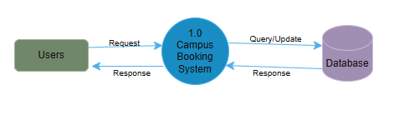

2.4 API endpoints
Authentication endpoints (/api/auth/):
Method | Endpoint | Description | Access
POST | /api/auth/register | Register a Lecturer or Student Leader | Public
POST | /api/auth/login | Obtain JWT access and refresh tokens | Public
POST | /api/auth/token/refresh | Refresh an expired access token | Public
GET | /api/auth/me | Retrieve the authenticated user's profile | JWT Bearer
POST | /api/auth/forgot password | Generate a password reset token | Public
POST | /api/auth/reset password | Reset password using a valid token | Public

Venue and building endpoints (/api/resources/):
Method | Endpoint | Description | Access
GET | /api/resources/buildings | List all seeded buildings | Public
GET | /api/resources/venues | List/filter venues (building, type, capacity, search) | Public
POST | /api/resources/venues/create | Create a new venue | Admin only
GET | /api/resources/venues/<id> | Venue detail with building info | Public
PUT/PATCH | /api/resources/venues/<id>/update | Update venue details | Admin only
DELETE | /api/resources/venues/<id> | Delete a venue | Admin only
GET | /api/resources/venues/<id>/availability | Calculate booked and free time slots for a date | Public

Booking endpoints (/api/resources/bookings):
Method | Endpoint | Description | Access
GET | /api/resources/bookings | List bookings (admin sees all; users see own) | JWT Bearer
POST | /api/resources/bookings | Submit a new booking request (conflict checked) | JWT Bearer
GET | /api/resources/bookings/<id> | Retrieve a specific booking | JWT Bearer
PUT | /api/resources/bookings/<id>/cancel | Cancel own booking | Booker / Admin
PUT/PATCH | /api/resources/bookings/<id>/status | Approve or decline a booking | Admin only

API security
All authenticated API endpoints require a valid JWT access token in the Authorization header (Bearer <token>). Role enforcement is implemented as custom DRF permission classes (IsAdmin, IsBooker) applied at the view level. The web dashboard separately uses Django session authentication with server-side role checks on every request, so hiding a menu item is never the only protection on a route.

2.5 Tools & Technologies
- Backend: Django 5.x (DRF)
- Database: MySQL 8.0
- API Testing: Django Test Case (unit test)
- Version Control: Git and GitHub
- Frontend: Django templates + Bootstrap 5 + custom SPU styling
- Environment: VS Code
- OS: Windows 11

3. Implementation

3.1 Project structure(simplified)
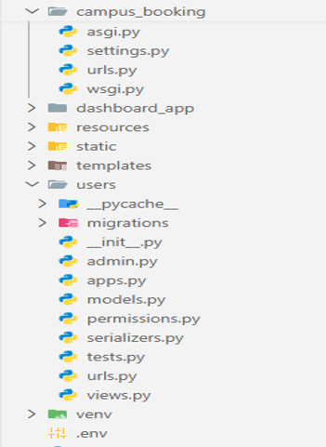

3.2 Sample code (Dashboard views.py)
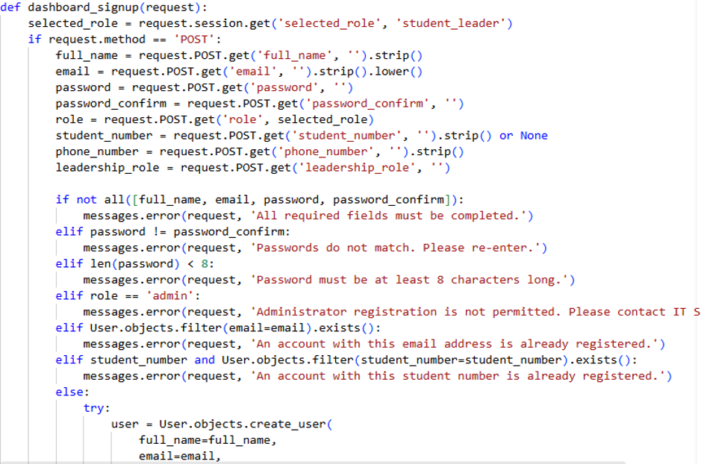

3.3 GitHub
https://github.com/Maje107/ADVANCED-DEVELOPMENT-SOFTWARE-PROJECT

3.4 Error Handling Example

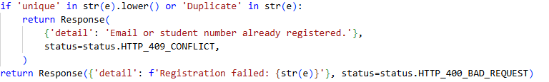

4. Testing and evaluation

4.1 Automated unit tests
The project ships with an automated test suite covering both apps. Run with python manage.py test (Pytest)
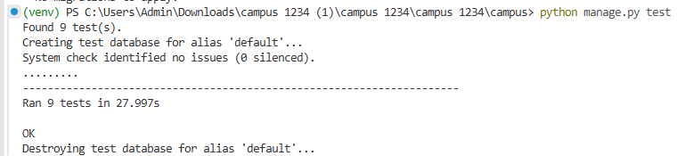

4.2 Unit Testing
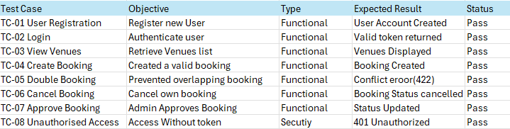

4.3 Performance and scalability notes
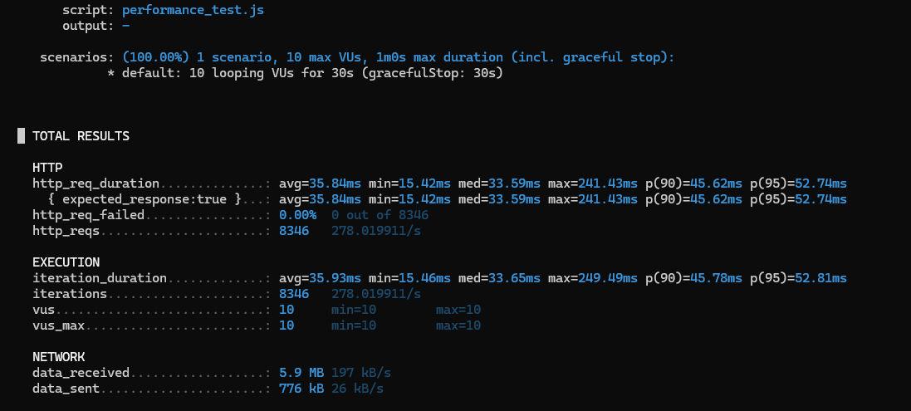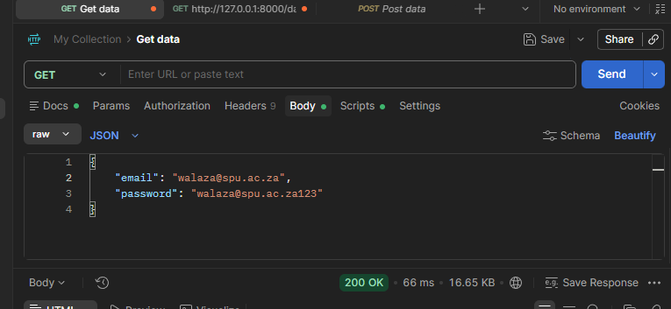

4.4 Api Testing
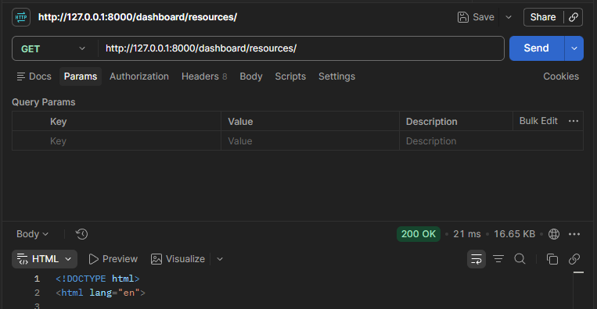

5. Report

5.1 Background and Context
The SPU Campus Booking System is designed to streamline the booking and management of campus venues, including lecture halls, laboratories, classrooms, tutorial rooms, event venues, auditoriums, and computer laboratories. The system replaces manual booking processes with a centralised digital platform that improves efficiency, reduces scheduling conflicts, and makes venue information and bookings easier to manage.

5.2 Methods
The system was developed using Django, MySQL, and RESTful architecture. The Agile methodology was followed throughout the development process. Testing was conducted using Pytest for unit testing, Postman for API testing, and k6 for performance testing.

5.3 Results and Discussion

The Campus Venue Booking System delivers a working service-driven solution addressing the problem statement in Section 1. Key outcomes:
- A functional REST API with 6 authentication endpoints and 12 resource/booking endpoints, returning consistent JSON and HTTP status codes
- Role-based access control enforced independently at the API layer and the web dashboard layer
- Conflict detection preventing double-booking of a venue for overlapping approved time slots
- A real-time availability endpoint calculating free and occupied slots for any requested date
- A token-based password reset flow
- 9 of 9 automated unit tests passing, with no Django system-check warnings

5.4 Limitations
- No email or SMS notification is sent on booking approval or decline; status changes are visible only when the user checks their booking list
- Booking decisions do not currently include an optional administrator comment or reason field
- Performance testing has been conducted only in single-user local development mode; load testing under concurrent traffic is future work
- No calendar/timeline view for visualising bookings across a week or month

5.5 Future improvements
- Email notifications on booking status change
- Calendar/timeline view for administrators to see all venue schedules briefly
- Recurring booking support for regularly scheduled sessions
- Deployment to a cloud platform with PostgreSQL and HTTPS
- API rate limiting and audit logging
- Admin comment/reason field on approval or decline decisions

6. CODE & DEMO
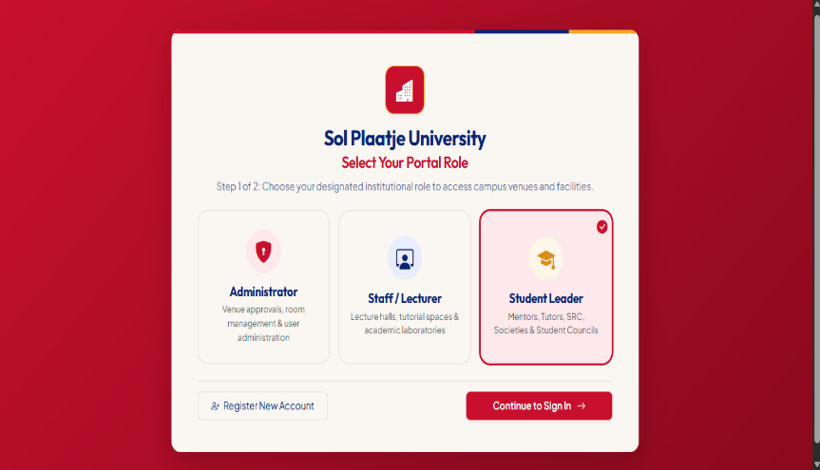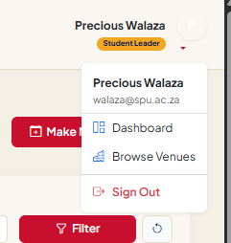

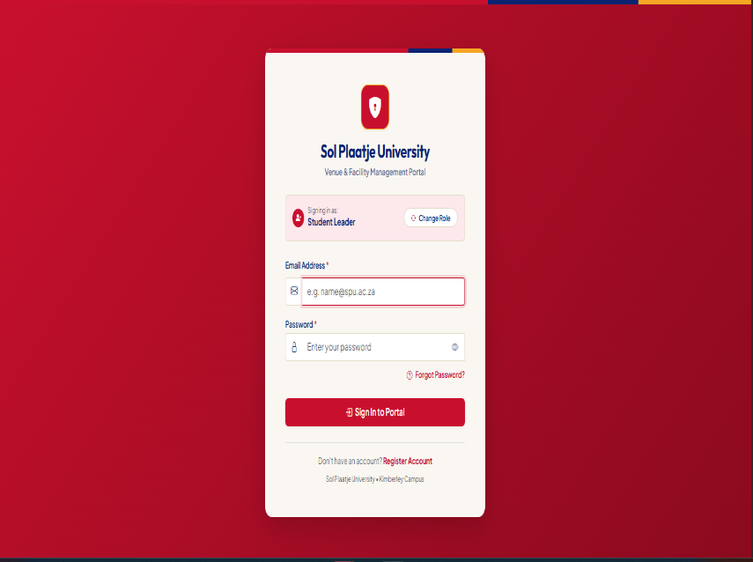

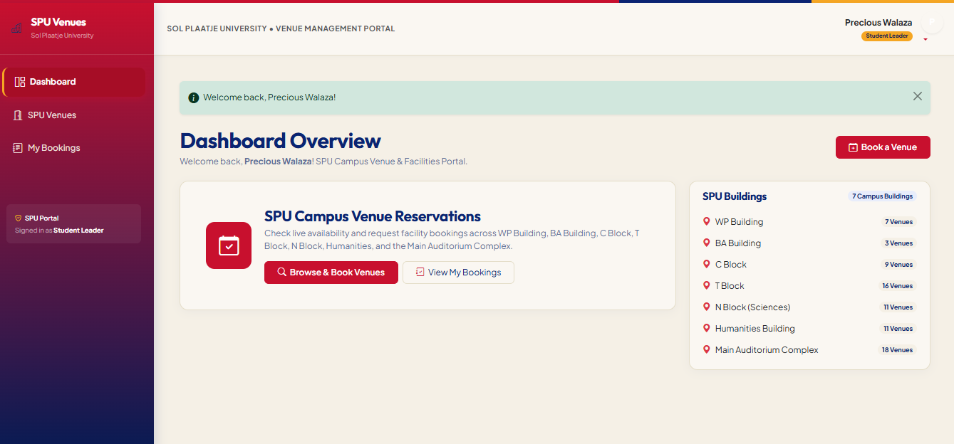

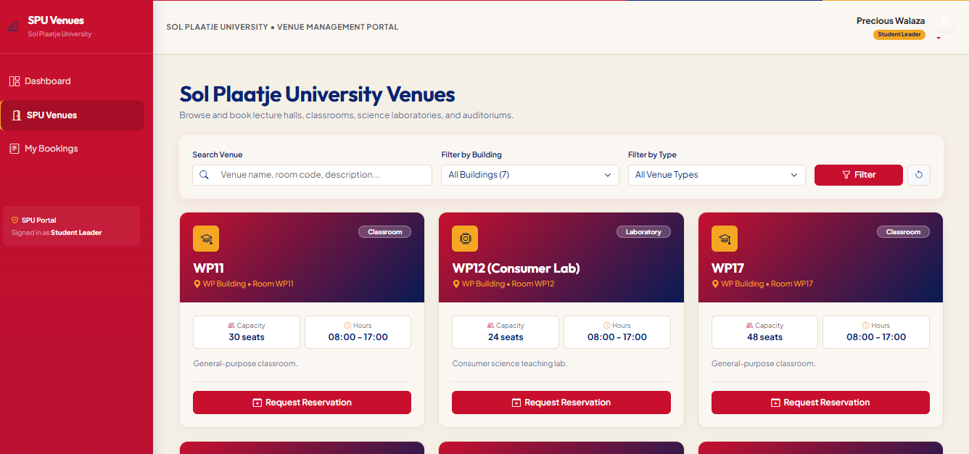

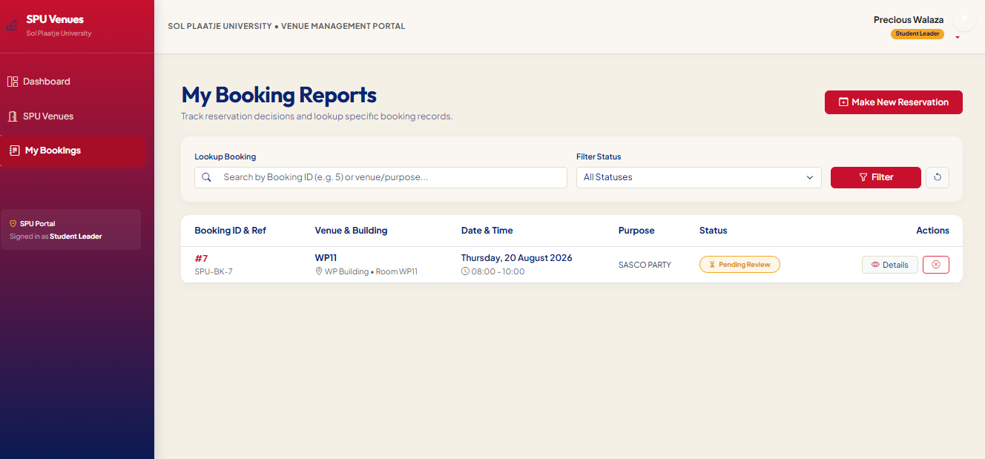

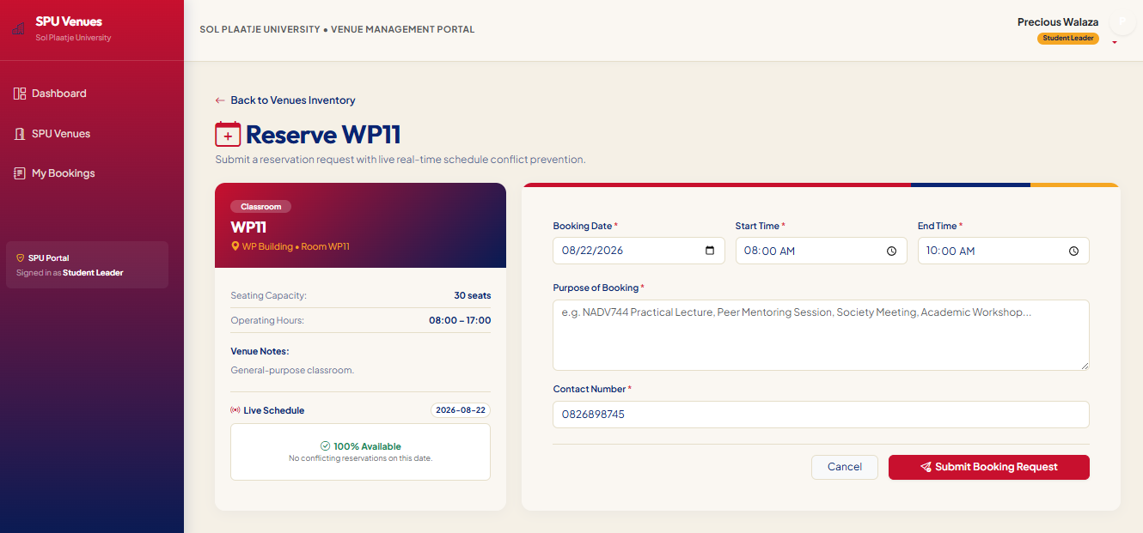

6.1 How to run the System
Git Clone: https://github.com/Maje107/ADVANCED-DEVELOPMENT-SOFTWARE-PROJECT

Commands:
cd project directory
cd CODE
cd campus
python manage.py runserver
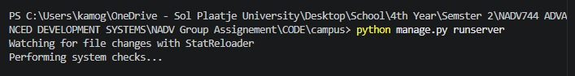

7. Conclusion
The Campus Venue Booking System is a working, service-oriented Django application combining a documented REST API (Django REST Framework and JWT), role-based access control, server-side conflict detection, and an automated test suite of 9 passing tests. It replaces SPU's ad-hoc manual venue allocation with a centralised system where availability, approvals, and bookings are recorded and auditable. The layered separation between the API and the web dashboard, sharing one domain model, gives the system a clear path for the future enhancements listed in Section 5.3.

