
PERSONAL SUBSCRIPTION TRACKER
PROJECT REPORT
Database Design — Bachelor of Information Technology
Course: Studio 1
GROUP 5
Name | Student ID
Abdul Majeed Mohammed (Leader) | 1000142471
Jaskaran Singh | 1000141233
Priyom Roy Sammo | 1000141638

Contents
Contents 2
Executive Summary 3
Design Analysis Process 3
Entity Relationship Diagram 4
Table Designs – Data Dictionary 5
Contributions 7
References 7

Executive Summary
Personal Subscription Tracker is a database-backed application, built by Group 5 for the Studio 1 Database Design paper, that helps a user manage the growing list of recurring subscriptions in their life — streaming services, software, gym memberships and cloud storage among them. A user records each subscription once (name, category, provider, cost, billing cycle and renewal date) and logs a quick check-in whenever they actually use it. The system then compares how often a subscription is used against what it costs and stores a plain keep / downgrade / cancel recommendation against it, together with whether the user accepted or dismissed that suggestion, so the same advice is never repeated unnecessarily.
The final design carries the five-entity model produced at the proposal stage — User, Subscription, Payment, Usage_Log and Recommendation — through into a working SQLite schema (Subscribtion_tracker.sql), seeded with sample data for three users and eleven related rows across Payment, Usage_Log and Recommendation. A single multi-table query joins all five entities together so that a user’s subscriptions, payments, usage history and recommendations can all be pulled back in one view, which is the foundation the dashboard, spend totals and renewal reminders described below are built on.

Design Analysis Process
The project began at the proposal stage with a written specification of the problem (people losing track of what they are paying for and how often they actually use it), the target users (budget-conscious individuals, students on a tight budget and flatmates or families sharing subscriptions), and a review of comparable products — Rocket Money, Bobby and TrackMySubs — none of which combine simple manual entry with a dedicated engine that turns usage-versus-cost into a specific cancel/downgrade/keep action. That gap is what the system is designed to close.
From that specification we listed the data the system would need to hold and grouped it into entities. The original proposal sketched three entities (User, Subscription, Payment); while working through the use cases below it became clear that “log usage” and “receive a recommendation” each needed their own timestamped, repeatable record rather than a field bolted onto Subscription, so Usage_Log and Recommendation were split out as their own entities — taking the design to the five entities implemented in the final schema.
The final schema is intentionally simpler than the proposal in a few places. The optional “connect an email or bank account to auto-detect charges” feature described in the proposal was left out of the database design entirely: it depends on an external integration rather than data the system itself owns, and was always framed as a stretch goal beyond the minimum build. category and billing_cycle are stored as plain TEXT rather than as separate lookup tables, which keeps the schema at a manageable five entities for this stage of the course rather than the eight or nine a fully normalised lookup-table version would need. Dates (renewal_date, paid_on, used_at) are stored as TEXT because SQLite has no dedicated date type; cost and amount are stored as REAL. Both choices keep the schema simple to query but mean date and currency formatting has to be validated by the application layer rather than the database itself.

List of Use Cases
The use cases below are the operations the system needs to support; each is implemented as (or directly feeds) a query against the schema described in the next section.
- Register a new subscription – insert a row into Subscription with its name, category, provider, cost, billing cycle and renewal date for a given user.
- Edit an existing subscription – update fields such as cost, billing_cycle or renewal_date when a price changes or a plan is upgraded/downgraded.
- Remove a subscription – delete a Subscription row (and its dependent Payment, Usage_Log and Recommendation rows) once a service is cancelled.
- View all subscriptions for a user – SELECT * FROM Subscription WHERE user_id = ? to build a user’s personal list.
- View a subscription’s full payment history – join Subscription to Payment on subscription_id to see every amount paid and when.
- View a subscription’s usage history – join Subscription to Usage_Log on subscription_id to see every time the service was used.
- View the recommendation attached to a subscription – join Subscription to Recommendation on subscription_id to see the current keep/downgrade/cancel suggestion.
- View the consolidated per-user dashboard – the multi-table join across User, Subscription, Payment, Usage_Log and Recommendation implemented in the .sql file, giving one row per subscription with everything attached to it.
- Calculate a user’s total spend – SUM(cost) from Subscription grouped by user_id to show monthly/annual outlay.
- Break down spend by category – SUM(cost) from Subscription grouped by category (Streaming, Fitness, Software, Cloud Storage) for the dashboard chart.
- List upcoming renewals – SELECT * FROM Subscription WHERE renewal_date BETWEEN ? AND ? to drive renewal/payment reminders.
- Measure usage frequency per subscription – COUNT(usage_id) from Usage_Log grouped by subscription_id, the input to the usage-versus-cost comparison.
- Filter recommendations by status – SELECT * FROM Recommendation WHERE status = 'Pending' to show the user which suggestions still need a decision.
- Filter subscriptions by provider or category – SELECT * FROM Subscription WHERE category = ? to answer “what am I paying Google/Netflix/Spotify for” style questions.

Use Case Diagram
The diagram below is carried over from the project proposal. It shows how the User interacts with the Personal Subscription Tracker and how the system, in turn, produces the dashboard, cancel/downgrade recommendations and renewal reminders described in the use cases above, with the optional bank/email data source shown as an alternate way transaction data can enter the system.

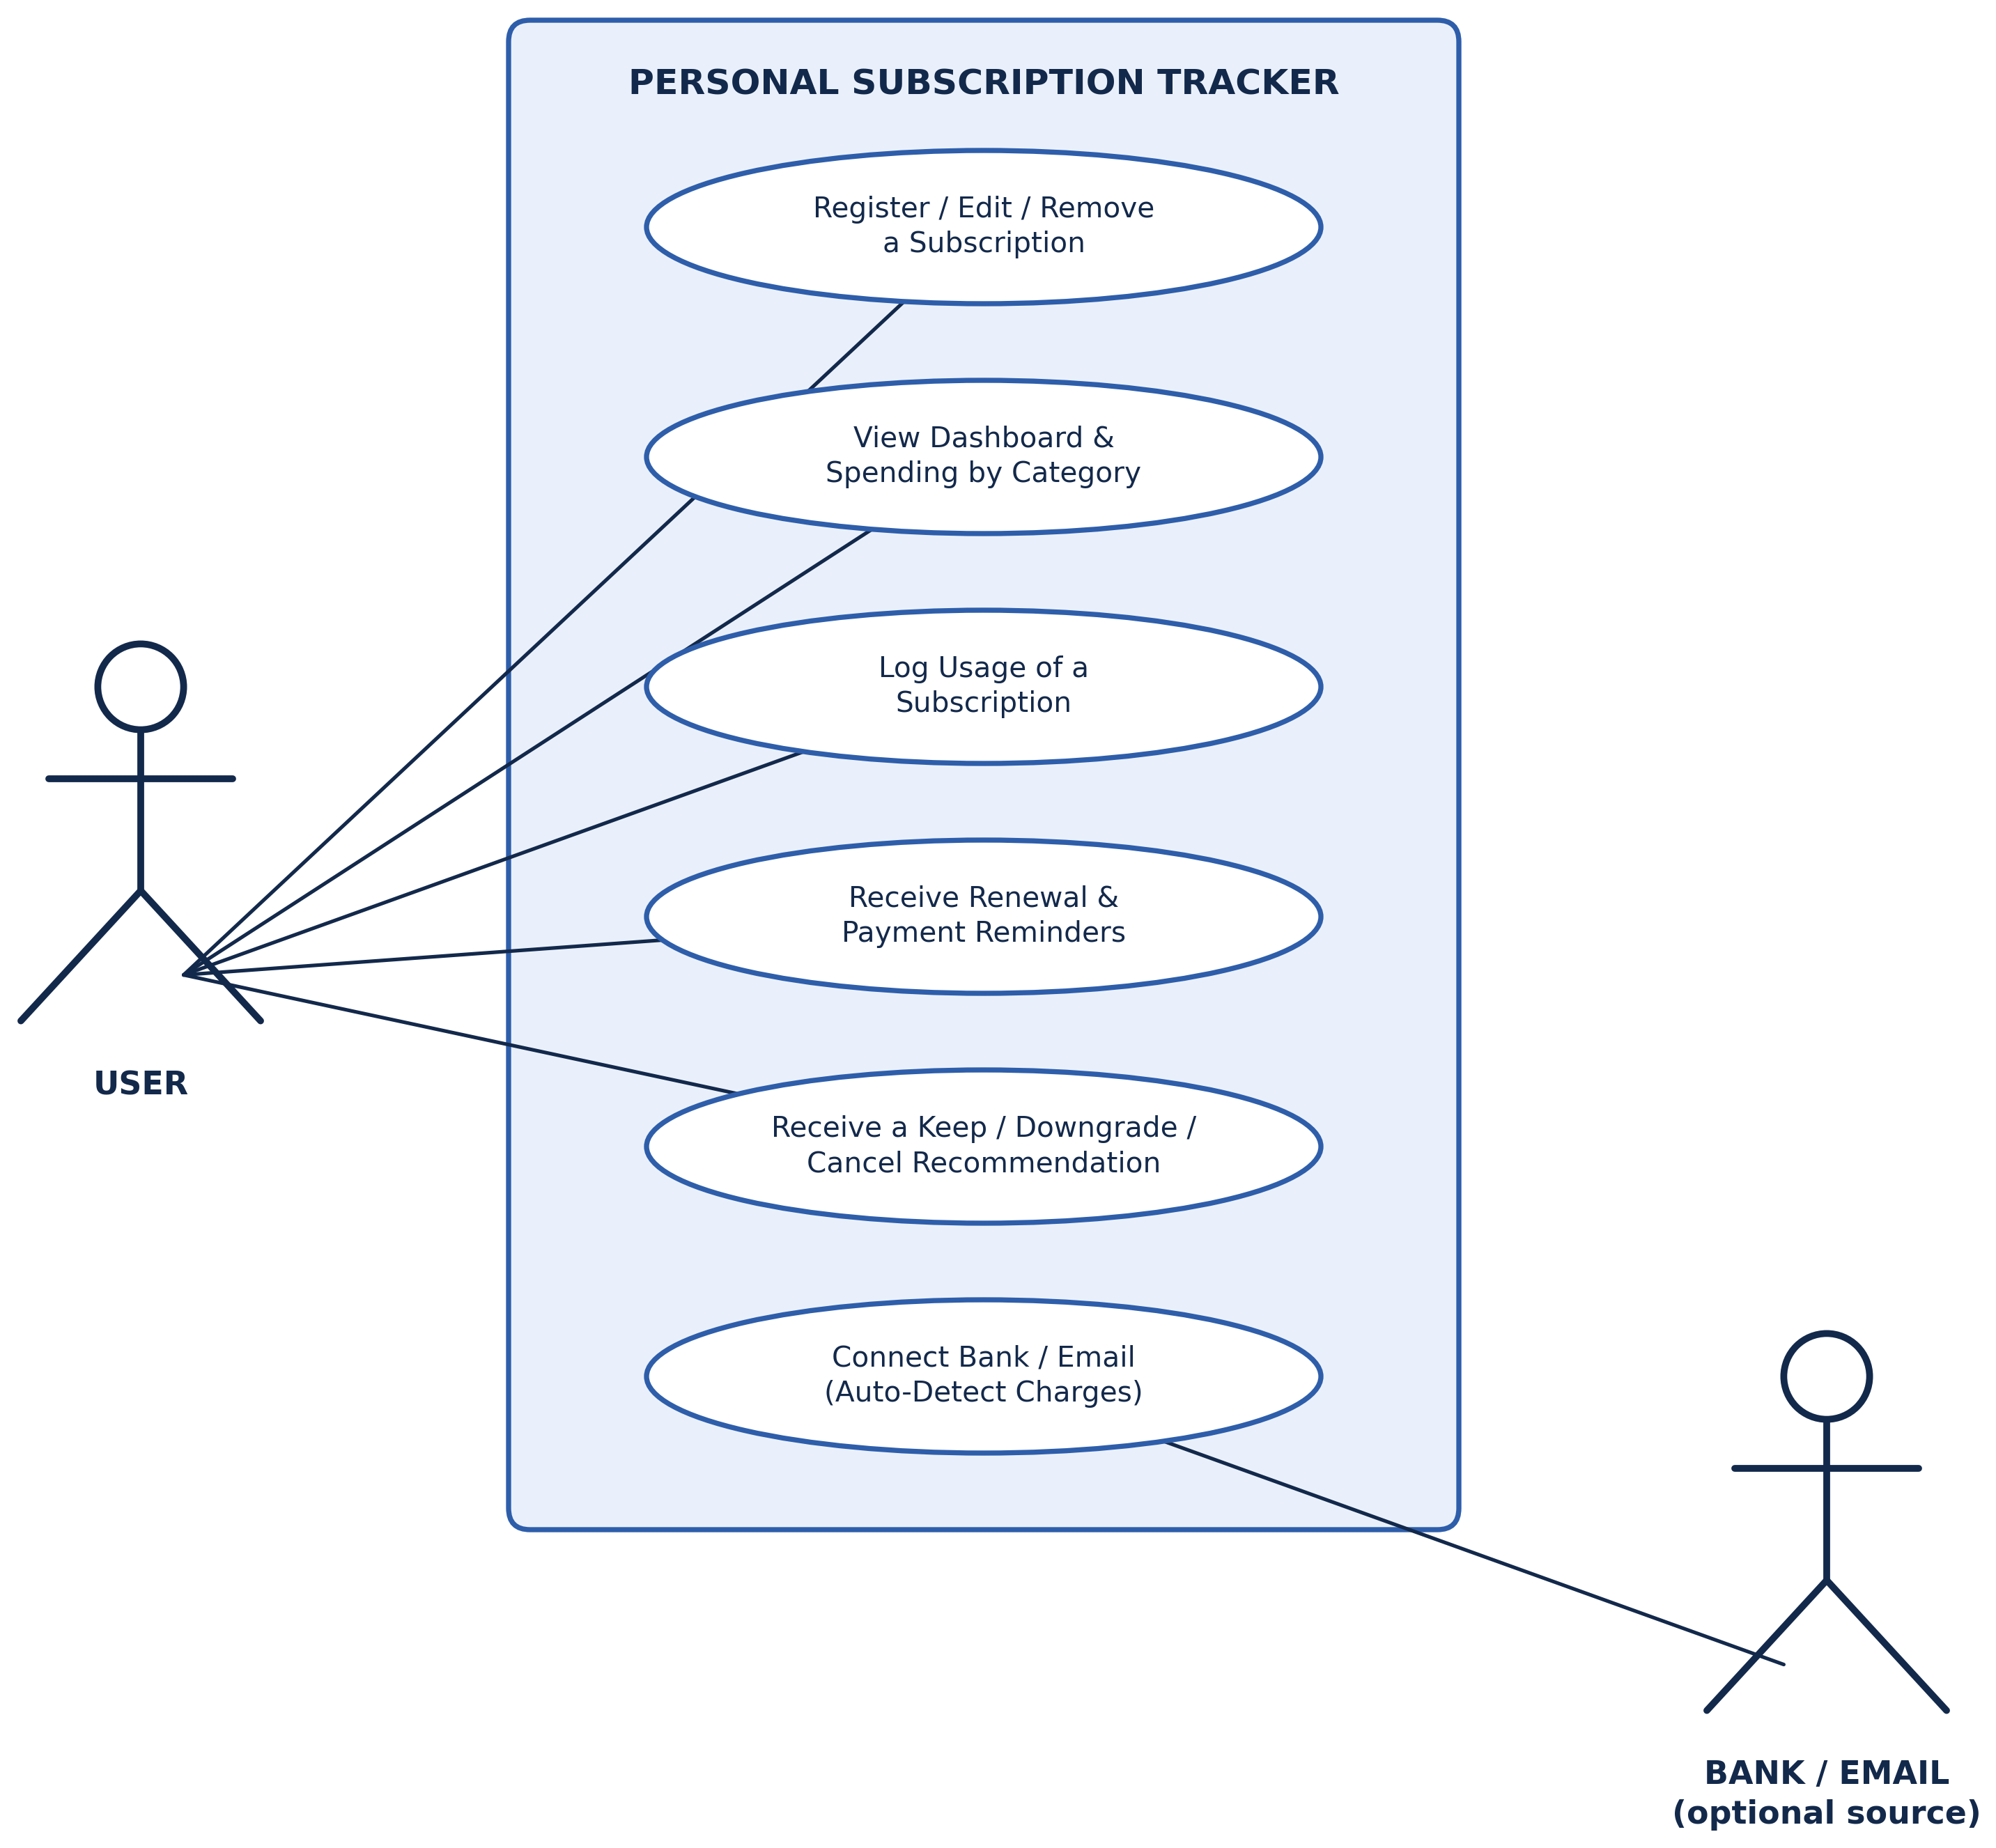

Entity Relationship Diagram
The diagram below is the ERD carried over unchanged from the project proposal. It sets out the same five entities — User, Subscription, Payment, Usage_Log and Recommendation — that were implemented in the final SQLite schema (Subscribtion_tracker.sql), with the primary keys (PK), foreign keys (FK) and relationships between them.
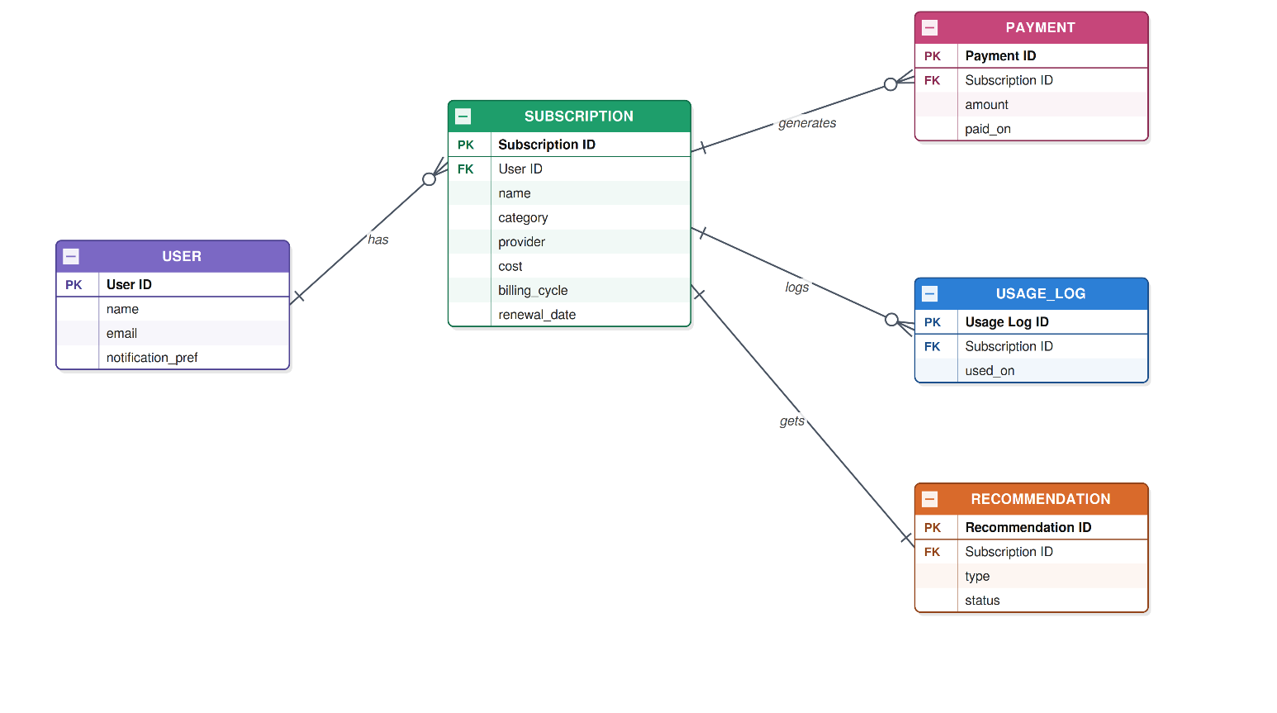

User – Subscription (1 : M): one user can hold many subscriptions; every subscription belongs to exactly one user (Subscription.user_id references User.user_id).
Subscription – Payment (1 : M): each subscription can accumulate many payment records over time; every payment belongs to exactly one subscription.
Subscription – Usage_Log (1 : M): each subscription can be logged as used many times; every usage entry belongs to exactly one subscription.
Subscription – Recommendation (1 : M): each subscription can receive one or more recommendations over its lifetime (the sample data holds one current recommendation per subscription); every recommendation belongs to exactly one subscription.

Table Designs – Data Dictionary
The tables below document every field implemented in Subscribtion_tracker.sql. Example values are taken from the seed data inserted into each table.

User
Entity Name | Entity Description
User | Stores the account details of each person using the tracker.

Field Name | Description | Data Type | Key Field | Constraints | Example
user_id | Uniquely identifies each user | INTEGER | PK | NOT NULL, auto-assigned | 1
name | Full name of the subscriber | TEXT |  | NOT NULL | Jaskaran Singh
email | Contact email, used for notifications | TEXT |  | NOT NULL, UNIQUE | jaskaran@email.com
notification_pref | How the user prefers to be reminded | TEXT |  | — | Email
Every subscription, and therefore every payment, usage entry and recommendation in the system, is ultimately owned by a row in this table.

Subscription
Entity Name | Entity Description
Subscription | Stores one row per recurring subscription a user has added to the tracker.

Field Name | Description | Data Type | Key Field | Constraints | Example
subscription_id | Uniquely identifies each subscription | INTEGER | PK | NOT NULL | 1
user_id | Owner of the subscription | INTEGER | FK → User | NOT NULL | 1
name | Name of the subscribed service | TEXT |  | NOT NULL | Netflix
category | Type of subscription | TEXT |  | NOT NULL | Streaming
provider | Company billing the subscription | TEXT |  | NOT NULL | Netflix
cost | Price charged per billing cycle | REAL |  | NOT NULL | 22.99
billing_cycle | How often the subscription is billed | TEXT |  | NOT NULL | Monthly
renewal_date | Next date the subscription renews or charges | TEXT |  | NOT NULL | 2026-09-15
This is the central table of the schema — Payment, Usage_Log and Recommendation all hang off subscription_id, which is what lets a single join pull a subscription’s full history together for the dashboard.

Payment
Entity Name | Entity Description
Payment | Stores a record of every amount actually charged against a subscription.

Field Name | Description | Data Type | Key Field | Constraints | Example
payment_id | Uniquely identifies each payment | INTEGER | PK | NOT NULL | 1
subscription_id | Subscription the payment was for | INTEGER | FK → Subscription | NOT NULL | 1
amount | Amount charged | REAL |  | NOT NULL | 22.99
paid_on | Date the payment was made | TEXT |  | NOT NULL | 2026-08-15
Keeping payments separate from Subscription allows the system to track spending trends over time rather than only ever knowing the current price.

Usage_Log
Entity Name | Entity Description
Usage_Log | Stores a timestamped entry every time a subscription is used.

Field Name | Description | Data Type | Key Field | Constraints | Example
usage_id | Uniquely identifies each usage entry | INTEGER | PK | NOT NULL | 1
subscription_id | Subscription that was used | INTEGER | FK → Subscription | NOT NULL | 1
used_at | Date and time the subscription was used | TEXT |  | NOT NULL | 2026-08-01 20:30:00
Counting rows in this table per subscription is what drives the usage-versus-cost comparison the recommendation engine is based on.

Recommendation
Entity Name | Entity Description
Recommendation | Stores the system’s keep / downgrade / cancel suggestion for a subscription, and whether the user has acted on it.

Field Name | Description | Data Type | Key Field | Constraints | Example
recommendation_id | Uniquely identifies each recommendation | INTEGER | PK | NOT NULL | 1
subscription_id | Subscription the recommendation applies to | INTEGER | FK → Subscription | NOT NULL | 1
type | The suggested action | TEXT |  | NOT NULL | Keep
status | Whether the user accepted, dismissed, or has not yet responded | TEXT |  | NOT NULL | Accepted
Storing status against each recommendation is what lets the system avoid re-suggesting an action the user has already dismissed.

Contributions
This report and the accompanying database were completed as a group effort by Group 5. The table below outlines each member’s contribution to this stage of the project, following the same division of work agreed at the proposal stage.
Team Member | Individual Work Done
Abdul Majeed Mohammed (Leader) | Coordinated the group and compiled the final report; wrote the Executive Summary; managed overall formatting and document structure; and worked with the team on designing the Entity Relationship Diagram.
Jaskaran Singh | Wrote the Design Analysis Process section, including the discussion of how the final schema differs from the proposal, and compiled the List of Use Cases; and worked with the team on designing the Entity Relationship Diagram.
Priyom Roy Sammo | Wrote the Entity Relationship Diagram section and the accompanying explanation of entity relationships and cardinalities; compiled the Table Designs – Data Dictionary; and worked with the team on designing the Entity Relationship Diagram.

GitHub Repository: https://github.com/Majeed-1771/Studio-01

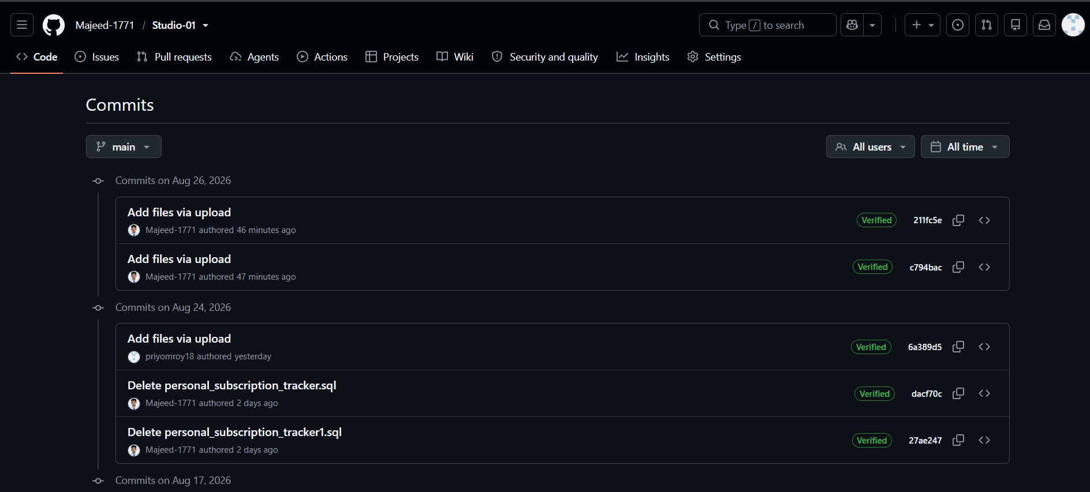
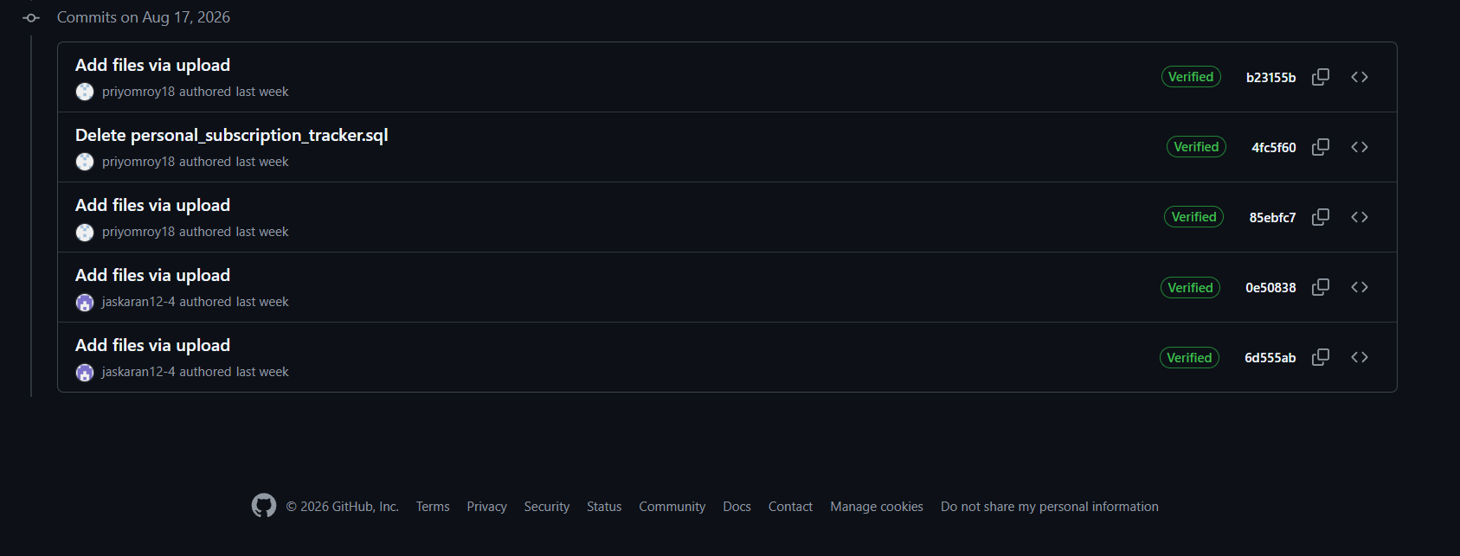

References
SQLite Documentation. (n.d.). SQLite Home Page. Retrieved from https://www.sqlite.org/
Rocket Money. (n.d.). Retrieved from https://www.rocketmoney.com

