# Portfolio 2

## Experimental Methods 3: Multilevel models and machine learning

### E22.147201U013.A

Submission: 1. November 2022

Student: Sara Kjær Kristensen

Email: [au702259@uni.au.dk](mailto:au702259@uni.au.dk)

Student no: 202105320

School of Communication and Cognition, University of Aarhus

Nordre Ringgade 104 4 th, 8200 Aarhus N, Denmark

Character count with spaces w/o plots: 4234

# Table of content

(a) Simulated effect sizes of pitch difference for schizophrenic and control participants 2

(b) Current evidence for distinctive vocal patterns in schizophrenia 4

Parts of this assignment have been made in a group consisting of Freddy Wulf (FW), Ida Møller (IM), Maria Mujemula (MM), Sabrina Zaki (SZ) & Sara Kjær Kristensen (SK).

E.g. Introduction (MM, SK)

Maria wrote the main part and Sara adapted it.

The main parts of the assignment have been discussed in the mentioned group, and written by SK. Only deviations from this is mentioned by parentheses.

### Simulated effect sizes of pitch difference for schizophrenic and control participants

#### Simulate

To get a grasp of how publication bias might push and pull in the estimated effect sizes and pertaining thereto standard deviations, a data set is simulated for a 100 studies with sample sizes following a gaussian distribution with a mean of 20, a standard deviation of 10 and a lower limit of 10. Each study was assigned a random effect size from a gaussian distribution with a mean of 0.4 and a standard deviation of 0.4. The measurement error was set to 0.8. As p-hacking is quite popular in research, three outliers with high effect sizes were added to the data.

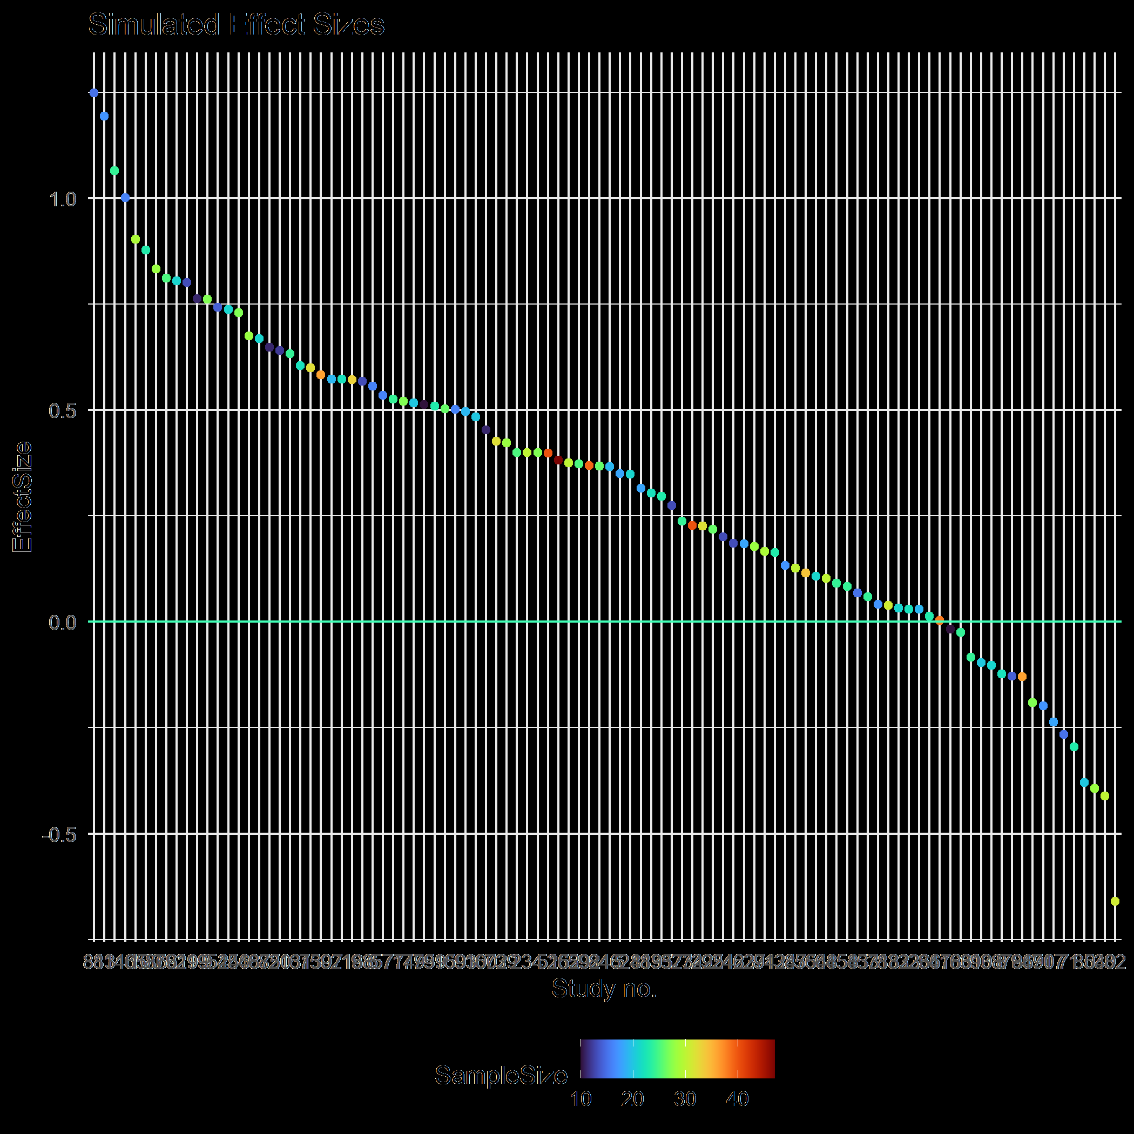

Figure 1 - Simulated studies and their effect sizes, individually coloured by sample size in descending order. Turqiuose line resempling zero effect.

The plot above shows the 100 different studies with their individual effect sizes and sample sizes coloured as a heat colour.

#### Analysis

Using a Bayesian workflow with model for effect size and a standard error (se) for the standard deviation of effect size (sd) predicted by a common intercept that varies by study:

$$Effect size | se\left(sd\right) \sim 1+(1|Study)$$

Priors was set for the intercept and standard deviation to vary by 0.3 and 0.2 respectively. Now what is interesting is to look at whether a study being published changes thmodel’sls predictions on the effect size and deviation estimates. To investigate this prior-posterior update checks are illustrated below:

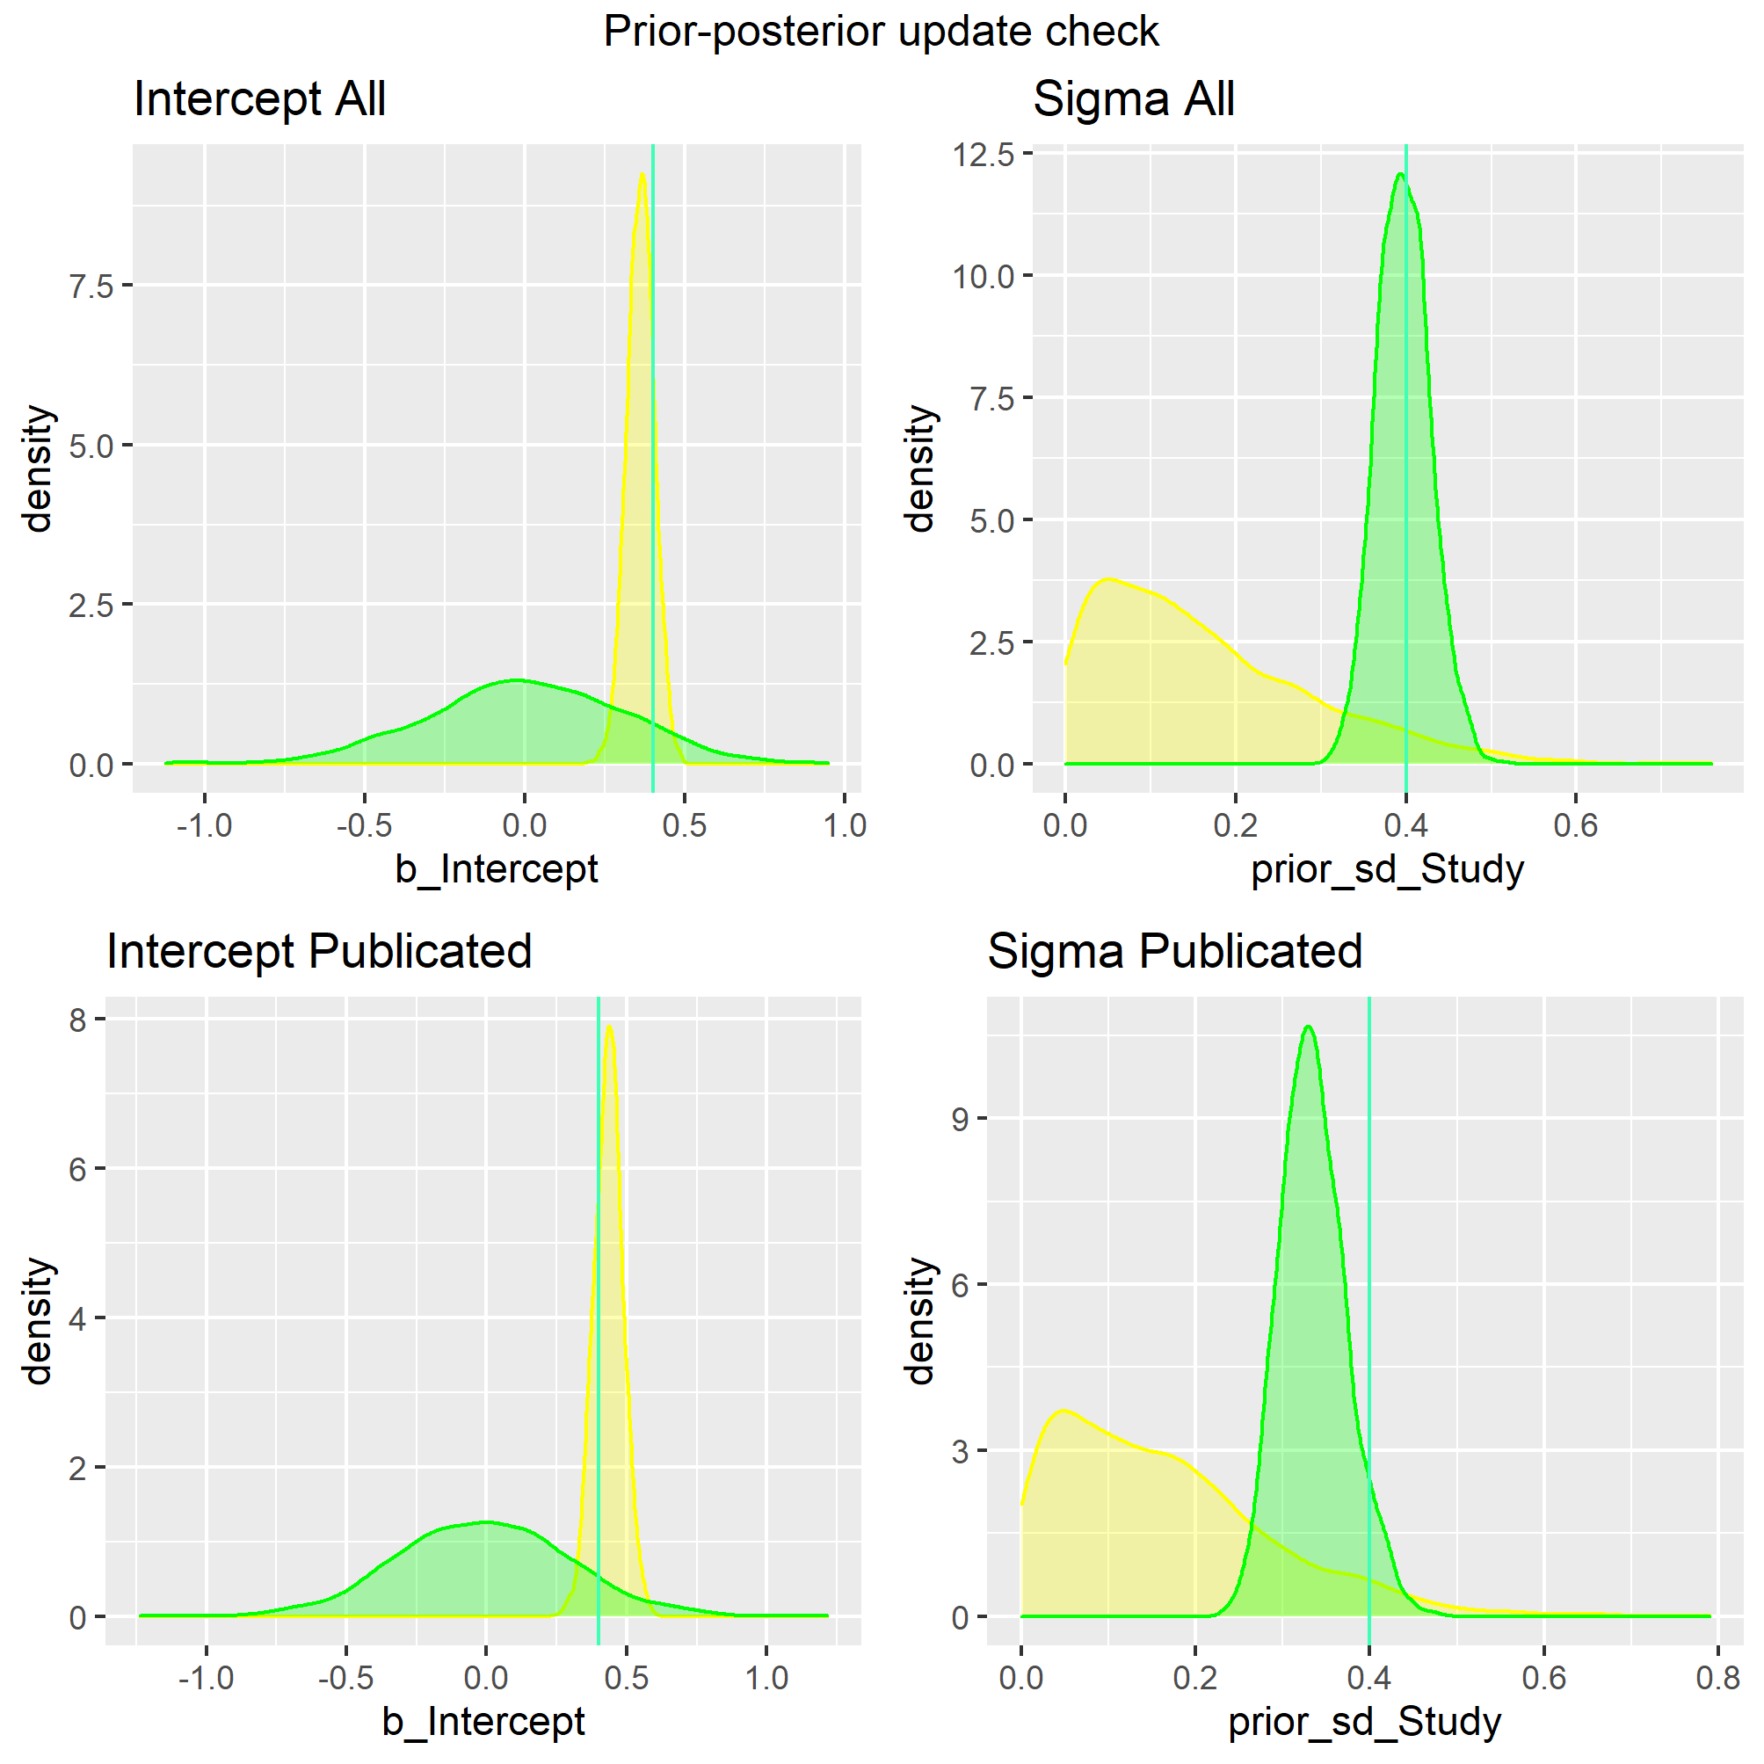

Figure 2 - Prior (yellow) posterior (green) update checks on the stimulated data for all the studies (All) versus only the published ones (Publicated) for the intercept of effect size and standard deviation. The turquoise line depicts the starting value 0.4 for both effect size and average deviation.

The prior-posterior update checks for the simulated data show not much difference in the mean effect size (plots named Intercept), as both their prior (yellow) and posterior (green) are similar. Visually, a bigger difference can be detected for the average deviation per study when comparing all the simulated studies versus those published. The average deviation for the published studies seems to have generally more confident standard deviations (plot named Sigma Publicated) than when taking all the studies into account.

Looking at the output of the models:

|  |  |  |  |  |  |
| --- | --- | --- | --- | --- | --- |
| Data |  | Estimate | Error | l-95% CI | u-95% CI |
| All | sd(Intercept) | 0.40 | 0.03 | 0.34 | 0.46 |
| Intercept | 0.36 | 0.04 | 0.28 | 0.44 |
| Published | Sd(Intercept) | 0.33 | 0.04 | 0.27 | 0.42 |
| Intercept | 0.43 | 0.03 | 0.33 | 0.54 |

The fitted model to all data points captures the set value of effect size and deviation the most, but the published-only model still has the set value in its interval. Meaning that the publication model is a bit tilted toward more positive effect sizes.

Q: Is this how the publication bias and effect of publication bias should be reported?

### Current evidence for distinctive vocal patterns in schizophrenia

Looking at some real studies that have measured the pitch of healthy controls (HC) and schizophrenic patients (SZ) we conduct a similar analysis. The data set used focuses on 48 different articles with 50 different studies published between 1977 and 2018. Only those studies with a sample of both HC and SZ was included in order to calculate effect size (Cohen’s D) between the two groups. 14 studies were eligible. Sample sizes for HC had a mean of 33.5 and standard deviation of 23.5; SZ with a mean of 43.21 and standard deviation of 20.2. Lastly the pitch for HC with a mean of 24.2 and standard deviation of 12.9; SZ with a mean of 20.6 and standard deviation of 12.9 as well.

Using the same model as before we investigate the prior posterior update checks for the intercept of effect sizes and the standard deviation.

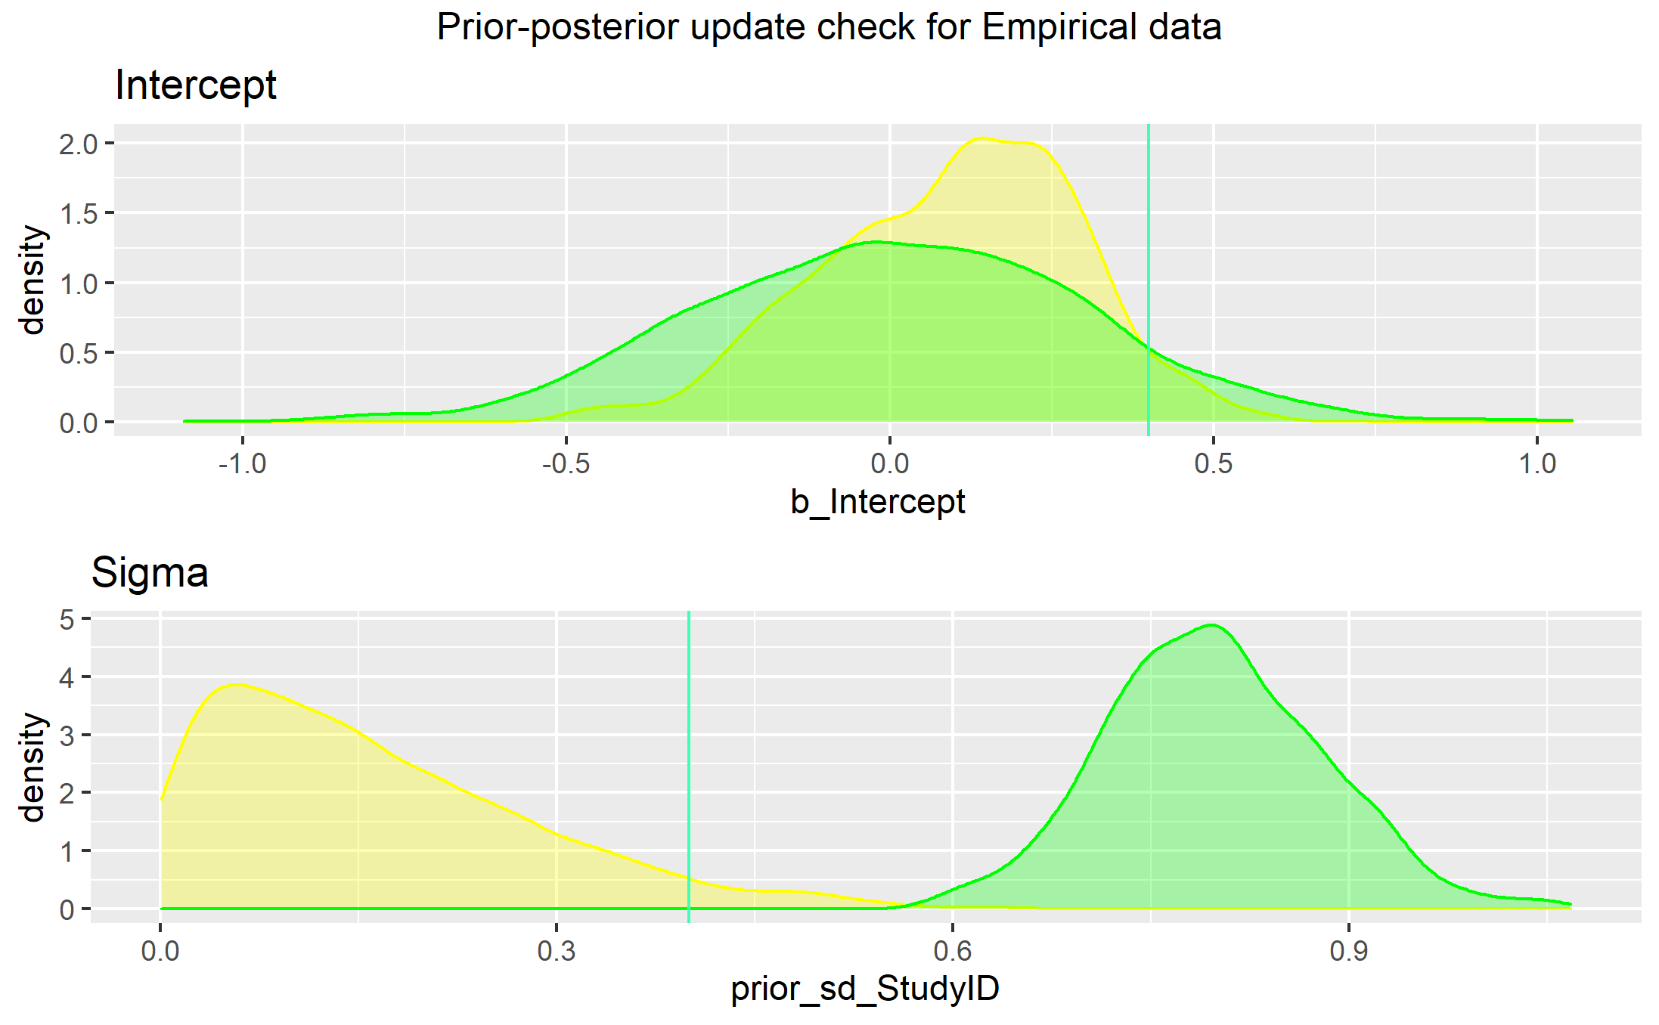

Figure 3 - Prior (yellow) posterior (green) update checks for the intercept of effect size and standard deviation. The turquoise line depicts the prior value 0.4 for both effect size and average deviation.

Now these plots show a standard deviation that is pushing towards the tail of the prior distribution. As the data is really pushing the prior to its outer corner, the intercept seems to take a bigger interval as possible effect sizes when the data is fitted to the model.

The model’s estimates for effect size and standard deviation are:

|  |  |  |  |  |
| --- | --- | --- | --- | --- |
|  | Estimate | Error | l-95% CI | u-95% CI |
| sd(Intercept) | 0.80 | 0.09 | 0.64 | 0.97 |
| Intercept | 0.09 | 0.20 | -0.30 | 0.45 |

Giving the impression that there is more noise and uncertainty with this model than with the simulated data since the effect size can vary on a wide interval.

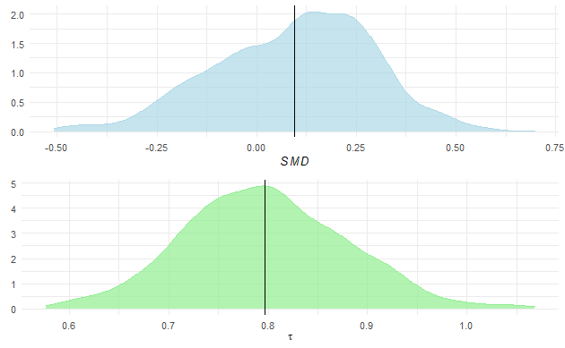

Figure 4 - SMD and Tau (IM) depicted with calculated mean (SK)

I am not sure what to do with this plot. It shows the standardized mean difference and tau with the black lines being the mean of the two parameters. Calculating the empirical cumulative distribution function for 0.30, I get a value of 0.86. which I do not know whether I can/should use for anything.

Not many of the studies keep 0 effect in their confidence interval:

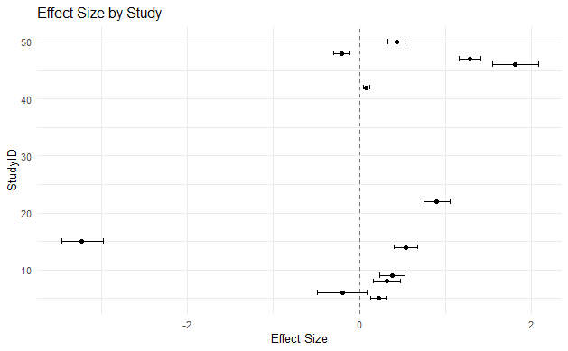

Figure 5 - Forest plot with effect sizes and zero effect (dashed line). Mean effect size of 0.18 with 95% CI 0.02-0.36.

This plot and the model output show that the published studies tend to show positive effect sizes rather than zero effect or negative effects for that matter.