# Tipsy Trips – Web Designer Creative Brief

## Business Information

Tipsy Trips LLC is a Maryland-based mobile app that connects customers with the best happy hour specials at local restaurants and bars. We go beyond the drink — creating an experience where patrons discover new venues, enjoy exclusive deals, and earn rewards with every visit.  
  
Our platform gamifies the happy hour experience through point-based rewards, collectible seasonal badges, premium member raffles, and a community hub for restaurants and users to connect. Launching first in Baltimore’s metropolitan area, Tipsy Trips targets the growing population of young professionals, with plans to expand into other major U.S. cities.

### Key Points to Highlight:

• Premium and standard membership options with exclusive perks.

• Gamified rewards where every sip earns points toward prizes.

• Partner benefits such as promotional boosts, event collaborations, and loyalty multipliers.

• Designed to increase restaurant traffic during non-peak hours while enhancing the customer’s social experience.

## Brand Elements

Slogan (Primary Tagline): Beyond the Glass, Where Every Sip Counts

Motto: More Than a Happy Hour

Call-to-Action: Pour, Play, Earn

## Logo

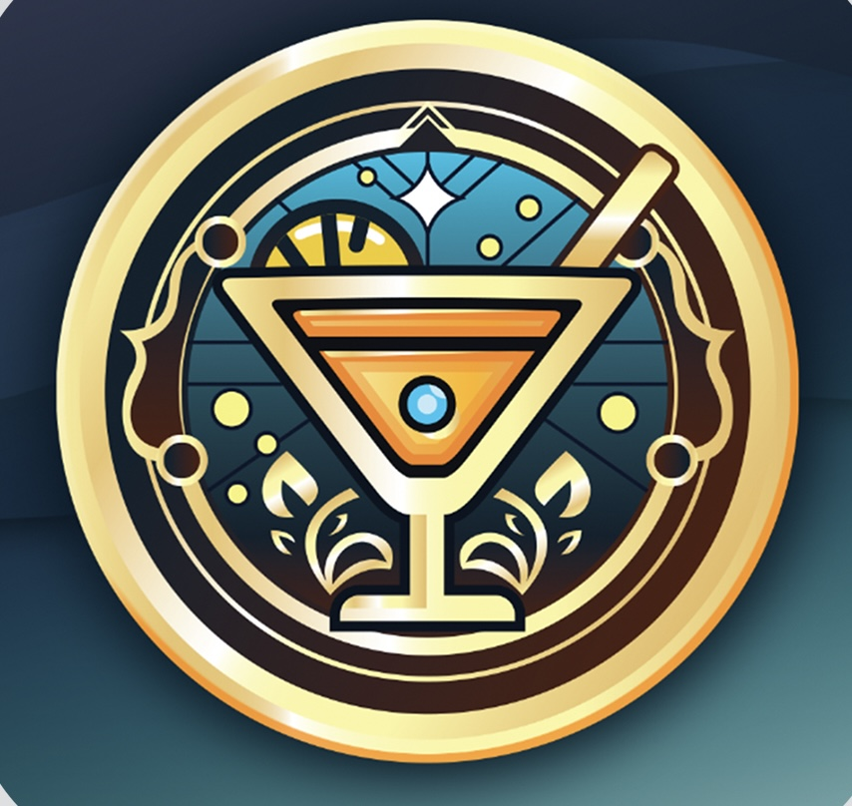

## Color Scheme (from Logo)

• Golden Amber – #E1A12D

• Light Gold – #F3D678

• Teal Blue – #0D4E5B

• Deep Brown – #362015

• Warm Orange – #F0A44C

• Soft Aqua – #CBE5F0

## Verbiage

Supporting Message: From flash deals to exclusive events, Tipsy Trips turns every happy hour into an experience worth sharing.

Membership Highlight: Premium members unlock bigger rewards, faster points, and access to one-of-a-kind events.