A
Project Report
On
Doctor Appointment Management System

Submitted by
KRISHNA SHANKAR [2305103140018]
SUDARSHAN SINHA [2305103140031]
SUPARNA DAS [2305103140032]
as
Partial fulfilment of Semester II
of Integrated Master of Computer Application
for A.Y. 2023-2024

Under the Guidance of
Internal Guide name: Prof Khyati Kariya
Submitted To
Parul Institute of Computer Application,
Faculty of IT & Computer Science
Parul University


Acknowledgement

The success and final outcome of this project required a lot of guidance and assistance from many people and we are extremely privileged to have got this all along the completion of our project. All that we have done is only due to such supervision and assistance and we would not forget to thank them.
I respect and thank Dr. Priya Swaminarayan, Dean, FITCS for providing us an opportunity to do the project work in BCA and giving us all support and guidance, which made us complete the project duly. We are extremely thankful to Mam for providing her support and guidance, although she had a busy schedule managing the academic affairs.
We would not forget to remember Dr. Hina Chokshi, HOD, BCA department for her encouragement and more over for her timely support and guidance till the completion of our project work.
We owe our deep gratitude to our project guide Prof. Khyati Kariya mam, who took keen interest on our project work and guided us all along, till the completion of our project work by providing all the necessary information for developing a good system.
I am thankful to and fortunate enough to get constant encouragement, support and guidance from our Parents, all Teaching staff of the BCA Department which helped us in successfully completing our project work. Also, we would like to extend our sincere esteems to all staff in the laboratory for their timely support.

[2305103140018] [Krishna Shankar]
[2305103140031] [Sudarshan Sinha]
[2305103140032] [Suparna Das]

INDEX
No. | Description | Page No.
1. | Introduction to Project System | 2
2. | System Requirement Specification  - Introduction to SRS  - Hardware Requirement  - Software Requirement  - System Users  - Description of Users Role  - System Models  - Description of Modules  - Timeline Chart | 3-7
3. | System Flow Diagram | 8
4. | Data Flow Diagram (All Levels of DFDs)  - Level 0 DFD  - Level 1 DFD  - Level 2 DFD | 9
5. | Use Case Diagram  5.1 Patient  5.2 Doctor  5.3Admin | 10-13
6. | Data Dictionary | 14
7. | Screenshots of Development Phase -1 | 15
8. | Screenshots of Development Phase -2 | 16
9. | Screenshots of Development Phase -3 | 17
10. | Conclusion | 18
11. | Future Enhancement | 19
12. | References | 20

ABSTRACT

The Doctor Appointment Management System is an online platform designed to simplify the process of scheduling and managing appointments between doctors and patients. This system provides a user-friendly interface that enables patients to search for and book appointments with doctors based on specialty, and availability. The system also allows doctors to manage their schedules and availability, review patient information, and accept or reject appointment requests. The Doctor Appointment Management System also includes features for handling payment-related tasks, such as processing payments and generating receipts. This ensures a smooth and secure payment process for both patients and doctors. Overall, the Doctor Appointment Management System is designed to improve access to healthcare services and simplify the appointment scheduling process for both patients and doctors. By providing an easy-to-use platform, this system can help increase patient satisfaction and improve the efficiency of healthcare services.

Chapter 1

Introduction to Project

The Doctor Appointment Management System is an online platform designed to simplify the process of scheduling and managing appointments between doctors and patients. This system provides a user-friendly interface that enables patients to search for and book appointments with doctors based on specialty, and availability. The system also allows doctors to manage their schedules and availability, review patient information, and accept or reject appointment requests.

Patients can register on the system and search for doctors based on their area of expertise. The search results provide information on the doctor's availability, allowing the patient to select an available time slot that suits them. Once the patient selects a suitable appointment time, they can proceed to book the appointment. Doctors can also register on the system and set their availability schedules. They can specify their working hours, and the system will automatically show their available time slots to patients searching for appointments. When a patient books an appointment, the doctor receives the request and can accept or reject it based on their availability.

The system includes features for rescheduling or canceling appointments, and patients can easily manage their appointments through the user-friendly interface. The system also generates appointment reminders for patients, ensuring they don't miss their scheduled appointments. Overall, the Doctor Appointment Management System is designed to improve access to healthcare services and simplify the appointment scheduling process for both patients and doctors. By providing an easy-to-use platform, this system can help increase patient satisfaction and improve the efficiency of healthcare services.

Chapter 2

System Requirement Specification

2.1 Introduction to SRS

2.1.1 What is SRS?

A software requirements specification (SRS) is a description of a software system to be developed. It lays out functional and non-functional requirements, and may include a set of use cases that describe user interactions that the software must provide.

2.1.2 Need of SRS
In order to fully understand one’s project, it is very important that they come up with a SRS listing out their requirements, how are they going to meet it and how will they complete the project. It helps the team to save upon their time as they are able to comprehend how are going to go about the project. Doing this also enables the team to find out about the limitations and risks early on.

2.2 Hardware Requirement

Hardware Components | Specification
Processor | Intel core I3,/I5
RAM | 4GB/8GB
Hard disk | 512GB/1TB
Monitor | 15.6 color monitor or advance
Device | Keyboard, Mouse

2.3 Software Requirement

Software Requirement
(For PHP)

Name of component | Specification
Operating System | WindowsXP, windows10/ windows11
Control Panel | Xampp Control Panel/Wamp Control Panel
Software development kit | Google Chrome, Internet Explorer, Mozilla Firefox (any appropriate or suitable browser)
Programming Language | PHP, HTML, JAVASCRIPT
Server | Apache Web Server
Database | MySQL

2.4 System Users
2.4.1 Patients
2.4.2 Doctors

2.5 Description of User Role

2.5.1 Patients: -

Patients are the primary users of the system. They use the system to search for doctors, book appointments, and manage their appointments. Patients can create an account on the system, which allows them to access the features of the system. Some of the key features available to patients include:

- Search for doctors based on specialty, and availability
- Book appointments with doctors
- View upcoming appointments and manage their schedule
- Reschedule or cancel appointments

2.5.2 Doctors: -

Doctors would use the system to manage their appointment schedules and communicate with patients. They would be able to create an account on the system, which would allow them to access the features of the system. Some of the key features available to doctors include:-

- Set their availability schedules
- Accept or reject appointment requests from patients
- View patient information
- Communicate with patients through the system
- Reschedule or cancel appointments

Apart from these two primary users, the system may also have additional users, such as administrators who manage the system and ensure its smooth operation. These administrators would be responsible for monitoring the system, managing user accounts, and resolving any technical issues that may arise.

In summary, the Doctor Appointment Management System developed using PHP would have two primary users: patients and doctors, and additional users such as administrators. The system would be designed to provide a user-friendly interface and streamline the process of booking appointments between patients and doctors.
2.6 System Features

2.6.1 Doctor profile
2.6.2 Patient Profile
2.6.3 Reminders & Notifications

2.7 Description of Features

2.7.1 Feature 1
A doctor's profile primarily includes the professional details about the doctor, such as their qualifications, experience, services and contact details.

2.7.2 Feature 2
Patience may involve perseverance in the face of delay; tolerance of provocation without responding in disrespect/anger; or forbearance when under strain, especially when faced with longer-term difficulties, or being able to wait for a long amount of time without getting irritated or bored.
2.7.3 Feature 3
A reminder profile is a preset list of reminders you can choose from to alert your patients of their upcoming appointments. Reminder profiles are easy to set up and provide an efficient way for you to remind your patients via email, text and phone call.

2.8 Timeline Chart

Development phase | 75 Days |  |  |  |  |  | Duration  N  (days)
Development phase | 0to10 days | 11to20  days | 21to30 days | 31to40 days | 41to50 days | 51to75  days | Duration  N  (days)
Requirement  Gathering |  |  |  |  |  |  | 07
Analysis |  |  |  |  |  |  | 09
Design |  |  |  |  |  |  | 10
Development Phase 1 |  |  |  |  |  |  | 13
Development Phase 2 |  |  |  |  |  |  | 13
Development Phase 3 |  |  |  |  |  |  | 13
Documentation |  |  |  |  |  |  | 10
Total time  (Days) |  |  |  |  |  |  | 75
2.8 Time line chart

Chapter 3

System Flow Diagram
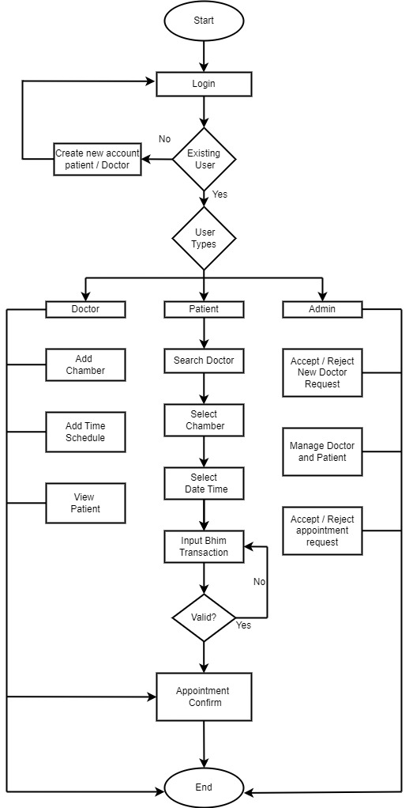

Figure no. 1. System Flowchart of Doctor Appointment Management System

Chapter 4

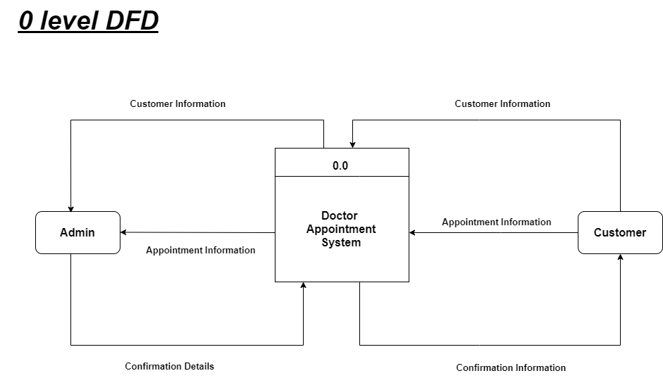
Data Flow Diagrams

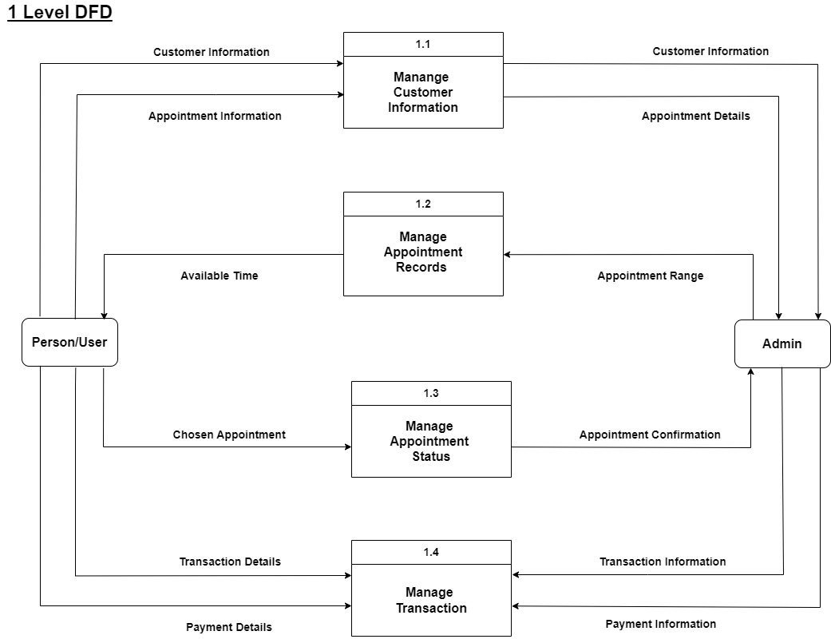

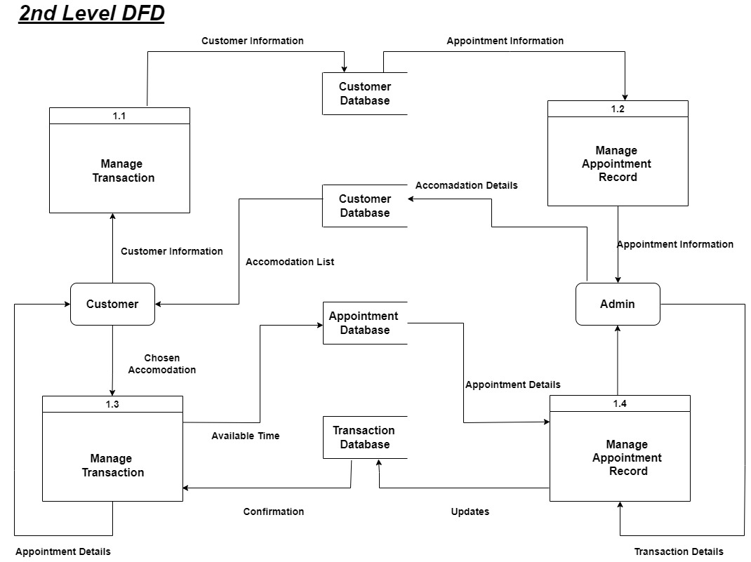

Figure no. 2. Data Flow Diagram of Doctor Appointment Management System

Chapter 5

Use Case Diagram
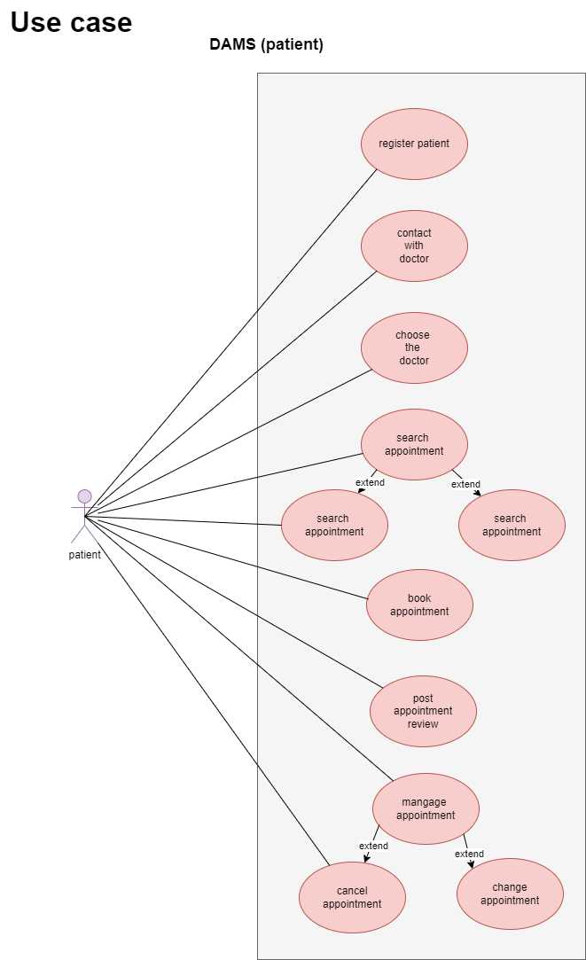
Figure no.3.1. Use Case Diagram of Doctor Appointment Management System (Dams patient)
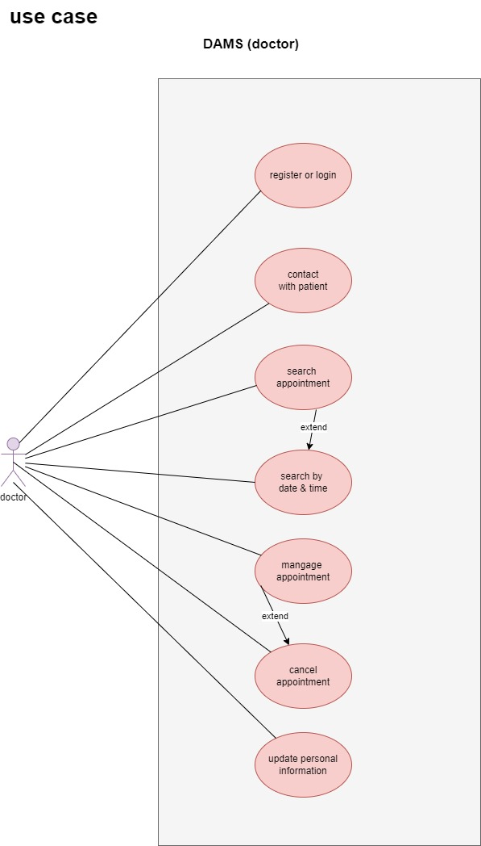
Figure no.3.2. Use Case Diagram of Doctor Appointment Management System (Dams Doctor)

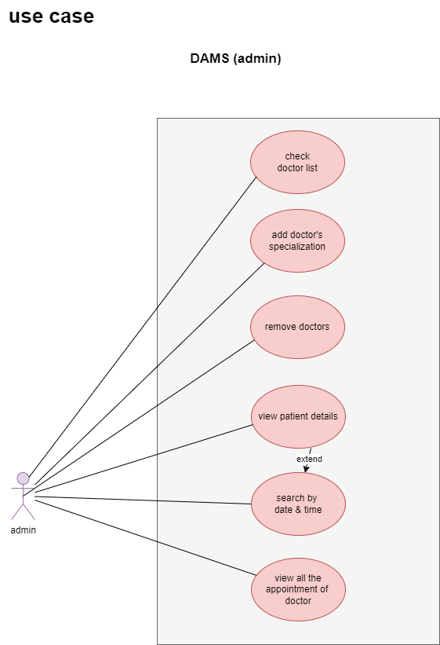
Figure no.3.3. Use Case Diagram of Doctor Appointment Management System (Dams Admin)

Chapter 6

Data Dictionary
6.1 Doctor Information

Sr. No. | Field Name | Data Type | Size | Constraint | Description | Example
1 | Doctor -id | Int | 11 | Primary key, auto-increment | Unique identifier for each doctor | 100
2 | Name | Varchar | 100 | Not null | Name of the doctor | Dr.mehta
3 | email | Varchar | 100 | Null  unique | Email address of the doctor | drmehta@gmail.com
Login Design

6.2 Doctor Information

Sr. No. | Field Name | Data Type | Size | Constraint | Description | Example
1 | Phone number | Varchar | 20 | null | Phone number of the doctor
Dashboard Design

Chapter 7

Screenshot of Development Phase 1
7.1 Login Design
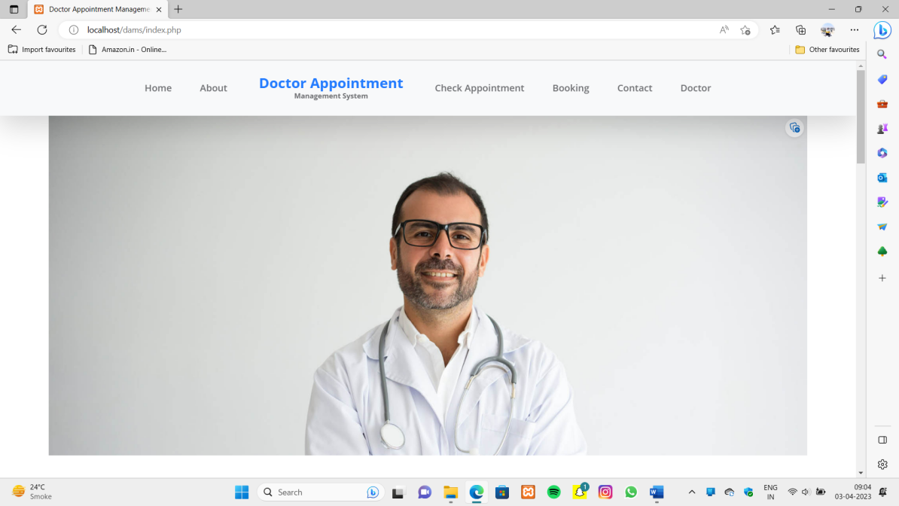

F
Figure 7.1 Login Design

7.2 Code of Login
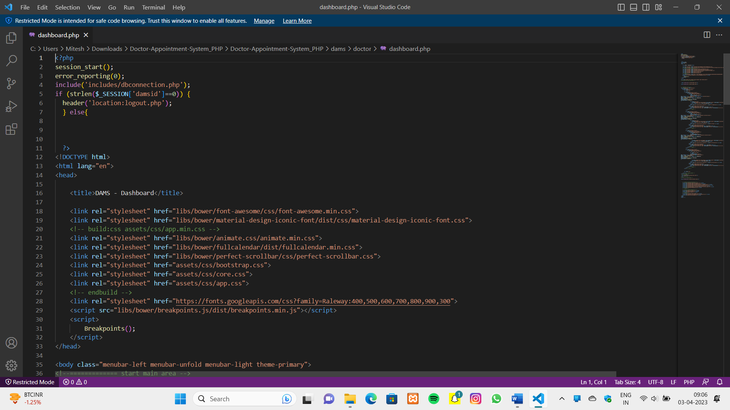

Figure 7.2 Code of Login
Chapter 8

Screenshot of Development Phase 2
8.1 Appointment Design
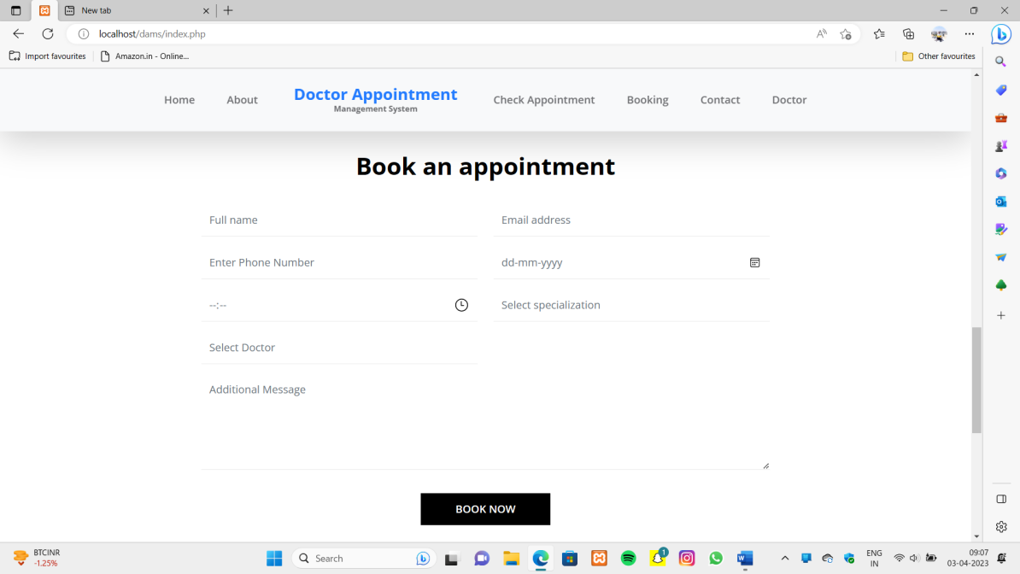

F
Figure 8.1 Appointment Booking Design

8.2Code of Appointment
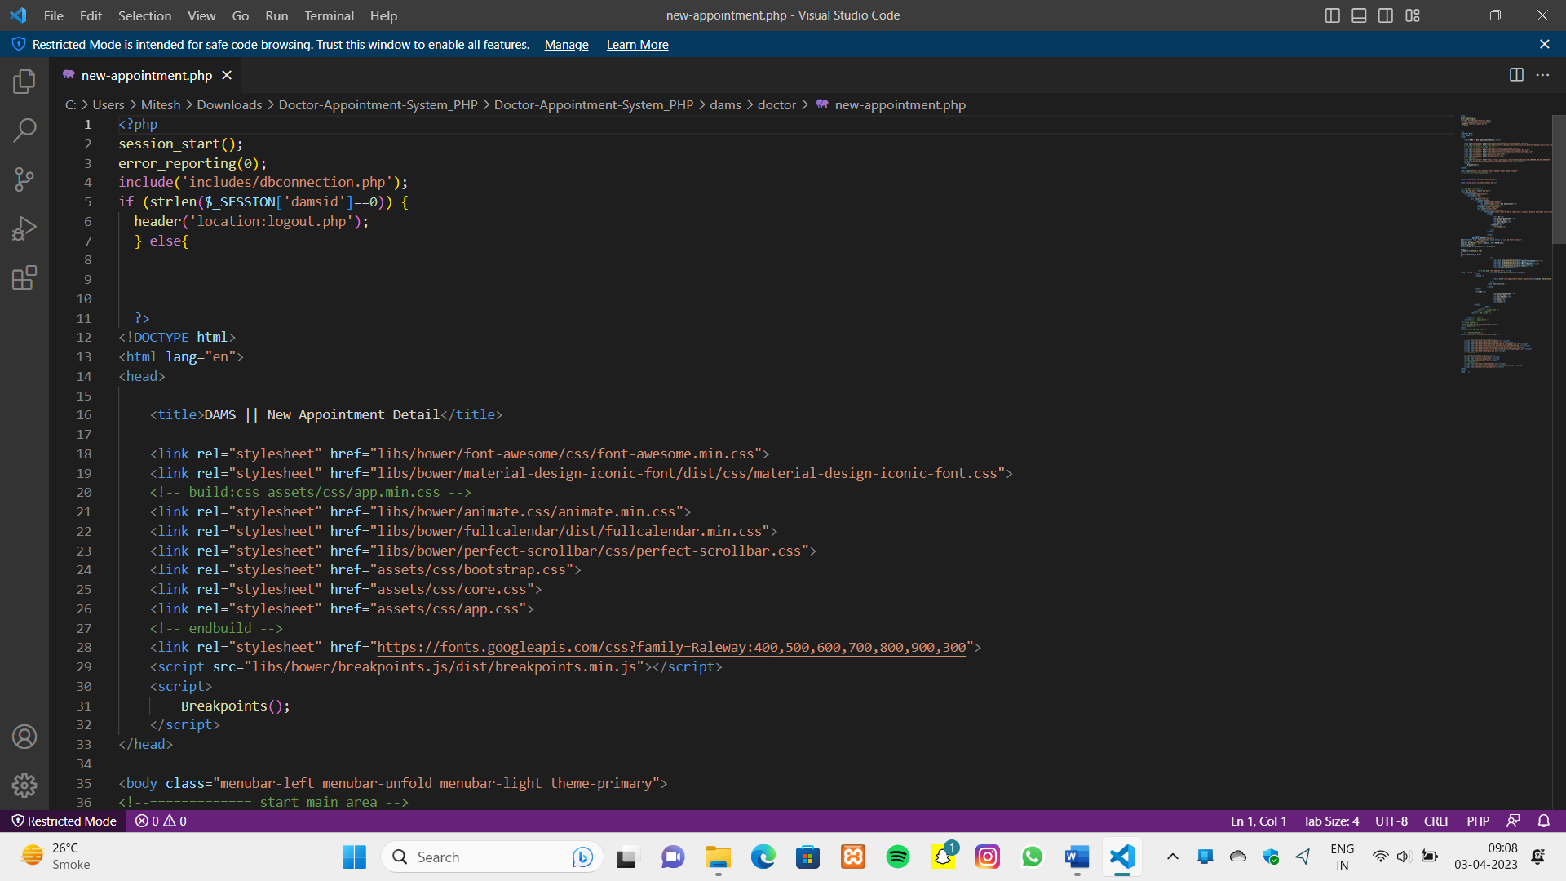

Figure 8.2 Code of Appointment Booking
Chapter 9

Screenshot of Development Phase 3

9.1 Dashboard Design
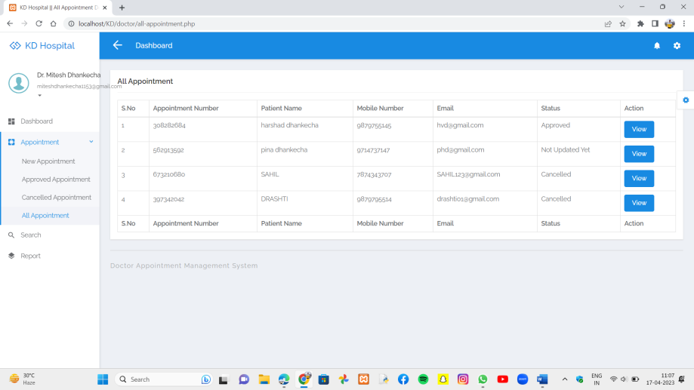

Figure 9.1 Dashboard Design

9.2Code of Dashboard

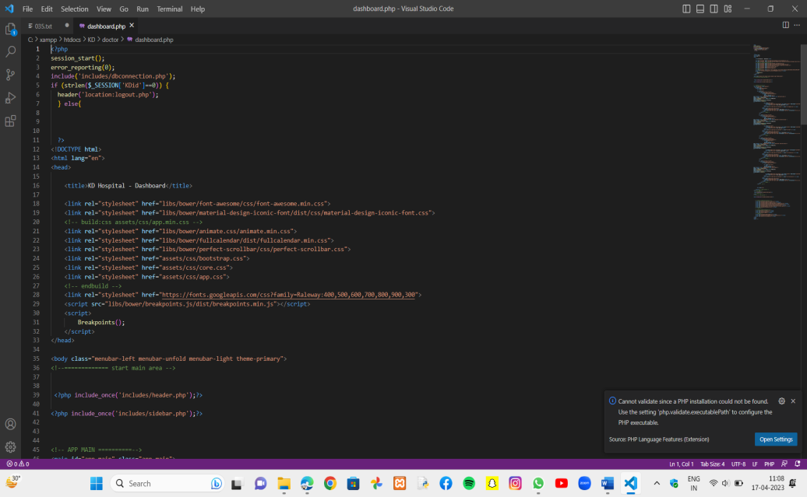

Figure 9.2 Code of Dashboard

Chapter 10

Conclusion

- In conclusion, a Doctor Appointment Management System developed using PHP can be an efficient solution for managing patient-doctor appointments.

- With the help of this system, patients can easily book appointments with doctors, manage their appointments, and receive appointment reminders, while doctors can manage their appointment schedules and communicate with patients.

- The system can also help to reduce administrative workload and increase the efficiency of the appointment booking process.

- PHP is a popular and widely used web development language, which makes it a suitable choice for developing the Doctor Appointment Management System. It offers a wide range of features and tools that can be used to create a user-friendly and efficient system.

- Overall, a Doctor Appointment Management System developed using PHP can benefit both patients and doctors by providing an easy-to-use and efficient system for booking appointments and managing schedules.

Chapter 11

Future Enhancement

There are several possible future enhancements that can be made to a Doctor Appointment Management System using PHP. Some of these include:

- Integration with telemedicine platforms: With the increasing adoption of telemedicine, it may be useful to integrate the Doctor Appointment Management System with popular telemedicine platforms such as Zoom or Skype to enable remote consultations.
- Mobile application development: Developing a mobile application for the Doctor Appointment Management System can make it more accessible and convenient for patients to book appointments.
- Electronic health records (EHR) integration: Integrating the system with EHRs can help streamline patient data management and reduce the chances of errors.
- Patient feedback and rating system: Implementing a feedback and rating system can help improve the quality of service and increase patient satisfaction.
- Artificial intelligence (AI) integration: AI technologies can be used to automate appointment scheduling, optimize resource allocation, and improve patient outcomes.
- Real-time notifications and reminders: Implementing real-time notifications and reminders via email or SMS can help patients and doctors stay on top of their appointments.
- Multi-language support: Adding multi-language support can make the system more accessible to patients from diverse linguistic backgrounds.
These enhancements can help improve the usability, functionality, and effectiveness of the Doctor Appointment Management System, making it a more valuable tool for patients, doctors, and healthcare organizations

Chapter 12

References
Website:
- https://www.tutorialrepublic.com/php-tutorial/php-mysql-login-system.php
- https://codewithmark.com/building-a-doctor-appointment-booking-system-in-php-with-source-code
- https://www.thecrazyprogrammer.com/2016/08/doctor-appointment-system-project-php-source-code.html.

Book:
- "PHP and MySQL for Dynamic Web Sites: Visual QuickPro Guide" by Larry Ullman This book provides a step-by-step guide to building dynamic websites using PHP and MySQL.
- "Beginning PHP and MySQL: From Novice to Professional" by W. Jason Gilmore This book covers the basics of PHP and MySQL.
- "PHP: The Complete Reference" by Steven Holzner This book is a comprehensive guide to PHP.
Other Resources:
- https://www.instructables.com/How-to-Create-a-Doctor-Appointment-System-in-PHP-/
- https://www.geeksforgeeks.org/online-doctor-appointment-system-using-php-mysql/
- https://www.thecrazyprogrammer.com/2016/08/doctor-appointment-system-project-php-source-code.html


PARUL INSTITUTE OF COMPUTER APPLICATION
CERTIFICATE

This is to certify that ____________________________________________the student(s) of Parul Institute of Computer Application, has/have satisfactorily completed the project entitled “________________________________” as a part of course curriculum in BCA / BSCIT/ IMCA semester-2 for the academic year 2023-2024 under guidance of ________________________________.

Enrolment Number: 2305103140018
Enrolment Number: 2305103140031
Enrolment Number: 2305103140032

Quality of work | Grade  A+ / A /B+ /B | Sign of Internal guide
Excellent / Good / Average /Poor

Date of submission:

HOD, Principal,
Dr. Hina Chokshi Dr. Priya Swaminarayan

