***Protocol to code for AAAS Competencies in a syllabus.*** Last updated 9.29.22

# Purpose

The purpose of this protocol is to provide clear directions on how to examine a college-level course syllabus and code the text for presence of AAAS core competencies. The data gathered will be used to assess whether or not AAAS competencies are taught in a course and which competencies are taught. Examining numerous course syllabi will elucidate how teaching biology is approached by different department and programs and where the emphasis lies. Further it will aid in determining the alignment of a department or programs with national recommendations.

We code a syllabus for the following six AAAS competencies initially proposed in 2010 and further interpreted by Clemmons et al. 2020 into learning outcomes:

* Ability to apply the process of science
* Ability to use quantitative reasoning
* Ability to use modeling and simulation
* Ability to tap into the interdisciplinary nature of science
* Ability to communicate and collaborate with other disciplines
* Ability to understand the relationship between science and society

For the purposes of coding and ease of use of the protocol, we defined the competencies to be mutually exclusive. Summaries of each competency along with learning outcomes are provided by Clemmons et al. 2020 and reproduced (need to get permission to include here).

**Step-by-step instructions:**

1. Read through Table 1 to become familiar with 6 categories of AAAS competencies and their sub-categories.
2. Read the learning outcomes (objectives) on the syllabus and decide whether any might fit into any of the 6 competency categories and indicate the competency with the following codes:

Process of Science = PS

Quantitative Reasoning = QR

Modeling = MO

Interdisciplinary nature of science = IN

Communication & collaboration = CC

Science & Society = SS

If the learning outcome/objective does not fall into an AAAS competency listed above, then code it as **NA.** Note that the learning outcome/objective will not have the same wording as found in Table 1 and you may have to decide whether it is an AAAS competency.

1. For each learning outcome/objective indicate the sub-category for the given competency. For multiple sub-categories include “;” after. For example: “ST; SD”. If the sub-category is not clear, then code it as **NC.**

***Process of Science* = PS**

Sub-categories: Scientific Thinking = ST

Information Literacy = IL

Question Formulation = QF

Study design = SD

Data Interpretation & Evaluation =DI

***Quantitative reasoning* = QR**

Sub-categories: Numeracy = NU

Quantitative & computational data analysis = QC

***Modeling = MO***

Sub-categories: Purpose of models = PM

Model application = MA

Modeling = MO

***Interdisciplinary nature of science* = IN**

Sub-categories: Connecting scientific knowledge = CK

Interdisciplinary problem solving = IP

***Communication & collaboration* = CC**

Sub-categories: Communication = CM

Collaboration = CL

Collegial review = CR

Metacognition = ME

***Science & society* = SS**

Sub-categories: Ethics = ET

Societal influences = SI

Science’s impact on society = SC

**Summary of workflow**

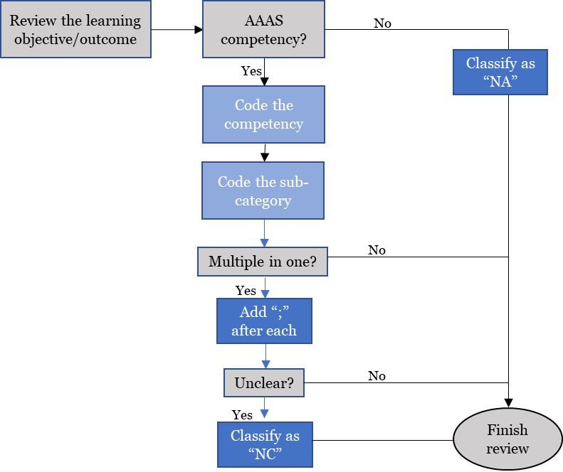

**Table 1.** AAAS competency descriptions along with learning outcomes (from Clemmons et al. 2020).

***Process of Science*  (PS)**

Process of science competency consists of five sub-categories. Scientific thinking and information literacy include foundational scientific competencies such as critical thinking and understanding the nature of science, and thus are integral to all parts of the process of science. Question formulation, study design, and data interpretation and evaluation are iteratively applied when carrying out a scientific study, and also must be mastered to achieve competence in evaluating scientific information. Course-based or independent research experiences in the lab or field are generally thought to be particularly well suited for teaching process of science; however, many of these outcomes can also be practiced by engaging with scientific literature and existing data sets. Competence in process of science outcomes will help students become not only proficient scientists, but also critical thinkers and scientifically literate citizens.

|  |  |  |  |
| --- | --- | --- | --- |
| **Code** | **Sub-category** | **Program-Level Learning Outcomes** | **Course-Level Learning Outcomes** |
| **ST** | Scientific Thinking | Explain how science generates knowledge of the natural world | Explain how scientists use inference and evidence-based reasoning to generate knowledge. |
| Describe the iterative nature of science and how new evidence can lead to the revision of scientific knowledge. |
| **IL** | Information Literacy | Locate, interpret, and evaluate scientific information | Find and evaluate the credibility of a variety of sources of scientific information, including popular science media and scientific journals. |
| Interpret, summarize, and evaluate evidence in primary literature. |
| Evaluate claims in scientific papers, popular science media, and other sources using evidence-based reasoning. |
| **QF** | Question Formulation | Pose testable questions and hypotheses to address gaps in knowledge | Recognize gaps in our current understanding of a biological system or process and identify what specific information is missing. |
| Develop research questions based on your own or others’ observations. |
| Formulate testable hypotheses and state their predictions. |
| **SD** | Study design | Plan, evaluate, and implement scientific investigations | Compare the strengths and limitations of various study designs. |
| Design controlled experiments, including plans for analyzing the data. |
| Execute protocols and accurately record measurements and observations. |
| Identify methodological problems and suggest how to troubleshoot them. |
| Evaluate and suggest best practices for responsible research conduct (e.g., lab safety, record keeping, proper citation of sources). |
| **DI** | Data Interpretation  & Evaluation | Interpret, evaluate, and draw conclusions from data in order to make evidence-based arguments about the natural world | Analyze data, summarize resulting patterns, and draw appropriate conclusions. |
| Describe sources of error and uncertainty in data. |
| Make evidence-based arguments using your own and others’ findings. |
| Relate conclusions to original hypothesis, consider alternative hypotheses, and suggest future research directions based on findings. |

***Quantitative reasoning*  QR**

This comprehensive interpretation of quantitative reasoning includes math, logic, data management and presentation, and an introduction to computation. Beyond being essential for many data analysis tasks, this competency is integral to work in all biological subdisciplines and an important component of several other core competencies. Indeed, the universality of math and logic provide a “common language” that can facilitate interdisciplinary conversations. Furthermore, the outcomes emphasize the application of quantitative reasoning *in the context of* understanding and studying biology, mirroring national recommendations to rethink how math is integrated into undergraduate biology course work.

|  |  |  |  |
| --- | --- | --- | --- |
|  |  | | |
| **Code** | **Sub-category** | **Program-Level Learning Outcomes** | **Course-Level Learning Outcomes** |
| **NU** | Numeracy | Use basic mathematics (e.g., algebra, probability, unit conversion) in biological contexts. | Perform basic calculations (e.g., percentages, frequencies, rates, means). |
| Select and apply appropriate equations (e.g., Hardy- Weinberg, Nernst, Gibbs free energy) to solve problems. |
| Interpret and manipulate mathematical relationships (e.g., scale, ratios, units) to make quantitative comparisons. |
| Use probability and understanding of biological variability to reason about biological processes and statistical analyses. |
| Use rough estimates informed by biological knowledge to check quantitative work. |
| Describe how quantitative reasoning helps biologists understand the natural world. |
| **QC** | Quantitative & computational data analysis | Apply the tools of graphing, statistics, and data science to analyze biological data. | Record, organize, and annotate simple data sets. |
| Create and interpret informative graphs and other data visualizations. |
| Select, carry out, and interpret statistical analyses. |
| Describe how biologists answer research questions using databases, large data sets, and data science tools. |
| Interpret the biological meaning of quantitative results. |

***Modeling* MO**

Models are tools that scientists use to develop new insights into complex and dynamic biological structures, mechanisms, and systems. Biologists routinely use models informally to develop their ideas and communicate them with others. Models can also be built and manipulated to refine hypotheses, predict future outcomes, and investigate relation- ships among parts of a system. It is important to note that there are many different types of models, each with its own applications, strengths, and limitations that must be evaluated by the user. The modeling outcomes can be practiced using an array of different model types: mathematical (e.g., equations, charts), computational (e.g., simulations), visual (e.g., diagrams, concept maps), and physical (e.g., 3D models).

|  |  |  |  |
| --- | --- | --- | --- |
| **Code** | **Sub-category** | **Program-Level Learning Outcomes** | **Course-Level Learning Outcomes** |
| **PM** | Purpose of models | Recognize the important roles that scientific models, of many different types (conceptual, mathematical, physical, etc.), play in predicting and communicating biological phenomena. | Describe why biologists use simplified representations (models) when solving problems and communicating ideas. |
| Given two models of the same biological process or system, compare their strengths, limitations, and assumptions. |
| **MA** | Model application | Make inferences and solve problems using models and simulations. | Summarize relationships and trends that can be inferred from a given model or simulation. |
| Use models and simulations to make predictions and refine hypotheses. |
| **MO** | Modeling | Build and evaluate models of biological systems. | Build and revise conceptual models to propose how a biological system or process works. |
| Identify important components of a system and describe how they influence each other (e.g., positively or negatively). |
| Evaluate conceptual, mathematical, or computational models by comparing their predictions with empirical data. |

***Interdisciplinary nature of science*** IN

Scientific phenomena are not constrained by traditional disciplinary silos. To have a full understanding of biological systems, students need practice integrating scientific concepts across disciplines, including multiple fields of biology and disciplines of STEM. Furthermore, today’s most pressing societal problems are ill-defined and multifaceted and therefore require interdisciplinary solutions. Efforts to solve these complex problems benefit from considering perspectives of those working at multiple biological scales (i.e., molecules to ecosystems), in multiple STEM fields (e.g., math, engineering), and in non-STEM fields (e.g., humanities, social sciences), and from input from those outside academia (e.g., city planners, medical practitioners, community leaders). Productive interdisciplinary biologists therefore recognize the value in collaborating with experts across disciplines and have the competency needed to communicate with diverse groups.

|  |  |  |  |
| --- | --- | --- | --- |
| **Code** | **Sub-category** | **Program-Level Learning Outcomes** | **Course-Level Learning Outcomes** |
| **CK** | Connecting scientific knowledge | Integrate concepts across other STEM disciplines (e.g., chemistry, physics) and multiple fields of biology (e.g., cell biology, ecology). | Given a biological problem, identify relevant concepts from other STEM disciplines or fields of biology. |
| Build models or explanations of simple biological processes that include concepts from other STEM disciplines or multiple fields of biology. |
| **IP** | Interdisciplinary problem solving | Consider interdisciplinary solutions to real-world problems. | Describe examples of real-world problems that are too complex to be solved by applying biological approaches alone. |
| Suggest how collaborators in STEM & non-STEM disciplines could contribute to solutions of real-world problems. |
| Be able to explain biological concepts, data, and methods, including their limitations, using language understandable by collaborators in other disciplines. |

***Communication & collaboration CC***

Communication and collaboration are essential components of the scientific process. These outcomes include competencies for interacting with biologists, other non-biology experts, and the general public for a variety of purposes. In the context of undergraduate biology, metacognition involves the ability to accurately sense and regulate one’s behavior both as an individual and as part of a team.

|  |  |  |  |
| --- | --- | --- | --- |
| **Code** | **Sub-category** | **Program-Level Learning Outcomes** | **Course-Level Learning Outcomes** |
| **CM** | Communication | Share ideas, data, and findings with others clearly and accurately | Use appropriate language and style to communicate science effectively to targeted audiences (e.g., general public, biology experts, collaborators in other disciplines). |
| Use a variety of modes to communicate science (e.g., oral, written, visual). |
| **CL** | Collaboration | Work productively in teams with people who have diverse backgrounds, skill sets, and perspectives. | Work with teammates to establish and periodically update group plans and expectations (e.g., team goals, project timeline, rules for group interactions, individual and collaborative tasks). |
| Elicit, listen to, and incorporate ideas from teammates with different perspectives and backgrounds. |
| Work effectively with teammates to complete projects. |
| **CR** | Collegial review | Provide and respond to constructive  feedback in order to improve  individual and team work. | Evaluate feedback from others and revise work or behavior appropriately. |
| Critique others’ work and ideas constructively and respectfully. |
| **ME** | Metacognition | Reflect on your own learning, performance, and achievements. | Evaluate your own understanding and skill level. |
| Assess personal progress and contributions to your team and generate a plan to change your behavior as needed. |

***Science & society* SS**

Science does not exist in a vacuum. Scientific knowledge is constructed by the people engaged in science. It builds on past findings and changes in light of new interpretations, new data, and changing societal influences. Furthermore, advances in science affect lives and environments worldwide. For these reasons, students should learn to reflexively question not only how scientific findings were made, but by whom and for what purpose. A more integrated view of science as a socially situated way of understanding the world will help students be better scientists, advocates for science, and scientifically literate citizens.

|  |  |  |  |
| --- | --- | --- | --- |
| **Code** | **Sub-category** | **Program-Level Learning Outcomes** | **Course-Level Learning Outcomes** |
| **ET** | Ethics | Demonstrate the ability to critically analyze ethical issues in the conduct of science. | Identify and evaluate ethical considerations (e.g., use of animal or human subjects, conflicts of interest, confirmation bias) in a given research study. |
| Critique how ethical controversies in biological research have been and can continue to be addressed by the scientific community. |
| **SI** | Societal influences | Consider the potential impacts of outside influences (historical, cultural, political, technological) on how science is practiced. | Describe examples of how scientists’ backgrounds and biases can influence science and how science is enhanced through diversity. |
| Identify and describe how systemic factors (e.g., socioeconomic, political) affect how and by whom science is conducted. |
| **SC** | Science’s impact on society | Apply scientific reasoning in daily life and recognize the impacts of science on a local and global scale. | Apply evidence-based reasoning and biological knowledge in daily life (e.g., consuming popular media, deciding how to vote). |
| Use examples to describe the relevance of science in everyday experiences. |
| Identify and describe the broader societal impacts of biological research on different stakeholders. |
| Describe the roles scientists have in facilitating public understanding of science. |

**References**

American Association for the Advancement of Science (AAAS). (2011). Vision and change in undergraduate biology education: A call to action. Washington, DC. www.visionandchange.org

Clemmons, A. W., Timbrook, J., Herron, J. C., & Crowe, A. J. (2020). BioSkills Guide: Development and national validation of a tool for interpreting the Vision and Change core competencies. *CBE—Life Sciences Education*, *19*(4), ar53.