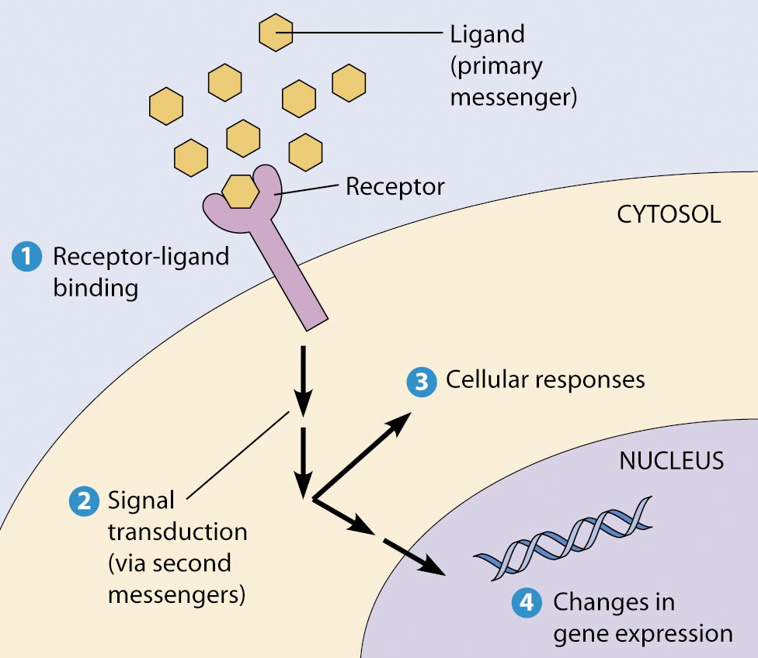
CELL BIOLOGY CBIO(BIOL) 3400
4 credit hours: 3 hours lecture and 1 hour discussion per week
Spring Semester 2011 January 10 – May 2, 2011
Final exam May 10, 2011 12:00 PM – 3:00 PM
Days | Time | Student Learning  Center
Tuesday &  Thursday | 1:00 PM-2:45 PM | 217

Objective: Structure and function of cells: cell architecture and organization, cell cycle and its control, membrane structure and transport, cell signaling, cytoskeleton elements and function in cell, disregulation of cell growth - cancer

Prerequisite: Biochemistry BCMB(BIOL)(CHEM) 3100 or BCMB 4010/6010
Prerequisite/corequisite: Genetics GENE(BIOL) 3200

Textbook: The World of the Cell, 7th Edition, Becker et al, 2009
Pearson Benjamin Cummings

Instructor:
Dr. Lynn Rumfelt
Tel: 678-359-5470; Cell: 832-373-7126; E-mail: lrumfelt@uga.edu

Instructor Office hours: Before or after class or call/e-mail to schedule an appointment.

Discussion Sessions: The 30 minute post-lecture time will be used for quizzes, homework review, methods discussions.

Attendance Policy:
- Roll is taken at beginning of class.
- If you miss class you are responsible for the lecture material/discussion and any assigned work. Ask your classmates what you missed.
- The following attendance policy is in accordance with the University of Georgia guidelines:
After four (4) missed classes, the students’ final grade may be dropped one letter grade at the discretion of the instructor.

Quizzes & homework and assignments (15 % total grade):
Quizzes will be given during discussion session and will be graded. Missed quizzes may not be made up.
Work will be assigned and graded from questions in the textbook and other materials. These will be graded with letter grade or pass/fail grade.

Exams (75 % total grade – 15% exams 1-4 and 15% grade final exam)
There will be four 1 hr 45 minute exams given during the semester. Exams cover material presented in class as lecture, power point, quizzes and assignments. If an exam is missed it will count as 0%. The missed exam grade will be replaced by the final exam grade.
Final exam is comprehensive and covers material covered in class and from previous exams.
Use of cell phones during quizzes or exams will result in a 0% score for the exam or quiz.
Topics Textbook Chapters________ Dates______________________
Review 1 – 6 1/11 – 1/13
Membranes: structure, function, transport 7 – 8, 12 1/18 – 2/1

Exam 1 2/3

Cytoskeletal systems & cellular movement 15 – 16 2/8 – 3/1
Cell adhesions, junctions, extracellular structures 17
Cell cycle and nucleus import/export 18 - 19

Exam 2 3/3
Article selection for class presentation due 3/3

Signal transduction I & II 13 – 14 3/8 – 4/5
Transcription, translation, protein sorting 21 – 22

Exam 3 4/7

Meiosis and chiasmata 20 4/12 – 4/19
Cancer 24

Exam 4 4/21
Final review 4/26
Article summary report due 4/26
Article presentations 4/28
Final exam 5/10 Tues 12:00 – 3:00 PM

Article presentation: (10% grade)
You will continue development of analytical skills by reviewing and presenting an original research article selected from recently published scientific literature in 2008 – 2010. You will work and together you will write a report and present the research article at the end of the semester on
Select any article meeting the following criteria:
1) Research article (not review articles) must be published in the top tier journals of Nature, Science, Cell, Journal of Cell Biology, Molecular Biology of the Cell or Molecular Cell.
2) Article selection is due by midterm March 3, 2011. Email article copy to me by this date so that I may post the article on eLearning Commons for reading. Clear reasoning, concise writing, and your own judgments are required for this analysis. Article selection on deadline is 2% grade.
The following questions may guide your thinking:
- Is the problem significant?
- Are the approaches suited to answering the question posed?
- Are the experiments well designed and presented?
- Are important control experiments performed?
- Do the results of the paper support the conclusions stated?
3) Write a two page summary report include references used in your analysis. Summary report is due by April 26, 2011 and is worth 4% grade. Your report and presentation will state
- Title, author(s), and journal
- Main questions or hypotheses addressed in the paper
- Specific sub-questions, the experimental approach(es) utilized, and the results
- Repeat C as needed to cover different parts of the study
- Major conclusions of the paper
- Significant criticism(s) of the experimental design, and conclusions.
4) Give a class presentation of the results showing all or selected figures from the article using PowerPoint or ELMO. Presentation is worth 4% grade.
Academic honesty:
The University of Georgia seeks to promote and insure academic honesty and personal integrity among students and other members of the University Community. All students agree to abide by the Student Honor Code by signing the UGA Admission Application. This codes provides, “I will be academically honest in all of my academic work and will not tolerate academic dishonesty of others.” All academic work must meet the standards contained in this Code and in “A Culture of Honesty.” Students are responsible for informing themselves of those standards before performing any academic work. Links for more detailed information can be found at:
http://www.uga.edu/honesty .

Grading scale:
Letter grade | Cumulative percentage
A | 90 - 100
A- | 87 - 89
B+ | 84 - 86
B | 80 - 83
B- | 77 - 79
C+ | 74 - 76
C | 70 - 73
C- | 67 - 69
D | 60 - 66
F | 59 or less

