|  |
| --- |
| **Welcome to General Ecology**  **University of Georgia**  **Fall, 2018** |

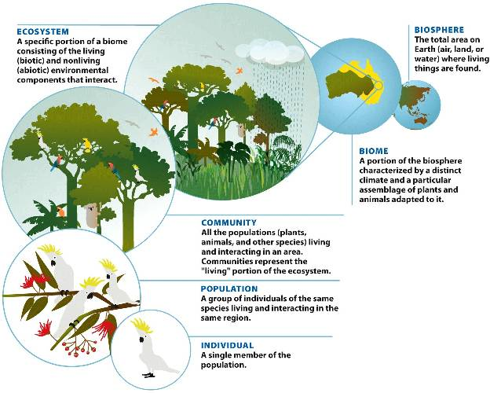

**Course Description**

This course is an introduction to core principles, classic experiments,  
current events, and ongoing research in ecology. We will examine processes at numerous scales, from individuals to the biosphere. As humans are also organisms, we will also explore how ecological processes shed light on human-environment interactions. Class activities aim to build confidence needed for you to become a creator of knowledge and interpersonal skills needed to collaboratively problem-solve with your peers.

*Hierarchical organization of ecological systems (Houtman et al. 2013)*

|  |  |  |  |
| --- | --- | --- | --- |
| **Course Details**  Credit: ECOL 3500/3505H, 4 credits  Required Resources:  *Elements of Ecology*  Smith and Smith. 2015. 9th edition  (eText or Paperback; ISBN: 0321934180)  TopHat Electronic Response System  <http://www.tophat.com>  Prerequisites:  BIOL 1104, BIOL 1108+L, or PBIO 1220+L and CHEM 1211+L or CHEM 1311H+L  Course Format:  face to face and online via eLC | | **Instructors** | |
| Dr. Jasmine Crumsey Forde (JC)  [jcrumsey@uga.edu](mailto:jcrumsey@uga.edu)  134 Ecology Building  Office Hours  MWF by appointment | http://www.ecology.uga.edu/cmsAdmin/uploads/website_photo.jpg  Dr. Ford Ballantyne  (FB)  [fb4@uga.edu](mailto:fb4@uga.edu)  164 Ecology Building  Office Hours  By appointment |
| **­** | |  | |
| **What’s in the syllabus?**  Course structure & goals  Grading scale  Readings/Quizzes/Exams  Course Policies  Course Schedule | 2  2  3  3-4  5 | **When do we meet?**  Lectures  MWF, 9:05 – 9:55 am  C127 Davison Life Sciences Building  Labs  Various times & days  302 Science Learning Center  Lab component is required | |

**Course Learning Outcomes**

Upon completion of this course, you will be able to apply principles of ecology to evaluate the structure and function of the natural world. This primary goal for your learning is supported by course content and four summative assessments, as well as four other learning outcomes outlined below:

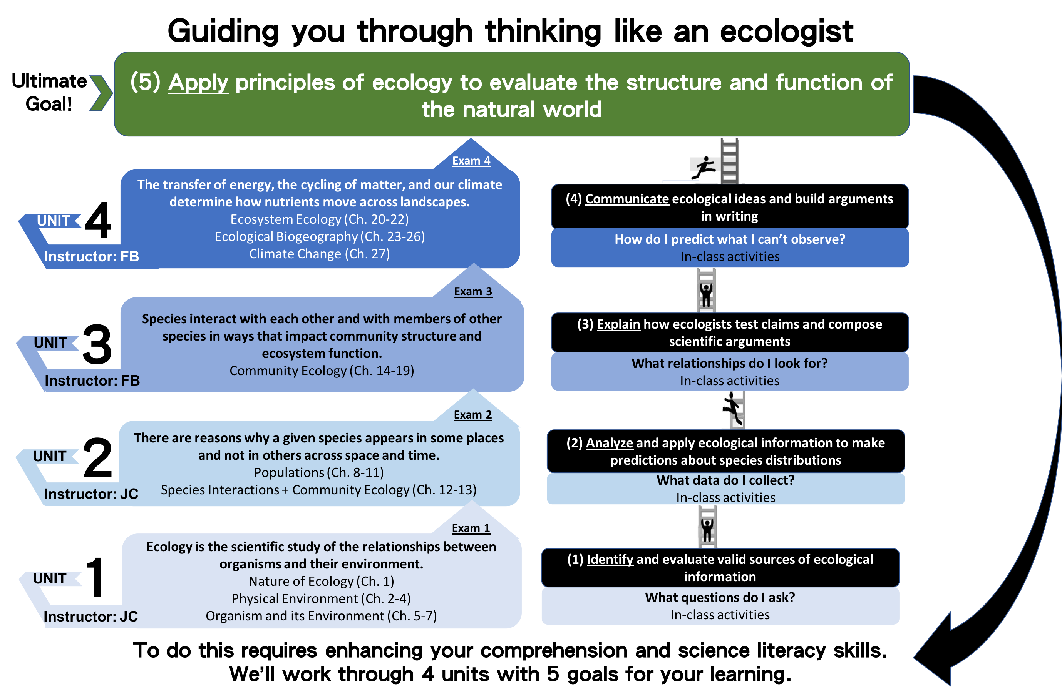

**Grading and Evaluation**

Grading schedule:

Exam 1 (Unit 1 material) 100 pts 10%

Exam 2 (Unit 2 material) 100 pts 10%

Exam 3 (Unit 3 material) 100 pts 10%

Final Exam (Unit 4 + some cumulative material) 100 pts 10%

Quizzes (top 5 scores of 7) 200 pts 20%

Participation (10 of 12 in-class responses) 100 pts 10%

Lab 300 pts 30%

Total 1000 pts 100%

Final Grades

The plus/minus grading system that corresponds to UGA policy will be used. This course grading will follow the scale provided below:

|  |  |  |  |
| --- | --- | --- | --- |
| A = 93 - 100 | B+ = 87-89 | C+ = 77-79 | D = 60-69 |
| A- = 90 - 92 | B = 83-86 | C = 73-76 | F = 0-59 |
|  | B- = 80-82 | C- = 70-72 |  |

Working in Groups

Each week includes in- and out-of-class assignments described below, some completed solo and others with a group. We will be assigning you to one of 37 groups seated throughout the classroom (Fridays only starting the second week of class). Check eLC for your assigned group.

Quizzes, Participation Activities, & Exams:

Weekly readings and quizzes will be posted on eLC and will require some out-of-class preparation. This preparation will involve reviewing lecture material from the week, and may involve reading the textbook, primary literature, and/or watching a video. **Seven Friday sessions will begin with a quiz administered through eLC (personal devices required).** For quizzes preceding an exam, student groups will then discuss the answers, re-take the quiz, and turn it in for a group score. Both quizzes are graded and if the group score is higher, the two grades are averaged for each student. The group score can’t hurt you if you have a higher individual score. This encourages individual accountability, and helps you to better understand the material as you discuss it with peers. Our aim is to encourage you to keep up with the material, rather than realizing you don’t totally understand it when you reach the exam. Total quiz points used to calculate your final grade will be determined from your highest 5 out of 7 scores.

**Twelve unannounced participation activities will take place over the semester.** These activities can include responses to Top Hat questions or a paper submission of either individual or group work. To receive 100% of the participation points, you must complete 10 out of these 12 activities.

**Three in-class exams and a final exam covering new material and some cumulative material (all multiple choice).** Note: Missed quizzes, exams, and participation activities may not be made up.

If unavoidable circumstances arise, absence from assessments must be arranged in advance and only for serious reasons. In special cases of documented emergencies, a makeup assessment may be allowed, at the discretion of the instructors (<http://bulletin.uga.edu/bulletin/ind/attendance.html>).

If the university cancels classes, such as for severe weather, students are expected to continue with readings as originally scheduled. Any assignments scheduled during those missed classes, such as a project or paper, are due at the next class meeting unless other instructions are posted at the course website or communicated via email.

How to Be Successful in This Course

* Complete out-of-class readings and assignments before each class. We will post journal articles that relate content lectures and lectures on Ecological Issues & Applications on eLC.
* Actively engage in in-class discussion of concepts and frameworks, quantitative analyses, case discussion, and team assignments.
* Constantly review and integrate concepts into your own frameworks and decision-making.
* Use the textbook in your learning; its content provides depth and clarity on lecture topics. Lecture materials should be your guide for knowing what to study.
* Get into the habit of studying concepts covered in lecture with your classmates and group.

**Course Policies**Communication Preferences

Please contact us through email. We will try to respond to emails within 24 hours (during the week). Policies that students should operate by in this course when writing academic emails are as follows:

1. **Use a clear subject line, leading with ‘ECOL 3500’.** The subject “ECOL 3500: Assignment 1 Question” is better than “heeeeelp!” (and much better than a blank subject line)
2. **Use a salutation and signature.** Begin with a greeting like “Hello”, and then address your professor by appropriate title and last name, such as “Prof. Forde”. Include a signature, e.g. “Sincerely,” and your name.
3. **Use standard punctuation, capitalization, spelling and grammar.** Instead of writing “idk what 2 rite about in my paper can you help??” try, “I am writing to ask about topics you suggested in class yesterday.”
4. **Do your part in solving what you need to solve.** If you email to ask something you could look up, you risk presenting yourself as less resourceful than you ought to be. Present yourself as responsible and taking initiative by mentioning that you’ve already checked the syllabus, and/or asked classmates.

Class Attendance and Participation

**During class, we will be using the Top Hat classroom response system**. You will be able to submit answers to in-class questions using Apple or Android smartphones and tablets, laptops, or through text message. Answering these questions helps us tell what you know and understand and what you are struggling to understand so that we can tailor instruction accordingly.

**To access Top Hat, you will need to register and pay a subscription by responding to an invitation sent to your official UGA email address (not your alias).** You can also visit [this link](https://support.tophat.com/s/article/Student-University-of-Georgia-Quick-Start-Guide) to view how to register for a Top Hat account and to get you up and running on the system. You will need to bring your device to class and log into your account beginning on the second day of class. You will need to respond to the questions posed during the semester using your official UGA username as your email and account on Top Hat. Students who require assistance with Top Hat must notify the instructor before leaving a class session and contact the Top Hat Support Team (1-888-663-5491).

**The Fine Print**

Academic Honesty Policy

As a UGA student, you have agreed to abide by the Student Honor Code: **“I will be academically honest in all of my academic work and will not tolerate academic dishonesty of others.”** All  work must meet the standards described in “A Culture of Honesty”, which can be read through this this link. Lack of knowledge of the academic honesty policy is not a reasonable explanation for a violation.

Questions related to the course and the academic honesty policy should be directed to the instructor. Students should also be aware that it is the instructors’ responsibility to report cases of suspected academic dishonesty directly to the Office of the Vice President for Instruction. This can result in a grade of “F” for the course, even worse penalties from the University, and much grief all around.

Technology Use in Class

Technology is great for learning but can at times disrupt our focus. Please refrain from instant messaging, e-mailing, surfing the Internet, playing games, writing papers, doing homework etc. during class time, which may distract your peers. **Acceptable uses of technology include taking notes, following along on presentation slides, as well as working on assigned in-class activities that require personal device use.**

Fostering an inclusive learning environment

If issues arise during the course or if you anticipate issues related to the format or requirements of this course, please meet with either of your instructors. We would like us to discuss ways to ensure your full participation in the course. Here are some valuable university resources you can use:

* **Academic Coaching -** assistance with time management, test and performance anxiety, note-taking, motivation, text comprehension, test preparation, and other barriers to success at UGA. Link for the [Office of Academic Enhancement](http://dae.uga.edu/resources/academic-coaching/).
* **Student Care and Outreach -** connects students with resources across campus and oversees the process for hardship withdrawals. Link for the [Office of Student Care and Outreach](http://sco.uga.edu/).
* **Disability Resource Center -** If you determine that formal, disability-related accommodations are necessary, it is very important that you register with the DRC (Voice: 706-542-8719 or TTY: 706-542-8778) and notify us of your eligibility for reasonable accommodations. We can then plan how best to coordinate your accommodations. Link for the [Disability Resource Center](https://drc.uga.edu/).

FERPA Notice

The Federal Family Educational Rights and Privacy Act (FERPA) grants students certain information privacy rights. See this link for the [UGA registrar’s explanation of FERPA](https://apps.reg.uga.edu/FERPA/).

**Course Schedule:**

The schedule, policies, and assignments in this course are subject to change in the event of extenuating circumstances, by mutual agreement, and/or to ensure better student learning. Students should read required material and complete assignments by the deadlines posted on eLC.

|  |  |  |  |  |  |  |
| --- | --- | --- | --- | --- | --- | --- |
| **UNIT 1: Organisms & their Environment** | | | | | | |
| Week |  | Monday |  | Wednesday |  | Friday (JC+FB) |
| 1  JC | Aug 13 | Course Intro  10 Key Ecological Concepts | Aug 15 | Ch. 1 Nature of Ecology | Aug 17 | Ch. 2 Climate |
| 2  JC | Aug 20 | Ch. 3 Aquatic Environment | Aug 22 | Ch. 4 Terrestrial Environment | Aug 24  **Quiz 1** | Ecological Applications:  Indirect effects of environmental change on species ecology |
| 3  JC | Aug 27 | Ch. 5 Adaptation & Natural Selection | Aug 29 | Ch. 6/7 Plant & Animal Adaptations | Aug 31  **Quiz 2** | Ecological Applications:  Kelp forest vulnerability to climate change |
| 4  JC | Sep 3 | HOLIDAY (Labor Day) | Sep 5 | Organisms & their Environment Wrap-up | Sep 7 | **EXAM 1** |
| **UNIT 2: Populations Across Space and Time** | | | | | | |
| Week |  | Monday |  | Wednesday |  | Friday (JC+FB) |
| 5  JC | Sep 10 | Introduction to Populations | Sep 12 | Ch. 8 Properties of Populations | Sep 14 | Ecological Applications:  Non-native & Invasive Species |
| 6  JC | Sep 17 | Ch 9. Population Growth | Sep 19 | Ch. 10 Life History | Sep 21  **Quiz 3** | Ecological Applications:  Extinctions & Habitat Loss |
| 7  JC | Sep 24 | Ch. 11 Intraspecific Population Regulation | Sep 26 | Ch. 11 Intraspecific Population Regulation | Sep 28  **Quiz 4** | Ecological Applications:  The Efficacy of Conservation + Populations Wrap Up |
| 8  JC | Oct 1 | Ch. 12 Species interactions introduction | Oct 3 | Ch. 13 Interspecific Competition | Oct 5 | **EXAM 2** |
| **UNIT 3: Species Interactions & Communities** | | | | | | |
| Week |  | Monday |  | Wednesday |  | Friday (JC+FB) |
| 9  FB | Oct 8 | Ch 14. Predation | Oct 10 | Ch. 15 Parasitism & Mutualism | Oct 12 | Ecological Applications:  Land Use & Infectious Diseases  [Mid-semester evaluation] |
| 10  FB | Oct 15 | Ch. 16 Community Structure | Oct 17 | Ch. 17 Factors Influencing the Structure of Communities | Oct 19  **Quiz 5** | Ecological Applications:  Complex Trophic Cascades |
| 11  FB | Oct 22 | Ch. 18: Community Dynamics | Oct 24 | Ch. 18: Community Dynamics | Oct 26 | HOLIDAY (Fall Break) |
| 12  FB | Oct 29 | Ch. 19 Landscape Dynamics | Oct 31 | Species Interactions & Communities Wrap-up | Nov 2 | **EXAM 3** |
| **UNIT 4: Ecosystems, Biodiversity, & Climate Change** | | | | | | |
| Week |  | Monday |  | Wednesday |  | Friday (JC+FB) |
| 13  FB | Nov 5 | Introduction to Ecosystem Ecology & Climate Change | Nov 7 | Ch. 20 Ecosystem Energetics | Nov 9 | Ecological Applications:  History of NPP and Oxygen on Earth |
| 14  FB | Nov 12 | Ch. 21 Decomposition and Nutrient Cycling | Nov 14 | Ch. 22 Biogeochemical Cycles | Nov 16  **Quiz 6** | Ecological Applications:  Human Impacts on the N cycle |
| 15  ---- | Nov 19 | HOLIDAY | Nov 21 | HOLIDAY | Nov 23 | HOLIDAY |
| 16  FB | Nov 26 | Ch. 23/24 Terrestrial & Aquatic Ecosystems | Nov 28 | Ch. 26 Large-Scale Patterns in Biodiversity | Nov 30  **Quiz 7** | Ecological Applications:  Balancing Conservation & Societal Needs |
| 17  FB | Dec 3 | Ch. 27 Ecology of Climate Change | Dec 5 | Course Wrap-up | Dec 10 | **FINAL EXAM**  **8:00 – 11:00am** |