

E-Project

Documentation



Developed And Designed By:

* Abdul Majid
* Umair Khan



CONTENT

CONTENT…………………………………………………………….1  User Profile………………………………………………………………23

INTRODUCTION……………………………………………………2 User Profile Code………………………………………………………24

OBJECTIVE OF THE PROJECT…………………………………3 Change Password………………………………………………………25

PROBLEM STATEMENT…………………………………………4 Change Password Code 1………………………………………….26

REQUIREMENT SPECIFICATION…………………………….5 Change Password Code 2………………………………………..27

HARDWARE/SOFTWARE REQUIREMENTS…………….6 Admin Dashboard……………………………………………………..28

Login Page……………………………………………………………7 Admin Dashboard Code 1………………………………………..29

PHP Code……………………………………………………………..8 Admin Dashboard Code 2………………………………………..30

User Board…………………………………………………………..9 Admin Dashboard Code 3…………………………………………31

User Dasboard Code 1………………………………………….10 Add Category …………………………………………………………….32

User Dashboard Code 2………………………………………..11 Add Category Code……………………………………………………..33

User Info Page……………………………………………………….12 View Category …………………………………………………………….34

User Info code………………………………………………………..13 View Category Code……………………………………………………..35

User Order Info 14 Add Brand……………………………………………………………………36

User Order Code 1 15 Add Brand Code…………………………………………………………37

User Order Code 2 16 View Brand…………………………………………………………………38

User Invoice Info 17 View Brand Code………………………………………………………..39

User Invoice Code 1 18 Add Product ……………………………………………………………….40

User Invoice Code 2 19 Add Product Code……………………………………………………….41

User Shopping Info 20 Stock Details ………………………………………………………………42

User Shopping Info Code 1 21 Stock Details Code…………………………………………………………43

User Shopping Info Code 2 22 Customers Details…………………………………………………………..44

Customers details Code……………………………………………………45

Order Details …………………………………………………………...46

Orders Details Code…………………………………………..47

Admin Profile…………………………………………………….48

Admin Profile Code…………………………………………….49

Admin FAQs ……………………………………………………….50

Admin FAQs Code………………………………………………..51

View Feedback……………………………………………………..52

View FeedBack Codes…………………………………………….53

Feedback………………………………………………………………..54

Home ……………………………………………………………………...55

About…………………………………………………………………………56

E.R Diagram…………………………………………………………………57



INTRODUCTION

The thirst for learning, upgrading technical skills and applying the concepts in real life environment at a fast pace is what the industry demands from IT professionals today. However busy work schedules, far-flung locations, unavailability of convenient time-slots pose as major barriers when it comes to applying the concepts into realism. And hence the need to look out for alternative means of implementation in the form of laddered approach.

The above truly pose as constraints especially for our students too! With their busy schedules, it is indeed difficult for our students to keep up with the genuine and constant need for integrated application which can be seen live especially so in the field of IT education where technology can change on the spur of a moment. *Well, technology does come to our rescue at such times!!*

Keeping the above in mind and in tune with our constant endeavour to use Technology in our training model, we at Aptech have thought of revolutionizing the way our students learn and implement the concepts using tools themselves by providing a *live and synchronous eProject learning environment!*

**So what is this eProject?**

eProject is a step by step learning environment that closely simulates the classroom and Lab based learning environment into actual implementation. It is a project implementation at your fingertips!! An electronic, live juncture on the machine that allows you to

* Practice step by step i.e. laddered approach.
* Build a larger more robust application.
* Usage of certain utilities in applications designed by user.
* Single program to unified code leading to a complete application.
* Learn implementation of concepts in a phased manner.
* Enhance skills and add value.
* Work on real life projects.
* Give a real life scenario and help to create applications more complicated and useful.
* Mentoring through email support.

The students at the centre are expected to complete this eProject and send complete documentation with source code to eProjects Team

Looking forward to a positive response from your end!!



**Objectives of the project**

The Objective of this program is to give a sample project to work on real life projects. These applications help you build a larger more robust application.

The objective is not to teach you concepts but to provide you with a real life scenario and help you create applications using the tools.

You can revise them before you start with the project.

It is very essential that a student has a clear understanding of the subject.

Kindly get back to eProjects Team in case of any doubts regarding the application or its objectives.

 **Problem Statement**

Problem statement is attached separately in a file “**Online Shopping Cart**”

**Standards plan:**

Every code block must have comments.

The logic of the program needs to be explained. Proper documentation should be maintained.

Complete Project Report along with synopsis, code and documentation should be prepared.

**Documentation:**

No project is complete without documentation. In fact, it is one of the most important activities during the development of a project. The documentation of an ideal project will be in the form of a project report comprising of the following documents:

* Certificate of Completion.
* Table of Contents.
* Problem Definition.
* Customer Requirement Specification.
* Project Plan.
* E-R Diagrams.
* Algorithms.
* GUI Standards Document.
* Interface Design Document.
* Task Sheet.
* Project Review and Monitoring Report.
* Unit Testing Check List.
* Final Check List.



**Hardware/ Software Requirements**

**Hardware:**

* A minimum computer system that will help you access all the tools in the courses is a Pentium 166 or better
* 128 Megabytes of RAM or better

**Operating System:**

* LINUX / Windows 2000 Server (or higher if possible)

**Software**

* PHP
* MySQL
* PERL
* Apache

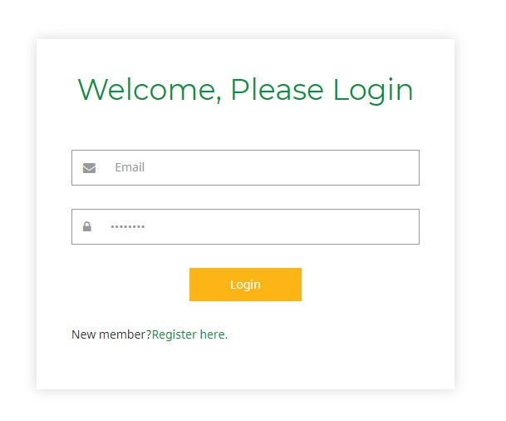 Login Page

 Login php code

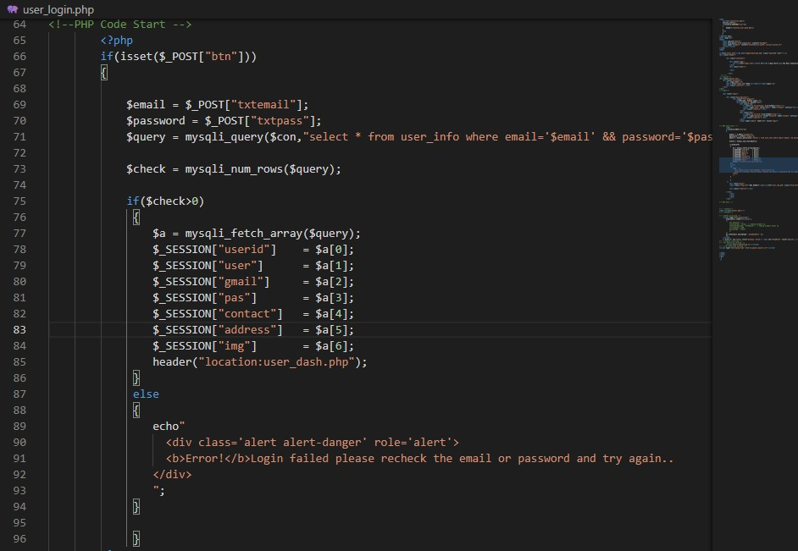

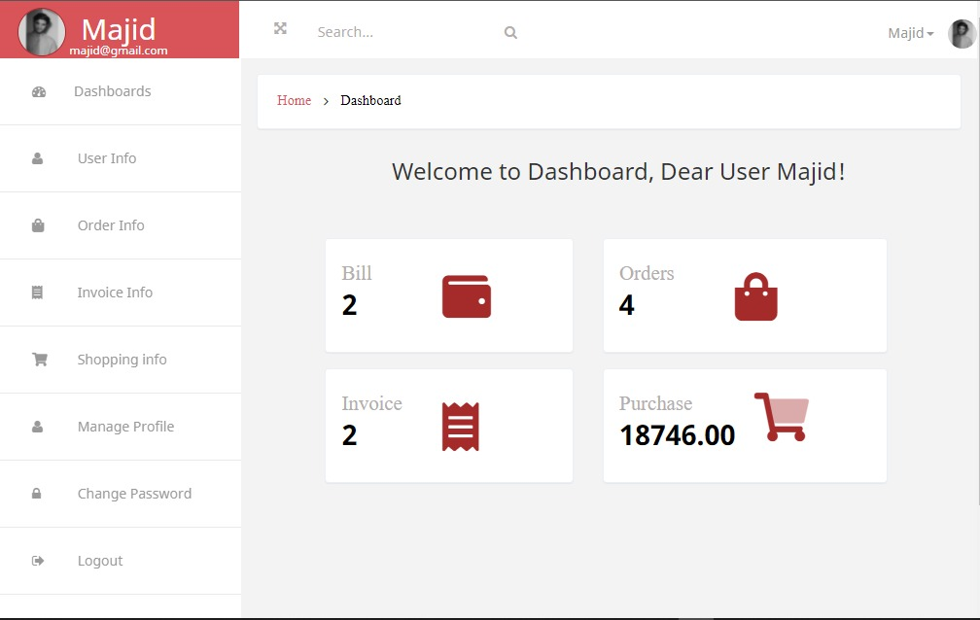 User Dashboard

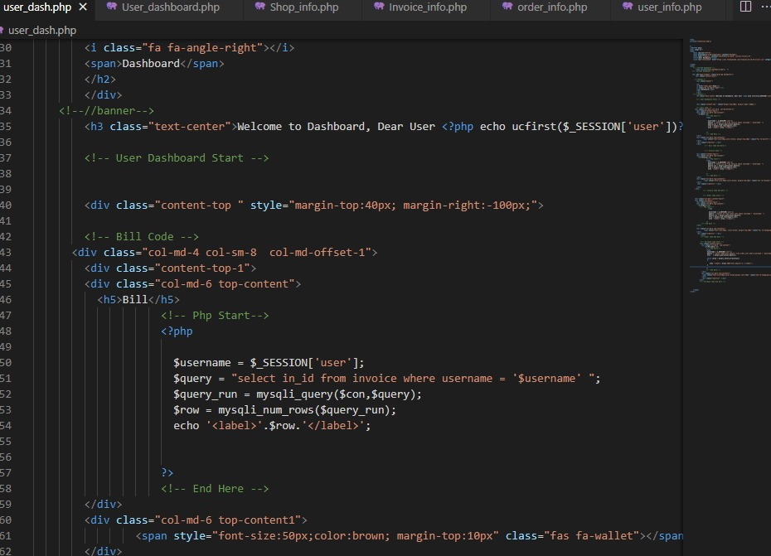 user dashboard code 1

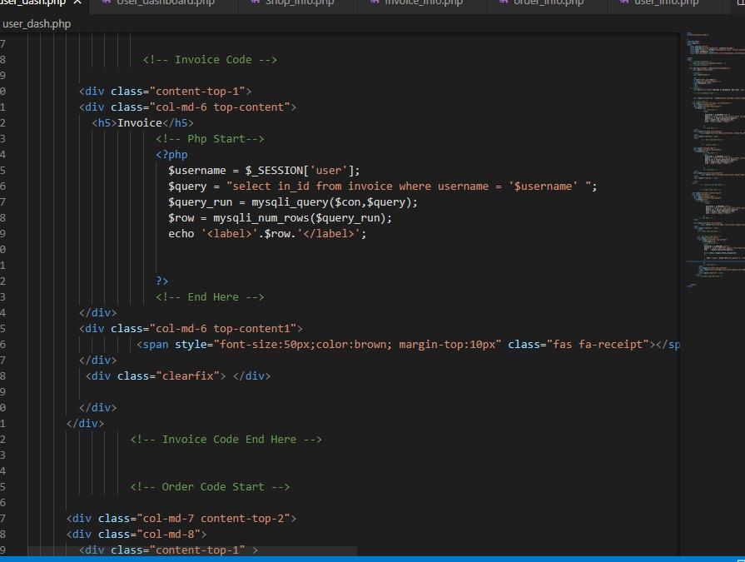 USER DASHBOARD CODE 2

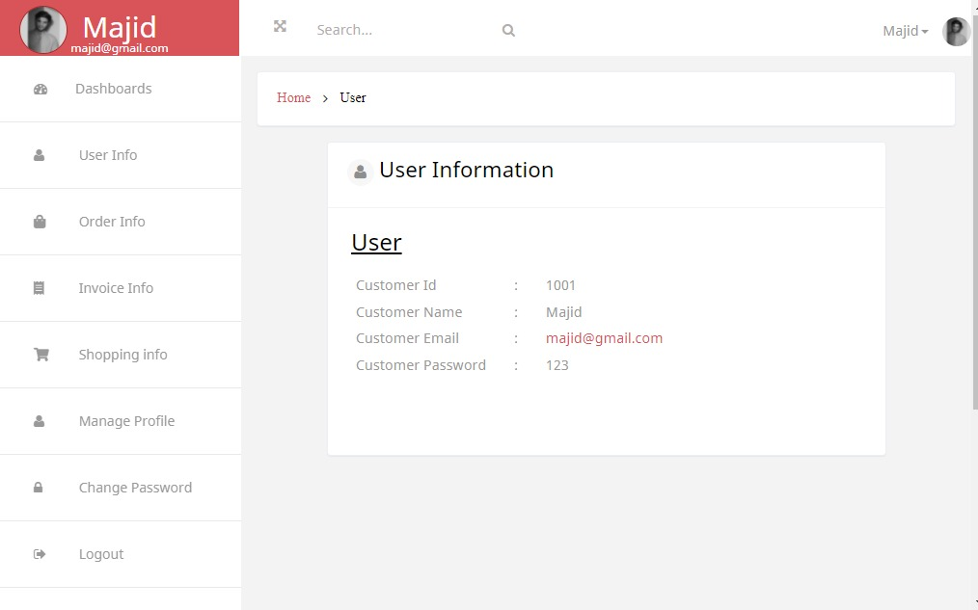 USER INFO PAGE

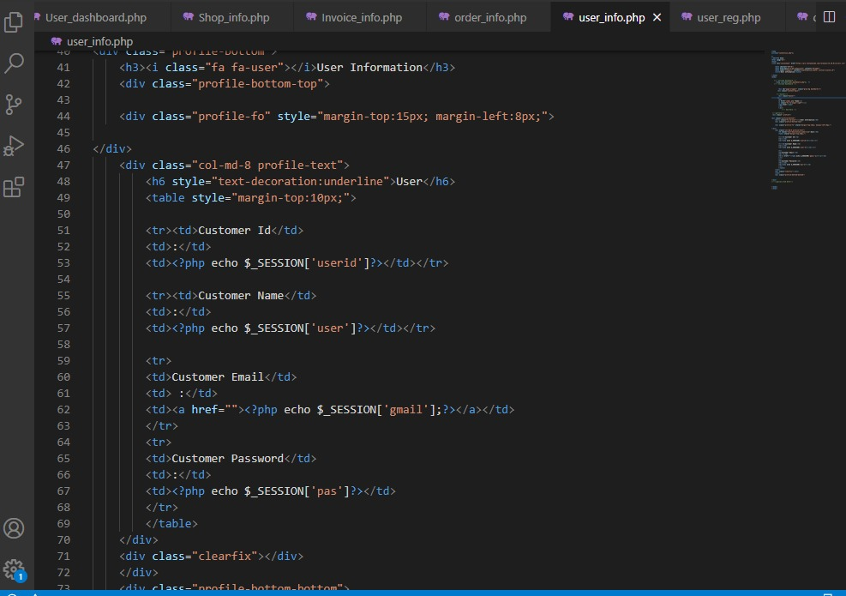 USER INFO CODE

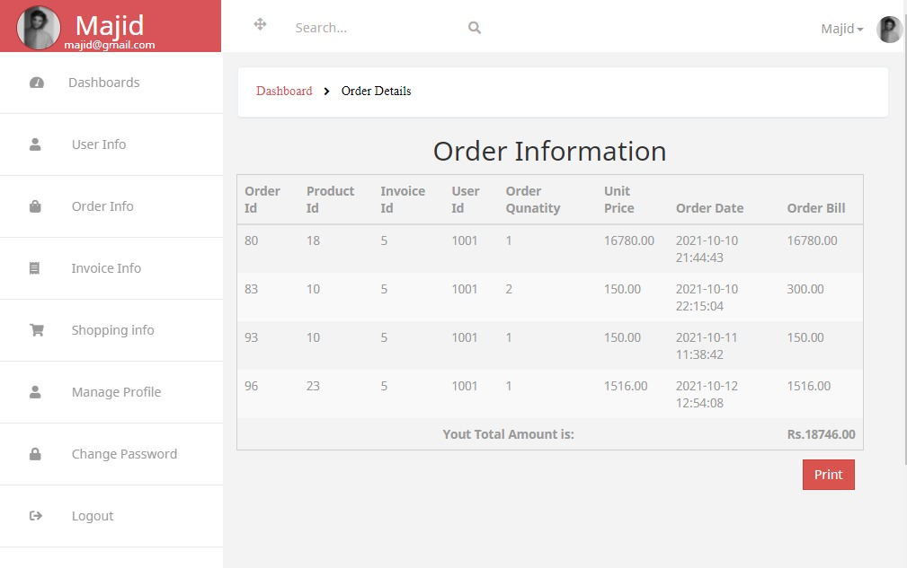 USER ORDER INFO

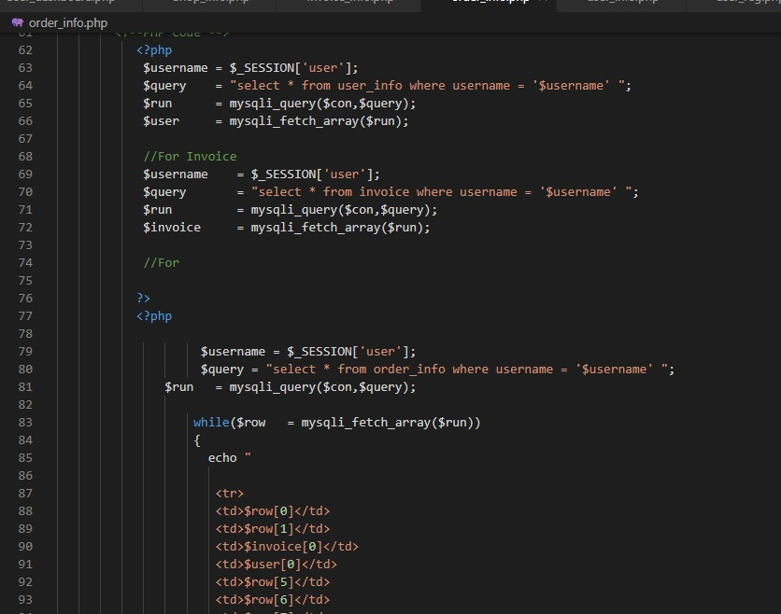 USER ORDER CODE 1

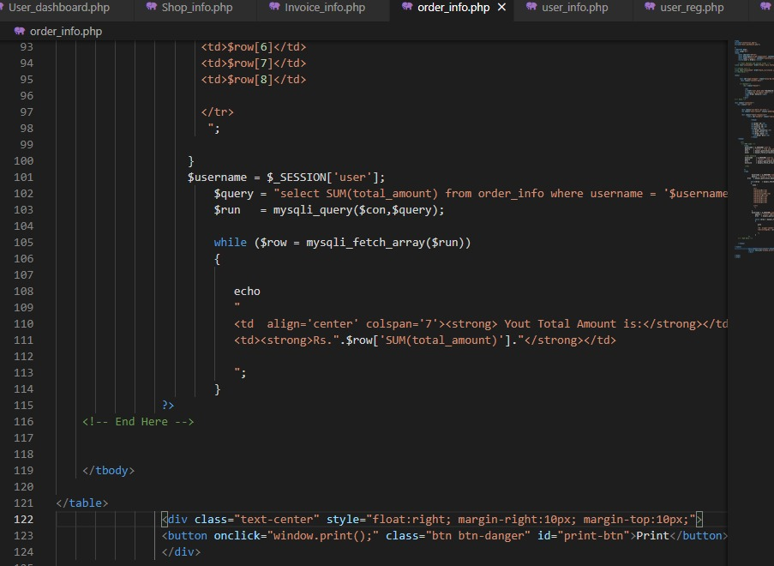 USER ORDER CODE 2

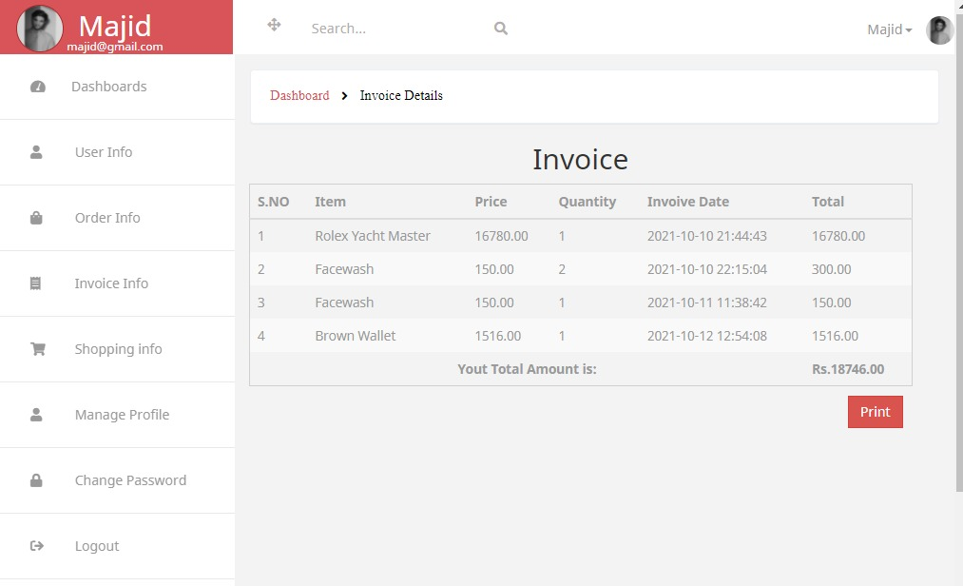 USER INVOICE INFO PAGE

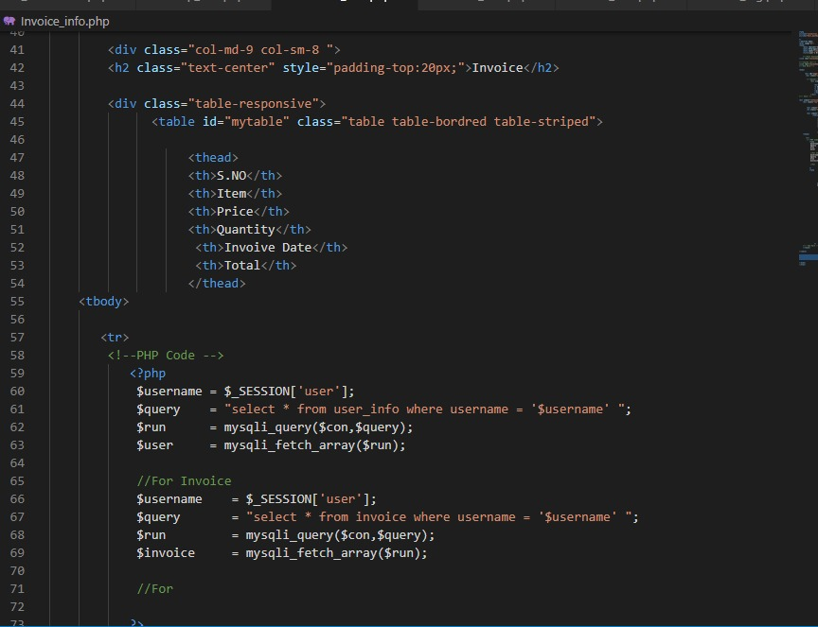 USER INVOICE INFO CODE 1

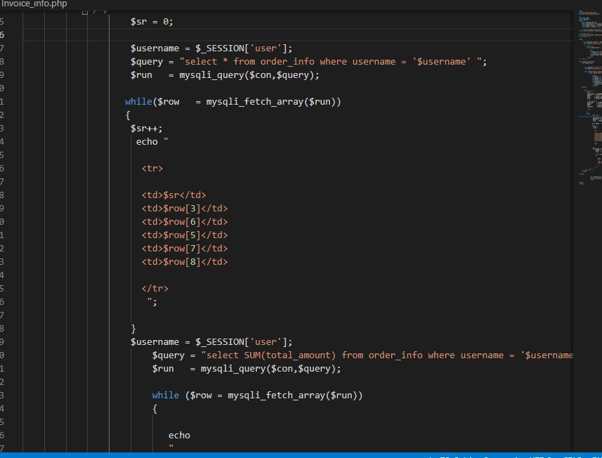 USER INVOICE INFO CODE 2

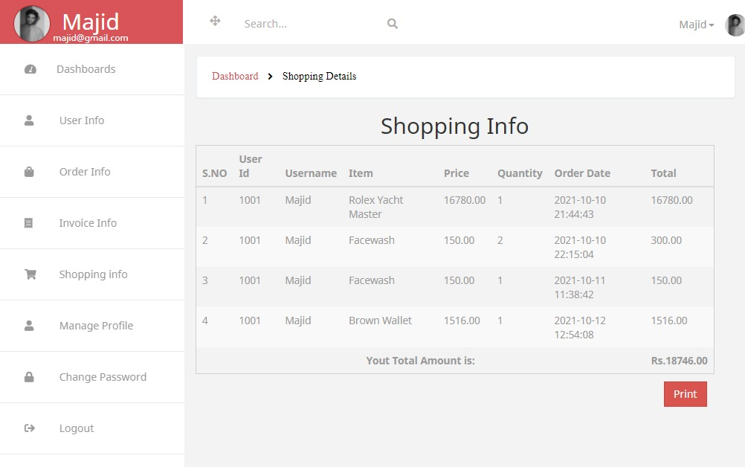 USER SHOPPING INFO PAGE

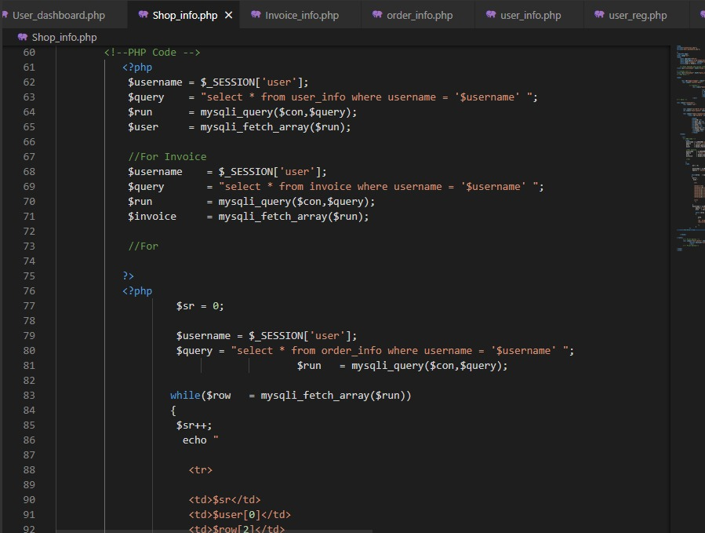 USER SHOPPING INFO CODE 1

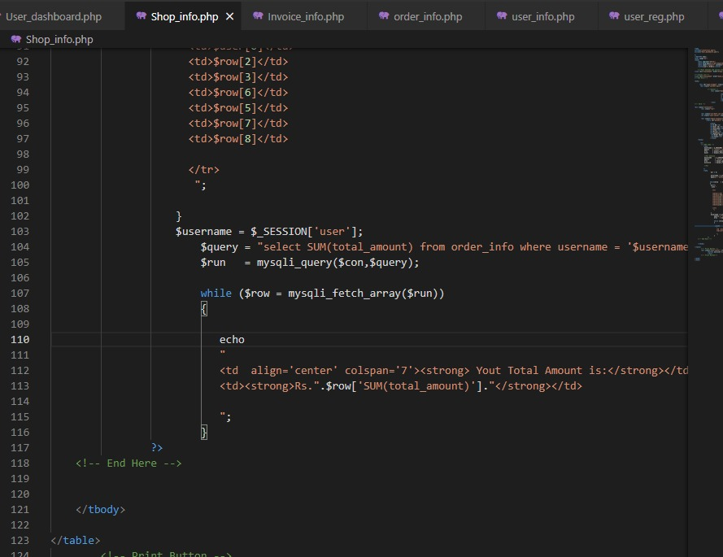 USER SHOPPING INFO CODE 2

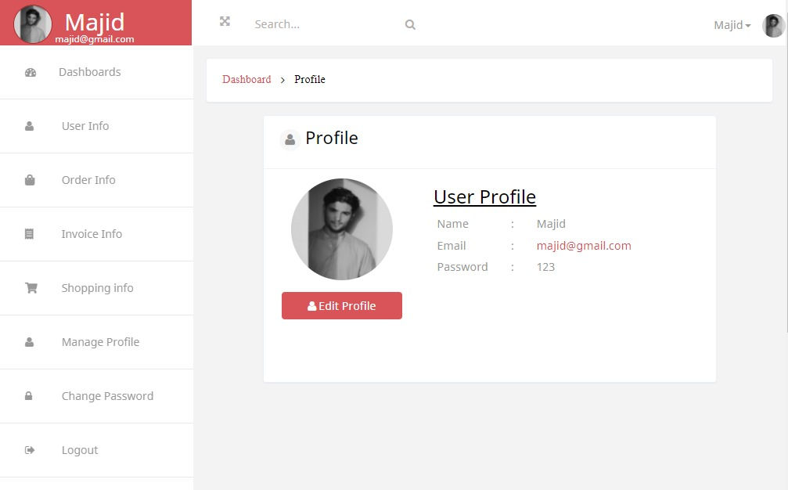 user profile

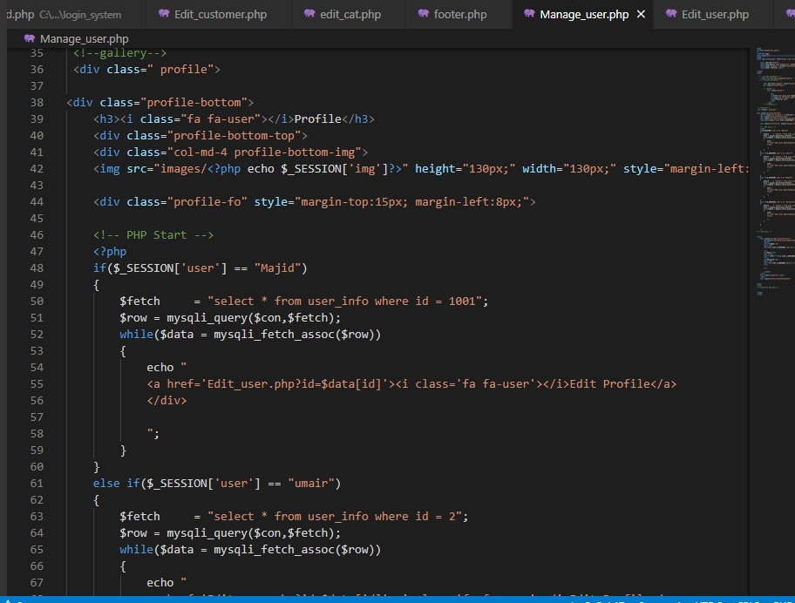 user profile code

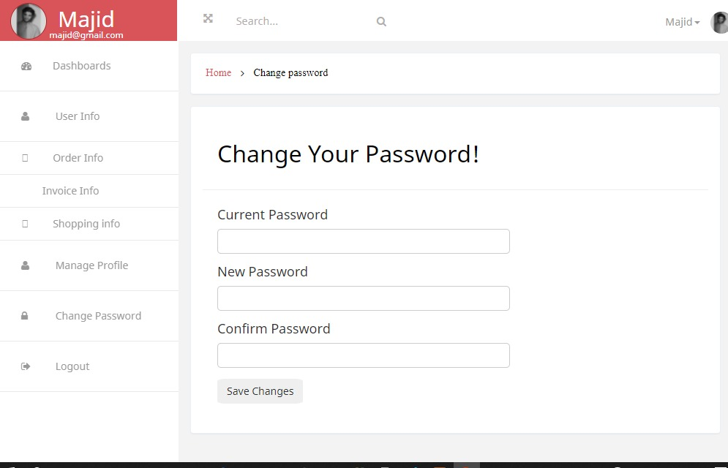 change password page

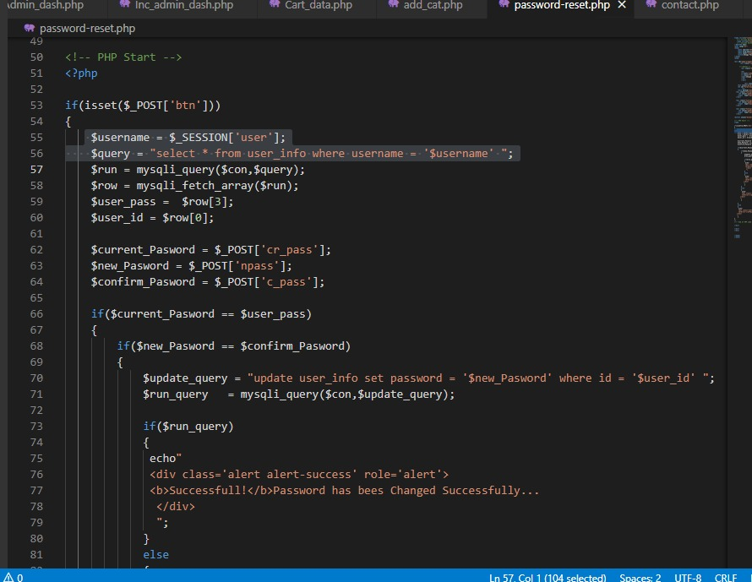 change password code 1

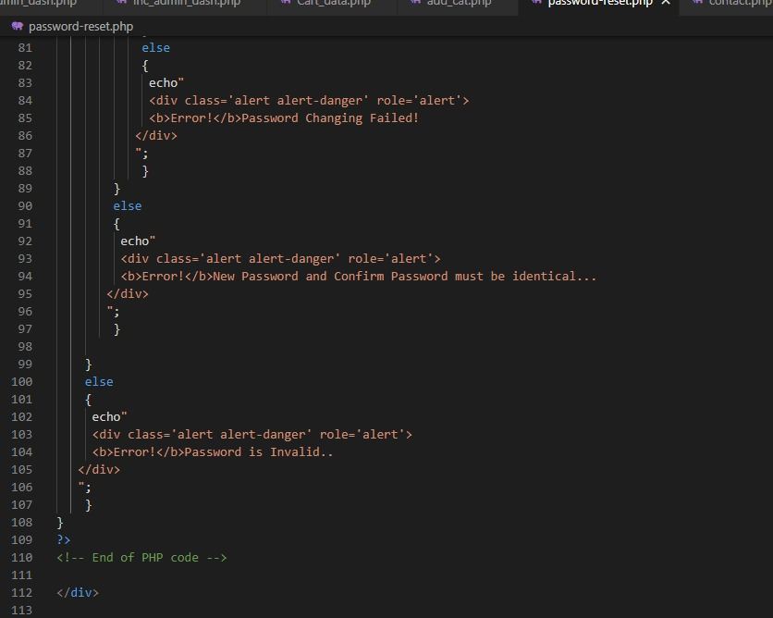 change password code 2

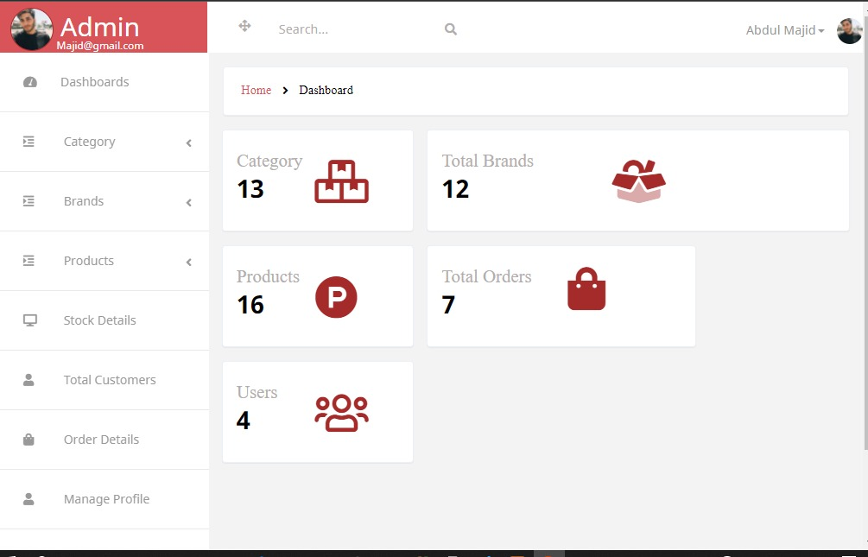 admin dashboard

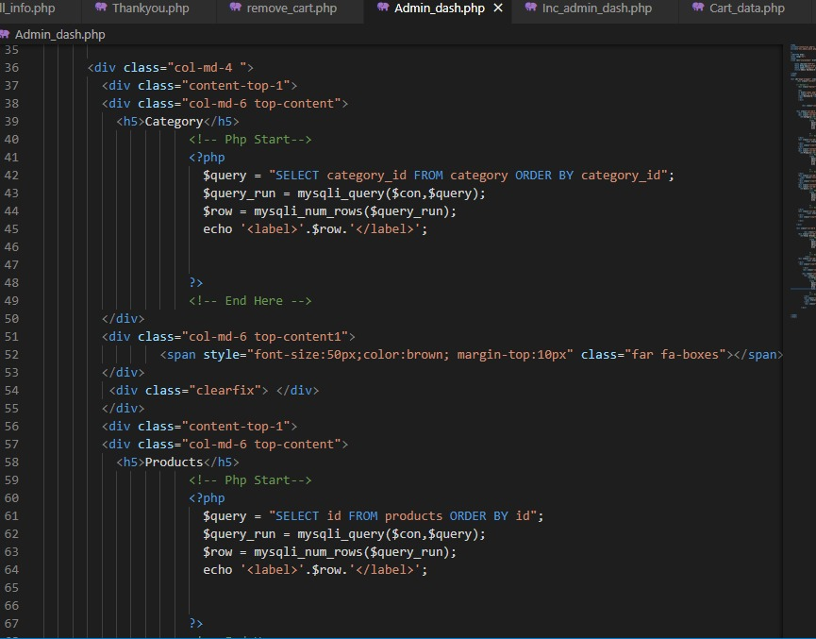 admin dashboard code 1

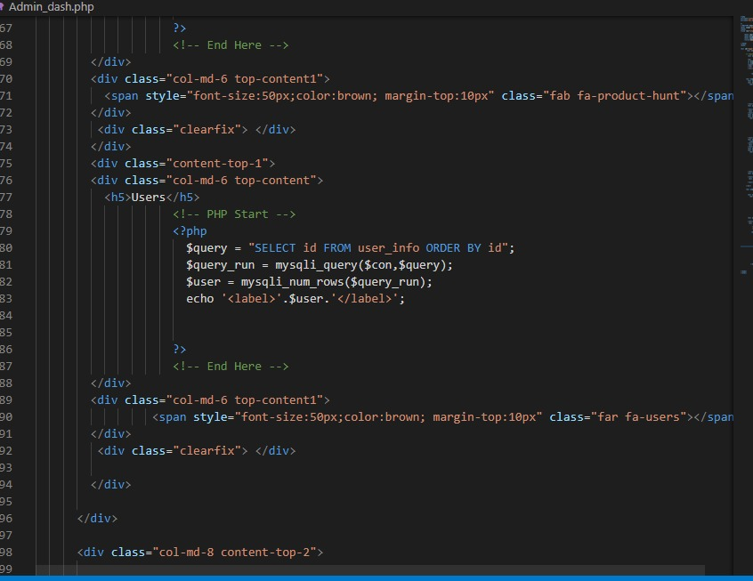 admin dashboard code 2

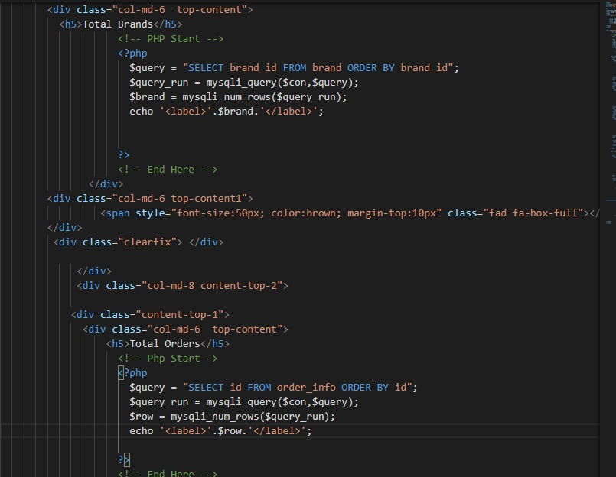 admin dashboard code 3

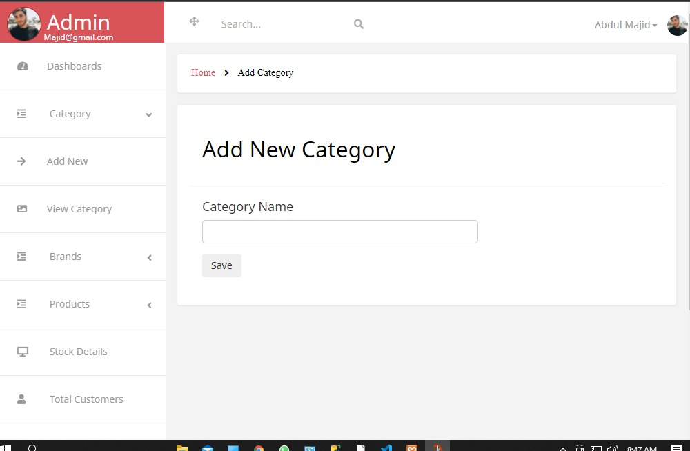 add category page

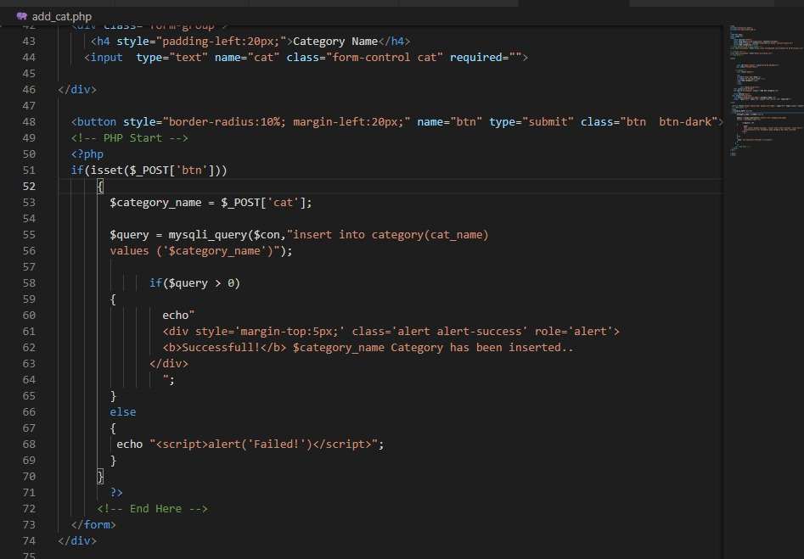 add category code

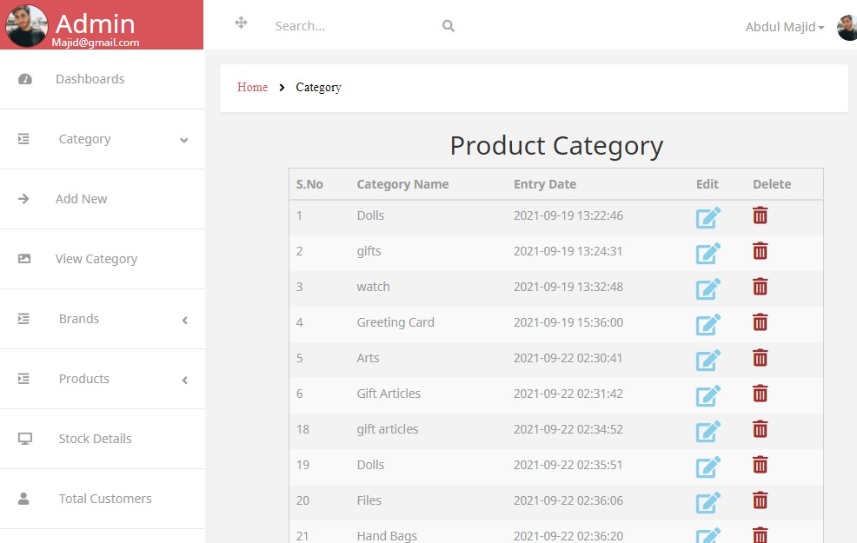 view category page

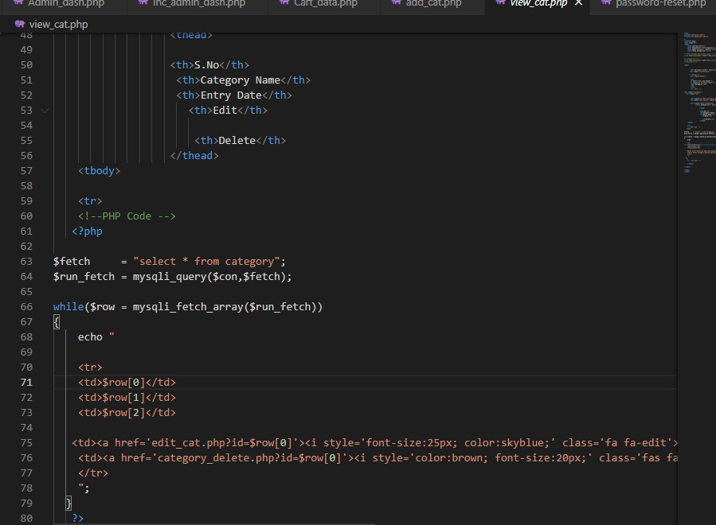 view category code

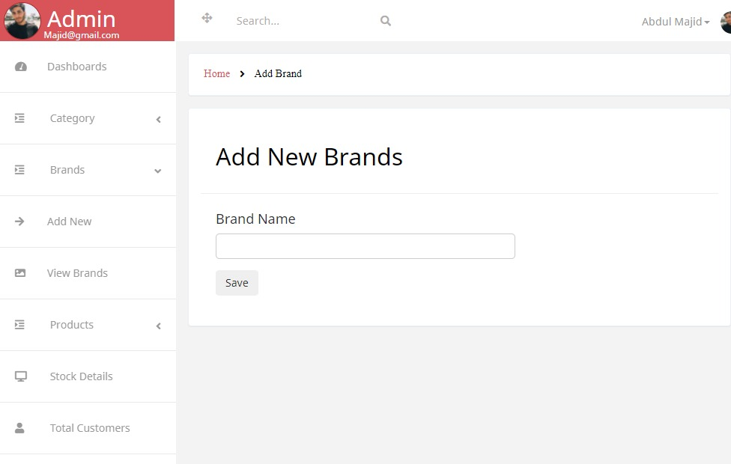 add brand

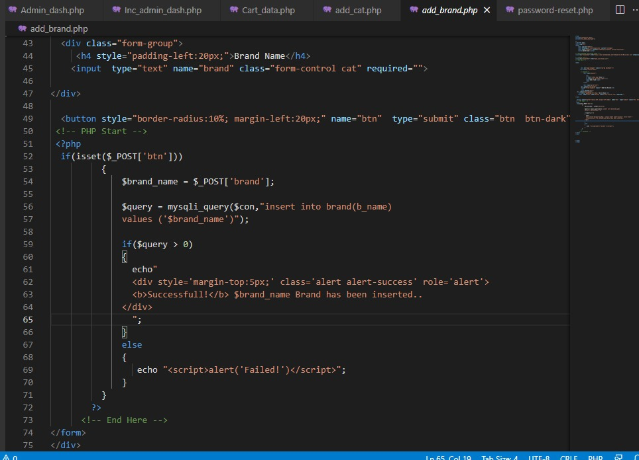 add brand code

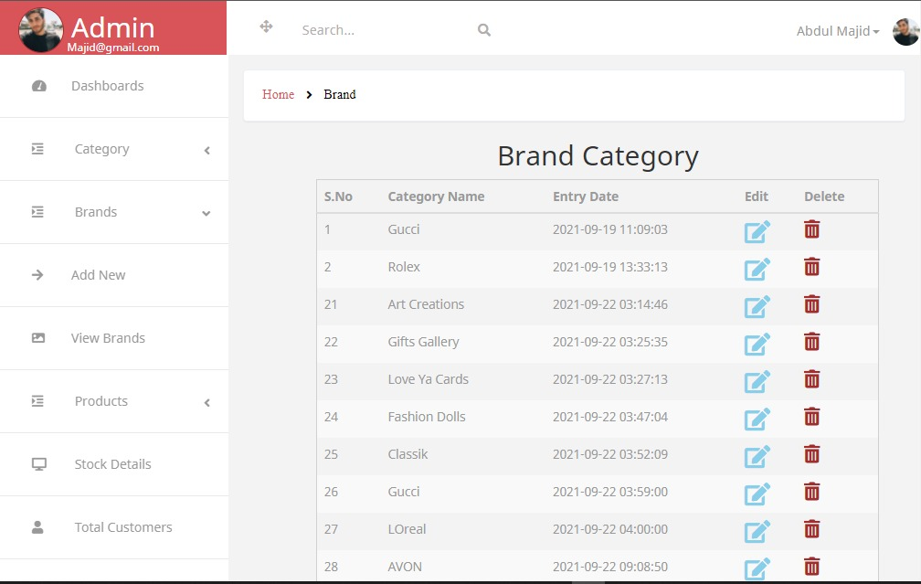 view brand

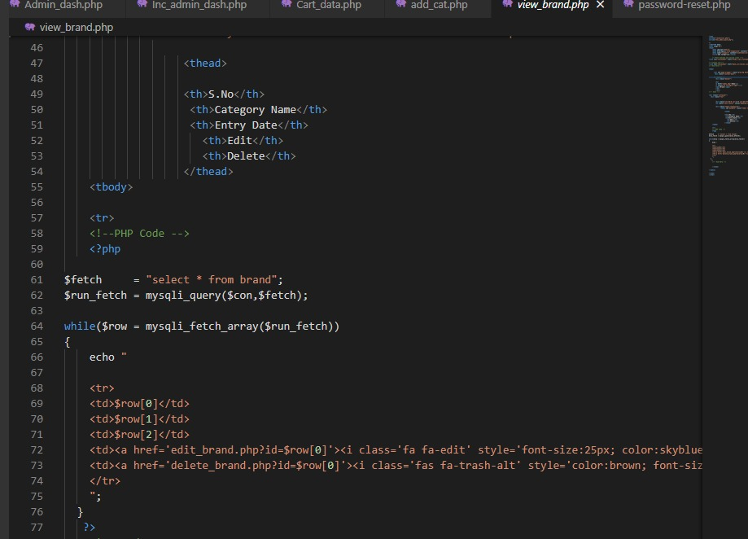 view brand code

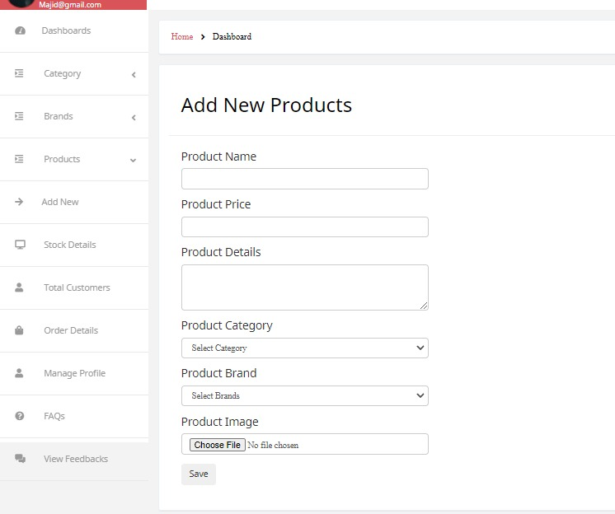 add product

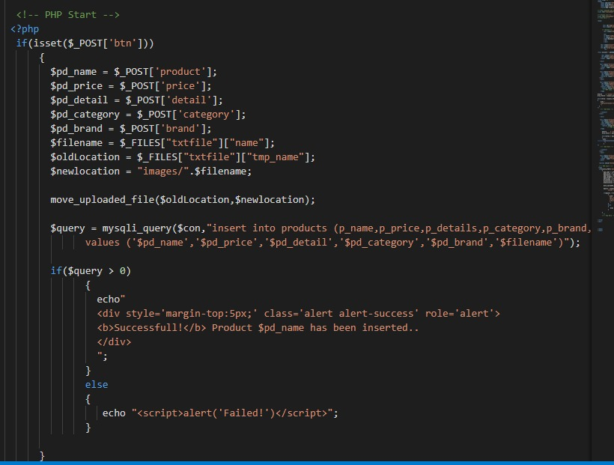 add product code

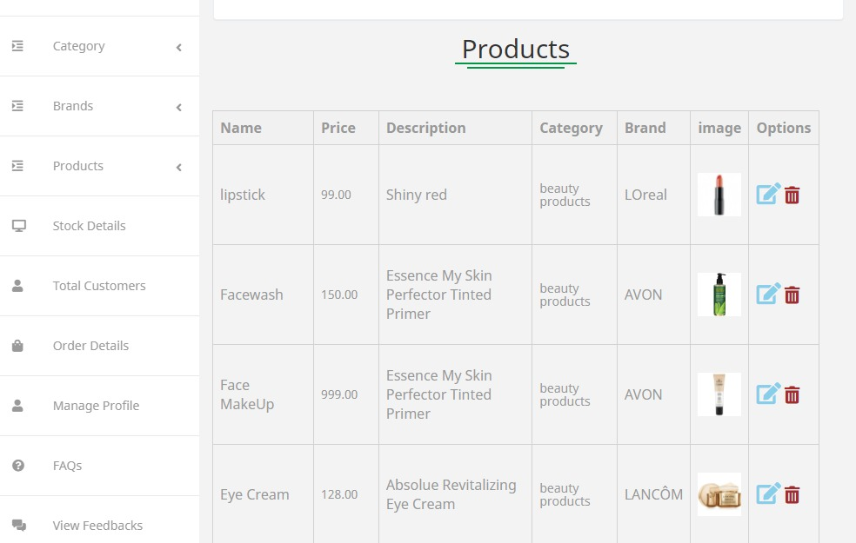 stock details

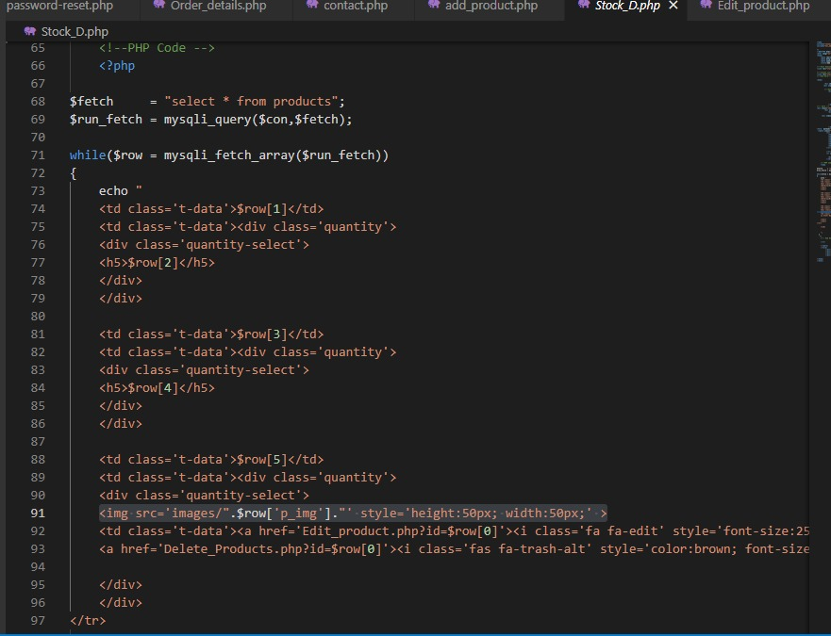 stock details code

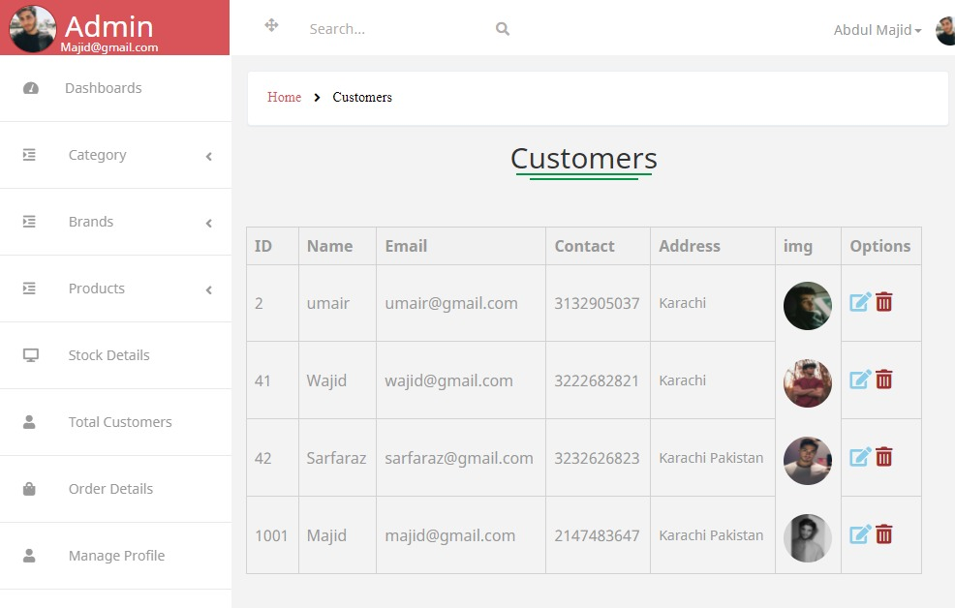 customers details

 customers details code

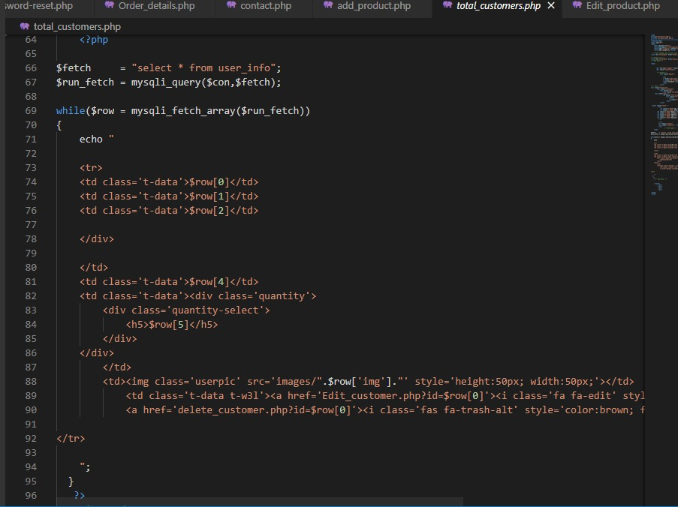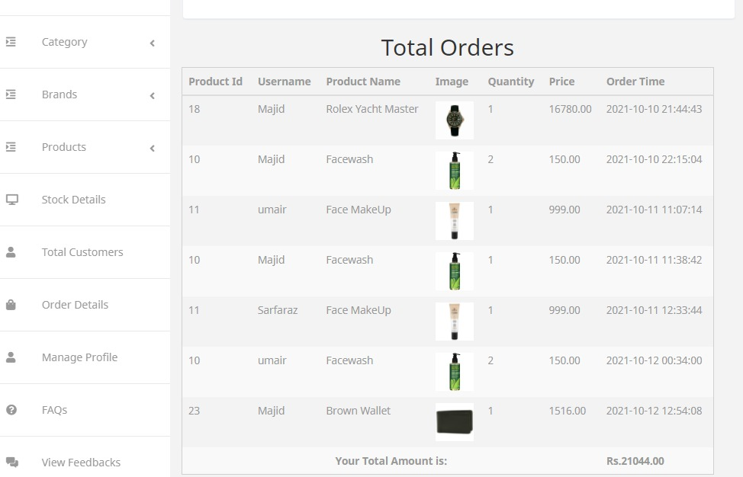 order details

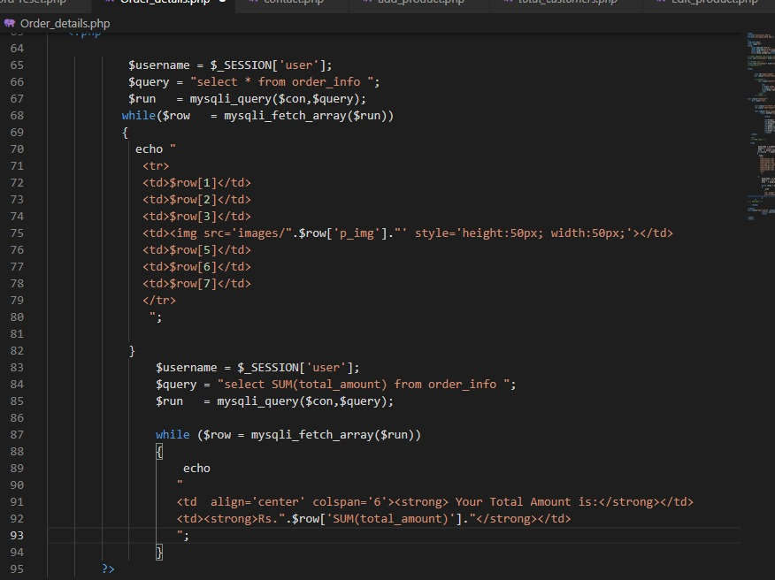 order details code

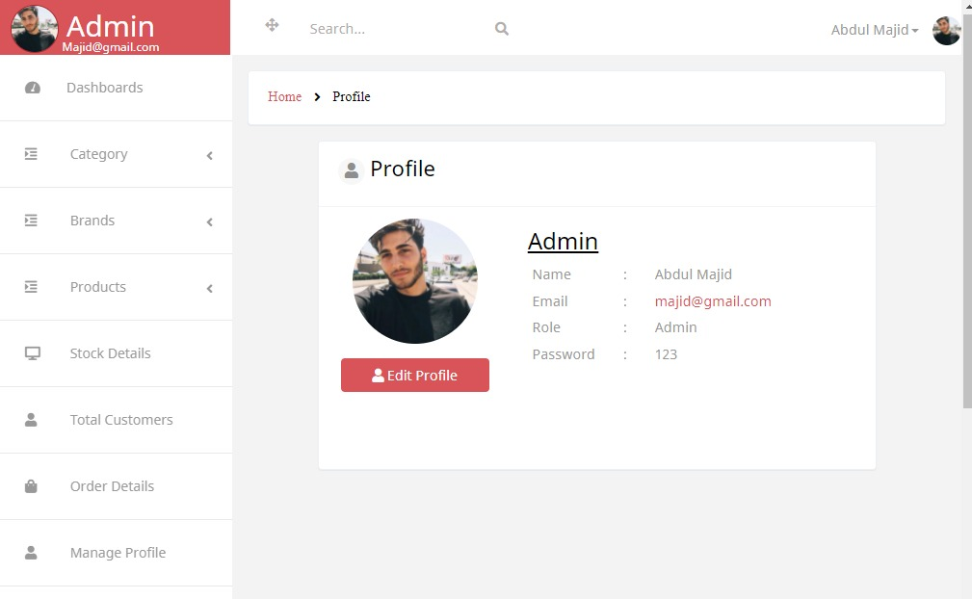 admin profile

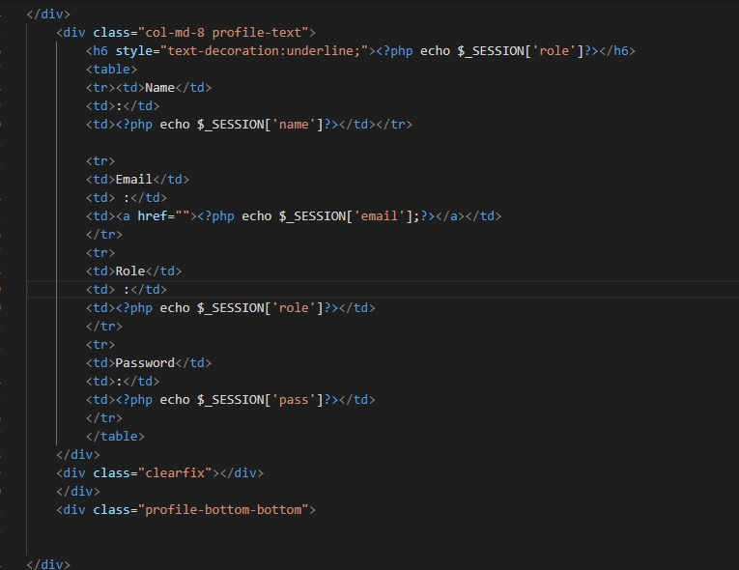 admin profile code

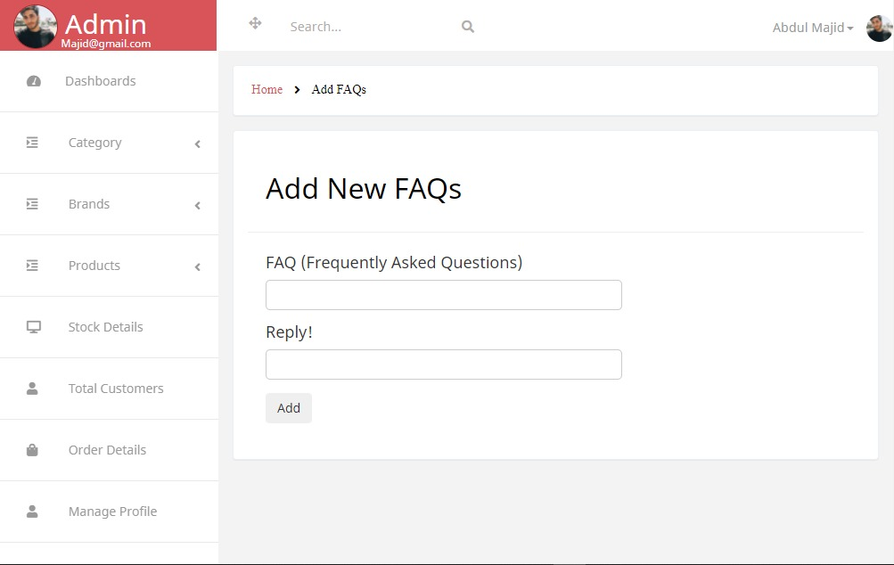 admin faqs

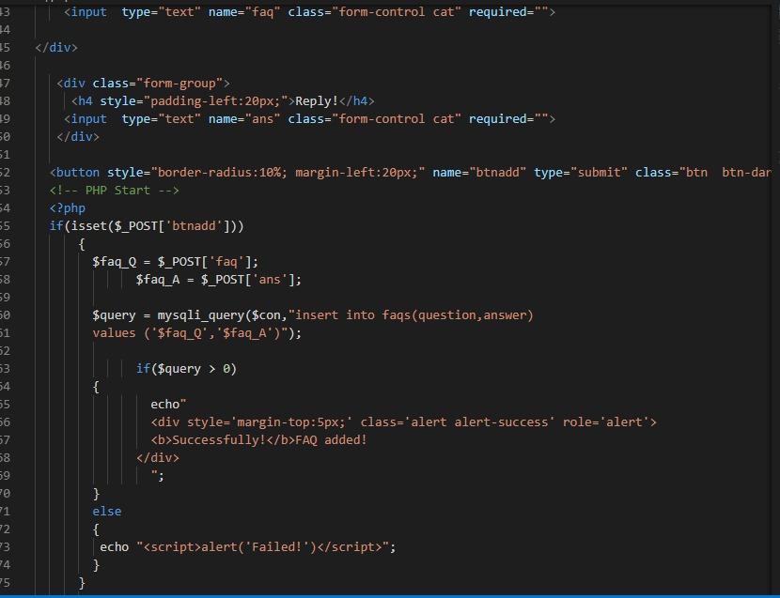 admin faqs code

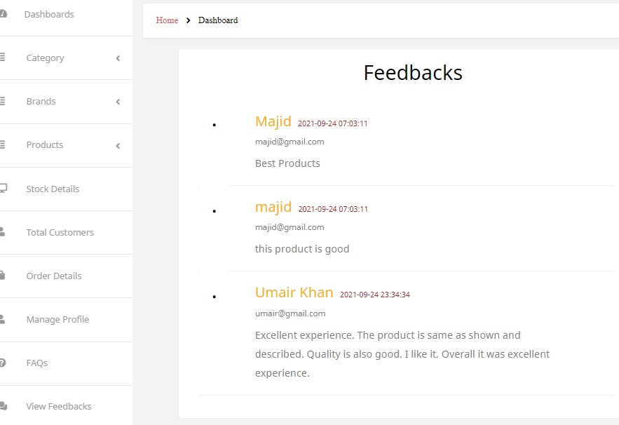 view feedback

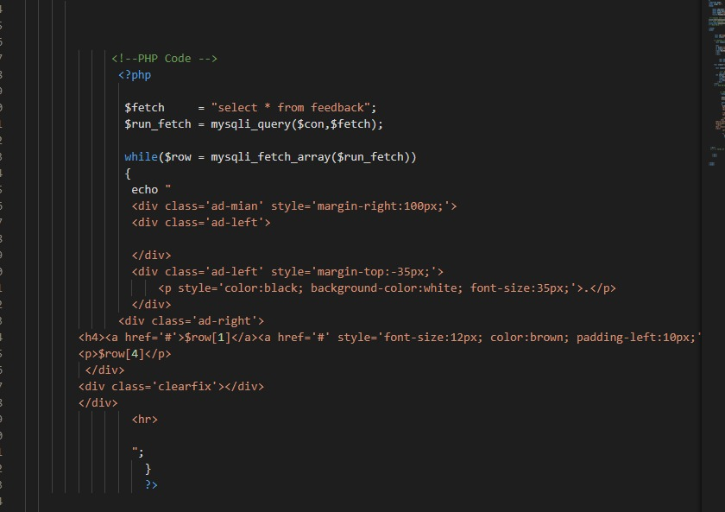 view feedback code

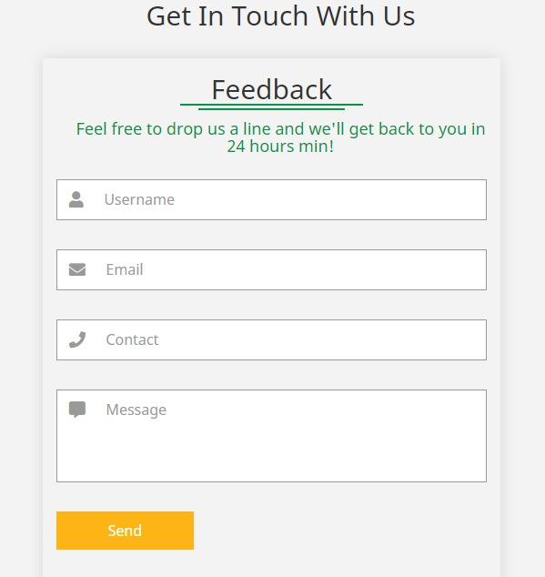 feedback

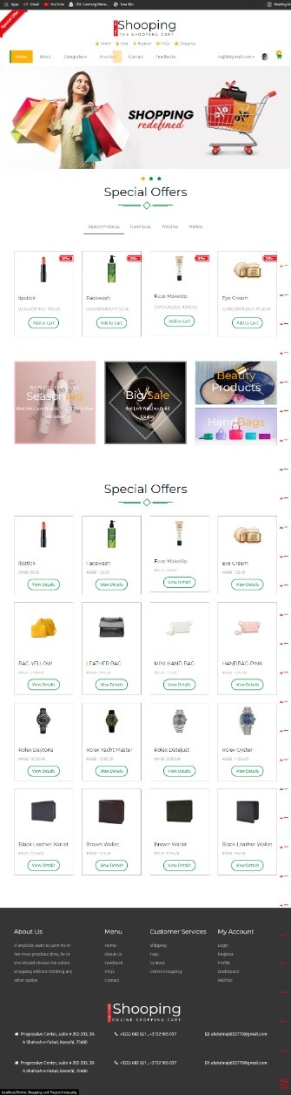 Home

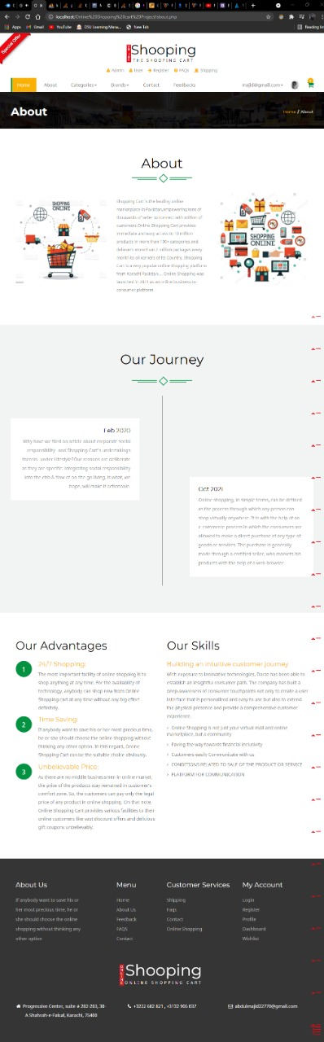 About Us

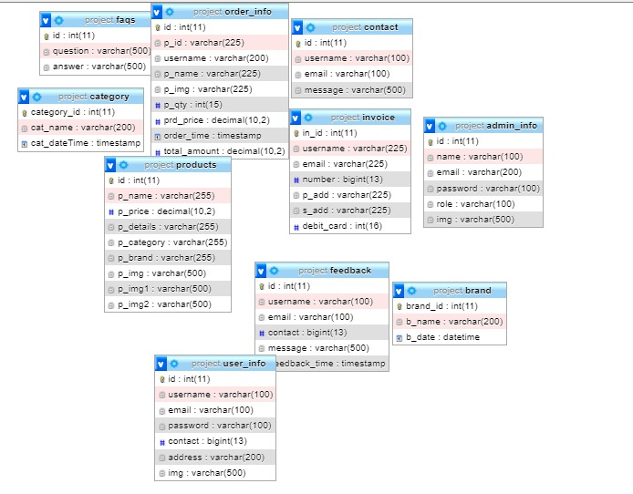 er.Diagram

Thank You

FiN