**Object Oriented Analysis And Design**

**Project Deliverable 1**

**Project Name:**

REXIX

**Group Number:** 6

**Group Members:**

Shahab-u-din BSEF19A001

Majid Fareed BSEF19A021

Suleman Awais BSEF19A041

**Vision**

REXIX is a platform(app/website) which allows the users to provide their feedback of any product they have used. The product could be anything until unless it has a registered brand name. The core purpose of this platform is to help people anticipate what to expect from a specific product/brand and to act like a bridge between consumers and brand owners as the communication between two parties is made easier through this platform.

**Positioning:**

This application will be user and brand centered. Our major focus is to provide end users, a very thrilling experience.

**Stakeholders:**

**Internal Stakeholders-** Project Manager, Project Team, Company, Funder

**External Stakeholders-** Customers(Users and Brands), Government, Supplier

**User level Goals:**

* The user needs to have an account and login with that account.
* The user should be presented with different brands related to his interest.
* There should be a search icon where user can search different brands.
* Different categories of the selected brand should be displayed.
* There should be a search icon where user can search a specific product of the respective category.
* Then the user should be allowed to give his feedback on that product.
* As we are targeting mass market, it should be multi-lingual.

**System level goals:**

* UI must be simple.
* It should be easy to interact with.
* User’s personal info must be kept private.
* Software should be secure i.e., unbreachable.
* It should be fast and efficient.

**Supplementary Specifications**

* Application should have all the required documents i.e., licenses.
* It should have complete reports.
* It should be well packaged.

**Major Requirements**

* Users should be able to sign up/log in to the application.
* Users should be able to post a review in application.
* Users should be given ranks based on their activity in application.
* Users can like or dislike a post based on their personal experience.
* Posts should be filtered i.e.; only relative and appropriate content should be posted in application.
* Reviews/Posts should be accurate (which can be checked by likes and dislikes of other users)
* Users who violate terms should be given a warning.
* After warning, if they again violate terms, they should be banned (temporarily or permanently)
* Users should be able to look for any brand (registered only) locally or internationally.
* Brands should be able to register in application.
* Brands should also be able to post about a product and ask for reviews.
* Brands should be given a score based on reviews.
* There should be a standard score/Ideal score.

**FURPS+**

**Functionality:**

* Users should be able to link other accounts such as Gmail, Facebook etc.
* Application should be robust as it is targeting a mass.
* Application should have options for interface i.e., Dark Mode, Light Mode or for Color Blind People.
* Application should be able to store a large amount data.
* Application should be very secure i.e.; data should not leak.

**Usability:**

* Users should be able to understand how to interact with the application.
* Application should be usable by masses.
* Application should have a user manual.
* Application’s terms and conditions must well documented.

**Reliability:**

* Application should not crash at any point.
* If somehow it crashes, it should be able to recover all the data.

**Performance:**

* Application should be fast and efficient i.e., its response time.
* Application should be very accurate in terms of suggestions.
* Application servers should not stay down for too long in case of any maintenance or updates.
* Application should be available to use 24/7.

**Supportability:**

* Application should run on all platforms i.e., ios, android etc.
* Application should be configured according to needs.

**Plus +:**

* Application should be easily implemented.
* It should not overuse resources.
* It should perform all possible operations.
* It should be well packaged.
* It should have all licenses and documents.

**Features List**

* Application should suggest specific content for specific type of users.
* Application should rank celebrity profiles higher than normal people.
* Application should allow brands to introduce their new products for beta testing.
* Application should have a suggestion box for brands in which users can give specific suggestions and other users can like or dislike that suggestion hence making it easier for brands to meet the requirements of masses.
* Application should allow brands to report a fake review.

**Domain Rules**

Application will have following Domain Rules:

* Fix amount of tax will be deducted from whatever the application may earn.
* Users are not allowed to post anything that is not related to vision.
* Only those users can post a review who are above 16 years of age.
* One user can use only one account at a time.
* Brands cannot ban users; they can only report fake reviews.
* Only those brands will be able to post who register them in application.
* Those users who do not follow any of the above rules, would be banned from the application.

**Risk List**

Application has followings risks:

* User’s account information must not be leaked.
* Payments must not be exposed.
* Cyber Attacks such as bots.

**Feasibility Analysis**

It involves following aspects:

**Technical**:

* This application can be developed because the tools and hardware required for this application is available.
* There should not be any difficulty in developing this software as brands and companies already have a review mechanism, we are just evolving it.

**Operational**:

* This application will mold the market including brands and consumers.
* This application is worth developing because it narrows down the far-fetched process of reviews.

**Economic**:

* The cost for developing this application will be affordable.

**Schedule**:

* This application can be developed and implemented in given time.

**Actors:**

* User
* Brands
* Manager

**Goals:**

* User Logs into the application via Email.
* User searches or scrolls through feed.
* User posts a review.
* User likes or dislikes other reviews.
* Brands Logs into the application and register themselves.
* Brand reports or react to a review.
* Brands advertise themselves.
* Manager looks for maintenance of application.
* Manager takes care of server issues.
* Manager confirms all payments.

**Use Cases**

**1- Reviewer Login**

**Main Scenario:**The user/Reviewer should have an account of the website/app. The user could sign up with an email or by linking his GOOGLE or Facebook account as well. Once he register his account, he can have complete access the website/app. Despite of a registered account, we will also introduce a Guest mode for the user with limited access to the application.

**Alternative Scenarios:**

* If the user enters incorrect email or password, a message will be displayed to the user that the email or password doesn't match with the registered one so he should enter it again.
* If the user doesn’t remember the password, then the website/app will display an option to change the password by sending a confirmation code to his registered email.

**2-Brand Categories**

**Main Scenario:**

There should be a category list of the brand that would be showing all the registered brands. If a brand ends up their contract with us, that specific brand will be removed from our website, but all of their previous ratings and reviews would be saved or removed as per contract.

**Alternative Scenario:**

There would be a search box at the top of the web page where user can search a specific brand. If the user doesn't find the brand he was looking for, then he can simply write the name of that brand in the search bar and then press the search button to see the details of that brand.

**3-Brand Selection:  
Main Scenario:**

After selecting a brand category of a specific type, all the brands of that categories would be list down with a sequence of that brands overall performance and rating. If a brand is having bad reviews, they would be warned a couple of times to either to remove that product or to alter that according to the reviews. But continuous chain of bad reviews would yield as an end of contract eventually.

**Alternative Scenario:**

If user enters a brand name whose contract with web has been canceled or expired then a pop-up will be shown with a message on it about the termination of contract.

**4- Product Selection**

When the user will select a brand, all the registered products of that brand will be shown to him in the form of a list where product name and his rating will be shown along with an image of that product. The user can either select a product from the list of products or he can simply type the full name of that product in the search bar.

**5- Product Review**

After selecting a specific product, a product reviewing interface will be shown to the user where all the details of that product will be displayed along with the previous rating of that product. The user will add his particular review and then he will post it, before posting a pop-up message will be displayed for the confirmation of the review.

**6- Product Rating**

If the user don't want to post his review then he will have a review rating option where he can agree or disagree with the previous reviews of that specific product. There would be at least 4 rating options like (Slightly agree, strongly agree, strongly disagree and slightly disagree).

**7- Guest Login**

Every registered reviewer could have a complete user level access to the web. But if a person wants to survey the website/app and he don’t wants to register his account then a guest mode will be there with a limited access of the web. The limited access will be just to find out brands and their products but it should be make sure that he could not post or rate a review without any registered account.

**8- Regular Backups**

To prevent loss of data there would be full backup of the web and the same goes for the data of the reviewer as well. All the user data which includes their login email and password, their recent activities on the web like any kind of review submission or review rating. Such kind of information would be saved by backing up data. These backups should be on regular basis to reduce the amount of risk to loss the progress of a brand's rating.

**9- Fake Reviews**

As the main theme of our website is to provide ratings and reviews of several products. Her comes a question that what would happen if a person gives a fake review?

If someone post a fake review then that particular user will receive a warning to not spoil the beauty of fair reviews. Still if he does the same, then his id would be temporarily banned for a couple of years. And not just his id, but his IP address as well, so that he could not come with another account.

**10- Web Security**

One of the most important issues regarding the web should be of the cyber security. While developing this should be make sure that no unauthorized person can access sensitive data or gain administrative access rights to the web application itself or even to the server.

**11- User Friendly Interface**

Simple but a good User Interface is important because it can make the user interact the website or web application. The UI not only focuses on the aesthetics but also maximizes responsiveness, efficiency, and accessibility of a website.

**12- Advertisements**

Web should focus on the advertisement of brands. This should make sure that if a brand is not registered or doesn't have a contract with the web, still they can advertise their products on our platform but those brands who has registered their brand would be given special discounts to appreciate them for contracting us. This would also influence other brand to register them, in order to avail discounts.

**13- Brand Ratings**

Every brand would have an overall rating that would be depending upon the rating of their products. The brand rating would be of different levels and a fix rating would be declared below which the brand has to remove some of their products to maintain their ratio else they would be removed from the web. This would influence new or growing brands to work harder on their products to compete the leading ones of their category.

**14- Brand Login**

Every registered brand will have a login with all the accessibility so that the brand representative could interact with their users in order to fulfill the goal of the website. This could make a friendly environment between the consumers and the manufactures.

**15- Report a Review**

Every brand will be given all the rights to report a review if they can justify that the product that’s been reviews is more efficient then the reviews that’s been passed on their products.

**Packages Diagram**

**Activity Diagram:**

**Use Case Diagrams:**

**Business Level**

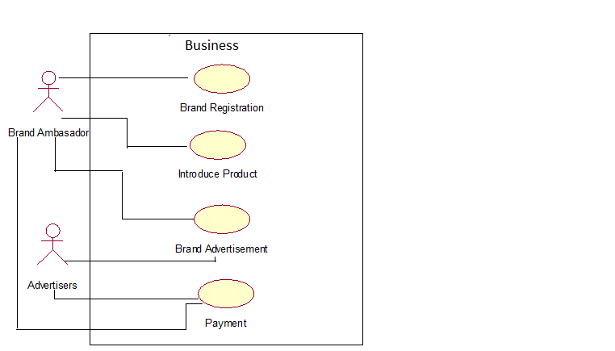

**Analysis Level**

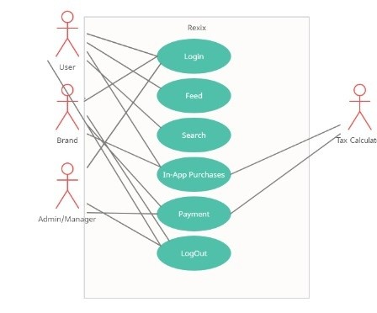

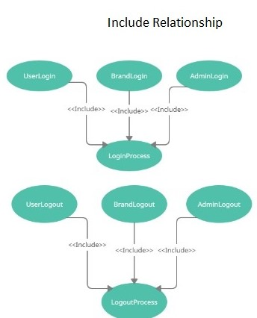

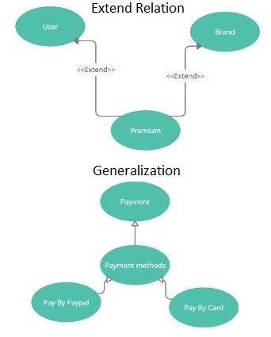

**State Chart Diagram:**

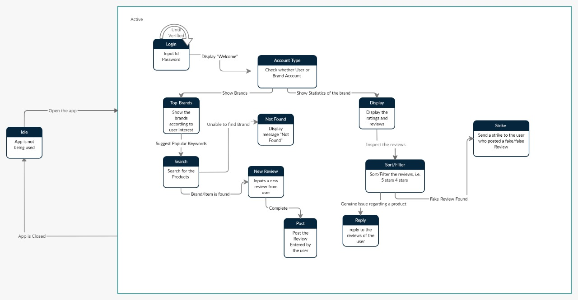

**(D2)**

**Design Class Diagram**

**System Sequence Diagrams**

**For Login**

**For Display**

**For Rating**

**For Category**

**For Report**

**For Selection**

**For Brands**

**For Manager**

**Sequence Diagram**

**Collaboration Diagram**

**Use Case Contracts**

**Contract 01: PostReview**

**Operation:** PostReview **Cross Reference:** Product Review

**Pre-Condition:** A review has to be given.

**Post-Condition:**

* An instance of Review rev was created.
* rev was associated with Product.

**Contract 02: likeOrDislike  
Operation:** likeOrDislike **Cross Reference:** Product Rating

**Pre-Condition:** A review is to be rated.

**Post-Condition:**

* rev.like will be incremented by 1 if the user likes the review.
* rev.dislike will be incremented by 1 if the user dislikes the review.
* pr.rating will be changed accordingly.

**Contract 03: postProduct  
Operation:** postProduct

**Pre-Condition:** A new product is to be introduced.

**Post-Condition:**

* An instance of product pr will be created.
* Brand will be associated with the product.
* pr.description will be updated as the description given by the brand.

**Contract 04: advertiseProduct  
Operation:** advertiseProduct

**Cross Reference:** Advertisements

**Pre-Condition:** A new product is to be advertised.

**Post-Condition:**

* An instance of Ads ad was created.
* Ads is associated with payment.
* ad.name was the name
* ad.description was the details of the ad.

**Contract 05: Pay  
Operation:** pay

**Cross Reference:** Advertisements

**Pre-Condition:** Payment of Ad is to be done.

**Post-Condition:**

* An instance of Payment py was created
* Py.paymentMode was the method used by the brand for this specific payment.
* Payment was associated with manager.
* Payment was verified by the manager.

**Contract 06: getPremium  
Operation:** getPremium

**Pre-Condition:** Payment of premium membership is to be done.

**Post-Condition:**

* An instance of Payment py was created
* Py.paymentMode was the method used by the user for this specific payment.
* Payment was associated with manager.
* Payment was verified by the manager.
* UserStatus is changed from normal to premium

**System Prototypes**

**For Log-in Selection**

**For Log-In**

**For Feed**

**For Specific Product**

**For Top Products**

**System Architecture**

**Glossary:**

UI- User Interface

IOS- iPhone Operating System

ID- Identification