Diaphragm Pump Design & Simulation Workflow
Engineering Design Steps, Inputs & Simulation Pipeline

1. REQUIREMENTS & PERFORMANCE (Initial Sizing)
Key Inputs:
• Required Flow Rate $Q$
• Maximum Operating Pressure $P_{max}$
• Vacuum / Suction Conditions $P_{vac/suc}$

Analytical Calculations:
• Displacement Volume: $V_{d}=\frac{Q}{N⋅η_{v}}$
• Stroke & Eccentric Radius: $S=2r , V_{d}=A_{eff}⋅S$
• Motor Power: $P_{motor}=\frac{Q⋅ΔP}{η_{total}}$
• Shaft Diameter: $d≥{\left(\frac{16T}{πτ_{allow}}\right)}^{1/3}$
• Valve Port Area: $A_{v}=\frac{Q}{v_{max}}$
⇓
Table 1.1 Gas Medium - Pump Function Focus
Function | Key Design Parameter | Key Design Equation | Main Focus
Compression | Pressure discharge maximization | $$P_{motor}=\frac{γ}{γ-1}\frac{P_{in}⋅Q}{η}\left[{\left(\frac{P_{out}}{P_{in}}\right)}^{\frac{γ-1}{γ}}-1\right]$$ | Diaphragm stress under high pressure & thermodynamic gas compression
Vacuum Generation | Minimum Dead Volume ($V_{dead}$) | $$P_{vac}≈\frac{V_{dead}}{V_{d}+V_{dead}}⋅P_{atm}$$ | Check valve opening & sealing under extremely low delta-P
Transfer | Maximum Flow Rate (Q) with minimum pressure drop | $$Q=V_{d}⋅N⋅η_{v}$$ | Internal flow optimization & port pressure drop reduction
Aspiration | Suction Pressure & Impact Resistance | $$A_{v}=\frac{Q}{v_{max}} ,$$  $$ΔP=ξ⋅\frac{ρv^{2}}{2}$$ | Diaphragm structural integrity against pulse loading & vacuum deflection
Table 1.2 Liquid Medium - Pump Function Focus
Function | Key Design Parameter | Key Design Equation | Main Focus
Transfer | Continuous Flow Rate (Q) & Incompressibility | $$P_{hydraulic}=Q⋅ΔP , P_{motor}=\frac{Q⋅ΔP}{η_{mech}⋅η_{vol}}$$ | Laminar/turbulent flow in valve passages & continuous hydraulic load
Aspiration | NPSHR & Cavitation Prevention | $$NPSHA=\frac{P_{atm}-P_{vapor}}{ρg}-h_{s}-h_{f}>NPSHR$$ | Cavitation detection during suction stroke & dynamic response of inlet valve
Dosing | Stroke Volume Repeatability & Response Time | $$V_{dose}=V_{d}=A_{eff}⋅S , \text{Error}=\frac{\left|V_{real}-V_{target}\right|}{V_{target}}≤1\%$$ | Transient stroke displacement accuracy & valve sealing delay during dosing pulse
Metering | Flow Linearity & High Precision Control | $$Q\left(N\right)=A_{eff}⋅S⋅N⋅η_{v}\left(P_{back}\right)$$ | Volumetric efficiency vs. backpressure & high-precision velocity profiles in CFD

⇓

2. MATERIAL SELECTION & TRANSIENT STRUCTURAL
Inputs:
• Material Properties (EPDM, NBR, PTFE - Hyperelastic models)
• Boundary Conditions (Fixed outer rim, center deflection/force)

• Hyperelastic Strain Energy Potential: $W=W\left(I_{1},I_{2},I_{3}\right)$
• Stress-Strain Relations: $S_{ij}=\frac{∂W}{∂E_{ij}}$
• Fatigue Life Prediction: $N_{f}=C⋅{\left(Δσ\right)}^{-β}$

Outputs / Evaluation:
• Diaphragm Deflection Profile
• Stress & Strain Distribution & Fatigue Life Analysis
⇓

3. FLUID DYNAMICS (CFD)
Inputs:
• Fluid Properties (Density $ρ$, Viscosity $μ$)
• Diaphragm Deflection Profile from FSI: Dynamic / Moving Mesh – UDF in ANSYS FLUENT

Formulas & Governing Equations:
• Navier-Stokes Equations: $ρ\left(\frac{∂\vec{v}}{∂t}+\vec{v}⋅∇\vec{v}\right)=-∇P+μ∇^{2}\vec{v}+\vec{f}$
• Continuity Equation: $∇⋅\vec{v}=0$
• Valve Pressure Drop: $ΔP_{valve}=ξ⋅\frac{ρv^{2}}{2}$

Outputs / Evaluation:
• Valve Pressure Drop & Flow Velocity Profiles
• Volumetric Efficiency Verification
⇓
4. SYSTEM-LEVEL SIMULATION
Input:
• Calculated motion profile for Signal Generator in Simulink

Block Components:

• Electric Motor Equations: $T_{m}=K_{t}⋅I , V=IR+L\frac{dI}{dt}+K_{e}ω$
• Kinematic Linkage / Crank-Slider: $x\left(t\right)=r\cos\left(ωt\right)+\sqrt{l^{2}-r^{2}\sin^{2}\left(ωt\right)}$
• Check Valve Dynamics: $m{\ddot{x}}_{v}+c{\dot{x}}_{v}+kx_{v}=A_{v}ΔP\left(t\right)$
• Instantaneous Mass Flow Rate: $\dot{m}\left(t\right)=ρ⋅A\left(t\right)⋅\sqrt{\frac{2ΔP\left(t\right)}{ρ}}$

Final Outputs:
• Characterization Curves
• Overall System Performance Optimization

Diaphragm Pump Design & Simulation Platform
An interactive engineering platform for the conceptual design, preliminary sizing, simulation, and optimization of diaphragm pumps for gas and liquid handling across diverse laboratory applications.
Tools: MATLAB (GUI Development) | Simulink / Simscape (System-Level Simulation) | ANSYS (Component-Level Simulation)
Feature | Gas Pump Platform | Liquid Pump Platform
Medium | Gas | Liquid
Functions | Aspiration, Compression, Transfer, Vacuum Generation | Aspiration, Dosing, Metering, Transfer
Design Inputs | Flow Rate, Outlet Pressure, Vacuum Level | Flow Rate, Pressure, Suction Height
Diaphragm | Diameter, Stroke, Material | Diameter, Stroke, Material
Valve | Valve Type, Valve Material | Valve Type, Valve Material
Sizing | Automatic / Manual | Automatic / Manual
Performance Analysis | Flow Rate, Pressure, Vacuum | Flow Rate, Pressure, Dosing Performance
Simulation | Motor-Driven & Diaphragm Motion | Motor-Driven & Diaphragm Motion
Optimization | Geometry & Operating Parameters | Geometry & Operating Parameters
Output | Preliminary Design & Performance Results | Preliminary Design & Performance Results

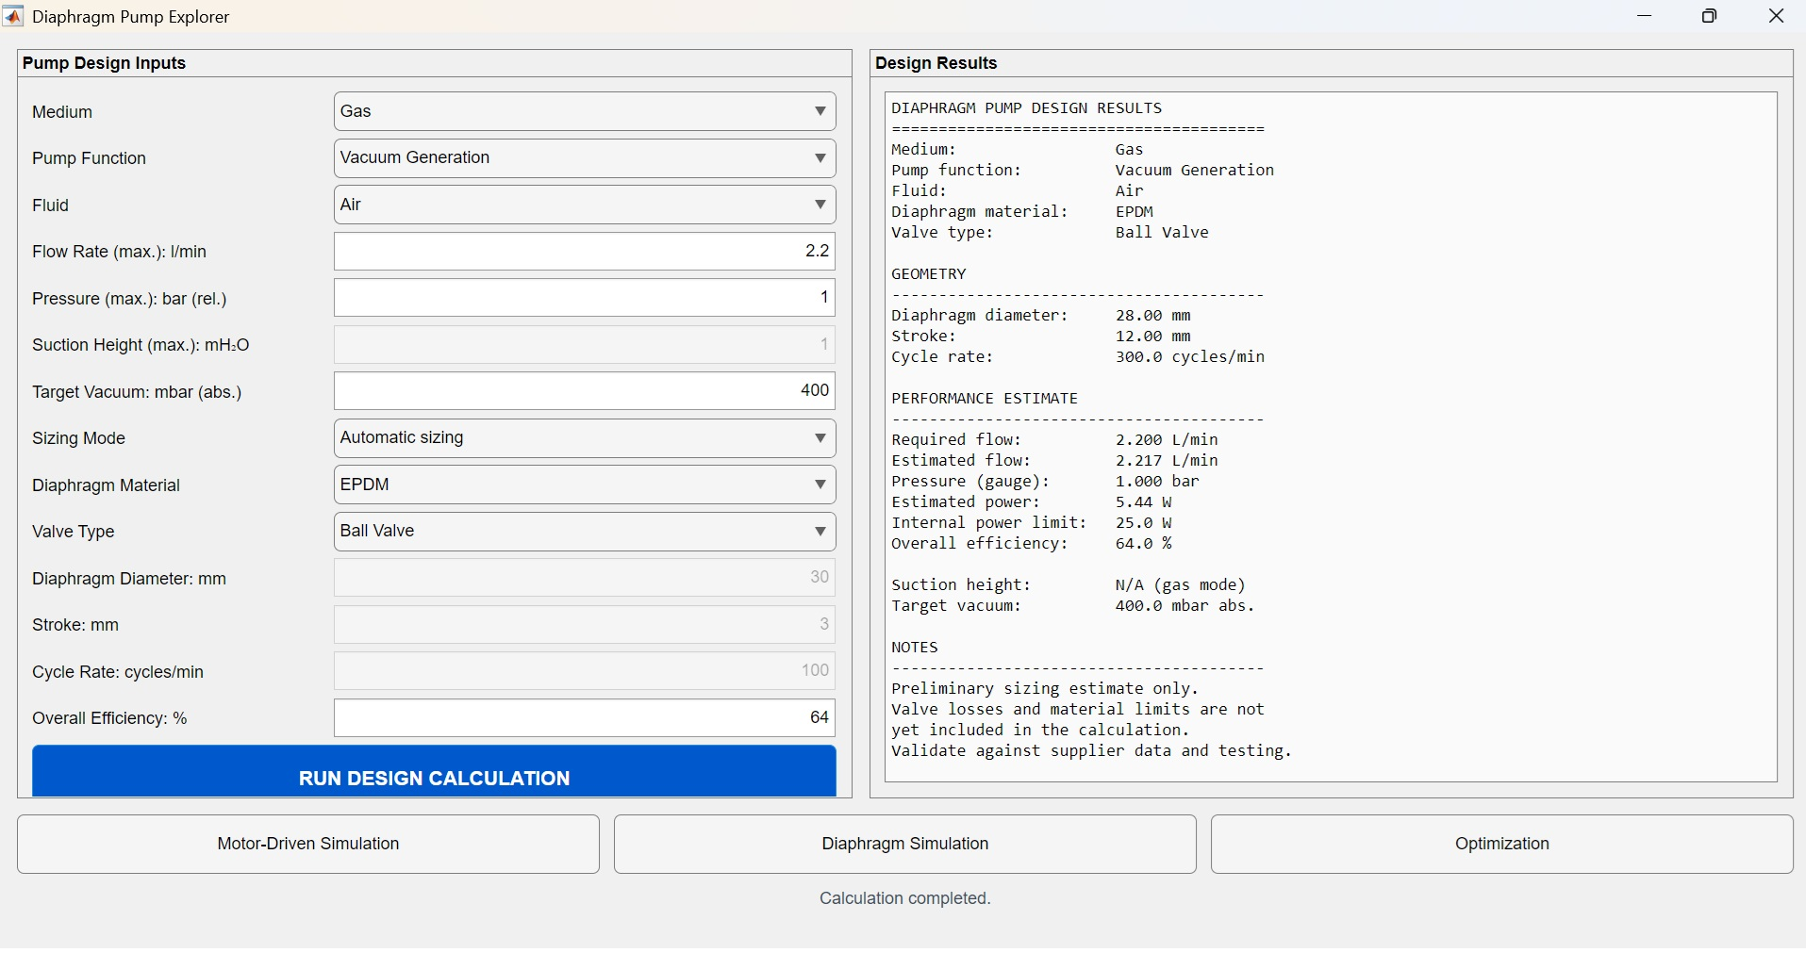
ANSYS Simulation – CFD Coupled with Structural

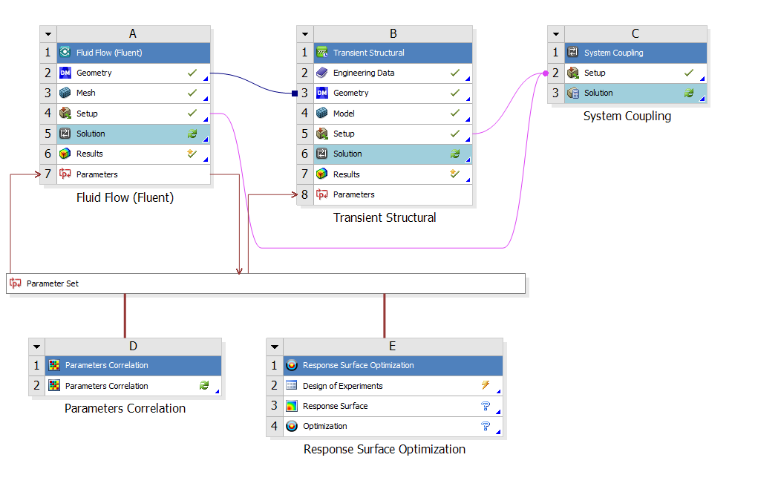
Displacement Profile – ANSYS Transient Structural
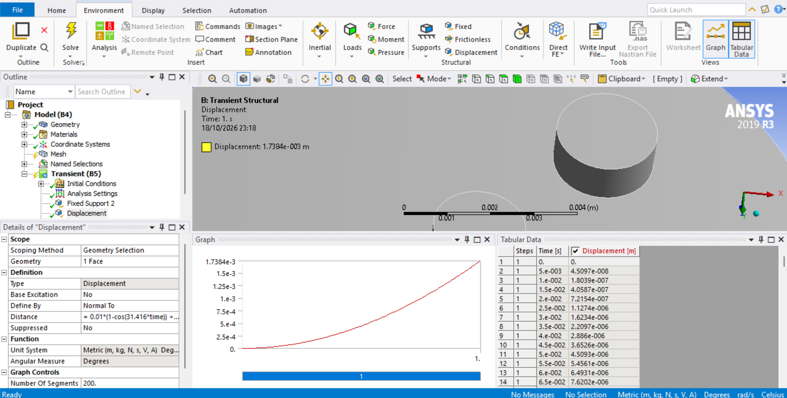

Parameters Definition – ANSYS Workbench
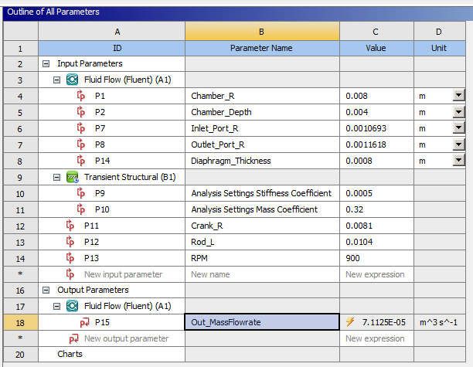

System Simulation without Motor – MATLAB Simulink
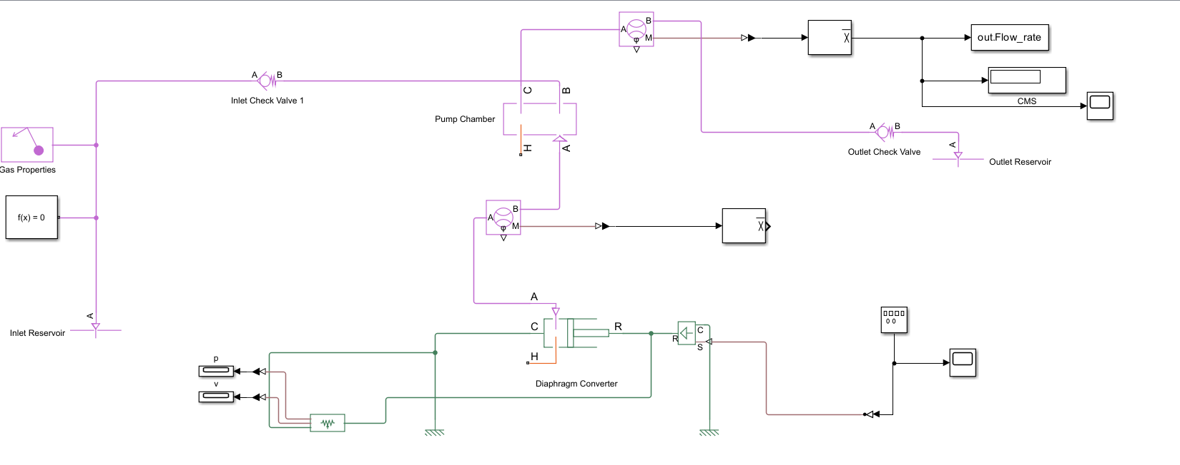

System Simulation with Motor RPM function – MATLAB Simulink
