ROTARY VANE VACUUM PUMP
Cooling System Development
Oil-Sealed Two-Stage Rotary Vane Vacuum System

DOCUMENT PURPOSE: Technical record of the engineering work, architecture, investigations, and open technical items.
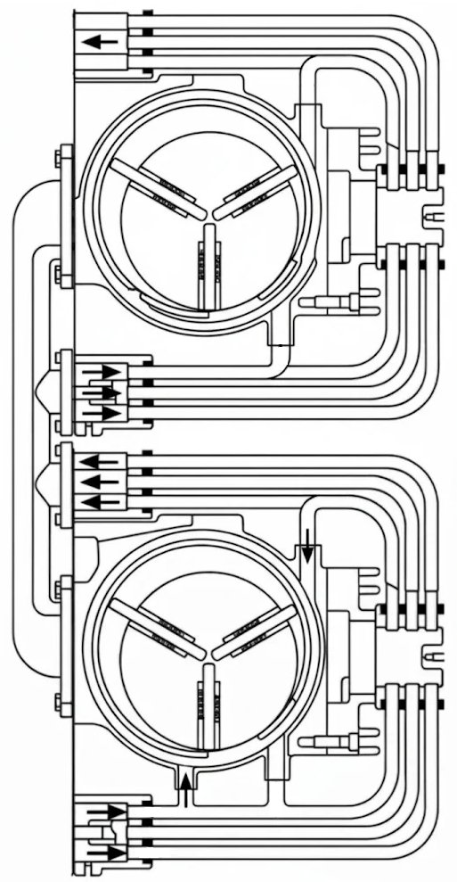
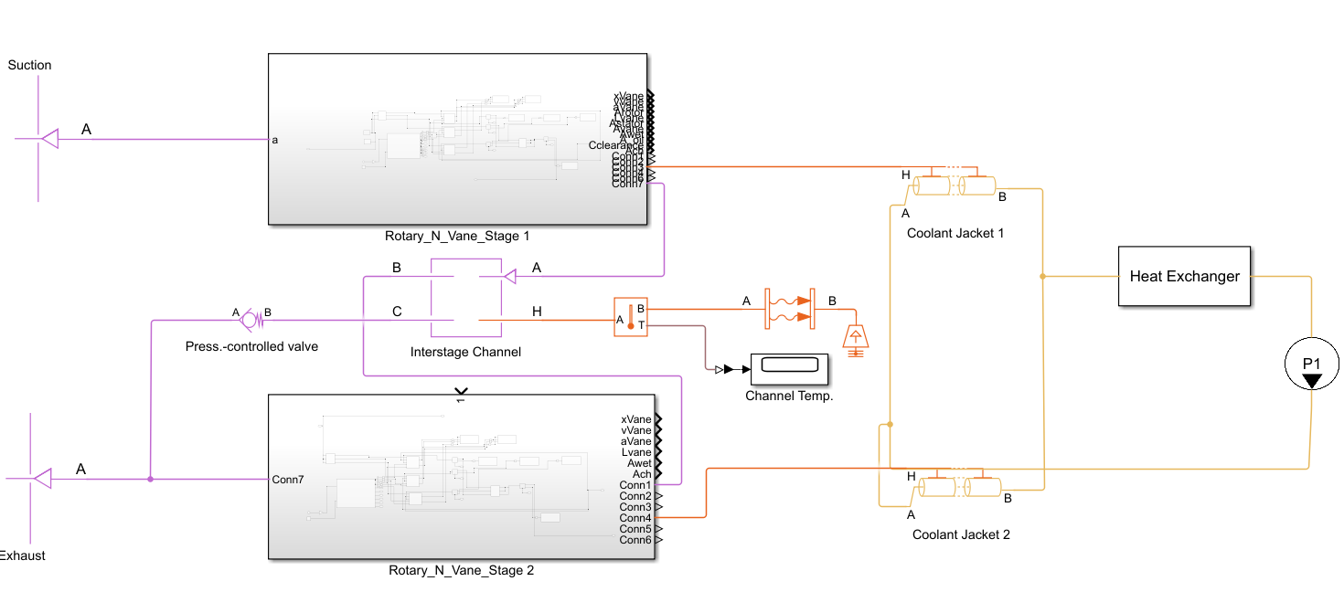
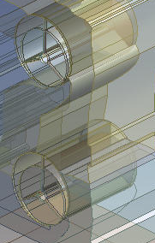

Executive Summary

This section summarizes the comprehensive thermal-fluid simulation, geometry & system optimization, and parameter modeling for a two-stage rotary vane vacuum pump operating within an advanced industrial cooling loop. The primary design objective is to achieve active thermal management across both compression stages, reducing localized thermal distortion, and optimizing overall performance.
Table 1: System Features
Component | Details
Vacuum System | Two-Stage Rotary Vane Pump
Cooling System | Dual Integrated Water Jackets
Lubrication System | Fresh-Oil Lubrication Layout with Injection Network

The recent development work focused on two connected engineering tracks for an oil-sealed, two-stage rotary vane vacuum pump: (1) establishing a physically meaningful dynamic model of the rotor–vane–chamber system, and (2) investigating the pump cooling architecture and the appropriate scope for a cooling-system design study.
The cooling-system investigation considered the distinction between oil lubrication/sealing and external heat rejection, including water jackets, through water cooling, closed-loop radiator-fan circuits. The actual architecture of the selected pump still requires confirmation from its manufacturer documentation or a verified part.

2. Two-Stage Vacuum System Representation

The portfolio scope identifies an oil-sealed two-stage rotary vane vacuum pump. A system-level model should therefore distinguish the low-vacuum (first) stage from the high-vacuum (second) stage and represent the inter-stage connection explicitly.
- Stage 1: suction-side chamber filling, compression, and transfer toward the inter-stage region.
- Inter-stage region: connecting volume and any relevant pressure losses or cooling/condensation effects supported by the actual pump design.
- Stage 2: further compression and discharge to the exhaust side.
- The exact stage arrangement, ports, internal bypasses, oil injection locations, and inter-stage cooling provisions must be taken from the selected pump's drawings.

3. Cooling-System Architecture

The thermal-system discussion examined what actually removes heat from an oil-sealed rotary-vane vacuum pump and whether water cooling is necessarily present. The key distinction is between oil's internal roles and the external heat-rejection mechanism.

3.1 Key engineering solutions

3.1.1 Outer Water Jacket: The primary jacket environment contained sinusoidal cooling fins designed for thermal exchange with air.
Engineering Change Implemented: To create a double water jacket system, these fins (Figure 1) were entirely enclosed by an Outer Shell. This formed a secondary water jacket around the main housing, allowing the coolant to pass through two distinct layers (an inner jacket near the stator and a secondary peripheral jacket).
Figure 1: Cross-sectional view illustrating the air-cooling fins surrounding the rotary vane stator and the hydrodynamic oil-seal film at the vane-stator interface.
3.1.2 Flow Circuit Separation for Two-Stage Pumps (Independent Stage Cooling)
Current Condition: The piping and fluid transfer conduits are in a parallel, integrated layout.
Engineering Change Implemented: In a two-stage pump, the high-pressure stage generates significantly more heat than the first stage due to final gas compression. Therefore, the water circuit must be split into two independent loops:
  - Inner Circuit: Coolant flows directly through the critical, high-temperature stator region first.
  - Outer Circuit: Coolant is routed to manage the overall body and end-cover temperatures to prevent non-uniform thermal distortion.
3.1.3 Manifold Block and Piping Optimization
Engineering Change: The thin parallel pipes on the right side introduce high pressure drops and are susceptible to dead zones. This assembly must be replaced with an Integrated Distribution Manifold that injects supply and return water at uniform flow rates and pressure distributions to both top and bottom jackets.
    - Flow Baffles and Turbulators
Engineering Change: To prevent laminar fluid movement within the jacket and increase the convective heat transfer coefficient $(h)$, transverse baffles or engineered surface features must be installed in the space between the inner and outer jackets. This transitions the flow into controlled turbulence, significantly enhancing cooling efficiency.
3.1.5 Materials Engineering for the Double Water Jacket Assembly
- Stator Shell (Stator Core / Inner Wall): Alloyed gray cast iron with spheroidal or flake graphite (EN-GJL-250 / GG-25) for dimensional stability and resistance to thermal deformation.
- Outer Jacket Sleeve: Cast aluminium (AlSi9Cu3) or stainless steel (AISI 304) to reduce weight and provide corrosion resistance against the cooling medium (water or water-glycol).

4. Verification and Validation

Table 2: Validation and verification package
Work package | Verification method | Acceptance evidence | Current status
Compressor Geometry | CFD & 1-D system simulations | Performance curves agree with reference. | numerical approach discussed; verification accepted.
Two-stage system | Check stage pressures, temperatures, inter-stage flow rates | Physically consistent pressure progression and stable initialization. | System validation done.
Cooling circuit | Thermal balance, component sizing, pressure-drop calculation, and temperature measurement. | Required heat duty removed with acceptable temperatures and flow resistance. | System Optimized.  (11% Improvement)  / Validation test pending

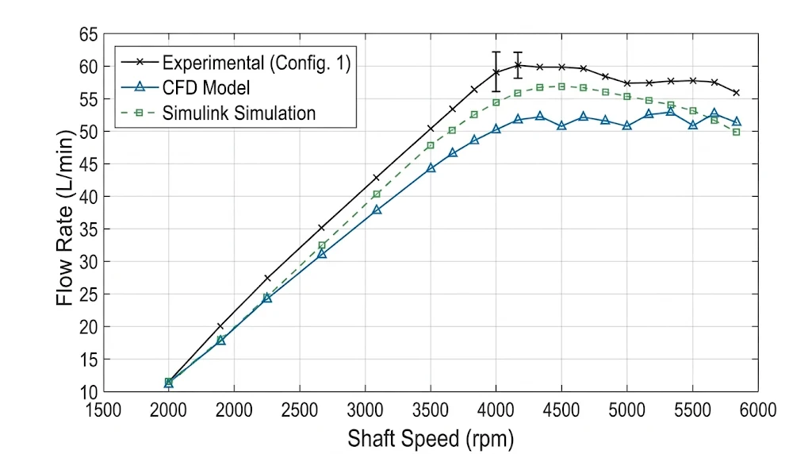
Figure 2: Experimental and numerical comparison of pump performance curves at 0.3 MPa

4.1 Methodology

The methodology was CFD analysis and DOE combined with system-level simulation (Simulink) to achieve high-fidelity results.
The MathWorks positive-displacement compressor block is primarily a ready-to-use performance model, rather than a direct replacement for a thermodynamic chamber model of a positive-displacement compressor. Unlike this MathWorks block which lacks a direct chamber thermal model, our developed model features an explicit energy conservation for direct thermal-fluid coupling. It tracks internal temperature and mass as dynamic state variables, enabling high-fidelity transient heat transfer analysis across casing walls and working fluid. This precise thermal visibility is vital for current vacuum system project to accurately simulate water-jacket cooling performance, thermal expansion, and operating limits. Besides, this model can simulate geometric oil coverage, oil-film shear, viscous friction and clearance geometry.
By integrating CFD results into this system-level framework, we achieved a powerful co-optimization strategy that significantly refines thermal-fluid design accuracy while drastically reducing project time and optimization cycles.
The Variable Volume Gas Chamber is equipped with input geometry functions designed to simulate various vacuum pumps, including rotary screw, rotary vane, scroll, and roots pumps.

Table 3: Comparison of Positive-Displacement Compressor (G) block and developed Variable Volume Gas Chamber (G) in Simulink
Feature | Variable Volume Gas Chamber Developed block | Positive-Displacement Compressor (G) Default block by MathWorks (Simulink)
Name | 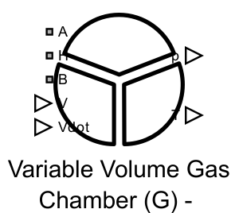  Inlet (A), Outlet (B), Heat Transfer (H), Pressure (P), Temperature (T) | 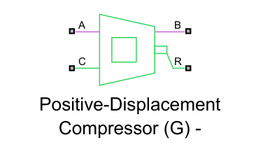  Inlet (A), Outlet (B), Mechanical input (R), Common (C)
Model Basis | Conservation of Mass and Energy | Compressor performance model
Mass Calculation | Dynamic | No mass accumulation
Internal Pressure | State variable | No direct chamber model
Internal Temperature | State variable | From thermodynamic model  (Polytropic & Isentropic)
Variable Volume | Direct input ($V$ and $\dot{V}$) | Parameterized displacement volume
Heat Transfer | H-port | No direct model
Lubrication & Sealing | Oil-film shear, viscous friction, and clearance geometry | No explicit oil-film or geometry-resolved leakage model / Simplified Lumped volumetric efficiency
Real Gas | Supported | Simplified performance model
Shaft Speed | Connectable via geometry | Mechanical input R
Multiple Independent Chambers | Yes, with different number of inlet and outlet ports | No, general compressor model

