Majid Tooranisama

7725070

Game Programming with Data Structures

Professor: Dr. Steve Hendrikse

December 10, 2018

Game Documentation

This game is designed in Visual Studio 2017 and Monogame programming. The purpose of game meets the requirements of the final project of Game programming course at Conestoga College. In this game, a Teddy bear is surrounded by two flying dragons in which, when Teddy touches them, he loses 600 score per second. Teddy has 10000 bonus score that helps him to start and achieve the treasures in the playground. Each treasure has 4000 score and after 20000 score, Teddy wins. If Teddy loses scores until zero score, he dies. The “R” key is for restarting the game and the “ESC” key is for returning to main menu. “LEFT” and “RIGHT” arrow keys also “A” and “D” keys are for moving the Teddy bear.

Design Class Diagram:

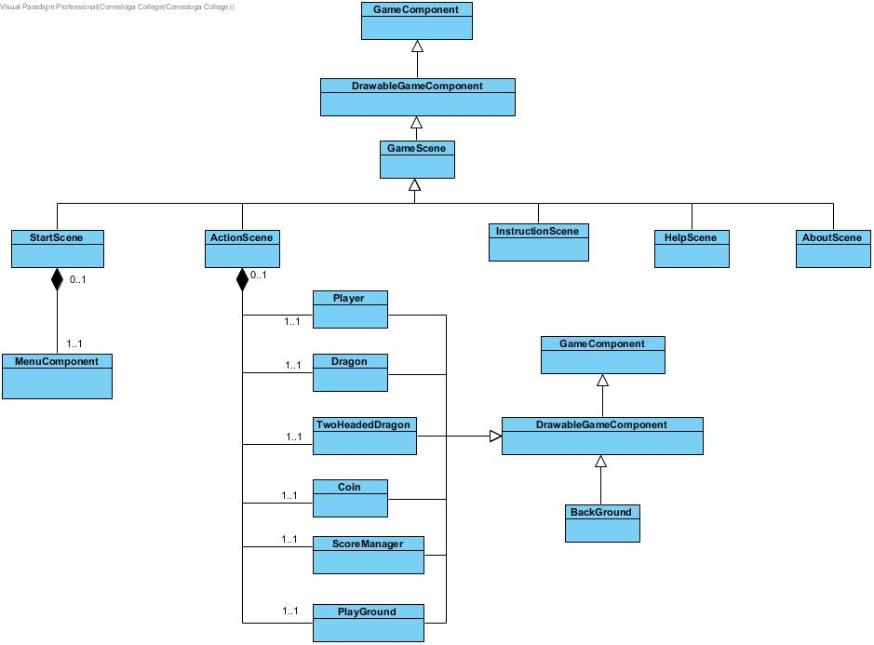

References:

<https://opengameart.org/>

AllInOneMono: (Main Menu Classes)

PROG2370CollisionLibrary: Collisions.cs

C3.XNA: Primitives2D.cs