

House Price Prediction
Ames Data set

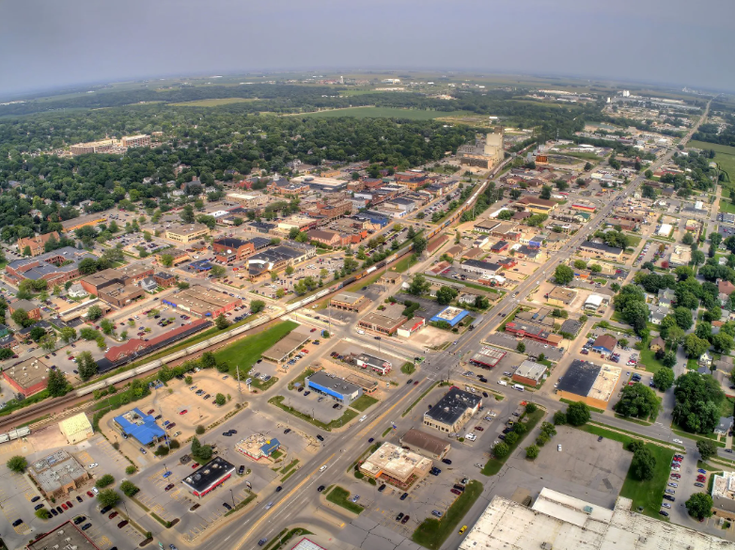

by
Mahmood Al Masqati
Majid Naseer Uppal

Table Of Contents
Problem Statement 4
Objective 4
Dataset 4
Project Workflow 5
EDA (Exploratory Data Analysis) 5
Housing Sale Price 5
Neighborhood 6
House Quality 7
Living area 7
Lot Area 8
MSZoning 9
Missing Data Handling 10
Feature Engineering 10
Feature Engineering - New Interaction Variable 11
Transformation Analysis 13
Dropping Features with Minimal Information 13
Sampling of the Data 14
Feature Selection Using stepAIC 14
Over fitting and Multi-collinearity Reduction 14
Living Area 15
Basement Area 15
Garage Area and Garage Cars 16
Quality Metrics 16
Outliers and Residuals Analysis 17
Final Multiple Regression Model 18
Ensemble Models 19
Bagging 20
Random Forest 20
XGBoosting 20
Ensemble Methods Variable Importance Table 21
Models Comparison 21
Model Comparison Table 21
Conclusion 21
Challenges 22
Future work 22
Appendix 23
Appendix 1 24
About Ames 24
Appendix 2 25
Data Description 25
Appendix 3 29
Project R – Code 29

Problem Statement
Buying a house is a crucial decision in one's life. Be it a dream house for you or perhaps an investment decision for gaining financial autonomy, every buyer ponders one question. “What is the right price?” In this project, we’ll try to answer that question

Objective
There are two goals of this project
- To predict the housing sale price.
- Compare performance among Multiple Linear Regression and Tree ensembles models.

Dataset
The Ames Housing dataset was compiled by Dean De Cock for use in data science education.
This project is taken from a Kaggle Competition. (https://www.kaggle.com/competitions/house-prices-advanced-regression-techniques/overview)
The dataset consists of 79 variables describing various aspects of residential houses in Ames, IOWA. This includes data about sales price, building class, zoning, neighborhood, house access, house quality, house condition-built year, remodeled year and fence quality etc. just to name a few. For more details, please refer to appendix 2.

Project Workflow
1. Exploratory Data Analysis (EDA)
- Dataset metrics understanding
- Deeper understanding and meaningful insights
- Visualizations
2. Missing Data Handling
- Handling permissible missing values as per data dictionary
- Removing missing data
3. Feature Engineering
- Re-categorization of the data
- Variable transformation
- Feature Creation
- Dropping Features

5. Feature Selection
- StepAIC Feature search
- Forward/Backward and Bidirectional Search
- Generalized feature creation

6. MLR Fine tuning
- VIF Analysis
- Variable Reduction
4. Train-Test Split
- Naive Bayes
- Model Building and performance evaluation

8. Model Comparison & Conclusion
- Model Comparison
- Conclusion
- Possible Future work
7. Tree Ensembles
- Bagging
- Random Forest
- XGBoosting

EDA (Exploratory Data Analysis)

Housing Sale Price
We started exploratory data analysis by focusing on the response variable “SalePrice”. The histogram of House “SalePrice” shows that the data is right skewed. This shows that while most of the houses are sold in a range, there is demand of high-priced homes in the market. The market economy limits the demand of the high-priced homes to limited number of wealthy buyers. For modelling we’ll like the data to be normally distributed so that the skewed values don’t impact our multiple linear regression model. After applying log transformation, we can see that histogram is close to a normal distribution which is what we will use for our Model.
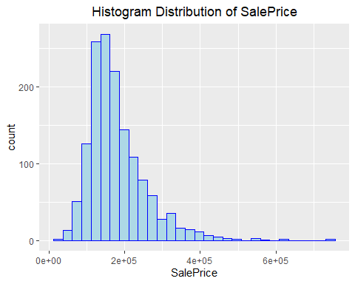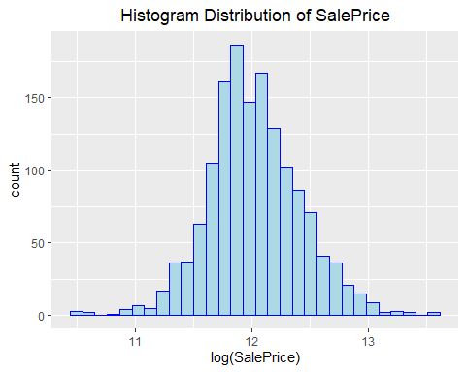

Neighborhood
Neighborhood is one of the important predictive variables in the Dataset. Next step in EDA was to analyze the relationship b/w “SalePrice” and different neighborhoods (“Neighbborhood”) in the dataset.
The boxplot distribution of Neighborhood Vs SalePrice shows a correlation b/w SalePrice and different Neighborhoods. Few Key Neighborhoods stands out where the Average SalePrice is higher than other neighborhoods like NridgHt, NoRidge and StoneBr. While at the same time few Neighborhoods show less Average Price like MeadowV, BrDale and IDOTRR.
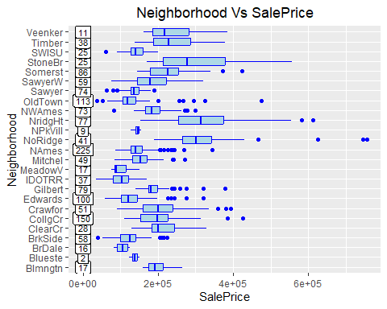
This phenomenon can also be seen from the bar plots below where we compared each neighborhood mean and median Sale Price. Since we have a smaller number of samples for some neighborhoods, we can re-categorized Neighborhood Variable into 3 Categories “High”, “Mid” and “Low” based upon the sale price.
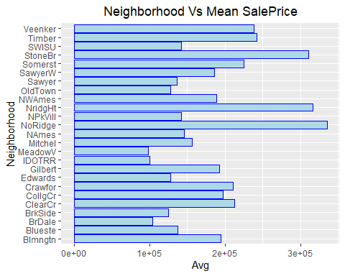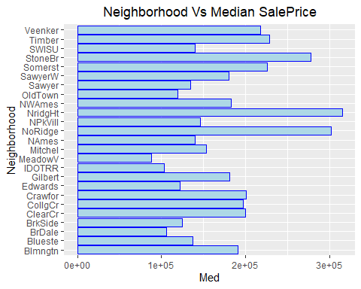

House Quality
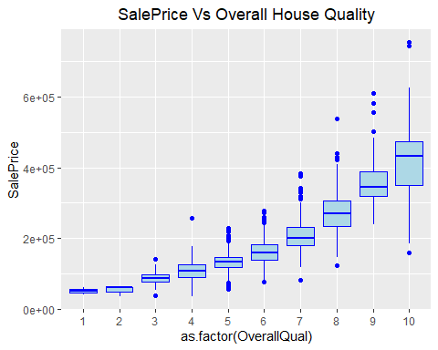
House Quality is one of the important factors that normally buyer will consider while deciding to buy a house. The boxplots below show this obvious behavior with a direct correlation b/w sale price (SalePrice) and overall quality (OverallQual).

Living area
Living area is another important factor that normally will dictate the House Sale Price. The scatter plot below shows that buyers are paying a higher price for bigger houses as expected. We can also see that there are two cases which are an outlier here. Upon further investigation, we found that both of the houses had deteriorated condition and located in low residential area. One of the houses was sold in middle of the famous housing crisis. Considering this we can consider to remove these outliers.
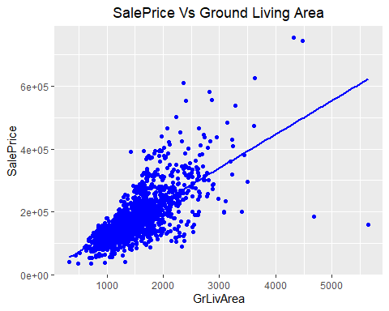

Lot Area
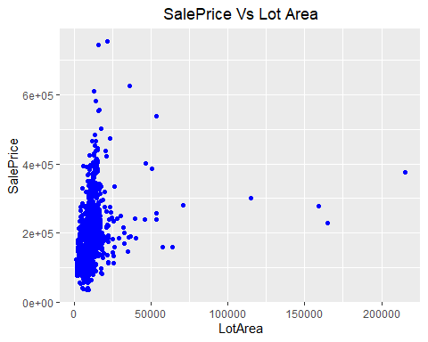
Lot Area is another important Variable that impacts the House Sale Price. On Average bigger lot size houses in a community will go with higher Sale Price. The scatter plot below does show correlation b/w Lot Price and House Price, but due to the wide variance in Lot Area it’s not very clear.
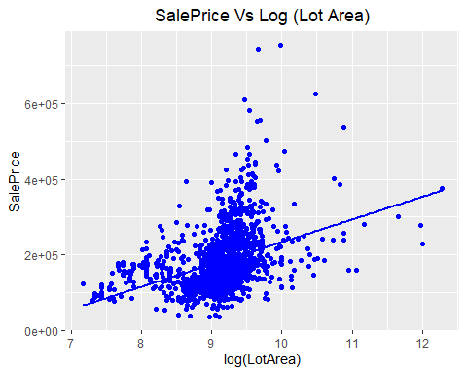

In order to normalize the relation between saleprice and lot area we decided to use Log Transformation on Lot Area. The above Scatter Plot depicts direct correlation b/w Sale Price and Lot Area. In the Plot we can still see some outliers where Lot Size even though is very high but Sale Price doesn’t correlate with the sale price. From real estate perspective such high lot size areas are normally not available in high demand neighborhoods and hence their prices might vary due to that factor as well.

MSZoning
Zoning describes the general zoning classification of the house, if it is in agriculture area, commercial, industrial, low density residential or residential. The boxplot below is showing that the zoning has a significant impact on the sale price. The scatter plot also shows that the sale price follows a different relation with the ground living area in each zoning classification. An interesting phenomenon is that the sale price increases significantly with increase in living area in low density residential area.
Since the number of samples are highly imbalanced as most of the houses falls under “RL” and “RM” Category, we decided to apply Feature Engineering on MSZoning Variable to recategorize the variable into a more generalized bucket of zoning classification.
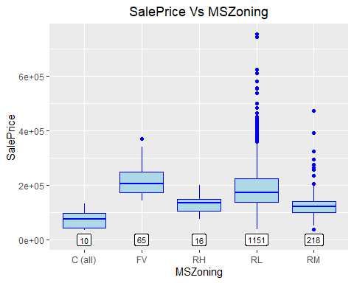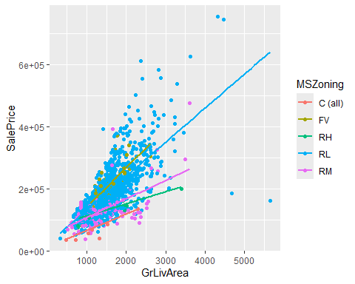

Missing Data Handling
In the original data set we have lot of Data with “N/A” values. After investigating further into each variable description, it was found that almost all the variables were valid values. The presence of N/A was showing absence of respective features. The data was cleaned by substituting the N/A fields with more meaningful values.
For Example, in case of GarageType we decided to replace N/A with “NoGarage” as per the description provided for the feature in data set description document. There were total of 18 such Features/Variables that can be find in R Code for Missing data handling.
After doing the cleanup, we were left with only 1 row with missing data values, which we decided to remove from the data set.

Feature Engineering
One of the Challenges we faced during EDA was some of the Categorical Variables have high imbalance across different Categories. This impacts the training of the models and results in overfitted models, where the difference in coefficient of determination (R-Square) for test and training models are much higher. To avoid this, we re-categorized these variables. Our methodology for recategorization was as follows.
- Features with less than 5% were considered for recategorization
- Recategorization was done by aligning the features with some commonalty on the house sale price
- Cases where not enough samples were available their individual categories were combined to a common bucket
An example of such case can be seen from the feature “LotShape”, which describes the shape of the property lot.
- Reg Regular
- IR1 Slightly irregular
- IR2 Moderately Irregular
- IR3 Irregular
The values here were highly imbalanced. The Bar Chart below shows that most of the Data Samples are in Regular(“Reg”) and slightly-irregular “IR1” Sub-Category while the others have few Data Sample Points.
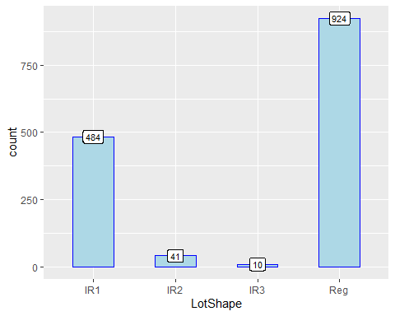
For example, in case of LotShape variable we have regrouped the categorical variable into 2 sub-categories, first one is Regular “Reg” and the 2nd one is Irregular(“IR”). “IR” is the combination of original sub-categories”IR1”, “IR2” and “IR3”.
Similarly, we recategorized roofing style based upon the material used and how value it adds to the house price. Another variable, discussed above was the neighborhood as well.

Feature Engineering - New Interaction Variable
Following 2 New Variables were created “Remodeled” and “Bath”.
Remodeled Variable explains if the property was remodeled and have 2 categorical replies “yes” and “no”. Since we couldn’t avoid the multicollinearity between “YearBuilt” and “YearRemodAdd”, we created a new variable “Remodeled”, which identifies if the house was remodeled or not. With this new variable (“Remodeled”) we will be using “YearRemodAdd” variable and will drop “YearBuilt” variable from our model.
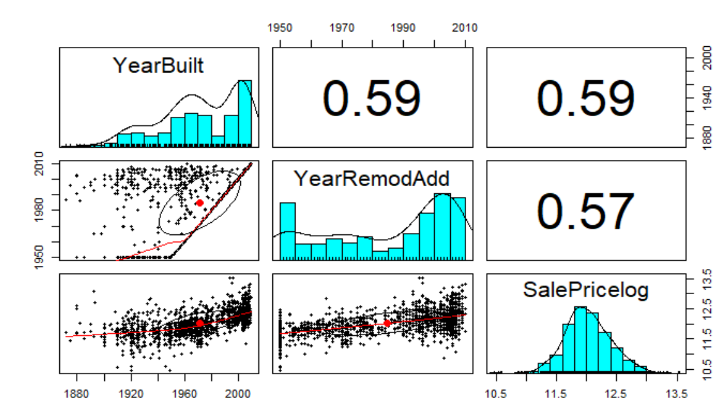

“Bath” Variable is a new interaction term in order to have cumulative impact of number of bathrooms in the house by combining different categorical variables representing different Type of Bathrooms into one Interaction Variable. And it’s given by following formula.
$$Bath=FullBath+0.5∗HalfBath+BsmtFullBath+0.5∗BsmtHalfBath$$
The Correlation Plot below shows that our Interaction term has higher correlation with Sale Price.
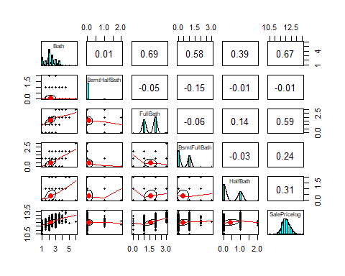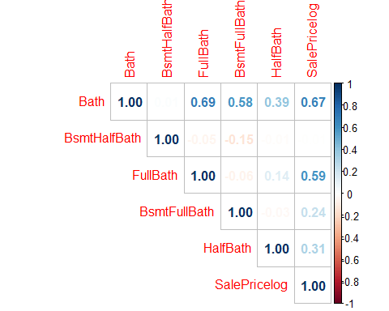

Transformation Analysis
All Numeric variables were analyzed to check if any kind of transformation is needed on those variables to meet the normality requirements. BoxCox Transformation was used to identify the type of transformation needed for each numeric variable. Only 2 Numeric Variable were Identified where BoxCox Transformation was needed namely “LotArea” and “GrLivArea”. Since the lambda values were close to zero, we decided to apply log transformation to both variables. Response Variable “SalePrice” was also Log transformed due to skewedness of data distribution.
Below variables were not transformed because of 0 values X1stFlrSF, X2ndFlrSF, LowQualFinSF, LotFrontage.

Dropping Features with Minimal Information
While reviewing the predictive variables, one of the observations was there were some Variables where data is overwhelmingly Imbalance in favor of one of the Sub-Categories. Due to which these variables don’t provide sufficient information and can’t add any value to the model. We have decided to remove any categorical variables where 1 of the Sub-Category has more than 95% of Samples while other sub-categories combine together has less than 5% contribution. One such example can be seen below for Street variable.
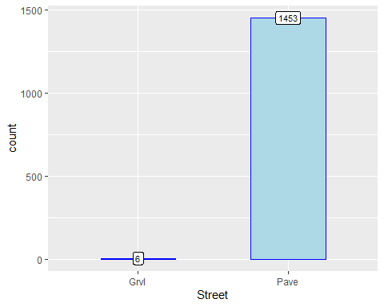
Categorical variables that fall under this list are: Street, Utilities, PoolQC, RoofMatl, Heating, MiscFeature.
Some other features were associated to each other. An example is Heating and HeatingQC. Since Heating was removed it was decided that HeatingQC will be dropped as well as it doesn’t make sense to keep HeatingQC as a feature. PoolArea and PoolQC has similar relation since Number of Houses with Pools were very limited, we can drop both the variables together.

Sampling of the Data
We have used 80-20 split of the dataset, where 80% samples will be used to train the model and 20% test data will be used to evaluate the model to check for any overfitting.

Feature Selection Using stepAIC
For feature selection we used stepAIC function in R. Here we utilized all three modes namely forward, backward and both (bidirectional). The backward and bi-directional iteration produced same models; however, the forward iteration had a different result.
Step AIC Type | Final No. Variables | R-Square | Test-R-Square
Forward AIC | 71 | 93.13 | 81.57
Backward/Both AIC | 41 | 92.7 | 82.29
We can clearly observe the following.
- All models are overfitting, as we can see from the differences in R-square between training and test data
- Backward/both are producing slightly better results with only 41 variables compared to 71 variables in forward AIC
- Forward AIC failed to reduce the number of variables (from a total of 80).
We took the model from backward/both directional AIC and started working on it. Analyzing the output, there were two major concerns here.
- The difference between the R-Square for the training and test have a difference of ~10% suggesting that the model is overfitted.
- The VIF shows lot of variables having high VIF (>10), showing a multicollinearity issue in the independent variables.

Over fitting and Multi-collinearity Reduction
To address the overfitting and high VIF, two actions were taken.
- For the over fitting problem, we opted to make the model more generalized by using more generalized independent variables. This will help us in variable reduction and keeping the model simple. Beside that the generalized model will reduce the over fitting problem as well. Further details on this will follow.
- We analyzed the correlation among the dependent and independent variables and tried to remove multi-collinearity cases as much as possible.

Living Area
As we can see below, from the pair plot that Ground living area (GrLivArea) has higher correlation with the SalePricelog, at the same time GrLivArea has high multicollinearity with 1st floor area (X1stFlrSF), as well as second floor area (X2stFlrSF). To address this and keeping a simple and generalized model, we’ll use Ground Area (GrLivArea) in our model.
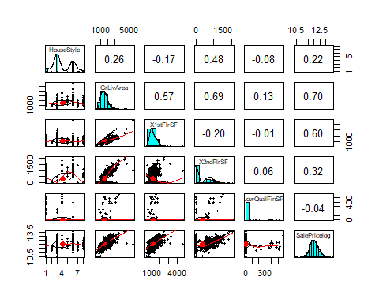

Basement Area
Similar issue of multicollinearity can also be seen for Total Basement area (TotalBsmtSF) with ‘BsmtFinSF1’ and ‘BsmtFinSF2’. For a more generalized model we shall use Total Basement area and in order to avoid multicollinearity we shall drop other three variables. Since we are only considering the total basement area, we can remove quality metrics for ‘BsmtFinSF1’ and ‘BsmtFinSF2’.
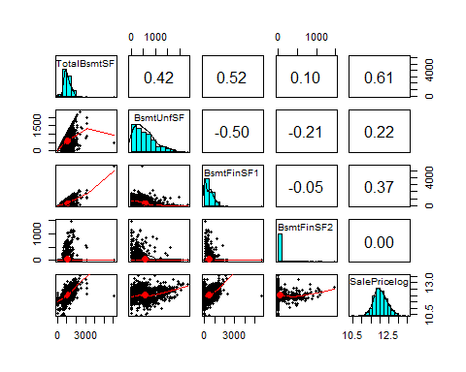

Garage Area and Garage Cars
We can also see below that the garage cars count and garage area are highly correlated with each other. This implies that using one of them will make the model better. In our case, we decided to use the GarageCars variable because of two reasons.
- The correlation between saleprice and garage car count is higher than garage square feet area.
- For understanding of the model, garage car count is more understandable for buyers compared to garage area.
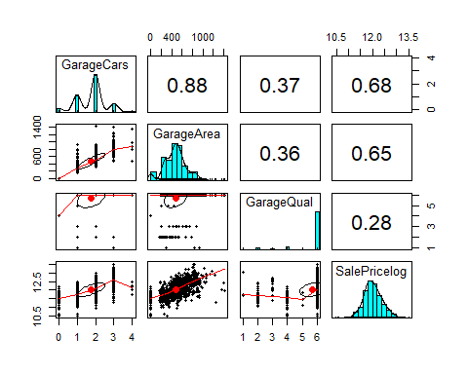

Quality Metrics
Numerous quality metrics can be seen in the dataset. Their pair plot shows that Overallquality will be more correlated with the Salepricelog. This makes sense, as if the overall quality of the house is good, it is very much likely that the garage, kitchen and basement will also be of good quality.
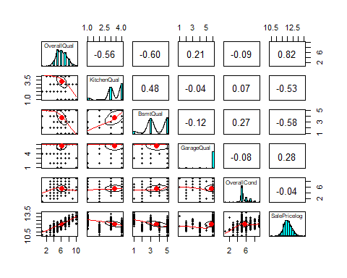

Outliers and Residuals Analysis
The residual analysis shows that the standardized residuals are close to a normal distribution as desired in multi variable regression.
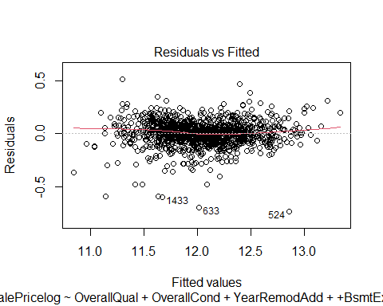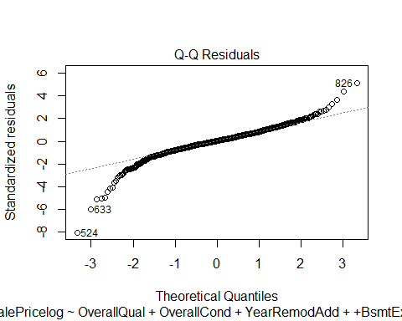
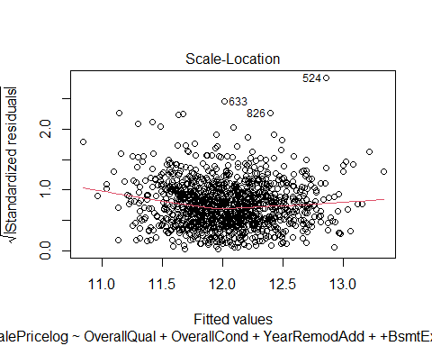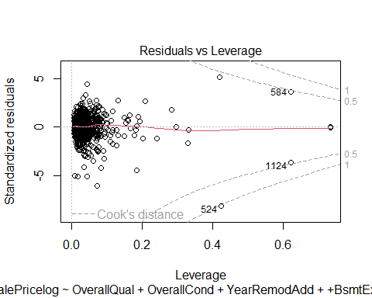
The Cooks distance is showing that point 524 and 1299 are outliers because of the low prices, also impacting the model. We’ll remove these points and rerun the model again.

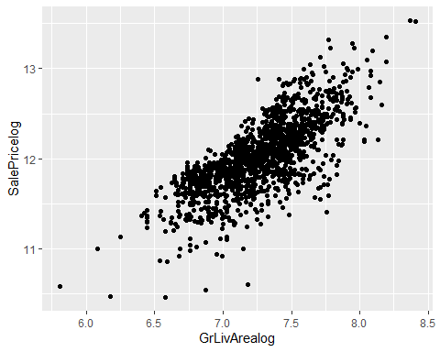

Retraining the model again after removing outliers, the VIF is less than 10%, which means that multicollinearity is under threshold. Seeing the p-Values, we eliminated 'MiscVal', 'Condition2M', 'LotConfigM', 'RoofStyleM', 'ExterCondM' and 'HouseStyleM' from the model, as they were not statistically significant.

Final Multiple Regression Model
As we can see in the final regression model that the most prominent features are:
Predicted_sale_price = exp(5.1745 + 0.0633 * OverallQual + 0.0341 * OverallCond + 0.0014 * YearRemodAdd -0.0216 * Remodeledyes + 0.045 * BsmtExposureGd -0.0219 * BsmtExposureMn -0.0384 * BsmtExposureNo + 0.061 * BsmtExposureNoBsmExposure + 0.0002 * TotalBsmtSF + 0.0742 * CentralAirY + 0.063 * Bath -0.1109 * KitchenAbvGr + 0.0374 * Fireplaces + 0.055 * GarageCars + 0.0487 * PavedDriveMY + 0.0151 * SaleConditionAdjLand -0.0856 * SaleConditionAlloca + 0.0514 * SaleConditionFamily + 0.0682 * SaleConditionNormal + 0.1526 * SaleConditionPartial + 0.0109 * Condition1MPos -0.031 * Condition1MRail -0.0635 * Condition1MRoad + 0.0232 * Exterior1MGood -0.0087 * Exterior1MNormal -0.1512 * nbrstatusLow -0.1032 * nbrstatusMid + 0.0916 * Functional1Typ -0.0366 * MSZoningMRL -0.0694 * MSZoningMRMH + 0.0716 * LotArealog + 0.3436 * GrLivArealog )

Some interesting observations about the model are as below.
- Ground Living Area, Sale Condition, Neighborhood status and Kitchen Area were the most impacted features while modelling the house sale price.
- Since log transformation was used for saleprice, we are using inverse log to get the values in currency
- It is interesting to note that the model is using number of bathrooms instead of number of bedrooms in the housing. Using bedrooms or using an interaction of bedroom and bathroom resulted in a less significant model based upon the higher p-value, with degradation in R-square.
- We can also see that the neighborhood status is assigning coefficients based upon the status. i.e. Neighborhoods within normal and lower price markets are assigned lower values compared to expensive neighborhoods. We can clearly see that the model is assigning coefficients as per the status of the neighborhood.

Model Type | RMSE |  | R-Squared
 | Train Data | Test Data | Train Data | Test Data
Multiple Linear Regression | 21953.64 | 24918.70 | 92.80% | 88.67%

Ensemble Models
Comparative Models were also created with different Ensemble Methods. Final Model will be chosen based on Model Comparison of Ensemble Models and Multiple Linear Regression Model.
- For Ensemble Methods no Log Transformation were applied on any variable.
- Same Data Split was used, to have accurate Comparison.

Bagging
First Ensemble Method used was Bagging to create the Model. Cross validation with repetition set to 2 was also applied on the Training Data set. Total of 20 most important Variables was identified. Out of 20, 15 of the Variables has Importance Percentage of more than 10%. Default parameters were used for Bagging Model creation.
R-square and RMSE was calculated for both train and test data. Below are the results.
Model Type | RMSE |  | R-Squared
 | Train Data | Test Data | Train Data | Test Data
Bagging | 30625.84 | 33515.58 | 92.97% | 89.27%
The five most important features for bagging were Living Area footage, basement area, overall quality, number of cars in garage and first floor area.

Random Forest
Next Ensemble Method called Random Forest was used to create the Model. Cross validation with repetition set to 2 was also applied on the Training Dataset. Total of 20 most important Variables identified by the Model can be seen below. Default parameters were used for Bagging Model creation. We got the lowest MAE (Mean Average Error) at mtry 74. Mtry describes how many random samples of the variables shall be taken for Random Forest.

Model Type | RMSE |  | R-Squared
 | Train Data | Test Data | Train Data | Test Data
Random Forest | 10173.57 | 26203.70 | 99.34% | 93.62%
The five most important features for Random Forest have been ground living area, overall quality, basement area, 1st floor area and basement 1st floor area. These features are some what different comparing with XGBoost and Bagging.
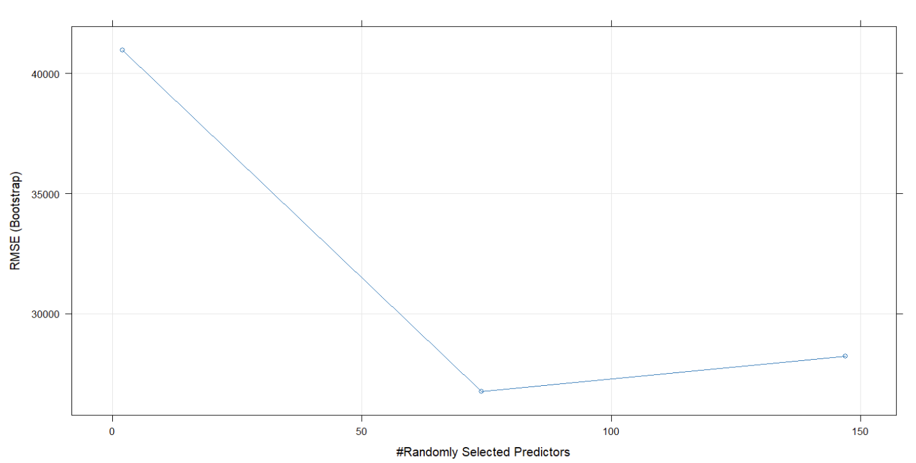

XGBoosting
XGBoosting samples the data based upon the high error terms for each and every model. Here nrounds, which define the number of boosting iterations, were kept at 500 and gamma which is the regularization parameter was kept at 2.1. Gamma helps us to reduce over fitting of the model. Eta, which describes the learning rate and helps in overfitting and controlling model complexity was set to 0.2.
Model Type | RMSE |  | R-Squared
 | Train Data | Test Data | Train Data | Test Data
XGBoosting | 3146.09 | 25025.91 | 99.92% | 94.18%

The five most important features for XGBoost were Overall quality, ground living area, basement size, car garages and number of bathrooms.
The top 20 most important variable for XGBoosting can be seen below in the table.

Ensemble Methods Variable Importance Table

Models Comparison

Model Comparison Table
Model Type | RMSE |  | R-Squared
 | Train Data | Test Data | Train Data | Test Data
Multiple Linear Regression | 21953.64 | 24918.70 | 92.80% | 88.67%
Bagging | 30625.84 | 33515.58 | 92.97% | 89.27%
Random Forest | 10173.57 | 26203.70 | 99.34% | 93.62%
XGBoosting | 3146.09 | 25025.91 | 99.92% | 94.18%

Conclusion
- Multiple linear regression model is comparatively simpler to understand because of the coefficient weights and operators (+, -) explains the impact on the final regression equation
- Tree ensemble models overall performed a lot better compared to multiple regression model
- XGBoost performed the best among all the models
- The tree ensemble models have overfitted the models slightly, but these values are still under threshold and can be fine-tuned by obtaining additional data with the passage of time.

Challenges

- Dealing with so many variables (79 variables) was a huge challenge. A lot of the methods we learned works good on smaller dataset. We handled this by grouping together similar parameters.
- We had to read the description of all the variables for this Kaggle competition dataset and understand what different abbreviations, fields and values meant. Some information was specific for people working in the real estate industry. We had to familiarize ourselves with that to get a better understanding of the data.
- Some of the categorical data has very less samples. We had to re-categorize them by grouping together the impact of each set within the category. This needed a lot of research.
- Many variables had skewness. Checking them all was a challenge. This took a lot of efforts where we analyzed the scatter plots and histograms for the variables.
- Pair-plot analysis for so many variables were impossible. That’s where we grouped similar fields together to analyze.
- The data had a lot of categorical variables. Handling these while performing multivariable regression needed a lot of effort.
- Tree ensemble methods used a lot of time for processing. It left little time for fine tuning XGBoost.

Future work
- With so many variables we’ll like to explore Lasso, Ridge and Elastic net regression for multivariable regression.
- XGBoost fine tuning will help us create a better model.
- Neural network implementation will be an interesting approach for this project, that we’ll like to compare against multiple linear regression and tree ensemble.

Appendix

Appendix 1

About Ames
Ames is a city in Story County, Iowa, United States, located approximately 30 miles, north of Des Moines in central Iowa. It is best known as the home of Iowa State University (ISU), with leading agriculture, design, engineering, and veterinary medicine colleges.





Appendix 2

Data Description
Fields | Description
SalePrice | The property's sale price in dollars. This is the target variable that you're trying to predict.
MSSubClass | The building class
MSZoning | The general zoning classification
LotFrontage | Linear feet of street connected to property
LotArea | Lot size in square feet
Street | Type of road access
Alley | Type of alley access
LotShape | General shape of property
LandContour | Flatness of the property
Utilities | Type of utilities available
LotConfig | Lot configuration
LandSlope | Slope of property
Neighborhood | Physical locations within Ames city limits
Condition1 | Proximity to main road or railroad
Condition2 | Proximity to main road or railroad (if a second is present)
BldgType | Type of dwelling
HouseStyle | Style of dwelling
OverallQual | Overall material and finish quality
OverallCond | Overall condition rating
YearBuilt | Original construction date
YearRemodAdd | Remodel date
RoofStyle | Type of roof
RoofMatl | Roof material
Exterior1st | Exterior covering on house
Exterior2nd | Exterior covering on house (if more than one material)
MasVnrType | Masonry veneer type
MasVnrArea | Masonry veneer area in square feet
ExterQual | Exterior material quality
ExterCond | Present condition of the material on the exterior
Foundation | Type of foundation
BsmtQual | Height of the basement
BsmtCond | General condition of the basement
BsmtExposure | Walkout or garden level basement walls
BsmtFinType1 | Quality of basement finished area
BsmtFinSF1 | Type 1 finished square feet
BsmtFinType2 | Quality of second finished area (if present)
BsmtFinSF2 | Type 2 finished square feet
BsmtUnfSF | Unfinished square feet of basement area
TotalBsmtSF | Total square feet of basement area
Heating | Type of heating
HeatingQC | Heating quality and condition
CentralAir | Central air conditioning
Electrical | Electrical system
1stFlrSF | First Floor square feet
2ndFlrSF | Second floor square feet
LowQualFinSF | Low quality finished square feet (all floors)
GrLivArea | Above grade (ground) living area square feet
BsmtFullBath | Basement full bathrooms
BsmtHalfBath | Basement half bathrooms
FullBath | Full bathrooms above grade
HalfBath | Half baths above grade
Bedroom | Number of bedrooms above basement level
Kitchen | Number of kitchens
KitchenQual | Kitchen quality
TotRmsAbvGrd | Total rooms above grade (does not include bathrooms)
Functional | Home functionality rating
Fireplaces | Number of fireplaces
FireplaceQu | Fireplace quality
GarageType | Garage location
GarageYrBlt | Year garage was built
GarageFinish | Interior finish of the garage
GarageCars | Size of garage in car capacity
GarageArea | Size of garage in square feet
GarageQual | Garage quality
GarageCond | Garage condition
PavedDrive | Paved driveway
WoodDeckSF | Wood deck area in square feet
OpenPorchSF | Open porch area in square feet
EnclosedPorch | Enclosed porch area in square feet
3SsnPorch | Three season porch area in square feet
ScreenPorch | Screen porch area in square feet
PoolArea | Pool area in square feet
PoolQC | Pool quality
Fence | Fence quality
MiscFeature | Miscellaneous feature not covered in other categories
MiscVal | $Value of miscellaneous feature
MoSold | Month Sold
YrSold | Year Sold
SaleType | Type of sale
SaleCondition | Condition of sale

Appendix 3

Project R – Code
# Importing Libraries
```{r setup, include=FALSE}
library(DAAG)
library(datasets)
library(ggplot2)
library(dplyr)
library(psych)
library(caret)
library(pROC)
library(nnet)
library(e1071)
library(car)
library(MASS)
library(mlbench)
library(BSDA)
library(readr)
library(visdat)
library(naniar)
library(GGally)
library(mice)
library(caret)
library(lime)
library(e1071)
library(DescTools)
library(corrplot)
```
# Loading Data Set
```{r, include=FALSE}
df_housing = read.csv('HousingDatatrain.csv')
str(df_housing)
```
## EDA
## Housing Price

```{r, echo=FALSE, results='hide',message=FALSE}
df_housing %>% ggplot(aes(x = SalePrice)) +
geom_histogram(color='blue',fill = 'lightblue') +
ggtitle('Histogram Distribution of SalePrice')+
theme(plot.title = element_text(hjust = 0.5))
```
# After Log Transformation
```{r, echo=FALSE, results='hide',message=FALSE}

df_housing %>% ggplot(aes(x = log(SalePrice)) )+
geom_histogram(color='blue',fill = 'lightblue') +
ggtitle('Histogram Distribution of SalePrice')+
theme(plot.title = element_text(hjust = 0.5))
```
## Neighborhood
```{r, echo=FALSE, results='hide',message=FALSE, warning=FALSE}

df_housing %>% ggplot(aes(x = SalePrice, y= Neighborhood )) +
geom_boxplot(color='blue',fill = 'lightblue') +
ggtitle('Neighborhood Vs SalePrice')+
geom_label(stat = "count", aes(label = ..count.., x = ..count..), size=3) +
theme(plot.title = element_text(hjust = 0.5))
```
# Mean & Average House SalePrice Vs Neighborhood
```{r, echo=FALSE, results='hide',message=FALSE}

par(mfrow = c(1,1))
df_housing %>% group_by(Neighborhood) %>% summarise(Avg = mean(SalePrice), Med = Median(SalePrice)) %>%
ggplot(aes(x = Avg, y= Neighborhood )) +
geom_col(color='blue',fill = 'lightblue') +
ggtitle('Neighborhood Vs Mean SalePrice')+
theme(plot.title = element_text(hjust = 0.5))

df_housing %>% group_by(Neighborhood) %>% summarise(Avg = mean(SalePrice), Med = Median(SalePrice)) %>% ggplot(aes(x = Med, y= Neighborhood )) +
geom_col(color='blue',fill = 'lightblue') +
ggtitle('Neighborhood Vs Median SalePrice')+
theme(plot.title = element_text(hjust = 0.5))
```
## House Quality
```{r, echo=FALSE, results='hide',message=FALSE}
df_housing %>% ggplot(aes(x = as.factor(OverallQual), y= SalePrice )) +
geom_boxplot(color='blue',fill = 'lightblue') +
ggtitle('SalePrice Vs Overall House Quality')+
theme(plot.title = element_text(hjust = 0.5))
```
# Living area
```{r, echo=FALSE, results='hide',message=FALSE}
df_housing %>% ggplot(aes(x = GrLivArea, y= SalePrice )) +
geom_point(color='blue') +
ggtitle('SalePrice Vs Ground Living Area')+
geom_smooth(se=0, method = 'lm', color = 'blue')+
theme(plot.title = element_text(hjust = 0.5))
```
#Lot Area
```{r, echo=FALSE, results='hide',message=FALSE}
df_housing %>% ggplot(aes(x = LotArea, y= SalePrice )) +
geom_point(color='blue') +
ggtitle('SalePrice Vs Lot Area')+
theme(plot.title = element_text(hjust = 0.5))
```
# Log Transformation Lot Area Vs SalePrice
```{r, echo=FALSE, results='hide',message=FALSE}

df_housing %>% ggplot(aes(x = log(LotArea), y= SalePrice)) +
geom_point(color='blue') +
ggtitle('SalePrice Vs Log (Lot Area)')+
geom_smooth(se=0, method = 'lm', color = 'blue')+
theme(plot.title = element_text(hjust = 0.5))
```
# MSZoning

```{r, echo=FALSE, results='hide',message=FALSE}
df_housing %>% ggplot(aes(x = MSZoning, y= SalePrice )) +
geom_boxplot(color='blue',fill = 'lightblue') +
geom_label(stat = "count", aes(label = ..count.., y = ..count..), size=3) +
ggtitle('SalePrice Vs MSZoning')+
theme(plot.title = element_text(hjust = 0.5))

df_housing %>% ggplot(aes(x= GrLivArea, y= SalePrice, color=MSZoning)) + geom_point() +
geom_smooth(se=0, method='lm')
```
## Missing Data Handling
```{r}
#Handling Missing data as per data description
df_housing$GarageType[is.na(df_housing$GarageType)] <- "NoGarage"
df_housing$GarageYrBlt[is.na(df_housing$GarageYrBlt)] <- 0
df_housing$GarageFinish[is.na(df_housing$GarageFinish)] <- "NoFinish"
df_housing$GarageQual[is.na(df_housing$GarageQual)] <- "NoQual"
df_housing$GarageCond[is.na(df_housing$GarageCond)] <- "NoCond"
df_housing$FireplaceQu[is.na(df_housing$FireplaceQu)] <- "NoFirePlace"
df_housing$PoolQC[is.na(df_housing$PoolQC)] <- "NoPool"
df_housing$Fence[is.na(df_housing$Fence)] <- "NoFence"
df_housing$MiscFeature[is.na(df_housing$MiscFeature)] <- "NoExtraFeatures"
df_housing$Alley[is.na(df_housing$Alley)] <- "NoAlleyAccess"
df_housing$BsmtQual[is.na(df_housing$BsmtQual)] <- "NoBasement"
df_housing$BsmtCond[is.na(df_housing$BsmtCond)] <- "NoBasementCondition"
df_housing$BsmtExposure[is.na(df_housing$BsmtExposure)] <- "NoBsmExposure"
df_housing$BsmtFinType1[is.na(df_housing$BsmtFinType1)] <- "NoBsmFinType1"
df_housing$BsmtFinType2[is.na(df_housing$BsmtFinType2)] <- "NoBsmFinType2"
df_housing$LotFrontage[is.na(df_housing$LotFrontage)] <- 0
df_housing$MasVnrArea[is.na(df_housing$MasVnrArea)] = 0
df_housing$MasVnrType[is.na(df_housing$MasVnrType)] = 'None'

df_housing[!complete.cases(df_housing),]
df_housing = df_housing[complete.cases(df_housing),]
```
# Variable Type Conversion
```{r, echo=FALSE, results='hide',message=FALSE}
#Categorial Data Conversion
cat_names=c('MSZoning','Street','Alley','LotShape','LandContour','Utilities','LotConfig','LandSlope','Neighborhood'
,'Condition1','Condition2','BldgType','HouseStyle','RoofStyle','RoofMatl','Exterior1st','Exterior2nd','MasVnrType',
'ExterQual','ExterCond','Foundation','BsmtQual','BsmtCond','BsmtExposure','BsmtFinType1','BsmtFinType2','Heating',
'HeatingQC','CentralAir','Electrical','KitchenQual','Functional','FireplaceQu','GarageType','GarageFinish','GarageQual','GarageCond','PavedDrive','PoolQC','Fence','MiscFeature','SaleType','SaleCondition')

for (i in 1:length(cat_names)){
df_housing[, cat_names[i]] = as.factor(df_housing[, cat_names[i]])
}
```
##Feature Engineering
# Lot Shape Example
```{r, echo=FALSE, results='hide',message=FALSE,warning=FALSE}
ggplot(data=df_housing, aes(x=LotShape)) +
geom_histogram(stat='count',color = 'blue', fill = 'lightblue', width = 0.5)+
geom_label(stat = "count", aes(label = ..count.., y = ..count..), size=3)
#+theme(axis.text.x = element_text(angle = 45, hjust = 1))
```
#Featuring
```{r, , echo=FALSE, results='hide',message=FALSE}
df_housing_copy1 = df_housing

df_housing$Condition1M[df_housing$'Condition1' %in% c('Norm')] = 'normal'
df_housing$Condition1M[df_housing$'Condition1' %in% c('PosA', 'PosN')] = 'Pos'
df_housing$Condition1M[df_housing$'Condition1' %in% c('RRAe', 'RRNn', 'RRNe', 'RRAn')] = 'Rail'
df_housing$Condition1M[df_housing$'Condition1' %in% c('Feedr', 'Artery')] = 'Road'
df_housing$Condition1M = factor(df_housing$Condition1M)

df_housing$Condition2M[df_housing$'Condition2' %in% c('Norm')] = 'normal'
df_housing$Condition2M[df_housing$'Condition2' %in% c('PosA', 'PosN')] = 'Pos'
df_housing$Condition2M[df_housing$'Condition2' %in% c('RRAe', 'RRNn', 'RRNe', 'RRAn')] = 'Rail'
df_housing$Condition2M[df_housing$'Condition2' %in% c('Feedr', 'Artery')] = 'Road'
df_housing$Condition2M = factor(df_housing$Condition2M)

df_housing$Exterior1M[df_housing$Exterior1st %in% c('BrkFace', 'Stone', 'Stucco', 'VinylSd', 'MetalSd')] = 'Good'
df_housing$Exterior1M[df_housing$Exterior1st %in% c('BrkComm', 'CBlock', 'CemntBd', 'Plywood', 'PreCast', 'Wd Sdng', 'AsphShn')] = 'Normal'
df_housing$Exterior1M[df_housing$Exterior1st %in% c('AsbShng', 'HdBoard', 'ImStucc', 'WdShing')] = 'Bad'
df_housing$Exterior1M = factor(df_housing$Exterior1M)

df_housing$Exterior2M[df_housing$Exterior2nd %in% c('BrkFace', 'Stone', 'Stucco', 'VinylSd', 'MetalSd', 'Other')] = 'Good'
df_housing$Exterior2M[df_housing$Exterior2nd %in% c('Brk Cmn', 'CBlock', 'CmentBd', 'Plywood', 'PreCast', 'Wd Sdng', 'AsphShn', 'Wd Shng')] = 'Normal'
df_housing$Exterior2M[df_housing$Exterior2nd %in% c('AsbShng', 'HdBoard', 'ImStucc')] = 'Bad'
df_housing$Exterior2M = factor(df_housing$Exterior2M)

# Neighborhood classification
df_housing$nbrstatus = 'Mid'
df_housing$nbrstatus [df_housing$Neighborhood %in% c('StoneBr', 'NridgHt', 'NoRidge')] = 'High'

df_housing$nbrstatus [df_housing$Neighborhood %in% c('BrDale', 'IDOTRR',
'MeadowV')] = 'Low'

df_housing$nbrstatus = factor(df_housing$nbrstatus)

#Funtional Status change
df_housing = df_housing %>% mutate(Functional1 = ifelse(Functional=='Typ', 'Typ', 'Dmg'))
df_housing$Functional1 = factor(df_housing$Functional1)

df_housing$MSZoningM[df_housing$MSZoning %in% c('RL', 'RP')] = 'RL'
df_housing$MSZoningM[df_housing$MSZoning %in% c('RM', 'RH')] = 'RMH'
df_housing$MSZoningM[df_housing$MSZoning %in% c('A','C (all)','FV', 'I')] = 'OTH'
df_housing$MSZoningM = factor(df_housing$MSZoningM)

df_housing$LotShapeM = ifelse(df_housing$LotShape == c('Reg'), 'Reg', 'IR')
df_housing$LotShapeM = factor(df_housing$LotShapeM)
df_housing$LandContourM = ifelse(df_housing$LandContour == 'Lvl', 'Lvl', 'nLvl')
df_housing$LandContourM = factor(df_housing$LandContourM)
df_housing$LotConfigM = ifelse(df_housing$LotConfig %in% c('FR2', 'FR3'), 'FR',
as.character(df_housing$LotConfig))
df_housing$LotConfigM = factor(df_housing$LotConfigM)
df_housing$LandSlopeM = ifelse(df_housing$LandSlope=='Gtl', 'Gtl', 'mod_sev')
df_housing$LandSlopeM = factor(df_housing$LandSlopeM)
df_housing$BldgTypeM[df_housing$BldgType %in% c('Twnhs', 'TwnhsE')] = 'Twnhs'
df_housing$BldgTypeM[df_housing$BldgType =='1Fam'] = '1Fam'
df_housing$BldgTypeM[df_housing$BldgType %in% c('2fmCon', 'Duplex')] = '2fm_con_dup'
df_housing$BldgTypeM = factor(df_housing$BldgTypeM)
df_housing$RoofStyleM[df_housing$RoofStyle %in% c('Flat', 'Shed')] = 'simp_slope'
df_housing$RoofStyleM[df_housing$RoofStyle %in% c('Gable', 'Gambrel')] = 'Gabbles'
df_housing$RoofStyleM[df_housing$RoofStyle %in% c('Hip', 'Mansard')] = 'Hipped_roof'
df_housing$RoofStyleM = factor(df_housing$RoofStyleM)
df_housing$MasVnrTypeM = ifelse(df_housing$MasVnrType %in% c('BrkCmn', 'BrkFace'), 'Brk',
as.character(df_housing$MasVnrType))
df_housing$MasVnrTypeM = factor(df_housing$MasVnrTypeM)
df_housing$ElectricalM = ifelse(df_housing$Electrical=='SBrkr', 'SBrkr', 'NonSBrkr')

df_housing$ElectricalM = factor(df_housing$ElectricalM)

df_housing$FenceM[df_housing$Fence %in% c('GdPrv', 'GdWo')] = 'Gd'
df_housing$FenceM[df_housing$Fence %in% c('MnPrv', 'MnWw')] = 'Mn'
df_housing$FenceM[df_housing$Fence %in% c('NoFence')] = 'NoFence'
df_housing$FenceM = factor(df_housing$FenceM)
df_housing$ExterCondM = ifelse(df_housing$ExterCond %in% c('Ex', 'Gd'), 'Gd', 'Nor')
df_housing$ExterCondM = factor(df_housing$ExterCond)

df_housing$AlleyM = ifelse(df_housing$Alley == 'NoAlleyAccess', 'NoAlleyAccess', 'Access')

df_housing$SaleTypeM = ifelse(df_housing$SaleType %in% c('Normal', 'Partial'), 'Abnormal',
as.character(df_housing$SaleType))
df_housing$SaleTypeM = factor(df_housing$SaleTypeM)

df_housing$HouseStyleM = ifelse(df_housing$HouseStyle=='1Story', '1Story', 'Other')
df_housing$HouseStyleM[df_housing$HouseStyle %in% c('1.5Fin', '1.5Unf', '2Story', '2.5Fin', '2.5Unf' )] = '2Story'
df_housing$HouseStyleM = factor(df_housing$HouseStyleM)

df_housing$PavedDriveM = ifelse(df_housing$PavedDrive == 'Y', 'Y', 'N')
df_housing$PavedDriveM = factor(df_housing$PavedDriveM)

data <- data.frame( Variable = c("LotShape", "MSZoning","LandContour","LotConfig","LandSlope","BldgType","RoofStyle","MasVnrType",
"Electrical","Fence","Alley","Condition1","Condition2","Exterior1st","Exterior2nd","Neighborhood","Functional","ExterCond","HouseStyle","PavedDrive"), ModVariable = c("LotShapeM","MSZoningM","LandContourM","LotConfigM","LandSlopeM","BldgTypeM","RoofStyleM","MasVnrTypeM",
"ElectricalM","FenceM","AlleyM","Condition1M","Condition2M","Exterior1stM","Exterior2ndM","nbrstatus","Functional1","ExterCondM","HouseStyleM","PavedDriveM"), Comments = c("Reg , IR=IR1+IR2+IR3","RL=RL+RP , RMH=RM+RH , OTH=A+C(all)+FV+I","Lv, nLv1=Bnk+HLS+Low","FR = FR2+FR3 , Inside , Corner , CulDSac","Gtl , mod_sev = Mod + Sev","Twnhs = Twnhs + TwnhsE , 1Fam , 2fm_con_dup = 2fmCon + Duplex","simp_slope = Flat + Shed , Gabbles = Gable + Gambrel , Hipped_roof = Hip + Mansard","Brk = BrkCmn + BrkFace , None , Stone , CBlock",
"SBrkr , NonSBrkr = FuseA + FuseF + FuseP + Mix","Gd = GdPrv + GdWo , Mn = MnPrv + MnWw , NoFence","NoAlleyAccess , Access = Grvl + Pave","normal = Norm , Pos = PosA + PosN , Rail = RRAe + RRNn + RRNe + RRAn , Road = Feedr + Artery","normal = Norm , Pos = PosA + PosN , Rail = RRAe + RRNn + RRNe + RRAn , Road = Feedr + Artery","Good = BrkFace + Stone + Stucco + VinylSd , Normal = BrkComm + Cblock + CemntBd + Plywood + PreCast + Wd Sdng + AsphShn , Bad = AsbShng + HdBoard + ImStucc + MetalSd + WdShing","Good = BrkFace + Stone + Stucco + VinylSd + MetalSd + Other , Normal = Brk Cmn + Cblock + CemntBd + Plywood + PreCast + Wd Sdng + AsphShn + Wd Shng , Bad = AsbShng + HdBoard + ImStucc","High = StoneBr + NridgHt + NoRidge , Low = BrDale + IDOTRR + MeadowV , Mid = Rest of Neighorhoods","Typ , Dmg = Rest of Other Categories", "Gd = Ex + Gd , Nor" , "1Story , Other = SFoyer + SLvl , 2Story = 1.5Fin + 1.5Unf + 2Story + 2.5Fin+ 2.5Unf" , "Y , N = N + P" ))
data
```
# Transformation Analysis
```{r, echo=FALSE, results='hide',message=FALSE}

df_housing$SalePricelog = log(df_housing$SalePrice)

df_housing$LotArealog = log(df_housing$LotArea)

df_housing$GrLivArealog = log(df_housing$GrLivArea)
```

# Feature Engineering - New Interaction Variable
```{r, echo=FALSE, results='hide',message=FALSE}
# Remodeled Variable Creation
# Use remodeled variable created
df_housing = df_housing %>% mutate(Remodeled= ifelse(YearBuilt!=YearRemodAdd, 'yes', 'no'))
df_housing$Remodeled = factor(df_housing$Remodeled)

cols = c('YearBuilt', 'YearRemodAdd','SalePricelog')
pairs.panels(df_housing %>% dplyr::select(cols))

# New Bath Variable Creation
df_housing$Bath = df_housing$FullBath + 0.5*df_housing$HalfBath + df_housing$BsmtFullBath + 0.5*df_housing$BsmtHalfBath

```
## Removing Columns
Example Plot
```{r,echo=FALSE, results='hide',message=FALSE,warning=FALSE}
(streetdistr <- df_housing %>%
group_by(Street) %>%
summarise(percentage = n() / nrow(df_housing) * 100))

(Utilitiesdistr <- df_housing %>%
group_by(Utilities) %>%
summarise(percentage = n() / nrow(df_housing) * 100))

(PoolQCdistr <- df_housing %>%
group_by(PoolQC) %>%
summarise(percentage = n() / nrow(df_housing) * 100))

(RoofMatldistr <- df_housing %>%
group_by(RoofMatl) %>%
summarise(percentage = n() / nrow(df_housing) * 100))

(Heatingdistr <- df_housing %>%
group_by(Heating) %>%
summarise(percentage = n() / nrow(df_housing) * 100))

(MiscFeaturedistr <- df_housing %>%
group_by(MiscFeature) %>%
summarise(percentage = n() / nrow(df_housing) * 100))

ggplot(data=df_housing, aes(x=Street)) +
geom_histogram(stat='count',color = 'blue', fill = 'lightblue', width = 0.5)+
geom_label(stat = "count", aes(label = ..count.., y = ..count..), size=3)
#+theme(axis.text.x = element_text(angle = 45, hjust = 1))
```
```{r, echo=FALSE, results='hide',message=FALSE,warning=FALSE}
#These columns are removed as they have been recategorized or removed because of uneven distribution of categories
remove_cols = c('Street', 'Utilities', 'PoolQC', 'RoofMatl', 'Heating', 'PoolQC',
'MiscFeature', 'MSZoning','LotShape', 'LandContour', 'LotConfig',
'LandSlope', 'BldgType', 'RoofStyle','MasVnrType', 'Electrical',
'Fence', 'SaleType', 'LotArea', 'GrLivArea', 'Condition1',
'Condition2', 'Exterior1st', 'Exterior2nd', 'Neighborhood',
'Functional', 'YearBuilt', 'SalePrice', 'Alley', 'ExterCond', 'HouseStyle', 'PavedDrive',
'KitchenAbvGr', 'HeatingQC')

df_housing_model = df_housing %>% dplyr::select(-remove_cols)
```
## Correlation Plots

```{r, echo=FALSE, results='hide',message=FALSE}
ggplot(df_housing, aes(x=GrLivArealog, y=SalePricelog, color=Functional1)) + geom_point()+
geom_smooth(se=0,method='lm')
```
As can be seen in below plot, Houses with similar GrLivArea tends to have lower SalePrice if the house is Single Story versus if the house is 2Story.

```{r, echo=FALSE, results='hide',message=FALSE}
ggplot(df_housing, aes(x=GrLivArealog, y=SalePricelog, color=HouseStyleM)) + geom_point()+
geom_smooth(se=0,method='lm')

```
##Sampling of the Data

```{r, echo=FALSE, results='hide',message=FALSE}
set.seed(123)

ind = sample(2, nrow(df_housing_model), replace = T, prob = c(0.8, 0.2))

train = df_housing_model[ind==1,]
test = df_housing_model[ind==2,]
```
# Running the AIC
```{r, echo=FALSE, results='hide',message=FALSE}
model = lm(SalePricelog~.-Id , train)
model_aic = stepAIC(model, direction = 'both', trace=F)
model_aic_f = stepAIC(model, direction = 'forward', trace=F)
model_aic_b = stepAIC(model, direction = 'backward', trace=F)
model_aic$call
model_aic_f$call
model_aic_b$call
```
#StepAIC Models Summary
```{r, echo=FALSE, results='hide',message=FALSE}
(s_aic = summary(model_aic))
(s_aic_b=summary(model_aic_b))
(s_aic_f = summary(model_aic_f))
s_aic$r.squared
s_aic$adj.r.squared
s_aic$fstatistic
s_aic$terms
p0_b = predict(model_aic, test)
r0_b = cor(p0_b, test$SalePricelog)
(r2_b = r0_b^2)
p0_f = predict(model_aic_f, test)
r0_f = cor(p0_f, test$SalePricelog)
(r2_f= r0_f^2)
```
# Using backward/both AIC Model

```{r, echo=FALSE, results='hide',message=FALSE}
m2 = lm(formula = SalePricelog ~ OverallQual + OverallCond + YearRemodAdd +
BsmtQual + BsmtExposure + BsmtFinType1 + BsmtFinSF1 + BsmtFinType2 +
BsmtFinSF2 + BsmtUnfSF + CentralAir + X2ndFlrSF + LowQualFinSF +
BsmtFullBath + FullBath + HalfBath + KitchenQual + Fireplaces +
GarageCars + GarageArea + GarageQual + WoodDeckSF + X3SsnPorch +
ScreenPorch + PoolArea + MiscVal + YrSold + SaleCondition +
Condition1M + Condition2M + Exterior1M + nbrstatus + Functional1 +
Remodeled + MSZoningM + LotConfigM + BldgTypeM + ExterCondM +
HouseStyleM + PavedDriveM + LotArealog + GrLivArealog, data = train)
summary(m2)
attributes(alias(m2)$Complete)$dimnames[[1]]
```
#Running the model again removing BsmtFinType1
#Not needed redo explanation for VIF

```{r, echo=FALSE, results='hide',message=FALSE}
m2_mod = lm(formula = SalePricelog ~ OverallQual + OverallCond + YearRemodAdd +
BsmtQual + BsmtExposure + BsmtFinSF1 + BsmtFinType2 +
BsmtFinSF2 + BsmtUnfSF + CentralAir + X2ndFlrSF + LowQualFinSF +
BsmtFullBath + FullBath + HalfBath + KitchenQual + Fireplaces +
GarageCars + GarageArea + GarageQual + WoodDeckSF + X3SsnPorch +
ScreenPorch + PoolArea + MiscVal + YrSold + SaleCondition +
Condition1M + Condition2M + Exterior1M + nbrstatus + Functional1 +
Remodeled + MSZoningM + LotConfigM + BldgTypeM + ExterCondM +
HouseStyleM + PavedDriveM + LotArealog + GrLivArealog, data = train)

vif(m2_mod)
anova(m2_mod)
```
# Feature Engineering
##Bathrooms:

```{r, echo=FALSE, results='hide',message=FALSE}
cor(df_housing$Bath, (0.5*df_housing$BsmtHalfBath+df_housing$FullBath+df_housing$BsmtFullBath+0.5*df_housing$HalfBath))
cor(df_housing$GrLivArea, (df_housing$X1stFlrSF+df_housing$X2ndFlrSF+df_housing$LowQualFinSF))
cor(df_housing$TotalBsmtSF, (df_housing$BsmtUnfSF+df_housing$BsmtFinSF1+df_housing$BsmtFinSF2))
```
###Generalization of Living Area metrics
```{r, echo=FALSE, results='hide',message=FALSE,warning=FALSE}
cols = c('HouseStyle', 'GrLivArea', 'X1stFlrSF', 'X2ndFlrSF', 'LowQualFinSF', 'SalePricelog')
pairs.panels(df_housing %>% dplyr::select(cols))
```
###Basement Area
```{r, echo=FALSE, results='hide',message=FALSE}
cols = c('TotalBsmtSF', 'BsmtUnfSF', 'BsmtFinSF1', 'BsmtFinSF2', 'SalePricelog')
pairs.panels(df_housing %>% dplyr::select(cols))
```
###Basement Quality
```{r, echo=FALSE, results='hide',message=FALSE}
cols = c('BsmtQual', 'BsmtFinType1', 'BsmtFinType2', 'BsmtExposure', 'TotalBsmtSF','SalePricelog')
pairs.panels(df_housing %>% dplyr::select(cols))
```
#Bathrooms
```{r, echo=FALSE, results='hide',message=FALSE}
cols = c('Bath', 'BsmtHalfBath','FullBath','BsmtFullBath','HalfBath', 'SalePricelog')
pairs.panels(df_housing %>% dplyr::select(cols))
corrplot(cor(df_housing %>% dplyr::select(cols)),method = 'number', type='upper')
```
###Garage Area and garage car count
```{r, echo=FALSE, results='hide',message=FALSE}
cols = c('GarageCars', 'GarageArea', 'GarageQual','SalePricelog')
pairs.panels(df_housing %>% dplyr::select(cols))
```
###Quality Metrics
```{r, echo=FALSE, results='hide',message=FALSE}
cols = c('OverallQual', 'KitchenQual', 'BsmtQual', 'GarageQual', 'OverallCond', 'SalePricelog')
pairs.panels(df_housing %>% dplyr::select(cols))
```
###Pool Area
```{r, echo=FALSE, results='hide',message=FALSE}
cols = c('GrLivArealog', 'WoodDeckSF', 'ScreenPorch','PoolArea', 'TotalBsmtSF', 'LotArealog', 'SalePricelog')
pairs.panels(df_housing %>% dplyr::select(cols))
```
#HouseStyle
```{r, echo=FALSE, results='hide',message=FALSE}
summary(aov(df_housing$SalePricelog~ df_housing$HouseStyle))
df_housing %>% group_by(HouseStyle) %>% summarize(cnt=n())
```
#New Model After Feature Engineering
```{r, echo=FALSE, results='hide',message=FALSE}
m3 = lm(formula = SalePricelog ~ OverallQual + OverallCond + YearRemodAdd +
+ BsmtExposure + TotalBsmtSF +
CentralAir + Bath + Fireplaces + GarageCars +
PavedDriveM + MiscVal + SaleCondition + Condition1M +
Condition2M + Exterior1M + nbrstatus + Functional1 + Remodeled +
MSZoningM + LotConfigM + RoofStyleM + ExterCondM + LotArealog +
GrLivArealog + HouseStyleM, data = train)
vif(m3)
summary(m3)
p3 = predict(m3, test)
(cor(p3, test$SalePricelog)^2)
```
###Analzing Cooks Distance and Residuals
```{r}
plot(m3)
ggplot(df_housing, aes(x=GrLivArea, y=SalePrice)) + geom_point()
df_housing %>% filter(GrLivArea>4500)
```
#Removing Outliers
```{r, echo=FALSE, results='hide',message=FALSE}
df_housing_final = df_housing[-c(524, 1299), ]
set.seed(123)
ind = sample(2, nrow(df_housing_final), replace = T, prob = c(0.8, 0.2))
train = df_housing_final[ind==1,]
test = df_housing_final[ind==2,]
ggplot(df_housing_final, aes(x=GrLivArealog, y=SalePricelog)) + geom_point()
df_housing_final %>% dplyr::filter(GrLivArea>4000)
```
#Retraining Model
```{r, echo=FALSE, results='hide',message=FALSE}
m3 = lm(formula = SalePricelog ~ OverallQual + OverallCond + YearRemodAdd +
+ BsmtExposure + TotalBsmtSF + MiscVal +
CentralAir + Bath + KitchenAbvGr + Fireplaces + GarageCars +
PavedDriveM + SaleCondition + Condition1M +
Condition2M + Exterior1M + nbrstatus + Functional1 + Remodeled +
MSZoningM + LotConfigM + RoofStyleM + ExterCondM + LotArealog +
GrLivArealog + HouseStyleM, data = train)
vif(m3)
summary(m3)
p3 = predict(m3, test)
(cor(p3, test$SalePricelog)^2)
```
#Final Model After Removing 'MiscVal', 'Condition2M', 'LotConfigM', 'RoofStyleM', 'ExterCondM' and 'HouseStyleM' due to high p-values.
```{r, echo=FALSE, results='hide',message=FALSE}
mfinal_reg = lm(formula = SalePricelog ~ OverallQual + OverallCond + YearRemodAdd +
+ BsmtExposure + TotalBsmtSF + CentralAir + Bath + KitchenAbvGr + Fireplaces + GarageCars +
PavedDriveM + SaleCondition + Condition1M +
Exterior1M + nbrstatus + Functional1 + Remodeled +
MSZoningM + LotArealog +
GrLivArealog, data = train)
vif(mfinal_reg)
summary(mfinal_reg)
```
#MLR Results
```{r}
predict_train = predict(mfinal_reg, train)
sale_price_train = exp(predict_train)
c_reg_train = cor(sale_price_train, exp(train$SalePricelog))
r_reg_train = c_reg_train^2
rmse_reg_train = sqrt(mean((sale_price_train - exp(train$SalePricelog))^2))
predict_test = predict(mfinal_reg, test)
sale_price_test = exp(predict_test)
c_reg_test = cor(sale_price_test, exp(test$SalePricelog))
r_reg_test = c_reg_test^2
rmse_reg_test = sqrt(mean((sale_price_test - exp(test$SalePricelog))^2))
print(paste("R-square_training=", r_reg_train))
print(paste("R-square_test", r_reg_test))
print(paste("RMSE_training", rmse_reg_train))
print(paste("RMSE_test", rmse_reg_test))
```
# Ensemble Methods Data Prep and Split
```{r}
remove_cols_tree = c('Street', 'Utilities', 'PoolQC', 'RoofMatl', 'Heating',
'MiscFeature', 'MSZoning','LotShape', 'LandContour', 'LotConfig',
'LandSlope', 'BldgType', 'RoofStyle','MasVnrType', 'Electrical',
'Fence', 'SaleType', 'LotArealog', 'GrLivArealog', 'Condition1',
'Condition2', 'Exterior1st', 'Exterior2nd', 'Neighborhood',
'Functional', 'YearBuilt', 'SalePricelog', 'Alley', 'ExterCond', 'HouseStyle', 'PavedDrive',
'KitchenAbvGr', 'HeatingQC')
df_housing_model_tree = df_housing %>% dplyr::select(-remove_cols_tree)
df_housing_final_tree = df_housing_model_tree[-c(524, 1299), ]
set.seed(123)
ind = sample(2, nrow(df_housing_final_tree), replace = T, prob = c(0.8, 0.2))
train_tree = df_housing_final_tree[ind==1,]
test_tree = df_housing_final_tree[ind==2,]
```
## Bagging
```{r Bagging}
#Bagging
cvcontrol = trainControl(method = 'repeatedcv', number=5, repeats=2, allowParallel=T)
bag = train(SalePrice~. - Id, data=train_tree, method='treebag', trControl=cvcontrol, importance=T, na.action=na.omit)
print(varImp(bag))
pb1t = predict(bag, train_tree)
rmse1b = sqrt(mean((pb1t - train_tree$SalePrice)^2))
r_sq1b = cor(pb1t, train_tree$SalePrice)
r_sq1b
pb1 = predict(bag, test_tree)
rmseb = sqrt(mean((pb1 - test_tree$SalePrice)^2))
r_sqb = cor(pb1, test_tree$SalePrice)
r_sqb
print(paste("R-square_Train_Bag=", r_sq1b))
print(paste("R-square_Test_Bag=", r_sqb))
print(paste("RMSE_Train_Bag=", rmse1b))
print(paste("RMSE_Test_Bag=", rmseb))
```
## Random Forest
```{r Random_Forest}
#Random Forest
cvcontrolf = trainControl(method = 'repeatedcv', number=5, repeats=2, allowParallel=T)
forest = train(SalePrice~. - Id,data=train_tree, method='rf', trainControl=cvcontrolf, importance=T)
forest
pf1=predict(forest, test_tree)
print(varImp(forest))
print(f1)
pf1t = predict(forest, train_tree)
rmse1f = sqrt(mean((pf1t - train_tree$SalePrice)^2))
r_sq1f = cor(pf1t, train_tree$SalePrice)
r_sq1f
rmsef = sqrt(mean((pf1 - test_tree$SalePrice)^2))
r_sqf = cor(pf1, test_tree$SalePrice)
r_sqf
print(varImp(forest))
forest$call
print(paste("R-square_Train_RF=", r_sq1f))
print(paste("R-square_Test_RF=", r_sqf))
print(paste("RMSE_Train_RF=", rmse1f))
print(paste("RMSE_Test_RF=", rmsef))
```
## XGBoosting
```{r}
xgbg = train(SalePrice~. -Id, data=train_tree, method='xgbTree', trControl=cvcontrol,
tunelength=10, tuneGrid = expand.grid(nrounds=500, max_depth=3, eta=0.2,
gamma=2.1, colsample_bytree=1, min_child_weight=1, subsample=1))
px1tg = predict(xgbg, train_tree)
rmse1tg = sqrt(mean((px1tg - train_tree$SalePrice)^2))
r_sq1tg = cor(px1tg, train_tree$SalePrice)
r_sq1tg
px1g = predict(xgbg, test_tree)
rmsexg = sqrt(mean((px1g - test$SalePrice)^2))
r_sqxg = cor(px1g, test_tree$SalePrice)
r_sqxg
print(varImp(xgbg))
xg_imp_g=varImp(xgbg)
df_xgb_var = data.frame(xg_imp_g$importance)
df_xgb_var %>% filter(Overall > 0)
print(paste("R-square_Train_XGB=", r_sq1tg))
print(paste("R-square_Test_XGB=", r_sqxg))
print(paste("RMSE_Train_XGB=", rmse1tg))
print(paste("RMSE_Test_XGB=", rmsexg))
```

