ماجد عنقاوي
MA LEARN

المستقبل .. تُخطّه أناملُ المبدعين
The future is drawn by the fingertips of the creative.
BRAND GUIDELINES
Version 1.0 - 2026

00 - Brand Logo

The MA mark is a distinctive geometric symbol formed by three angular paired strokes, reading simultaneously as the letters M and A. The mark is shared across both brand identities — MA Learn and Majid Angawi — with typographic treatment differentiating each application.

  MA Learn  Education Platform | 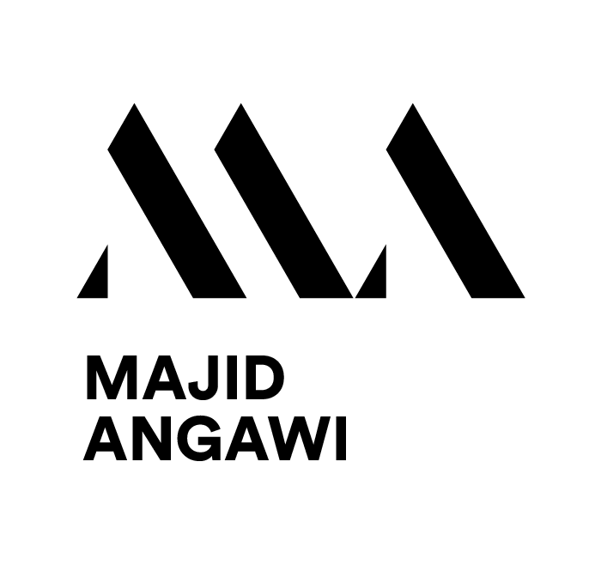  Majid Angawi  Personal Brand

The MA Lettermark
* Three grouped angular strokes that form the letters M and A simultaneously in a single unified mark
* The left and right groups form the outer legs of the M; the center stroke forms both the valley of the M and the peak of the A
* The geometry is sharp, architectural, and precise — reflecting both creative vision and structural discipline
* The mark is always used in black on light backgrounds and white on dark backgrounds
* Never recolor the mark in gold or any brand accent color — it is strictly monochrome

MA Learn vs. Majid Angawi
Element | MA Learn | Majid Angawi
Mark weight | Light / refined | Bold / authoritative
Wordmark | LEARN — light weight | MAJID ANGAWI — bold
Brand tone | Institutional, platform | Personal, individual
Primary use | Website, courses, store | Link in Bio, socials, personal work
Background | Dark (website) / Light (print) | Dark (bio) / Light (print)

Logo Usage Rules
* Always maintain clear space around the logo equal to the height of the letter A in the wordmark
* Minimum size: 80px wide for digital, 25mm wide for print
* Dark backgrounds: use the white version of the logo
* Light backgrounds: use the black version of the logo
* Never stretch, rotate, recolor, add drop shadows, or place on a busy background without a clear zone
* Never place the MA Learn logo and Majid Angawi logo side by side without intentional design context

01 - Brand Overview

Who is Majid Angawi?
Majid Angawi is a Saudi creative director, fashion and jewelry photographer, AI creative specialist, educator, and mentor with over 16 years of professional experience. He is the official Fujifilm ambassador in Saudi Arabia and has published 17+ magazine covers including Harper's Bazaar, Vogue Arabia, Elle Arabia, and Esquire.

His personal brand and MA Learn Academy represent a single unified vision: combining artistic mastery, AI-driven creativity, and accessible Arabic-language education to inspire a generation of creative professionals.
MA Learn Academy
An Arabic creative education platform offering professional courses in fashion photography, lighting, and AI creativity tools. It targets aspiring and professional creatives in Saudi Arabia and the broader Arabic-speaking world, delivering premium educational content through a highly refined digital experience.
Brand Tagline
المستقبل .. تُخطّه أناملُ المبدعين
"The future is drawn by the fingertips of the creative."
Brand Positioning
* Premium but accessible - luxury aesthetic, approachable human tone
* Arabic-first, bilingual where needed for international context
* Education as illumination - knowledge as light cutting through darkness
* Authentic expertise - real-world credentials, not theory
* Forward-looking - AI, innovation, and the future of creative work

02 - Color Palette

The brand uses a dark, moody palette anchored by near-black backgrounds and warm gold accents. This palette evokes depth, sophistication, and illumination - the feeling of a single warm light source in darkness.

Primary Colors
Deep Space  #07070F  Primary Background | Heritage Gold  #C9A84C  Primary Accent | Warm Ivory  #F5F0E8  Primary Text

Secondary Colors
Luminous Gold  #E8D08A  Hover / Highlight | Deep Gold  #8A6420  Dividers / Dim | Silver Mist  #BBBBBB  Body Text | Warm Grey  #888888  Muted / Meta

Dark Scale
Void Black  #080808  Site Background | Card Background  #0E0E0E  Section / Card BG | Elevated Surface  #141414  Hover Card State

Color Usage Rules
* Gold (#C9A84C) is reserved for accents, CTAs, and highlights - never as dominant fill
* Never use pure white (#FFFFFF) - always use Warm Ivory (#F5F0E8) for warmth
* Never place gold on gold or dark on dark - maintain strong contrast always
* Semi-transparent gold overlays (rgba 5-15%) for card hover states only
* Background grain texture always applied at 3-5% opacity for tactile depth

03 - Typography

Typography is the backbone of the MA Learn identity. Gumela Arabic was chosen for its distinctive, refined character - bridging traditional Arabic letterforms with a modern editorial aesthetic that feels both cultured and contemporary.
Primary Typeface - Gumela Arabic
Weight | Size | Usage | Example
Bold - 700 | 34-88 px | Hero titles, name, H1 headings, CTA buttons | ماجد عنقاوي - MA LEARN
Regular - 400 | 17-22 px | Navigation links, labels, course titles | الدورات المتاحة
Light - 300 | 13-17 px | Body text, bio, subtitles, meta, sublabels | مدير إبداعي - معلّم ومرشد

Fallback - Cairo (Google Fonts)
When Gumela Arabic is unavailable (email, documents), Cairo is the fallback. It shares a similar geometric Arabic structure and maintains brand consistency with zero licensing concerns.
Typography Rules
* Gumela Arabic is the exclusive typeface across all brand touchpoints
* Bold (700) for all display: names, headings, section labels, buttons
* Light (300) for all supporting text: bio, subtitles, descriptions, meta
* Arabic is always the primary language - English appears secondary or bilingual
* Generous line-height: 1.7-1.9 for body text, 1.1-1.2 for display
* Wide letter-spacing (0.18em+) for uppercase labels and eyebrow text
* Never use system fonts as primary type
* Avoid all-caps in Arabic text - use sparingly for short English labels only

04 - Photography & Visual Style

Photography is the soul of this brand. Every image should feel intentional, cinematic, and editorial. Majid Angawi's visual signature blends high-contrast portraiture with rich moody lighting that speaks to both artistry and emotion.
Portrait Photography
* Primary treatment: black & white or lightly desaturated (grayscale 15-25%)
* High-contrast studio lighting - dramatic shadows, defined highlights
* White or near-white studio backgrounds for maximum contrast on dark digital environments
* On dark backgrounds, apply mix-blend-mode: luminosity to blend the photo seamlessly
* On hover or interaction, portraits may reveal subtle color for engagement
* Consistent framing: portrait orientation (3:4 ratio) preferred for profile and about sections
* Subject gazes should convey confidence, warmth, or upward aspiration
Hero / Slideshow Images
* Full-bleed, full-viewport images with dark gradient overlays up to 72% opacity at edges
* A uniform dark layer (rgba 40% black) applied over all hero images for text legibility
* Images scale subtly on entrance (1.07 to 1.0 over 8 seconds) for a cinematic effect
* Subject matter: fashion sets, behind-the-camera moments, lighting setups, creative environments
* All imagery must be authentic from Majid's own portfolio - no stock photography
Image Color Treatment
* Warm tones preferred - amber, gold, and deep shadow tones complement the brand palette
* Avoid cool or blue-tinted images unless used sparingly and intentionally
* Photo integration on dark UI: brightness 0.92, contrast 1.1
* Grain overlay (fractal noise, 3-5% opacity) applied globally across all digital surfaces

05 - Digital Design System

The digital design language is built around three core concepts: illumination (light from darkness), motion (orbiting systems, floating particles), and refinement (precise spacing, restrained color). Every element should feel crafted, not assembled.
Background & Atmosphere
* Background: Deep Space (#07070F / #080808) - never pure black or white
* Grain texture (fractal noise SVG) as a fixed overlay at 3-5% opacity across all pages
* Radial gold glow orb: large blurred circle above-center, suggesting a warm light source
* Floating particle system: gold and cream micro-dots drifting upward slowly
Motion & Animation
* Entrance: staggered fadeUp with cubic-bezier(0.22, 1, 0.36, 1) - natural spring easing
* Orbiting rings: two concentric rings at different speeds (18s and 34s) around focal elements
* Orbital dot: a small glowing point traveling the ring path - the signature brand motion detail
* Hero slideshow: 4.9-second intervals, 1.6s cross-fade with Ken Burns zoom pan
* Hover lift: translateY(-2px) + gold border glow + diagonal gradient shimmer
* All transitions: 0.25-0.4s - never instant, never slow
* Scroll reveal: elements animate from opacity 0 + translateY(40px) on viewport intersection
Cards & Interactive Elements
* Cards: near-transparent background (rgba white 3%), 1px gold border, 14px radius
* Backdrop blur (4px) on all card surfaces for depth layering
* Hover: border brightens to 45% opacity + subtle gold gradient shimmer from top-left
* CTAs: solid Heritage Gold fill, deep black text - no radius on main site, rounded on bio
Layout & Spacing
* Maximum content width: 1200px, horizontally centered
* Desktop padding: 48px horizontal, 80-100px vertical per section
* Mobile padding: 20px horizontal, 48-64px vertical - fully responsive
* Grid gaps: 2px between cards - clean separation without heavy visual dividers
* Section dividers: fading gradient lines (transparent - gold - transparent)
* RTL layout throughout: all Arabic interfaces use dir='rtl'

06 - Voice, Tone & Writing

The MA Learn voice is that of a trusted, experienced mentor who speaks with warmth, authority, and a touch of poetic flair. It is direct but never cold, aspirational but never unreachable.
Core Voice Traits
* Authentic - speaks from real experience, not theory or marketing language
* Aspirational - every message should lift the reader toward possibility
* Warm and direct - Saudi Arabic dialect is welcome in casual CTAs and social copy
* Poetic where appropriate - taglines and bio carry a literary, memorable quality
* Bilingual - Arabic primary; English for brand names, tech terms, and international context
Writing Examples
Tagline / Bio (poetic, literary):
"المستقبل .. تُخطّه أناملُ المبدعين"
(The future is drawn by the fingertips of the creative.)
CTA / Conversational (warm, Saudi dialect):
"خلينا نشتغل مع بعض !"
(Let's work together!)
Course description (benefit-driven):
"اكثر من 15 اعداد اضاءة احترافي - تعلّمها مرة واحدة واستخدمها طوال حياتك"
Tone by Channel
Channel | Tone
Website (malearnsa.com) | Editorial, professional, aspirational - Arabic primary
Link in Bio | Concise, bilingual, elegant - two lines maximum per card
Instagram | Personal, behind-the-scenes, visual storytelling, dialect welcome
WhatsApp / Direct | Warm, conversational, personal - like talking to a mentor
Course Content | Clear, structured, practical - no fluff, maximum value
CTAs / Buttons | Action-oriented, inviting, never pushy

07 - Do's & Don'ts

Design
DO  * Use Heritage Gold as accent only - not dominant fill  * Apply grain texture on all dark surfaces  * Use mix-blend-mode: luminosity for B&W photos on dark BG  * Keep animations subtle and purposeful  * Maintain 48px+ desktop padding consistently  * Use the orbiting ring motif to highlight focal elements | DON'T  * Use pure white or bright colors as backgrounds  * Use purple gradients or trendy AI aesthetic cliches  * Mix fonts - Gumela only, Cairo only as fallback  * Overcrowd layouts - generous space is a brand value  * Use heavy drop shadows or excessive glow effects  * Use stock or low-quality photography

Voice & Language
DO  * Write Arabic first, English as secondary or bilingual  * Use literary, poetic language in taglines and bios  * Use warm personal dialect in conversational CTAs  * Be specific and benefit-led in course descriptions  * Use the dot separator ( . ) for titles and roles  * Pair Arabic text with English where useful for reach | DON'T  * Use jargon or overly formal corporate language  * Use hype language: Best ever!, Number 1!, etc.  * Mix languages mid-sentence without purpose  * Use emojis in website or formal communications  * Overuse exclamation marks - reserve for warm moments  * Write in all-caps in Arabic text

08 - Digital Touchpoints

malearnsa.com - Main Website
* Platform: Static HTML hosted on GitHub Pages
* Language: Arabic (RTL) throughout, dir='rtl'
* Structure: Fullscreen slideshow -> Courses grid -> About Majid -> Store CTA -> Footer
* Navigation: Transparent on load, blurred dark on scroll with gold bottom border
* Hero: 4-slide carousel, 4.9s intervals, 1.6s cross-fade, Ken Burns zoom, RTL text
* Courses: 2px-gap grid, gold-accented cards with ghost large numerals (01, 02, 03)
* About: Portrait with orbiting rings + stats achievement grid + brand client logo tags
* Store CTA: Full-width banner with right-side gold accent stripe

linkinbio.malearnsa.com - Link in Bio
* Platform: Single-page HTML, custom subdomain via GoDaddy CNAME record
* Language: Arabic (RTL) throughout
* Structure: Profile photo with orbiting rings -> Name + subtitle -> Bio tagline -> 4 link cards
* Links in order: MA Learn Academy / Instagram / WhatsApp / Discovery Call (Calendly)
* Atmosphere: Canvas particle system + fixed radial gold glow orb
* Photo: mix-blend-mode luminosity, contrast 1.1, brightness 0.92
* Fonts: Gumela Arabic embedded as base64 for zero-dependency rendering

Social & Contact
Instagram: instagram.com/majidangawi
WhatsApp: api.whatsapp.com/message/54FW53NIALIWO1
Calendly: calendly.com/angawi-majid/30min

المستقبل .. تُخطّه أناملُ المبدعين
MA Learn Brand Guidelines - Version 1.0 - 2026

