Sentiment Analysis Using
Machine Learning Classifiers
A Thesis Report
Submitted in partial fulfilment of the requirements
for the award of the degree of
Master of Technology
in
Computer Science and Engineering

I K Gujral Punjab Technical University
Jalandhar Punjab India
Submitted by
Soliha Mohi Ud Din
Roll Number 2306708
Under the supervision of
Dr Vandana Head of Department CSE
Ms Suvidha Assistant Professor SVIET

Swami Vivekananda Institute of Engineering and Technology
Chandigarh Patiala Highway Banur India

Declaration
I, Soliha Mohi Ud Din, Roll Number 2306708, a student of Master of Technology in Computer Science and Engineering at I K Gujral Punjab Technical University, Punjab, declare that the dissertation entitled “Sentiment Analysis Using Machine Learning Classifiers” is my work carried out under the guidance of Dr Vandana and Ms Suvidha.
This dissertation is submitted in partial fulfilment of the requirements for the award of the Master of Technology degree. The work presented has not been submitted by me for the award of another degree at any other institute or university.
Sources and prior research used in the dissertation are acknowledged in the text and references.
Date ____________________
Soliha Mohi Ud Din
Roll Number 2306708

Certificate
This is to certify that the dissertation entitled “Sentiment Analysis Using Machine Learning Classifiers”, submitted by Soliha Mohi Ud Din, Roll Number 2306708, embodies work carried out under our supervision and is worthy of consideration for the award of the Master of Technology degree in Computer Science and Engineering at I K Gujral Punjab Technical University, Punjab.
The statement made by the student in the declaration is correct to the best of our knowledge and belief.
Date ____________________
Dr Vandana
Head of Department
Computer Science and Engineering
Ms Suvidha
Assistant Professor
Swami Vivekananda Institute of Engineering and Technology

Acknowledgement
I express my sincere gratitude to my supervisors, Dr Vandana and Ms Suvidha, for their guidance, constructive suggestions and encouragement throughout this research. Their support helped me develop the study and complete the dissertation.
I thank the faculty members of the Department of Computer Science and Engineering for sharing their knowledge and providing an environment in which I could pursue this work. I also acknowledge the researchers whose publications and software have contributed to the methods used in this thesis.
I am grateful to my parents and friends for their patience, encouragement and support during the course of my studies.
Soliha Mohi Ud Din
Roll Number 2306708

Abstract
This thesis compares Multinomial Naive Bayes and a linear Support Vector Machine for three-class sentiment analysis of English-language text. Both models use the same cleaned corpus and the same term frequency–inverse document frequency (TF-IDF) representation, allowing their predictions to be evaluated on a common held-out test set. The work also implements a Streamlit interface that displays the two model predictions and a validation-ranked voting result.
Data preparation removes missing or empty entries, conflicting labels, repeated normalized texts and training texts that overlap the test set. The resulting corpus contains 27,367 training records and 3,529 test records. Text normalization retains stopwords, negation, punctuation and emoji as candidate features. Unigrams and bigrams form a vocabulary of 20,000 TF-IDF features. A stratified 80/20 split within the training data establishes model priority before final fitting and test evaluation.
On the shared test set, Naive Bayes achieves 67.07% accuracy and 0.6701 macro F1, while the linear SVM achieves 68.35% accuracy and 0.6868 macro F1. The SVM makes 45 additional correct predictions and improves negative and positive recall, but its neutral recall is lower. The observed accuracy difference is approximately 1.28 percentage points. Because SVM ranks first on validation and resolves split votes, the two-model voting output is identical to SVM and provides no independent accuracy gain.
The findings support a modest advantage for the specified SVM configuration on this corpus, alongside clear class-level trade-offs. The experiment does not establish statistical significance or generalisation to other domains. Unverified corpus provenance, a single validation split and limited modelling of context constrain the conclusions. Further work should prioritise documented datasets, stronger validation, controlled ablations and comparisons with contextual language models.
Keywords: sentiment analysis; natural language processing; TF-IDF; Multinomial Naive Bayes; linear SVM; model evaluation.

Contents
Chapter 1 Introduction 1
1.1 Background 1
1.2 Overview of sentiment classification 1
1.3 Problem statement 2
1.4 Research objectives 2
1.5 Scope and contribution 3
1.6 Organisation of the thesis 3
Chapter 2 Literature Review 4
2.1 Classical approaches to sentiment analysis 4
2.2 Microblogging and lexical methods 4
2.3 Text representation and contextual models 5
2.4 Recent perspectives on sentiment evaluation 5
2.5 Literature synthesis 6
2.6 Position of the present study 6
Chapter 3 Methodology 7
3.1 Experimental design 7
3.2 Dataset definition and cleaning audit 8
3.3 Class distribution and validation split 9
3.4 Text normalization 10
3.5 TF-IDF feature extraction 10
3.6 Classifier configurations 11
3.7 Evaluation measures 12
3.8 Ranking and voting procedure 12

Contents continued
Chapter 4 System Implementation 13
4.1 Software and project structure 13
4.2 Training execution 13
4.3 Prediction and interface workflow 14
4.4 Model persistence and consistency 15
4.5 Verification of the reported experiment 15
4.6 Implementation boundaries 15
Chapter 5 Results and Discussion 16
5.1 Evaluation basis and validation results 16
5.2 Overall test performance 16
5.3 Naive Bayes performance 17
5.4 Linear SVM performance 18
5.5 Class-level trade-offs 19
5.6 Voting result and interpretation 20
5.7 Limitations of the results 20
Chapter 6 Conclusion and Future Scope 21
6.1 Conclusions 21
6.2 Future scope 22
References 23
Appendix A Reproduction Procedure 25
A.1 Environment and commands 25
A.2 Artifact and data checks 25
A.3 Interpretation of historical files 25
Appendix B Publication Record 26

List of Figures
Figure 3.1 Experimental workflow 7
Figure 3.2 Class proportions in the cleaned corpus 9
Figure 4.1 Single-text inference workflow 14
Figure 5.1 Naive Bayes confusion matrix 17
Figure 5.2 Linear SVM confusion matrix 18
Figure 5.3 Recall by sentiment class 19
Figure 5.4 Overall test scores 20

List of Tables
Table 2.1 Literature review synthesis 6
Table 3.1 Sequential data cleaning audit 8
Table 3.2 Cleaned corpus class counts 9
Table 3.3 Feature and classifier settings 11
Table 4.1 Main project files 13
Table 5.1 Validation results on 5474 records 16
Table 5.2 Test performance on the same 3529 records 16
Table 5.3 Naive Bayes classification report 17
Table 5.4 Linear SVM classification report 18

Chapter 1 Introduction

1.1 Background
Sentiment analysis is a natural language processing task that assigns an evaluative label to text. In a three-class setting, the labels are negative, neutral and positive. The task is useful when a collection contains more comments than a person can read individually, but the meaning of a label depends on the text, its context and the annotation scheme. A classifier predicts the supplied label; it does not directly measure a person's emotional state or establish a representative public opinion.
Early supervised studies established sentiment classification as a problem distinct from topic classification. Pang, Lee and Vaithyanathan [1] compared Naive Bayes, maximum entropy and support vector machines on movie reviews. Their work showed that familiar text classifiers could be useful while also demonstrating that sentiment presented difficulties beyond ordinary topic categorisation. Pang and Lee [2] subsequently organised the field around subjectivity, polarity, opinion extraction and sentiment-aware applications.
This thesis compares Multinomial Naive Bayes and a linear Support Vector Machine using a shared representation and a common held-out test set. Both models receive TF-IDF features extracted from the same cleaned English-language corpus. The comparison therefore concerns two specified model configurations under one experimental protocol. It does not attempt to identify a universally superior sentiment classifier.

1.2 Overview of sentiment classification
A positive label generally indicates approval, satisfaction or favourable evaluation; a negative label generally indicates criticism or dissatisfaction. Neutral text may report information without a clear positive or negative orientation. For illustration, “I enjoyed the service” expresses a positive evaluation, “The service was disappointing” expresses a negative evaluation, and “The service starts at nine” is primarily factual. These examples explain the categories and are not additional experimental observations.
Polarity and emotion are related but different targets. A positive label does not distinguish joy from gratitude, and a negative label does not distinguish anger from sadness. The present system predicts polarity only. It also assigns one label to the complete input, so it cannot separately describe a favourable product design and an unfavourable delivery experience within the same sentence.

1.3 Problem statement
Short social-media-style texts contain abbreviations, inconsistent punctuation, links, mentions and incomplete sentences. Meaning can also depend on negation, surrounding conversation or shared knowledge. A model may encounter the word “good” in both a positive statement and a negative phrase such as “not good.” Sarcasm creates a further difficulty because the literal wording may conflict with the intended evaluation.
An experimental comparison can be misleading if classifiers are trained or tested on different data. Different sample sizes, class proportions and domains can change the apparent difficulty of the task. The research problem addressed here is therefore to compare two classical classifiers on the same cleaned corpus while making the data preparation, feature extraction, validation and evaluation stages explicit.
The practical question is whether the specified linear SVM improves overall classification and class-level performance relative to the specified Multinomial Naive Bayes baseline. Accuracy alone is insufficient to answer that question. Precision, recall, F1-score and confusion matrices are needed to show whether any overall improvement is accompanied by gains or losses for individual classes.

1.4 Research objectives
- Prepare a shared corpus by handling missing values, inconsistent labels, duplicate texts, conflicting labels and exact normalized-text overlap between training and test files.
- Represent text with the same TF-IDF vocabulary and compare Multinomial Naive Bayes with LinearSVC under fixed, documented settings.
- Use a stratified validation split within the training data to rank the models, keeping the external test labels out of that ranking.
- Evaluate both final models on the same held-out test set using accuracy, macro F1, weighted metrics and class-level confusion matrices.
- Demonstrate single-text inference in a Streamlit interface and explain the behaviour and limitations of the two-model voting rule.
These objectives support an empirical comparison and an inspectable implementation. The work does not introduce a new learning algorithm, claim state-of-the-art performance or establish that the application is suitable for decisions about individual people.

1.5 Scope and contribution
The experimental corpus consists of the text and sentiment columns in the project files train.csv and test.csv. After cleaning, it contains 27,367 training records and 3,529 test records. The other available columns are excluded from model input. The smaller sen1.csv file and the historical notebook outputs are separate exploratory material and are not used for the comparison reported in this thesis.
The contribution is a consistent workflow joining data cleaning, feature extraction, model comparison and an interactive demonstration. Using the same test records makes the reported difference interpretable within this experiment. Recording the class counts, model settings and saved evaluation also makes it possible to check that the written results correspond to the implemented system.
The original acquisition and annotation provenance of the supplied CSV corpus is unverified. The study therefore treats the supplied labels as reference labels without claiming an independently validated annotation process. Sampling coverage, demographic representativeness and the origins of additional metadata are not established. This limits the interpretation of results to the available corpus and excludes population-level claims about platforms, years, countries or users.

1.6 Organisation of the thesis
Chapter 2 reviews sentiment analysis research and the rationale for the selected baselines. It distinguishes the present comparison from aspect extraction, contextual language modelling and multimodal sentiment analysis. Chapter 3 specifies the corpus, cleaning audit, feature representation, classifiers, validation procedure and evaluation measures.
Chapter 4 describes the implementation, model persistence and Streamlit inference interface. Chapter 5 presents validation and test results, confusion matrices, class-level trade-offs and the consequences of the voting rule. Chapter 6 summarises the findings and identifies further experiments that would address the limitations of the study.
Appendix A records the reproduction procedure and the relationship between the project files. Appendix B preserves the earlier publication certificate as a separate publication record. The updated experiment reported in this thesis is dated October 2026 and is not represented as an experiment contained in the earlier publication.

Chapter 2 Literature Review

2.1 Classical approaches to sentiment analysis
Pang, Lee and Vaithyanathan [1] investigated sentiment classification with Naive Bayes, maximum entropy and support vector machines. Their movie-review experiments provide an early basis for treating sentiment as supervised text classification. The present work retains two of those model families but studies a different three-class corpus and feature configuration; the numerical results are therefore not directly comparable.
Pang and Lee [2] surveyed opinion mining and sentiment analysis, including distinctions between sentiment classification and opinion extraction. Their account supports the separation of task definitions in this thesis. Predicting one polarity for an input differs from identifying who expressed an opinion, what the opinion targets and which individual aspect carries it.
Hu and Liu [3] studied mining and summarising customer reviews by identifying product features and the opinions associated with them. This illustrates why a whole-text label may discard useful detail. The present classifier does not extract product aspects; its single-label output should not be interpreted as a detailed summary of each feature mentioned in a review.
Kim and Hovy [4] examined the sentiment of opinions with attention to a topic and the holder of an opinion. Their work provides context for the distinction between textual polarity and a person's position about a particular target. The current system does not resolve opinion holders or targets, which remains a limitation when a sentence quotes or contrasts different viewpoints.

2.2 Microblogging and lexical methods
Pak and Paroubek [5] described Twitter as a corpus for sentiment analysis and opinion mining, including positive, negative and neutral classification. Their study demonstrates the relevance of short informal text to sentiment research. It also illustrates that corpus construction is part of the experimental method, rather than a detail that can be inferred from a filename. Their corpus is background literature and is not asserted to be the source of the supplied project files.
Taboada et al. [6] investigated lexicon-based methods for sentiment analysis. Lexical approaches provide another way to associate expressions with polarity and to consider linguistic modifiers. They are useful context for the treatment of negation, although this thesis evaluates supervised TF-IDF classifiers and does not report a lexicon-based baseline.

2.3 Text representation and contextual models
Manning, Raghavan and Schütze [7] describe vector-space representations, term weighting and text classification in information retrieval. TF-IDF provides a compact way to give terms different weights according to their occurrence within a document and across a corpus. In this study, its role is to produce shared sparse inputs for both classifiers. It is a numerical weighting scheme, not an image transformation or a contextual language model.
Pedregosa et al. [8] describe scikit-learn as a machine learning library with a consistent interface for common learning tasks. The present implementation uses its vectorizer, estimators, stratified split and evaluation functions. The original library paper provides background; version-specific API documentation [13]–[15] and the recorded software version specify the implemented settings.
Devlin et al. [9] introduced BERT, a language representation model that uses bidirectional contextual pretraining and can be fine-tuned for downstream tasks. Such representations provide a relevant direction for future comparison with sparse features. BERT is not trained or evaluated in the current experiment, so no claim is made that it would achieve a particular improvement on this corpus.

2.4 Recent perspectives on sentiment evaluation
Zhang et al. [10] evaluated large language models across 13 sentiment-related tasks and 26 datasets. Their results distinguish simpler sentiment tasks from tasks requiring deeper or more structured understanding and also examine few-shot settings. The study supports evaluating models against a clearly defined task and protocol rather than assuming that one model family dominates every sentiment problem.
Venkit et al. [11] critically reviewed the conceptual and sociotechnical assumptions of sentiment analysis. Their discussion motivates explicit definitions of sentiment, attention to label construction and caution about downstream interpretation. This thesis consequently treats negative, neutral and positive as corpus labels and limits conclusions to predictive performance on the supplied test set.
Yang et al. [12] surveyed text-centric multimodal sentiment analysis and the role of large language models. Their work concerns combinations of text with other modalities and research directions for those systems. It is included to position future work; the current application processes text alone and provides no experimental evidence about images, speech or video.

2.5 Literature synthesis
Table 2.1 Literature review synthesis
Studies | Focus | Relevance to this thesis
Pang et al. [1]; Pang and Lee [2] | Supervised classification and surveys | Classical baselines and explicit task definitions
Hu and Liu [3]; Kim and Hovy [4] | Aspects, opinions and targets | Boundaries of a single polarity label
Pak and Paroubek [5]; Taboada et al. [6] | Microblogs and lexical methods | Corpus design and linguistic variation
Manning et al. [7]; Pedregosa et al. [8] | Text representation and software | Sparse features and reproducible implementation
Devlin et al. [9]; Zhang et al. [10] | Contextual models and LLM evaluation | Future baselines and task-specific evaluation
Venkit et al. [11]; Yang et al. [12] | Critical and multimodal perspectives | Limits of labels and text-only analysis

2.6 Position of the present study
The reviewed work establishes several relevant directions: classical supervised classification, aspect-level analysis, lexical interpretation, contextual representations and broader questions about the meaning of sentiment labels. The present study adopts a narrower experimental scope so that its model comparison can be traced to a specific corpus, representation and evaluation procedure.
The comparison uses established algorithms and fixed baseline settings. Its value lies in documenting the conditions under which the observed result was obtained, including cleaning losses, class proportions and model-specific errors. A different result on a different corpus would not contradict the findings because the conclusions are explicitly tied to this protocol.
The research does not fill a claimed absence of prior Naive Bayes versus SVM comparisons. Instead, it provides a reproducible implementation and a critical interpretation of that comparison for the project corpus. The literature also motivates the limitations discussed later: sensitivity to annotation and sampling, limited handling of context, and the need for fair evaluation when introducing more complex models.

Chapter 3 Methodology

3.1 Experimental design
Both classifiers follow the same sequence: read the supplied data, normalize text, clean the records, construct TF-IDF features, fit the models and evaluate their predictions. A validation stage uses only the cleaned training file. Final models are then fitted on the complete cleaned training file and evaluated against the cleaned external test file. Figure 3.1 shows the separation between these stages.
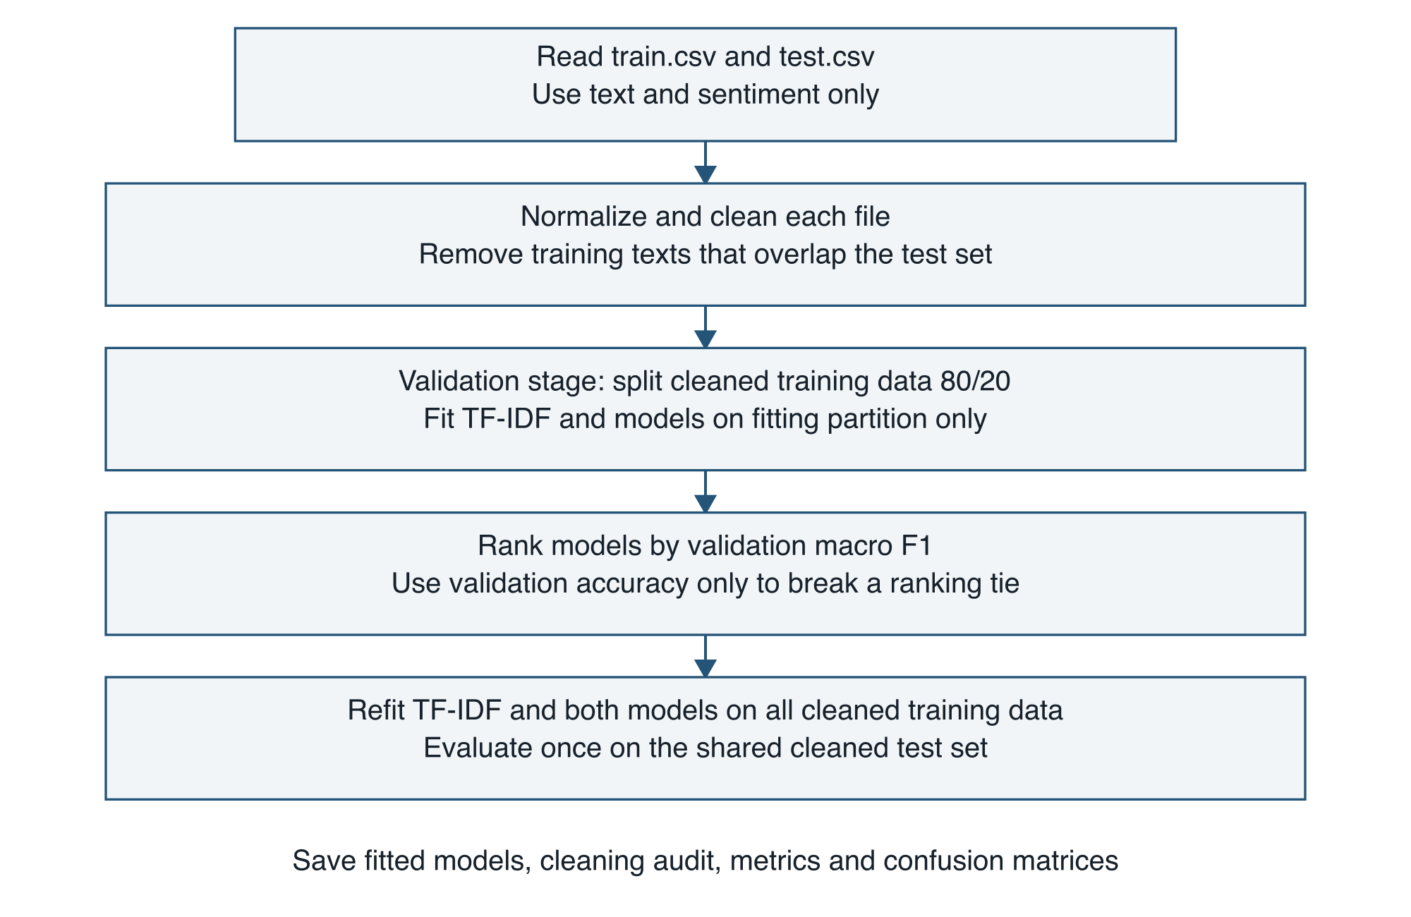
Figure 3.1 Experimental workflow
The model configurations are fixed baselines, not the outcome of a hyperparameter search. Validation determines the priority used when the two model predictions disagree. The external test labels are used for final evaluation and do not determine this priority, the vocabulary, or model parameters.

3.2 Dataset definition and cleaning audit
The input files contain 27,481 training rows and 4,815 test rows. The loader reads only text and sentiment, attempting UTF-8 first and using ISO-8859-1 if decoding fails. Labels are trimmed and lowercased, and the accepted label set is negative, neutral and positive. Text is normalized before duplicate and overlap checks. The counts in Table 3.1 are sequential cleaning losses, not independent estimates.
Table 3.1 Sequential data cleaning audit
Stage | Training rows | Test rows
Raw records | 27481 | 4815
Removed missing or empty text or labels | 1 | 1281
Removed conflicting-label rows | 15 | 0
Removed repeated normalized texts | 74 | 5
Removed training overlap with cleaned test | 24 | Not applied
Final usable records | 27367 | 3529
After removing missing or empty entries, the procedure groups records by normalized text. If identical normalized text has more than one label within a file, all rows in that conflicting group are removed. Remaining repeated normalized texts are deduplicated. This avoids choosing an arbitrary label from a conflicting group or allowing repeated copies to dominate the sample.
Next, normalized training texts that also appear in the cleaned test file are excluded from training. The test records are preserved. This rule uses text identity, not the test labels, and removes 24 additional training rows. It reduces exact overlap but does not establish that paraphrases, near-duplicates, shared authors or related conversations are absent.
The final corpus contains 27,367 training texts and 3,529 test texts. Cleaning does not relabel records or validate the original annotations. The dataset's acquisition and annotation provenance remains unverified, so the analysis is restricted to these supplied records and their labels.

3.3 Class distribution and validation split
Table 3.2 Cleaned corpus class counts
Class | Training | Test | Test share
Negative | 7,762 | 999 | 28.31%
Neutral | 11,088 | 1,429 | 40.49%
Positive | 8,517 | 1,101 | 31.20%
Total | 27,367 | 3,529 | 100.00%
The neutral class is the largest in both partitions, accounting for approximately 40.52% of training records and 40.49% of test records. The remaining observations are divided between negative and positive labels. This distribution makes accuracy useful but incomplete, since a model may gain correct neutral predictions while losing recall for the other classes.
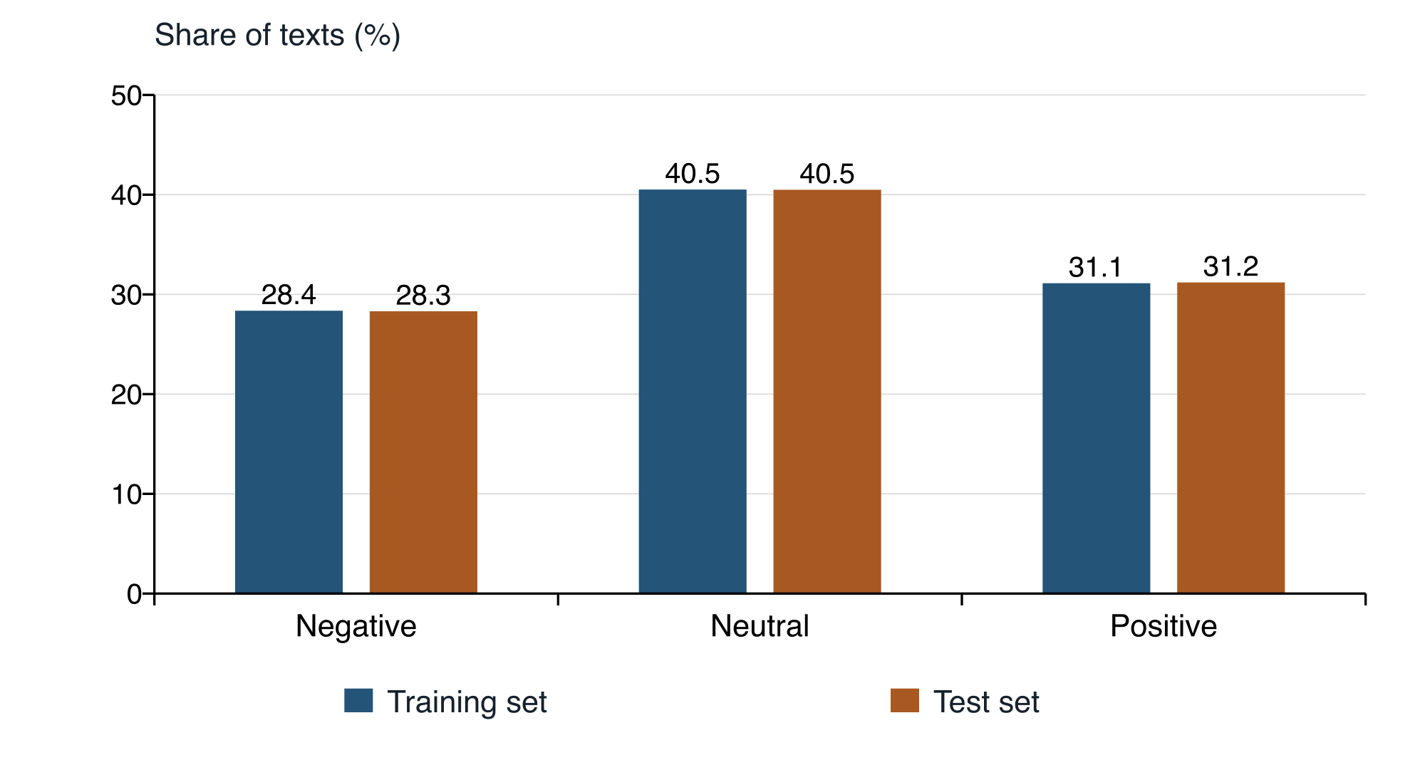
Figure 3.2 Class proportions in the cleaned corpus
For validation, the cleaned training data is split with test_size=0.2, stratify=sentiment and random_state=42. This produces 21,893 fitting records and 5,474 validation records. The vectorizer is fitted on the fitting partition only, and the same fitted transformation is applied to validation text. After ranking, a new vectorizer and new model instances are fitted on all 27,367 training records. The 3,529 test records are used only for the final scores.

3.4 Text normalization
The normalization procedure applies Unicode NFKC normalization, converts text to lowercase, standardizes curly apostrophes and backticks to straight apostrophes, replaces URLs with urltoken, replaces user mentions with usertoken, expands selected negative contractions and collapses repeated whitespace. The same procedure is used for training records, test records and application inputs.
The contractions “can't” and “won't” become “can not” and “will not.” The general ending “n't” becomes “ not.” Retaining an explicit negation token helps preserve the distinction between examples such as “good” and “not good,” although the presence of a token alone does not guarantee that either model will interpret the expression correctly.
Stopwords are retained. Stemming and lemmatization are not applied in this implementation. Punctuation and emoji are also retained as candidate tokens. This policy avoids deliberately deleting expressions that may contribute to sentiment, but the frequency threshold and vocabulary limit can still exclude rare tokens. The system does not contain a dedicated emoji interpretation model.

3.5 TF-IDF feature extraction
TfidfVectorizer uses word unigrams and bigrams, min_df=2, max_features=20000 and sublinear_tf=True. Its token pattern accepts word tokens and individual non-whitespace symbols. Adjacent token pairs provide a limited representation of local context. The final fitted vocabulary contains 20,000 features; features absent from that vocabulary are ignored at prediction time.
For a term with positive count tf in a document, sublinear term frequency is 1 + ln(tf). Smoothed inverse document frequency is ln((1 + N)/(1 + df)) + 1, where N is the number of fitting documents and df is the number containing the term. Their product gives the unnormalized TF-IDF weight. The vectorizer then applies its default L2 normalization [13].
The validation and final training stages use separate vocabulary fits. This prevents validation text from influencing the representation used to rank models. At final evaluation, the shared vectorizer is fitted only on the complete cleaned training set. All model inputs are sparse numerical vectors, not images or learned contextual embeddings.

3.6 Classifier configurations
Table 3.3 Feature and classifier settings
Component | Setting
Shared vectorizer | Unigrams and bigrams; min_df=2; max_features=20000; sublinear_tf=True; L2 normalization
Naive Bayes | MultinomialNB; alpha=0.5; learned class priors
Linear SVM | LinearSVC; C=1.0; balanced class weights; random_state=42
Validation | Stratified 80/20 split of cleaned training data; seed 42
Model selection for voting | Validation macro F1, then validation accuracy

3.6.1 Multinomial Naive Bayes
Multinomial Naive Bayes scores a class using its prior probability and the contribution of each observed feature. Its simplifying assumption is that feature contributions are conditionally independent given the class. The predicted class is the one with the greatest posterior score, not the class whose individual words occur most often. Additive smoothing is set to alpha=0.5; class priors are learned from the training labels [14].
The implementation accepts the non-negative TF-IDF feature values as input. Unigrams and bigrams can supply useful associations, but overlapping features also make the conditional-independence assumption an approximation. The experiment measures the resulting predictions without assuming that these scores are calibrated probabilities of correctness.

3.6.2 Linear Support Vector Machine
LinearSVC learns linear decision functions over the shared TF-IDF features. The implementation uses C=1.0, class_weight="balanced" and random_state=42, with the library's default L2 penalty and squared-hinge loss. Multiclass classification uses one-versus-rest decision functions [15]. The model is a linear classifier and does not use an RBF kernel.
Balanced class weights make the loss contribution depend inversely on class frequency. This changes the training objective and can affect the balance between precision and recall. The study compares this weighted SVM configuration with the specified Naive Bayes baseline; it does not isolate the effect of class weighting from the effect of the classifier family.

3.7 Evaluation measures
Accuracy is the proportion of all test texts that receive the correct label. Precision for a class measures how often predictions of that class are correct. Recall measures how many actual examples of that class are recovered. F1 is the harmonic mean of precision and recall. For each class, true positives, false positives and false negatives are defined by treating that class as the target and the remaining classes as non-targets.
$$Accuracy = \frac{Correct predictions}{All predictions}$$
$$Precision = \frac{True positives}{True positives + False positives}$$
$$Recall = \frac{True positives}{True positives + False negatives}$$
$$F1 = \frac{2 × Precision × Recall}{Precision + Recall}$$
Macro F1 is the arithmetic mean of the three class F1-scores, giving every class equal weight. Weighted F1 averages the same scores in proportion to class support. Weighted precision and recall are calculated in the same support-weighted manner. In this single-label task, weighted recall equals accuracy; it is not an independent confirmation of performance.
A confusion matrix records the number of predictions for each actual and predicted class. Rows represent actual labels and columns represent predictions, consistently ordered as negative, neutral and positive. The diagonal contains correct predictions. Off-diagonal entries identify which labels are confused and support the class-level interpretation in Chapter 5.

3.8 Ranking and voting procedure
Validation macro F1 determines model priority, followed by validation accuracy if needed. An exact tie in both measures follows the fixed displayed model order. Each model casts one vote at inference. Agreement selects the shared label; disagreement produces a one-to-one tie, resolved by the higher-ranked model. With only two models and this rule, the voting output always equals that higher-ranked model. Vote agreement is not a calibrated probability, and no independent ensemble improvement is claimed.

Chapter 4 System Implementation

4.1 Software and project structure
The system is implemented in Python with scikit-learn for modelling, pandas for CSV preparation, joblib for model persistence and Streamlit for the interface. The documented runtime is Python 3.12. The saved evaluation records scikit-learn 1.9.1; the project requirements pin pandas 2.3.3, joblib 1.6.0 and Streamlit 1.64.0. These versions identify the environment expected by the submitted application.
Table 4.1 Main project files
File | Purpose
sentiment.py | Data cleaning, feature extraction, training, evaluation and prediction
app.py | Streamlit interface for single-text predictions
train.csv and test.csv | Input corpus; only text and sentiment are model inputs
artifacts/sentiment.joblib | Saved vectorizer, classifiers and evaluation metadata
artifacts/sentiment.json | Readable cleaning audit, metrics and confusion matrices
requirements.txt | Pinned application dependencies
The training and prediction functions are separated from the interface. Training creates a fitted vectorizer, two fitted classifiers and evaluation metadata. The interface loads the saved artifact rather than fitting a model on each page refresh. The CSV source files remain unchanged because cleaning is performed in memory.
The historical notebooks are retained as exploratory records, but their machine-specific paths and older outputs do not define the current application's results. The experimental configuration described in Chapter 3 is implemented in sentiment.py, and the quantitative findings in Chapter 5 come from the corresponding saved report.

4.2 Training execution
The training entry point prepares the corpus, performs validation, ranks the model configurations, refits both models and the vectorizer, and computes the external test results. Classification reports and confusion matrices are written into the JSON evaluation file. Saving to a temporary artifact before replacing the existing model reduces the chance that an interrupted training run leaves the application with a partly written model file.

4.3 Prediction and interface workflow
Figure 4.1 shows how a new text reaches both models. The prediction function applies the same normalization used during training and transforms the text through the saved vocabulary. It then requests one label from each classifier and applies the voting rule using the stored validation priority.
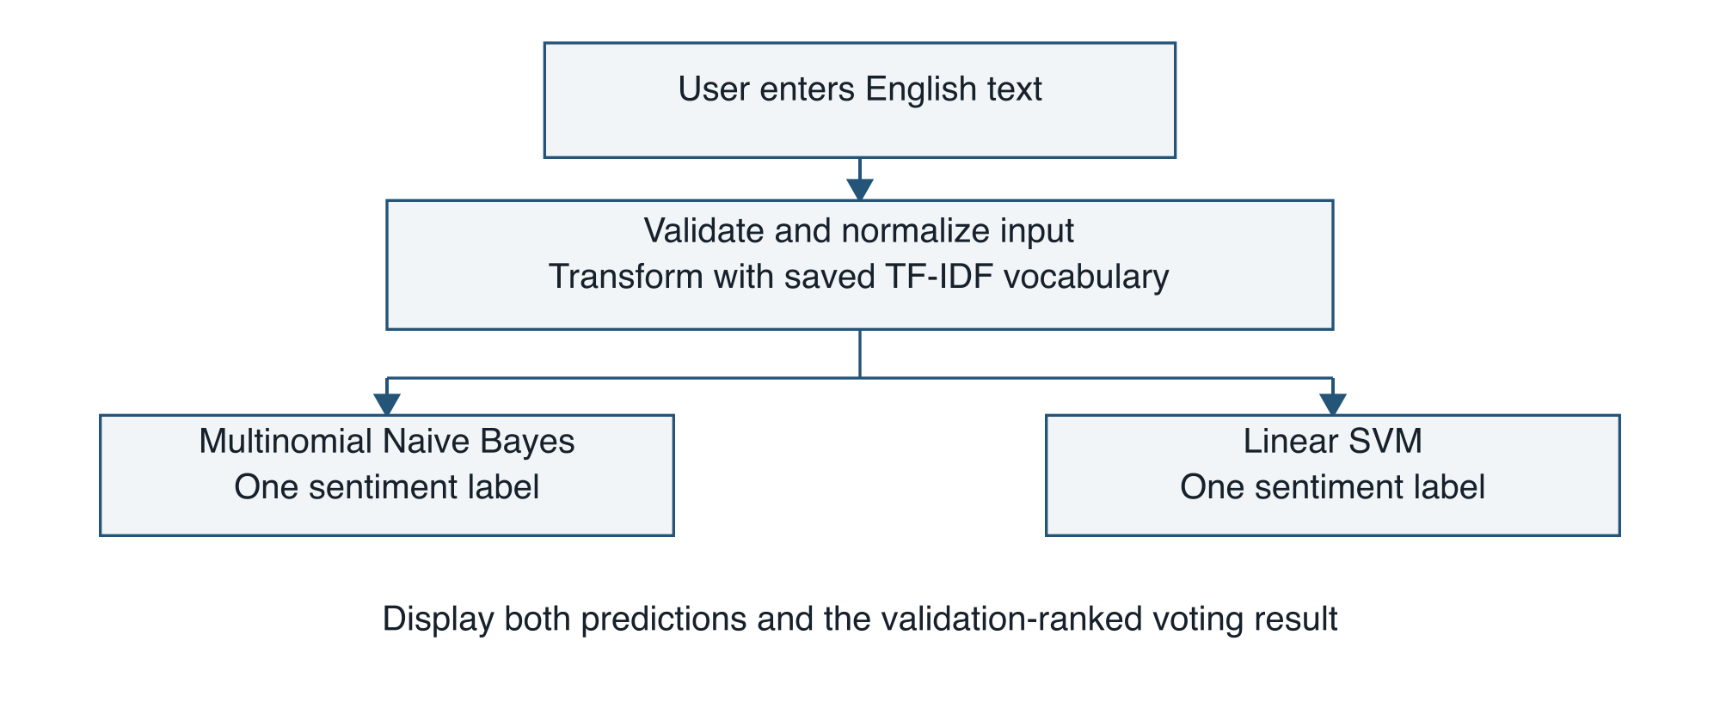
Figure 4.1 Single-text inference workflow
The Streamlit page contains a text area, example inputs, an analysis button and a result panel. Separate model cards show the Naive Bayes and SVM predictions. The result panel displays the selected sentiment, the number of agreeing models and an explanation when a split vote is resolved. A performance panel reports the stored evaluation and explains why two-model voting follows the higher-ranked classifier.
Inputs are limited to 5,000 characters. Empty inputs, inputs without an English alphabetic character and inputs that produce no known vocabulary features are rejected with an explanatory message. The alphabetic-character check is a basic validation rule rather than a complete language detector. Mixed-language content may still pass the check and remains outside the evaluated scope.
The interface clears a previous result when the input changes so that an older prediction is not presented as the result for newly entered text. The current application accepts one text at a time and does not provide file upload or batch analysis. It does not save submitted text to disk through its prediction path. These implementation properties describe the demonstration and are not evidence of measured deployment performance.

4.4 Model persistence and consistency
The saved joblib artifact contains the vectorizer, both estimators and the evaluation report. The report includes the training timestamp, scikit-learn version, random seed, cleaning audit, validation scores, ranking and test scores. Storing these objects together preserves the relationship between the vocabulary expected by a classifier and the classifier's learned parameters.
Loading checks the artifact schema, recorded scikit-learn version and expected model names. A missing, incompatible or outdated artifact requires retraining. Because joblib uses pickle-based persistence, the loader is intended for locally generated model files. The user interface does not accept uploaded model artifacts.

4.5 Verification of the reported experiment
The evaluation artifact records a training time of 7 October 2026 at 18:12:17 UTC. During verification of the thesis results, the stored models were loaded and applied to the cleaned current test file. The cleaning audit, accuracy values, classification reports and confusion matrices matched the saved report. This check confirms consistency between the available data, fitted models and reported test metrics; it is not a repeated-training or cross-validation study.
No model retraining is required to open the application once a compatible artifact exists. Training is required when the data, preprocessing, model settings or scikit-learn version change. A reproducible rerun must use the same input files and dependency versions, not merely the same model names. Appendix A lists the commands and configuration needed to reproduce the workflow.

4.6 Implementation boundaries
The system returns categorical predictions and does not provide calibrated probabilities, explanations of individual feature contributions or an abstention mechanism for uncertain text. Agreement between two models can be displayed, but agreement alone does not establish correctness. Both models may rely on related lexical features and can make the same mistake.
The project does not report measured training time, inference latency, peak memory use or throughput. Consequently, claims about speed, scalability or suitability for low-resource deployment are treated as questions for further measurement. The working interface demonstrates the use of saved classifiers; it does not establish service-level performance or robustness under operational traffic.

Chapter 5 Results and Discussion

5.1 Evaluation basis and validation results
All final comparisons in this chapter use the same 3,529 cleaned test records. Both models are fitted on the same 27,367 cleaned training records and use the same final TF-IDF feature matrix. Their different learning algorithms and specified configurations are described in Chapter 3. Reported decimal metrics are rounded to four places and accuracy is expressed as a percentage.
Table 5.1 Validation results on 5474 records
Model | Accuracy | Macro F1 | Rank
Naive Bayes | 64.74% | 0.6433 | 2
Linear SVM | 67.81% | 0.6814 | 1
The SVM has the higher validation macro F1 and is therefore ranked first. Its validation accuracy is also higher, so no ranking tie occurs. The priority is established before evaluating the external test labels. Validation scores describe models fitted on 21,893 records; final test scores describe new model instances fitted on all 27,367 training records. They are therefore different stages of the experiment.

5.2 Overall test performance
Table 5.2 Test performance on the same 3529 records
Model | Accuracy | Macro F1 | Weighted F1
Naive Bayes | 67.07% | 0.6701 | 0.6707
Linear SVM | 68.35% | 0.6868 | 0.6836
Voting result | 68.35% | 0.6868 | 0.6836
The SVM achieves 68.35% test accuracy compared with 67.07% for Naive Bayes, an absolute difference of approximately 1.28 percentage points. Macro F1 increases from 0.6701 to 0.6868. These are modest observed improvements under the stated configuration. They do not establish universal superiority or statistical significance across alternative samples, domains or training runs.
Predicting neutral for every test record would yield 40.49% accuracy because 1,429 of the 3,529 reference labels are neutral. This is an analytically calculated majority-class reference, not an additional fitted classifier. Both evaluated models exceed it, but their error rates remain substantial.

5.3 Naive Bayes performance
Table 5.3 Naive Bayes classification report
Class or average | Precision | Recall | F1 | Support
Negative | 0.7460 | 0.5586 | 0.6388 | 999
Neutral | 0.5881 | 0.7705 | 0.6671 | 1,429
Positive | 0.7789 | 0.6431 | 0.7045 | 1,101
Macro Avg | 0.7043 | 0.6574 | 0.6701 | 3,529
Weighted Avg | 0.6923 | 0.6707 | 0.6707 | 3,529
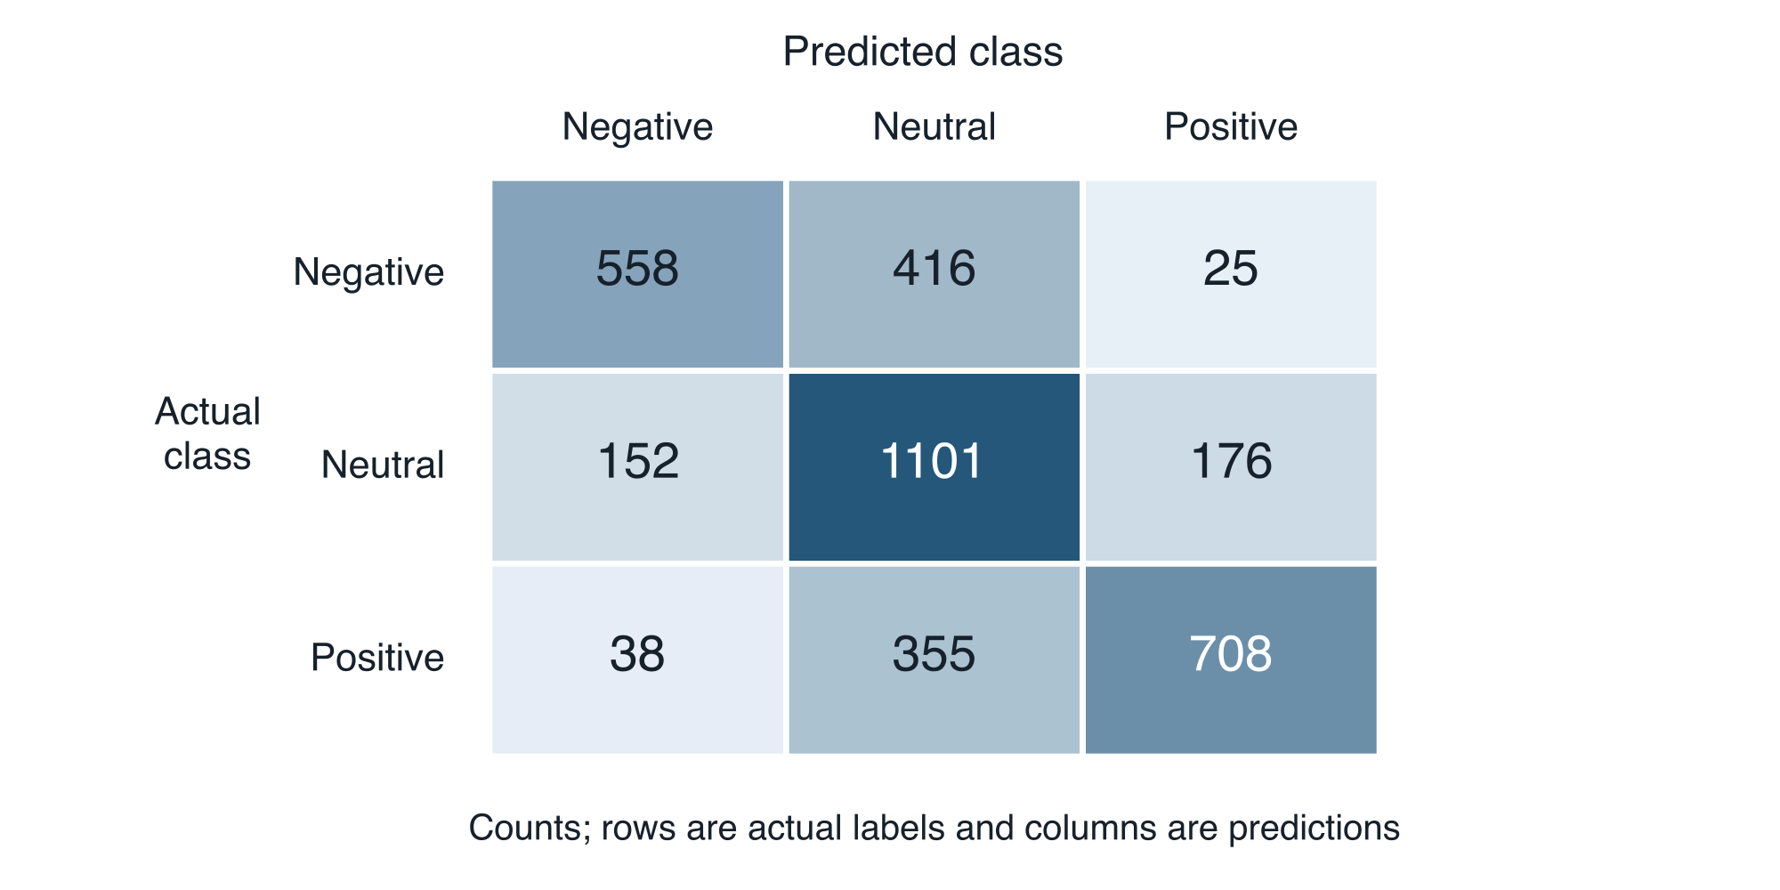
Figure 5.1 Naive Bayes confusion matrix
Naive Bayes correctly classifies 2,367 test records. It recovers 558 of 999 negative texts, 1,101 of 1,429 neutral texts and 708 of 1,101 positive texts. The neutral class has the highest recall, while positive predictions have the highest precision. Negative recall is only 55.86%, so 441 actual negative examples receive another label.
The model predicts neutral for 1,872 records, considerably more than the 1,429 actual neutral records. This total includes 416 negative texts and 355 positive texts assigned to neutral. The matrix supports a conclusion that this configuration favours neutral predictions. It does not by itself prove that sarcasm or a particular linguistic construction caused these errors; that explanation would require an annotated analysis of the misclassified texts.

5.4 Linear SVM performance
Table 5.4 Linear SVM classification report
Class or average | Precision | Recall | F1 | Support
Negative | 0.6670 | 0.6677 | 0.6673 | 999
Neutral | 0.6450 | 0.6473 | 0.6462 | 1,429
Positive | 0.7489 | 0.7448 | 0.7468 | 1,101
Macro Avg | 0.6870 | 0.6866 | 0.6868 | 3,529
Weighted Avg | 0.6837 | 0.6835 | 0.6836 | 3,529
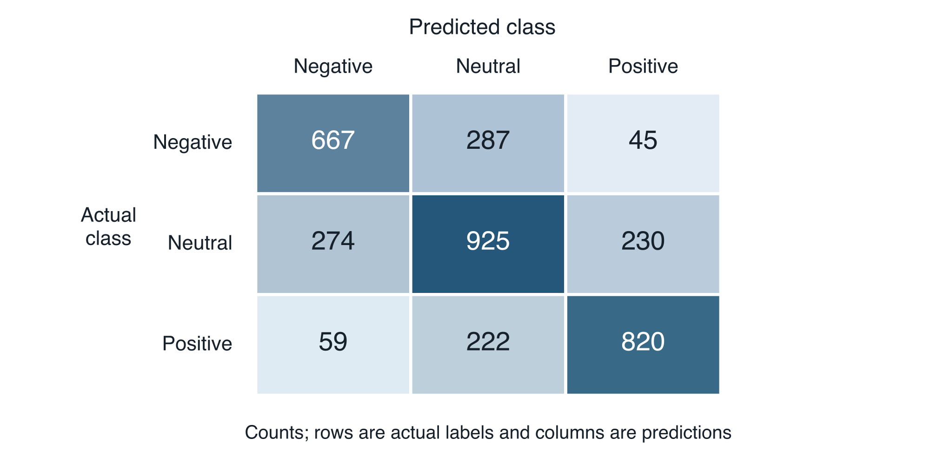
Figure 5.2 Linear SVM confusion matrix
The SVM correctly classifies 2,412 test records: 667 negative, 925 neutral and 820 positive. Compared with Naive Bayes, it makes 109 more correct negative predictions and 112 more correct positive predictions, but 176 fewer correct neutral predictions. The net gain is 45 correct predictions on the common test set.
Negative recall rises to 66.77%, while positive recall rises to 74.48%. Neutral recall falls to 64.73%. SVM still misses 332 of the 999 negative texts. Its positive-class F1 is higher than Naive Bayes, and its negative-class F1 is also higher, but its neutral-class F1 is lower. These differences show why the overall result should not be described as an improvement on every class and every metric.

5.5 Class-level trade-offs
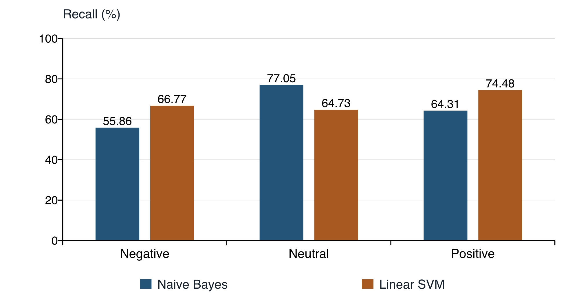
Figure 5.3 Recall by sentiment class
The SVM improves negative recall by 10.91 percentage points and positive recall by 10.17 percentage points, while reducing neutral recall by 12.32 percentage points. Negative precision falls from 74.60% to 66.70%, indicating that the higher negative recall comes with more false positives for the negative class. In the confusion matrices, neutral texts predicted as negative increase from 152 to 274.
The larger neutral class helps explain why improved recovery of the two non-neutral classes produces only a small overall accuracy gain. Macro F1 gives equal importance to each class, while weighted metrics give more influence to larger classes. Neither averaging rule removes the need to inspect the class-level results.
The balanced class weights used by SVM are a plausible contributor to these trade-offs because they change how class errors are penalised during fitting. However, this experiment does not include an otherwise identical unweighted SVM. It therefore cannot attribute the observed differences to weighting alone. The results apply to the complete configurations, including their feature representation and model settings.
The appropriate choice depends on the intended use. A task that prioritises recovering negative examples may prefer the observed SVM trade-off. A task that prioritises neutral recall may value the Naive Bayes result. Such choices require an application-specific assessment of error costs and an evaluation corpus representative of that application.

5.6 Voting result and interpretation
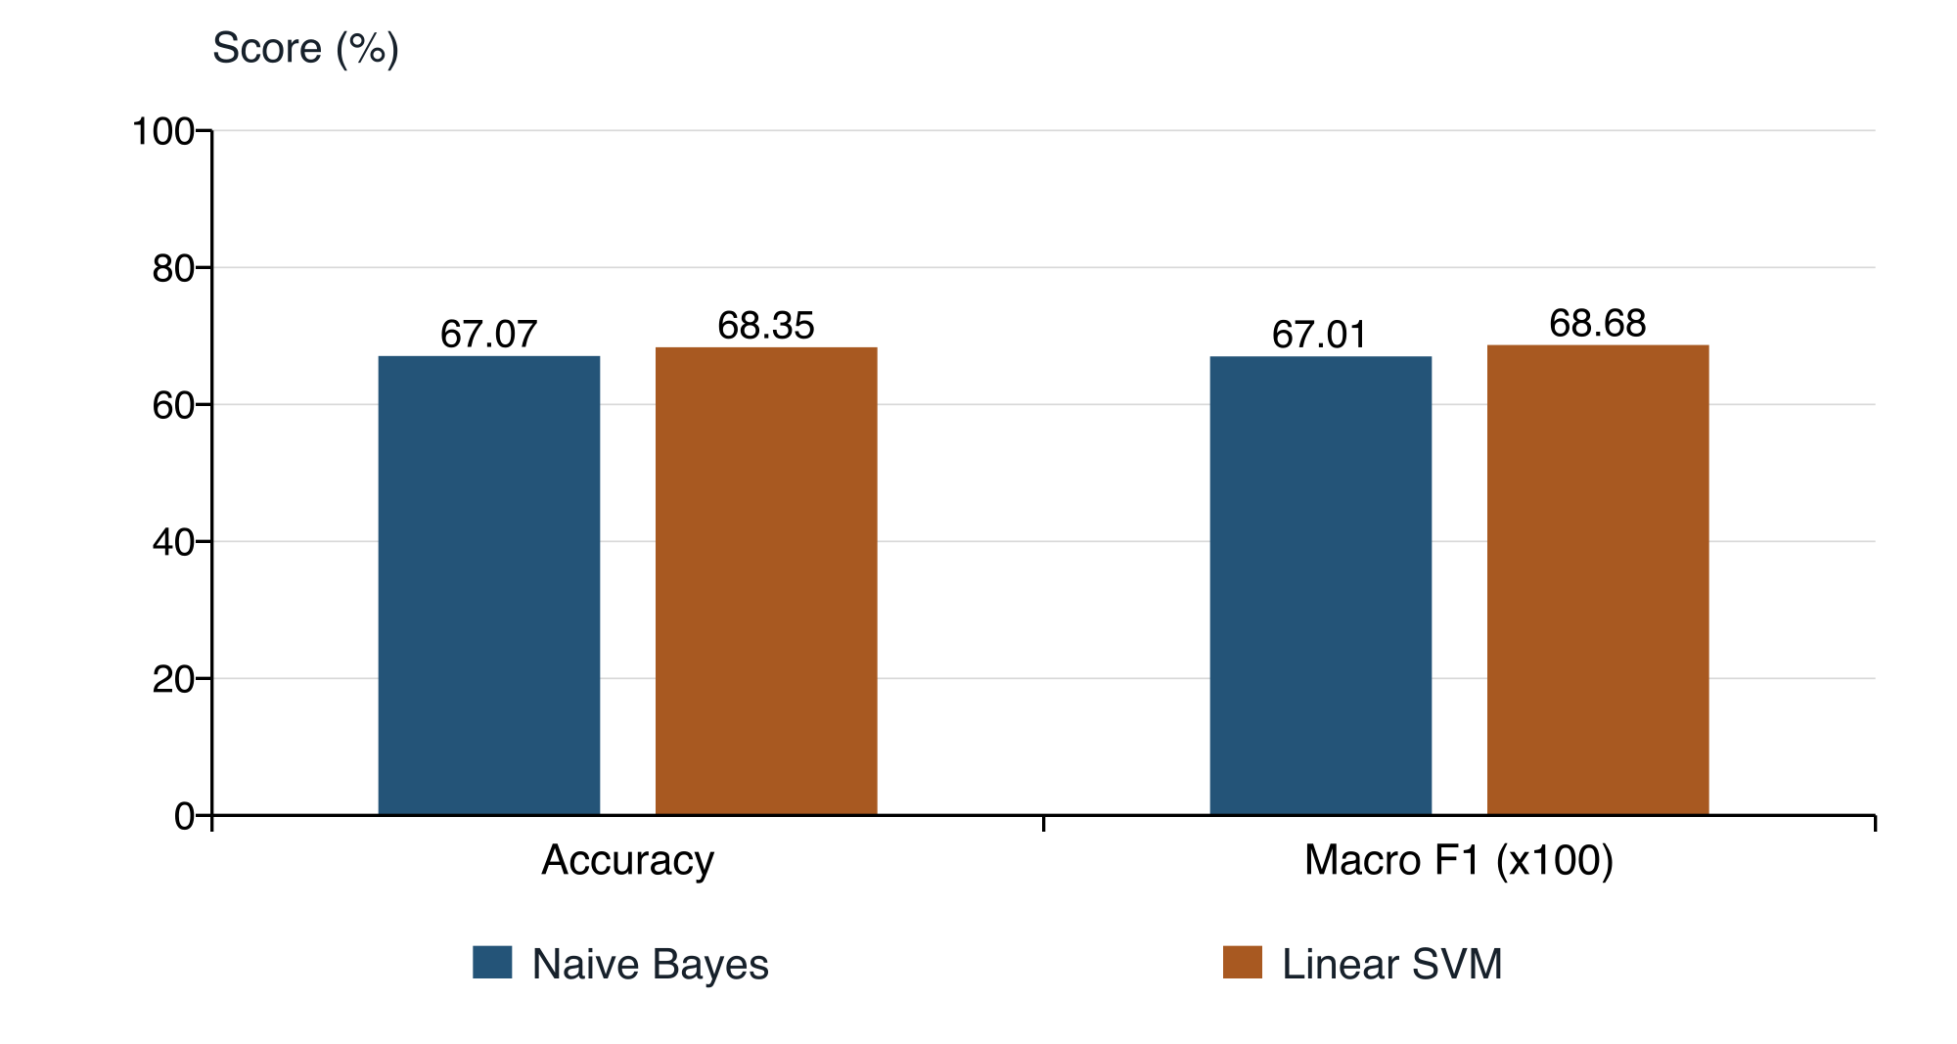
Figure 5.4 Overall test scores
The voting procedure produces exactly the same predictions and scores as SVM. Agreement already selects SVM's label, while disagreement is resolved by SVM's higher validation rank. The two-model rule therefore never selects a different label from SVM.
The display shows agreement and disagreement without demonstrating an ensemble improvement. An additional model or a different combination rule would require validation and a separate final evaluation. The final test labels must remain outside the selection process.

5.7 Limitations of the results
The experiment uses one supplied corpus, one validation split and one external test file. It does not report cross-validation, repeated-seed variability, confidence intervals or a paired significance test. The 1.28 percentage-point accuracy difference should therefore be interpreted as an observed difference on this test set, without a claim of statistical significance.
The corpus provenance and annotation process are unverified. Exact normalized-text overlap is removed, but semantic duplication and related records may remain. No demographic fairness, temporal robustness, cross-domain transfer or multilingual evaluation is performed. The confusion matrices describe label errors but do not establish their linguistic causes. These constraints limit generalisation to practical deployments beyond the supplied corpus.

Chapter 6 Conclusion and Future Scope

6.1 Conclusions
This study compares Multinomial Naive Bayes and a linear Support Vector Machine for negative, neutral and positive sentiment classification. A common workflow cleans the supplied corpus, preserves negation and punctuation as candidate features, builds unigram and bigram TF-IDF representations, and evaluates both models on the same held-out texts. Documenting the cleaning audit and model configuration makes the comparison traceable to the implemented system.
The final training set contains 27,367 records, and the shared test set contains 3,529. Naive Bayes achieves 67.07% accuracy and 0.6701 macro F1. SVM achieves 68.35% accuracy and 0.6868 macro F1. Thus, the specified SVM configuration provides a modest overall improvement on this corpus. The difference is 45 additional correct predictions, or approximately 1.28 percentage points in accuracy.
The class-level results qualify that finding. SVM increases recall for negative and positive texts while reducing neutral recall. Naive Bayes has higher negative and positive precision, whereas SVM has higher neutral precision. Consequently, the experiment supports a trade-off between configurations rather than the claim that one model is better on every measure. The choice should reflect the cost of different errors in the intended application.
The two-model voting output is identical to SVM because validation ranks SVM first and the voting rule uses it to resolve disagreement. The interface makes the individual predictions visible, but the voting result does not constitute an independent performance gain. It should be described as a presentation and selection rule rather than a separately learned classifier.
The principal outcome is a documented baseline comparison and a working single-text demonstration. The evidence does not establish robustness across datasets, annotation schemes, languages or deployment conditions. In particular, unverified corpus provenance and the absence of repeated evaluation limit broader conclusions. These limitations guide the further work proposed in the next section.

6.2 Future scope
Future work should begin with a corpus whose acquisition, permitted use, sampling design and annotation procedure are documented. A label audit, a review of ambiguous examples and an assessment of inter-annotator agreement would help distinguish model errors from uncertain reference labels. Duplicate detection could also be extended beyond exact normalized text to related comments, repeated authors or near-identical content where such information is legitimately available.
The next experimental stage should compare models under a stronger validation design. Repeated stratified evaluation or cross-validation can estimate sensitivity to the split, while a protected external test set can retain a clear final assessment role. Paired prediction records would support an appropriate significance analysis of model differences. Hyperparameters should be selected within the training procedure, not by repeated inspection of the final test results.
Ablation experiments would help explain which implementation choices matter. Examples include comparing unigrams with unigrams and bigrams, testing the effect of retaining negation and punctuation, varying the vocabulary limit, and comparing weighted with unweighted SVM. The present results do not isolate these factors. Each proposed change should be tested with the same evaluation rules and reported with class-level measures.
Contextual encoders such as BERT [9] provide a further baseline for comparison with sparse TF-IDF representations. A meaningful study would measure both predictive performance and computational requirements, rather than assuming that a more complex model is automatically preferable. Cross-domain and multilingual extensions should likewise use suitable labelled evaluation sets before expanding the application's claims.
Finally, the demonstration could be extended with calibrated confidence estimates, an option to abstain on uncertain inputs, measured latency and throughput, and a carefully designed batch interface. Any revised ensemble should have a documented validation rule and demonstrate a benefit beyond its strongest constituent model. These extensions would address specific limitations while preserving the distinction between an interactive demonstration and an independently validated deployment.

References
[1] B. Pang, L. Lee and S. Vaithyanathan, “Thumbs up? Sentiment Classification using Machine Learning Techniques,” Proceedings of EMNLP, pp. 79–86, 2002. https://aclanthology.org/W02-1011/
[2] B. Pang and L. Lee, “Opinion Mining and Sentiment Analysis,” Foundations and Trends in Information Retrieval, vol. 2, nos. 1–2, pp. 1–135, 2008. doi: 10.1561/1500000001
[3] M. Hu and B. Liu, “Mining and Summarizing Customer Reviews,” Proceedings of the Tenth ACM SIGKDD International Conference on Knowledge Discovery and Data Mining, pp. 168–177, 2004. doi: 10.1145/1014052.1014073
[4] S.-M. Kim and E. Hovy, “Determining the Sentiment of Opinions,” Proceedings of COLING, pp. 1367–1373, 2004. https://aclanthology.org/C04-1200/
[5] A. Pak and P. Paroubek, “Twitter as a Corpus for Sentiment Analysis and Opinion Mining,” Proceedings of the Seventh International Conference on Language Resources and Evaluation, 2010. https://aclanthology.org/L10-1263/
[6] M. Taboada, J. Brooke, M. Tofiloski, K. Voll and M. Stede, “Lexicon-Based Methods for Sentiment Analysis,” Computational Linguistics, vol. 37, no. 2, pp. 267–307, 2011. doi: 10.1162/COLI_a_00049
[7] C. D. Manning, P. Raghavan and H. Schütze, Introduction to Information Retrieval. Cambridge University Press, 2008. https://nlp.stanford.edu/IR-book/
[8] F. Pedregosa et al., “Scikit-learn: Machine Learning in Python,” Journal of Machine Learning Research, vol. 12, pp. 2825–2830, 2011. https://www.jmlr.org/papers/v12/pedregosa11a.html

References continued
[9] J. Devlin, M.-W. Chang, K. Lee and K. Toutanova, “BERT: Pre-training of Deep Bidirectional Transformers for Language Understanding,” Proceedings of NAACL-HLT, vol. 1, pp. 4171–4186, 2019. https://aclanthology.org/N19-1423/
[10] W. Zhang, Y. Deng, B. Liu, S. J. Pan and L. Bing, “Sentiment Analysis in the Era of Large Language Models: A Reality Check,” arXiv:2305.15005, 2023. https://arxiv.org/abs/2305.15005
[11] P. N. Venkit, M. Srinath, S. Gautam, S. Venkatraman, V. Gupta, R. J. Passonneau and S. Wilson, “The Sentiment Problem: A Critical Survey towards Deconstructing Sentiment Analysis,” arXiv:2310.12318, 2023. https://arxiv.org/abs/2310.12318
[12] H. Yang, Y. Zhao, Y. Wu, S. Wang, T. Zheng, H. Zhang, Z. Ma, W. Che and B. Qin, “Large Language Models Meet Text-Centric Multimodal Sentiment Analysis: A Survey,” arXiv:2406.08068, 2024. https://arxiv.org/abs/2406.08068
[13] Scikit-learn developers, “TfidfVectorizer,” scikit-learn 1.9.1 documentation. Accessed 10 October 2026. https://scikit-learn.org/stable/modules/generated/sklearn.feature_extraction.text.TfidfVectorizer.html
[14] Scikit-learn developers, “MultinomialNB,” scikit-learn 1.9.1 documentation. Accessed 10 October 2026. https://scikit-learn.org/stable/modules/generated/sklearn.naive_bayes.MultinomialNB.html
[15] Scikit-learn developers, “LinearSVC,” scikit-learn 1.9.1 documentation. Accessed 10 October 2026. https://scikit-learn.org/stable/modules/generated/sklearn.svm.LinearSVC.html

Appendix A Reproduction Procedure

A.1 Environment and commands
The following commands describe the project workflow. They are run from the project directory after creating a Python 3.12 virtual environment. Training regenerates the saved artifacts; launching the interface reuses them. The original CSV files are read without modification.
python3.12 -m venv .venv
source .venv/bin/activate
python -m pip install -r requirements.txt
python sentiment.py --train
python -m streamlit run app.py
For a terminal prediction, run python sentiment.py --text "I really enjoyed this!". The example is an input demonstration, not a reported test case or a guarantee of a particular label.

A.2 Artifact and data checks
The evaluation used in this thesis is the saved report dated 7 October 2026 at 18:12:17 UTC, with random seed 42 and scikit-learn 1.9.1. A reproduction should recover the cleaning totals, 5,474 validation rows, SVM-first validation ranking, 3,529 final test rows and the confusion matrices in Figures 5.1 and 5.2. A change in these checks indicates that the data, environment or implementation differs.
The saved joblib artifact contains locally trained Python objects and must be loaded only from a trusted project copy. A change of scikit-learn version requires retraining. Exact package versions are listed in requirements.txt, and the estimator settings are specified in Table 3.3.

A.3 Interpretation of historical files
The original nb.ipynb uses train.csv and test.csv, whereas svm.ipynb uses the separate 499-row sen1.csv dataset. Their historical accuracy values are not used as the controlled comparison in this thesis. The current sentiment.py workflow supplies both classifiers with the same cleaned training and test partitions. Platform and year plots derived from sen1.csv are therefore outside the reported experiment.

Appendix B Publication Record
Research paper: “Sentiment Analysis Using Machine Learning Classifiers”.
Author: Soliha Mohi Ud Din. The supplied certificate names the author as Soliha Mohi ud Din.
Journal: International Journal for Research in Engineering Application & Management. The certificate records Volume 11, Issue 08, November 2025.
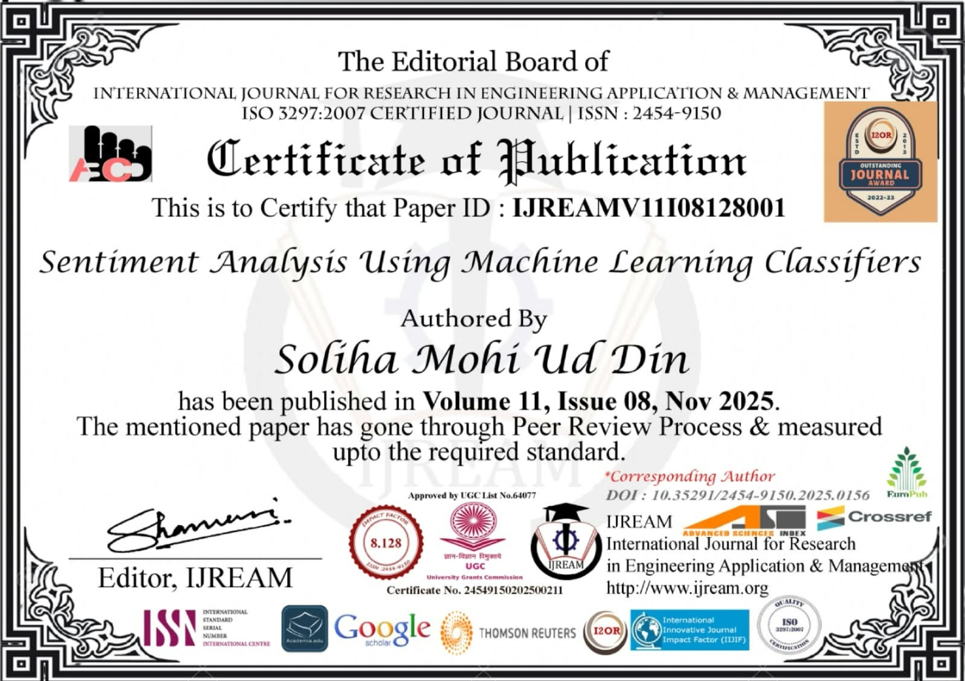
Certificate of publication reproduced from the supplied thesis.
This certificate documents the earlier publication record. The updated model evaluation in Chapters 3 to 6 is dated October 2026 and is not represented as a result certified by the November 2025 publication. The certificate image is preserved without alteration.

