The code generates a district-level summary of several data about academic achievement and test results for students. The indicators include the overall passing percentage, average math and reading scores, number of schools and students, total budget, and proportion of children passing the math and reading tests. The code also generates a summary at the school level using indicators, such as school type, budget, per student spending, average test scores, and math and reading test passing percentages.

The two conclusions about this challenge are that the average math and reading exam scores of a school are positively correlated with its funding. Average test results in both areas are generally higher in schools with bigger budgets, which shows that resources and financing may have an impact on them.

The district’s overall passing rate is defined by the proportion of children who pass both math and reading is quite low. This shows that there is space for improvement in the district's educational system and that more funding, assistance, and instructional initiatives would be required to help more students pass both subjects.

The following part explains the objective and result of this challenge with the result obtained

This Challenge was divided technically in 10 sections with a lot of values that had to be obtained. To begin with, the first sections was about creating a path for the two dataset and then merging them. After that, the table with the information was printed. 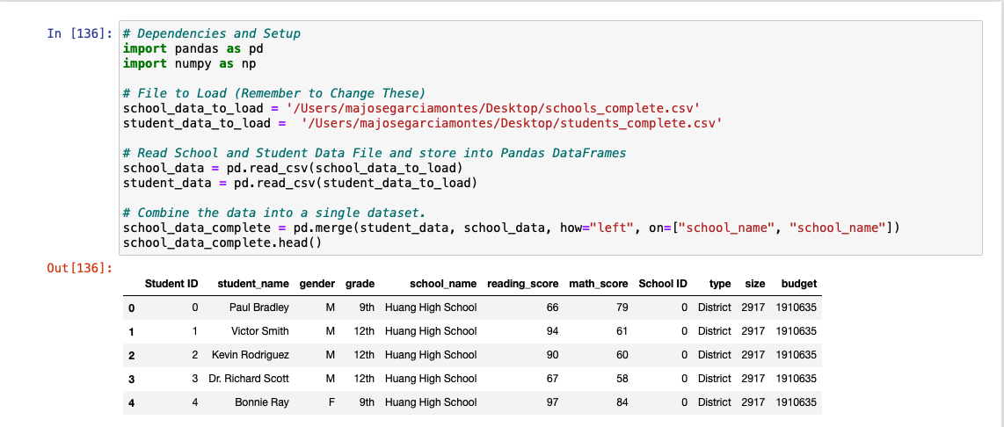

The second part, consisted in calculating the following information:

* Total number of unique schools
* Total students
* Total budget
* Average math score
* Average reading score
* % Passing math (the percentage of students who passed math)
* % Passing reading (the percentage of students who passed reading)
* % Overall passing (the percentage of students who passed math AND reading)

After that, these where the results obtained:

In the next section, the objective was to Perform the necessary calculations and then create a DataFrame that summarizes key metrics about each school.

Include the following:

* School name
* School type
* Total students
* Total school budget
* Per student budget
* Average math score
* Average reading score
* % passing math (the percentage of students who passed math)
* % passing reading (the percentage of students who passed reading)
* % overall passing (the percentage of students who passed math AND reading)

The results obtained were the following: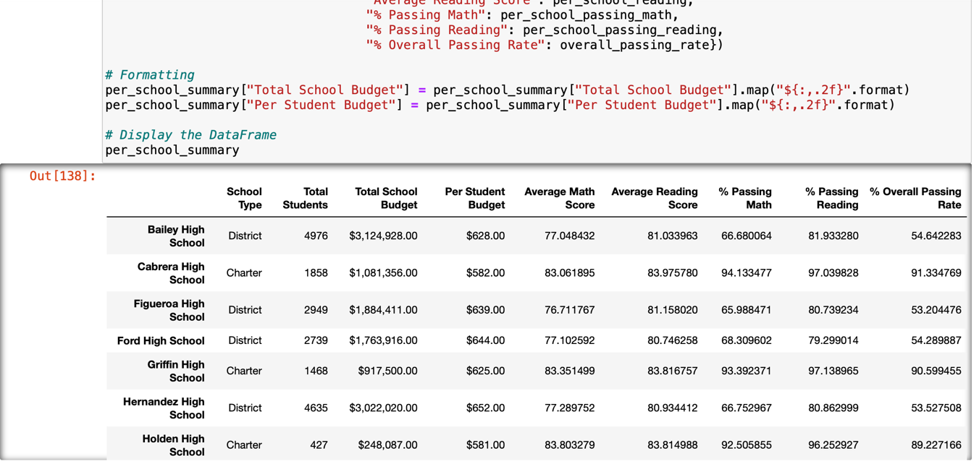

Then, we were asked to sort the schools by the percentage in descending and ascending order, and to print 5 rows. This were the results obtained:

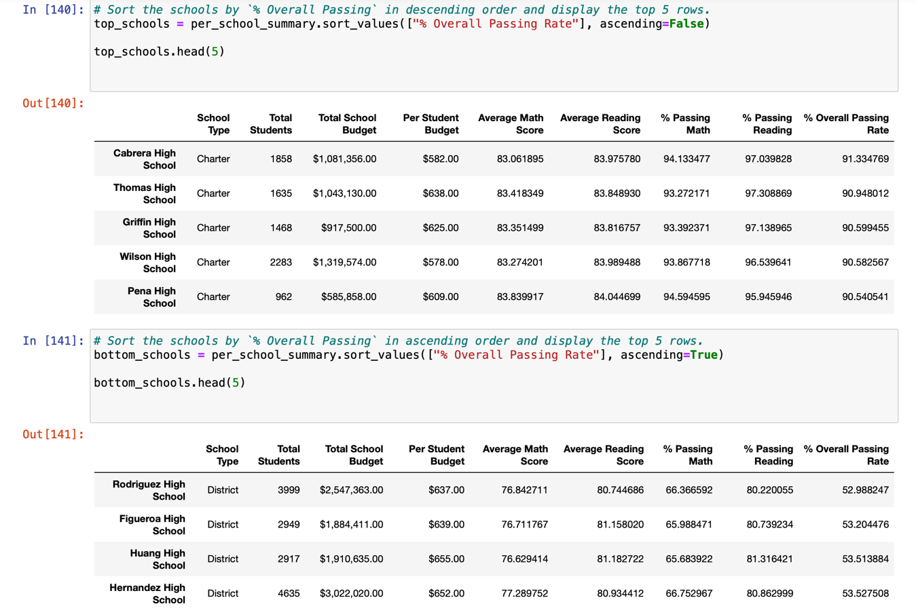

After that, the calculations to create a DataFrame that lists the average math and reading scores for students of each grade level (9th, 10th, 11th, 12th) at each school where obtained. These were the results:

(MATH)

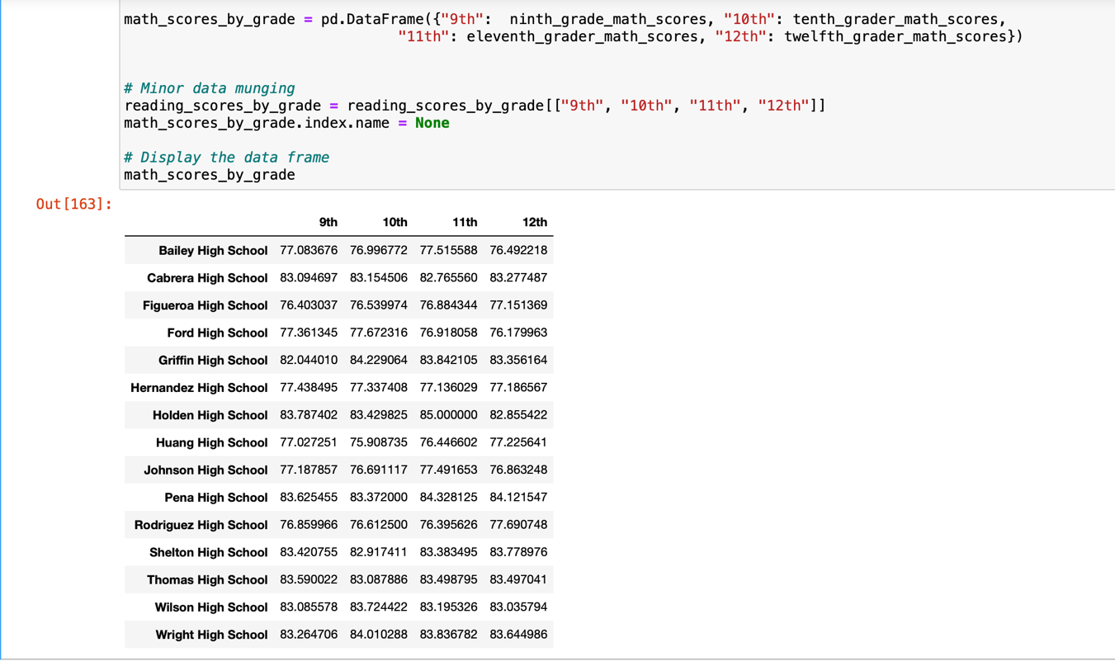

(READING)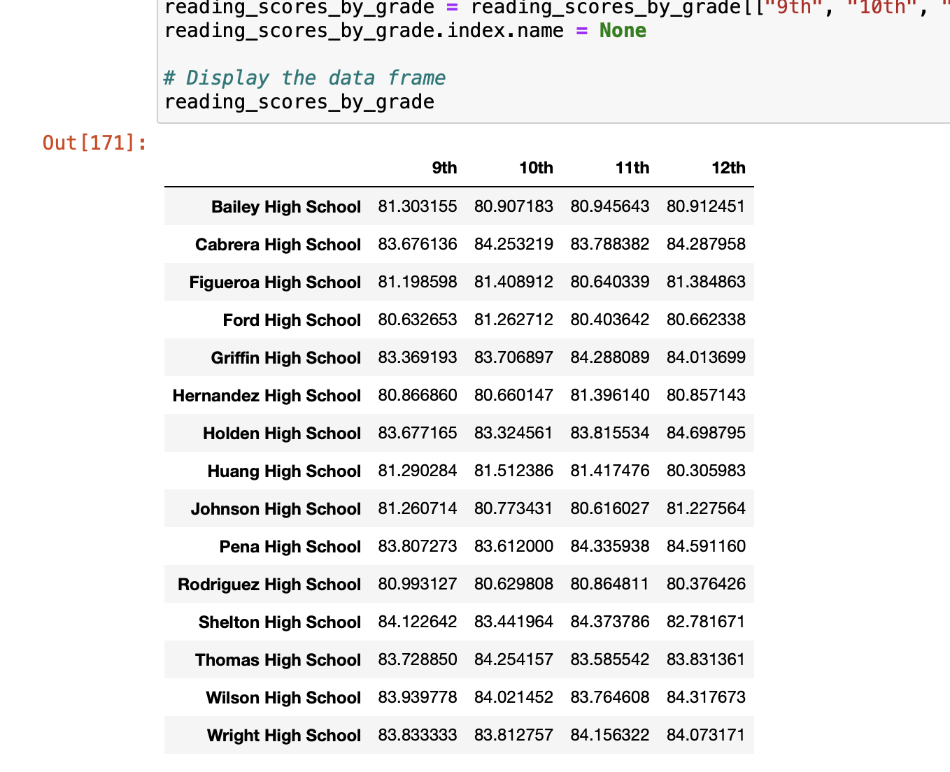

Then, a code for defining the spending bins and label it for categorizing the schools was created. After doing that, the values of Average math score, Average reading score, % passing math, % passing reading % overall passing where obtained. The different sized obtained where the following:

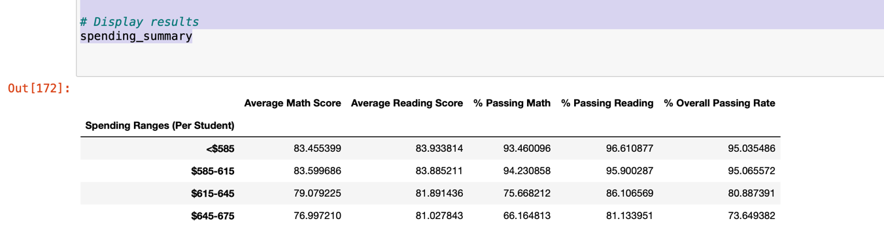

After that, a code for defining the size bins for categorizing the schools and labeled each bin range was obtained. After doing that, the values of Average math score, Average reading score, % passing math, % passing reading % overall passing where obtained. The different sized obtained where the following:

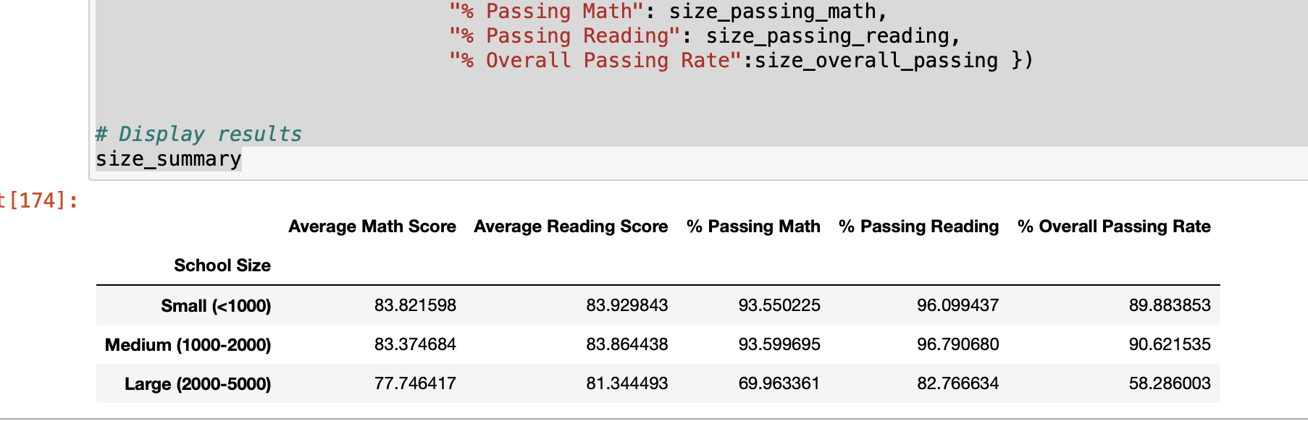

Finally, the las section consisted in creating a new DataFrame that shows school performance based on the "School Type". The results obtained where the following:

