Persistence Overview
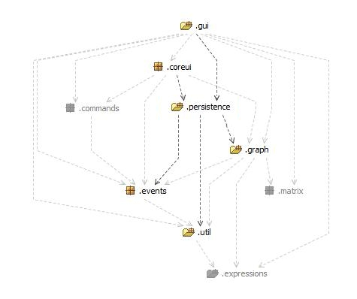Illustration 1: Persistence's location within the framework.
Illustration 1 provides a view of how persistence is located within the framework, its dependencies and modules that depend on it. Obviously the user interface is dependent on the persistence module being present for the ability to save or load neural networks which have been designed within the application. Persistence depends on the model of these networks, a few core utilities and events for serialization and de-serialization of networks. This is coherent with the low coupling design of the framework.

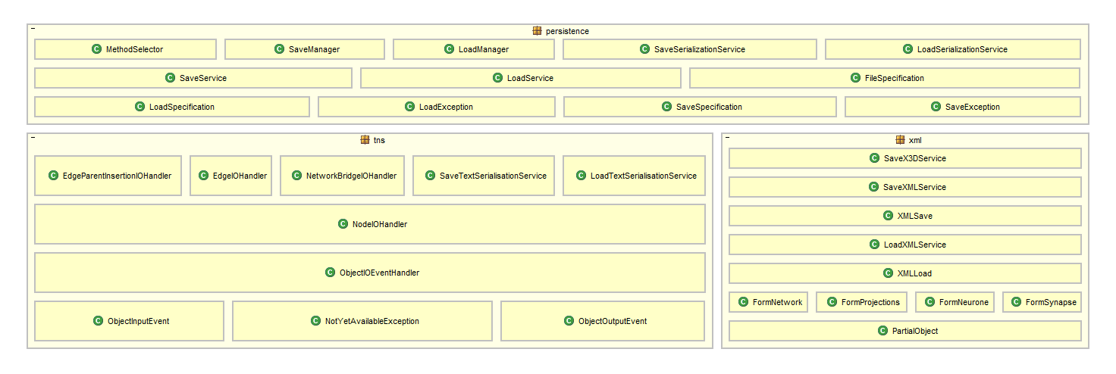Illustration 2: Persistence Modules Implementation.
Illustration 2 is an overview of all the classes and interfaces within the Persistence module and their package separation. XML and TNS have their own packages as they required specific classes for their implementation, where Java Serialization makes use of the in built Java ability to serialization objects to a persistable storage location, X3D is dependent on XML but required no other classes apart from its own for its persistence.
Persistence Design
The persistence layer has been designed like many aspects of the application to be completely plug-able with new extension, adding a plug-in requires no existing code to be changed and your new plug-in to extend the SaveService for saving networks and LoadService for loading networks, these abstract classes provide the method headers for creating persistence services. A new plug-in doesn't have to implement both loading and saving, as in the case with the X3D service which is only available for exporting networks too.
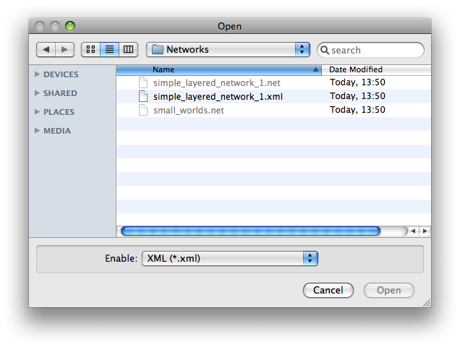Figure 1: View of Open Dialogue, Available files are highlighted.
A number of persistence plug-ins are provided with the standard distribution, they are:
- Java Serialization – the network is serialized using the Java Serializable interface, this is used as the default persistence option and preferred over the other modules, especially when not transporting the neural network to another application. This is because it is extremely fast and guarantees that all information is persisted and that will be able to be loaded again. As the serialized network is the actual objects of our implementation, the only applications that would be able to make use of this format is one which uses our classes for network representation. Files are given the .net extension.
- NeuroML (XML) – this is the main persistence module for exporting to a number of other applications that also support the NeuroML Layer 3 Network Schema for representing in neural networks. Import is also supported for taking NeuroML for other applications that also use this schema, allowing for some cross-application computability. The XML that is generated is well-formed and NeuroML validated, meaning that other applications should accept this format without errors. Files are given the .xml extension.
- TextNetworkSerializer – is a simple export and import specification which outputs records of all the objects into ASCII format for storage, it is however a non-standard format which is only implemented by our application so it cannot be used for exporting to or importing from other application. It does however have a low storage overhead compared to XML as records are separated by new lines and values by commas. Files are given the .tns extension.
- X3D – is a royalty-free open standards file format and run-time architecture to represent and communicate 3D scenes and objects using XML. We implemented only an export feature to X3D as applications that implement this standard are designed for viewing, not modelling items, also the feature is implemented by an XSL transformation from our NeuroML that is generated and we chose not to implement an XSLT for transforming from X3D to NeuroML. Files are given the .x3d extension.

Further plug-ins for persistence which would expand the project could include PyNN and the Neural Network Tool within Matlab.
Persistence Implementation
As previously mentioned with the highly pluggable architecture, loading and saving is abstract out as far as possibly into plug-ins, all loading and saving is handled by their respective managers which is the last point in the chain of the core system before becoming plug-ins. Its the managers job to take a load or save specification which includes information about where to write or read too and also which plug-in to use to perform the persistence operation. The manager then loads the required plug-in before making the appropriate method calls.

Networks must be saveable and/or serializable to be used with the SaveManager and save plug-ins, further still any object that has parameters or variables that require being persisted to storage must have them annotated with the annotation @persistable, this is for when an object is being persisted it, reflection can be used to retrieve all information from the object that needs to be exported. It is also used when loading persisted information and populating information in objects when they are created on reading a persisted network.

Serialization was the simplest implementation as it makes use of Java's ability to serialize objects to file and allow them to be read back in, as the loading plug-ins are used for when a user wishes to insert a network from file into one which they are editing currently, after the network is loaded, objects must have their Ids regenerated to prevent Id conflictions.

TNS and NeuroML are implemented in a very similar way, the some difference is when information is output, NeuroML has to conform to the NeuroML schema, which specifies that networks and their neurones must be output and then the synapses, TNS outputs objects as it gets them. This requires NeuroML to buffer some information so that it can be output at the correct time. NeuroML does a breadth first search of the network to discover all the networks and network bridges that are in the network being persisted.

Importing TNS and NeuroML is more interesting, TNS read each line of the file, as each record is a single line, and then can form the complete object as all the information is provided within the record, this can then be used when all the information has been loaded and objects created to link up the whole network before returning the completed network. With the NeuroML however information is note only stored in a single tag, but multiple tags, including meta-data tags, this requires more information to be stored and lead to the PartialObject idea, which stores information until completed and then will produce the desired object with parameters set as it knows. More information needed to be stored because the XML parser that was used to read the XML was SAX (Simple API for XML) SAX is event driven and dependent on what the parser has read at that time is what you receive. So depending on the type of tag seen, if it is an opening tag for a neurone, network or synapse then a partial object is placed on a stack, as further meta-data seen is relevant to the last seen partial object. Then on closing tags for neurone, network or synapse, the partial object creates the complete object based on the parameters that it has stored and returns it. At the end of the document the network is connected up with sub-networks and the final network can be retrieved. Objects that require methods to be called other than the standard constructer when being loaded from persisted storage may create methods that are persistable but have no value, so that they are called when loaded, any further method calls can be placed within that single public

X3D is currently depended on the XML persistence plug-in as the network must first be exported to XML, the XML file is then read and an extensible style sheet (XSL) is applied to the XML to transform it to the X3D schema. X3D persistence was implemented this way because it was a quick addition as the XSL was already available from the NeuroML project. This implementation is not ideal as it makes use of the Java XML libraries, which has problems when applying an XSL transformation to a large XML document, which is why in Persistence Performance Analysis no data is available for save execution time and file size for X3D documents with a node count over 100. Dependencies on other plug-ins is resolved by the Plug-in Manager and so not an issue for the Persistence Module.
Persistence Examples
For reference, across the following pages are examples of an exported network in NeuroML, TNS and X3D, Java serialization wasn't included as it is not a human readable form.

The example network is two Excitatory Spiking Neurones with synapses to each other and themselves (otherwise known as 100% connectivity). A view of the network in the ANNE tool is shown below:

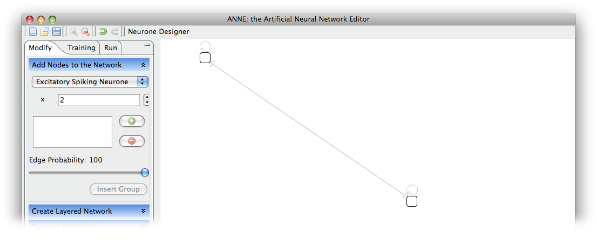Figure 2: View of the example network in ANNE.
It is easy to see that the TNS output is very light but hard to interpret by reading, on the contrary, both the XML formats are very long but very intuitive to read. Its also clear that the X3D output has lost a large amount of information on the neural network, which is the main reason why no importer for X3D was written.

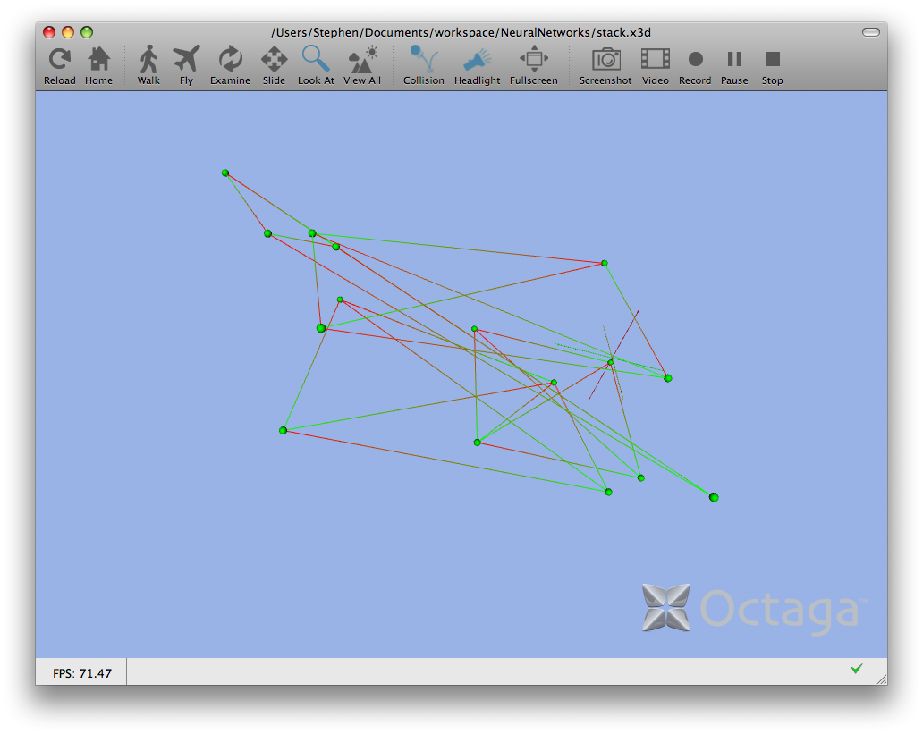Figure 3: View of a Network produced in ANNE displayed in Octaga.
Above is an example of the X3D output from ANNE being loaded into an X3D viewer called Octaga. This allows users to view their networks in 3D if they find that feature useful and demonstrates some of the inter-application support within ANNE.

<?xml version="1.0" encoding="UTF-8"?>
<networkml xmlns="http://morphml.org/networkml/schema"
xmlns:xsi="http://www.w3.org/2001/XMLSchema-instance"
xmlns:meta="http://morphml.org/metadata/schema"
xsi:schemaLocation="http://morphml.org/networkml/schema/Schemata/v1.7.3/Level3/NetworkML_v1.7.3.xsd"
lengthUnits="micron">
<meta:notes>Produced by ANNE: the Artifical Neural Network Editor</meta:notes>
<populations>
<population name="14">
<instances size="2">
<instance id="16">
<meta:properties>
<meta:property tag="instance_type" value="uk.ac.ic.doc.neuralnets.graph.neural.SpikingNeurone" />
<meta:property tag="postSpikeReset" value="-56.17718294810968" />
<meta:property tag="z" value="0" />
<meta:property tag="recoverySensitivity" value="0.2" />
<meta:property tag="recoveryScale" value="0.02" />
<meta:property tag="x" value="73" />
<meta:property tag="trigger" value="30.0" />
<meta:property tag="charge" value="-65.0" />
<meta:property tag="y" value="26" />
<meta:property tag="pSRRecovery" value="4.0027868923975625" />
</meta:properties>
<location x="73" y="26" z="0" />
</instance>
<instance id="15">
<meta:properties>
<meta:property tag="instance_type" value="uk.ac.ic.doc.neuralnets.graph.neural.SpikingNeurone" />
<meta:property tag="postSpikeReset" value="-58.618716832163614" />
<meta:property tag="z" value="0" />
<meta:property tag="recoverySensitivity" value="0.2" />
<meta:property tag="recoveryScale" value="0.02" />
<meta:property tag="x" value="456" />
<meta:property tag="trigger" value="30.0" />
<meta:property tag="charge" value="-65.0" />
<meta:property tag="y" value="292" />
<meta:property tag="pSRRecovery" value="4.551832219630733" />
</meta:properties>
<location x="456" y="292" z="0" />
</instance>
</instances>
</population>
</populations>
<projections units="Physiological Units">
<projection name="Network-Synapses" source="14" target="14">
<synapse_props synapse_type="uk.ac.ic.doc.neuralnets.graph.neural.Synapse" />
<connections size="4">
<connection id="17" pre_cell_id="16" post_cell_id="16">
<properties weight="0.8604082982707334">
<meta:properties>
<meta:property tag="instance_type" value="uk.ac.ic.doc.neuralnets.graph.neural.Synapse" />
</meta:properties>
</properties>
</connection>
<connection id="20" pre_cell_id="15" post_cell_id="15">
<properties weight="0.5024901465406223">
<meta:properties>
<meta:property tag="instance_type" value="uk.ac.ic.doc.neuralnets.graph.neural.Synapse" />
</meta:properties>
</properties>
</connection>
<connection id="18" pre_cell_id="16" post_cell_id="15">
<properties weight="0.270062017417825">
<meta:properties>
<meta:property tag="instance_type" value="uk.ac.ic.doc.neuralnets.graph.neural.Synapse" />
</meta:properties>
</properties>
</connection>
<connection id="19" pre_cell_id="15" post_cell_id="16">
<properties weight="0.13243622803794775">
<meta:properties>
<meta:property tag="instance_type" value="uk.ac.ic.doc.neuralnets.graph.neural.Synapse" />
</meta:properties>
</properties>
</connection>
</connections>
</projection>
</projections>
</networkml>
Code 1: Example network in NeuroML (XML) format.
<?xml version="1.0" encoding="UTF-8"?>
<X3D profile="Immersive.." version="2.0">
<Scene>
<Background skyColor="0.6 0.7 0.9"/>
<Viewpoint description="Down z axis, 500 microns away" position="0 0 500"/>
<Viewpoint description="Down z axis, 200 microns away" position="0 0 200"/>
<Viewpoint description="Down z axis, 2mm away" position="0 0 2000"/>
<Transform rotation="0 0 1 -1.570795">
<Shape>
<Appearance>
<Material diffuseColor="0 1 0"/>
</Appearance>
<Cylinder height="200" radius="0.5"/>
</Shape>
<Transform translation="0 105 0">
<Shape>
<Appearance>
<Material diffuseColor="0 1 0"/>
</Appearance>
<Cone height="10" bottomRadius="1"/>
</Shape>
</Transform>
</Transform>
<Transform>
<Shape>
<Appearance>
<Material diffuseColor="1 1 0"/>
</Appearance>
<Cylinder height="200" radius="0.5"/>
</Shape>
<Transform translation="0 105 0">
<Shape>
<Appearance>
<Material diffuseColor="1 1 0"/>
</Appearance>
<Cone height="10" bottomRadius="1"/>
</Shape>
</Transform>
</Transform>
<Transform rotation="1 0 0 1.570795">
<Shape>
<Appearance>
<Material diffuseColor="1 0 0"/>
</Appearance>
<Cylinder height="200" radius="0.5"/>
</Shape>
<Transform translation="0 105 0">
<Shape>
<Appearance>
<Material diffuseColor="1 0 0"/>
</Appearance>
<Cone height="10" bottomRadius="1"/>
</Shape>
</Transform>
</Transform>
<Transform translation="73 26 0">
<Shape>
<Appearance>
<Material diffuseColor="0 1 0"/>
</Appearance>
<Sphere radius="5"/>
</Shape>
</Transform>
<Transform translation="456 292 0">
<Shape>
<Appearance>
<Material diffuseColor="0 1 0"/>
</Appearance>
<Sphere radius="5"/>
</Shape>
</Transform>
<!--Projection Network-Synapses between 14 and 14-->
<Transform>
<Shape>
<Appearance>
<Material/>
</Appearance>
<LineSet vertexCount="2">
<Coordinate point="73 26 0, 73 26 0"/>
<Color color="0 1 0, 1 0 0"/>
</LineSet>
</Shape>
</Transform>
<Transform>
<Shape>
<Appearance>
<Material/>
</Appearance>
<LineSet vertexCount="2">
<Coordinate point="456 292 0, 456 292 0"/>
<Color color="0 1 0, 1 0 0"/>
</LineSet>
</Shape>
</Transform>
<Transform>
<Shape>
<Appearance>
<Material/>
</Appearance>
<LineSet vertexCount="2">
<Coordinate point="73 26 0, 456 292 0"/>
<Color color="0 1 0, 1 0 0"/>
</LineSet>
</Shape>
</Transform>
<Transform>
<Shape>
<Appearance>
<Material/>
</Appearance>
<LineSet vertexCount="2">
<Coordinate point="456 292 0, 73 26 0"/>
<Color color="0 1 0, 1 0 0"/>
</LineSet>
</Shape>
</Transform>
</Scene>
</X3D>
Code 2: Example network in X3D (XML) format.

0,uk.ac.ic.doc.neuralnets.graph.neural.NeuralNetwork,@@,
1,uk.ac.ic.doc.neuralnets.graph.neural.NeuralNetwork,@@,0
3,uk.ac.ic.doc.neuralnets.graph.neural.SpikingNeurone,@@postSpikeReset=-64.81116438247822@@z=0@@x=73@@recoverySensitivity=0.2@@recoveryScale=0.02@@trigger=30.0@@charge=-65.0@@pSRRecovery=7.850554546968316@@y=26@@,1
2,uk.ac.ic.doc.neuralnets.graph.neural.SpikingNeurone,@@postSpikeReset=-58.609280417269574@@z=0@@x=456@@recoverySensitivity=0.2@@recoveryScale=0.02@@trigger=30.0@@charge=-65.0@@pSRRecovery=5.045980335180888@@y=292@@,1
4,uk.ac.ic.doc.neuralnets.graph.neural.Synapse,@@,1
4,uk.ac.ic.doc.neuralnets.graph.neural.Synapse,@@,3:3:-1
6,uk.ac.ic.doc.neuralnets.graph.neural.Synapse,@@,1
6,uk.ac.ic.doc.neuralnets.graph.neural.Synapse,@@,2:3:-1
7,uk.ac.ic.doc.neuralnets.graph.neural.Synapse,@@,1
7,uk.ac.ic.doc.neuralnets.graph.neural.Synapse,@@,2:2:-1
5,uk.ac.ic.doc.neuralnets.graph.neural.Synapse,@@,1
5,uk.ac.ic.doc.neuralnets.graph.neural.Synapse,@@,3:2:-1
Code 3: Example network in Text Network Serializer format.

Persistence Performance

Networks were generated with the number of excitatory spiking neurones as specified in the table and a 100% connectivity probability, networks were regenerated when changing between sizes.

Benchmarking System:
- CPU - 2.33GHz Core 2 Duo
- Memory - 2GB, 667MHz DDR2
- Hard Disk - 160GB, 5,400rpm, 16MB cache.
- File System - Journaled HFS+
- OS - Mac OS X 10.5.6

Network Size | Java Serialization | NeuroML (XML) | TNS | X3D
10 | 0.01 | 0.00 | 0.00 | 0.06
50 | 0.19 | 0.06 | 0.00 | 0.48
100 | 0.74 | 0.65 | 0.00 | 4.25
500 | 16.97 | 5.43 | 4.27
1000 | 74.33 | 19.95 | 24.36
Table 1: Persistence Performance Analysis - Save Execution Time

Network Size | Java Serialization | NeuroML (XML) | TNS
10 | 0.06 | 0.15 | 0.05
50 | 0.35 | 0.41 | 0.23
100 | 1.01 | 0.71 | 0.69
500 | 23.37 | 11.21 | 20.29
1000 | 94.67 | 57.14 | 2091.74
Table 2: Persistence Performance Analysis - Load Execution Time

Network Size | Java Serialization | NeuroML (XML) | TNS | X3D
10 | 11196 | 37893 | 14192 | 21528
50 | 190396 | 784778 | 311878 | 476128
100 | 733896 | 3065153 | 1230880 | 1885870
500 | 17861896 | 74209903 | 33611758
1000 | 71221896 | 296670598 | 125334485
Table 3: Persistence Peformance Analysis - File Size

Note: Graphs depicting the information in the above tables can be found on the following page.

The obvious first point is that X3D failed to successfully produce any output on networks of size 500 and 1000, after further debugging the problem lies with the Java XML Transformer which is incapable from transforming large XML documents. Also because of the implementation, nearly twice as much storage is required during export, as the XML document needs to be produced so that it can then be read and can only be deleted after completion. Its clear that a future release of the X3D plug-in should be implemented in a more efficient way.

NeuroML and Serialization grow linearly on a logarithmic graph for Save and Loading time suggesting that their execution time would predictably grow with larger networks and would be easily estimated with network sizes within the range of network sizes sampled. NeuroML does generally perform better than Java Serialization, especially with large networks, however this is offset by NeuroML having a considerably larger resulting file size than Serialization, which with ever increasing networks would start to cause problems, an option of compressing the output of the text based persistence methods could provide further persistence options to the user.
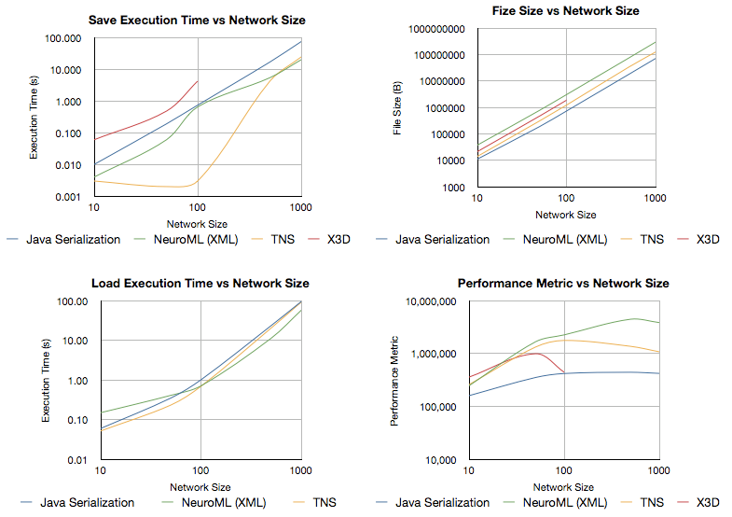Graph 1: Performance Analysis Graphs
TNS has some interesting cases, firstly that for networks below 100 neurones in it requires significantly less time than all other persistence methods and requires no more time for up to 100. After this it rises sharply but looks to begin levelling out to the same rate of increase as NeuroML and Serialization. File sizes generated are less than NeuroML but not as small as Serialization and the load time is good, but insignificantly different from serialization or NeuroML.

A performance metric was calculated that took into account the loading and save times, as well as the file size generated, compared to the network being persisted. The performance metric was as follows:

A lower value implies better peformance, as we can see from the graph which plots the metric against the network size that Java Serialization is the obvious winning, that was to be expected as even though it has a poor saving time it produces significantly smaller files than the other persistence methods and requires no extra time for loading. TNS and NeuroML look to be improving after reaching an initial storage overhead on network size, TNS beating NeuroML though because of the smaller file sizes produced. X3D was included for completeness, but now real information can be taken from the graph as X3D has no load time and could not complete all the tests.

Its worth noting that this performance analysis was only a fleeting look at persistences real world performance and tests were only run once instead of multiple times to verify results. This means little more statistical analysis can be done on these results as there isn't the required information.
Persistence Evaluation and Further Development

The Persistence module provides an easy and extensible way of implementing persistence plug-ins which can export the neural network model to storage or possibly another application. The initial persistence plug-ins provide the average user with a number of options for saving and exporting, with Java Serialization the recommend method for saving a neural network for use with other instances of the ANNE application or incremental backup. NeuroML export is available for transferring your network to other applications and importing back from it.

Due to the plug-in nature, further version of a persistence option would not require to be released at the same time as the core framework, allowing for them to be worked on and released separately. New persistence options could be added later on if required for exporting to more specific or propriety formats, this would allow developers of other applications, perhaps closed-source to write their own plug-in to read their application output which could be distributed without having to reveal a specification of their file format. This ease of implementation would hopefully help ANNE become a more popular solution to model neural networks with.

Further development other persistence could include:
- Further performance analysis of all the persistence plug-in and optimizations of their code to improve execution time and memory usage.
- The option for file compression after export would reduce the file sizes produced but obviously at a cost of execution time. There may be a point where a network reaches a certain size that it may be necessary to compress the output file, already with 1000 neurones, NeuroML files reach 280MB, which even with current hard drive capacities is a large file. With the option to saved to a compressed format, automatic decompression of files when loading would be required so that the new compressed files where supported. Perhaps a flag in each persistence plug-in for compression with compression itself being another persistence plug-in.
- X3D's current implementation is incapable of exporting large networks because of the problems using XSL transformation on large XML documents. A bespoke plug-in which is not dependent on the NeuroML plug-in would probably be the best implementation. Also this would reduce the amount of storage required for export as currently an XML must be produced before being read again and then deleted.
- Further persistence options such as exporting to other neural network modelling standards and file formats such as the previously mentions PyNN and Mat-labs Neural Network tool.
- An auto-save feature would be a positive addition, meaning that users aren't required to remember to periodically save their work, incase of mistake or system failure. It could be implemented by creating another thread which sleeps for the auto-save time period and then fires the save manager off before sleeping again.

ttp://java.sun.com/j2se/1.4.2/docs/api/java/io/Serializable.html
http://www.neuroml.org/
http://www.web3d.org/about/overview/
http://neuralensemble.org/trac/PyNN/
http://www.mathworks.com/access/helpdesk/help/toolbox/nnet/index.html
http://www.saxproject.org/
http://www.neuroml.org/NeuroMLValidator/NeuroMLFiles/Schemata/v1.7.2/Level3/NeuroML_Level3_v1.7.2_X3D.xsl
http://java.sun.com/j2se/1.5.0/docs/api/javax/xml/transform/Transformer.html
http://www.octaga.com

