Kepner-Tregoe building on Problem Task
On upgrade to Madrid existing customers will not see any changes in Problem Management by default (*).
(*) The only small difference is for customers using Knowledge v3 we now the hide Post News action as that was only for the legacy Knowledge v2.
Existing customers will optionally be able to activate nearly all of the new Madrid best practice plugins.
As we do not have a migration tool as yet, the last plugin is hidden from customers because that contains the new states – so is only enabled for new customers (or those that zboot their instance).
We are in the early phase of exploring options with professional services to see if they can help upgrade customers to migrate to the new states before we have an official migration tool.

High level differences between new customers and upgrade
New customers | Upgrade customers
Madrid best practice plugin for new states is activated | Madrid best practice plugin for new states is not available as we do not have a migration tool – the plugin is development / maint only.
Problem task has a Type field to differentiate between problem task types (it is possible to have more than one task type in the same table for example: General or Root Cause Analysis). | Problem task does not have a Type field.  The Task type can be used instead (the name of the table).
Problem task interceptor used to ask which kind of problem task to create (this is what you will extend) | Problem task interceptor is not used. You will use a UI action instead for upgrade customers.

- Pre-requisites:
  - Upgrade to Madrid
- Activate the plugin: Problem Management Best Practice - Madrid
  - New features:
    - Roles for problem management including:
      - Problem task analyst – can create and work on problem tasks.
      - Problem coordinator – can create and work on problem tasks and problems.
      - Problem manager – can coordinate and manage the problem properties.
      - Problem administrator – can manage and delete problems and problem tasks.
    - Provides fields to record the category (and subcategory), where the issue was first reported (useful when you have more than one linked incident, etc) the workaround, the cause notes and the fix notes
    - Search for and attach knowledge articles using Contextual Search within a problem record.
    - Communicate when a workaround or fix is available.
    - Clears the ‘Assigned to’ field when changing the ‘Assignment Group’

- New Problem Fields:
Field name | Type | Reference | Max length | Default value
Category | Choice |  | 40
Cause notes | HTML |  | 65,536
Confirmed | Date/Time |  | 40
Confirmed by | Reference | User | 32
Duplicate of | Reference | Problem | 32
First reported by | Reference | Task | 32
Fix communicated | Date/Time
Fix communicated by | Reference | User | 32
Fix notes | HTML |  | 65,536
Primary Known Error article | Reference | Known Error article | 32
Resolution code | Choice |  | 40
Resolved | Date/Time |  | 40
Resolved by | Reference | User | 32
Subcategory | Choice |  | 40
Workaround | HTML |  | 65,536
Workaround applied | True/False |  | 40 | false
Workaround communicated | Date/Time
Workaround communicated by | Reference | User | 32
- Problem Form Layout: 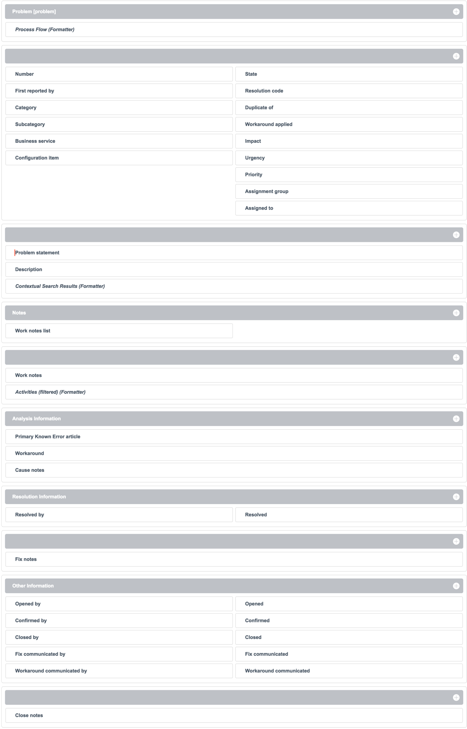
- Problem Task new fields:
Field name | Type | Reference | Max length | Default value
Cause code | Choice |  | 40
Cause notes | HTML |  | 65,536
Close code | Choice |  | 40
Proposed fix notes | HTML |  | 65,536
Workaround | HTML |  | 65,536
Other reason | String |  | 100
Type | String |  | 40 | general
Vendor | Reference | Company | 32

- Problem Task Form Layout:
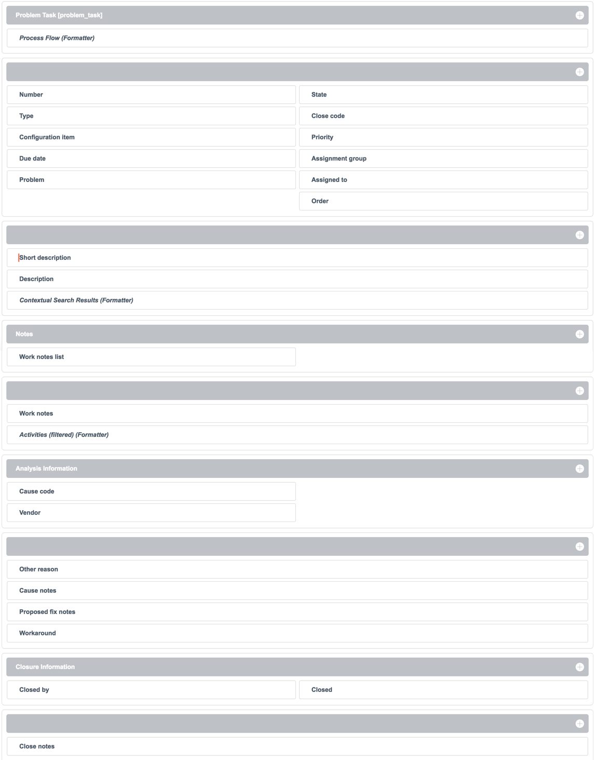

- Make Problem Task extensible:
  - Note: Due to optimizations in the platform, as nothing OOB extends from Problem Task it won’t automatically be marked as extensible – but the admin can change that.
  - Make sure you are in the Global scope:
    - Go to Settings > Developer and check Show application picker in header
Note: Now you can use the application picker to switch to Global (or another scope like your new scoped app).
  - Go to System Definitions > Tables > Problem Task > Controls
  - Check Extensible and Save
- Create your scoped app:
  - Go to System Applications > Studio > Create Application to create your app.
  - Create your new table that extends from Problem Task
Note: You don’t need to create a module menu for your new table.
For example: Structured Problem Analysis
  - Table permissions:
Role | Permission
Problem Task Analyst | Read & Write
Problem Admin | Delete

  - Do your regular form design and states and process flow (top of the page) and UI actions
  - Decide (client-end) what is mandatory or visible or read-only and when:
    - Go to: System UI > UI Policies
  - Decide (server-side) what is mandatory and when:
    - Go to: System Policy > Data Policies

- Apps for new vs existing customers:
  - App for new customers:
    - Go to your new table > Columns > Type > Dictionary overrides.
    - Add a Dictionary override to override the Default value to:
Structured Problem Analysis – or whatever you want to call it. This is how you differentiate between problem tasks.
    - Update the Problem Task interceptor to add your problem task type:
      - Go to: System Definition > Interceptors
      - Find the Problem Task interceptor
      - New > Simple question to redirect the URL
      - Name: Direct to Problem Task of type Structured Problem Analysis
      - Order: 1000
      - User Prompt: Structured Problem Analysis
      - Target URL: <your_table_id>.do?sys_id=-1
Example: x_kt_structured_problem_analysis.do?sys_id=-1
    - Set up your process flow (state transitions):
      - Defines how you can transition from one state to another
      - Go to State Management > State Models
      - The simplest version would be to manually create your own version of the Problem Task: Default Flow state model

    - Set up your ribbon:
      - Shows where you are in the problem task process
      - Set up your ribbon states:
        - Go to: System UI > Process Flow
        - The simplest version would be to manually create your own version of the Problem Task flow formatters
      - Set up the ribbon formatter:
        - Go to: System UI > Formatters
        - The simplest version would be to create your own copy of the Problem Task formatter for your table.
  - App for existing customers:
    - Create a UI action on the problem table to create your task type:
      - Go to: System UI > UI Actions
      - Create a new UI Action
      - Name: Create Structured Problem Analysis – or whatever you want to call the action
      - Form link: Checked
      - Form context menu: Checked
      - Table: Problem
      - Order: 1000

      - Simple script example to create a new record and link it back to this problem:
var kt = new
GlideRecord('<your-table-name>’);
kt.initialize();
kt.problem = current.sys_id;
kt.insert();
action.setRedirectURL(kt);
action.setReturnURL(current);
    - You can add the Task type to the Problem Task list to differentiate between task types (problem task vs. your problem task).

