Scoped Certified Application Design
Kepner-Tregoe Advanced Problem Management
May 15th, 2019

Table of Contents
1 Overview 3
1.1 References 3
2 Application overview and intended use 3
2.1 Third-party dependencies 3
3 Software architecture overview 3
4 Software design description 4
5 Performance considerations and concerns 4
6 Security considerations and concerns 4
7 Application components 5
7.1 Components created by the application: 5
7.2 Integration components created by the application: 5
8 Future plans 6
9 Service Level Agreement Definition 6
10 Debugging and troubleshooting 6
10.1 Debugging tips: 6
10.2 Failure modes: 6

Overview
Your Design Document describes the design of your scoped application and will be used throughout the certification process. The document is used internally by ServiceNow only and is not shared with your customers.
To prepare your Design Document, enter a thorough response in each section of this template document. If a section is not applicable, state the reasons clearly.
This document is intended to enable ServiceNow Certification Engineers and Technical Support members to:
- Understand your integration completely
- Identify areas of risk to platform security or platform stability
- Troubleshoot any potential third-party issues

References

# | Document Identifier | Document Title
[R1] | ID | Add your document references.  One line per document

Application overview and intended use
The Advanced Problem Management application provides a structured approach for collecting and documenting key information required for performing Root Cause Analysis for defined Problems in alignment with the Kepner-Tregoe methodologies. The application is integrated with and extends the capabilities of ServiceNow out-of-the-box Problem Management Best Practice – Madrid plugin.
By capturing information in a structured manner, it helps reduce time required to get to root cause, reduces effort and minimizes unnecessary actions. Problem analysts are able to quickly document data and identify what critical questions may still need to be asked. This helps propose a superior solution, protect their fix, organize change management activities, and execute a plan.
Stakeholders would use the app to quickly review status, understand involvement, make decsions and prepare executive updates.

Third-party dependencies
List third-party dependencies:
Kepner-Tregoe Advanced Incident Management plugin is optional.
The Advanced Problem Management application is dependent on the “Problem Management Best Practice Plugin - Madrid” plugin. For instances that are upgrading to Madrid from a previous release, the plugin must be activated prior to installing the Advanced Problem Management application. The plugin is already active for new instances provisioned starting with Madrid.

There are two primary differences with the “Problem Management Best Practice Plugin - Madrid” plugin installed on an upgraded instance versus a new instance.
- State values on the Problem Task form
- Process Flow Formatter appears on the Problem Task form only for new instances starting with Madrid
The Advanced Problem Management application is compatible with both cases.

Software architecture overview
Tables included with the Kepner-Tregoe Advanced Problem Management application

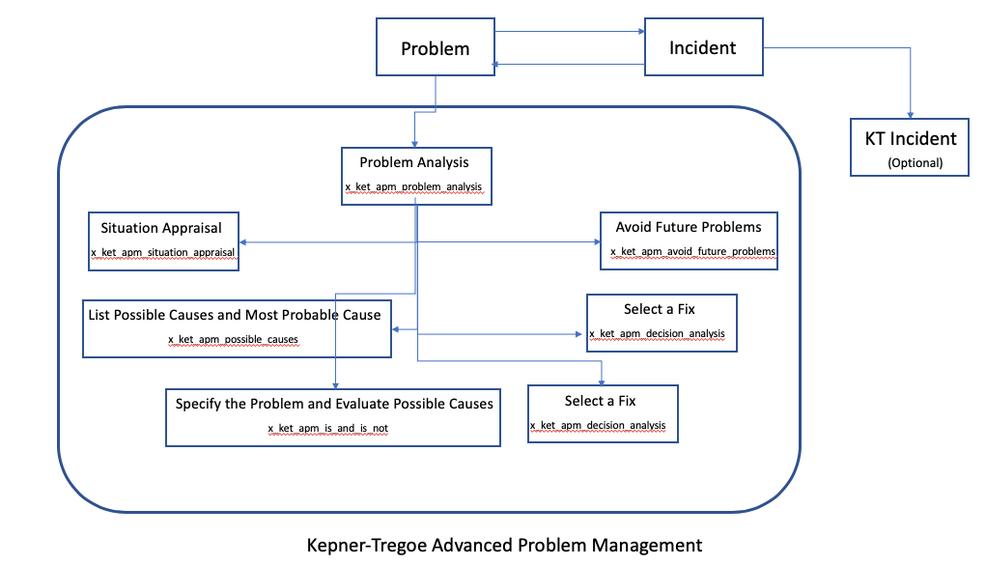

Software design description
Attach class diagrams, collaboration / sequence diagrams, and deployment diagrams to illustrate your description.
If your application imports and/or exports data, specify:
- How often does import/export occur? None
- What kind of data? N/A
- What considerations did you implement to ensure optimal performance? N/A

Performance considerations and concerns
- This is not a high-volume application - all data is entered manually

Security considerations and concerns
- Describe security considerations and concerns: No additional security considerations above ServiceNow standards
- List insecure protocols: N/A
- List all roles: x_ket_apm.user
- List all users: Problem Management users
- List any externally accessible services N/A
- Sensitive Information Handling:
  - If your application handles sensitive information (i.e. passwords, PHI, social security #’s, etc.) please outline how you encrypt or otherwise protect this information: N/A
  - If you are processing financial transactions, please be aware that the credit card information processed cannot be stored within ServiceNow. Please outline how financial transactions are handled: N/A

Application components
In this section, identify both newly created artifacts and modifications to base ServiceNow artifacts:

Components created by the application:
- List all script includes: None
- List all newly defined tables: x_ket_apm_problem_analysis, x_ket_apm_possible_causes, x_ket_apm_decision_analysis, x_ket_apm_is_and_is_not, x_ket_apm_situation_appraisal,
x_ket_apm_risk_management, x_ket_apm_avoid_future_problems
- List all business rules: Initialize KT Problem Analysis, Populate Process Flow State
- List all client Scripts: None
- List all applications/modules: Application: Kepner Tregoe Problem Management V2, Module: Problem Analysis V2
- List all externally accessible services: None
- List all properties (including system properties): None
- Specify the scope(s) used: x_ket_apm
- List the integration user & roles created for the integration user authentication (note: the user may need to be created as a part of the installation/configuration process, however please outline the details for this user here): N/A
- Components modified by the integration: Problem Task table will automatically become Extensible = true when the app is installed since x_ket_apm_problem_analysis is extended from problem_task
- List all modules: Problem Analysis V2
- List all externally accessible services: None
- Fix script: Advanced Problem Management V2 Migration (Runs one time during installation. Migrates records from previous version of KT Advanced Problem Management plugin)

Integration components created by the application:
- List any inbound web services: <SOAP, REST, etc.> None
- List the target tables of each inbound web service <incident.do, problem.do, etc.> N/A
- List all import set tables: None
- List all transformation maps: None
- List any scheduled jobs for data exports: None
- List any non-Public API’s utilized: None

Future plans
Describe how you envision the application evolving and/or include product roadmaps.
No major updates planned. Minor changes may be implemented based on future enhancements to the ServiceNow Problem application.

Service Level Agreement Definition
In this section, you define the Service Level Agreement (SLA) for your customers.
Customers will be instructed to contact the integration provider (your organization) for technical support. If a customer first contacts ServiceNow Customer Support, then ServiceNow Customer Support will isolate the problem and instruct the customer to resolve the issue with your organization.
- Support Hours of Operation: (including time zone): 8am - 5pm ET
- Support Days of Operation: Monday - Friday (except Federal holidays)
- Promised Call Response Time: Within 2 business days of received support request
- Promised Call Resolution Time: Within 5-10 business days of response
- Contact Method: Email
- Contact Details: SNow-support@kepner-tregoe.com

Debugging and troubleshooting
Describe how to debug the integration: : n/a – data is displayed only, no back end calculations are performed.
Describe issues that you have observed and provide troubleshooting tips and workarounds: None
Describe anticipated issues: None

Debugging tips:
Describe debugging techniques that may assist Tech Support or the Customer to identify issues. N/A

Failure modes:
List expected failure modes (for example, third-party server down): None

End of Document

