Scoped Certified Application Design
Kepner-Tregoe Incident Module
Software version: 1.05

Table of Contents
1 Overview 3
1.1 References 3
2 Application overview and intended use 3
2.1 Third-party dependencies 3
3 Software architecture overview 3
4 Software design description 4
5 Performance considerations and concerns 4
6 Security considerations and concerns 4
7 Application components 4
7.1 Components created by the application: 5
7.2 Integration components created by the application: 5
8 Future plans 5
9 Service Level Agreement Definition 5
10 Debugging and troubleshooting 6
10.1 Debugging tips: 6
10.2 Failure modes: 6

Overview
Your Design Document describes the design of your scoped application and will be used throughout the certification process. The document is used internally by ServiceNow only and is not shared with your customers.
To prepare your Design Document, enter a thorough response in each section of this template document. If a section is not applicable, state the reasons clearly.
This document is intended to enable ServiceNow Certification Engineers and Technical Support members to:
- Understand your integration completely
- Identify areas of risk to platform security or platform stability
- Troubleshoot any potential third-party issues

References

# | Document Identifier | Document Title
[R1] | ID | Add your document references.  One line per document

Application overview and intended use
Describe, at a high level, what the application does:
Describe the business need that the application solves:
Describe each specific customer use case:
The plugin aims to make your incident, problem, and change teams successfully work together to restore service degradation and improve IT stability
Incident Managers and Incident coordinators are able to quickly document data as an incident unfolds, being reminded of what data has been collected, and what critical questions may still need to be asked.
Technical team leads and SMEs would contribute, adding facts that quickly help everyone on a bridge/conference call understand the data they need to help them propose a superior solution, protect their fix, organize change management activities, and execute a plan.
Stakeholders would use the plugin to quickly review status, understand involvement, and prepare executive updates.
Problem management teams can use the plugin to help transition facts, perform post-incident exercises, and reduce the amount of time necessary to handover.

Third-party dependencies
List third-party dependencies: Kepner-Tregoe Problem Module (optional)

Software architecture overview
In this section, you describe the top-level software components and their interactions/relationships.
If you have attached a system architecture document, refer to it here:
Attach any UML package diagrams and/or layer diagrams and/or interface diagrams:
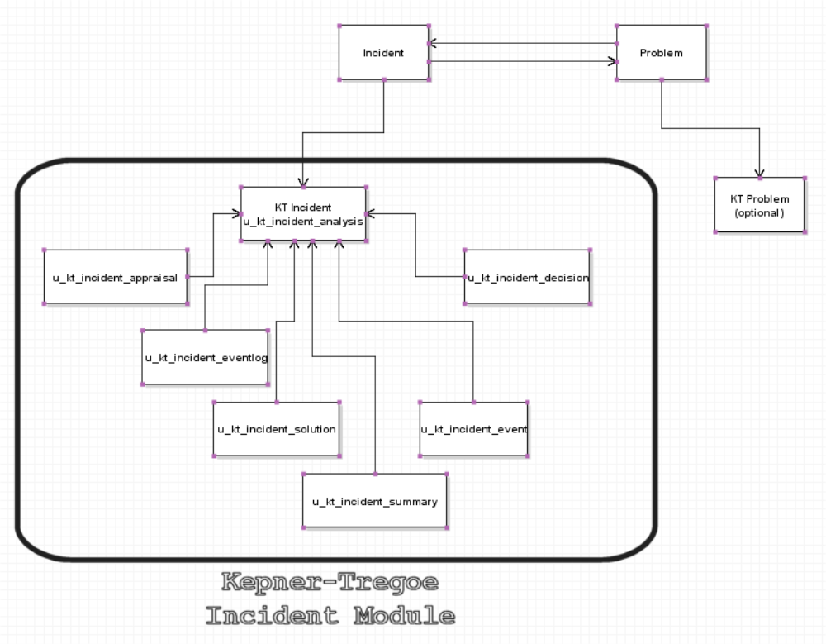

List the operating systems that the software runs on: n/a (all internal to service-now)
List any additional external required components (for example, desktop clients, scripts, and so on): n/a

Software design description
Attach class diagrams, collaboration / sequence diagrams, and deployment diagrams to illustrate your description.
If your application imports and/or exports data, specify:
- How often does import/export occur? None, n/a
- What kind of data? None, n/a
- What considerations did you implement to ensure optimal performance?

Performance considerations and concerns
- Describe potential performance risks or high volume transactions that the integration may impose on the platform: The KT Incident module does not rely upon any external connections
- Describe the performance metrics of the integration: n/a
- Describe inbound web services and declare an acceptable threshold of transactions per second: n/a
- Describe outbound web services and declare an acceptable threshold of transactions per second: n/a
- Please describe any error handling mechanisms that you have in place: if trying to copy data to the KT Problem area, and this plugin has not been installed, the application will exit gracefully.
- If languages other than English are supported, please list the supported languages here: n/a
- If designed specifically for mobile support, list all devices supported: n/a
- If your application is supported on specific web browsers, list supported browsers here: n/a

Security considerations and concerns
- Describe security considerations and concerns: n/a
- List insecure protocols: n/a
- List all roles: itil role is needed for adding and viewing records to the Kepner-Tregoe Incident tables
- List all users: n/a
- List any externally accessible services: n/a
- Sensitive Information Handling: n/a

Application components
In this section, identify both newly created artifacts and modifications to base ServiceNow artifacts:

Components created by the application:
- List all script includes: InitializeKTIncidentAnalysis – script Include used to help initialize new KTIncident records
- List all newly defined tables: u_kt_incident_analysis; u_kt_incident_solution; u_kt_incident_decision; u_kt_incident_event; u_kt_incident_eventlog; u_kt_incident_appraisal; u_incident_analysis_what_is; u_kt_incident_summary; u_incident_analysis_extent_is
- List all business rules: none
- List all client Scripts: KT Inc Analysis: Prime Fields – used when a new KTIncident is created to call the InitializeKTIncidentAnalysis script include
- List all applications/modules:
- List all externally accessible services: none
- List all properties (including system properties): none
- Specify the scope(s) used: incident
- List the integration user & roles created for the integration user authentication (note: the user may need to be created as a part of the installation/configuration process, however please outline the details for this user here): none
- Components modified by the integration: UI Action: Create Problem (from include) – modified to copy KT Incident data (if it exists) to the KTProblem module (if it is installed).
- List all modules:
- List all externally accessible services: none

Integration components created by the application:
- List any inbound web services: none
- List the target tables of each inbound web service: n/a
- List all import set tables: none
- List all transformation maps: none
- List any scheduled jobs for data exports: none
- List any non-Public API’s utilized: none

Future plans
Describe how you envision the application evolving and/or include product roadmaps.
Future plans involve higher integration with the KT Problem modules, as well as additional reporting features.

Service Level Agreement Definition
In this section, you define the Service Level Agreement (SLA) for your customers.
Customers will be instructed to contact the integration provider (your organization) for technical support. If a customer first contacts ServiceNow Customer Support, then ServiceNow Customer Support will isolate the problem and instruct the customer to resolve the issue with your organization.
Support Hours of Operation: 8am - 5pm ET
Support Days of Operation: Monday - Friday (except weekends and Federal Holidays)
Promised Call Response Time: Within 2 business days of received support request
Promised Call Resolution Time: Within 5-10 business days of response
Contact Method: Email
Contact Details: SNow-support@kepner-tregoe.com

Debugging and troubleshooting
Describe how to debug the integration: n/a – data is displayed only, no back end calculations are performed.
Describe issues that you have observed and provide troubleshooting tips and workarounds: none
Describe anticipated issues: none

Debugging tips:
Describe debugging techniques that may assist Tech Support or the Customer to identify issues: n/a (see 10)

Failure modes:
List expected failure modes (for example, third-party server down): none

End of Document

