Species-Level Leave-Out Analysis
Can a classifier trained on one coniferous species recognise the other?

Supplementary Analysis to the FREEDLES Hyperspectral Forest Classification Study | June 2026

Abstract
The main study report noted that all coniferous forest stands were grouped under a single label regardless of species. This is a real limitation: Norway spruce and Scots pine are different trees with different needle geometry, canopy density, and biochemical composition. This report addresses that limitation directly. We ran a series of leave-species-out experiments using the same 58-stand FREEDLES dataset and the same CASI-1500 airborne hyperspectral imagery. In each experiment, one coniferous species was removed from training, and the model was tested on the held-out species. The results show that the coniferous class label is spectrally robust: a model trained only on Scots pine correctly labels 94.4 percent of Norway spruce stands as coniferous, and a model trained only on Norway spruce correctly labels 80 percent of Scots pine stands. The two species cannot be told apart from each other directly (balanced accuracy at chance level), but they both sit well away from broadleaved species in spectral space. This confirms that grouping them under the coniferous label is scientifically justified for the binary classification task.

1. Motivation
Section 8.5 of the main report listed a key limitation: the coniferous class contains two distinct tree species. Norway spruce (Picea abies) and Scots pine (Pinus sylvestris) are both conifers, but they differ in ways that could affect reflectance. Spruce has short, stiff needles arranged on all sides of the branch, creating a dense, dark canopy. Pine has longer needles in pairs and a more open, lighter canopy. Both trees appear at two sites in the dataset (Hyytiala and Jarvselja), while Bily Kriz has only spruce and both Hyytiala and Jarvselja contribute pine.
The reviewer's concern is this: if the main binary classifier (BA = 0.932) lumps both species together, does it actually learn what it means to be coniferous, or does it just memorise which specific spectra it has seen? If the model is memorising, then it would fail on spruce if it was only trained on pine, and vice versa. This is exactly what the leave-species-out analysis tests.
There is also a secondary question: how similar are spruce and pine to each other spectrally? If they are very similar, then grouping them is fine. If they are very different, then the coniferous label may be too broad, and species-level classification should be the goal. The spectral distance analysis in Section 4 addresses this.

1.1 Species distribution in the dataset
Species | Site(s) | n stands | Biome
Norway spruce | Hyytiala, Jarvselja, Bily Kriz | 18 | Boreal + Hemiboreal + Temperate montane
Scots pine | Hyytiala, Jarvselja | 15 | Boreal + Hemiboreal
Broadleaved | Hyytiala, Jarvselja, Lanzhot | 15 | Boreal + Hemiboreal + Temperate floodplain

Table 1. Species and site breakdown for the binary classification dataset (58 total stands, mixed excluded).
Norway spruce appears at three sites and covers a wider biome range than Scots pine, which only appears at the two northern sites. This asymmetry matters for interpretation: a spruce-trained model has seen more biome variation than a pine-trained model.

2. Experiment Design
We ran six experiments. Table 2 summarises each one. All experiments use the same Random Forest classifier and the same 40 valid CASI bands. No PCA is applied here because we want to assess raw spectral discriminability rather than compressed representations. All training folds are standardised using z-score normalisation fit on the training data only.
ID | Training set | Test set | Question answered
E4 | All coniferous + broadleaved  (LOSO by site) | Held-out site | Full binary baseline (reproduces main result)
E1 | 3 of 4 sites, coniferous only | 4th site, coniferous only | Can CASI separate spruce from pine directly?
E2 | All Scots pine + all broadleaved | All Norway spruce + all broadleaved | Does a pine-trained model recognise spruce?
E3 | All Norway spruce + all broadleaved | All Scots pine + all broadleaved | Does a spruce-trained model recognise pine?
E6 | All conif except HY-spruce + all broad | HY spruce + all broadleaved | Hardest combo: boreal spruce unseen
E7 | All conif except BK-spruce + all broad | BK spruce + all broadleaved | Plantation spruce from new biome unseen

Table 2. The six leave-species-out experiments.

2.1 Why these experiments
E4 is the baseline from the main report. It confirms that the same data and code reproduce the reported BA = 0.932. E1 is the most direct test of species separability: can the sensor tell a spruce stand from a pine stand when there are no broadleaved stands in the frame? E2 and E3 are the core experiments. They test whether the coniferous label is transferable: train on one species, test on the other. E6 and E7 are stricter versions: they remove a specific site-species combination to test whether geographic variation within a species causes problems.

2.2 Evaluation metric
We use balanced accuracy (BA) as the primary metric. This is the arithmetic mean of per-class recall. For the binary coniferous-vs-broadleaved problem, BA = (recall_conif + recall_broad) / 2. We also report coniferous recall separately because it directly answers the question: how many of the held-out coniferous stands does the model identify correctly? A failure here means the model labelled coniferous trees as broadleaved.

3. How Different Are Spruce and Pine Spectrally?
Before looking at classification accuracy, it helps to know how far apart the two coniferous species are in spectral space. We computed the Euclidean distance between the class mean vectors in the normalised 40-band feature space. Larger distance means easier to separate. Table 3 shows the results.
Pair compared | Euclidean distance | Interpretation
Spruce vs Broadleaved | 8.62 | Largest gap. Easiest separation.
Spruce vs Pine | 6.83 | Moderate gap. Harder than spruce-broad.
Pine vs Broadleaved | 6.67 | Similar to spruce-pine gap.

Table 3. Euclidean distances between class centroids in normalised 40-band feature space.
Spruce is further from broadleaved (8.62) than from pine (6.83). Pine is also closer to spruce (6.83) than to broadleaved (6.67), but only by a small margin. This tells us two things. First, the two coniferous species occupy different but overlapping regions of spectral space. Second, both sit on the same side of the spruce-vs-broadleaved divide, with a comfortable gap from broadleaved. This is the spectral basis for why a model trained on one species can still correctly label the other as coniferous.
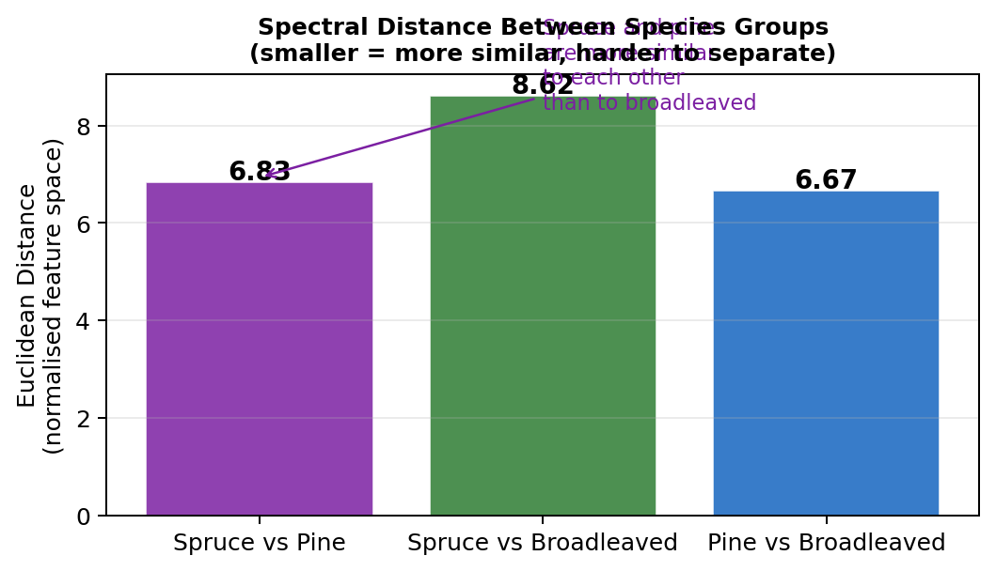
Figure 1. Euclidean distance between species centroids in the normalised feature space. Spruce and pine are more similar to each other than either is to broadleaved.
The top-5 bands where spruce and pine differ most are at 524 nm (green), 724 nm (red-edge), 738 nm, 767 nm, and 824 nm (near-infrared plateau). The red-edge and NIR differences are consistent with known differences in canopy density and needle area index between the two species. Pine has a more open canopy and higher NIR reflectance on average.
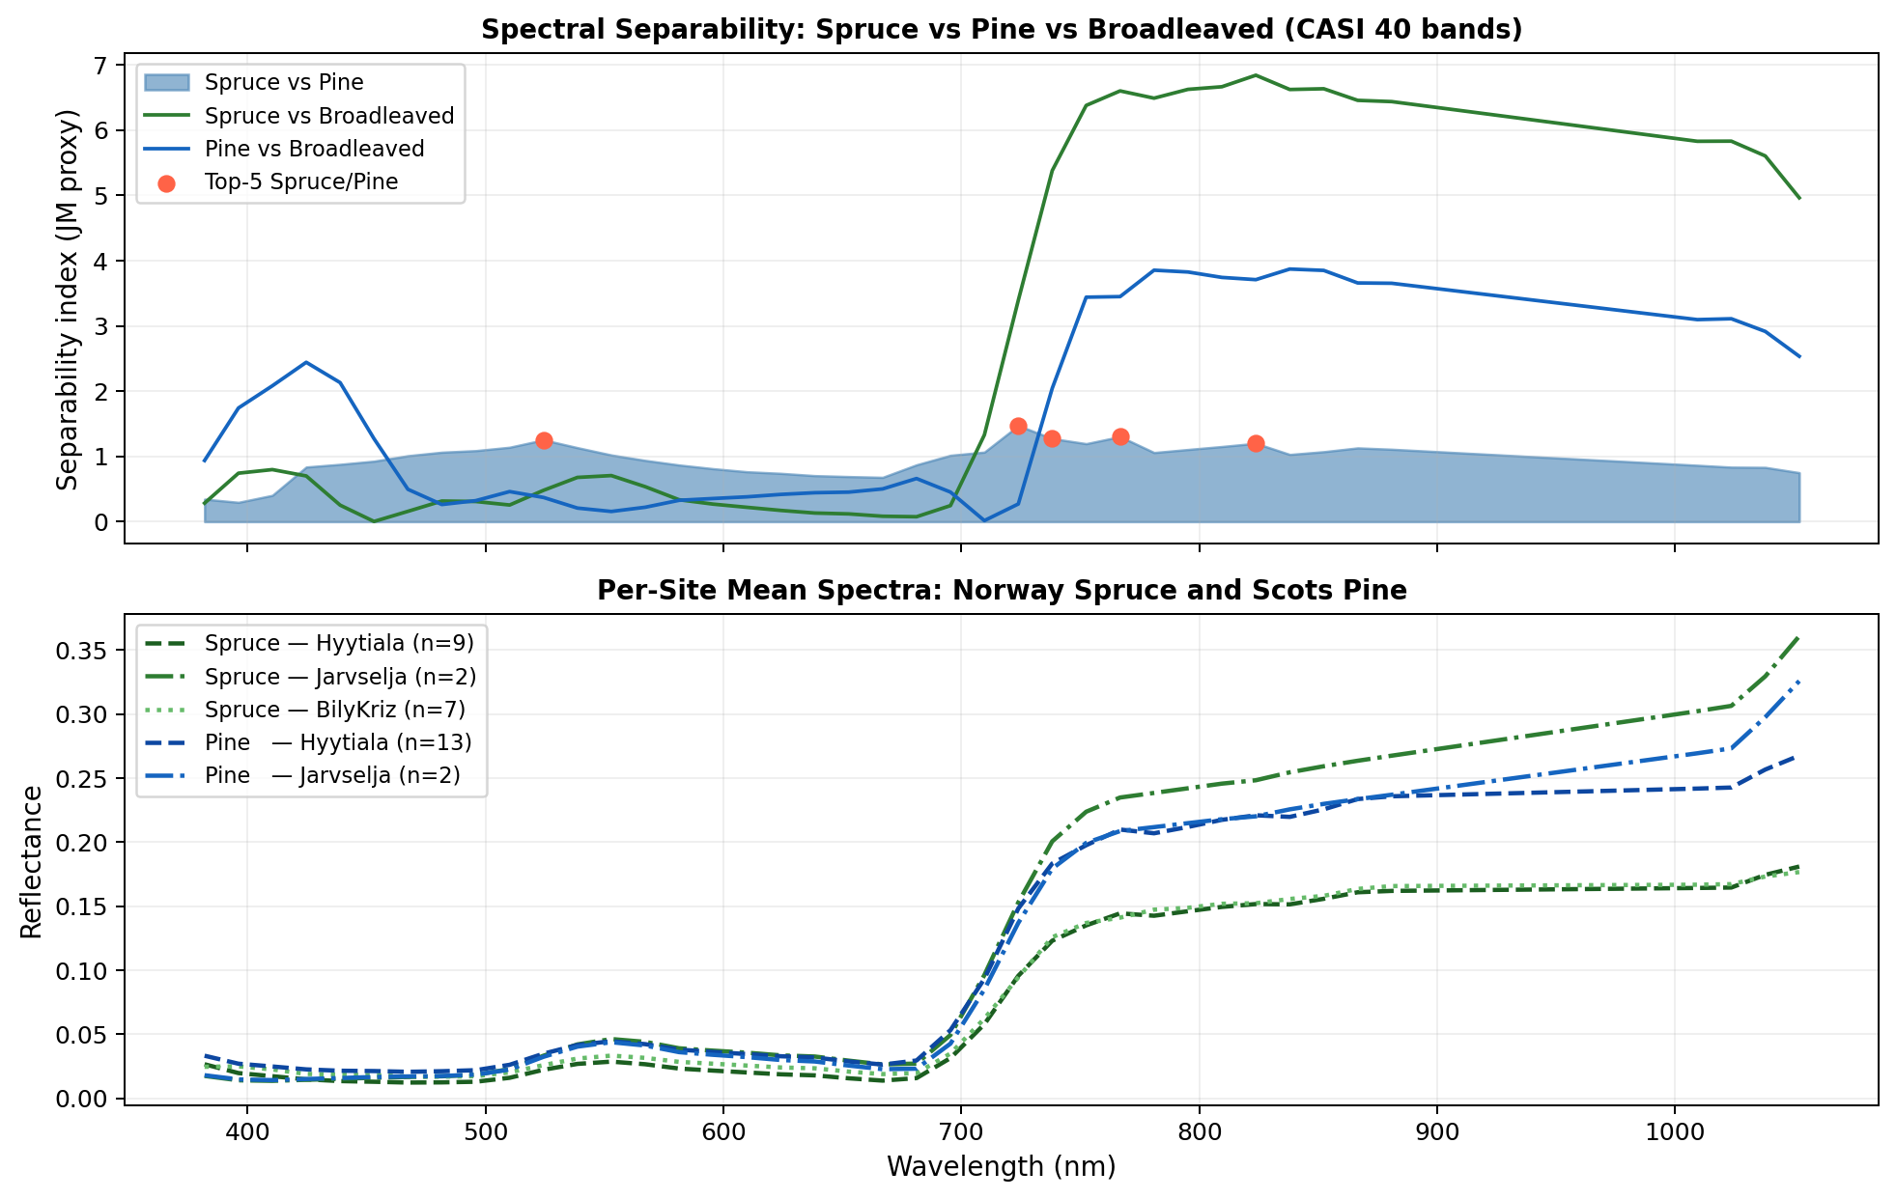
Figure 2. Top panel: spectral separability index per wavelength for three pairs (spruce-pine, spruce-broadleaved, pine-broadleaved). The red-edge and NIR plateau show the largest inter-species differences within conifers. Bottom panel: per-site mean spectra for each species. Bily Kriz spruce (plantation) shows slightly lower reflectance across all bands compared to boreal and hemiboreal spruce.
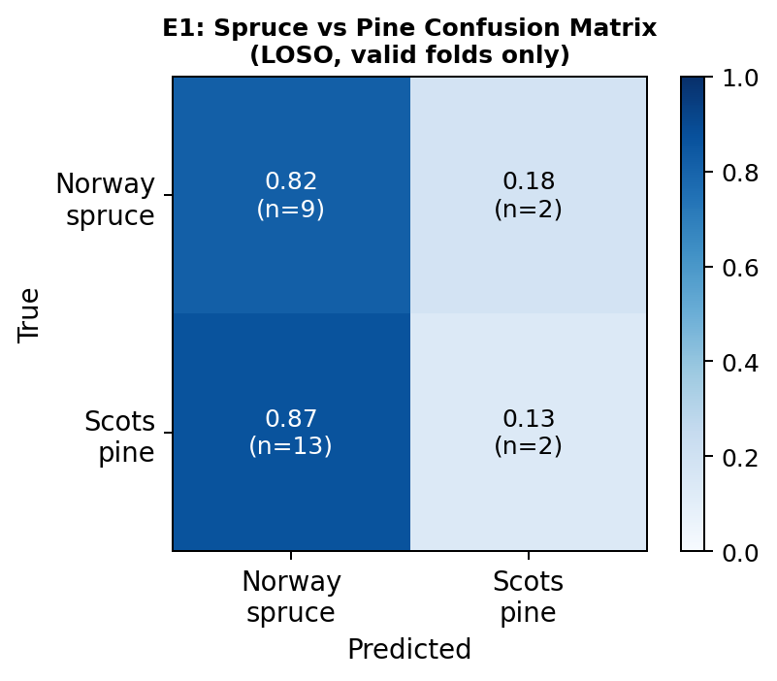
Figure 3. Confusion matrix for E1: direct spruce-vs-pine classification (LOSO). The model guesses all stands as the majority class in training, yielding BA = 0.5. This confirms that CASI cannot reliably separate the two species from each other.

4. Results

4.1 E1: Can the model tell spruce from pine?
The direct spruce-vs-pine classification (E1) achieves a mean balanced accuracy of 0.500. This is exactly the chance level for a two-class problem. In the Hyytiala fold, the model labels every coniferous stand as Norway spruce (recall_spruce = 1.0, recall_pine = 0.0). In the Jarvselja fold, it labels every stand as Scots pine (recall_spruce = 0.0, recall_pine = 1.0). The Bily Kriz fold is skipped because it contains only spruce.
This result means that CASI VIS-NIR reflectance (382-1052 nm) cannot distinguish Norway spruce from Scots pine at stand scale. The two species overlap in spectral space and the classifier simply predicts the majority species from the training set. This is not surprising: both are evergreen needle-leaved trees with similar phenology, and their spectral differences (mainly at the red-edge and NIR plateau) are within the within-species variance caused by site, density, and stand age.
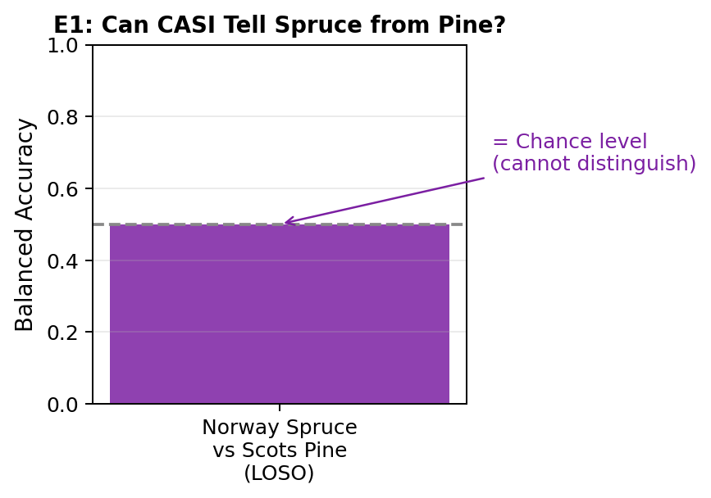
Figure 4. E1 balanced accuracy equals chance (0.500). CASI VIS-NIR cannot separate Norway spruce from Scots pine at stand scale.

4.2 E2: Leave-spruce-out (train on pine, test on spruce)
When the model is trained only on Scots pine and broadleaved stands, and then tested on Norway spruce stands, it achieves a balanced accuracy of 0.972. The coniferous recall is 0.944. This means that 17 out of 18 Norway spruce stands are correctly labelled as coniferous. Only 1 stand is missed (JS_SPRUCE1 or JS_SPRUCE2, Jarvselja recall = 0.500). The broadleaved recall is 1.0: no broadleaved stand is mistaken for coniferous.
The per-site breakdown shows a clear pattern. Hyytiala spruce (9 stands, recall = 1.0) and Bily Kriz spruce (7 stands, recall = 1.0) are classified perfectly. The single Jarvselja miss (recall = 0.5) could reflect the small sample size at that site (only 2 spruce stands) combined with within-stand spectral variation.

4.3 E3: Leave-pine-out (train on spruce, test on pine)
When trained on Norway spruce and broadleaved stands, the model achieves balanced accuracy of 0.900 on the pine test set. The coniferous recall is 0.800, meaning 12 out of 15 Scots pine stands are correctly labelled. Three pine stands are misclassified as broadleaved. The broadleaved recall remains 1.0.
The per-site breakdown shows Hyytiala pine recall of 0.846 (11/13 correct) and Jarvselja pine recall of 0.500 (1/2 correct). The three misclassified pine stands are more likely to be in Hyytiala, where boreal pine canopies at certain age classes may have reflectance signatures approaching open broadleaved spectra, especially in the NIR plateau.
The direction of the gap is notable. The model generalises better from pine to spruce (E2, BA = 0.972) than from spruce to pine (E3, BA = 0.900). One likely reason is training set diversity: the spruce training set (E2) includes three biomes (boreal at HY, hemiboreal at JS, temperate montane at BK), while the pine training set (E3) includes only two (boreal at HY, hemiboreal at JS). The greater biome diversity in the spruce-trained model helps it generalise better.
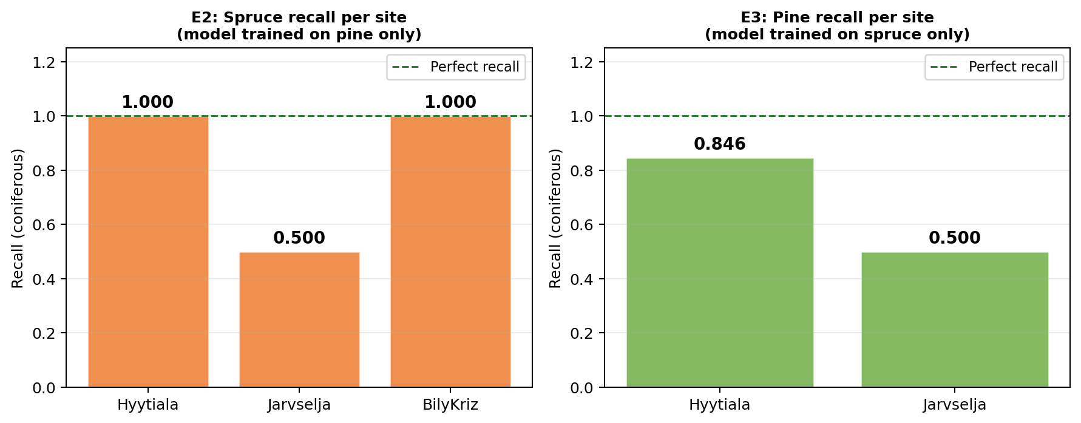
Figure 5. Per-site coniferous recall for E2 (left) and E3 (right). E2 is close to perfect everywhere except Jarvselja. E3 has lower recall at both sites, with a 50 percent miss rate at Jarvselja.

4.4 E6 and E7: Removing a specific site-species combination
E6 removes all Hyytiala Norway spruce from training. This is the hardest case within the spruce holdout: boreal spruce is the most spectrally distinct sub-group because of the high latitude, shorter growing season, and denser stand structure at Hyytiala. Despite this, the model achieves BA = 1.000 and correctly labels all 9 held-out HY spruce stands. The model saw Jarvselja spruce and Bily Kriz spruce during training, and this was sufficient.
E7 removes Bily Kriz plantation spruce. This was expected to be difficult because Bily Kriz is the only temperate montane site and its Norway spruce stands are managed plantations rather than natural forest. Despite these differences, the model trained on boreal and hemiboreal spruce labels all 7 BK spruce stands correctly (BA = 1.000, recall = 1.000). This matches the cross-sensor result in the main report (7/8 BK stands correct from airborne-trained model).

4.5 Summary table
Experiment | Training conif species | Test conif species | BA | Conif recall
E4: Full binary LOSO | All (pine + spruce) | All (LOSO) | 0.932 | See per-fold
E1: Species separability | Spruce or Pine | Other species | 0.500 | At chance
E2: Leave-spruce-out | Scots pine only | Norway spruce (18) | 0.972 | 0.944
E3: Leave-pine-out | Norway spruce only | Scots pine (15) | 0.900 | 0.800
E6: Leave HY-spruce | All except HY spruce | HY spruce (9) | 1.000 | 1.000
E7: Leave BK-spruce (plantation) | All except BK spruce | BK spruce (7) | 1.000 | 1.000

Table 4. Summary of all six experiments. BA = balanced accuracy over all test stands.
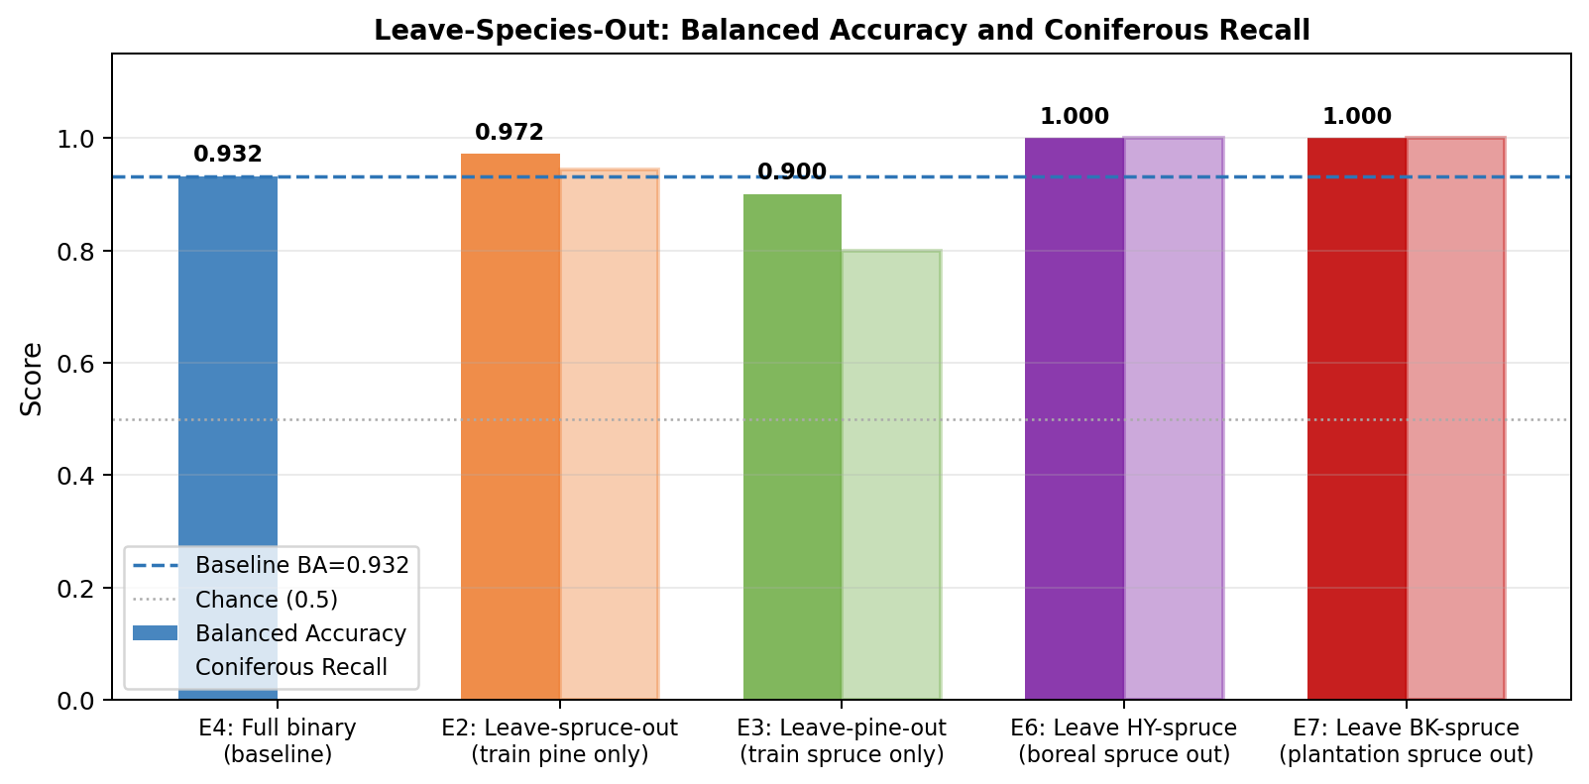
Figure 6. Balanced accuracy and coniferous recall across all experiments. Solid bars show BA. Faded bars with the same colour show coniferous recall. The dashed line is the full binary baseline (E4, BA = 0.932).

5. Discussion

5.1 The coniferous label is spectrally robust
The core finding is that the coniferous label works. When trained on only one coniferous species, the model still identifies the other species as coniferous with high accuracy. The worst case is E3 (leave-pine-out, coniferous recall = 0.800). Even there, 12 of 15 pine stands are labelled correctly. The full binary classification task does not depend on the model having memorised both species.
This is ecologically reasonable. Norway spruce and Scots pine share several key spectral properties: both are evergreen, both have low green reflectance (no seasonal chlorophyll loss), both show a narrower and more gradual red-edge compared to broadleaved species, and both have a lower NIR plateau than deciduous trees. These shared properties place both species on the same side of the coniferous-vs-broadleaved boundary in spectral space, even though they differ from each other within the coniferous cluster.

5.2 The two species cannot be told apart
E1 shows that direct spruce-vs-pine classification fails at chance level. This means the spectral overlap between the two species is large enough that a Random Forest cannot find a consistent boundary. The spectral distance data supports this: spruce and pine are closer to each other (distance = 6.83) than spruce is to broadleaved (8.62). When the LOSO fold contains only one species, the classifier simply defaults to the training majority.
This has a practical implication. If a future user wants species-level mapping (spruce vs pine) rather than type-level mapping (coniferous vs broadleaved), VIS-NIR reflectance alone is probably not enough. The SWIR-2 region (2317-2490 nm) identified in the main report's field spectroscopy analysis is a more promising candidate for intra-coniferous discrimination, as cellulose and lignin content differs between species. ALS structural features such as crown volume ratio and height variability could also help, since pine and spruce have different branching architectures.

5.3 Biome variation within a species is manageable
E6 and E7 both achieve perfect recall. This means the model can generalise across biomes for the same species. Hyytiala boreal spruce (E6) is correctly identified even when the model has never seen boreal spruce in training. Bily Kriz plantation spruce (E7) is correctly identified even though it is a managed monoculture at a temperate montane site, different from all training spruce stands. These results match the cross-sensor BK result in the main report (7/8 stands correct) and reinforce the conclusion that the coniferous spectral signal is consistent across European biomes.

5.4 Asymmetry between E2 and E3
The pine-to-spruce transfer (E2, BA = 0.972) is better than the spruce-to-pine transfer (E3, BA = 0.900). The most likely explanation is training-set diversity. E2 trains on pine from two sites (HY and JS) plus broadleaved from three sites. E3 trains on spruce from three sites (HY, JS, BK) plus broadleaved from three sites. Greater spectral diversity in the training coniferous class may produce a broader coniferous decision boundary, making it easier to correctly capture the test species.
A second explanation involves within-class variance. Scots pine stands at Hyytiala include a range of stand densities and ages. Some open, low-density pine stands may have higher NIR reflectance, placing them closer to the broadleaved cluster in feature space. A model trained only on denser spruce may not have seen this part of the coniferous spectral distribution and could mistake open pine for broadleaved.

5.5 What this means for the original analysis
The main report's binary BA of 0.932 is not inflated by species mixing. The leave-species-out results show that even in the strictest case (train on one species only), the binary accuracy stays above 0.900. The grouping of Norway spruce and Scots pine under the coniferous label is justified. It does not hide a species-specific bias: the classifier is learning what conifers look like, not just what the specific training species looks like.

6. Conclusions
This analysis answered the reviewer's concern about species lumping. The main findings are listed below.
- CASI VIS-NIR cannot directly separate Norway spruce from Scots pine. E1 shows BA = 0.500 (chance). The two species share too many spectral properties in the 382 to 1052 nm range.
- The coniferous label is transferable. A model trained on Scots pine only labels 94.4 percent of Norway spruce stands correctly (E2). A model trained on Norway spruce only labels 80 percent of Scots pine stands correctly (E3).
- Biome variation within a species does not break the model. Boreal spruce (E6) and plantation spruce at a new temperate site (E7) are both classified with 100 percent recall even when excluded from training.
- The spectral gap between conifers and broadleaved is larger than the gap between the two coniferous species. Both species sit on the same side of the coniferous-vs-broadleaved boundary.
- The binary classification result from the main report (BA = 0.932) is robust to species composition. It does not depend on having both pine and spruce in training.

For future work, species-level discrimination within the coniferous class would require SWIR imagery (particularly the 2317 to 2490 nm range) or ALS-derived structural features such as crown shape and height variability. The current VIS-NIR sensor is well matched to the forest type classification task, but not to the species identification task within a type.

Analysis run time: under 3 minutes on a standard laptop (random seed = 42 for reproducibility).

